Week 4: Mobile Development  - App components  - Activities  - The activity lifecycle  - Override  - Tasks and back stack  - Save UI states  - Services  - Types of services  - Foreground  - Background  - Bound  - Starting and stopping a service  - The service lifecycle  - Broadcast receivers  - Receiving broadcast  - Sending broadcast  - Content providers  - Intents and starting activities  - Explicit intent  - Implicit intent  - Pending intent  - Intent filter  - Passing data between activities  - Fragments  - Fragment manager  - Fragment transactions  - Add fragment via XML  - Add fragment programmatically  - Fragment lifecycle | - More  - Context  - Serializable  - Parcelable  - View binding  - Data binding  - App manifest  - XML  - XML namespaces  - AlertDialog/FragmentDialog  - PopupMenu  - Toast  - Snackbar  - ANRs  - Causes of ANR  - How to prevent ANR  - Platform architecture  - Linux kernel  - Hardware abstraction layer  - Android runtime  - Native C/C++ libraries  - Java API framework  - System apps  - Layouts in views  - View  - Button  - TextView  - EditText  - ImageView  - RadioGroup  - RadioButton  - Checkbox  - ViewGroup  - LinearLayout  - RalativeLayout  - ConstraintLayout  - FrameLayout  - ListView  - GridView
    - RecyclerView

App Components
- App components are the essential building blocks of an Android app.
- Each component is an entry point.
  - Activities
  - Services
  - Broadcast receivers
  - Content providers
Activities
- Activity represents a single screen with UI.
- Basic building blocks of Android application.
- Each activity has its own lifecycle.
- Activities can also interact with each other and pass data between them.

The activity lifecycle
- Various states an activity goes through from creation destruction.
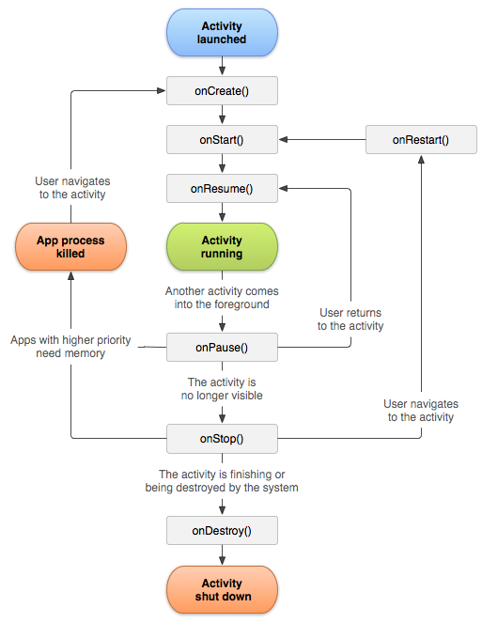
Override
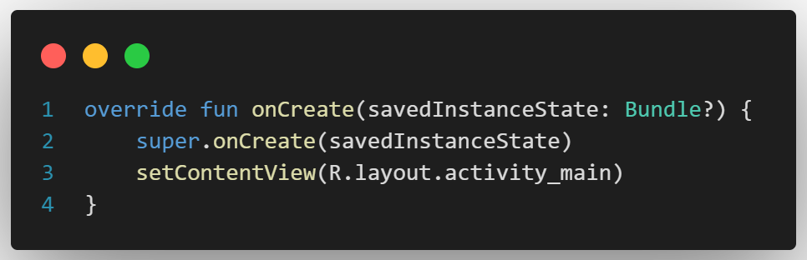
Tasks and back stack
- A task is a collection of activities that users interact with when trying to do something in your app.
- These activities are arranged in a stack called the back stack in the order in which each activity is opened.
Save UI states
- SavedInstanceState is a mechanism to preserve the state of an activity.
- Allows you to restore data when the activity is recreated.
Services
- A service is an application component that can perform long running operations in the background.
- It does not have a UI.
- It can continue running even after the user switches to another application.
Types of services
- Foreground
  - Performs some operation that is noticeable to the user.
  - Foreground services must use notification.
  - Continue running even when the user isn’t interacting with the app.
- Background
  - Perform an operation that isn’t directly noticed by the user.
- Bound
  - A service is bound when an app component binds to it by calling bindService().
  - Offers client service interface to interact with the service.
  - Runs only as long as another app component is bound to it.
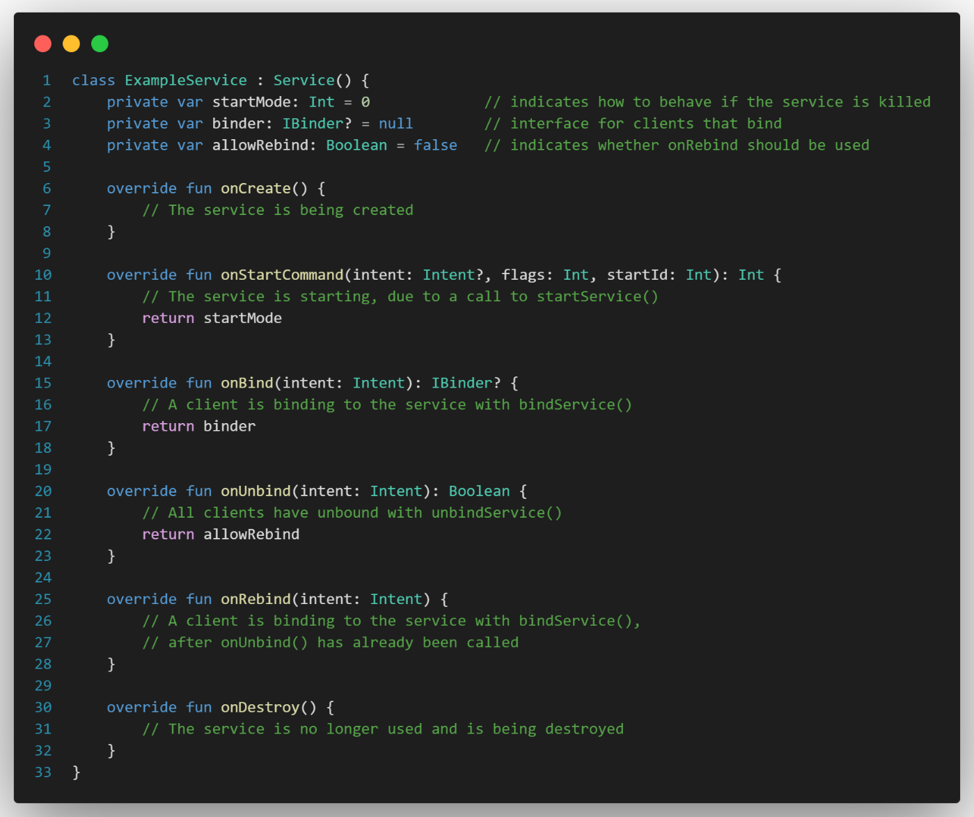
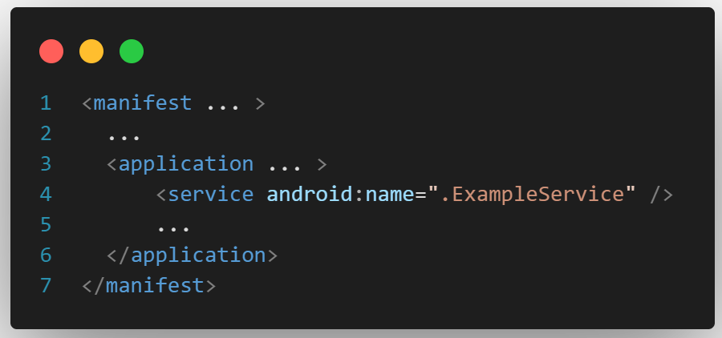

Starting and stopping a service
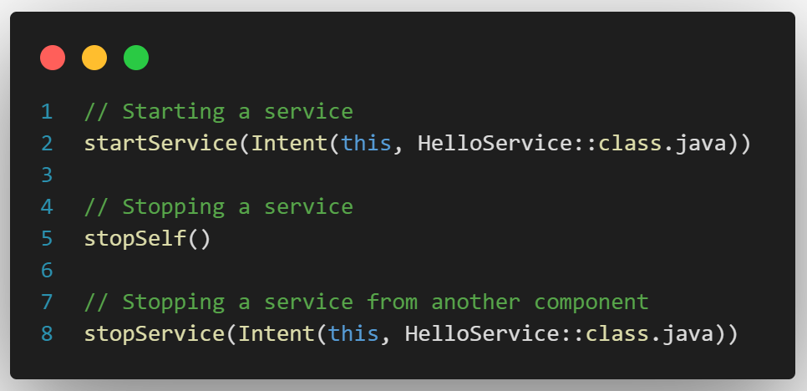
The service lifecycle
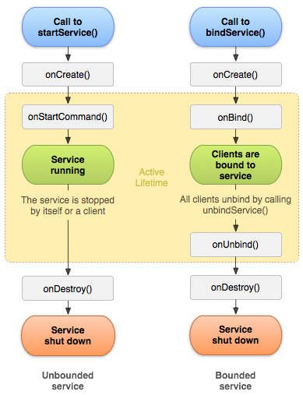
Broadcast receivers
- Android apps can send or receive broadcast messages from the Android system and other Android apps.
- These broadcasts are sent when an event of interest occurs.
Receiving broadcasts
- Apps can receive broadcasts in two ways
  - manifest-declared receivers.
  - context-registered receivers.
Sending broadcasts
- Android provides three ways for apps to send broadcast
  - sendOrderedBroadcast(Intent, String)
  - sendBroadcast(Intent)
Content providers
- Content providers can help an application manage access to data stored by itself or stored by other apps and provide a way to share data with other apps.
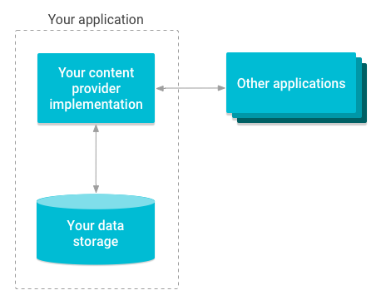
Intents and starting activities
- An Intent is a messaging object you can use to request an action from another app component. Such as
  - Starting an activity.
  - Starting a service.
  - Delivering a broadcast.
Explicit intent
- Specify the exact component to start.
- Usually within the same app.
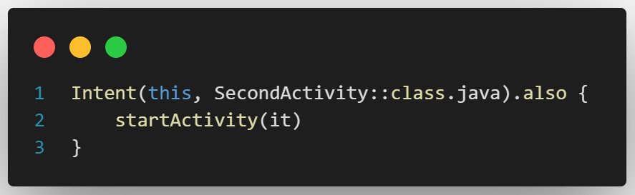
Implicit intent
- Do not name a specific component, but instead declare a general action to perform, which allows a component from another app to handle it.
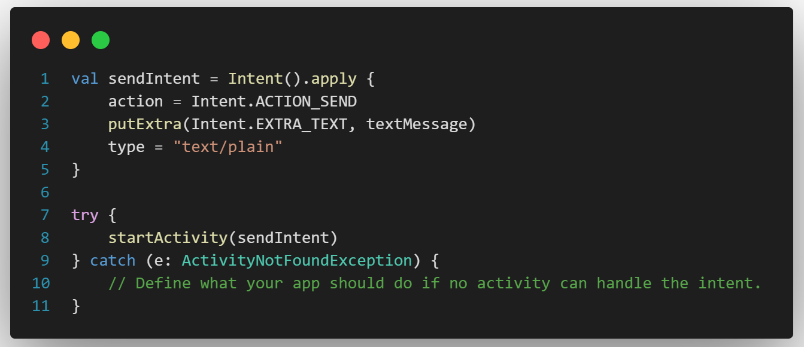

Pending intent
- Grant permission to a foreign app to use the contained intent as if it were executed from your app’s own process.
Intent filter
- An Intent Filter in Android is a component of the Android manifest file that tells the Android system which intents an app component can respond to.
Passing data between activities
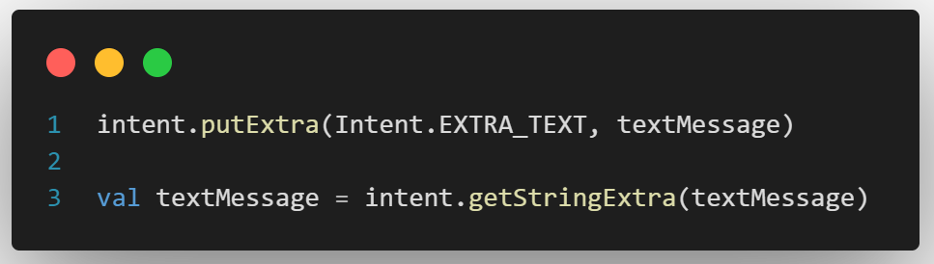
- To pass a data class use @Serializable and pass the object.
val data = Intent.getSerializableExtra(“key”) as Data
Fragments
- A Fragment represents a reusable portion of your app's UI.
- Fragments are lightweight and have their own lifecycle.
- Their lifecycle is closely tied to the host activities lifecycle.
Fragment manager
- Responsible for performing actions on your app's fragments, such as adding, removing, or replacing them and adding them to the back stack.
Fragment transactions
- FragmentManager can add, remove, replace, and perform other actions with fragments in response to user interaction.
- Each set of fragment changes that you commit is called a transaction.

Add fragment via xml
class ExampleFragment : Fragment(R.layout.example_fragment)
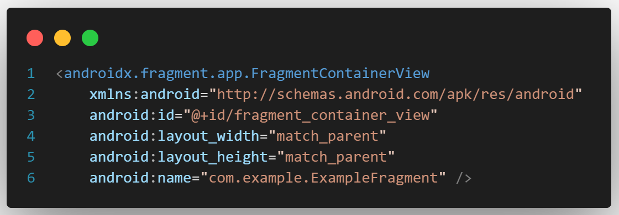
Add a fragment programmatically
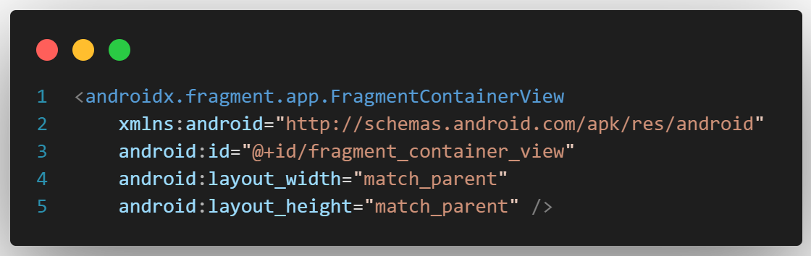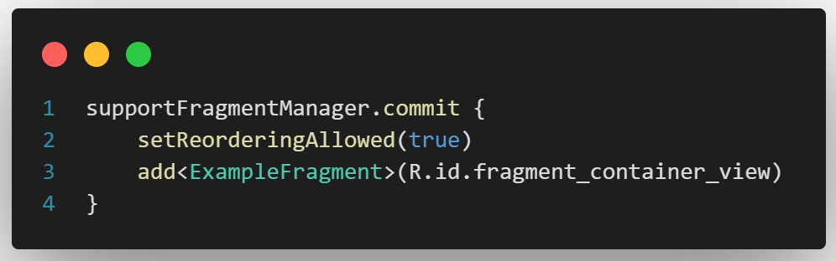

Fragment lifecycle
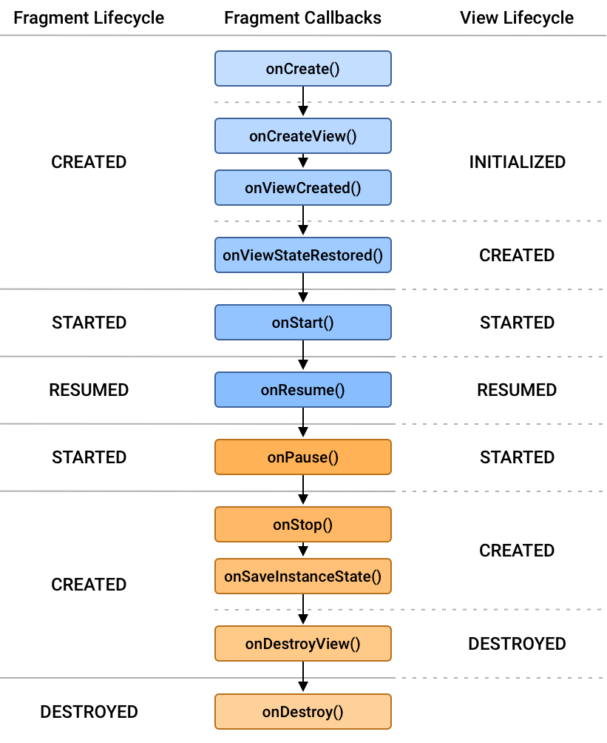

Context
Interface to global information about an application environment. This is an abstract class whose implementation is provided by the Android system. It allows access to application-specific resources and classes, as well as up-calls for application-level operations such as launching activities, broadcasting and receiving intents, etc.
Serializable
Serializable is a standard Java interface used to convert an object into a byte stream, allowing the object to be easily saved to a file, sent over a network, or stored in a database.
Parcelable
Parcelable is an Android-specific interface that enables an object to be passed as a parameter from one activity to another. This is a more efficient method compared to serialization, as it doesn’t require the object to be converted into a byte stream.
View binding
It generates a binding class for each XML layout file present in that module. An instance of a binding class contains direct references to all views that have an ID in the corresponding layout.
Data binding
The Data Binding Library is a support library that allows you to bind UI components in your layouts to data sources in your app using a declarative format rather than programmatically.
App manifest
The manifest file describes essential information about your app to the Android build tools, the Android operating system, and Google Play. It declares,
- The components of the app, including all activities, services, broadcast receivers, and content providers.
- The permissions that the app needs in order to access protected parts of the system or other apps.
- The hardware and software features the app requires.
XML
- Extensible Markup Language
- XML is used to define the layout of activities and fragments in Android. Each layout file represents a single screen or part of a screen in the app.
- Basically, the XML tags are not predefined in XML. We need to implement and define the tags in XML.
XML namespaces
XML files in Android often include a namespace declaration like xmlns:android="http://schemas.android.com/apk/res/android", which is necessary to distinguish Android attributes from other XML attributes.

ANRs
- When the UI thread of an Android app is blocked for too long, an "Application Not Responding" (ANR) error is triggered.
- If the app is in the foreground, the system displays a dialog to the user.
- The ANR dialog gives the user the opportunity to force quit the app.
Causes of ANR
- Main Thread Blocking: The most common cause is when the main thread (also known as the UI thread) is blocked by a long-running operation, such as:
  - Performing network operations.
  - Accessing the file system (reading/writing large files).
  - Querying a large database.
  - Performing heavy computations.
- Deadlocks: If two or more threads are waiting on each other to release resources, a deadlock occurs, which can lead to ANR if it involves the main thread.
- Too Many Broadcast Receivers: If your app registers too many broadcast receivers and they take too long to execute, this can cause the app to hang and trigger an ANR.
- ContentProvider Operations: Long-running queries or database operations in ContentProvider can also block the main thread and lead to ANRs.
How to prevent ANR
- Use Background Threads: Offload long-running operations to background threads using mechanisms like:
  - AsyncTask (deprecated in newer versions of Android)
  - HandlerThread
  - IntentService (also deprecated, use WorkManager instead)
  - Executors
  - Coroutines in Kotlin
- Use Async I/O Operations: Always perform I/O operations (like network requests and database queries) asynchronously to avoid blocking the main thread.
- Optimize ContentProvider Queries: Make sure any database queries or other heavy operations performed in ContentProvider are efficient and use background threads where possible.
- Limit the Execution Time of Broadcast Receivers: Keep the execution time of BroadcastReceiver as short as possible. If a longer operation is necessary, start a background service.
- Avoid Long Synchronous Operations: Avoid performing long synchronous operations on the main thread.
- Use StrictMode: Utilize StrictMode during development to detect accidental long-running operations on the main thread.

Platform architecture
Linux kernel
- The foundation of the Android platform is the Linux kernel.
- For example, the Android Runtime (ART) relies on the Linux kernel for underlying functionalities such as threading and low-level memory management.
Hardware abstraction layer (HAL)
- The hardware abstraction layer (HAL) provides standard interfaces that expose device hardware capabilities to the higher-level Java API framework.
Android runtime
- For devices running Android version 5.0 (API level 21) or higher, each app runs in its own process and with its own instance of the Android Runtime (ART).
- ART is written to run multiple virtual machines on low-memory devices by executing Dalvik Executable format (DEX) files.
Native C/C++ libraries
- Many core Android system components and services, such as ART and HAL, are built from native code that requires native libraries written in C and C++.
- The Android platform provides Java framework APIs to expose the functionality of some of these native libraries to apps.
Java API framework
- The entire feature-set of the Android OS is available to you through APIs written in the Java language.
- These APIs form the building blocks you need to create Android apps by simplifying the reuse of core, modular system components and services.
System apps
- Android comes with a set of core apps for email, SMS messaging, calendars, internet browsing, contacts, and more.
- Apps included with the platform have no special status among the apps the user chooses to install.
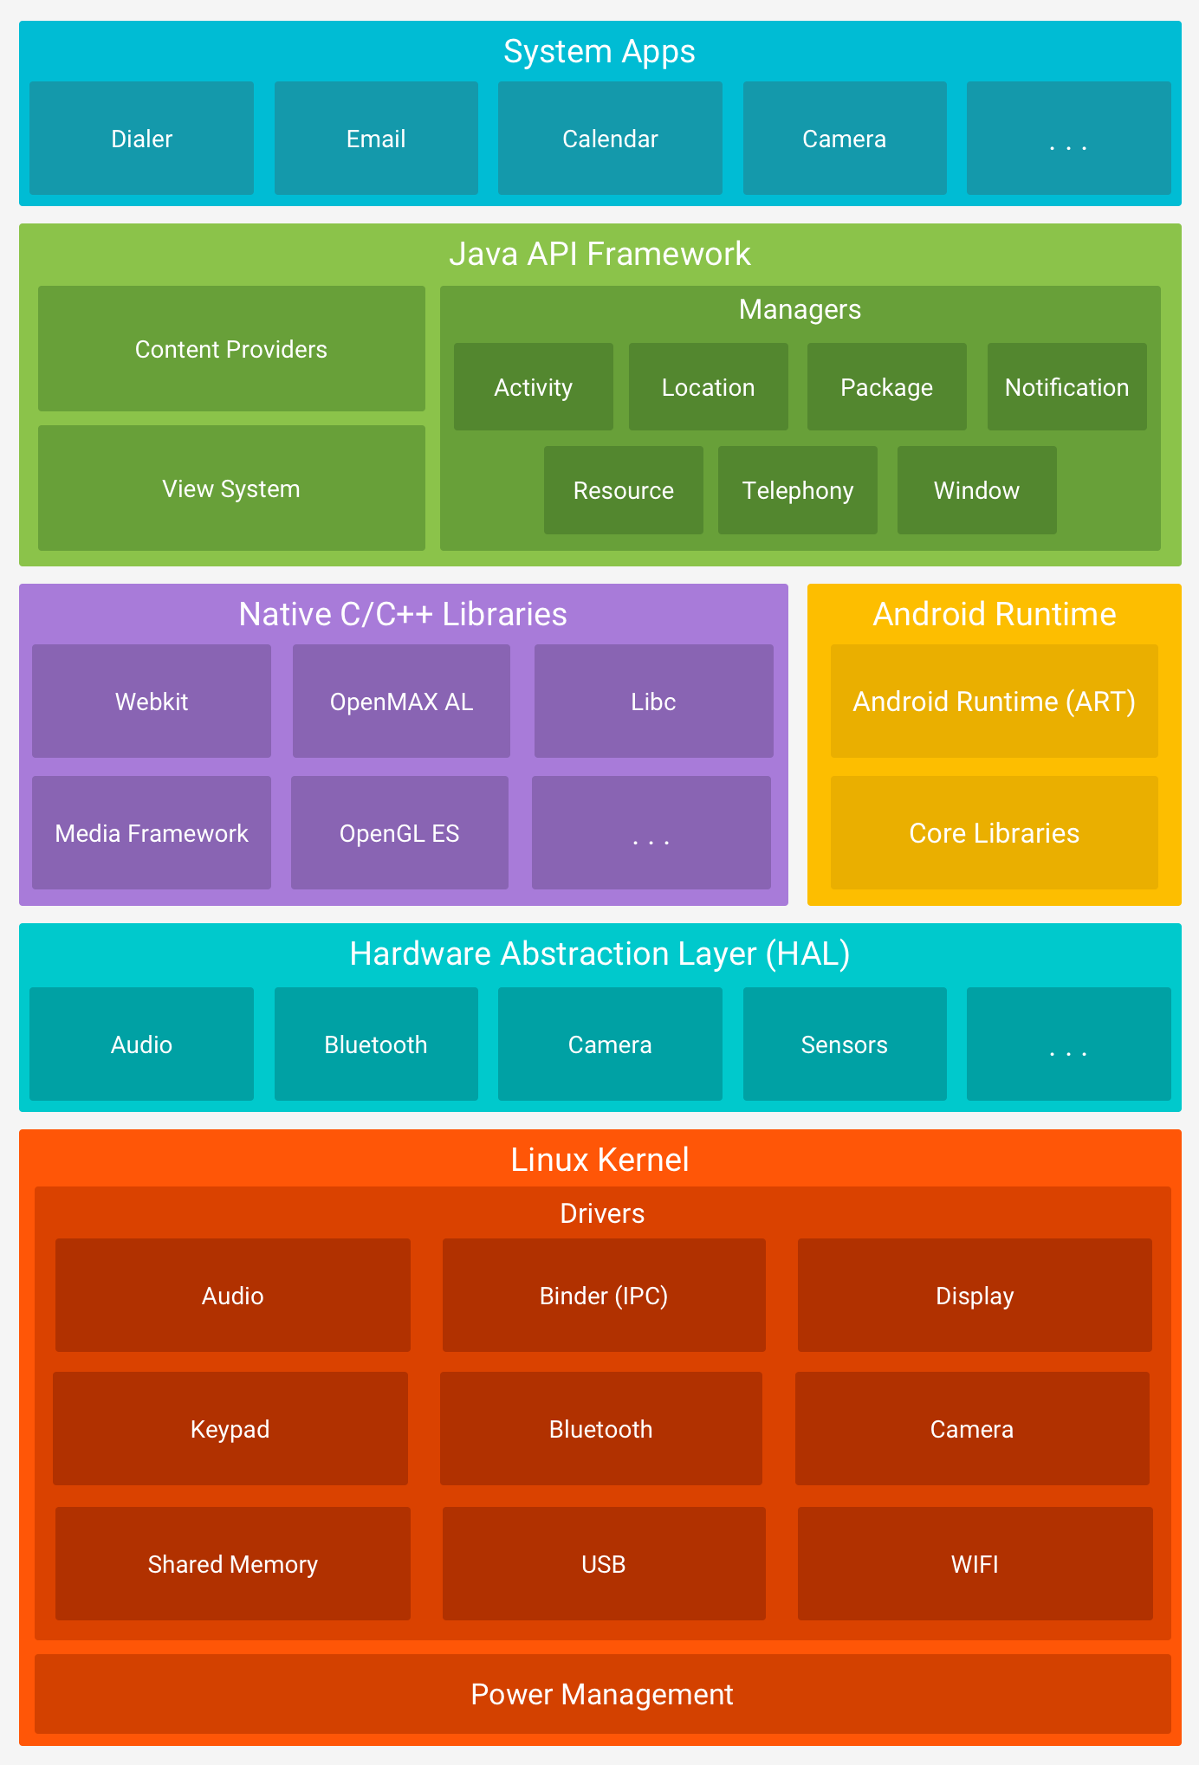

Layouts in views
- A layout defines the structure for a user interface in your app, such as in an activity.
- All elements in the layout are built using a hierarchy of View and ViewGroup objects.
View
- A View usually draws something the user can see and interact with.
  - Button
  - TextView
  - EditText
  - ImageView
  - RadioGroup
  - RadioButton
  - CheckBox
ViewGroup
- A ViewGroup is an invisible container that defines the layout structure for View and other ViewGroup objects.
  - LinearLayout
  - Aligns all the children either horizontally or vertically.
  - You can specify the layout direction with the android:orientation attribute.
  - RelativeLayout
  - RelativeLayout is a view group that displays child views in relative positions.
  - The position of each view can be specified as relative to sibling elements (such as to the left-of or below another view) or in positions relative to the parent RelativeLayout area (such as aligned to the bottom, left or center.
- android:layout_alignParentTop
- android:layout_centerVertical
- android:layout_below
- android:layout_toRightOf
  - ConstrainLayout
  - ConstraintLayout lets you create large, complex layouts with a flat view hierarchy—no nested view groups.
  - It's similar to RelativeLayout, but it's more flexible than RelativeLayout and easier to use with Android Studio's Layout Editor.
  - FrameLayout
  - Contains a single child view.
  - It can hold multiple child views, but each child will overlap with others.
  - Stack them on top of each other.
  - ListView
  - Displays vertically scrollable collection of views.
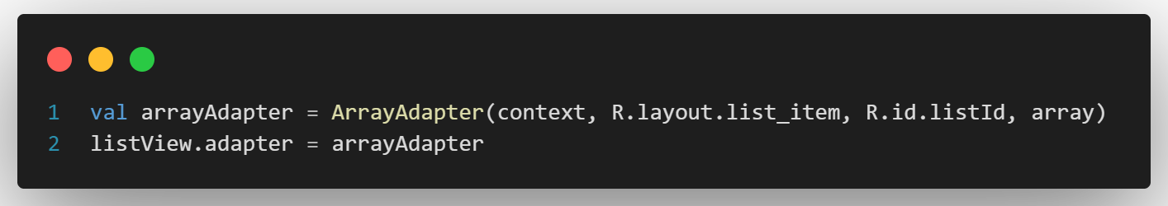
  - GridView
  - Displays items in the grid format, with multiple rows and columns.
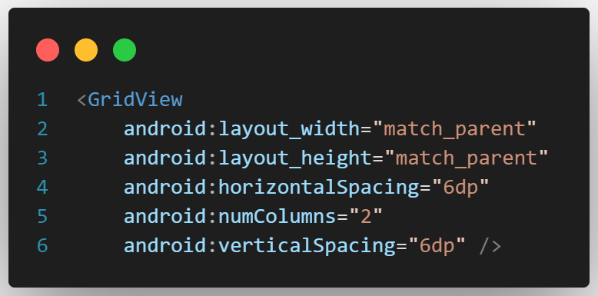

  - RecyclerView
  - RecyclerView makes it easy to efficiently display large sets of data.
  - When an item scrolls off the screen, RecyclerView doesn't destroy its view. Instead, RecyclerView reuses the view for new items.
