IAM Hands-On Lab Portfolio
Module M2 — Initial Configuration of Microsoft Entra ID
Mubashshir Athani • SC-300 Track • Free Entra ID tenant lab • Completed Sep 2026

About this lab
This document is hands-on evidence that I configured a Microsoft Entra ID tenant from scratch in a free lab environment — covering navigation, sign-in branding, least-privilege role assignment, and tenant-wide governance settings. Each task below shows what I did, why it matters, and a real screenshot.
Lab tenant: mubbolaboutlook.onmicrosoft.com • Test users: login1, login2, login3 • Role: Global Administrator (me).

Task 1 — Explore the Entra admin center
🔧 What I did
Signed in to the Entra admin center and located the tenant Overview — confirmed the Tenant ID (74f67e36-c136-4c85-8fef-8fdba9c7a4a3), primary domain, license (Entra ID Free), and that all 4 users exist.
💡 Why it matters
The Overview is an admin’s home base — you confirm tenant identity, domain, and license state before making any change.
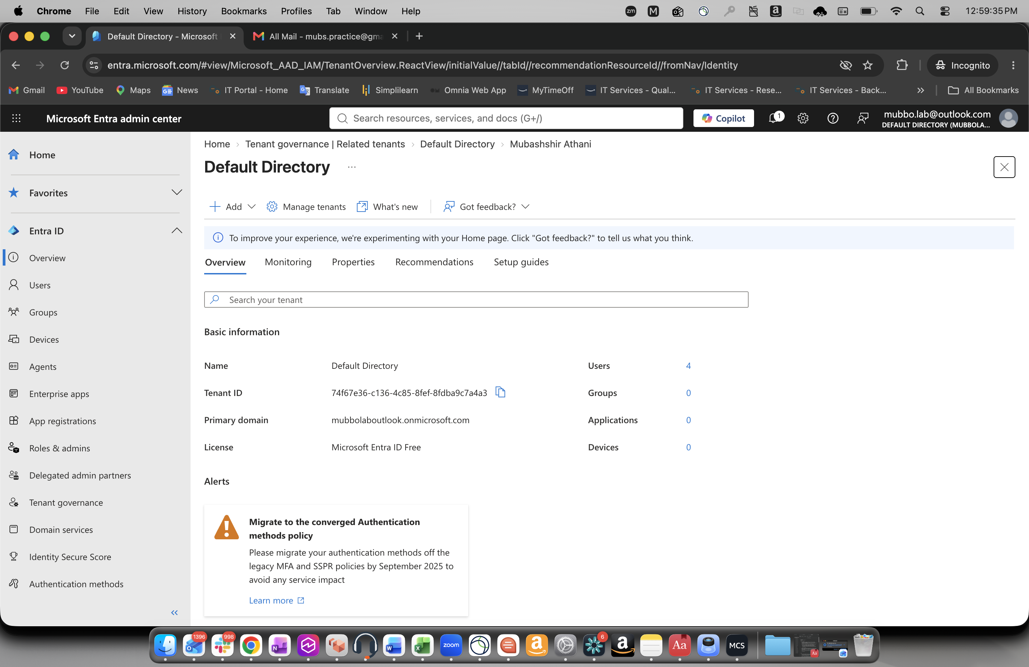
📸 Tenant Overview — Tenant ID, primary domain, license, and 4 users.

Task 2 — Configure Company Branding
🔧 What I did
Customised the default sign-in experience — set a page background colour (#72a175 green) and a footer message “Mubashshir IT Security – Securing every dot”. Left all image fields empty (all optional).
💡 Why it matters
Branding is a security control, not decoration: users who recognise their real sign-in page are far less likely to fall for phishing pages that lack it.
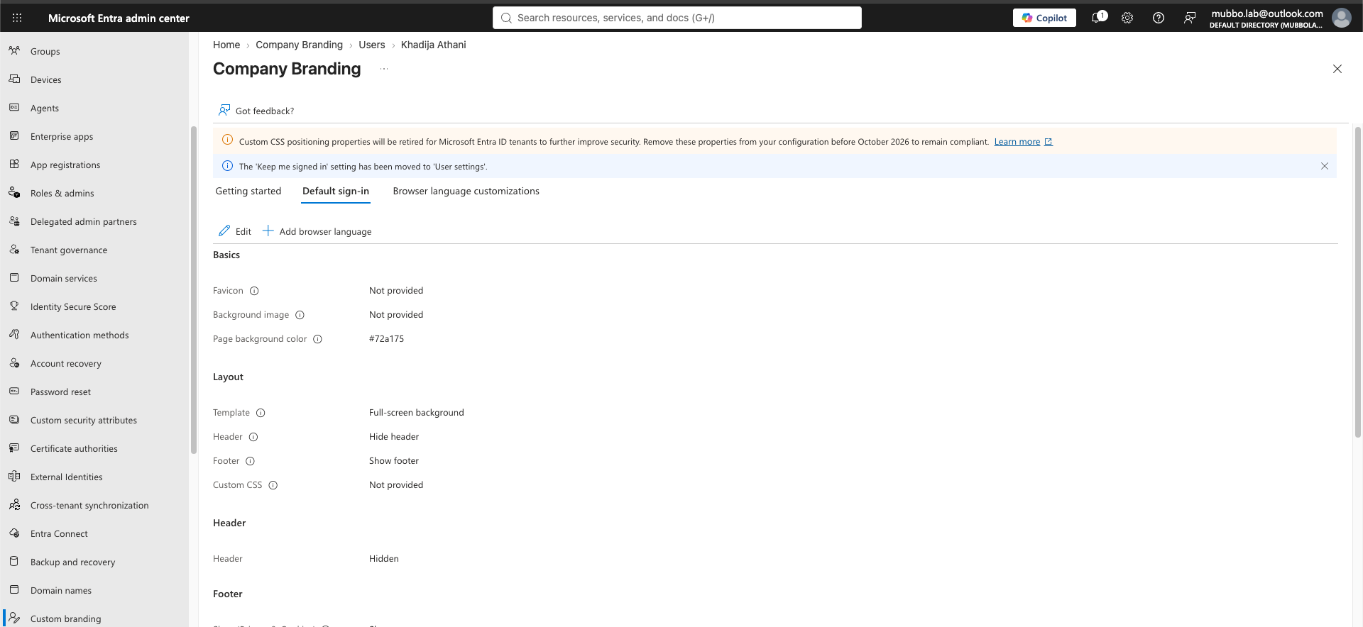
📸 Company Branding config — background colour + footer text saved (images skipped).
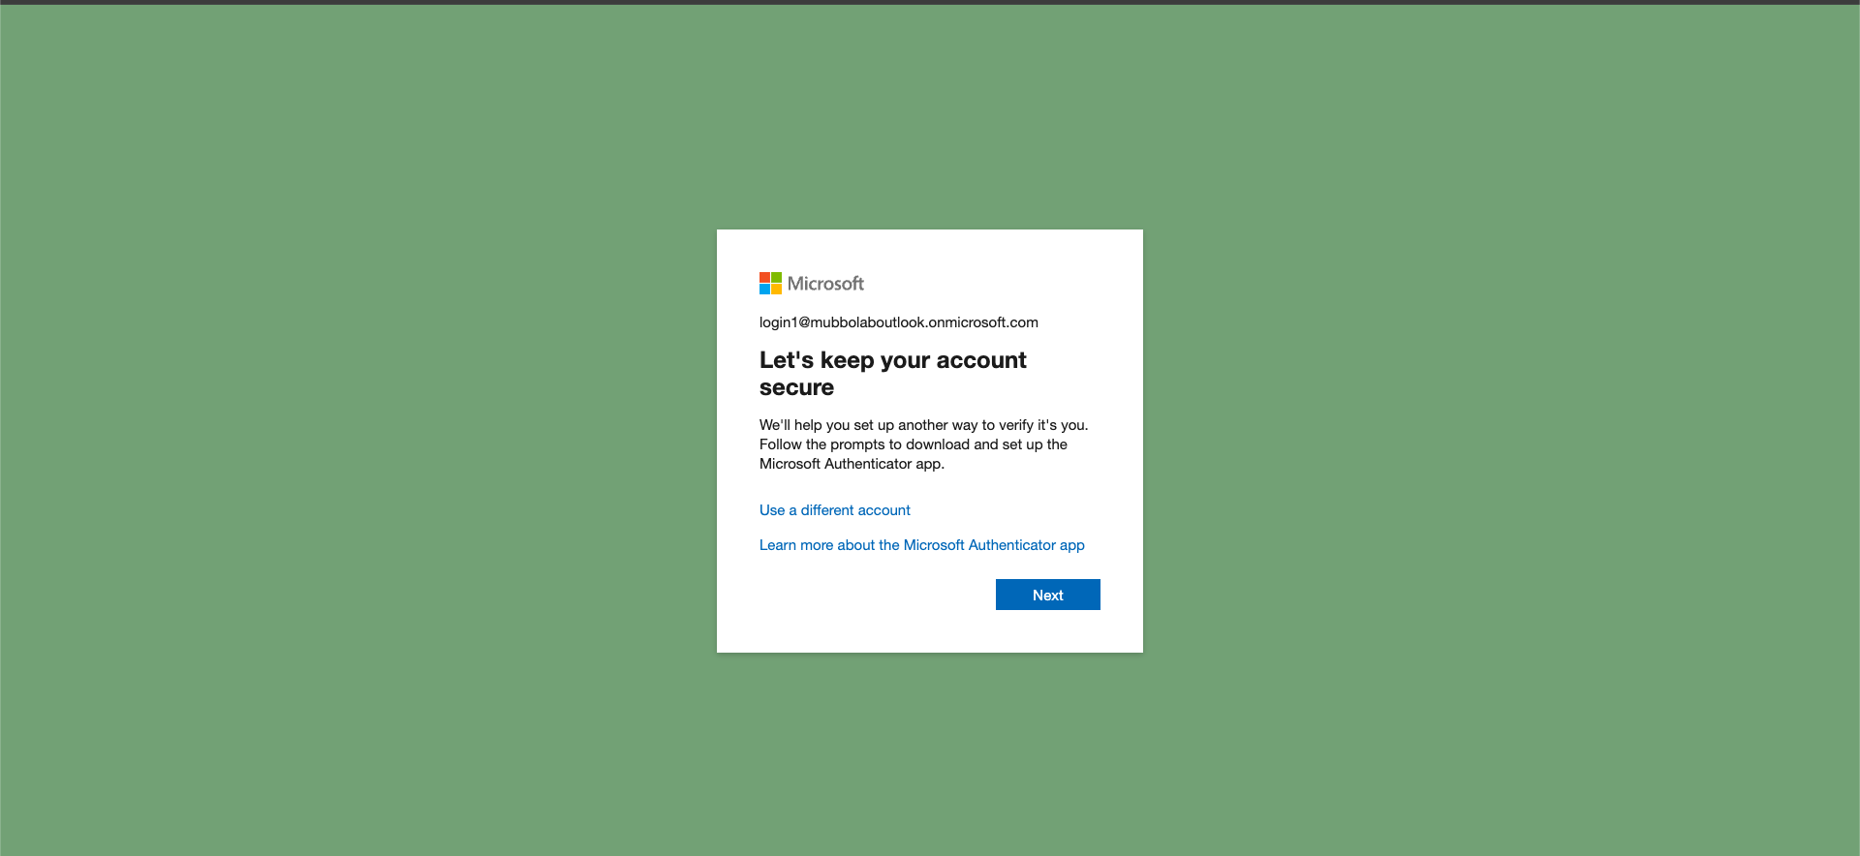
📸 Branding live — login1’s sign-in page shows the custom green background.

Task 3 — Assign an Admin Role (Least Privilege)
🔧 What I did
Assigned login1 (Khadija Athani) the Helpdesk Administrator role — a focused role limited to password resets for non-admin users — instead of Global Administrator.
💡 Why it matters
This is Least Privilege in practice: grant the minimum role the job needs. If the account is compromised, the blast radius is tiny — no billing, no Conditional Access, no ability to create other admins.
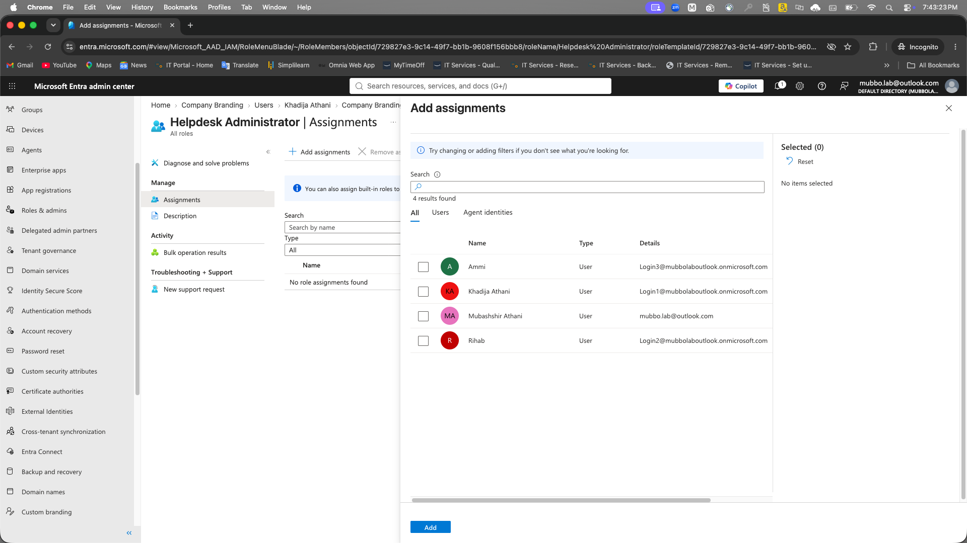
📸 Add assignments — selecting login1 for the Helpdesk Administrator role.
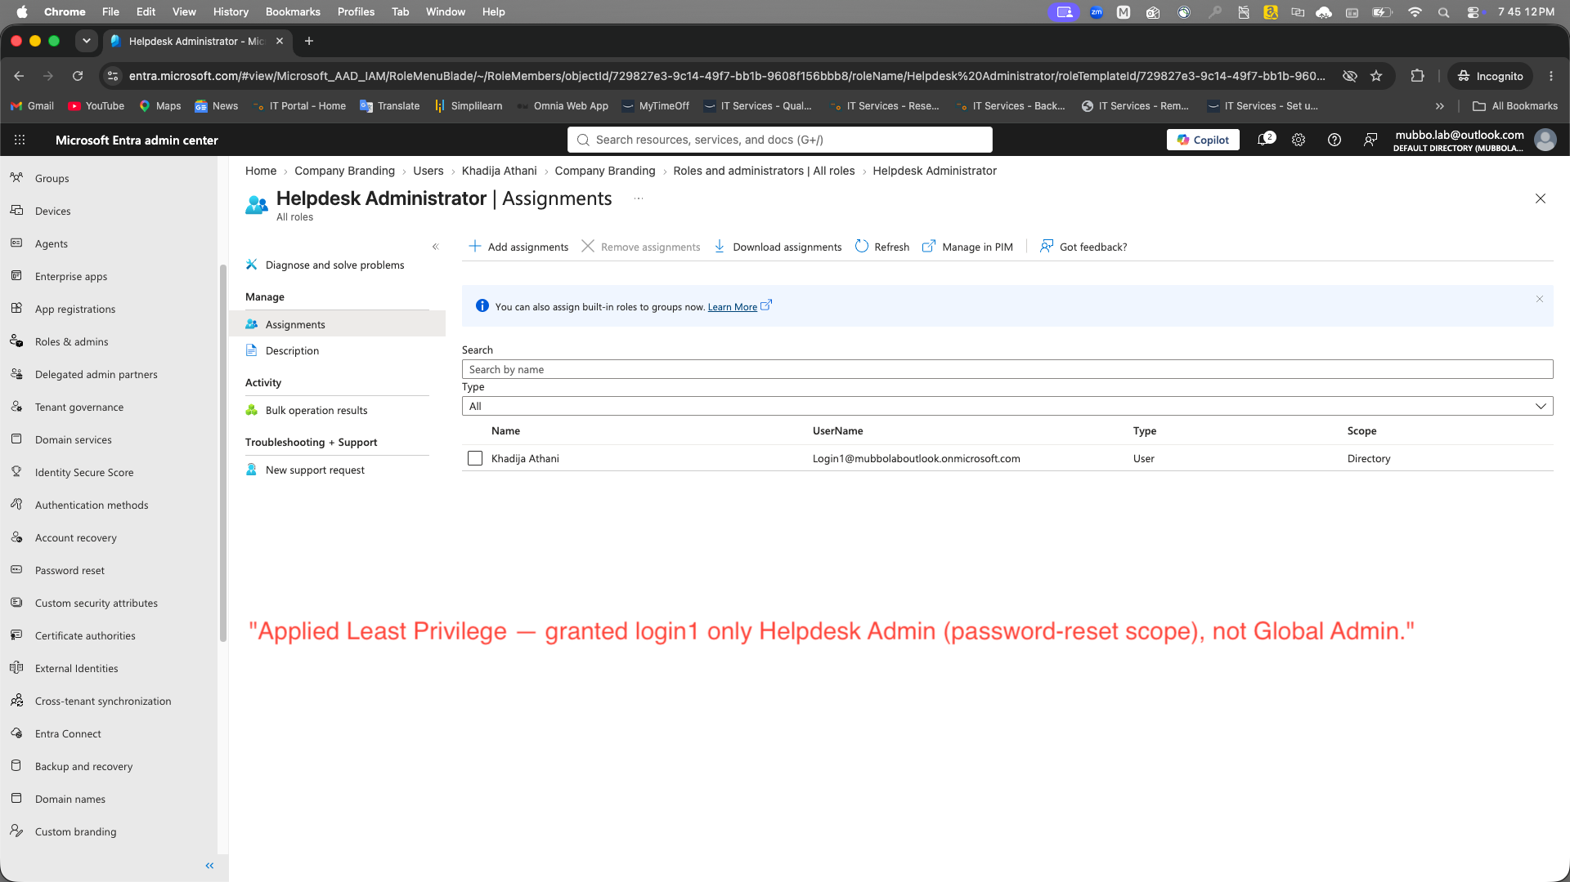
📸 Least Privilege proof — login1 assigned Helpdesk Administrator (Directory scope), not Global Admin.

Task 4 — Harden Tenant-wide Settings
🔧 What I did
In User settings, set “Users can register applications” to No and “Restrict access to the Microsoft Entra admin center” to Yes. Reviewed guest-access restrictions (left at limited access).
💡 Why it matters
These are tenant-wide governance defaults — they apply to everyone at once. Disabling self-service app registration reduces shadow-IT risk; restricting admin-center access keeps normal users out of the management portal.
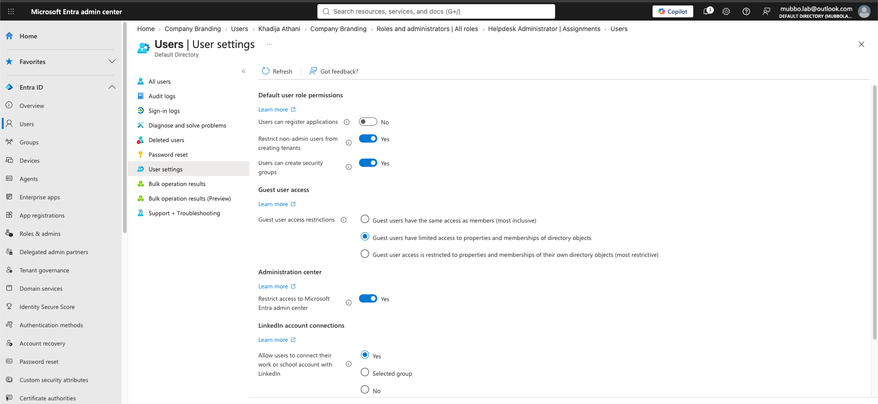
📸 User settings — app registration disabled and admin-center access restricted.

Skills demonstrated
Task | Skill proven
Explore admin center | Confident navigation of Microsoft Entra ID; reading tenant identity & license.
Company branding | Anti-phishing hardening of the sign-in experience.
Admin role assignment | Least Privilege — scoped role assignment over Global Admin.
Tenant-wide settings | Governance hardening — app registration & admin-center restrictions.

Part of my SC-300 (Microsoft Identity & Access Administrator) hands-on learning journey.

