Artificial Intelligence Lab
Final Project Report
Smart City Traffic & Emergency Response AI System

Group Member 1: Mubeen Ahmer [24F0604]
Group Member 2: Moiz-Ul-Islam [24F3024]

1. Project Overview
The Smart City Traffic and Emergency Response AI System is a software-based simulation developed for the Artificial Intelligence Lab final project. The system models urban traffic management as an integrated AI problem, combining multiple artificial intelligence techniques to handle different types of traffic requests.

Rather than relying on a single AI technique, the system uses a modular pipeline architecture where different modules are activated depending on the type of request received. Routine traffic requests may require only route generation, while emergency situations involve priority prediction, policy validation, traffic signal control, and optimized navigation working together.

1.1 System Goals
- Design an AI-based traffic management platform for a smart city environment
- Support route generation for both regular and emergency movement requests
- Prioritize emergency traffic using predictive urgency analysis via ANN
- Validate traffic-control actions using policy and rule-based reasoning
- Assign and adjust signal-control actions under constraints using CSP
- Combine multiple AI methods inside one modular and explainable system
- Produce clear and actionable final responses for system users

1.2 Request Categories

Category | Modules Used | Purpose
Route_Request | Search (BFS) | Standard route guidance for normal traffic
Policy_Check | Knowledge Base | Validation of rule-based traffic conditions
Control_Allocation_Request | KB → CSP | Signal assignment under constraints
Emergency_Response_Request | ANN → KB → CSP → Search | Full emergency pipeline
Integrated_City_Service_Request | ANN → KB → CSP → Search | Combined routing and control

2. System Architecture
The system follows a pipeline-based modular architecture. Each request passes through a structured progression from input to final output. The request category determines which modules are activated, preventing unnecessary computation.

2.1 Pipeline Flow
Traffic Request
↓
Input & Preprocessing → Validates and normalizes the request
↓
Request Router → Selects the correct module pipeline
↓
ANN Module → Predicts urgency/priority (if needed)
↓
Knowledge Base → Validates policy and authorization
↓
CSP Scheduler → Assigns signal phases under constraints
↓
Search & Navigation → Finds best route through city graph
↓
Final Response Layer → Combines and presents the decision

2.2 Project File Structure
SmartTraffic/
├── main.py ← Entry point and menu system
├── data/
│ └── city_graph.py ← City graph, CSP data, constants
└── modules/
├── preprocessing.py ← Input validation and normalization
├── router.py ← Pipeline selection
├── ann.py ← ANN priority prediction
├── knowledge_base.py ← Rule-based policy reasoning
├── csp.py ← Constraint satisfaction scheduling
├── search.py ← BFS, UCS, A* navigation
└── response.py ← Final response formatting

3. Description of AI Concepts Used

3.1 Search Algorithms (search.py)
The Search and Navigation module implements three classical AI search algorithms over the city road network. Intersections are modeled as nodes and roads as edges with optional weights.

Breadth-First Search (BFS)
BFS operates on the unweighted city graph and finds the path with the fewest number of hops. It uses a FIFO queue to explore neighbors level by level, guaranteeing the shortest path in terms of edges traversed.

Uniform Cost Search (UCS)
UCS operates on the weighted city graph and finds the path with the lowest total cost. It uses a priority queue (min-heap) to always expand the cheapest node first, guaranteeing the optimal cost path.

A* Search
A* combines UCS with a heuristic function to guide the search toward the destination faster. The priority of each node is calculated as f(n) = g(n) + h(n), where g(n) is the actual cost from start and h(n) is the heuristic estimate to the destination. A manually defined heuristic table provides estimated distances from each node to City_Hospital.

Algorithm | Graph Type | Strategy | Guarantee
BFS | Unweighted | FIFO Queue | Fewest hops
UCS | Weighted | Priority Queue (cost) | Lowest cost
A* | Weighted + Heuristic | Priority Queue (cost + h) | Optimal if h is admissible

3.2 Artificial Neural Network (ann.py)
The ANN module predicts the urgency or priority level of a request using a Multi-Layer Perceptron (MLP) built from scratch using NumPy. No external machine learning libraries are used.

Architecture
- Input Layer: 6 neurons (vehicle class, severity, time sensitivity, traffic density, priority claim, distance)
- Hidden Layer 1: 8 neurons with ReLU activation
- Hidden Layer 2: 6 neurons with ReLU activation
- Output Layer: 4 neurons with Softmax activation (Low / Normal / High / Critical)

Training
The network is trained using backpropagation with gradient descent. 15 manually prepared training examples cover all priority classes. Cross-entropy loss is used as the loss function. The model trains for 1000 epochs with a learning rate of 0.01, achieving a final loss of approximately 0.054.

Feature Vector
# Input feature encoding:
vehicle_class → EmergencyVehicle=1, CivilianVehicle=0
incident_severity → Low=0, Medium=1, High=2
time_sensitivity → True=1, False=0
traffic_density → float (0.0 to 1.0)
priority_claim → True=1, False=0
distance → float (estimated route distance)

3.3 Logic / Knowledge Base (knowledge_base.py)
The Knowledge Base module implements rule-based reasoning using logical predicates defined in the project specification. It answers two questions: what priority does this vehicle have, and what actions is it authorized to perform?

Priority Rules
EmergencyVehicle + IncidentSeverity(High) → Priority: Critical
EmergencyVehicle + TimeSensitive → Priority: High
CivilianVehicle → Priority: Normal

Authorization Rules
EmergencyVehicle + SignalZone → Authorized: SignalOverride
CivilianVehicle + SignalZone → NOT Authorized: SignalOverride
EmergencyVehicle + Destination is Hospital → Authorized: EmergencyCorridor
EmergencyCorridor → Authorized: EmergencyRoute

Approval Rules
Route_Request → Always Approved
Policy_Check + Authorized → Approved
Control_Allocation + AllowedAction → Approved
Emergency_Response + EmergencyRoute → Approved
Integrated + Critical + EmergencyRoute → Approved

3.4 Constraint Satisfaction Problem — CSP (csp.py)
The CSP Scheduler assigns valid signal phases to intersections while respecting conflict and coordination constraints. It uses recursive backtracking to find a consistent assignment.

CSP Formulation
- Variables: S1 (Central_Junction), S2 (North_Station), S3 (East_Market), S4 (River_Bridge), S5 (City_Hospital)
- Domains: Each intersection has a set of valid phases — e.g. S1: {PhaseA, PhaseB}
- Constraints: Conflicting intersections must not share the same phase — (S1, S2) and (S1, S3)
- Coordination: S2 and S4 should share the same phase where possible
- Emergency Override: When priority is Critical, S1=PhaseA, S4=PhaseC, S5=PhaseB are forced

Backtracking Algorithm
The backtracking algorithm selects each unassigned variable in order, tries each value in its domain, checks consistency against all constraints, and backtracks if no valid assignment is found. This guarantees a complete and valid signal plan.

4. Module Descriptions and Run Sequence

Module | File | Function | Run Order
Input & Preprocessing | preprocessing.py | preprocess(request) | 1st — always
Request Router | router.py | route_request(request) | 2nd — always
ANN Priority | ann.py | run_ann(request) | 3rd — if needed
Knowledge Base | knowledge_base.py | run_knowledge_base(request) | 4th — if needed
CSP Scheduler | csp.py | run_csp(request, actions, priority) | 5th — if needed
Search Navigation | search.py | find_route(start, dest, algo) | 6th — if needed
Final Response | response.py | build_response(...) | 7th — always

4.1 How to Run the Program
1. Make sure Python 3.x and NumPy are installed.
2. Navigate to the project folder in terminal.
3. Run the main file:
python main.py
4. A menu will appear with 6 options. Select a request type and enter the required details.
5. The system will run the appropriate pipeline and display the final response.

5. Code Snippets

5.1 Preprocessing — preprocess()
def preprocess(request):
"""
Master preprocessing function. Validates, normalizes,
and prepares the request. Returns cleaned request.
"""
check_required_fields(request)
request = normalize_request(request)
validate_fields(request)
request["feature_vector"] = build_feature_vector(request)
return request

5.2 Router — route_request()
def route_request(request):
"""Selects the module pipeline based on request category."""
category = request["request_category"]
if category == "route_request":
pipeline = ["search"]
elif category == "emergency_response_request":
pipeline = ["ann", "knowledge_base", "csp", "search"]
# ... other categories
return pipeline

5.3 ANN — forward pass and predict()
def forward(self, x):
"""Forward pass through the MLP network."""
self.z1 = np.dot(x, self.W1) + self.b1
self.a1 = relu(self.z1)
self.z2 = np.dot(self.a1, self.W2) + self.b2
self.a2 = relu(self.z2)
self.z3 = np.dot(self.a2, self.W3) + self.b3
self.a3 = softmax(self.z3)
return self.a3

def predict(self, features):
"""Returns predicted priority label."""
x = np.array(features, dtype=float)
output = self.forward(x)
predicted_index = np.argmax(output)
return PRIORITY_LABELS[predicted_index]

5.4 CSP — backtrack()
def backtrack(assignment):
"""Recursively assigns phases using backtracking."""
if len(assignment) == len(CSP_VARIABLES):
return assignment
for var in CSP_VARIABLES:
if var not in assignment:
unassigned = var
break
for value in CSP_DOMAINS[unassigned]:
if is_consistent(unassigned, value, assignment):
assignment[unassigned] = value
result = backtrack(assignment)
if result is not None:
return result
del assignment[unassigned]
return None

5.5 Search — A* Algorithm
def astar(start, destination):
"""A* Search using manual heuristic table."""
heap = []
heapq.heappush(heap, (HEURISTIC[start], 0, [start]))
visited = set()
while heap:
priority, cost, path = heapq.heappop(heap)
current = path[-1]
if current in visited:
continue
visited.add(current)
if current == destination:
return path, cost
for neighbor, weight in WEIGHTED_CITY_GRAPH[current].items():
if neighbor not in visited:
new_cost = cost + weight
new_priority = new_cost + HEURISTIC[neighbor]
heapq.heappush(heap, (new_priority, new_cost, path + [neighbor]))
return None, -1

6. Test Scenarios and Screenshots
The following five scenarios were tested to verify correct operation of all modules. Screenshots should be inserted below each scenario description.

Scenario 1 — Route Request (Civilian Vehicle)
Field | Value
Vehicle Type | car
Category | route_request
From | Stadium
To | City_Hospital
Severity | low
Algorithm Used | BFS

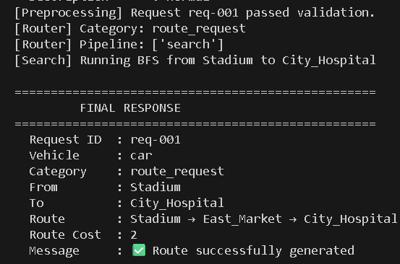

Scenario 2 — Policy Check (Police Vehicle)
Field | Value
Vehicle Type | police
Category | policy_check
From | Police_HQ
To | Central_Junction
Severity | medium

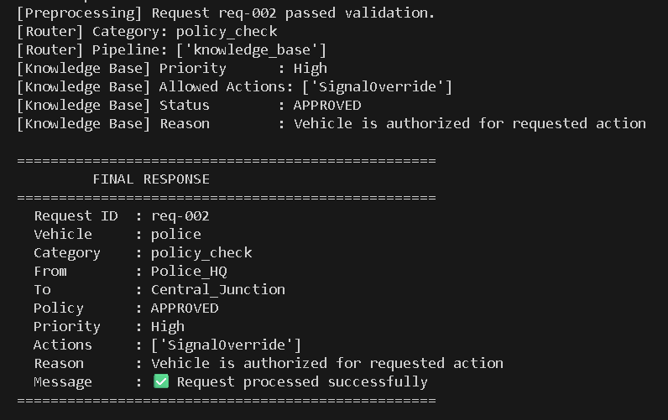

Scenario 3 — Control Allocation (Fire Truck)
Field | Value
Vehicle Type | fire_truck
Category | control_allocation_request
From | Fire_Station
To | Industrial_Zone
Severity | high

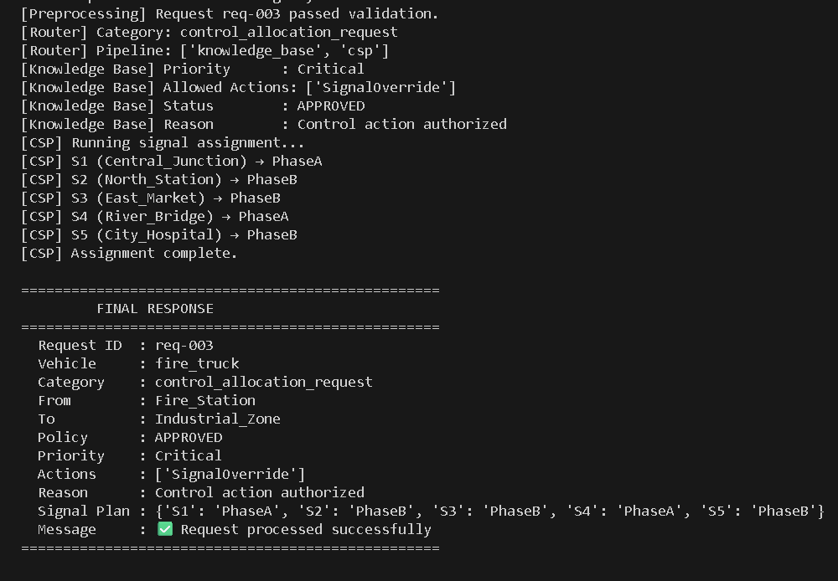

Scenario 4 — Emergency Response (Ambulance)
Field | Value
Vehicle Type | ambulance
Category | emergency_response_request
From | Central_Junction
To | City_Hospital
Severity | high
Time Sensitive | true
Traffic Density | 0.85

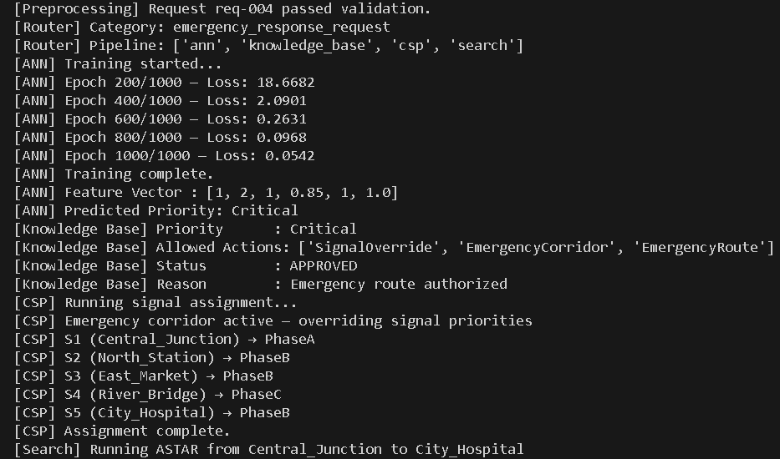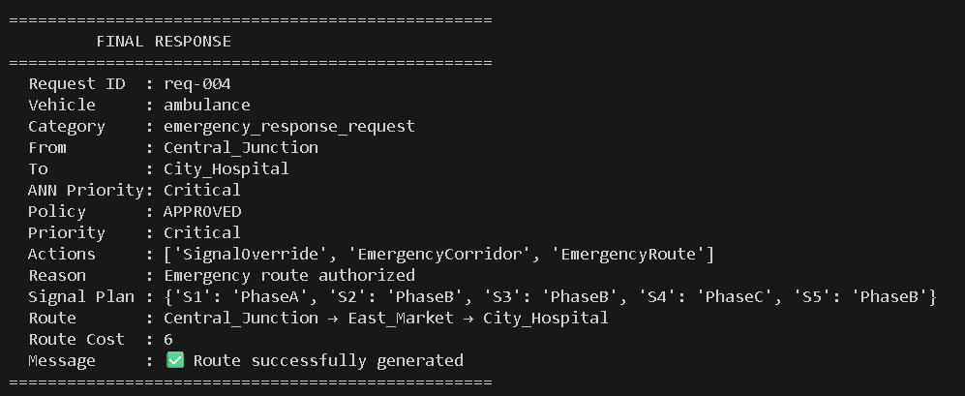

Scenario 5 — Error Handling
Testing invalid inputs to verify exception handling:
- Invalid vehicle type (e.g. helicopter) → ValueError: Vehicle type helicopter is invalid
- Traffic density out of range (1.5) → ValueError: Traffic density must be between 0.0 and 1.0
- Empty location field → ValueError: current_location cannot be empty
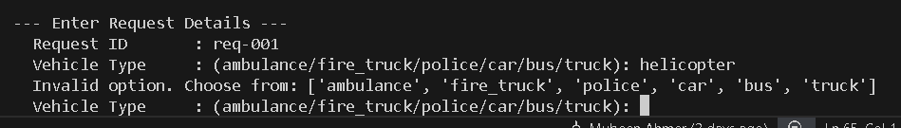

8. Conclusion
The Smart City Traffic and Emergency Response AI System successfully demonstrates the integration of multiple AI techniques within a single modular architecture. Each module implements a distinct AI concept — search algorithms for routing, an ANN for priority prediction, rule-based reasoning for policy validation, and constraint satisfaction for signal scheduling.

The system correctly handles all five request categories, activating only the modules required for each request type. Error handling ensures the system rejects invalid inputs gracefully without crashing. The pipeline architecture makes the system explainable — each decision can be traced through the modules that produced it.

