Convolutional Neural Network

(Using Tensor Flow, Keras and Sklearn)

Name: Mubeen Khalid Reg. no.: SP21-BSE-015

Class: BSE-6A Subject: Artificial Intelligence

# Lab Terminal

# Link to notebook:

# <https://colab.research.google.com/drive/1NDYpiI6BJoc7bmPxWGAOFw0OMUZ4INC1?usp=sharing>

# Source Code

## Model:

# Import necessary libraries

import tensorflow as tf

from tensorflow.keras import layers, models

from tensorflow.keras.datasets import cifar10

from tensorflow.keras.preprocessing.image import ImageDataGenerator

from tensorflow.keras.utils import to_categorical

# Loading and preprocessing

(x_train, y_train), (x_test, y_test) = cifar10.load_data()

# Normalizing pixel values

x_train, x_test = x_train / 255.0, x_test / 255.0

# encoding labels

y_train = to_categorical(y_train, 10)

y_test = to_categorical(y_test, 10)

# Data augmentation

datagen = ImageDataGenerator(rotation_range=20, width_shift_range=0.2, height_shift_range=0.2, horizontal_flip=True)

# CNN model

model = models.Sequential()

model.add(layers.Conv2D(32, (3, 3), activation='relu', input_shape=(32, 32, 3)))

model.add(layers.BatchNormalization())

model.add(layers.MaxPooling2D((2, 2)))

model.add(layers.Conv2D(64, (3, 3), activation='relu'))

model.add(layers.BatchNormalization())

model.add(layers.Flatten())

model.add(layers.Dense(256, activation='relu'))

model.add(layers.Dropout(0.5))

model.add(layers.Dense(128, activation='relu'))

model.add(layers.Dense(10, activation='softmax'))

# Compilation

model.compile(optimizer=tf.keras.optimizers.Adam(learning_rate=0.0001), loss='categorical_crossentropy', metrics=['accuracy'])

# Training

batch_size = 64

epochs = 100

history = model.fit(datagen.flow(x_train, y_train, batch_size=batch_size),

                    steps_per_epoch=len(x_train) / batch_size,

                    epochs=epochs,

                    validation_data=datagen.flow(x_test, y_test, batch_size=batch_size))

# Evaluation

loss, accuracy = model.evaluate(x_test, y_test, verbose=1)

accuracy = 100*accuracy

print(f'\nTest accuracy: {accuracy:.2f} percent')

# saving

model.save('CNN_labFinalTF.keras')

## Classification Report:

from sklearn.metrics import classification_report

import numpy as np

from tensorflow.keras.models import load_model

# Load the trained model

model = load_model('/content/CNN_labFinalTF.keras')

# Make predictions on the test set

y_pred = model.predict(x_test)

y_pred_classes = np.argmax(y_pred, axis=1)

y_true_classes = np.argmax(y_test, axis=1)

# Generate classification report

report = classification_report(y_true_classes, y_pred_classes)

# Print the report

print("Classification Report:\n", report)

## Prediction:

import numpy as np

from tensorflow.keras.preprocessing import image

from tensorflow.keras.models import load_model

# Load the trained model

model = load_model('/content/CNN_labFinalTF.keras')

img_path = '/content/frog.jpeg'

img = image.load_img(img_path, target_size=(32, 32))

img_array = image.img_to_array(img)

img_array = np.expand_dims(img_array, axis=0)

img_array /= 255.0

# Make predictions

predictions = model.predict(img_array)

# Get the predicted class label

predicted_class = np.argmax(predictions[0])

# Label descriptions

label_descriptions = {

    0: 'airplane',

    1: 'automobile',

    2: 'bird',

    3: 'cat',

    4: 'deer',

    5: 'dog',

    6: 'frog',

    7: 'horse',

    8: 'ship',

    9: 'truck',

}

# Get the predicted class description

predicted_description = label_descriptions.get(predicted_class, 'Unknown Class')

# Print the predicted class description

print(f'The predicted class is: {predicted_description}')

# Output

## Accuracy:

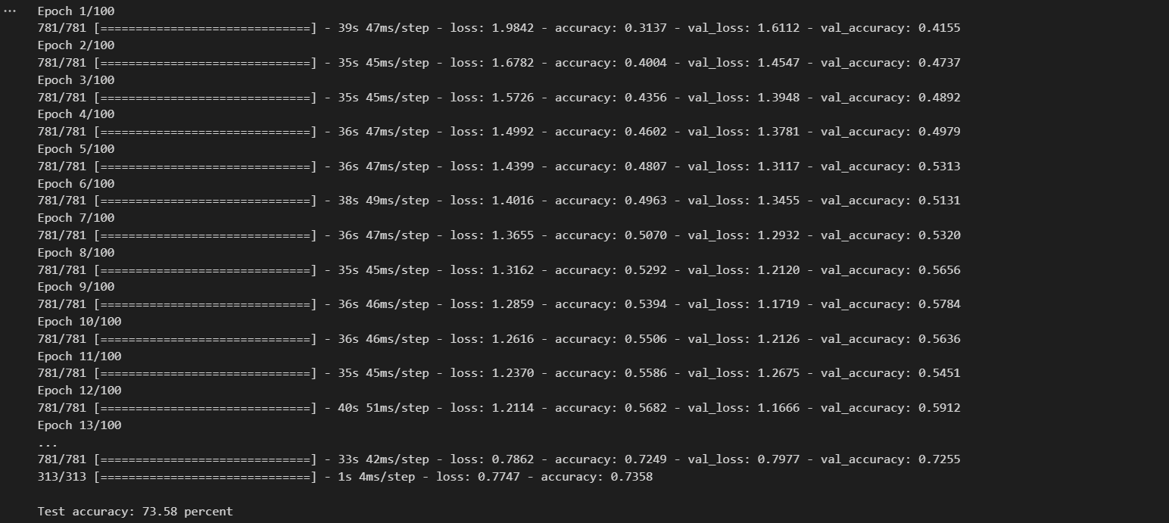

## Input Image:

## Prediction:

## Classification Report:

