## 

Mubeen Khalid

SP21-BSE-015

Design Patterns Lab

# Task 1:

## Dog:

/**

 * Dog

 */

public class Dog {

    private String name;

    Dog() {

    }

    Dog(String n) {

        this.name = n;

    }

    void bark() {

        System.out.println(name + " barks.");

    }

}

## HerdingDog

public class HerdingDog extends Dog {

    private String name;

    HerdingDog(String n) {

        this.name = n;

    }

    @Override

    void bark() {

        System.out.println(name + " barks.");

    }

    void herd() {

        System.out.println(name + " is  herding");

    }

}

## TrackingDog

public class TrackingDog extends Dog {

    private String name;

    TrackingDog(String n) {

        this.name = n;

    }

    @Override

    void bark() {

        System.out.println(name + " barks.");

    }

    void track() {

        System.out.println(name + " is  tracking");

    }

}

## Main

## Output

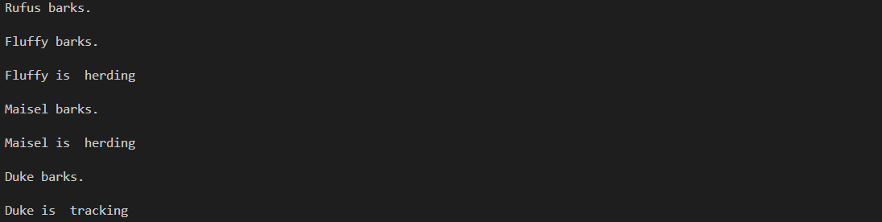

# Task 2

## Car

public class Car {

    String name;

    String color;

    String brand;

    String model;

    Car(String n, String c, String b, String m) {

        this.name = n;

        this.color = c;

        this.brand = b;

        this.model = m;

    }

    void repaint() {

        System.out.println("My car name is " + name + " it is of color " + color + " and its brand is " + brand

                + " and its model is " + model);

    }

}

## Main

public class Main {

    public static void main(String[] args) {

        Dog Rufus = new Dog("Rufus");

        HerdingDog Fluffy = new HerdingDog("Fluffy");

        HerdingDog Maisel = new HerdingDog("Maisel");

        TrackingDog Duke = new TrackingDog("Duke");

        Car myCar = new Car("Dinky", "red", "Dodge", "Charger");

        Car helensCar = new Car("Dinky2", "blue", "Nissan", "Ultima");

        System.out.println();

        myCar.repaint();

        System.out.println();

        helensCar.repaint();

        System.out.println();

        Rufus.bark();

        System.out.println();

        Fluffy.bark();

        System.out.println();

        Fluffy.herd();

        System.out.println();

        Maisel.bark();

        System.out.println();

        Maisel.herd();

        System.out.println();

        Duke.bark();

        System.out.println();

        Duke.track();

    }

}

## Output

