**COMSATS University Islamabad, Abbottabad Campus**

**Department of Computer Science**

**Project Proposal**

**Construction Material and Equipment Store**

**CSC392 Object Oriented Software Engineering**

Group Members:

Mubeen Khalid (SP21-BSE-015)

Mugheer Islam Khattak (SP21-BSE-017)

Table of Contents

CHAPTER 1 PROJECT PROPOSAL 5

Introduction 5

Vision and Business Case 5

Use-Case Model 5

Supplementary Specification 6

Risk List & Risk Management Plan 6

CHAPTER 2 USE CASES 6

Use Case Diagram 7

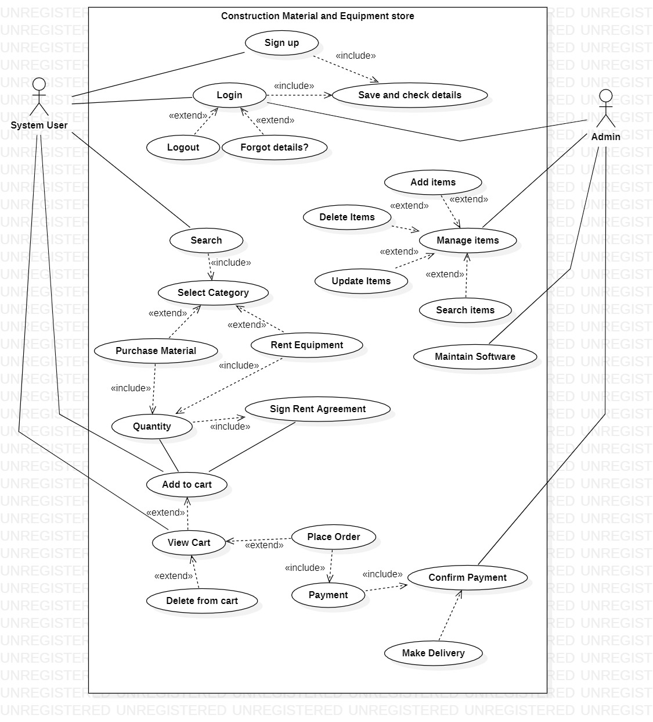Brief Level Use Cases 7

Mubeen Khalid (SP21-BSE-015) 7

Mubeen Khalid (SP21-BSE-015) 8

Frequency of Occurrence: 9

Mubeen Khalid (SP21-BSE-015) 10

Frequency of Occurrence: 11

Mubeen Khalid (SP21-BSE-015) 11

Frequency of Occurrence: 12

Mubeen Khalid (SP21-BSE-015) 12

Frequency of Occurrence: 13

Mubeen Khalid (SP21-BSE-015) 14

Frequency of Occurrence: 14

# CHAPTER 1 PROJECT PROPOSAL

## Introduction

# Constructease is the e-commerce store where people can buy or rent any construction related equipment or material with ease. The “Constructease” is derived from Construction and easy.

## Vision and Business Case

Constructease is a startup ecommerce store that sells construction related material and equipment. Rental services are also provided by Constructease. All the material and the equipment on the store is top notch with high sustainability. The products are of high quality and the startup offers money back guarantee for the customers in case they don’t like the product or are not satisfied with the product. Constructease is sold exclusively online; no retailers will be carrying any Constructease products.

## Use-Case Model

* The system must allow users to sign up before logging into the website by providing the necessary details. (To make any purchase log in is a must and before logging in, sign up is a must).
* The system must allow users to log into their accounts by entering their email and password before making any purchase. (Login will allow users to roam the website using their profile which they created).
* The system must allow the admin to add, remove and update the items at any time. (At any point in time the admin will be able to add, remove or update the products from the admin panel).
* The system must allow the admin to view the stock remaining.
* The system must allow users to view the products and roam in without logging in.
* The system must allow users to view the categories and select one according to their desired product.
* The system must allow users to search for their desired product on the site if it is available otherwise tell them that it is not available.
* The system must allow users to select multiple products and add them to the cart at once. (Multiple selections of items at one time).
* The system must allow users to view the cart at any time. (Cart will contain the items which the user selected during the scrolling phase).
* The system must allow users to write a review regarding the product.
* The system must allow the admin to view the review and take steps accordingly.
* The system must allow users to make orders for the items in the cart.
* The system must create a unique id against every id and assign that to the customer.
* The system must tell the customer to fill out a compulsory form before completing the order and doing the payment.
* The system must perform the form validation to make sure that the details are correct or not.
* The system must allow the customer to do the payment via credit card or cash on delivery (if cash on delivery is selected the customer must pay some amount at the order confirmation time).

# CHAPTER 2 USE CASES

## Use Case Diagram

## Brief Level Use Cases

### Mubeen Khalid (SP21-BSE-015)

#### Use Case: Add Items

Use case “Add Items” is a sub-function of “Manage Items” handled by the admin. The admin can add any item by using this use case to the system. The items with additional details like quantity, quality, image, and prices will be added to the system. No other user rather than the admin can have access to this.

#### Use Case: Delete Items

Case in point "Delete Items" is a sub-function of "Manage Items," which is managed by the administrator. Using this use case, the administrator can delete any object from the system. Items containing additional information such as number, quality, picture, and the price will be removed from the system. This information is only accessible to the administrator.

#### Use Case: Update items

As an instance, "Update Items" is a sub-function of the administrator-managed "Manage Items." The administrator can utilize this use case to update any item in the system. Items with extra information, such as number, quality, image, and price, can be changed in the system. Only the administrator has access to this information.

#### Use Case: Search Items

"Search Items," for example, is a sub-function of the administrator-managed "Manage Items." The administrator can utilize this use case to search the system for any required object. Items with additional information, such as number, quality, image, and price, may be found and analyzed in the system. This information is only accessible to the administrator.

#### Use Case: Categories

Case in point, "Select Categories" is a sub-function of the system user-managed "Search." Using this use case, the system user will select one of the categories to search for any needed object. In the system, items lying under the following category will be located and viewed by the user. Both the administrator and any system user have access to this information.

Fully Dressed Use Cases

### Mubeen Khalid (SP21-BSE-015)

| Use Case UC1: Add Items |
| --- |
|  |

**Scope**: Construction Material and Equipment Store

**Level**: Subfunction

**Primary** **Actor**: Admin

**Stakeholders and Interests**:

* Owner of the system wants to add items for sale/rent on a system with ease so that he/she will be able to sell his/her products.
* Customer: Wants items to view on the application.

**Preconditions**:

* The user must Sign up.
* The user must log in to the admin panel before adding any items.

**Success Guarantee** (or Postconditions): The items would have been added to the respective categories, the list is updated the and item is visible for sale.

**Main Success Scenario (or Basic Flow):**

* The user requests the system to show what items have been added to it.
* The system retrieves the list of items updated and displays it to the user.
* The user selects a category (buy/rent) to add any item.
* The system confirms that the item has been added.

**Extensions (or Alternative Flows):** If at any time the system is unable to retrieve, record, or provide details then the system informs the user of the problem, attempts to record the time and nature of the failure and the use case ends.

**Special Requirements:**

* Colors and sizes of text fonts used must provide - or be able to provide - for the visually impaired (e.g., color blindness).
* Items must be uploaded with high-quality pictures for the quality variations for the user to view

Frequency of Occurrence: Could be nearly continuous.

**Open Issues:**

* Do we have a full list of items for every category?
* Do we have a full list of items for every category?

**Screen Shots:**

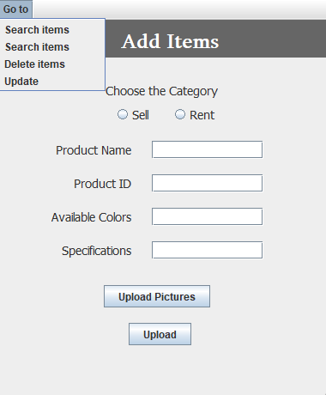

### Mubeen Khalid (SP21-BSE-015)

| Use Case UC1: Search Items |
| --- |

**Scope**: Construction Material and Equipment Store

**Level**: Subfunction

**Primary** **Actor**: Admin

**Stakeholders and Interests**:

Owner of the system: Wants to search items available on the system with ease so that he/she will be able to confirm whether the product is available or not.

**Preconditions**:

* The user must Sign up.
* The user must log in to the admin panel before adding any items.

**Success Guarantee** (or Postconditions): The items available on the system would be visible to the user.

**Main Success Scenario (or Basic Flow):**

* The user requests the system to show whether the searched items are available or not.
* The system retrieves the list of items updated and displays it to the user.
* The user selects a category (sell/rent) to search for any item.
* The system confirms that the items are available.

**Extensions (or Alternative Flows):**

**Special Requirements:**

* Colors and sizes of text fonts used must provide - or be able to provide - for the visually impaired (e.g., color blindness).
* All data related to the item selected for deletion must not be visible to the user.

Frequency of Occurrence: Could be nearly continuous.

**Open Issues:**

* Do any items have minimum capacity issues?
* Do we have a full list of items for every category?

**Screen Shots:**

### Mubeen Khalid (SP21-BSE-015)

| Use Case UC1: Update items |
| --- |

**Scope**: Construction Material and Equipment Store

**Level**: Subfunction

**Primary** **Actor**: Admin

**Stakeholders and Interests**: Owner of the system wants to update items for sale/rent on a system with ease so that he/she will be able to edit product details.

**Preconditions**:

* The user must Sign up.
* The user must log in to the admin panel before adding any items.

**Success Guarantee** (or Postconditions): The items would have been updated in the respective categories, the list is updated and so the items.

**Main Success Scenario (or Basic Flow):**

* The user requests the system to show what items have been updated.
* The system retrieves the list of items updated and displays it to the user.
* The user selects a category (buy/rent) to update any item.
* The system confirms that the item has been updated.

**Extensions (or Alternative Flows):** If at any time the system is unable to retrieve, record, or provide details then the system informs the user of the problem, attempts to record the time and nature of the failure and the use case ends.

**Special Requirements:**

* Colors and sizes of text fonts used must provide - or be able to provide - for the visually impaired (e.g., color blindness).
* All data related to the item selected for modification must be visible to the user.

Frequency of Occurrence: Could be nearly continuous.

**Open Issues:**

* do any items have minimum/maximum capacity issues?
* do we have a full list of items for every category?

**Screen Shots:**

### Mubeen Khalid (SP21-BSE-015)

| Use Case UC1: Delete Items |
| --- |

**Scope**: Construction Material and Equipment Store

**Level**: Subfunction

**Primary** **Actor**: Admin

**Stakeholders and Interests**: Owner of the system wants to delete items for sale/rent on a system with ease so that he/she will be able to delete/remove products.

**Preconditions**:

* The user must Sign up.
* The user must log in to the admin panel before adding any items.

**Success Guarantee** (or Postconditions): The items would have been deleted from the respective categories, the list is updated the and item is not visible.

**Main Success Scenario (or Basic Flow):**

The user requests the system to show what items have been deleted from it.

The system retrieves the list of items updated and displays it to the user.

The user selects a category (buy/rent) to delete any item.

The system confirms that the item has been deleted.

**Extensions (or Alternative Flows):** If at any time the system is unable to retrieve, record, or provide details then the system informs the user of the problem, attempts to record the time and nature of the failure and the use case ends.

**Special Requirements:**

* Colors and sizes of text fonts used must provide - or be able to provide - for the visually impaired (e.g., color blindness).
* All data related to the item selected for deletion must not be visible to the user.

Frequency of Occurrence: Could be nearly continuous.

**Open Issues:**

* do any items have minimum capacity issues?
* do we have a full list of items for every category?

**Screen Shots:**

### Mubeen Khalid (SP21-BSE-015)

| Use Case UC1: Categories |
| --- |

**Scope**: Construction Material and Equipment Store

**Level**: Subfunction

**Primary** **Actor**: System user

**Stakeholders and Interests**: User of the system wants to select the desired category of items available for sale/rent on the system with ease so that he/she will be able to search and view the products.

**Preconditions**:

The user must click the search button to view the categories option.

**Success Guarantee** (or Postconditions): The items would have been displayed from the respective categories; the user views the updated list.

**Main Success Scenario (or Basic Flow):**

* The user requests the system to show items by choosing the desired category.
* The system retrieves the list of items and displays it to the user.
* The system confirms that the item is available.

**Extensions (or Alternative Flows):** If at any time the system is unable to retrieve, record, or provide details then the system informs the user of the problem, attempts to record the time and nature of the failure and the use case ends.

**Special Requirements:**

* Colors and sizes of text fonts used must provide - or be able to provide - for the visually impaired (e.g., color blindness).
* All data related to the item selected for deletion must not be visible to the user.

Frequency of Occurrence: Could be nearly continuous.

**Open Issues:**

* do we have a full list of items for every category?

**Screen Shots:**

