**COMSATS University Islamabad, Abbottabad Campus**

**Department of Computer Science**

**Project Proposal**

**Construction Material and Equipment Store**

**CSC392 Object Oriented Software Engineering**

Group Members:

Mubeen Khalid (SP21-BSE-015)

Mugheer Islam Khattak (SP21-BSE-017)

CHAPTER 1 PROJECT PROPOSAL 2

Introduction 2

Constructease is the e-commerce store where people can buy or rent any construction related equipment or material with ease. The “Constructease” is derived from Construction and easy. 3

Vision and Business Case 3

Use-Case Model 3

Supplementary Specification 4

Risk List & Risk Management Plan 4

CHAPTER 2: USECASE DIAGRAM 4

Usecase Diagram: 4

BRIEF LEVEL USECASES: 6

Mugheer islam khattak (SP21-BSE-017) 6

Use Case: Purchase Material 6

Use Case: Rent Equipment 6

Use Case: Rent Agreement 6

Use Case: Quantity 6

Use Case: Add to Cart 6

FULLY DRESSED USE CASES:Mugheer islam khattak (SP21-BSE-017) 6

Use Case UC1: Purchase Material: 7

Frequency of Occurrence: 7

Use Case UC1: Rent Equipment: 8

Frequency of Occurrence: 8

Use Case UC1: Rent Agreement: 9

Frequency of Occurrence: 9

Use Case UC1: Quantity: 10

Frequency of Occurrence: 10

Use Case UC1: Add to Cart: 11

Frequency of Occurrence: 11

# CHAPTER 1 PROJECT PROPOSAL

## Introduction

# Constructease is the e-commerce store where people can buy or rent any construction related equipment or material with ease. The **“Constructease”** is derived from Construction and easy.

## Vision and Business Case

Constructease is a startup ecommerce store that sells construction related material and equipment. Rental services are also provided by Constructease. All the material and the equipment on the store is top notch with high sustainability. The products are of high quality and the startup offers money back guarantee for the customers in case they don’t like the product or are not satisfied with the product. Constructease is sold exclusively online; no retailers will be carrying any Constructease products.

## Use-Case Model

* The system must allow users to sign up before logging into the website by providing the necessary details. (To make any purchase log in is a must and before logging in, sign up is a must).
* The system must allow users to log into their accounts by entering their email and password before making any purchase. (Login will allow users to roam the website using their profile which they created).
* The system must allow the admin to add, remove and update the items at any time. (At any point in time the admin will be able to add, remove or update the products from the admin panel).
* The system must allow the admin to view the stock remaining.
* The system must allow users to view the products and roam in without logging in.
* The system must allow users to view the categories and select one according to their desired product.
* The system must allow users to search for their desired product on the site if it is available otherwise tell them that it is not available.
* The system must allow users to select multiple products and add them to the cart at once. (Multiple selections of items at one time).
* The system must allow users to view the cart at any time. (Cart will contain the items which the user selected during the scrolling phase).
* The system must allow users to write a review regarding the product.
* The system must allow the admin to view the review and take steps accordingly.
* The system must allow users to make orders for the items in the cart.
* The system must create a unique id against every id and assign that to the customer.
* The system must tell the customer to fill out a compulsory form before completing the order and doing the payment.
* The system must perform the form validation to make sure that the details are correct or not.
* The system must allow the customer to do the payment via credit card or cash on delivery (if cash on delivery is selected the customer must pay some amount at the order confirmation time).

## Supplementary Specification

***Describes other requirements, mostly non-functional. During inception, it is useful to have some idea of the key non-functional requirements that have will have a major impact on the architecture.***

## Risk List & Risk Management Plan

***Describes the risks (business, technical, resource, schedule) and ideas for their mitigation or response.***

For example, leadership really wants a demo at the POSWorld trade show in Hamburg, in 18 months. But the effort for a demo cannot yet be even roughly estimated until deeper investigation.

For example, in the NextGen POS, for what remote services (e.g., tax calculator) will fail-over to local services be allowed? Why? Do they provide exactly the same services locally as remotely, or are there differences?

# CHAPTER 2: USECASE DIAGRAM

## Usecase Diagram:

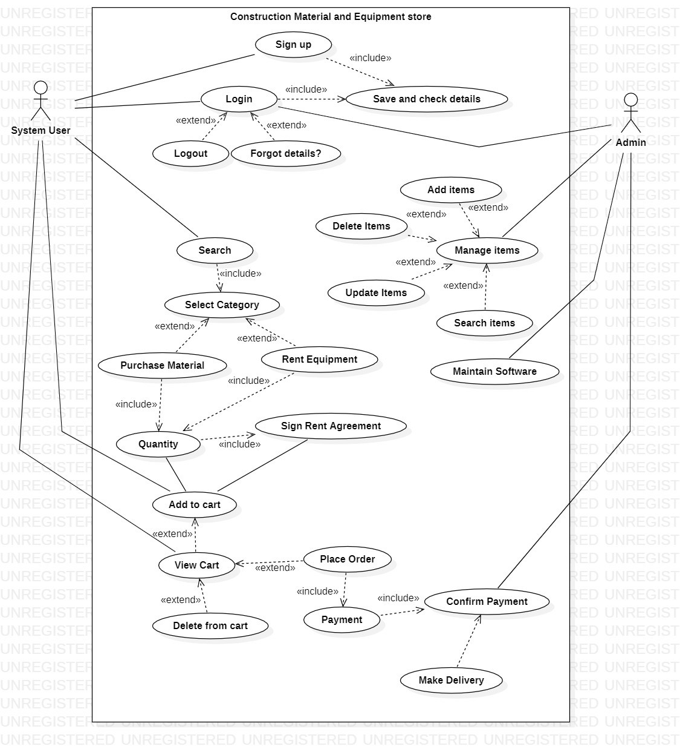

## BRIEF LEVEL USECASES:

## Mugheer islam khattak (SP21-BSE-017)

### Use Case: Purchase Material

Case in point, "Purchase Material" is a sub-function of the system user-managed "Select Categories". Using this use case, the system user will be directed to the material section where the user will be able to select any material and then add it to cart and then followed by order completion. In the system, items lying under the Purchase category will be located and viewed by the user. Both the administrator and any system user have access to this information.

### Use Case: Rent Equipment

Case in point, "Rent Equipment" is a sub-function of the system user-managed "Select Categories". Using this use case, the system user will be directed to the equipment section where the user will be able to select any Equipment for rent by fulfilling the terms and conditions followed by that equipment and then add it to the cart, and then followed by order completion. In the system, items lying under the Rent Equipment category will be located and viewed by the user. Both the administrator and any system user have access to this information.

### Use Case: Rent Agreement

Case in point, "Rent Agreement" is a sub-function of the system user-managed "Rent Equipment". Using this use case, the system user will have to accept the terms and conditions followed by that equipment. In the system, items lying under the Rent Equipment category will require the completion of the rental agreement before proceeding to the cart. Both the administrator and any system user have access to this information.

### Use Case: Quantity

As an instance, “Quantity” is a sub-function of “Purchase Material, Rent Equipment.” In this use case, the system user will have to add a quantity of the material to purchase and add a quantity of equipment before accepting the agreement. All users will have access to this.

### Use Case: Add to Cart

“Add to cart” is the main function of the system where the number of items selected by the user will be added. The user will not be able to make any order before proceeding with to the cart. The customer will have access to this in case he/she wants to purchase or rent anything.

### FULLY DRESSED USE CASES: Mugheer islam khattak (SP21-BSE-017)

## Use Case UC1: Purchase Material:

**Scope**: Construction Material and Equipment Store

**Level**: Subfunction

**Primary** **Actor**: System User

**Stakeholders and Interests**:

* User of the system wants to select the desired category of items available for sale on the system with ease so that he/she will be able to purchase the products.

**Preconditions**:

The user must select a category: purchase material.

**Main Success Scenario (or Basic Flow):**

* The user requests the system to show items by choosing the desired category.
* The system retrieves the list of items and displays it to the user.
* The system confirms that the item is available.

**Extensions (or Alternative Flows):**

If at any time the system is unable to retrieve, record, or provide details then the system informs the user of the problem, attempts to record the time and nature of the failure and the use case ends.

**Special Requirements:**

* Colors and sizes of text fonts used must provide - or be able to provide - for the visually impaired (e.g., color blindness).
* All data related to the item selected for purchasing must be visible to the user.

**Frequency of Occurrence:** Could be nearly continuous.

**Open Issues:**

Do we have a full list of items for every category?

## Use Case UC1: Rent Equipment:

**Scope**: Construction Material and Equipment Store

**Level**: Subfunction

**Primary** **Actor**: System User

**Stakeholders and Interests**:

* User of the system wants to select the desired category of items available for rent on the system with ease so that he/she will be able to rent the equipment.

**Preconditions**:

The user must select a category: Rent Equipment.

**Main Success Scenario (or Basic Flow):**

* The user requests the system to show items by choosing the desired category.
* The system retrieves the list of items and displays it to the user.
* The system confirms that the item is available.

**Extensions (or Alternative Flows):**

If at any time the system is unable to retrieve, record, or provide details then the system informs the user of the problem, attempts to record the time and nature of the failure and the use case ends.

**Special Requirements:**

* Colors and sizes of text fonts used must provide - or be able to provide - for the visually impaired (e.g., color blindness).
* All data related to the item selected for Renting must be visible to the user.

**Frequency of Occurrence:**

Could be nearly continuous.

**Open Issues:**

Do we have a full list of items for every category?

## Use Case UC1: Rent Agreement:

**Scope**: Construction Material and Equipment Store

**Level**: Subfunction

**Primary** **Actor**: System User

**Stakeholders and Interests**:

* User of the system wants to select the desired category of items available for rent on the system with ease so that he/she will be able to rent the equipment by fulfilling the given agreement.

**Preconditions**:

The user must select any equipment for rent.

**Main Success Scenario (or Basic Flow):**

* The user requests the system to show the agreement required to rent the selected equipment.
* The system confirms that the item is available for rent.
* The user selects the quantity of equipment to rent.

**Extensions (or Alternative Flows):**

If at any time the system is unable to retrieve, record, or provide details then the system informs the user of the problem, attempts to record the time and nature of the failure and the use case ends.

**Special Requirements:**

* Colors and sizes of text fonts used must provide - or be able to provide - for the visually impaired (e.g., color blindness).
* The agreement related to the item selected for the rental purpose must be visible to the user.

**Frequency of Occurrence:**

Could be nearly continuous.

**Open Issues:**

Do we have a full list of items for every category?

Do we have the quantity of the equipment chosen by the user for rent?

## Use Case UC1: Quantity:

**Scope**: Construction Material and Equipment Store

**Level**: Subfunction

**Primary** **Actor**: System User

**Stakeholders and Interests**:

* User of the system wants to select the number of items chosen to rent or purchase on the system with ease so that he/she will be able to rent/purchase the items.

**Preconditions**:

the user must have selected any material for purchase or equipment for rent.

**Main Success Scenario (or Basic Flow):**

* The user selects the quantity of material or equipment.
* The system confirms that the number of items selected by the user is available.
* The system grants the quantity required by the user and proceeds to the next step

**Extensions (or Alternative Flows):**

If at any time the system is unable to retrieve, record, or provide details then the system informs the user of the problem, attempts to record the time and nature of the failure and the use case ends.

**Special Requirements:**

* Colors and sizes of text fonts used must provide - or be able to provide - for the visually impaired (e.g., color blindness).

**Frequency of Occurrence:**

Could be nearly continuous.

**Open Issues:**

Do we have a full list of items for every category?

Do we have the quantity of the item?

## Use Case UC1: Add to Cart:

**Scope**: Construction Material and Equipment Store

**Level**: Main function

**Primary** **Actor**: System User

**Stakeholders and Interests**:

* User of the system wants to select the number of items chosen to rent or purchase on the system with ease so that he/she will be able to rent/purchase the items.

**Preconditions**:

the user must have selected any material for purchase or equipment for rent.

**Main Success Scenario (or Basic Flow):**

* The user selects the quantity of material or equipment.
* The system grants the quantity required by the user and adds it to the cart.

**Extensions (or Alternative Flows):**

If at any time the system is unable to retrieve, record, or provide details then the system informs the user of the problem, attempts to record the time and nature of the failure and the use case ends.

**Special Requirements:**

* Colors and sizes of text fonts used must provide - or be able to provide - for the visually impaired (e.g., color blindness).

**Frequency of Occurrence:**

Could be nearly continuous.

**Open Issues:**

Do we have a full list of items for every category?

Do we have the quantity of the item?