FARM MANAGEMENT SYSTEM
A Salesforce Project Documentation
Category: Salesforce | Domain: Agriculture
Prepared by: [M. Mubeena] Team Members: [G. Navaneetham
- Navina, V. Parameshwari, M. Pavithra]
Date: [27/09/2026]
College: Kamban College of Arts and Science for Women
University: Thiruvalluvar University

User Story
As a farmer, farm manager, or system administrator, I need a single Salesforce-based platform where I can record and manage information about farms, crops, farmers, and buyers, so that agricultural data is stored securely and consistently in one place.
The platform should let me enter and update farm details, crop production records, and buyer transactions through a simple, guided interface, with validation in place so that incomplete or incorrect data cannot be saved.
It should also generate real-time reports and interactive dashboards, so productivity and sales trends are visible at a glance, and it should enforce role-based access so that sensitive data is only visible to the right people.
Together, this reduces manual paperwork, cuts down on errors, and supports faster, better-informed farm management decisions.

1. Introduction

1.1 Project Overview
The Farm Management System (FMS) is a Salesforce-based application built to digitize and streamline agricultural operations. It stores and organizes data on farms, crops, farmers, and buyers, and surfaces that data back to users through reports and dashboards so day-to-day activities can be monitored and acted on quickly.

1.2 Purpose
This project sets out to:
- Digitize agricultural record-keeping
- Improve the accuracy and accessibility of farm data
- Automate routine record handling
- Enable real-time monitoring of farm activity
- Support data-driven decisions for farmers and managers
- Improve overall productivity and transparency

2. Ideation Phase

2.1 Problem Statements
The table below captures the core frustrations of each user group before this system existed.
Persona | Trying To | Blocked Because | Root Cause | Resulting Feeling
Farmer | Maintain farm and crop records | Data is often incomplete or incorrect | Records are kept manually in registers | Frustrated, confused
Farm Manager | Monitor farm productivity and sales | Reports are delayed and inaccurate | Data is scattered across files and sheets | Stressed, inefficient
Buyer | Check crop availability and pricing | Information isn't updated regularly | No centralized digital system exists | Uncertain, dissatisfied
System Admin | Manage user access and system security | Unauthorized access can occur | Access control is handled manually | Concerned, insecure

2.2 Empathy Map
Target users: Farmers, Farm Managers, Buyers, and System Administrators.
- Think & Feel — need accurate, up-to-date farm data
- Hear — feedback and guidance from agricultural officers
- See — registers, paper files, and scattered spreadsheets
- Say & Do — enter and re-enter records by hand
- Pain — data loss, mistakes, and delays
- Gain — automation and faster reporting

2.3 Brainstorming
Options considered before settling on an approach:
- Continue with manual, paper-based records
- Move to Excel-based tracking
- Build a custom web application
- Build a mobile-first farm app
- Build on Salesforce as a managed platform
Selected approach: a Salesforce-based Farm Management System — chosen for its ready-made security model, cloud hosting, and native reporting tools, which map directly onto the pain points above.

3. Requirement Analysis Phase

3.1 Customer Journey Map
A user's path through the system runs through seven stages:
- Log in to the org
- Open the Farm Management App
- Enter farm and crop data
- Register farmers and buyers
- Generate reports
- Analyze the results
- Make a decision based on the insight

3.2 Solution Requirements

Functional Requirements
ID | Requirement
FR-1 | User authentication
FR-2 | Farm, Crop, Farmer, and Buyer record management
FR-3 | Data entry with validation
FR-4 | Relationship mapping between objects
FR-5 | Report generation
FR-6 | Dashboard visualization
FR-7 | User and role management

Non-Functional Requirements
Quality | Requirement | How It's Met
Usability | Easy to use interface | Simple Lightning UI
Security | Data stays protected | Profiles and roles
Reliability | No data loss | Cloud backup
Performance | Fast access to data | Optimized reports
Availability | Accessible anytime | Cloud hosting
Scalability | Grows with the business | Supports more farms and users

3.3 Data Flow
Data moves through the system in a single, traceable path:
User → Salesforce UI → Custom Objects (Farm, Crop, Farmer, Buyer) → Validation Rules → Relationships → Reports → Dashboards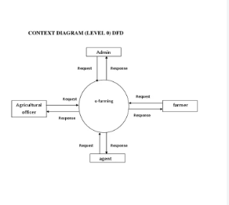

3.4 Technology Stack
Layer | Technology
Frontend | Salesforce Lightning UI
Backend | Salesforce Platform
Database | Salesforce Cloud
Automation | Validation Rules
Analytics | Reports & Dashboards

4. Project Design Phase

4.1 Problem–Solution Fit
Manual record-keeping across farms, crops, farmers, and buyers causes missing data, slow reporting, and avoidable errors. The FMS replaces that manual process with cloud-based, automated data management: centralized storage prevents data loss, dashboards make analysis faster, and real-time reports remove reporting delays — giving everyone accurate, timely agricultural insight.

4.2 Proposed Solution
Parameter | Description
Problem | Manual maintenance of records leads to errors, data loss, and delays.
Solution | A Salesforce-based FMS with centralized storage and automation.
Innovation | Automated validation, cloud storage, and live reporting dashboards.
Impact | Better accuracy, faster reporting, better-informed decisions.
Business Model | A digital farm-management and agricultural data platform.
Scalability | Supports more farms, users, and regions as the org grows.

4.3 Solution Architecture
The application is organized into four layers:
- Presentation Layer — the Salesforce Lightning UI users interact with
- Application Layer — validation rules and object relationships
- Data Layer — the Farm, Crop, Farmer, and Buyer custom objects
- Analytics Layer — reports and dashboards
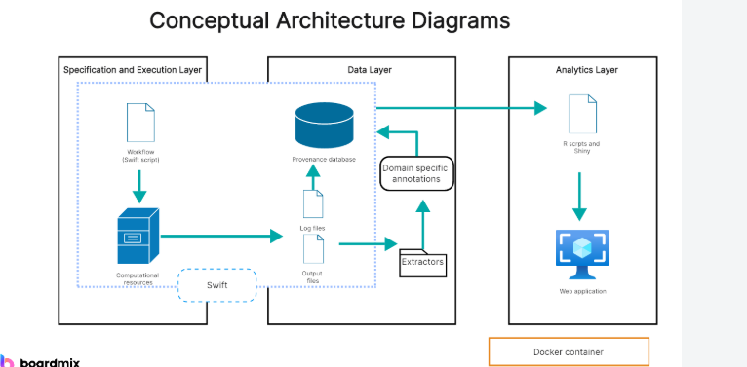

5. Project Planning & Scheduling

5.1 Project Planning
At a high level, delivering this project involves:
- Setting up a Salesforce Developer Org
- Building the custom objects
- Configuring tabs and the Lightning App
- Adding fields and relationships
- Designing profiles and roles
- Creating users and sharing rules
- Building reports and dashboards
- Testing and reviewing the finished app

5.2 Product Backlog & Sprint Schedule
Fill in your team's epics, user stories, and assignments below.
Sprint | Epic | User Story | Priority | Team Member
Sprint 1 | Developer Setup | Create and configure a Salesforce developer org | High | [Name]
Sprint 2 | Data Modeling | Create the Farm, Crop, Farmer, and Buyer objects and relationships | High | [Name]
Sprint 2 | Data Modeling | Add tabs and a Lightning App for daily navigation | High | [Name]
Sprint 3 | Automation | Add validation rules for required and correctly formatted fields | High | [Name]
Sprint 3 | Automation | Add automated flows for crop updates and buyer notifications | High | [Name]
Sprint 4 | Security | Set up role-based access for farmers, managers, and buyers | High | [Name]
Sprint 5 | Reports | Build reports on crop yield, sales, and buyer transactions | High | [Name]
Sprint 6 | Dashboards | Build dashboards for productivity, sales, and operations | Medium | [Name]

5.3 Project Tracker
Track actual progress against the plan as each sprint closes.
Sprint | Start Date | Planned End | Completed? | Actual Release Date
Sprint 1 | [Date] | [Date] | [ ] | [Date]
Sprint 2 | [Date] | [Date] | [ ] | [Date]
Sprint 3 | [Date] | [Date] | [ ] | [Date]
Sprint 4 | [Date] | [Date] | [ ] | [Date]
Sprint 5 | [Date] | [Date] | [ ] | [Date]
Sprint 6 | [Date] | [Date] | [ ] | [Date]

6. Project Development Phase
This section walks through building the Farm Management System in a Salesforce Developer Org, milestone by milestone. Follow each activity in your own org, then capture a screenshot and record the result in the spaces provided.
Milestone 1 — Setting Up Salesforce
A Developer Org is a free Salesforce environment with everything needed to build and test this project.
Activity 1 — Create a Salesforce Developer Org
- Go to developer.salesforce.com/signup
- Enter your name, email, role, company, country, postal code, and a unique username
- Submit the form, then verify your account by email and set a password
- Log in at login.salesforce.com to reach the Setup home page
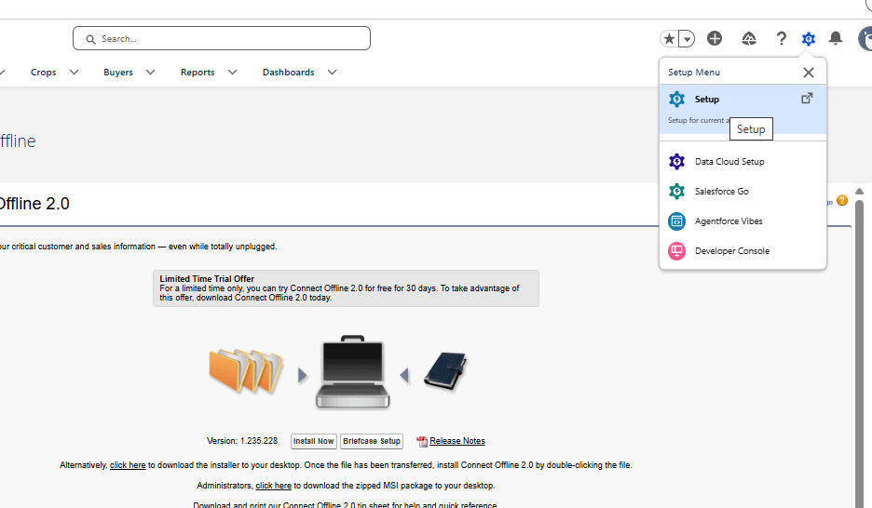
Milestone 2 — Custom Objects
A custom object is a database table for data specific to this app. This project uses four: Farm, Crop, Farmer, and Buyer.

Activity 1 — Create the Farm object
- In Setup, open Object Manager → Create → Custom Object
- Label: Farm · Plural Label: Farms · Record Name: Farm Name (Text)
- Enable Allow Reports, Allow Search, and Track Field History
- Add Notes and Attachments to the default page layout, then Save
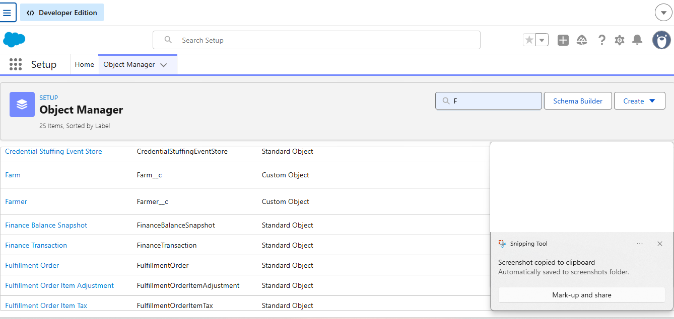

Activity 2 — Create the Crop object
- Label: Crop · Plural Label: Crops · Record Name: Crop Name (Text)
- Enable Allow Reports and Allow Search, then Save
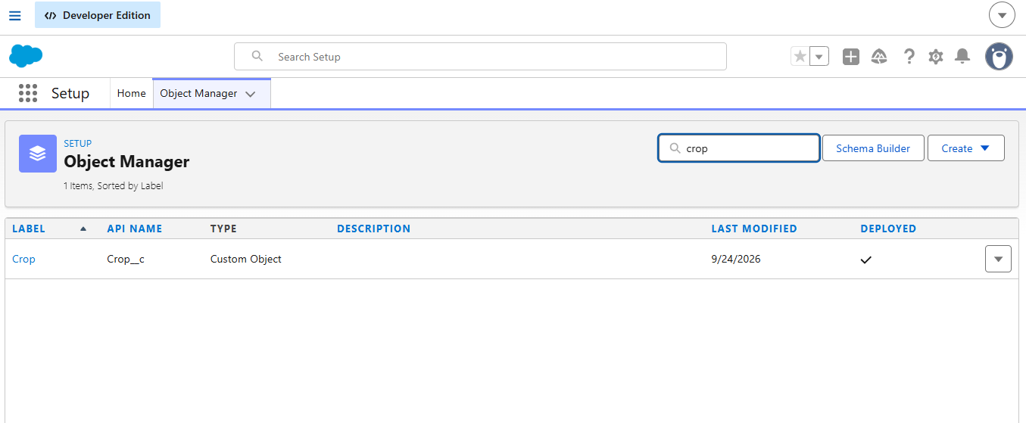

Activity 3 — Create the Farmer object
- Label: Farmer · Plural Label: Farmers · Record Name: Farmer Name (Text)
- Enable Allow Reports and Allow Search, then Save

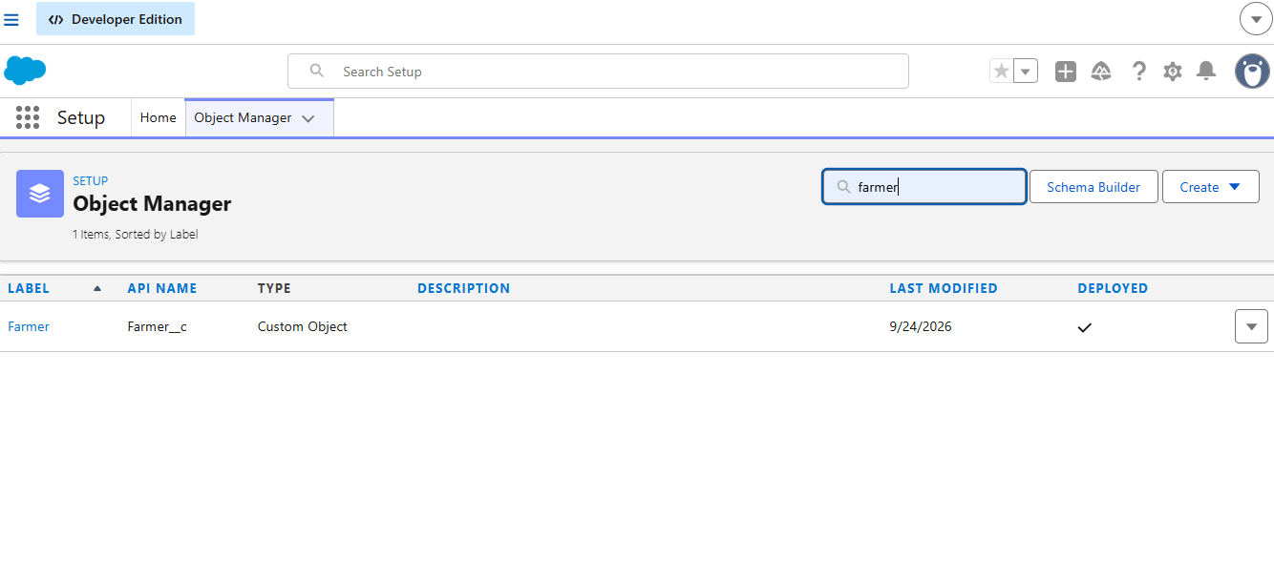
Activity 4 — Create the Buyer object
- Label: Buyer · Plural Label: Buyers · Record Name: Buyer Name (Text)
- Enable Allow Reports and Allow Search, then Save
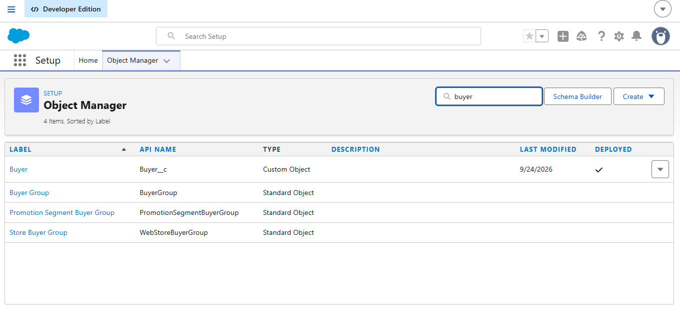
Milestone 3 — Tabs
Tabs give users a direct way to open an object's records from the navigation bar.
Activity 1 — Create the Farm tab
- Go to Setup → Tabs → Custom Object Tabs → New
- Choose the Farm object and any tab style/icon, then Save
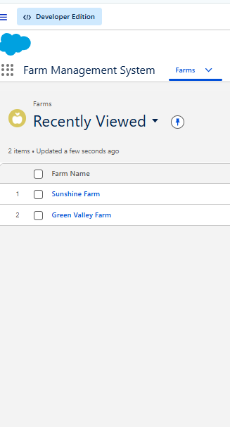
Activity 2 — Create the Crop tab
- Repeat the same steps, selecting the Crop object
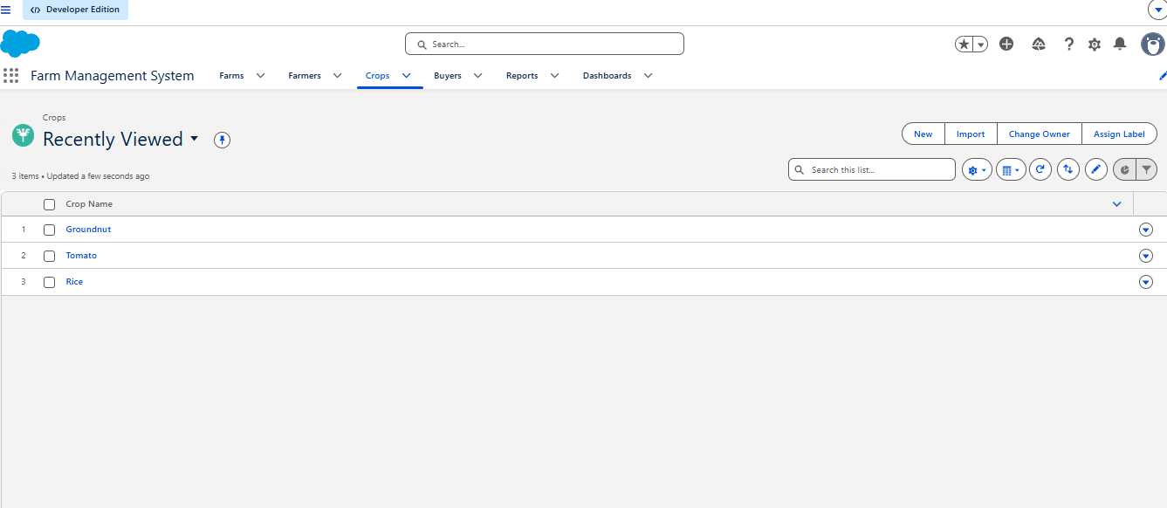

Activity 3 — Create the Farmer tab
- Repeat the same steps, selecting the Farmer object
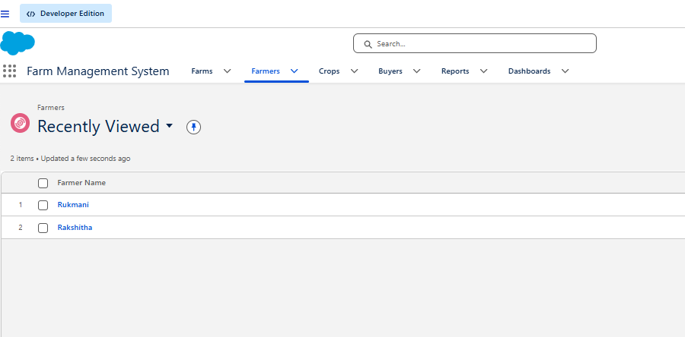

Activity 4 — Create the Buyer tab
- Repeat the same steps, selecting the Buyer object
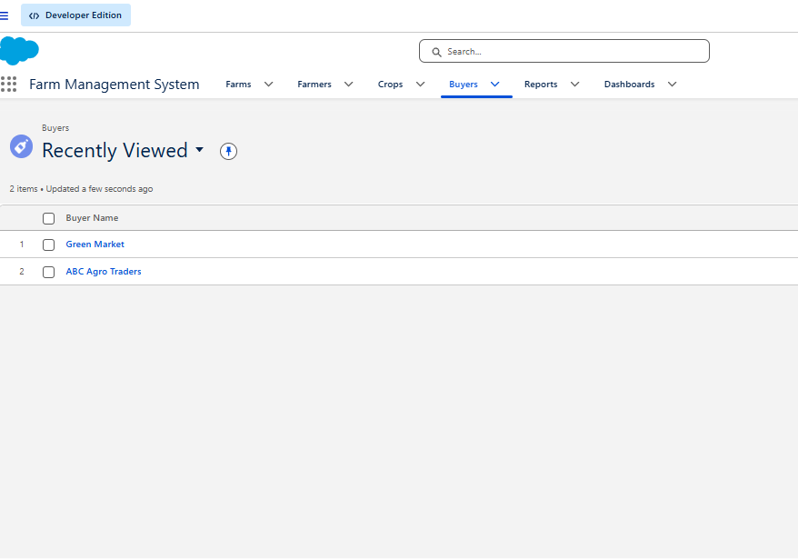
Milestone 4 — Lightning App
An app groups a set of tabs, a name, and a logo into one working unit that users open from the App Launcher.
Activity 1 — Create the Farm Management System app
- Go to Setup → App Manager → New Lightning App, name it Farm Management System
- Keep the default App Options and Utility Items
- Add Farm, Crop, Farmer, Buyer, Reports, and Dashboards to Selected Items
- Assign the System Administrator profile, then Save & Finish
- Verify it from the App Launcher

Milestone 5 — Fields & Relationships
Fields store the specific details each object needs to hold.
Activity 1 — Fields for Farm
- Farm Type (Picklist: Crop, Livestock, Mixed)
- Soil Quality (Picklist: Organic, Cover Crops, Composting)
- Irrigation Type (Picklist: Sprinkler, Drip, Localized)
- Location (Text) and Size (Text)
- A Master-Detail relationship to the Farmer object

Activity 2 — Fields for Crop
- Crop Name (Text), Planting Date and Harvest Date (Date)
- A Lookup relationship to the Farm object
- Actual Yield (Currency) and Total Acres Harvested (Number)
- A formula field, Expected Yield per Acre, calculated as Actual Yield ÷ Total Acres Harvested

Activity 3 — Fields for Farmer
- Contact Number (Phone)
- State (Picklist), District (Picklist), Village (Picklist)
- A field dependency so District options narrow based on the selected State

Activity 4 — Fields for Buyer
- Contact (Phone), Email (Email), Address (Text Area)
- Buyer Type (Picklist: Wholesale, Retail)

Milestone 6 — Profiles
A profile is the set of permissions that decides what a user can see and do across objects, fields, tabs, and apps.
Activity 1 — Create a custom profile
- Go to Setup → Profiles → clone the Standard User profile
- Name it Sales Department, then Save

Activity 2 — Create a second custom profile
- Clone the Standard User profile again
- Name it Farm Manager, then Save

Milestone 7 — Roles
Roles define the reporting hierarchy and control which records a user can see based on where they sit in that hierarchy.
Activity 1 — Create a role
- Go to Setup → Roles → Set Up Roles
- Below the top-level role, add a new role labeled Farm Manager and Save

Milestone 8 — Users
A user is anyone who logs into the org. Each user is tied to one profile and, usually, one role.
Activity 1 — Create a user
- Go to Setup → Users → New User
- First name: Farm · Last name: Manager · enter an email and a unique username
- Role: Farm Manager · License: Standard Platform User · Profile: Farm Manager
- Save

Activity 2 — Create a second user
- Repeat the steps above with the username Sales Department and the Sales Department profile

Milestone 9 — Sharing Rules
Sharing rules extend record access beyond what a profile or role already grants — they widen visibility, never restrict it.
Activity 1 — Share Crop records with Farm Managers
- Go to Setup → Sharing Settings → [Crop object] → New
- Set the rule criteria, share with the Farm Manager role, and grant Read/Write access
- Save

Activity 2 — Share Buyer records with the Sales Department
- Repeat the same steps for the Buyer object, sharing with the Sales Department with Read/Write access

Milestone 10 — User Adoption
Creating a real record confirms the objects, fields, and tabs work together as intended.
Activity 1 — Create a Farmer record
- Open the App Launcher → Farm Management System → Farmer tab
- Click New, fill in the farmer's details, and Save

Milestone 11 — Reports
A report lists records that match chosen criteria, grouped and filtered as needed, and saved to a folder for reuse.
Activity 1 — Report on Farmers with Farms
- Open the App Launcher → Reports → New Report
- Choose the Farmers with Farms report type and Start Report
- Select the columns to display and any grouping needed
- Save as Farmer with Farms in a public folder

Activity 2 — Report on Crops and Buyers
- Repeat the steps above using the Crop and Buyer objects

Milestone 12 — Dashboards
Dashboards combine several reports into one visual summary, making trends easier to spot than reading reports one at a time.
Activity 1 — Build the Farmers with Farms dashboard
- Open the Dashboards tab → New Dashboard, name it Farmers with Farms
- Add a component sourced from the Farmer with Farms report
- Choose a chart type (for example, a gauge chart) and Add
- Save and Done

Activity 2 — Add a Crop/Buyer component
- Add a second component sourced from the Crop/Buyer report

Milestone 13 — Viewing Reports & Dashboards
A final walkthrough confirms everything is reachable the way an end user would use it.
Activity 1 — View the report
- App Launcher → Farm Management System → Reports tab → open Farmer with Farms

- 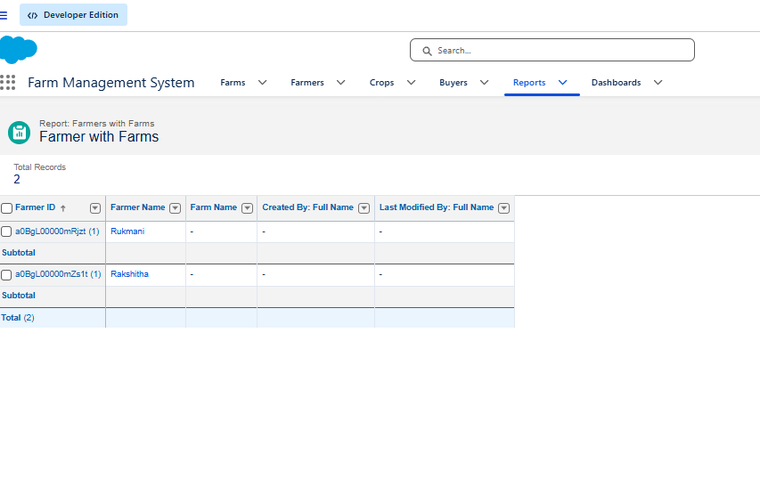
Activity 2 — View the dashboard
- App Launcher → Farm Management System → Dashboards tab → open Farmers with Farms

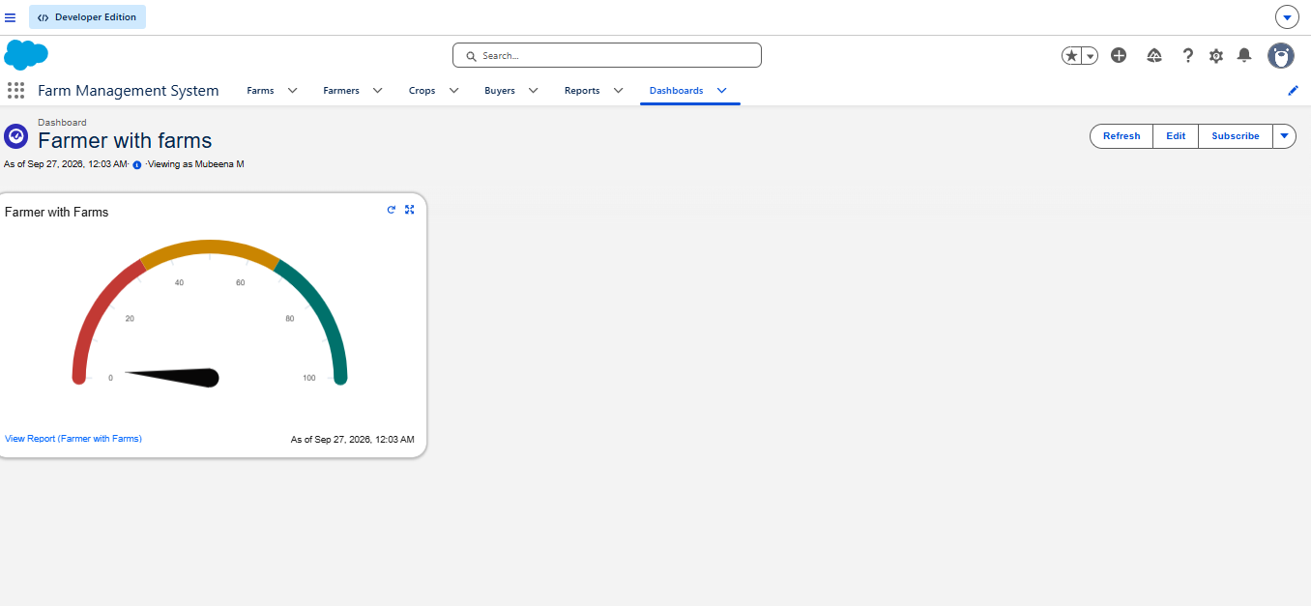

7. Functional & Performance Testing
Confirm the following before calling the build complete:
- Records can be created for Farm, Crop, Farmer, and Buyer
- Required and formatted fields are validated correctly
- Relationships and field dependencies behave as expected
- Each profile and role sees only what it should
- Sharing rules extend access to the intended groups
- Reports and dashboards generate and refresh correctly

8. Advantages & Disadvantages

Advantages
- One centralized data system
- Less paperwork
- Improved data accuracy
- Better monitoring of farm activity
- Real-time analytics

Disadvantages
- Requires an internet connection
- Depends on Salesforce licensing
- Limited offline access

9. Conclusion
The Farm Management System digitizes agricultural data management on Salesforce, replacing manual, error-prone record-keeping with a centralized, automated platform. It improves accuracy, speeds up reporting, and gives farmers and managers the real-time insight they need to make better decisions.

10. Future Scope
- A companion mobile application
- AI-assisted crop yield prediction
- Integration with live weather data
- IoT sensor connectivity for field conditions
- Integration with government agricultural schemes
- Market price forecasting

11. Appendix
- Source Code: Salesforce configuration and metadata
- Dataset: Farm, Crop, Farmer, and Buyer sample records
- Tools Used: Salesforce Developer Org

