Department Of Computer Science

NAME:

M. Ghazanfar Iqbal

Roll No:

F24BDOCS1M01476

Section:

M7 BSCS(4th)

Assignment No:

02

Date:

27-04-2026

Submitted To:

Ms. Beenish Manzoor

Topic: Implementing html table tags:
Code:

<!DOCTYPE html>
<html lang="en">
<head>
<meta charset="UTF-8">
<title>Student Table</title>
<style>
body {
font-family: Arial, sans-serif;
background-color: white;
color: black;
}
table {
border-collapse: collapse;
width: 80%;
box-shadow: 0 0 10px rgba(0,0,0,0.5);
margin: 100px 100px;
}
th, td {
border: 1px solid black;
padding: 12px;
text-align: center;
}
th {
background-color: #504d50;
color: white;
}
caption {
caption-side: top;
font-size: 24px;
margin-bottom: 10px;
font-weight: bold;
}
</style>
</head>
<body>
<table>
<caption>Student Performance Table</caption>
<tr>
<th rowspan="2">Name</th>
<th colspan="3">Subjects</th>
<th rowspan="2">Total</th>
</tr>
<tr>
<th>Math</th>
<th>Physics</th>
<th>Chemistry</th>
</tr>
<tr>
<td>Ali</td>
<td>85</td>
<td>78</td>
<td>92</td>
<td>255</td>
</tr>
<tr>
<td>Omar</td>
<td>82</td>
<td>62</td>
<td>91</td>
<td>235</td>
</tr>
<tr>
<td>Ahmed</td>
<td>75</td>
<td>88</td>
<td>80</td>
<td>243</td>
</tr>
<tr>
<td>Usman</td>
<td>90</td>
<td>85</td>
<td>95</td>
<td>270</td>
</tr>
<tr>
<td colspan="4"><strong>Class Average</strong></td>
<td><strong>250</strong></td>
</tr>
</table>

</body>
</html>

OUTPUT:

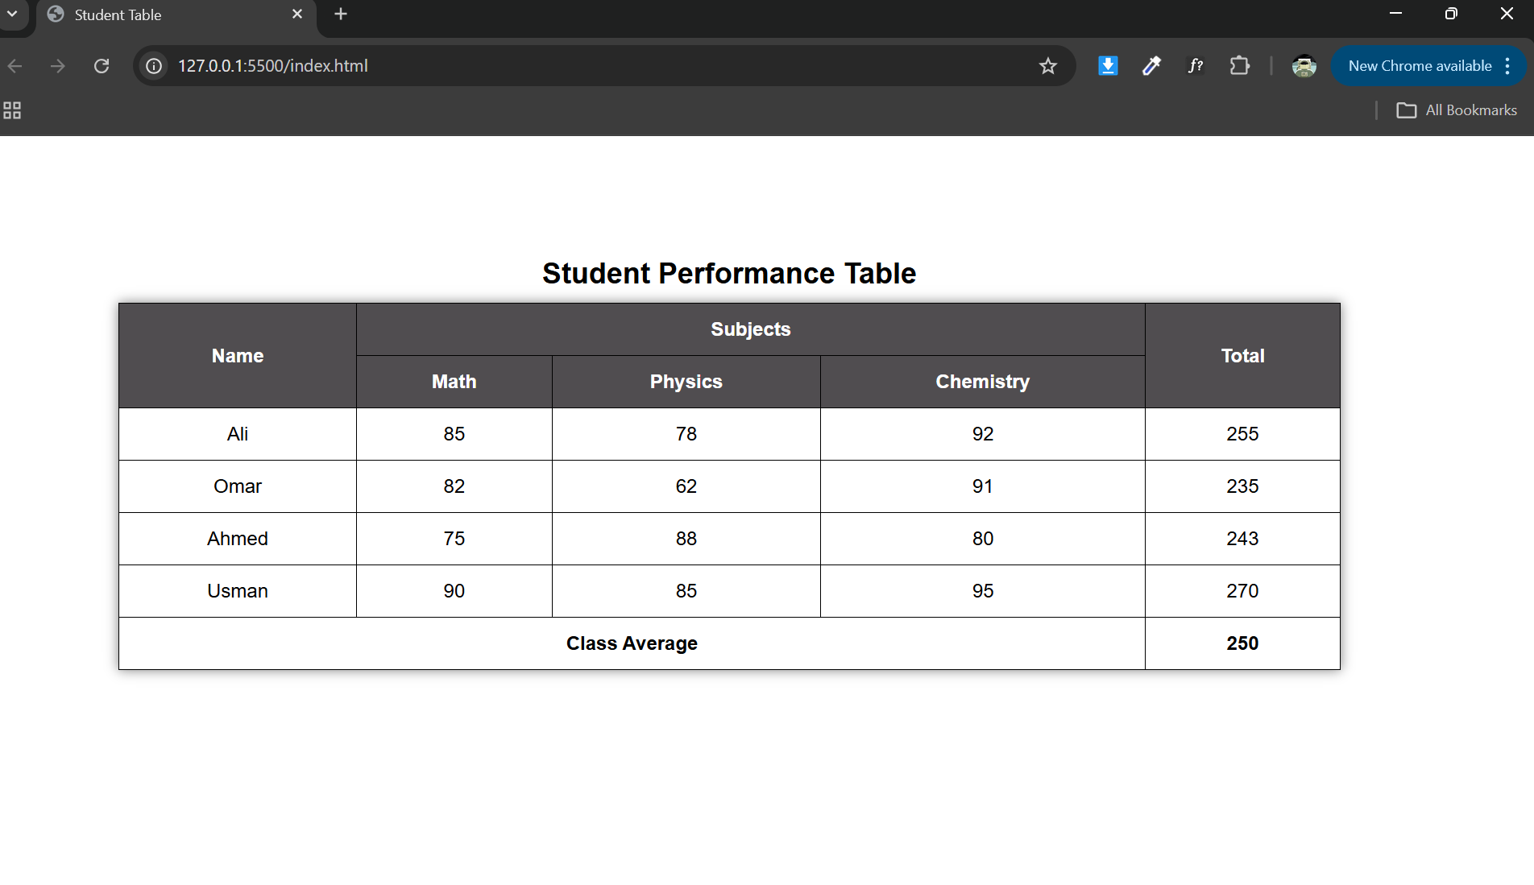

Q.2: Different Browsers and their JavaScript Engines

1.Google Chrome:
V8 JavaScriptEngine

2. Mozilla Firefox:
SpiderMonkey JavaScript Engine

3. Microsoft Edge
V8 JavaScriptEngine

4. Apple Safari
JavaScriptCore (Nitro) Engine

5. Opera Browser
V8 JavaScriptEngine
6. Brave Browser
V8 JavaScriptEngine

