University of Engineering
and Technology, Mardan

Submitted to:
Sir Humayun
Submitted by:
Mubeen Shahid
Reg no:
25MDSWE441
Dep: Computer Software Engineering
OBJECT ORIENTED PROGRAMMING(LAB)
Lab#4
TOPIC: Constant And Non_Constant Function
Task#1
Headerfile:
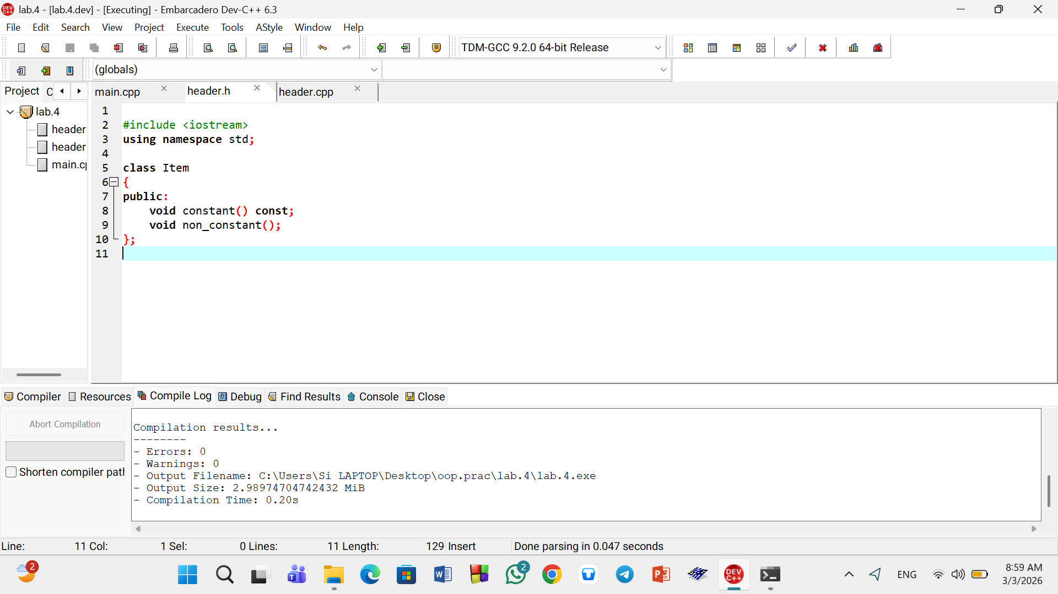
Source file:
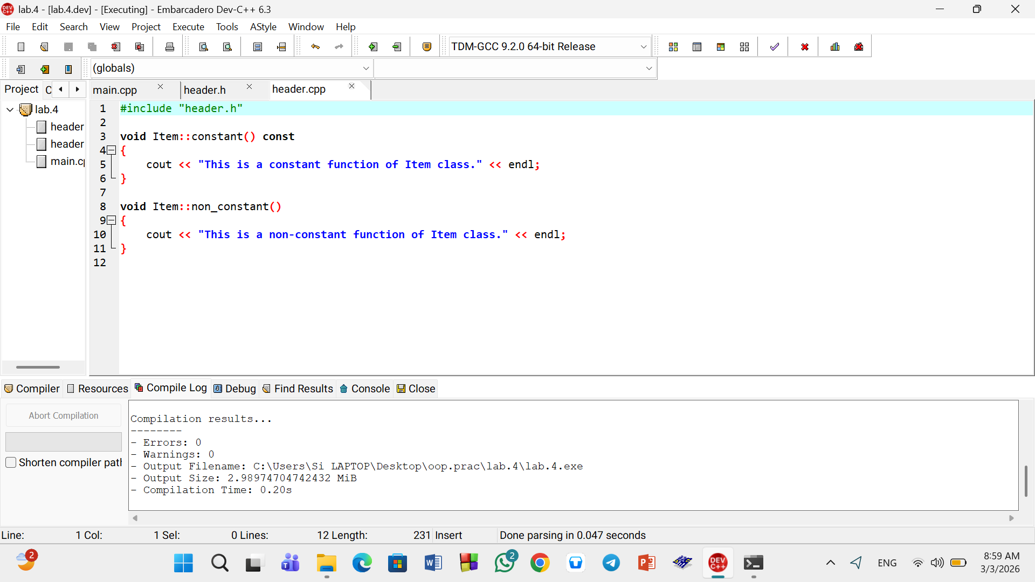
Main.cpp
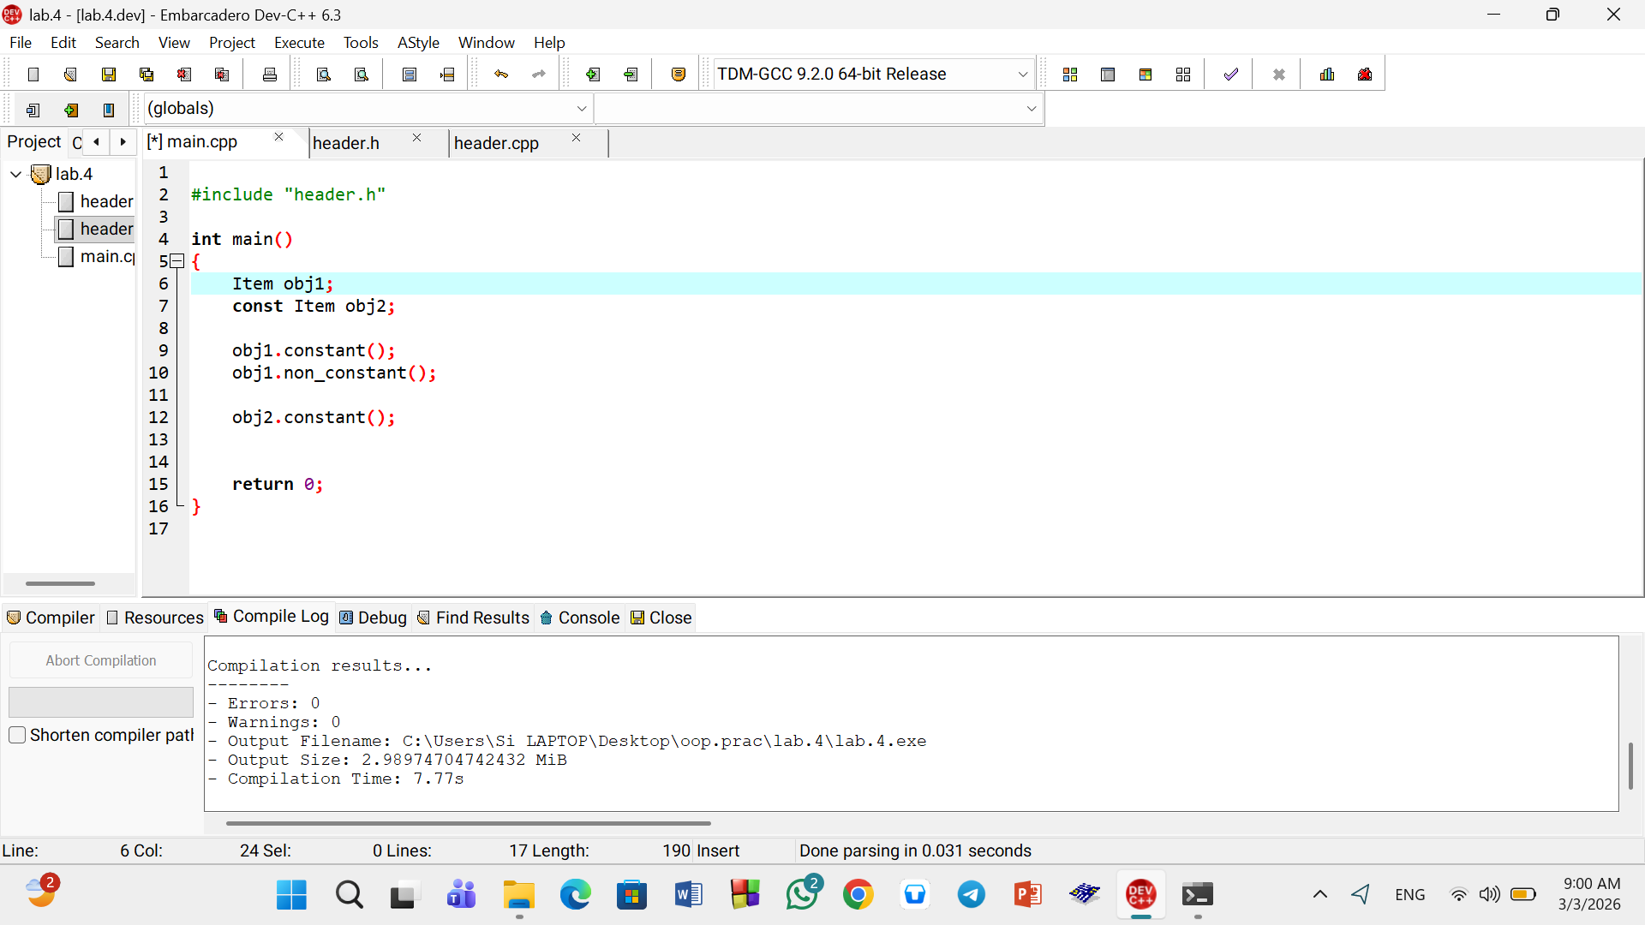
Output:
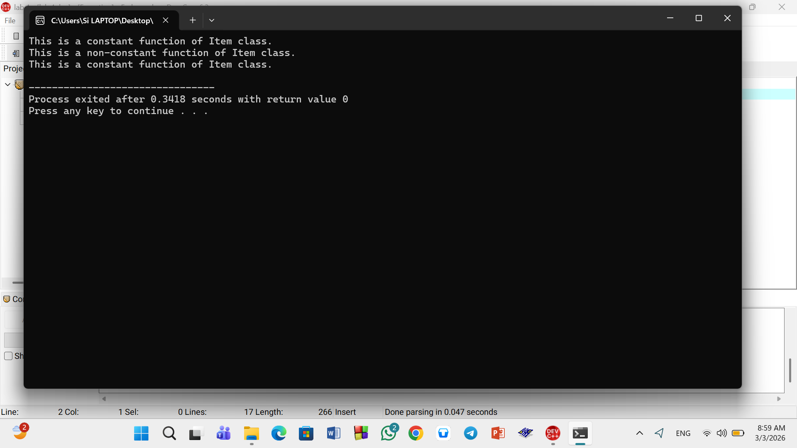

Task#2
Headerfile:
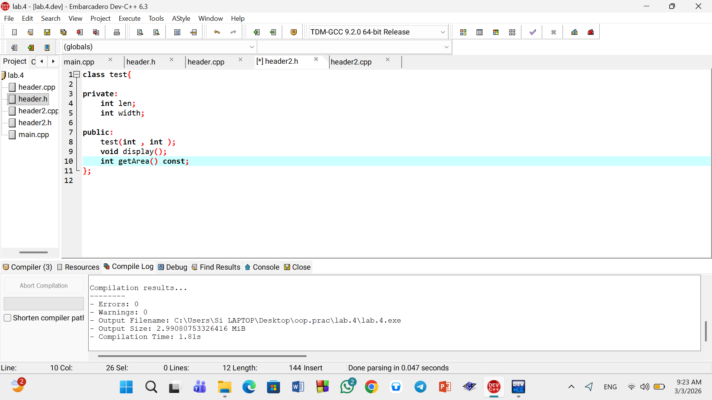
Source file: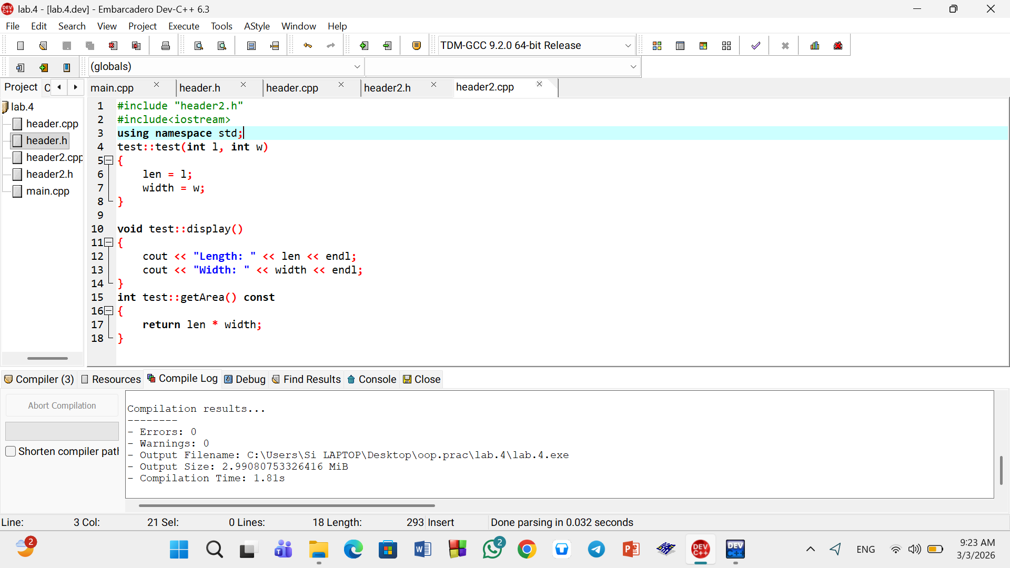
Main.cpp:
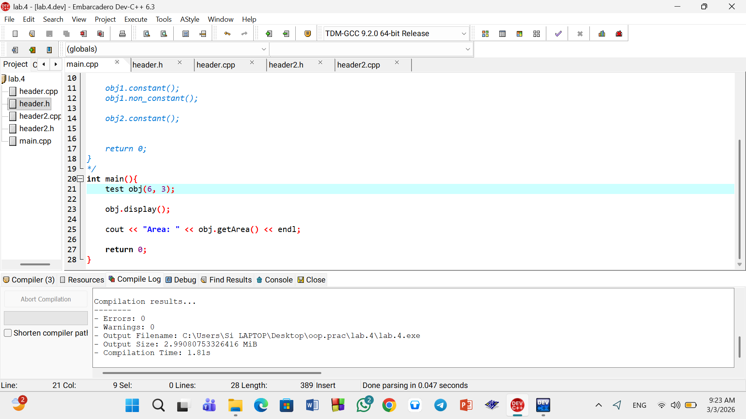

Output:
