
University of Engineering and Technology, Mardan

SUBMITTED BY:
MubeenShahid
(25MDSWE-440)
SEMESTER:
CSE 2ND (A)
INSTRUCTOR:
M.HUMAYUN
OBJECT ORIENTED PROGRAMMING(LAB)
LAB#05
Topic: Static Data Member & Member Function.
TASK#01
Main file and output:
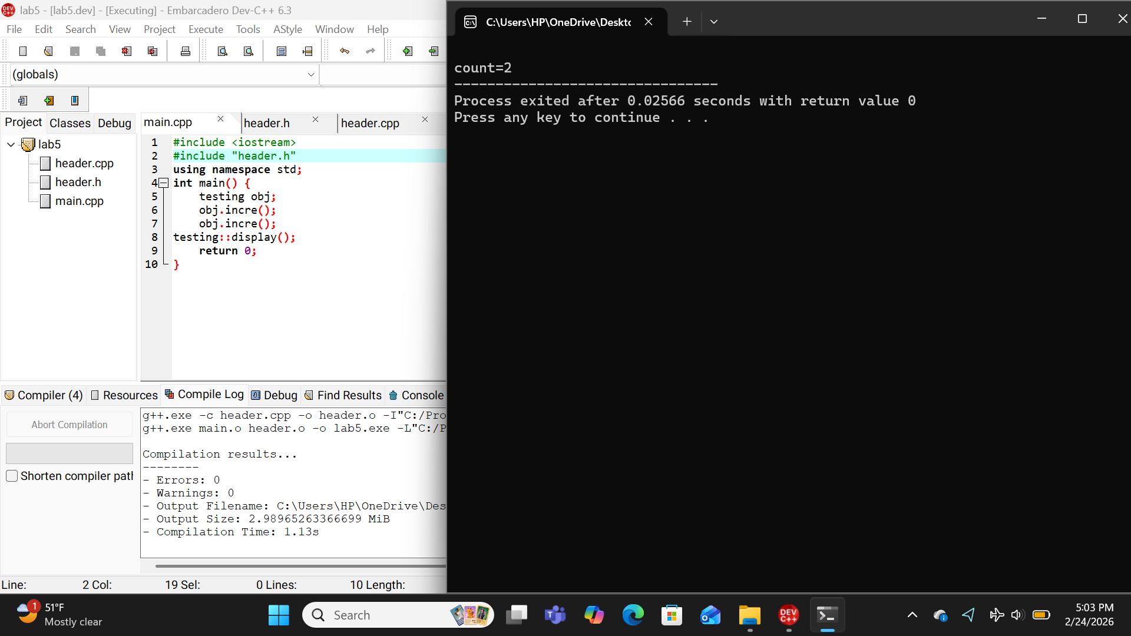
Header file :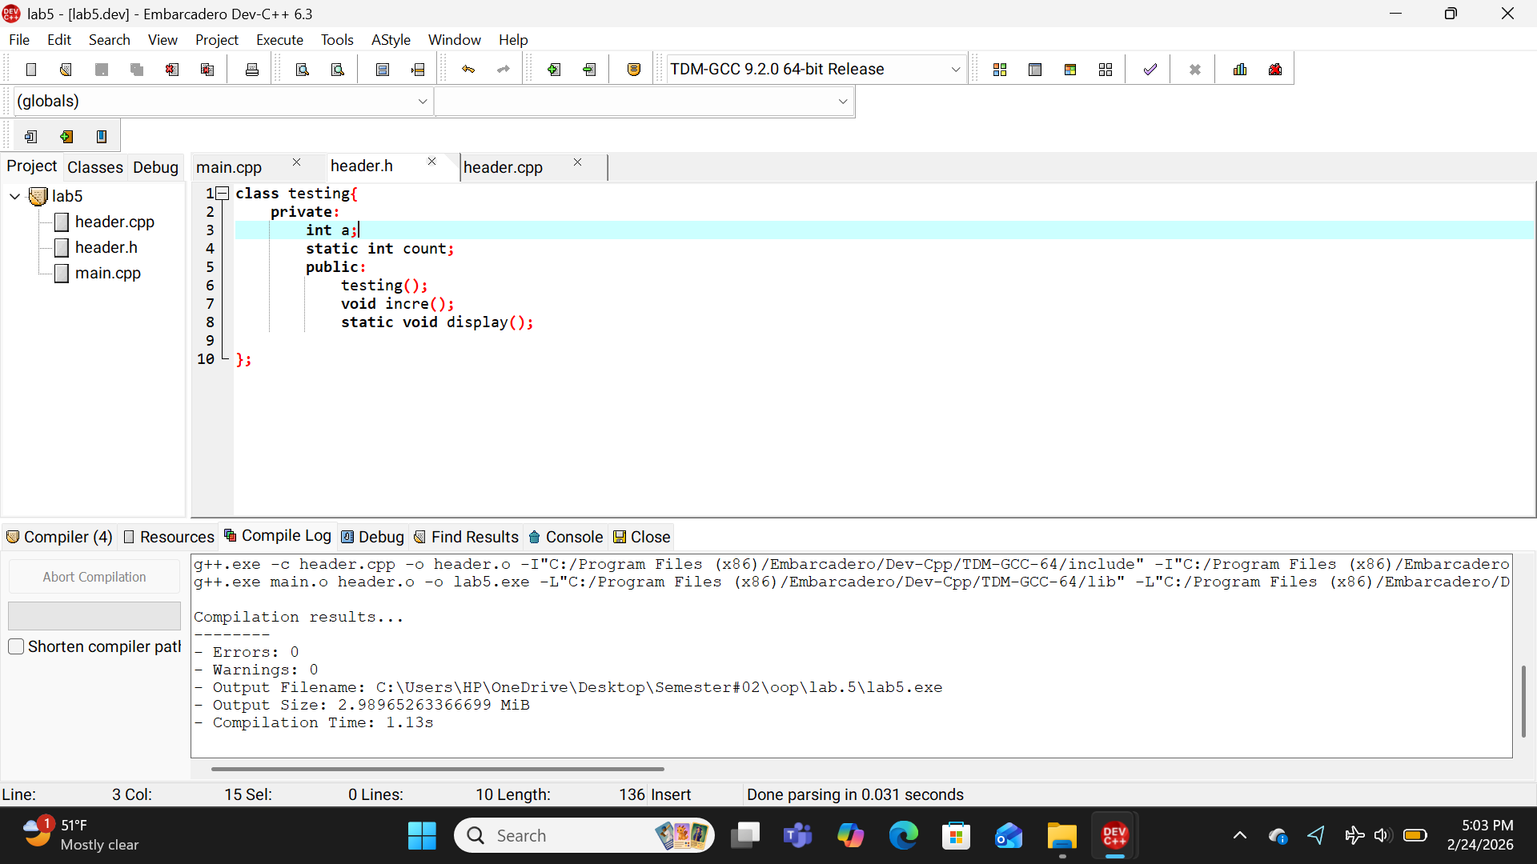Implementation file :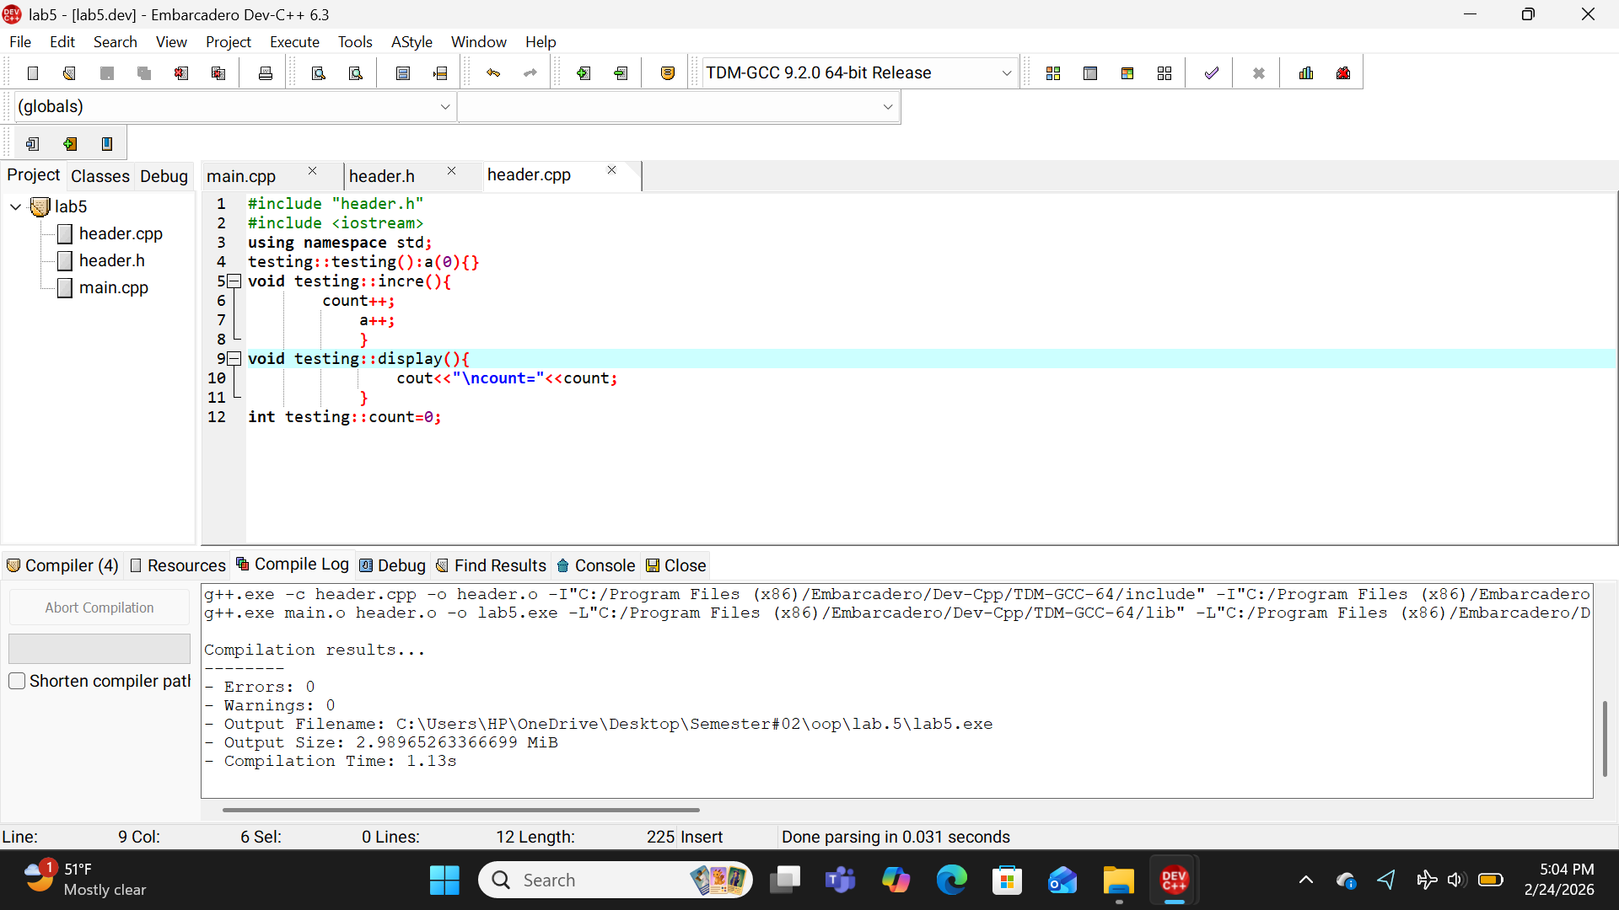
TASK#02
Main file and output:
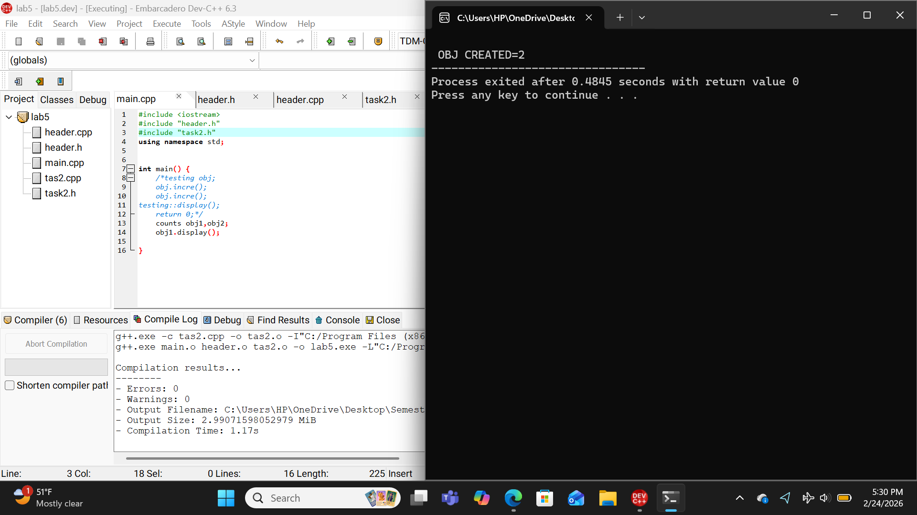
Header file :
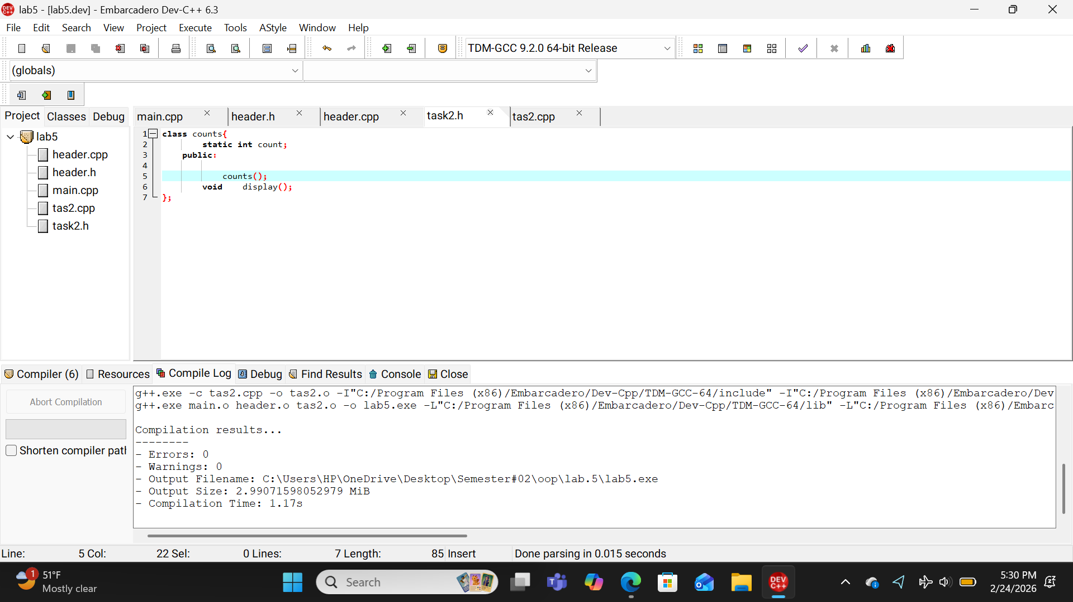
Implementation file 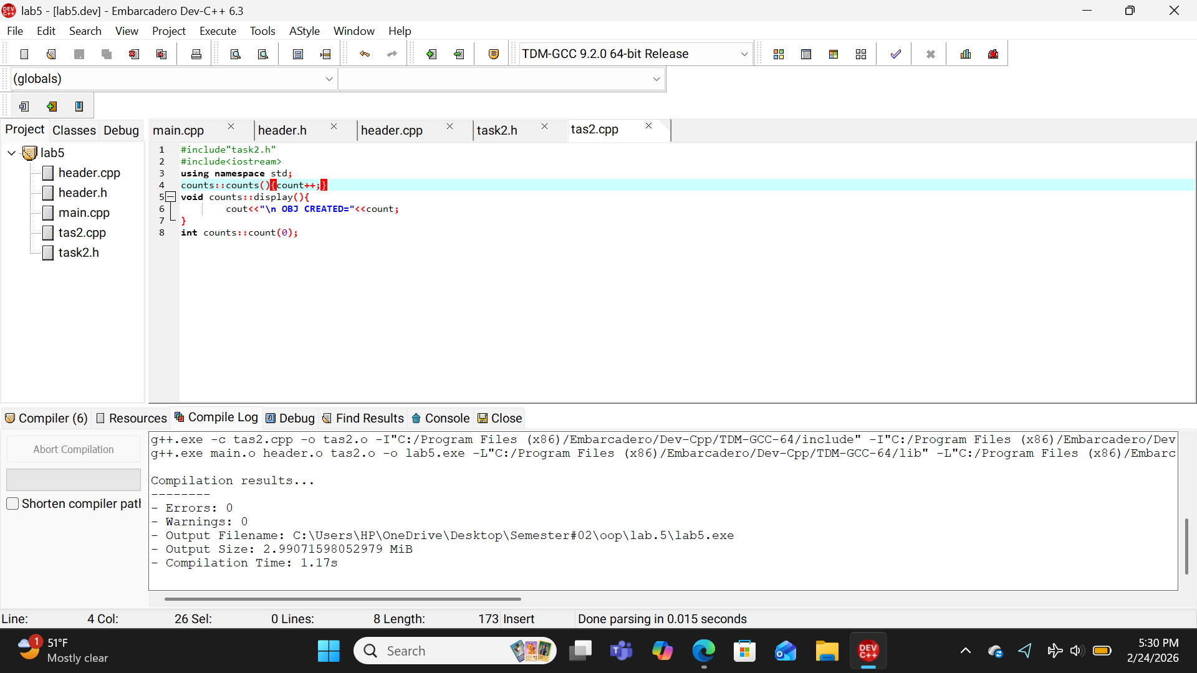
TASK#03
Main file and output:
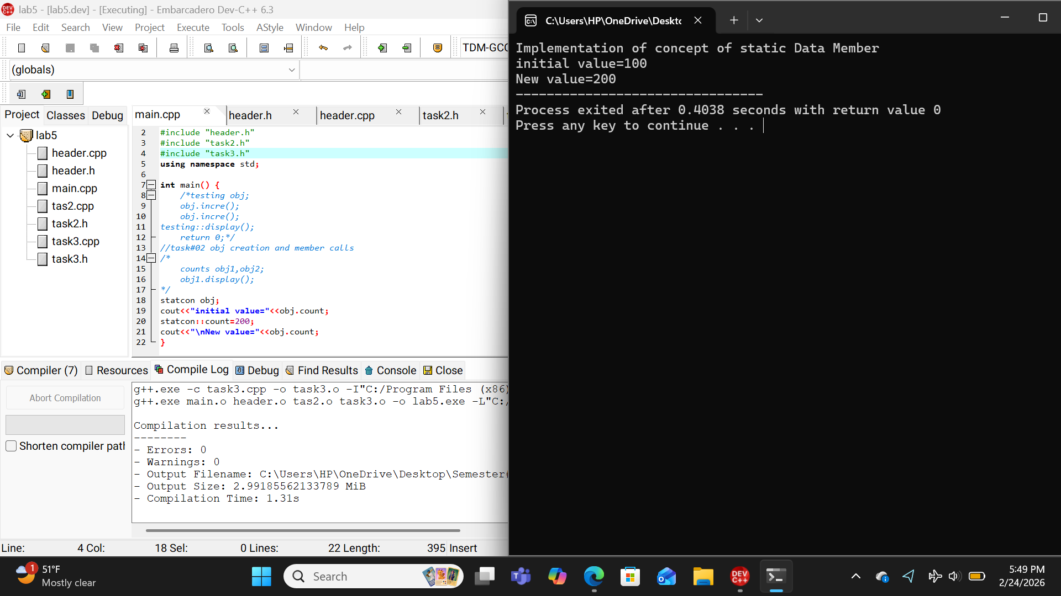
Header file :
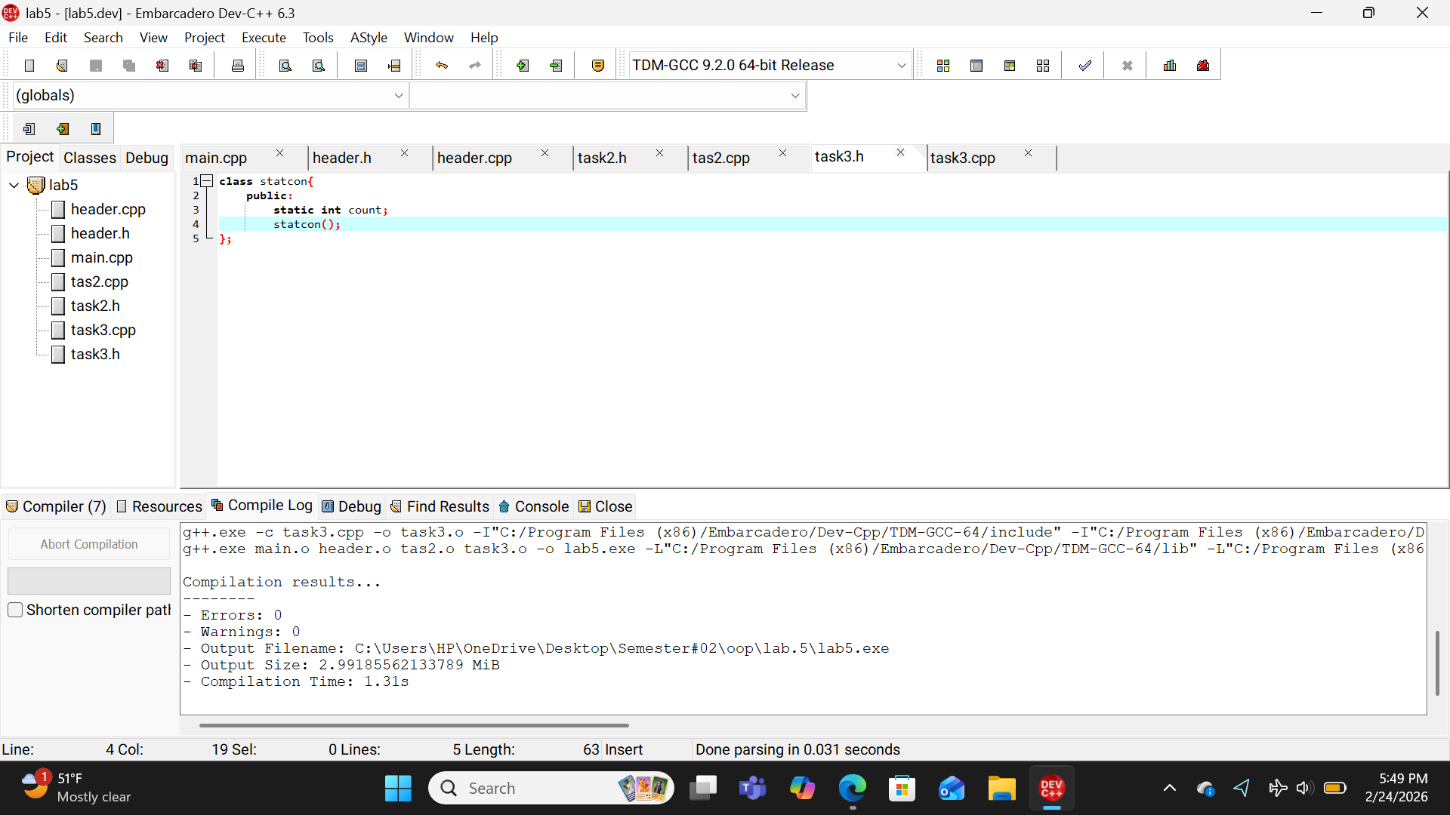
Implementation file:
