Product Optimization & Revenue Contribution Analysis
Afficionado Coffee Roasters

1. Background and Context
In specialty coffee retail, not all products contribute equally to revenue. Common challenges include high-volume products with low revenue contribution, high-priced products with low sales frequency, and overcrowded menus that slow service and confuse customers. This analysis examines transaction-level sales data from Afficionado Coffee Roasters to build product-centric intelligence that supports menu optimization and merchandising strategy.

2. Problem Statement
Although transaction-level product data was available, Afficionado Coffee Roasters lacked clear visibility into product popularity versus profitability, category-level revenue dependency, and identification of low-impact or underperforming menu items. Without structured product analytics, menu decisions have historically been intuition-driven.

3. Methodology
The dataset consists of 149,116 transaction-level records from 2025, covering 80 distinct products across 9 categories and 3 store locations (Lower Manhattan, Hell's Kitchen, and Astoria). The data was validated for completeness: all fields were fully populated with no missing values, and quantities/prices were confirmed positive and realistic (unit prices $0.80-$45.00, quantities 1-8 per transaction). Revenue was computed at the transaction level as quantity multiplied by unit price, then aggregated by product, product type, and category. Products were ranked by both revenue and volume, and a Pareto analysis identified how many products account for 80% of total revenue.

4. Key Findings

4.1 Overall Performance
Across the analysis period, Afficionado Coffee Roasters generated $698,812.33 in total revenue from 214,470 units sold across 80 products and 3 store locations.

4.2 Category Revenue Distribution
Coffee is the dominant category at 38.63% of total revenue ($269,952.45), followed by Tea at 28.11% ($196,405.95). Together these two categories drive nearly 67% of revenue. Bakery (11.78%) and Drinking Chocolate (10.36%) are secondary contributors, while Branded, Loose Tea, Flavours, and Packaged Chocolate together contribute under 5.5% of revenue.
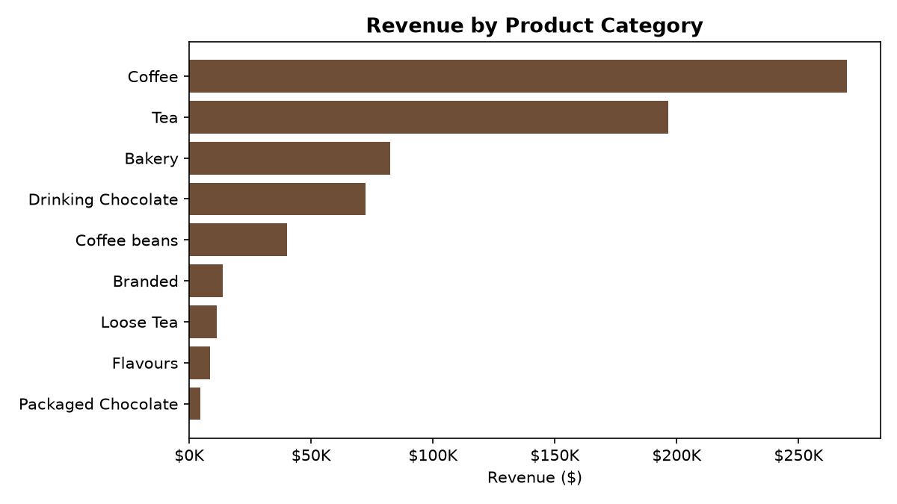

4.3 Top-Performing Products
The highest revenue-generating product is Sustainably Grown Organic Lg (Drinking Chocolate) at $21,151.75, followed closely by Dark Chocolate Lg at $21,006.00. Notably, the top revenue product ranks only 11th in unit volume, indicating it is a premium, higher-margin item rather than a high-traffic one.
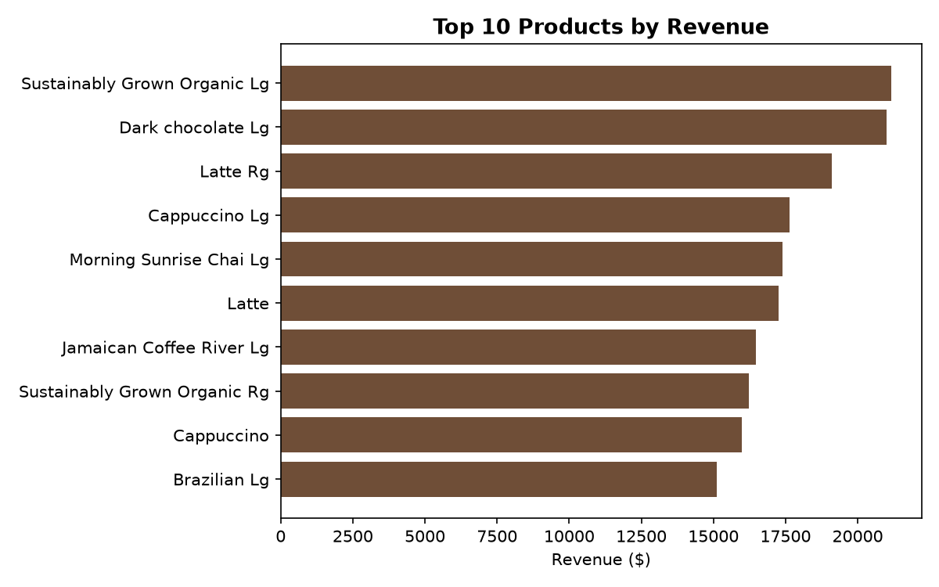

4.4 Underperforming Products
The lowest-revenue products are concentrated almost entirely in the Loose Tea category, with items such as Morning Sunrise Chai, Peppermint, and Lemon Grass each contributing under 0.23% of total revenue. These are strong candidates for menu simplification.

4.5 Popularity vs. Revenue
Comparing volume rank to revenue rank reveals two product archetypes. Traffic drivers such as Earl Grey Rg rank #1 in units sold (4,708 units) but only #26 in revenue -- high frequency, low value per visit. Premium items such as Sustainably Grown Organic Lg show the inverse: lower volume, outsized revenue. Volume alone is a misleading signal of a product's business value.
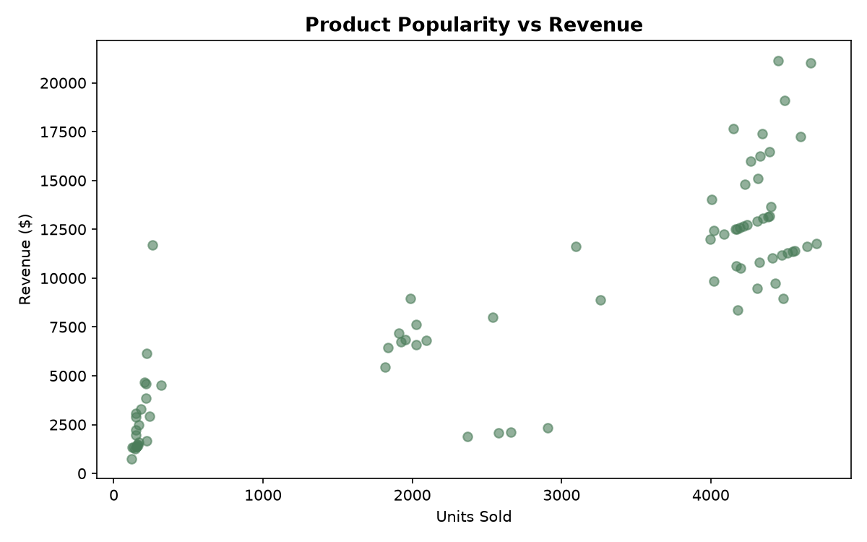

4.6 Revenue Concentration (Pareto Analysis)
A classic 80/20 pattern would show roughly 20% of products driving 80% of revenue. This menu shows a notably flatter distribution: it takes 43 of the 80 products (53.8%) to reach 80% of total revenue. This indicates the menu is broad-based rather than dependent on a small number of hero items -- a lower-risk revenue structure, but one with less concentrated leverage for targeted promotion.
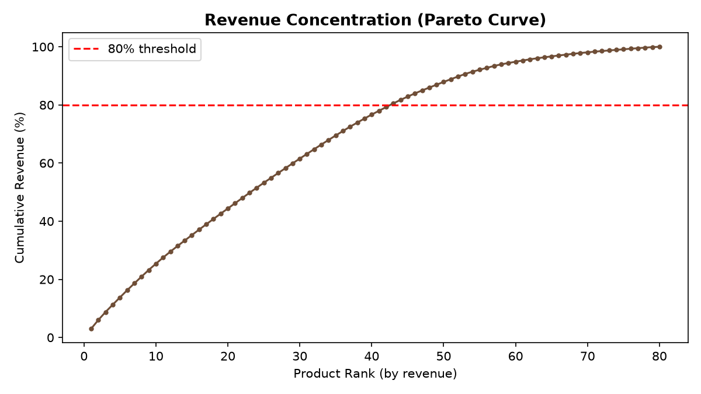

5. Recommendations
- Protect and promote premium, high-margin items (e.g., Sustainably Grown Organic Lg, Dark Chocolate Lg) -- these carry outsized revenue impact relative to their volume.
- Review the Loose Tea category for simplification; its products collectively contribute only 1.6% of revenue despite occupying multiple menu slots.
- Consider bundling or upselling around high-traffic, lower-revenue items like Earl Grey Rg to convert footfall into higher-margin sales.
- Because revenue is broad-based rather than concentrated, menu changes should be tested incrementally -- no single product removal poses outsized risk.
- Continue monitoring category dependency: Coffee and Tea together drive two-thirds of revenue, so disruptions in these categories carry the greatest financial risk.

6. Conclusion
This analysis shifts the focus from when customers buy to what they buy and what actually drives revenue. By combining product popularity, revenue contribution, category dependency, and concentration analysis, Afficionado Coffee Roasters now has a data-driven basis for menu optimization, merchandising strategy, and long-term profitability planning.

