**Department of Computer Science**

Software Project Proposal

|  |  |  |  |
| --- | --- | --- | --- |
| **Course** | OBJECT ORIENTED PROGRAMMING 2 | **Group No.** |  |

|  |  |  |
| --- | --- | --- |
| **Student ID** | **Name** | **Section** |
| 23-50139-1 | Abdullah Al Mubin | S |
|  |  |  |
|  |  |  |
|  |  |  |

|  |
| --- |
| Project Title: |
| Farmlink |

**FarmLink**

**Project Description: FarmLink**

In Bangladesh, farmers work tirelessly to grow crops, yet when it comes to selling them, they are often trapped by powerful market syndicates. These groups control supply chains, raise prices unfairly, and leave farmers earning only a fraction of what their produce is worth. Meanwhile, consumers and small shop owners pay inflated prices without realizing the struggle behind the market.

FarmLink is a C# .NET-based platform designed to break this cycle. It directly connects farmers with buyers (everyday users or shop owners), allowing farmers to list their products and sell without relying on exploitative middlemen. Users register as buyers, sellers, or farmers. Each user has basic credentials such as name, email, password, role, image, and location.

Sellers (who are also users) can list multiple products with details such as name, description, image, unit price, and quantity. Buyers can browse these products and add them to their cart, from which they can place orders. The cart maintains the buyer-product relationship before placing an order.

When orders are placed, they include product details like quantity, unit price, image, and description. An order is part of an order history for a buyer and includes payment information and status tracking.

However, farmers often face challenges when selling in bulk-they may not have the time, skills, or resources to negotiate large deals. This is why agents are introduced into the system. Approved by an admin, agents help farmers sell large quantities of products to buyers or shop owners and, in return, earn a commission. This is tracked with commission amounts and payment information. Farmers can hire agents and pay them based on sales, while agents get commissions for helping sell farmer products.

The admin oversees agent approvals and work hours, and also approves agents and monitors major operations in the system, ensuring trust and transparency.

Through FarmLink, we aim to empower farmers, reduce market manipulation, and build a fairer, more direct agricultural market for Bangladesh.

**Case Study: FarmLink**

FarmLink is a digital agricultural marketplace built using C# .NET that connects farmers in Bangladesh directly with buyers and shop owners, bypassing exploitative middlemen. In this system, users register with roles such as buyer, seller, farmer, or agent. Each seller (who is a user) can list multiple products, specifying attributes like description, unit price, quantity, and image. Buyers can browse and add these products to their cart, and place orders which include product-specific details and are tied to payments. Farmers may assign agents to help them sell products in bulk-these agents are hired by the farmers and must be approved by an admin before operating. Agents earn commissions when they facilitate sales for the farmers. Each agent can be linked to multiple farmers and sales, while each farmer can hire only one agent. Admins play a crucial role in maintaining platform integrity by verifying and approving agents and monitoring major transactions and work hours. The system keeps detailed records of order history, payments, and commissions, ensuring fair trade and transparent operations. This structure promotes fairness and efficiency in the agricultural supply chain by aligning directly with the real-world relationships represented in the FarmLink ER diagram.

**User Story**: **FarmLink**

|  |  |  |
| --- | --- | --- |
| **Use Case Name** | **Actor** | **User Story** |
| Sign In | User | As a user of the system, I want to sign in so that I can access my account and role-specific features. |
| Register | User | As a new user, I want to register with my details so I can become a part of the FarmLink system. |
| List Product | Seller | As a seller, I want to list products with descriptions and prices so that buyers can view and purchase them. |
| Browse Products | Buyer | As a buyer, I want to browse products so I can choose items to add to my cart or place an order. |
| Add to Cart | Buyer | As a buyer, I want to add products to my cart so I can purchase multiple items at once. |
| Place Order | Buyer | As a buyer, I want to place an order so I can purchase selected products from sellers. |
| Assign Agent | Farmer | As a farmer, I want to assign an agent so they can help me sell my products in bulk. |
| Approve Agent | Admin | As an admin, I want to approve agents so that only verified agents operate in the system. |
| Sell via Agent | Agent | As an agent, I want to sell products on behalf of farmers so I can earn commissions. |
| Approve Order | Admin | As an admin, I want to approve high-value orders to ensure secure transactions. |
| Make Payment | Buyer | As a buyer, I want to make a payment for my order to complete the purchase process. |
| Receive Payment | Seller | As a seller, I want to receive payment for the products I sold to buyers. |

**ER Diagram: FarmLink**

**Use case Diagram: FarmLink**

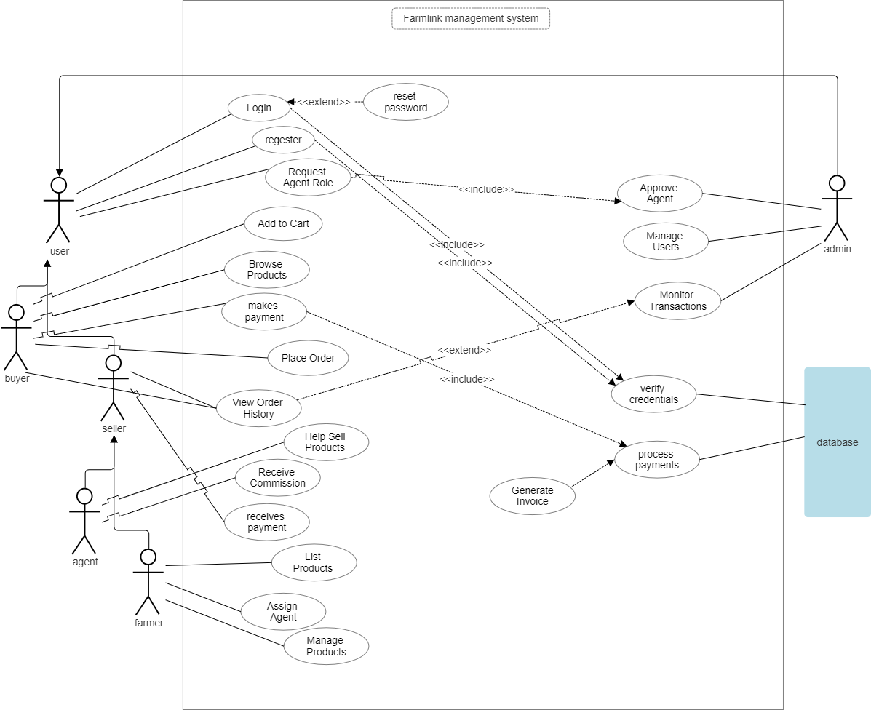

**User Interface design : FarmLink**

Figure Landing Page

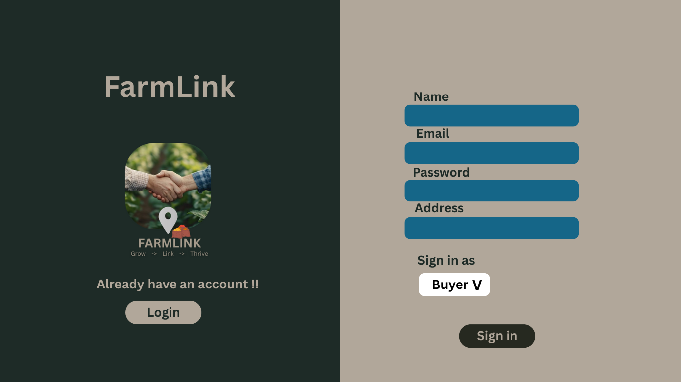

Figure registration page

Figure login page

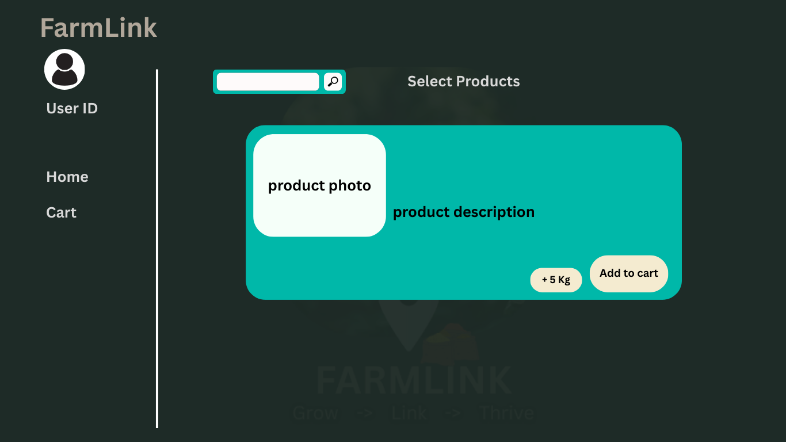

Figure home page

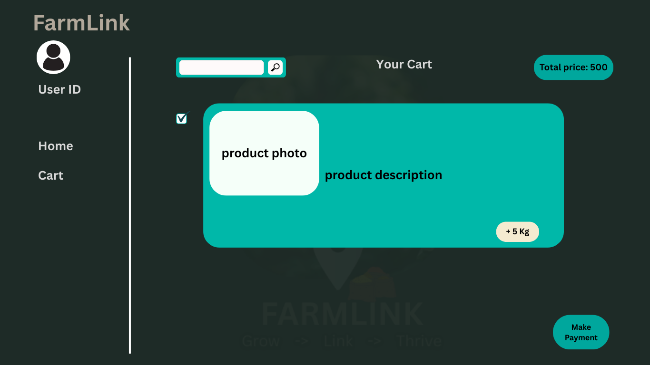

Figure product cart

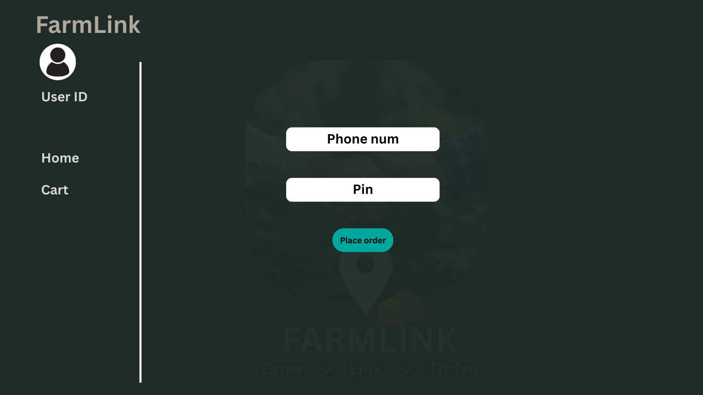

Figure payment

**Project links: Farmlink**

Github : <https://github.com/mubin25-dodu/Farmlink>