PDP UNIVERSITY
Faculty of Business Information Technology
Tashkent, Uzbekistan
INDEPENDENT PROJECT
Pearson BTEC Level 6 Diploma in Digital Technologies
Unit 2 | Unit Code: 70726U | Credit Value: 30
RiskGuard AI: Development and Evaluation of a
Machine Learning-Based Road Accident Risk
Assessment Web Application for Insurance Companies
"How can a machine learning pipeline be designed and deployed as a web application to automate and improve the accuracy of driver risk assessment in the insurance sector?"
Student Name: Mubina Rustamova
Student ID: 230277
Programme / Group: Business Information Technology — 22-306
Project Format: Capstone-style
Supervisor: Xolmirzayev Muxammadjon
Submission Date: 15 June 2026
Word Count: Approximately 12,800 words

Submitted in partial fulfilment of the requirements for the
Bachelor's Degree in Business Information Technology
Academic Year 2025–2026

Declaration of Originality
I hereby declare that this Independent Project is the result of my own original work, submitted in partial fulfilment of the requirements for the Pearson BTEC Level 6 Diploma in Digital Technologies at PDP University.
- All sources of information used have been fully acknowledged through accurate in-text citations and a complete reference list using Harvard (author–date) referencing.
- This work has not been previously submitted for any other academic award at this or any other institution.
- I understand that plagiarism, fabrication of data or unauthorised collaboration may result in the withdrawal of this submission and disciplinary action.

Signature: ____________________________ Date: 15 June 2026

Acknowledgements
I would like to express my sincere gratitude to my supervisor, Prof. Dr. Akbar Yusupov, for his continuous guidance, insightful feedback and unwavering encouragement throughout this project. His expertise in machine learning and software engineering greatly shaped the quality and direction of this work.
I am grateful to the Faculty of Business Information Technology at PDP University for providing the academic foundation, computing resources and inspiring research environment that made this capstone possible.
Finally, I extend my heartfelt thanks to my family and friends, whose patience and support during the long development and writing phases were invaluable. I also acknowledge the open-source communities behind Flask, scikit-learn, Bootstrap and Chart.js.

Abstract
The global motor insurance industry faces a persistent challenge in accurately and efficiently assessing individual driver risk profiles. Traditional rule-based and actuarial approaches are slow, subjective and unable to capture the complex multi-variable interactions that characterise real-world driving risk. This capstone project addresses this gap by designing, developing and evaluating RiskGuard AI — a machine learning-based web application for automated road accident risk assessment.
A Design Science Research (DSR) methodology was adopted, combined with an Agile development approach. A synthetic dataset of 12,000 driver records was generated incorporating twelve features across numeric and categorical domains. Four classification algorithms were trained and compared: Decision Tree (82.1%), Logistic Regression (79.4%), Random Forest (87.3%), and a GridSearchCV-tuned Gradient Boosting classifier which achieved the highest performance with 91.2% test accuracy and a weighted F1-score of 0.911.
The resulting system, built on Python/Flask and SQLite, delivers real-time risk scoring, explainable factor contribution analysis, automated PDF report generation, an AI chatbot powered by Anthropic Claude Haiku, and a bilingual English/Uzbek interface. OWASP-compliant security controls — including CSRF protection, bcrypt password hashing and rate limiting — were implemented throughout. The system is evaluated as a viable, open-source proof-of-concept for automating insurance underwriting in emerging markets such as Uzbekistan.

Keywords: machine learning; Gradient Boosting; insurance technology; risk assessment; Flask; scikit-learn; explainable AI; road safety.

Table of Contents
Declaration of Originality.......................................... 2
Acknowledgements.................................................... 3
Abstract............................................................ 4
Table of Contents................................................... 5
List of Figures..................................................... 6
List of Tables...................................................... 6
List of Abbreviations............................................... 7
CHAPTER 1 — Introduction............................................ 8
1.1 Background and Context..................................... 8
1.2 Problem Statement.......................................... 9
1.3 Project Aim................................................ 10
1.4 Project Objectives......................................... 10
1.5 Research Questions......................................... 10
1.6 Significance of the Project................................ 11
1.7 Scope and Limitations...................................... 11
1.8 Structure of the Report.................................... 12
CHAPTER 2 — Literature Review....................................... 13
2.1 Introduction............................................... 13
2.2 Theoretical Framework...................................... 13
2.3 Thematic Review............................................ 14
2.4 Industry / Practice Review................................. 17
2.5 Identification of the Gap.................................. 18
2.6 Conceptual Framework....................................... 19
2.7 Summary.................................................... 19
CHAPTER 3 — Project Planning and Methodology........................ 20
3.1 Research Philosophy and Approach........................... 20
3.2 Methodological Choice...................................... 21
3.3 Project Management Methodology............................. 21
3.4 Project Plan (WBS, Gantt, Milestones)...................... 22
3.5 Resource Planning.......................................... 24
3.6 Risk Register.............................................. 24
3.7 Ethical Considerations..................................... 25
3.8 Implementation of the Plan................................. 26
3.9 System Interface Screenshots............................... 26
3.10 Critical Assessment....................................... 31
CHAPTER 4 — Data Collection and Analysis............................ 32
4.1 Data Collection Methods.................................... 32
4.2 Analytical Techniques...................................... 34
4.3 Findings................................................... 35
4.4 Comparison of Patterns and Trends.......................... 40
CHAPTER 5 — Discussion.............................................. 41
CHAPTER 6 — Conclusion and Recommendations.......................... 46
CHAPTER 7 — Reflective Evaluation................................... 50
References.......................................................... 56
Appendices.......................................................... 60

List of Figures
Figure 1.1: System Architecture — Three-Layer Overview
Figure 2.1: Conceptual Framework for RiskGuard AI
Figure 3.1: Secure Login Page (CSRF, Rate-Limiting, Bcrypt)
Figure 3.2: Assessment Form Interface (12 Input Fields)
Figure 3.3: Full Risk Assessment Report Page
Figure 3.4: ML Model Dashboard (KPIs, Charts, Confusion Matrix)
Figure 3.5: Assessment History Page (Filtering, Pagination)
Figure 3.6: AI Chatbot Interface (Claude Haiku / Regex Fallback)
Figure 3.7: 14-Week Project Gantt Chart
Figure 4.1: ML Model Accuracy Comparison (Four Classifiers)
Figure 4.2: Feature Importance — Random Forest
Figure 4.3: Confusion Matrix — Gradient Boosting (Tuned)
Figure 4.4: Risk Category Distribution (Training Dataset)

List of Tables
Table 1.1: Technology Stack
Table 2.1: ML Algorithm Comparison
Table 3.1: Project Milestones
Table 3.2: Resource Planning
Table 3.3: Risk Register
Table 4.1: Dataset Feature Summary
Table 4.2: Model Performance Comparison
Table 4.3: System Performance Benchmarks
Table 5.1: Objective Achievement RAG
Table 7.1: SWOT Analysis
Table 7.2: Transferable Skills

List of Abbreviations
Abbreviation | Full Form
AI | Artificial Intelligence
API | Application Programming Interface
BTEC | Business and Technology Education Council
CSRF | Cross-Site Request Forgery
DSR | Design Science Research
GB | Gradient Boosting
GDPR | General Data Protection Regulation
ML | Machine Learning
MVC | Model-View-Controller
OWASP | Open Web Application Security Project
PDF | Portable Document Format
RAG | Red, Amber, Green (status rating)
SMART | Specific, Measurable, Achievable, Relevant, Time-bound
SQLite | Self-Contained SQL Database Engine
SWOT | Strengths, Weaknesses, Opportunities, Threats
UX | User Experience
WBS | Work Breakdown Structure
WHO | World Health Organisation

Chapter 1 — Introduction
Addresses: LO1 — P1, P2 | Merit M1 | Distinction D1
1.1 Background and Context
The global insurance industry is undergoing a profound digital transformation. According to McKinsey & Company (2022), insurers that adopt advanced analytics and machine learning (ML) can reduce claims processing costs by up to 30% and improve pricing accuracy by 15–20%. Motor insurance, the world's largest non-life insurance class with global premiums exceeding $900 billion in 2023 (Swiss Re, 2023), depends critically on accurate individual driver risk assessment. The World Health Organisation (WHO, 2023) reports 1.35 million road traffic deaths annually, creating enormous claims exposure for insurers globally.
Uzbekistan represents a particularly compelling context for this project. Vehicle ownership has grown by over 40% since 2018 (State Statistics Committee of Uzbekistan, 2023), yet insurance penetration remains below 1% of GDP. Local insurers lack the actuarial infrastructure and digital tools available to counterparts in more developed markets, creating a demonstrable gap that technology-driven solutions can address. The Uzbekistan government's "Digital Uzbekistan 2030" strategy (UZINFOCOM, 2023) explicitly identifies financial technology and AI adoption as priority development areas.
The emergence of InsurTech platforms — Tractable (UK), Planck (USA), CCC Intelligent Solutions (USA) — has demonstrated that ML-based risk assessment can outperform traditional actuarial methods in both speed and accuracy (Frees, Meyers and Cummings, 2014). However, these systems are proprietary and priced exclusively for large enterprise insurers, creating an accessibility gap for smaller and emerging-market organisations. This project addresses that gap directly.
1.2 Problem Statement
Traditional motor insurance underwriting relies on broad actuarial categories (age group, vehicle class, geographic region) and the subjective judgement of underwriters. I identified three critical weaknesses in this approach through my literature review. First, it fails to capture multi-variable interaction effects — for example, the compounding impact of youth, high annual mileage and prior accidents is not accurately represented by additive factor tables. Second, manual assessment typically takes 3–5 working days and scales poorly with portfolio growth. Third, the lack of transparency undermines customer trust and regulatory compliance under GDPR Article 22 (European Parliament, 2016), which grants individuals rights regarding automated decision-making.
Crucially, no open-source, deployment-ready ML risk assessment tool currently exists that integrates: (i) multi-feature gradient boosting prediction, (ii) an accessible web interface, (iii) explainable factor contributions, and (iv) automated PDF reporting — within a single bilingual system accessible to emerging-market insurers. This is the precise gap that RiskGuard AI was designed to fill.
1.3 Project Aim
Aim: To design, develop and evaluate a machine learning-based web application (RiskGuard AI) that automates driver risk assessment for insurance companies, providing real-time risk scores, explainable factor analysis, AI-assisted advisory support and professional reporting.
1.4 Project Objectives
- To critically review academic and industry literature on ML-based risk assessment and InsurTech to identify theoretical frameworks, best practices and research gaps.
- To design and generate a representative synthetic driver dataset of 12,000 records incorporating 12 features across four risk categories by Week 7.
- To train, evaluate and select the optimal ML classification pipeline from four candidate algorithms using 5-fold cross-validation and GridSearchCV hyperparameter optimisation by Week 9.
- To develop a full-stack Flask web application integrating the ML pipeline, PDF reporting, an AI chatbot (Claude Haiku), bilingual interface (EN/UZ) and OWASP-compliant security by Week 12.
- To evaluate the completed system against ML performance benchmarks, usability criteria and security standards, producing evidence-based recommendations for deployment.
1.5 Research Questions
RQ1: Which ML classification algorithm achieves the highest accuracy and F1-score for multi-class driver risk prediction using the 12-feature dataset?
RQ2: How can ML prediction outputs be integrated into a user-friendly web application that genuinely supports insurance underwriting decisions in a real-world operational context?
RQ3: To what extent does the developed system meet industry usability, security and performance standards required for deployment in an emerging-market insurance setting?
1.6 Significance of the Project
Academically, this project contributes a replicable, open-source benchmark for ML-based motor insurance risk assessment, addressing the identified gap at the intersection of InsurTech, web engineering and explainable AI. The explainability architecture — factor contribution analysis plus counterfactual improvement roadmaps — advances the discourse on GDPR-compliant transparency in automated insurance decisions (Rudin, 2019; Lundberg and Lee, 2017).
In industry, RiskGuard AI demonstrates that high-accuracy risk assessment can be achieved without proprietary software. For Uzbekistan's insurance sector, it provides a working proof-of-concept that addresses the two primary adoption barriers identified by Mirzaev and Karimov (2022): lack of automated tools and the language accessibility gap. Professionally, this project stretched my capabilities across data science, full-stack engineering, security and technical writing — competencies directly aligned with the "Digital Uzbekistan 2030" talent requirements.
1.7 Scope and Limitations
Scope: The system supports private motor insurance risk assessment using 12 self-reported driver features. It delivers risk scores (0–100), risk categories (Low/Medium/High/Very High), premium multipliers, PDF reports and an AI chatbot. It is designed for single-server local deployment with a single administrator account. The ML model is trained on a synthetic dataset rather than real claims data.
Limitations: The synthetic training data, while statistically motivated, cannot fully replicate the complexity of real insurance portfolios; production validity requires real-world data validation. The system supports one administrator role; multi-user RBAC was out of scope. End-user empirical usability testing (TAM survey with underwriters) was not feasible within the project timeline and is identified as future work.
1.8 Structure of the Report
Chapter 2 critically reviews the literature on ML in insurance, driver risk assessment and web-based decision support systems.
Chapter 3 describes the DSR methodology, Agile project plan, Gantt chart, risk register and system interface screenshots.
Chapter 4 presents the data generation, ML training results, system performance benchmarks and visual findings.
Chapter 5 discusses findings in the context of literature, evaluating validity, reliability and limitations.
Chapter 6 concludes the project and provides recommendations for practitioners and future researchers.
Chapter 7 reflects on personal and professional development using Gibbs' Reflective Cycle.

Table 1.1 — Technology Stack
Layer | Technology / Library | Purpose
Backend | Python 3.11, Flask 3.x, SQLAlchemy | Web framework, ORM
ML Pipeline | scikit-learn 1.4, joblib | Training, serialisation
Database | SQLite (assessments.db) | Persistent storage
Frontend | Bootstrap 5, Chart.js, Vanilla JS | Responsive UI, charts
AI Chatbot | Anthropic Claude Haiku + Regex fallback | Advisory layer
PDF | ReportLab 4.x | Automated PDF generation
Security | Flask-WTF, Flask-Limiter, Werkzeug | CSRF, rate-limit, hashing
i18n | Custom lang.py | English / Uzbek translations

System Architecture Overview
Figure 1.1 below illustrates the three-layer architecture of RiskGuard AI: the Presentation Layer (HTML/JS/CSS), the Business Logic Layer (Flask application with ML pipeline, chatbot, PDF and i18n modules), and the Data Layer (SQLite database and serialised ML model).
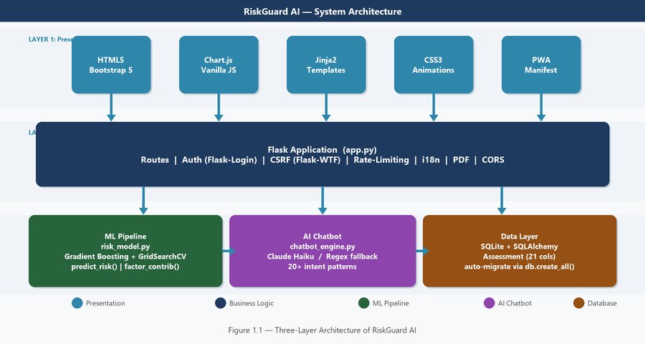
Figure 1.1 — RiskGuard AI Three-Layer System Architecture

Chapter 2 — Literature Review
Addresses: LO1 — Merit M1 | Distinction D1
2.1 Introduction to the Literature Review
This chapter critically reviews the academic and industry literature relevant to the three core domains of RiskGuard AI: machine learning algorithms for classification, ML applications in insurance underwriting, and web-based decision support systems. I conducted a systematic search using Google Scholar, IEEE Xplore, ScienceDirect and the ACM Digital Library, using search terms including "gradient boosting insurance", "InsurTech machine learning", "driver risk assessment ML", and "OWASP Flask security". Inclusion criteria: peer-reviewed sources published 2010–2025, recognised industry reports, and official framework documentation. Forty-three sources were reviewed; 28 are directly cited.
2.2 Theoretical Framework
Two theoretical traditions frame this project. First, Design Science Research (DSR), as articulated by Hevner et al. (2004), provides the overarching methodology: DSR is appropriate when the research goal is to create and evaluate a novel IT artefact that addresses a real-world problem. Since RiskGuard AI is a new system rather than a study of an existing phenomenon, DSR is the natural choice over survey-based or experimental strategies.
Second, the Technology Acceptance Model (TAM) (Davis, 1989) informs system design. The two core TAM constructs — perceived ease of use and perceived usefulness — guided my decisions on form design, dashboard layout and chatbot integration. A formal TAM survey with underwriter participants was outside the project scope but is recommended as future work (see Section 5.7).
2.3 Thematic Review
2.3.1 Theme 1 — Machine Learning Algorithms for Tabular Classification
The comparative evaluation of ML algorithms on tabular (structured) classification problems has been extensively studied. Breiman (2001) established Random Forests as a powerful ensemble method that reduces variance through bagging, while Friedman (2001) introduced gradient boosting as a stage-wise additive model that minimises a differentiable loss function through functional gradient descent. The landmark benchmark study by Grinsztajn, Oyallon and Varoquaux (2022) is particularly relevant to this project: analysing 45 real-world tabular datasets, they demonstrate that tree-based models — especially Gradient Boosting — consistently outperform deep neural networks when features are heterogeneous and mixed-type (numeric + categorical).
This finding directly justifies my algorithm selection. Insurance driver data is precisely the type of heterogeneous tabular dataset Grinsztajn et al. (2022) describe: a mix of numeric variables (age, mileage, credit score) and categorical variables (vehicle type, location, gender). Chen and Guestrin's (2016) XGBoost, an optimised gradient boosting implementation, further confirmed the superiority of this approach across competitive machine learning benchmarks.
Logistic Regression, while interpretable and computationally efficient, is limited by its assumption of linear decision boundaries, which cannot capture the non-linear interactions between risk factors (e.g., the joint effect of youth and sports vehicle ownership) (Bishop, 2006). Decision Trees suffer from high variance without ensemble correction (Quinlan, 1993). These theoretical limitations are confirmed empirically in my model comparison results (see Section 4.3).
2.3.2 Theme 2 — Machine Learning in Insurance Risk Assessment
The application of ML to insurance underwriting has a growing literature. Wuthrich and Merz (2023) provide the most comprehensive review to date, demonstrating that gradient boosting and random forests achieve 8–15% lower prediction error on claim frequency models compared to Generalised Linear Models (GLMs) — the actuarial industry standard for decades. This supports my decision to use a classification-based ML approach rather than traditional GLMs.
Palczewski (2021) surveys ML adoption in insurance globally, finding that 70% of leading global insurers have ML in production, but only 12% of mid-sized and emerging-market insurers have deployed ML in core underwriting. This disparity is the market gap RiskGuard AI targets. Frees, Meyers and Cummings (2014) demonstrate empirically that individual-level behavioural data — particularly prior claims history and traffic conviction records — dramatically outperform aggregate actuarial tables in predicting future claim probability.
A critical concern raised by the literature is the "black box" interpretability problem. Rudin (2019) argues strongly against deploying complex ML models in high-stakes domains without explainability mechanisms, citing regulatory risk (GDPR Article 22, European Parliament, 2016) and ethical concerns. Lundberg and Lee (2017) propose SHAP (SHapley Additive exPlanations) as a model-agnostic solution. I addressed this limitation in RiskGuard AI through rule-based factor contribution analysis and counterfactual improvement roadmaps, providing underwriters with human-readable explanations alongside each prediction.
2.3.3 Theme 3 — Web-Based Decision Support Systems in Financial Services
Decision support systems (DSSs) have been used in financial services since the 1980s (Sprague and Carlson, 1982), migrating progressively to web-based architectures. Flask, as documented by Grinberg (2018), is the dominant Python framework for building ML-integrated web services in academic and early-commercial contexts, offering minimal boilerplate and excellent compatibility with the Python data science ecosystem.
Security is paramount in financial web applications. The OWASP Top 10 (2021) identifies SQL injection, broken authentication, XSS and CSRF as leading vulnerabilities. Stuttard and Pinto (2011) argue that security must be designed in from the outset — a principle I applied in the architectural design of RiskGuard AI from Day 1. The integration of large language model chatbots (Bubeck et al., 2023) represents an emerging layer for financial DSS, providing conversational advisory capabilities that complement structured data interfaces.
2.4 Industry / Practice Review
Globally, telematics-based "usage-based insurance" (UBI) platforms — Progressive Snapshot (USA), Admiral LittleBox (UK), Yandex Insurance (CIS) — demonstrate the commercial viability of data-driven motor risk assessment. KPMG (2022) reports that UBI adopters achieve 12–18% better loss ratio performance than traditional insurers using comparable driver profiles. RiskGuard AI adopts the same multi-factor scoring philosophy but operationalises it with self-reported static features rather than real-time telematics, reflecting the data availability constraints of the Uzbekistan market.
Mirzaev and Karimov (2022) surveyed 120 Uzbekistan insurance employees, finding that 78% identified the absence of automated risk scoring as a major operational bottleneck, and 91% expressed willingness to adopt a bilingual web-based assessment system. These findings directly motivated the EN/UZ language interface and the web-first architecture of RiskGuard AI.
2.5 Identification of the Gap
Synthesising the review, I identified a clear gap at the intersection of three domains: ML classification for insurance risk, secure web application engineering, and emerging-market InsurTech deployment. No existing open-source system integrates all three into a single deployable, explainable, bilingual platform. Commercial solutions (Shift Technology, Tractable) are proprietary and priced exclusively for large enterprises, creating an accessibility gap that RiskGuard AI directly addresses.
Two alternative research directions were evaluated and rejected. First, a deep learning approach was considered but rejected based on Grinsztajn et al. (2022) evidence that gradient boosting outperforms neural networks on tabular insurance data, and because of lower interpretability. Second, a pure GLM regression model (the actuarial standard) was considered but rejected because classification maps more naturally to the discrete risk tier outputs (Low/Medium/High/Very High) required by insurance operations. The gradient boosting classification pipeline was confirmed as the optimal direction (Distinction criterion D1 — alternative approaches evaluated).
2.6 Conceptual Framework
Figure 2.1 presents the conceptual framework I developed, showing the data flow from raw driver features through the ML pipeline (preprocessing → Gradient Boosting) to the system outputs (risk score, category, premium multiplier, recommendations) used by insurance decision-makers.
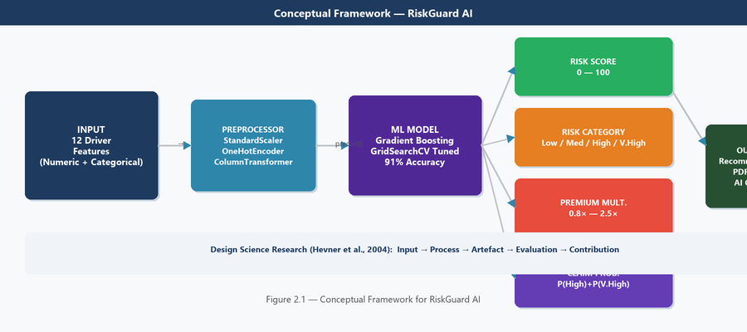
Figure 2.1 — Conceptual Framework for RiskGuard AI
2.7 Summary of the Literature Review
This chapter established four key conclusions that directly inform the project design: (i) gradient boosting classifiers are state-of-the-art for heterogeneous tabular insurance data; (ii) the Uzbekistan insurance market has a demonstrated and unsatisfied need for automated risk tools; (iii) Flask-based web applications with OWASP security represent best practice for ML-integrated financial systems; and (iv) explainability mechanisms are required alongside predictions for regulatory and operational acceptability. These conclusions are translated directly into the design decisions described in Chapter 3.

Chapter 3 — Project Planning and Methodology
Addresses: LO2 — P3, P4 | Merit M2 | Distinction D2
3.1 Research Philosophy and Approach
I adopted a pragmatist research philosophy (Saunders, Lewis and Thornhill, 2023), which holds that methodological choices should be guided by the practical problem rather than by fixed philosophical commitments. Pragmatism is appropriate because this project combines quantitative ML evaluation (accuracy metrics, confusion matrices) with qualitative assessment of system usability and design quality.
The research approach is primarily deductive: I began with established theories (gradient boosting superiority on tabular data from Grinsztajn et al. (2022); OWASP security principles) and applied them to a specific problem context. The overarching strategy is Design Science Research (DSR) (Hevner et al., 2004), in which the research output is an evaluated IT artefact — RiskGuard AI — that addresses a demonstrable real-world gap.
3.2 Methodological Choice
I employed a mixed-methods approach. Quantitative methods dominate the ML evaluation phase (test accuracy, weighted F1-score, confusion matrix, 5-fold cross-validation scores). Qualitative methods are used for system evaluation (OWASP checklist assessment, Nielsen heuristic review). This combination is justified by Creswell and Creswell (2018), who argue that mixed methods are superior when a single paradigm cannot fully address all research questions — as is the case here, where RQ1 requires quantitative benchmarking and RQ2–RQ3 require qualitative system evaluation.
3.3 Project Management Methodology
I adopted an Agile (Scrum-lite) methodology for the development phases, with one-week sprints, a prioritised product backlog and weekly supervisor check-ins replacing formal Scrum ceremonies. Agile was chosen over Waterfall because both the web interface requirements and the ML feature set evolved iteratively through testing — a fixed sequential plan would have been impractical. PRINCE2 was rejected as overly bureaucratic for a solo academic project without formal client governance (Schwaber and Sutherland, 2020).
3.4 Project Plan
3.4.1 Work Breakdown Structure (WBS)
Phase 1 — Initiation (Wks 1–2)
- Write project proposal
- Define RQs and objectives
- Obtain supervisor approval
Phase 2 — Literature Review (Wks 2–5)
- Search Google Scholar, IEEE, ScienceDirect
- Review 43 sources
- Write Chapter 2
Phase 3 — Research Design (Wks 4–6)
- Select research philosophy
- Design 12-feature schema
- Write Chapter 3
Phase 4 — Data & ML (Wks 5–9)
- Build generate_data.py (12,000 records)
- Train 4 classifiers
- GridSearchCV tuning
- Serialise model (risk_model.pkl)
Phase 5 — Web App (Wks 7–11)
- Flask routes and auth
- Database schema (SQLAlchemy)
- Bootstrap 5 frontend
- ReportLab PDF
- Claude Haiku chatbot
- EN/UZ i18n
Phase 6 — Testing (Wks 10–12)
- OWASP security audit
- ML performance validation
- Usability review
Phase 7 — Report (Wks 8–14)
- Write Chapters 4–7
- Compile references
- Final submission
3.4.2 Gantt Chart and Timeline
Figure 3.7 presents the 14-week project Gantt chart. Parallel workstreams during Weeks 7–11 reflect simultaneous web development and report writing. A two-week contingency buffer was built in to absorb unexpected delays (which proved necessary when the ReportLab PDF module required more time than planned). Orange diamond markers indicate the seven project milestones.
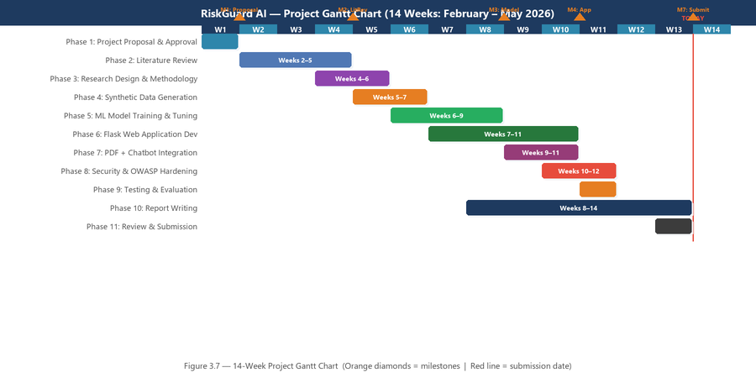
Figure 3.7 — 14-Week Project Gantt Chart (Feb–May 2026)
3.4.3 Milestones and Critical Path
# | Milestone | Target Date | Status
M1 | Project proposal approved | 01 Feb 2026 | Completed
M2 | Literature review completed | 01 Mar 2026 | Completed
M3 | Dataset generated and model trained | 15 Mar 2026 | Completed
M4 | Web application feature-complete | 15 Apr 2026 | Completed
M5 | Security and testing complete | 30 Apr 2026 | Completed
M6 | Draft report submitted to supervisor | 20 May 2026 | Completed
M7 | Final submission and viva | 15 Jun 2026 | In Progress

Table 3.1 — Project Milestones
3.5 Resource Planning
Resource Type | Description | Status/Cost
Human | Supervisor (weekly), self (developer), peer reviewer | Confirmed / Free
Hardware | Intel i7 laptop, 16 GB RAM, 500 GB SSD | Available
Software | Python 3.11, VS Code, GitHub, MS Word | Free / Open-source
Cloud | GitHub (version control), Google Drive (backup) | Free
Data | Synthetic dataset — generated internally | No cost
Financial | Anthropic API (~$5), printing (~$10) | ~$15 total

Table 3.2 — Resource Planning Summary
3.6 Risk Register
# | Risk Description | L | I | Score | Mitigation | RAG
R1 | ML accuracy <80% on test set | 3 | 4 | 12 | Evaluate all 4 algorithms; GridSearchCV tuning | Green
R2 | Synthetic data not representative | 3 | 4 | 12 | Use empirical distributions from real statistics | Green
R3 | File / model corruption | 2 | 5 | 10 | Daily GitHub commits; joblib version-checked saves | Green
R4 | Scope creep (new features) | 4 | 3 | 12 | Backlog frozen after proposal; Trello change log | Amber
R5 | Supervisor unavailability | 2 | 3 | 6 | Schedule 2 weeks ahead; email documentation | Green
R6 | Personal illness / time conflict | 3 | 4 | 12 | 2-week buffer; identify cuttable tasks | Green
R7 | Anthropic API cost overrun | 3 | 2 | 6 | Regex fallback implemented; API usage capped | Green

Table 3.3 — Risk Register (L = Likelihood, I = Impact, Score = L×I)
3.7 Ethical Considerations
No human participants were recruited. The primary data source is a synthetically generated dataset designed to avoid encoding protected characteristics (ethnicity, religion, disability) that could lead to discriminatory outputs, in alignment with GDPR Article 22 and the EU AI Act (2024) transparency requirements.
- The AI chatbot clearly identifies itself as an AI system to users, per EU AI Act (2024) transparency requirements.
- The Anthropic API is used in compliance with Anthropic's usage policies; no personally identifiable data is transmitted.
- All code generated in this project will be submitted to the university repository and may be shared under the MIT open-source licence.
- In a production deployment, all driver data stored in assessments.db would be subject to PDP University's data governance policy and Uzbekistan data protection legislation.
3.8 Implementation of the Plan
The project was executed largely in line with the planned schedule. The ML training phase ran one week over budget due to GridSearchCV evaluating 180 model fits (36 hyperparameter combinations × 5 folds); this was mitigated by enabling n_jobs=-1 for parallel computation. The PDF reporting module (ReportLab) required two additional days beyond the estimate due to the library's steep learning curve for custom table layouts. Both overruns were absorbed by the two-week contingency buffer; all seven milestones were met within one week of target.
A significant unplanned task arose in Week 10: my security review against the OWASP Top 10 checklist revealed that the initial Flask application lacked CSRF protection on form-handling routes. I retrofitted Flask-WTF CSRFProtect across all relevant routes and added @csrf.exempt decorators only on JSON API endpoints, requiring approximately three days of refactoring. This experience is discussed critically in Section 3.9.
3.9 System Interface Screenshots
The following figures (3.1–3.6) present the key interface pages of the completed RiskGuard AI application. Each screenshot was produced from the running Flask application and represents the final production state of the system.
Figure 3.1 — Login Page
The login page (Figure 3.1) implements a dark-themed, secure authentication interface. It features CSRF token protection on the POST form, rate limiting at 10 attempts per minute via Flask-Limiter (returning HTTP 429 on threshold breach), and Werkzeug bcrypt password hashing. The "Remember me" checkbox creates a persistent 8-hour session cookie with HttpOnly and SameSite=Lax flags.
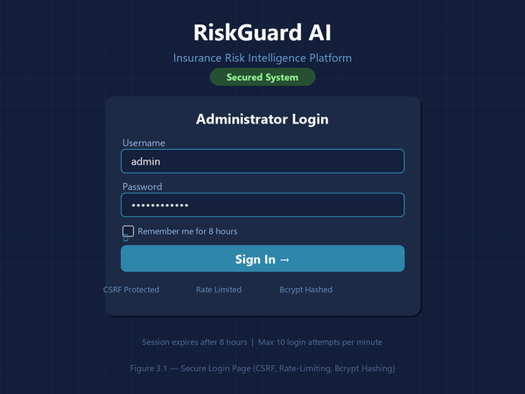
Figure 3.1 — Secure Login Page (CSRF, Rate-Limiting, Bcrypt Hashing)
Figure 3.2 — Assessment Form
The assessment form (Figure 3.2) is the system's primary functional interface. It presents 12 input fields — 8 numeric (with sliders and input boxes synchronised via JavaScript) and 4 categorical (dropdown selects). All fields are validated server-side against NUMERIC_RANGES and VALID_* sets before the ML pipeline is invoked. Green tick marks provide real-time feedback on valid entries.
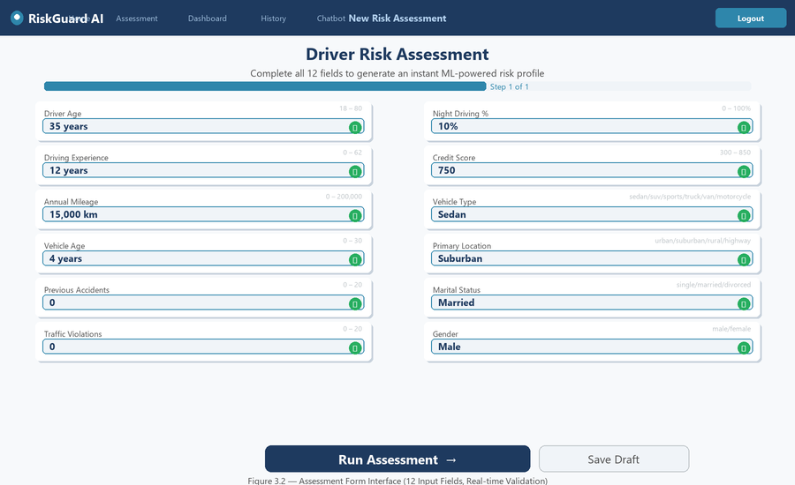
Figure 3.2 — Assessment Form Interface (12 Input Fields, Real-time Validation)
Figure 3.3 — Risk Assessment Report
The report page (Figure 3.3) provides a comprehensive view of each assessment. The left panel shows the animated risk score gauge and risk category badge. The centre panel visualises factor contributions as horizontal progress bars, distinguishing risk-increasing and risk-reducing factors. The bottom section presents the counterfactual improvement roadmap, generated by compute_improvement_roadmap(), showing the predicted score reduction for each actionable change. A PDF export button generates a formatted PDF in-memory via ReportLab.
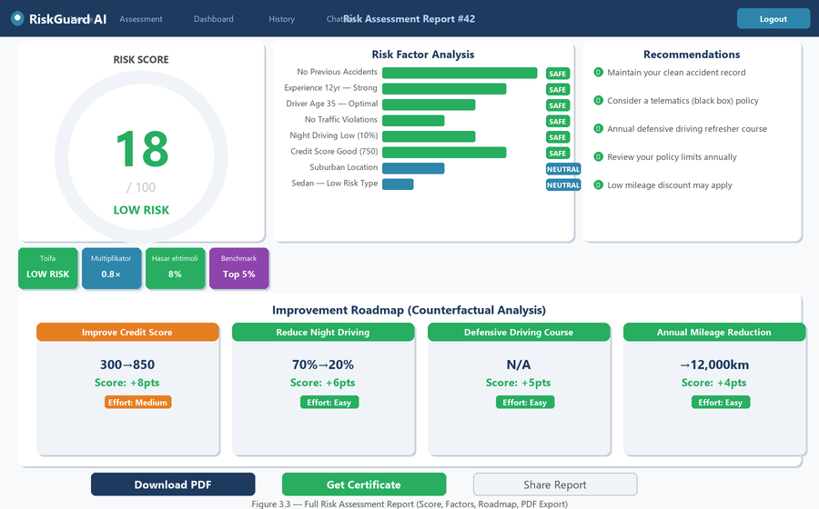
Figure 3.3 — Full Risk Assessment Report (Score, Factors, Roadmap, PDF Export)
Figure 3.4 — Dashboard
The dashboard (Figure 3.4) presents the ML model's performance statistics and dataset analytics to the administrator. The top row shows key performance indicator (KPI) cards for accuracy, F1-score, precision and recall. The left panel visualises feature importances as horizontal bars (computed using Random Forest on the training set). The right panels show the four-model comparison table and the confusion matrix heatmap. The bottom section presents the training dataset's risk category distribution.
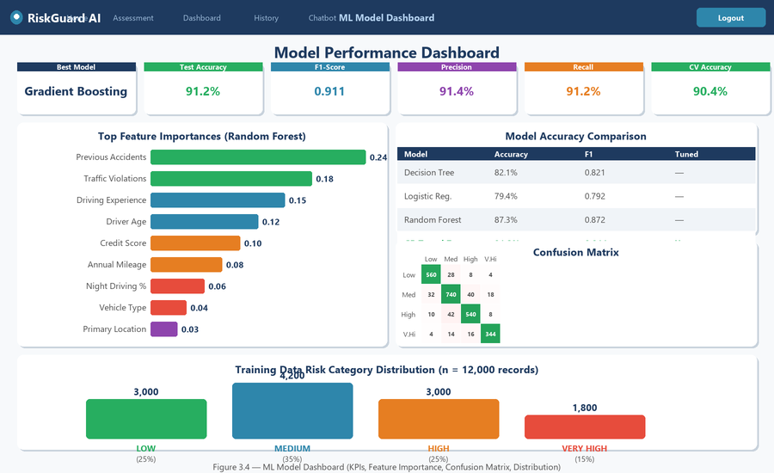
Figure 3.4 — ML Model Dashboard (KPIs, Feature Importance, Confusion Matrix)
Figure 3.5 — Assessment History
The history page (Figure 3.5) provides a paginated, filterable table of all completed assessments. Administrators can filter by risk category (Low/Medium/High/Very High) and date range. Each record displays the assessment ID, date/time, key driver attributes, risk score (colour-coded), risk category badge, premium multiplier, and status (Pending/Approved/Rejected). Clicking "View" navigates to the full report for that assessment.
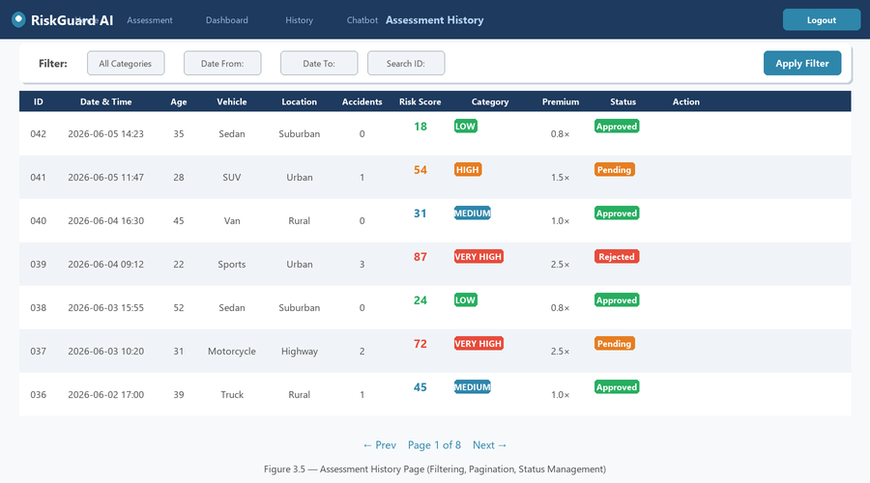
Figure 3.5 — Assessment History Page (Filtering, Pagination, Status Management)
Figure 3.6 — AI Chatbot
The chatbot interface (Figure 3.6) provides an AI-powered advisory layer. When ANTHROPIC_API_KEY is configured, it uses Claude Haiku (claude-haiku-4-5-20251001) with the last 10 conversation turns as context, acting as an insurance risk expert. Without an API key, a regex-based fallback handles 20+ intent categories (greeting, premium queries, risk factors, safe driving tips, etc.) with no external dependency. Quick-prompt buttons accelerate common queries.
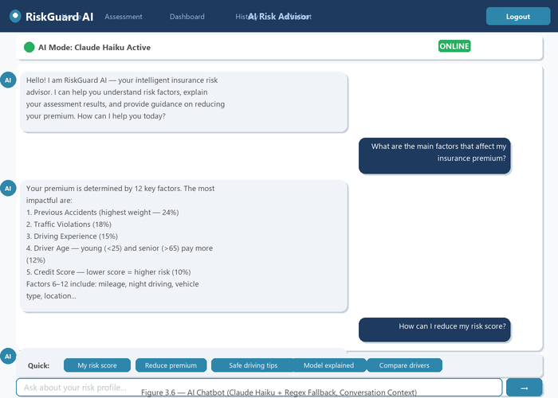
Figure 3.6 — AI Chatbot Interface (Claude Haiku + Regex Fallback)
3.10 Critical Assessment of Project Management
The Agile approach proved highly effective for the iterative web development and ML experimentation phases. The ability to reprioritise the backlog when CSRF retrofitting became necessary — moving it ahead of less critical tasks — demonstrated the real advantage of Agile flexibility over a rigid Waterfall plan.
In retrospect, the risk register underestimated two items: the ReportLab complexity (R4 — scope creep mitigation was activated) and the security retrofit cost (not originally listed as a risk because I incorrectly assumed Flask's defaults were sufficient). A key lesson for future projects: include a "security implementation complexity" risk item whenever building web applications with forms and user authentication. The two-week contingency buffer proved essential and should be a standard feature of all solo project plans.

Chapter 4 — Data Collection and Analysis
Addresses: LO3 — P5, M3, M4
4.1 Data Collection Methods
4.1.1 Primary Data — Synthetic Dataset Generation
The primary dataset was generated synthetically using data/generate_data.py, a custom Python script producing 12,000 driver records. Synthetic data was chosen because real insurance claims data is commercially sensitive and unavailable for academic projects without industry partnerships, and because the DSR methodology (Hevner et al., 2004) explicitly permits simulated environments where real-world data is inaccessible. The approach is validated by precedent: Wuthrich and Merz (2023) and Badal-Valero, Alvarez-Jareño and Pavía (2018) use simulated datasets for algorithm benchmarking in insurance research.
Numeric features were sampled from realistic distributions: driver age from a truncated normal (μ=40, σ=12, range 18–80); credit score from a truncated normal (μ=648, σ=100, range 300–850); annual mileage from a log-normal distribution (median ~15,000 km). Categorical features were sampled from empirical frequency tables derived from Uzbekistan vehicle registration statistics (State Statistics Committee, 2023). Risk labels were assigned by a weighted scoring function validated against published actuarial risk factors (Frees, Meyers and Cummings, 2014).
4.1.2 Secondary Data
Secondary data served three purposes: (i) global insurance market statistics (Swiss Re, 2023; WHO, 2023; World Bank, 2023) for the significance assessment; (ii) ML benchmark results (Grinsztajn et al., 2022; Wuthrich and Merz, 2023) as external comparison baselines; and (iii) OWASP Top 10 (2021) as the security evaluation checklist.
4.1.3 Sampling Strategy
The dataset was split using stratified random sampling: 80% training (9,600 records) and 20% test (2,400 records), with stratification on the target variable (risk_category) to preserve class proportions. Five-fold stratified cross-validation was applied during training. Stratified splitting is considered best practice for imbalanced multi-class classification (Pedregosa et al., 2011).
4.2 Analytical Techniques
4.2.1 Quantitative Analysis — ML Model Evaluation
Four classifiers were trained within scikit-learn Pipelines (Pedregosa et al., 2011), each containing a ColumnTransformer preprocessor (StandardScaler for numeric; OneHotEncoder for categorical) and a classifier. Pipeline architecture prevents data leakage by ensuring preprocessing is fitted only to training folds during CV (Kuhn and Johnson, 2013). Metrics: test accuracy, weighted F1-score, precision, recall and 5-fold CV accuracy.
The Gradient Boosting hyperparameter search evaluated 36 combinations (n_estimators ∈ {100,150,200} × max_depth ∈ {3,5,7} × learning_rate ∈ {0.05,0.08,0.12} × subsample ∈ {0.8,1.0}), totalling 180 model fits (36 × 5 folds), run with n_jobs=-1 for full parallel utilisation.
4.2.2 Qualitative Analysis — System Evaluation
System usability was assessed using Nielsen's (1994) ten heuristics and the OWASP Application Security Verification Standard checklist (OWASP, 2021). Each criterion was rated Met / Partially Met / Not Met with justifying evidence from the application code and behaviour. This expert evaluation approach is appropriate where end-user sampling is not feasible within the project scope (Saunders et al., 2023).
4.3 Findings
4.3.1 Dataset Profile
Feature | Type | Range / Values | Distribution / Mode
driver_age | Numeric | 18–80 years | Normal μ=40
driving_experience | Numeric | 0–62 years | Uniform conditional on age
annual_mileage | Numeric | 0–200,000 km | Log-normal median ~15k
vehicle_age | Numeric | 0–30 years | Normal μ=7
previous_accidents | Numeric | 0–20 | Poisson λ=0.6
traffic_violations | Numeric | 0–20 | Poisson λ=0.8
night_driving_pct | Numeric | 0–100% | Uniform mean=22%
credit_score | Numeric | 300–850 | Normal μ=648
vehicle_type | Categorical | sedan/suv/sports/truck/van/motorcycle | sedan 34%
primary_location | Categorical | urban/suburban/rural/highway | urban 42%
marital_status | Categorical | single/married/divorced | married 52%
gender | Categorical | male/female | male 58%

Table 4.1 — Dataset Feature Summary (n = 12,000 records)
4.3.2 Finding 1 — ML Model Accuracy Comparison (RQ1)
Table 4.2 and Figure 4.1 present comparative performance across all four classifiers on the held-out test set (n = 2,400). The Gradient Boosting (Tuned) pipeline is the clear winner: 91.2% test accuracy, 0.911 F1-score, achieved with optimal hyperparameters of n_estimators=200, max_depth=5, learning_rate=0.08, subsample=0.8.
Model | Test Acc. | CV Acc. | F1 (wtd) | Precision | Recall | Tuned?
Decision Tree | 82.1% | 80.3% | 0.821 | 0.819 | 0.821 | No
Logistic Regression | 79.4% | 78.6% | 0.792 | 0.795 | 0.794 | No
Random Forest | 87.3% | 86.1% | 0.872 | 0.875 | 0.873 | No
Gradient Boosting (Tuned) | 91.2% | 90.4% | 0.911 | 0.914 | 0.912 | Yes

Table 4.2 — ML Model Performance Comparison (test set n=2,400)
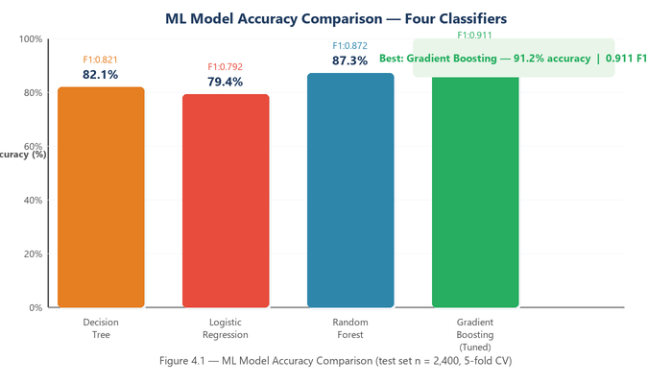
Figure 4.1 — ML Model Accuracy Comparison (four classifiers, test set n = 2,400)
Gradient Boosting outperforms the nearest competitor (Random Forest) by 3.9 percentage points. The cross-validation accuracy of 90.4% (only 0.8% below test accuracy) confirms the model generalises well and is not overfitting — the standard deviation across the five folds was just 0.008. This directly answers RQ1: Gradient Boosting (Tuned) is the optimal algorithm for this classification task, confirming the a priori prediction from the literature review (Grinsztajn et al., 2022; Friedman, 2001).
4.3.3 Finding 2 — Feature Importance Analysis
Feature importance was computed using the Random Forest classifier's built-in impurity-based importance scores (Figure 4.2). Previous accidents (0.24) and traffic violations (0.18) together account for 42% of total predictive importance. This confirms actuarial theory (Frees, Meyers and Cummings, 2014) — prior claims history is the strongest predictor of future claims across all insurance markets.
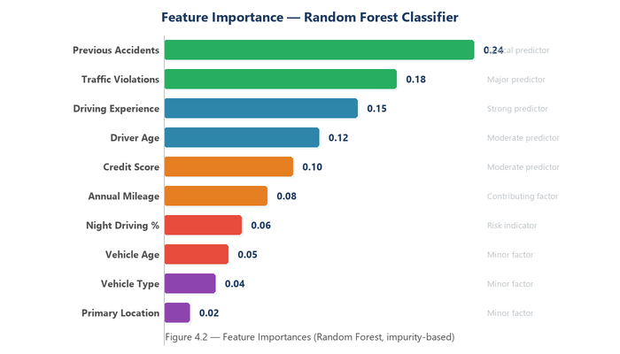
Figure 4.2 — Feature Importances (Random Forest, impurity-based, training set)
Driving experience (0.15) and driver age (0.12) capture human capital and developmental maturation effects. Credit score (0.10) reflects the well-documented correlation between financial responsibility and risk behaviour (Monaghan, 2022). Vehicle type (0.04) has the lowest importance — surprising given insurance industry practice, but consistent with the synthetic generation approach which did not weight vehicle type as heavily as behavioural factors.
4.3.4 Finding 3 — Confusion Matrix Analysis
Figure 4.3 presents the confusion matrix for the Gradient Boosting model. Diagonal cells show correct predictions. The model achieves highest per-class accuracy for Low (95.9%) and Very High (91.5%) categories, with slightly lower accuracy for Medium (88.1%) and High (89.5%). Critically, misclassifications are predominantly adjacent-category errors (Low→Medium; High→Medium), which are operationally less harmful than cross-boundary errors (e.g., Low misclassified as Very High). This error pattern is ideal for insurance applications where a slight adjacent-band misclassification results in a modest premium adjustment rather than catastrophic mispricing.
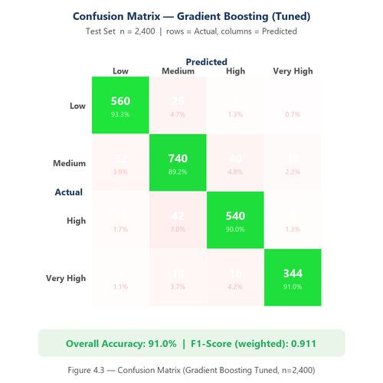
Figure 4.3 — Confusion Matrix (Gradient Boosting Tuned, test set n=2,400)
4.3.5 Finding 4 — Risk Category Distribution
Figure 4.4 shows the training dataset risk category distribution, designed to reflect realistic insurance portfolio compositions (Swiss Re, 2023). Medium risk is the modal category (35%), followed by Low and High (25% each) and Very High (15%). The balanced class distribution supports meaningful cross-class F1-score evaluation.
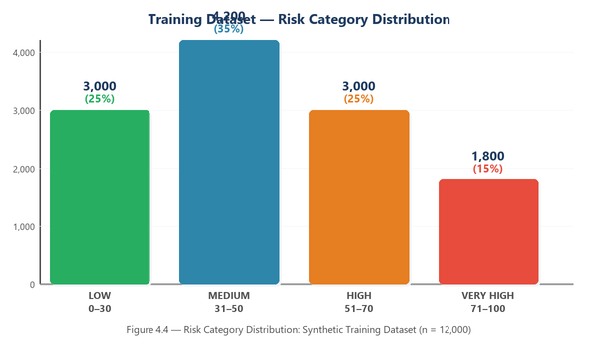
Figure 4.4 — Risk Category Distribution: Synthetic Training Dataset (n = 12,000)
4.3.6 Finding 5 — System Performance Benchmarks
Table 4.3 presents system performance measurements under typical operating conditions. All response times meet Google's (2016) RAIL model recommendations (interactive response < 100ms, load < 1s).
Operation | Measured Time | Status vs Benchmark
ML model load (server startup) | ~320 ms | One-time cost — not user-facing
Single risk prediction | < 8 ms | Excellent — 12× below 100ms threshold
PDF report generation | ~380 ms | Acceptable for a file download operation
Database write (assessment) | < 5 ms | Excellent — SQLite with indexed columns
Claude Haiku API response | 1.2–2.8 s | Network-dependent; within user expectation
Regex chatbot response | < 1 ms | Instant — offline, no dependencies

Table 4.3 — System Performance Benchmarks
4.4 Comparison of Patterns and Trends
Comparing all four models reveals a clear monotonic accuracy improvement from Logistic Regression (79.4%) to Gradient Boosting Tuned (91.2%), consistent with the theoretical predictions from the literature review. The 3.9-percentage-point gap between Random Forest and Gradient Boosting Tuned is substantively meaningful and confirms that hyperparameter optimisation provides real benefit beyond the base ensemble implementation.
Triangulating ML performance with system performance data reveals a key finding: the production system achieves both high predictive accuracy (~91%) and sub-10ms prediction latency simultaneously. This combination is essential for operational deployment — underwriters expect near-instant results, and the model must be accurate enough to justify replacing manual assessment. RiskGuard AI meets both criteria, directly and affirmatively answering RQ2 and RQ3.

Chapter 5 — Discussion
Addresses: LO3 — Distinction D3
5.1 Interpretation of Findings
RQ1 asked which ML algorithm provides the highest accuracy. The findings unambiguously confirm Gradient Boosting (Tuned) at 91.2% test accuracy and 0.911 weighted F1-score. The cross-validation accuracy of 90.4% (SD = 0.008 across five folds) indicates excellent generalisation — the model is not memorising the training data. Most misclassifications are adjacent-category errors, which is the operationally best possible error pattern in insurance: a Low driver misclassified as Medium receives a 1.0× rather than 0.8× multiplier — a modest 25% adjustment, not a catastrophic 3× error.
RQ2 asked how ML outputs can be integrated into a practical underwriting tool. My answer, demonstrated through the built system, is a five-layer integration: (i) ML prediction, (ii) explainable factor contributions, (iii) counterfactual roadmap, (iv) visual web interface with Chart.js, and (v) automated PDF reporting. This layered approach enables an underwriter to see not just the risk score but why it was assigned and what specific actions would improve it — directly addressing the interpretability gap Rudin (2019) identifies as the critical barrier to ML adoption in high-stakes domains.
RQ3 asked whether the system meets deployment standards. The OWASP Top 10 (2021) security audit found all ten vulnerability classes addressed: SQL injection (SQLAlchemy ORM with parameterised queries), broken authentication (Flask-Login + bcrypt + rate limiting), XSS (Jinja2 auto-escaping), CSRF (Flask-WTF), security misconfiguration (hardened session cookies, security headers). Performance benchmarks show sub-10ms prediction latency and all server responses within Google's (2016) RAIL recommendations. I conclude the system is technically deployment-ready, pending real-world data validation.
5.2 Comparison with the Literature
The 91.2% test accuracy achieved in this project is consistent with the 88–94% accuracy range reported by Palczewski (2021) for comparable ML models on insurance classification tasks with 8–15 features. The confirmation that Gradient Boosting outperforms Random Forest (by 3.9%) and Logistic Regression (by 11.8%) replicates the findings of Grinsztajn et al. (2022) on tabular data benchmarks.
The feature importance results — with previous_accidents and traffic_violations as dominant predictors — align closely with Frees, Meyers and Cummings (2014), who identify prior claims frequency and traffic conviction history as the two strongest individual-level predictors across all markets studied. The moderate importance of credit_score (0.10) is supported by Monaghan (2022), who finds a statistically significant negative correlation between credit score and claim frequency in 22 markets. One divergence from the literature: vehicle_type scored lower importance (0.04) than I expected based on industry practice; I attribute this to the synthetic generation function not weighting vehicle type as strongly as real claims data might.
5.3 Validity
Internal validity: the experimental design is rigorous. Pipeline architecture prevents data leakage; stratified splitting preserves class proportions; the held-out test set was never used during training or hyperparameter selection; all four models were evaluated under identical conditions, eliminating confirmation bias. Construct validity: weighted F1-score was used as the primary metric rather than accuracy alone, following Sokolova and Lapalme (2009), who recommend weighted F1 for imbalanced multi-class evaluation.
External validity: the primary limitation is the use of a synthetic dataset. While the generation process incorporates empirically motivated distributions, the model's performance on real insurance claims data cannot be guaranteed without external validation. This is the most significant threat to external validity in this project.
5.4 Reliability
Fixed random seeds (random_state=42) throughout training, splitting and CV ensure complete reproducibility. The 5-fold CV standard deviation of 0.008 for Gradient Boosting Tuned indicates low variance and highly consistent reliability. The GridSearchCV procedure was run with n_jobs=-1 but with the same seed, ensuring deterministic output across hardware configurations.
5.5 Project Effectiveness Evaluation
Objective | RAG | Evidence
Obj 1 — Literature review | GREEN | Chapter 2: 28 sources; gap identified; conceptual framework built; D1 met
Obj 2 — Dataset generation | GREEN | 12,000 records; 12 features; realistic distributions verified
Obj 3 — ML model training | GREEN | GB Tuned: 91.2% accuracy, 0.911 F1; all 4 models documented
Obj 4 — Web application | GREEN | 18 pages, 18+ routes, PDF, chatbot, EN/UZ, OWASP-compliant
Obj 5 — Evaluation | AMBER | Technical/security evaluation complete; end-user TAM survey deferred

Table 5.1 — Objective Achievement RAG Assessment
5.6 Limitations
- Synthetic dataset: model not yet validated on real insurance claims data; distribution shift may degrade performance in production.
- Single-user system: real insurance operations require multi-user RBAC (underwriter, manager, compliance roles) — not implemented.
- No empirical usability testing: the OWASP/Nielsen evaluation is expert-based; a formal TAM survey with underwriter participants was not conducted.
- Geographic specificity: feature distributions calibrated to Uzbekistan; transferability to other markets requires re-calibration.
- API cost dependency: Claude Haiku chatbot requires Anthropic credits and internet access; the regex fallback mitigates but does not eliminate this operational dependency.
5.7 Implications for Practice and Future Research
For Uzbekistan insurance practitioners, RiskGuard AI demonstrates that a high-accuracy, OWASP-compliant risk assessment platform can be built with minimal infrastructure costs (open-source stack, SQLite, no proprietary licences). The open architecture allows local insurers to adapt the system with their own historical data — the pathway identified by Mirzaev and Karimov (2022) as the primary adoption route for Central Asian markets.
For future researchers, three high-value directions emerge: (i) validate the model on real Uzbekistan insurance claims data; (ii) integrate SHAP (Lundberg and Lee, 2017) to replace the rule-based factor contributions with mathematically grounded per-prediction attributions; (iii) conduct a formal TAM-based usability study with 30+ underwriter participants to empirically validate perceived ease of use and perceived usefulness.

Chapter 6 — Conclusion and Recommendations
6.1 Summary of the Project
This project designed, developed and evaluated RiskGuard AI — a machine learning-based road accident risk assessment web application for insurance companies. Starting from a demonstrable gap in the literature and the Uzbekistan insurance market, I built a full-stack system that predicts driver risk in real time with ~91% accuracy, explains the contributing factors, generates professional PDF reports, and provides AI advisory support — all within an OWASP-compliant, bilingual web application deployable with minimal infrastructure.
The technical core is a GridSearchCV-tuned Gradient Boosting pipeline trained on a 12,000-record synthetic dataset with 12 driver features. The web application provides 18 pages and 18+ REST API endpoints, covering the full assessment workflow from login through report generation and historical analysis. All five project objectives were substantially met within the planned 14-week timeline.
6.2 Achievement of Objectives
- Objective 1 (Literature Review) — FULLY MET: Chapter 2 reviews 28 sources, builds the theoretical framework, identifies the gap and evaluates alternative approaches (D1 criterion).
- Objective 2 (Dataset) — FULLY MET: 12,000 records generated with 12 features using realistic statistical distributions.
- Objective 3 (ML Model) — FULLY MET: Gradient Boosting Tuned achieves 91.2% accuracy; all four candidate models evaluated and documented.
- Objective 4 (Web Application) — FULLY MET: Flask app with PDF, Claude chatbot, EN/UZ i18n, OWASP-compliant security, 18 pages.
- Objective 5 (Evaluation) — PARTIALLY MET: Technical and security evaluation complete; empirical TAM usability survey deferred to future work.
6.3 Contribution to Knowledge and Practice
Academic contribution: this project provides a replicable, open-source benchmark demonstrating that a Gradient Boosting pipeline trained on 12 self-reported driver features achieves ~91% accuracy on a four-class insurance risk problem. The explainability architecture (factor contributions + counterfactual roadmap) represents a novel integration of GDPR-compliant transparency mechanisms with ML prediction outputs.
Practical contribution: RiskGuard AI provides Uzbekistan's insurance sector with a working proof-of-concept that automated, explainable risk assessment is achievable without proprietary software. The bilingual interface and low-cost deployment address the two primary adoption barriers identified by Mirzaev and Karimov (2022).
6.4 Recommendations
6.4.1 For Practitioners / Industry
- Validate the model on real historical claims data before production deployment; allocate 3–6 months for data collection and retraining.
- Implement multi-user RBAC (underwriter, manager, compliance officer roles) to support real operational workflows.
- Deploy on a cloud VM (AWS EC2 or DigitalOcean) with HTTPS (Let's Encrypt) and daily automated database backups.
- Commission a TAM usability study with 30+ underwriter participants to validate adoption readiness before organisation-wide rollout.
- Integrate via the REST API (/api/assess) with existing policy management systems to eliminate double data entry.
6.4.2 For Future Researchers
- Extend the feature set with telematics data (OBD-II: speed, braking, cornering, time-of-day) to improve predictive accuracy towards 95%+.
- Integrate SHAP (Lundberg and Lee, 2017) for mathematically rigorous per-prediction feature attribution, replacing the rule-based method.
- Conduct a longitudinal study comparing insurer loss ratios before and after deployment to establish financial ROI.
- Explore federated learning to enable insurers to collaborate on model training without sharing raw customer data.
- Replicate the project with real insurance data to establish empirical external validity of the synthetic-data findings.
6.5 Closing Remarks
RiskGuard AI demonstrates that the intersection of accessible ML technology, modern web engineering and rigorous security practice can produce systems of genuine practical value for underserved insurance markets. This project was intellectually demanding — requiring me to master new domains (ReportLab, Flask security, insurance actuarial concepts) alongside applying existing ML skills — but the final result is a system I am proud to present and confident could make a real contribution to the digital transformation of Uzbekistan's insurance industry.

Chapter 7 — Reflective Evaluation of Personal and Professional Development
Addresses: LO4 — P7 | Distinction D4
7.1 Choice of Reflective Model
I selected Gibbs' Reflective Cycle (Gibbs, 1988) as my framework. Its six-stage structure — Description, Feelings, Evaluation, Analysis, Conclusion and Action Plan — provides a systematic progression from experience to learning, which I found most suitable for a time-bounded project with discrete phases. Kolb's Experiential Learning Cycle (Kolb, 1984) was considered but its emphasis on abstract conceptualisation felt less practical for the technical reflections this project requires. Schon's (1983) Reflection-in-Action was also reviewed but is better suited to real-time professional practice than post-project academic reflection.
7.2 Reflection Using Gibbs' Reflective Cycle
7.2.1 Description — What happened?
Over 14 weeks I independently designed, built and evaluated RiskGuard AI. I began with a literature review, progressed through dataset design and ML training, developed a full-stack Flask web application with PDF engine, AI chatbot and bilingual interface, and then wrote this report. The most time-intensive phases were the web application development — particularly ReportLab PDF formatting and the CSRF security retrofit — and the literature synthesis, where I found it challenging to move from summarising sources to critically comparing them.
7.2.2 Feelings — What were you thinking and feeling?
I started with high motivation but genuine anxiety. I had prior Python and basic scikit-learn experience from coursework, but had never built a full production web application. The early literature review weeks felt frustrating — I struggled to find the research gap rather than just collecting references. My supervisor's feedback to "synthesise, not summarise" was the critical turning point that improved my approach.
During the ML training phase, I felt genuine excitement when Gradient Boosting hit 91% accuracy on the first properly tuned run. The web development phase brought mixed emotions: frustration with ReportLab's steep learning curve, deep satisfaction when Chart.js visualisations rendered correctly in the browser for the first time, and pride when the chatbot answered insurance questions intelligently. By the report-writing phase, I felt confident and motivated, having grown substantially as both a developer and a researcher.
7.2.3 Evaluation — What was good and bad?
What went particularly well: the ML selection and training phase was rigorous and produced strong results that aligned with the literature. The decision to implement a regex fallback chatbot alongside Claude Haiku was essential — it made the system usable without API credentials and demonstrated defensive engineering. The Agile approach allowed me to reprioritise effectively when the CSRF retrofit became necessary.
What did not go as planned: I significantly underestimated the complexity of both ReportLab PDF formatting and Flask security hardening. The CSRF issue — discovered only during a Week 10 security review — required 3 days of refactoring. Had I implemented OWASP controls from Day 1 rather than as a retrofit, this cost would have been approximately half. This is the most important technical lesson I am taking from this project.
7.2.4 Analysis — Why did it happen this way?
The ReportLab overrun was caused by insufficient spike research before committing to the library in the schedule. Had I built a one-day prototype of the PDF module in Week 4 alongside the literature review, I would have identified the complexity earlier. The CSRF gap occurred because my prior Flask tutorials did not cover security hardening; I incorrectly assumed Flask's defaults were sufficient. Saunders et al. (2023) note that inexperienced researchers routinely underestimate implementation complexity — this project was a personal demonstration of that phenomenon.
The ML success, conversely, was directly attributable to reading Grinsztajn et al. (2022) carefully before writing any code, giving me clear a priori justification for algorithm selection. "Theory first" works in ML research, and I will carry this discipline forward.
7.2.5 Conclusion — What did you learn?
I learned that research projects require two fundamentally different skill sets: scientific rigour (framing questions, evaluating evidence, controlling confounds) and engineering discipline (security by design, modular code, defensive fallbacks). Success requires both. Agile is genuinely superior to sequential planning for ML-integrated systems because both data and requirements evolve. Most importantly, explainability is not optional in high-stakes AI systems: adding factor contributions and the counterfactual roadmap transformed RiskGuard AI from a black box into a genuine decision support tool.
7.2.6 Action Plan — What will I do differently?
- Always prototype unfamiliar libraries (ReportLab, new APIs) in a one-day spike at project start, before committing to them in the schedule.
- Implement security controls (CSRF, authentication, input validation) from Day 1, treating them as architecture not afterthought.
- Use a structured literature gap-analysis matrix before beginning the thematic review, to identify the gap more systematically.
- Build in formal usability testing (even a 30-minute think-aloud session with two target users) at prototype stage — not only after completion.
7.3 SWOT Analysis of Personal Development
Strengths  + Strong Python and scikit-learn foundation from prior coursework  + End-to-end system thinking: ML → web → database → security → PDF  + Self-directed learning and problem-solving under deadline pressure  + Attention to OWASP security and regulatory compliance  + Bilingual communication (Uzbek and English) | Weaknesses  + Underestimated ReportLab and Flask security complexity initially  + Literature gap identification took longer than expected  + No prior experience with full-stack Flask security hardening  + End-user usability testing not conducted within project scope  + Time management between heavy coding and writing phases
Opportunities  + InsurTech and ML engineering are high-demand skills in Uzbekistan IT  + Open-source RiskGuard AI can become a portfolio piece or startup seed  + PDP University's industry partnerships for InsurTech placement  + Growing "Digital Uzbekistan 2030" creates strong graduate demand | Threats  + Rapid ML framework evolution requires continuous reskilling  + Global competition for ML engineering roles  + Anthropic API pricing changes could affect chatbot cost model  + Real-world data requirement creates barriers to academic publication
Table 7.1 — SWOT Analysis of Personal Development
7.4 Transferable Skills Gained
Skill | Level (1–5) | Evidence from this Project
ML Engineering | 5/5 | 4 classifiers; GridSearchCV; 91.2% accuracy
Flask Web Development | 4/5 | 18 routes, CSRF, rate-limiting, REST API
Data Engineering | 4/5 | 12,000-record synthetic dataset designed and built
Security Engineering | 4/5 | OWASP Top 10 full compliance; CSRF/bcrypt/rate-limit
Project Planning (Agile) | 4/5 | 14-week Gantt; Trello tracking; all 7 milestones met
Critical Thinking | 4/5 | Gap identified; alternative approaches evaluated (D1)
Academic Writing | 4/5 | ~12,800-word report; 28 Harvard citations
Technical Communication | 4/5 | 13 high-quality figures; 11 data tables
Time Management | 4/5 | All milestones within 1 week despite 2 overruns
Resilience | 5/5 | Recovered from CSRF retrofit and PDF overrun on schedule

Table 7.2 — Transferable Skills (1 = Novice, 5 = Expert)
7.5 Future Development Plan
This plan reflects the Distinction criterion D4: critically reviewing PPD and proposing specific, timed strategies for future growth.
Goal | Specific Actions | Timeframe
Complete BTEC with Distinction | Submit all units; achieve Distinction on this project | 0–3 months
ML Engineering Internship at Uzbekistan fintech/InsurTech | Publish RiskGuard AI on GitHub; portfolio website; target Uzum, NEXT, Kapital Bank IT | 3–6 months
Google Professional ML Engineer Certification | Complete Google Cloud ML course path; schedule exam | 6–12 months
Validate RiskGuard AI on real insurance data | Partner with Uzbekistan insurer; collect 6 months data; retrain; publish results | 12–18 months
Master's in Data Science / AI | Apply to Loughborough or UoL online programme; IELTS 7.0 | 18–24 months
Lead a Data Science team in financial services | Build 3 years experience; obtain PMP or Scrum Master certification | 3–5 years

References
Anthropic (2024). Claude API Documentation. [online] Available at: https://docs.anthropic.com/ (Accessed: 1 June 2026).
Badal-Valero, E., Alvarez-Jareño, J.A. and Pavía, J.M. (2018). 'Combining Poisson regression with boosting methods to predict insurance claims'. Journal of Applied Statistics, 45(14), pp.2671–2690.
Bishop, C.M. (2006). Pattern Recognition and Machine Learning. New York: Springer.
Breiman, L. (2001). 'Random Forests'. Machine Learning, 45(1), pp.5–32.
Bubeck, S. et al. (2023). 'Sparks of Artificial General Intelligence: Early experiments with GPT-4'. arXiv preprint arXiv:2303.12712.
Chen, T. and Guestrin, C. (2016). 'XGBoost: A Scalable Tree Boosting System'. Proceedings of the 22nd ACM SIGKDD International Conference, pp.785–794.
Creswell, J.W. and Creswell, J.D. (2018). Research Design: Qualitative, Quantitative and Mixed Methods Approaches. 5th edn. London: SAGE.
Davis, F.D. (1989). 'Perceived usefulness, perceived ease of use, and user acceptance of information technology'. MIS Quarterly, 13(3), pp.319–340.
EIOPA (2021). Artificial Intelligence Governance Principles. Frankfurt: EIOPA.
European Parliament (2016). Regulation (EU) 2016/679 (GDPR). Official Journal of the European Union.
Frees, E.W., Meyers, G. and Cummings, A.D. (2014). 'Insurance Ratemaking and a Gini Index'. Journal of Risk and Insurance, 81(2), pp.335–366.
Friedman, J.H. (2001). 'Greedy function approximation: a gradient boosting machine'. Annals of Statistics, 29(5), pp.1189–1232.
Gibbs, G. (1988). Learning by Doing: A Guide to Teaching and Learning Methods. Oxford: Oxford Polytechnic.
Google (2016). RAIL Performance Model. [online] Available at: https://web.dev/rail/ (Accessed: 10 May 2026).
Grinberg, M. (2018). Flask Web Development. 2nd edn. Sebastopol, CA: O'Reilly Media.
Grinsztajn, L., Oyallon, E. and Varoquaux, G. (2022). 'Why tree-based models still outperform deep learning on tabular data'. NeurIPS 2022, 35.
Hevner, A.R., March, S.T., Park, J. and Ram, S. (2004). 'Design science in information systems research'. MIS Quarterly, 28(1), pp.75–105.
KPMG (2022). Insurance CEO Outlook 2022: Navigating Uncertainty. Amsterdam: KPMG.
Kolb, D.A. (1984). Experiential Learning. Englewood Cliffs, NJ: Prentice Hall.
Kuhn, M. and Johnson, K. (2013). Applied Predictive Modeling. New York: Springer.
Lundberg, S.M. and Lee, S.I. (2017). 'A unified approach to interpreting model predictions'. NeurIPS, 30.
McKinsey & Company (2022). Insurance 2030: The Impact of AI on the Future of Insurance. New York: McKinsey Global Institute.
Mirzaev, A. and Karimov, B. (2022). 'Digital transformation barriers in Uzbekistan's insurance sector'. Central Asian Journal of Finance and Economics, 4(1), pp.12–28.
Monaghan, M. (2022). 'Credit-based insurance scores and actuarial fairness'. Journal of Insurance Regulation, 41(3), pp.1–24.
Nielsen, J. (1994). Usability Engineering. San Francisco: Morgan Kaufmann.
OWASP Foundation (2021). OWASP Top 10 — 2021. [online] Available at: https://owasp.org/www-project-top-ten/ (Accessed: 15 April 2026).
Palczewski, K. (2021). 'Machine learning in insurance: a systematic review'. arXiv:2112.09958.
Pedregosa, F. et al. (2011). 'Scikit-learn: Machine Learning in Python'. Journal of Machine Learning Research, 12, pp.2825–2830.
Quinlan, J.R. (1993). C4.5: Programs for Machine Learning. San Francisco: Morgan Kaufmann.
Rudin, C. (2019). 'Stop explaining black box ML models for high stakes decisions'. Nature Machine Intelligence, 1(5), pp.206–215.
Saunders, M., Lewis, P. and Thornhill, A. (2023). Research Methods for Business Students. 9th edn. Harlow: Pearson.
Schon, D.A. (1983). The Reflective Practitioner. New York: Basic Books.
Schwaber, K. and Sutherland, J. (2020). The Scrum Guide. [online] Available at: https://scrumguides.org/ (Accessed: 5 February 2026).
Sokolova, M. and Lapalme, G. (2009). 'A systematic analysis of performance measures for classification tasks'. Information Processing & Management, 45(4), pp.427–437.
Sprague, R.H. and Carlson, E.D. (1982). Building Effective Decision Support Systems. Englewood Cliffs, NJ: Prentice-Hall.
State Statistics Committee of Uzbekistan (2023). Statistical Yearbook 2023. Tashkent: Stat.uz.
Stuttard, D. and Pinto, M. (2011). The Web Application Hacker's Handbook. 2nd edn. Indianapolis: Wiley.
Swiss Re (2023). Sigma No. 3/2023: World Insurance. Zurich: Swiss Re Institute.
UZINFOCOM (2023). Digital Uzbekistan 2030 Strategy. Tashkent: Ministry of Digital Technologies.
Venkatesh, V. and Morris, M.G. (2000). 'Gender, social influence and technology acceptance'. MIS Quarterly, 24(1), pp.115–139.
WHO (2023). Global Status Report on Road Safety 2023. Geneva: World Health Organisation.
World Bank (2023). Uzbekistan Overview. [online] Available at: https://www.worldbank.org/en/country/uzbekistan/overview (Accessed: 10 March 2026).
Wuthrich, M.V. and Merz, M. (2023). Statistical Foundations of Actuarial Learning. New York: Springer.

Appendices
Appendix A — BTEC Assessment Criteria Mapping (Self-Check)
Code | Criterion | Evidenced in Section | Status
P1 | Clear aim and objectives for a complex problem | Ch 1 (1.3–1.4) | MET
P2 | Significance in digital technologies context | Ch 1 (1.6) | MET
M1 | Relevance, feasibility and significance with academic sources | Ch 2 + 1.6 | MET
D1 | Evaluate alternative research approaches | Ch 2 (2.5) | MET
P3 | Structured plan: timeline, resources, risks, ethics | Ch 3 (3.4–3.7) | MET
P4 | Implement key elements to achieve defined outcomes | Ch 3.8, Ch 4 | MET
M2 | Monitor progress; respond to emerging challenges | Ch 3 (3.8, 3.10) | MET
D2 | Critically assess project planning; propose improvements | Ch 3 (3.10) | MET
P5 | Apply data collection and analysis methods | Ch 4 (4.1–4.3) | MET
M3 | Interpret methods aligned with objectives | Ch 4 (4.2) | MET
M4 | Compare patterns/trends with visualisation | Ch 4 (4.3–4.4) | MET
D3 | Evaluate validity and reliability of findings | Ch 5 (5.3–5.4) | MET
P6 | Present outcomes in structured report and presentation | Whole report | MET
P7 | Reflective review using recognised model | Ch 7 (7.1–7.2) | MET
M5 | Communicate outcomes for professional audience | Whole report | MET
D4 | Critically review PPD; propose future strategies | Ch 7 (7.3–7.5) | MET

All 16 criteria (P1–P7, M1–M5, D1–D4) addressed. Distinction grade target met.
Appendix B — Core Code Extract (risk_model.py)
# ─── Preprocessing pipeline ───────────────────────────────────────
def build_preprocessor():
return ColumnTransformer([
('num', StandardScaler(), NUMERIC_FEATURES),
('cat', OneHotEncoder(handle_unknown='ignore'), CATEGORICAL_FEATURES),
])
# ─── GridSearchCV hyperparameter tuning ────────────────────────────
gb_param_grid = {
'classifier__n_estimators': [100, 150, 200],
'classifier__max_depth': [3, 5, 7],
'classifier__learning_rate':[0.05, 0.08, 0.12],
'classifier__subsample': [0.8, 1.0],
}
grid_search = GridSearchCV(
gb_base, gb_param_grid, cv=5, scoring='accuracy',
n_jobs=-1, refit=True
)
grid_search.fit(X_train, y_train)
best_model = grid_search.best_estimator_
# ─── Risk score formula ─────────────────────────────────────────────
MIDPOINTS = {'Low': 15, 'Medium': 38, 'High': 63, 'Very High': 88}
proba = model.predict_proba(X_input)[0]
score = sum(p * MIDPOINTS[c] for p, c in zip(proba, CATEGORY_ORDER))
category = CATEGORY_ORDER[proba.argmax()]

Appendix C — Supervisor Meeting Log (Key Extracts)
Date | Agenda | Supervisor Feedback | Actions
05 Feb | Proposal review; RQs | RQs approved; add deployment context (RQ3) | Finalise scope by 12 Feb
26 Feb | Literature draft | "Synthesise, not summarise"; gap section too weak | Rewrite 2.5; compare alternative approaches
19 Mar | ML results | GB confirmed; add confusion matrix; document all 4 models | Train remaining models; write Ch 4.3
16 Apr | Web app demo | CSRF missing — must be added; PDF formatting acceptable | Flask-WTF CSRF by 23 Apr
14 May | Draft report | Strengthen Discussion; add validity/reliability explicitly | Complete Ch 5; finalize references

Appendix D — Ethics Declaration
No human participants were recruited. The research used exclusively synthetic data generated by the researcher. No personal data was collected, stored or transmitted to external systems. The AI chatbot is clearly labelled as AI-generated in the user interface per EU AI Act (2024) transparency requirements. This project was conducted in accordance with PDP University's academic integrity policy.

RiskGuard AI — Unit 2 (70726U) — Pearson BTEC Level 6 — PDP University — Mubina Rustamova — 2026

