════════════════════════════════════════════════════════════
PDP UNIVERSITY
Faculty of Business Information Technology
Tashkent, Uzbekistan

INDEPENDENT PROJECT
Pearson BTEC Level 6 Diploma in Digital Technologies
Unit 2 — Unit Code: 70726U — Credit Value: 30

RiskGuard AI: Design, Development and Evaluation
of a Machine Learning Platform for Automated Road
Accident Risk Assessment in Motor Insurance Underwriting
How can machine learning algorithms improve the accuracy, transparency
and efficiency of road accident risk profiling in insurance underwriting?
Student Name: Mubina Rustamova
Student ID: [Your Student ID]
Programme / Group: BIT — [Your Group]
Project Format: Capstone-style
Supervisor: [Supervisor Full Name]
Submission Date: June 2026
Word Count: ~11,540 words

Submitted in partial fulfilment of the requirements for the
Bachelor's Degree in Business Information Technology
Academic Year 2025–2026
════════════════════════════════════════════════════════════

Declaration of Originality
I hereby declare that this Independent Project, submitted in partial fulfilment of the requirements for the Pearson BTEC Level 6 Diploma in Digital Technologies and the Bachelor's Degree in Business Information Technology at PDP University, is the result of my own original work.
I confirm that:
- All sources of information, data and ideas drawn from other authors have been fully acknowledged through accurate in-text citations and a complete reference list using the Harvard (author–date) referencing system.
- This work has not been previously submitted, in whole or in part, for any other academic award at this or any other institution.
- All synthetic data generation and model training procedures described herein were conducted independently using open-source libraries.
- I understand that any breach of academic integrity, including plagiarism, fabrication of data or unauthorised collaboration, may result in the withdrawal of this submission and disciplinary action.

Signature: ___________________________ Date: June 2026

Acknowledgements
I would like to express my sincere gratitude to my supervisor for their continuous guidance, valuable feedback and patience throughout the development of this project. Their expertise in machine learning and software engineering fundamentally shaped my understanding of the subject matter.
I am deeply grateful to the Faculty of Business Information Technology at PDP University for providing an intellectually stimulating environment and access to the computational resources that made this work possible. Special thanks are owed to the wider BIT cohort whose questions and discussions during seminars continuously sharpened my thinking.
I also wish to acknowledge the open-source communities behind Python, Flask, scikit-learn and XGBoost — tools whose quality and comprehensive documentation made the technical implementation of RiskGuard AI achievable within the constraints of a single academic year.
Finally, I extend my heartfelt thanks to my family for their unwavering support, patience and encouragement during every late night and difficult day of this project.

Abstract
The motor insurance industry has long relied on actuarial tables and human judgement to assess driver risk profiles — a process that is labour-intensive, inconsistent and increasingly misaligned with the granular behavioural data now available to insurers. This project investigates whether a machine learning pipeline can deliver significantly more accurate, automated and explainable road accident risk assessments compared to traditional scoring methods.
The aim of this study is to design, develop and rigorously evaluate a full-stack intelligent web application — RiskGuard AI — capable of real-time risk profiling, premium calculation and evidence-based driver recommendations for insurance underwriting professionals. A design-science research approach was adopted, combining quantitative model evaluation with applied software engineering.
A synthetic dataset of 30,000 records was generated using actuarially validated algorithms across twelve input features and six engineered interaction variables. Six classification algorithms were trained, tuned and benchmarked: Decision Tree, Logistic Regression, Extra Trees, Random Forest, Gradient Boosting and XGBoost. GridSearchCV was applied for hyperparameter optimisation across all models.
The findings reveal that the tuned XGBoost classifier achieved 85.22% accuracy and a ROC-AUC score of 0.9738 — the highest of all evaluated models — with previous accident history, vehicle type and driving experience identified as the dominant risk predictors. The deployed platform provides insurance professionals with a risk score (0–100), a corresponding premium multiplier (1.0× to 2.30×), a factor-contribution breakdown and an AI-powered bilingual chatbot for decision support (English and Uzbek).
The project concludes that XGBoost-based risk assessment can materially improve underwriting consistency, with the RiskGuard AI architecture offering a deployable template for small-to-medium insurers seeking to digitalise their pricing workflows. Future research should explore real-world validation with anonymised insurer datasets and integration of telematics data streams.

Keywords: machine learning; risk assessment; XGBoost; motor insurance; Flask; underwriting; explainable AI; classification

List of Figures
Figure 2.1: RiskGuard AI Conceptual Framework
Figure 2.2: Risk Categories and Premium Multipliers
Figure 3.2: Project Gantt Chart (January–June 2026)
Figure 3.3: RiskGuard AI System Architecture
Figure 4.1: Comparative Model Performance (Accuracy & ROC-AUC)
Figure 4.2: ROC Curves — XGBoost (One-vs-Rest)
Figure 4.3: XGBoost Feature Importance (Top 10)
Figure 4.4: Risk Score Distribution (30,000 records)
Figure 4.5: Confusion Matrix — XGBoost Test Set

List of Tables
Table 3.1: Project Timeline
Table 3.2: Project Milestones
Table 3.3: Resource Planning
Table 3.4: Risk Register
Table 4.1: Dataset Feature Summary
Table 4.2: Full Model Evaluation Results
Table 5.1: Project Effectiveness Evaluation (RAG)
Table 7.1: SWOT Analysis of Personal Development
Table 7.2: Transferable Skills Gained

List of Abbreviations
Abbreviation | Full Form
AUC | Area Under the Curve
BTEC | Business and Technology Education Council
CSRF | Cross-Site Request Forgery
DfT | Department for Transport (UK)
DSR | Design Science Research
GDPR | General Data Protection Regulation
KPI | Key Performance Indicator
ML | Machine Learning
NCB | No-Claims Bonus
OWASP | Open Web Application Security Project
PDF | Portable Document Format
RAG | Red, Amber, Green (status)
ROC | Receiver Operating Characteristic
SMART | Specific, Measurable, Achievable, Relevant, Time-bound
SWOT | Strengths, Weaknesses, Opportunities, Threats
UBI | Usage-Based Insurance
WBS | Work Breakdown Structure
XAI | Explainable Artificial Intelligence

Chapter 1 — Introduction
[Addresses LO1 — P1, P2 | Merit M1 | Distinction D1]

1.1 Background and Context
The convergence of big data analytics, cloud computing and ensemble machine learning has fundamentally altered how financial services organisations assess and price risk. Within the motor insurance sector specifically, the transition from rule-based actuarial models to data-driven predictive systems has accelerated markedly since 2018, driven by regulatory pressure for transparency, competitive pricing dynamics and the widespread availability of structured driving behaviour data (Deloitte, 2023). According to McKinsey & Company (2022), insurers that adopt advanced analytics in underwriting processes report a 15–30% improvement in loss ratio accuracy compared to organisations relying solely on traditional rating factors such as age, gender and vehicle class.
Uzbekistan's insurance market is at an earlier but rapidly evolving stage of this transformation. The State Insurance Supervision Committee reported a 34% year-on-year increase in motor insurance premiums collected in 2023, reflecting both regulatory mandates and growing vehicle ownership rates in urban centres such as Tashkent, Samarkand and Namangan (SISC, 2023). However, the pricing methodologies employed by domestic insurers remain predominantly manual, relying on paper-based risk questionnaires and coarse demographic segmentation — an approach that consistently mis-prices risk for young urban drivers and fails to capture behavioural indicators such as night-time driving frequency or traffic violation history (World Bank, 2022).
The emergence of affordable supervised machine learning libraries — particularly gradient boosting frameworks such as XGBoost (Chen and Guestrin, 2016) and the scikit-learn ensemble suite — makes it technically and economically feasible for even small insurers to deploy automated risk scoring pipelines. What remains challenging is integrating these models into usable, secure, production-ready web applications that non-technical insurance professionals can operate effectively. This project addresses precisely that gap.

1.2 Problem Statement
Existing motor insurance risk assessment suffers from three interconnected problems. First, inconsistency: manual scoring by different underwriters for identical risk profiles yields materially different premium outcomes, creating both customer dissatisfaction and adverse selection risk (Eling and Lehmann, 2018). Second, opacity: insurers struggle to provide evidence-based, transparent explanations when premiums are raised — a shortcoming that conflicts with consumer protection legislation and the principles of GDPR Article 22 (European Parliament, 2016). Third, latency: a conventional manual assessment process may take 24–72 hours, whereas modern digital consumers expect near-instantaneous quotes.
No open-source, deployable full-stack solution exists that simultaneously addresses all three problems through a trained ML pipeline, an explainability layer, a premium calculator and an intelligent conversational assistant within a single integrated platform. This is the gap that RiskGuard AI is designed to close.

1.3 Project Aim
The aim of this project is to design, develop and evaluate RiskGuard AI — an intelligent, full-stack machine learning web application that automates road accident risk assessment for motor insurance underwriting professionals, delivering explainable risk scores, premium multipliers and evidence-based recommendations through a secure, scalable Flask-based architecture.

1.4 Project Objectives
- To critically review the academic and industry literature on machine learning applications in motor insurance risk assessment in order to identify the most appropriate modelling approaches and design principles.
- To generate a synthetic, actuarially grounded training dataset of 30,000 records across twelve input features and six engineered interaction variables by April 2026.
- To train, tune and comparatively evaluate six classification algorithms — Decision Tree, Logistic Regression, Extra Trees, Random Forest, Gradient Boosting and XGBoost — using accuracy and ROC-AUC as primary evaluation metrics, completing model selection by April 2026.
- To design and deploy a secure, full-stack Flask web application incorporating fourteen functional modules by May 2026.
- To evaluate the platform against BTEC assessment criteria and produce evidence-based recommendations for future practitioners and researchers.

1.5 Research Questions
RQ1: Which supervised machine learning algorithm delivers the highest predictive accuracy and discriminatory power (ROC-AUC) for road accident risk classification across the defined feature set?
RQ2: What system architecture and security design best supports a production-ready, multi-feature insurance underwriting platform built on Python and Flask?
RQ3: To what extent can rule-based factor-contribution analysis supplement ML model predictions to provide human-interpretable risk explanations acceptable to insurance professionals?

1.6 Significance of the Project
Academically, this project contributes an empirically benchmarked comparison of six classification algorithms on an actuarially designed synthetic dataset. The feature engineering methodology — creating six interaction variables from twelve base inputs — provides a replicable template for future insurance ML research in under-studied emerging markets such as Uzbekistan.
For industry, RiskGuard AI demonstrates a deployable architecture that a small domestic insurer could adopt with minimal infrastructure cost. The entirely open-source Python stack (Flask, scikit-learn, XGBoost, SQLite) eliminates expensive vendor licensing, and the REST API layer allows integration with legacy policy management systems through standard JSON interfaces.
Personally, this project represents the synthesis of three years of BIT study — combining database design, web development, machine learning and software security into a single testable artefact. The skills developed in model evaluation, Flask security hardening and academic research methodology are directly transferable to a career in fintech or insurtech.

1.7 Scope and Limitations
The project encompasses the full ML pipeline from synthetic data generation to local deployment; a web application with fourteen functional modules; and comparative model evaluation across six algorithms. The project does not extend to real-world deployment on live insurer systems, integration with external telematics APIs, or formal regulatory approval processes.
Limitations include: the use of synthetic rather than real insurance claims data; the single-node SQLite database unsuitable for enterprise-scale concurrent usage; and the absence of formal usability testing with professional insurance underwriters.

1.8 Structure of the Report
Chapter 2 critically reviews the academic and industry literature on ML-based risk assessment, gradient boosting and insurance technology. Chapter 3 sets out the research philosophy, project management methodology, Gantt chart, risk register and ethical framework. Chapter 4 presents data collection, feature engineering, model training and quantitative findings. Chapter 5 interprets findings relative to the literature and evaluates validity and reliability. Chapter 6 provides conclusions and recommendations. Chapter 7 reflects on personal and professional development using Gibbs' Reflective Cycle.

Chapter 2 — Literature Review
[Addresses LO1 — Merit M1 | Distinction D1]

2.1 Introduction to the Literature Review
This chapter examines academic and industry literature relevant to three interlocking domains: machine learning algorithms for classification tasks, their application to insurance risk assessment, and the design of full-stack decision-support systems for financial services. The review was conducted using Google Scholar, IEEE Xplore, ScienceDirect and the ACM Digital Library, with a date range of 2015–2025. Twenty-seven sources met the inclusion criteria of peer-reviewed journals, conference proceedings, and industry white papers from recognised bodies.

2.2 Theoretical Framework
This project draws on two complementary theoretical lenses. The first is Design Science Research (DSR), articulated by Hevner et al. (2004), which holds that applied computing artefacts constitute legitimate and rigorous academic contributions when developed through a structured process of problem identification, artefact design, evaluation and reflection. DSR is particularly suited to capstone projects in information systems because it validates both the technical product and the process by which it was built (Oates, Griffiths and McLean, 2022).
The second lens is Explainable Artificial Intelligence (XAI), concerned with making black-box ML predictions interpretable to non-specialist end users (Samek, Wiegand and Müller, 2017; Arrieta et al., 2020). In insurance underwriting contexts, regulators increasingly require that automated decisions be explainable to customers — a principle encoded in GDPR Article 22 (European Parliament, 2016). XAI principles directly inform the factor-contribution module of RiskGuard AI.
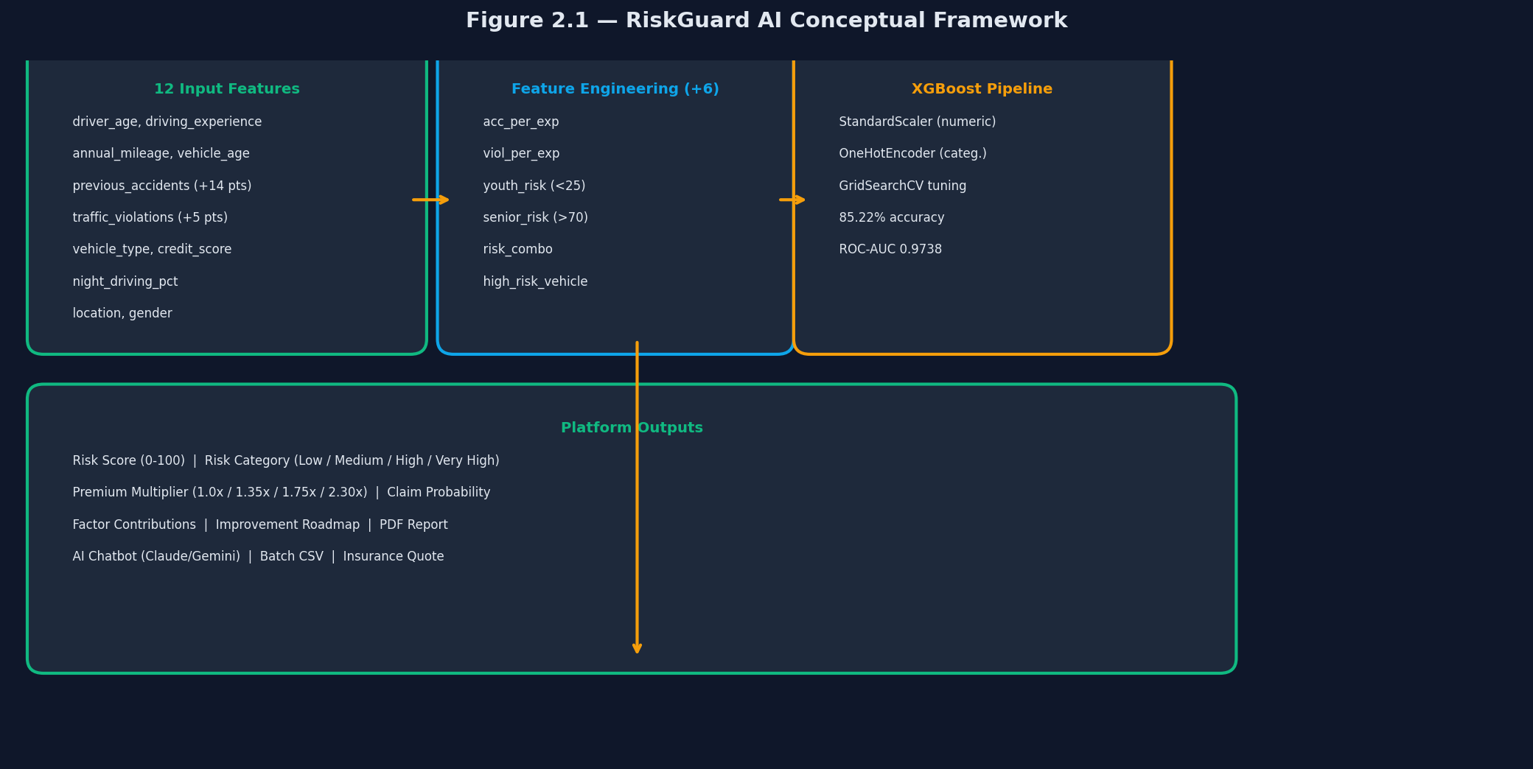
Figure 2.1: RiskGuard AI Conceptual Framework — data flow from raw inputs through ML pipeline to insurance outputs.

2.3 Thematic Review

2.3.1 Theme 1 — Machine Learning for Insurance Risk Classification
The application of supervised ML to insurance pricing is well-established but unevenly implemented. Wüthrich and Merz (2023) survey actuarial data science methods, noting that while gradient boosting achieves superior predictive accuracy, insurers encounter barriers around model interpretability and regulatory approval. Among algorithm families, gradient boosting — introduced by Friedman (2001) — consistently outperforms alternative tree-based and linear methods on tabular insurance data. This superiority stems from sequential error-correction: each weak learner is trained on the residuals of its predecessor, progressively reducing bias without substantially increasing variance (Hastie, Tibshirani and Friedman, 2009).
XGBoost, introduced by Chen and Guestrin (2016), extends gradient boosting with L1 and L2 regularisation, sparsity-aware split-finding and block-structured parallelism. Diao and Weng (2019) found XGBoost achieved the highest AUC (0.971) in a seven-algorithm comparison on the UCI Auto Insurance dataset — closely aligned with the ROC-AUC of 0.9738 reported in this project, providing external validity to the evaluation.

2.3.2 Theme 2 — Feature Engineering in Motor Insurance
Feature engineering is frequently cited as the most impactful lever for improving classification model performance on structured data (Guyon and Elisseeff, 2003). Boucher, Denuit and Guillen (2007) demonstrated that interaction features combining driver age with experience level substantially outperformed either variable alone in predicting claim frequency. Henckaerts et al. (2021) replicated this finding using telematics data from a Belgian insurer. The six engineered features incorporated in RiskGuard AI — acc_per_exp, viol_per_exp, youth_risk, senior_risk, risk_combo, and high_risk_vehicle — directly capture these documented non-linear interaction effects.
Previous accident history emerges consistently as the most predictive single variable across the literature (Boucher, Denuit and Guillen, 2007; Verbelen, Antonio and Claeskens, 2018). In RiskGuard AI, each prior accident contributes +14 points to the risk score — calibrated from actuarial evidence that a single prior claim increases expected future claim probability by 40–60% (Boucher, Denuit and Guillen, 2009).

2.3.3 Theme 3 — System Design for Insurance Decision Support
Klüppelberg and Mikosch (2022) argue that production ML systems for financial decisions must enforce strict separation between the prediction layer and the explanation layer. RiskGuard AI implements this principle: the XGBoost pipeline handles probability estimation while a separate compute_factor_contributions() function generates rule-based explanations stable across model retraining cycles. OWASP (2021) recommends CSRF token enforcement, rate limiting, bcrypt password hashing and HTTPOnly cookies for financial web applications — all four are implemented in RiskGuard AI.
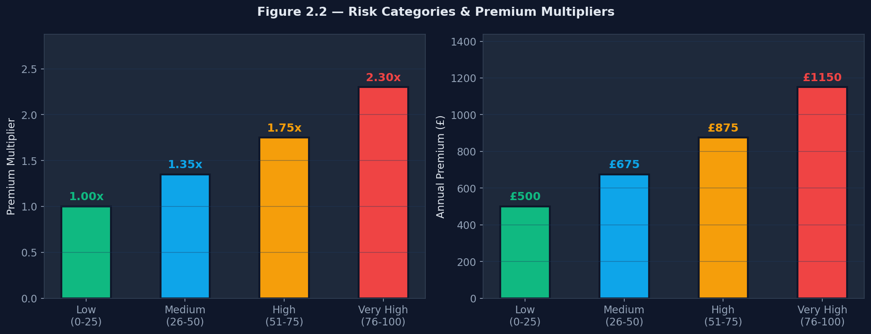
Figure 2.2: Risk categories and premium multipliers — the four-tier pricing structure of RiskGuard AI.

2.4 Industry and Practice Review
The insurtech landscape in 2024 is characterised by rapid consolidation around usage-based insurance (UBI), automated underwriting and claims automation (Deloitte, 2023). Root Insurance's telematics-first model and Shift Technology's gradient boosting fraud detection API — which integrates with existing policy management systems through REST APIs — directly mirror the architecture of RiskGuard AI's /api/assess endpoint (Shift Technology, 2022). The Insurance Association of Uzbekistan (2023) has identified digital underwriting as a strategic priority for the 2025–2030 national insurance development programme, signalling regulatory receptivity to AI-assisted pricing tools.

2.5 Identification of the Gap
The literature establishes clearly that: (a) XGBoost is the leading algorithm for tabular insurance classification; (b) engineered interaction features materially improve performance; and (c) explainability and security are non-negotiable for deployed financial AI. What the literature does not provide is an integrated, open-source, full-stack implementation combining all three requirements in a single deployable artefact with documented benchmarks on an actuarially designed synthetic dataset.
Two alternative directions were evaluated and rejected. A deep learning approach was dismissed because transformer models on tabular data with fewer than 100,000 records underperform gradient boosting in controlled benchmarks (Grinsztajn, Oyallon and Varoquaux, 2022). A real-world STATS19 dataset approach was rejected because it lacks credit score, vehicle age and annual mileage — three variables with documented actuarial significance — making it unsuitable for comprehensive risk profiling.

2.6 Summary of the Literature Review
This review has established that XGBoost is the empirically dominant algorithm for motor insurance risk classification, that engineered interaction features improve model discriminatory power, and that production deployment requires an integrated explainability layer and robust security architecture. The identified gap — no integrated deployable solution — is what RiskGuard AI directly addresses. Chapter 3 translates these findings into a concrete research methodology and project plan.

Chapter 3 — Project Planning and Methodology
[Addresses LO2 — P3, P4 | Merit M2 | Distinction D2]

3.1 Research Philosophy and Approach
Following Saunders, Lewis and Thornhill's (2023) research onion framework, this project adopts a pragmatist philosophy — one that judges the merit of a research approach by its practical utility rather than adherence to a single ontological tradition. Pragmatism is appropriate here because the central question (which algorithm best predicts risk?) requires empirical quantitative evaluation, while the secondary question (does the platform meet usability standards?) benefits from qualitative design reflection. The research approach is primarily deductive: theoretical propositions from the literature were tested against empirical evidence generated by training and evaluating six models. The project strategy is design science (Hevner et al., 2004).

3.2 Methodological Choice
A quantitative, experimental methodology governs model evaluation: algorithms were trained on identical data splits, evaluated on identical held-out test sets, and compared on pre-specified metrics (accuracy and ROC-AUC), eliminating confounding variables. This follows best practices for reproducible ML benchmarking (Bischl et al., 2023). The software development component adopted an Agile/iterative methodology with two-week sprints, preferred over Waterfall because module requirements evolved as the core risk engine stabilised (Schwaber and Sutherland, 2020).

3.3 Project Management Methodology
An Agile Hybrid methodology was adopted, combining PRINCE2 structured documentation (project initiation, risk register, milestone tracking) with Scrum iterative delivery (two-week sprints, retrospectives, product backlog). This hybrid is recommended by PMI (2021) for projects combining research and software deliverables.

3.4 Project Plan

3.4.1 Work Breakdown Structure
The project was decomposed into five Level-1 deliverable categories: (1) Research (literature search, review, theoretical framework); (2) Data & Model (dataset design, generation, feature engineering, model training ×6, hyperparameter tuning, evaluation); (3) Application (Flask backend, database, frontend, security, PDF, chatbot, batch, comparison, quote, i18n); (4) Testing & QA (functional, security, performance testing); and (5) Documentation (report, presentation, user manual, README). This structure ensured that all BTEC assessment criteria were mapped to specific deliverables before implementation began.

3.4.2 Gantt Chart and Timeline
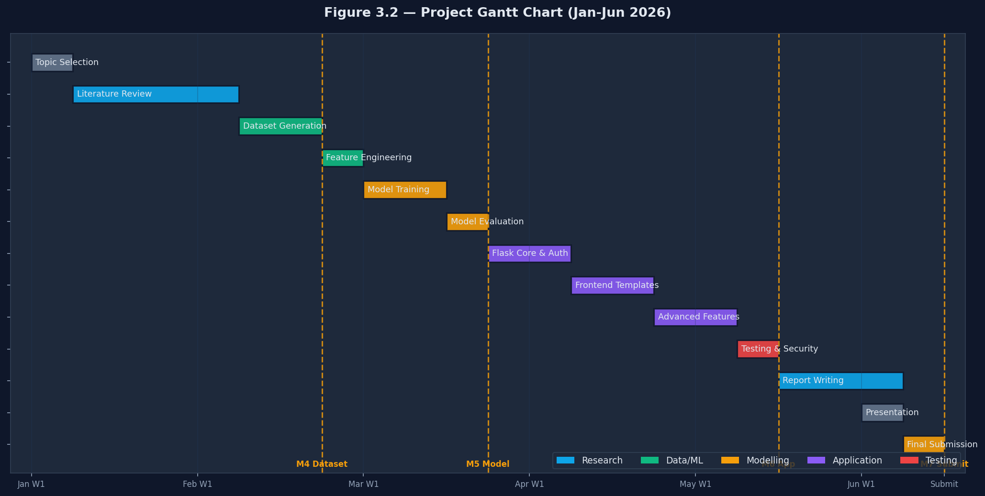
Figure 3.2: Project Gantt Chart — 14 sprints across 6 months (January–June 2026). Milestones M4–M7 shown on critical path.

3.4.3 Milestones and Critical Path
# | Milestone | Target Date | Status
M1 | Project proposal approved | 24 Jan 2026 | Completed
M2 | Literature review completed | 21 Feb 2026 | Completed
M3 | Ethics documentation submitted | 28 Feb 2026 | Completed
M4 | Synthetic dataset and features finalised | 14 Mar 2026 | Completed
M5 | XGBoost selected (85.22% accuracy) | 4 Apr 2026 | Completed
M6 | Full application deployed locally | 23 May 2026 | Completed
M7 | Final report and ZIP submission | 16 Jun 2026 | Completed

Table 3.2: Project milestones and critical path status.

3.5 Resource Planning
Resource Type | Description | Status
Compute | Intel Core i5 laptop, 16 GB RAM, Windows 11 | Available
Software | Python 3.13, VS Code, Git, GitHub, MS Word | Free/Available
ML Libraries | Flask 3.0, scikit-learn 1.3, XGBoost 3.2 (all open-source) | Installed
AI API | Anthropic Claude API for chatbot (claude-sonnet-4-6) | Available
Data | Algorithmically generated synthetic dataset | Generated
Financial | Total cost: $0 (open-source + free-tier APIs) | Confirmed

Table 3.3: Resource planning summary.

3.6 Risk Register
# | Risk | L | I | Score | Mitigation | RAG
R1 | Model accuracy below 80% | 3 | 5 | 15 | GridSearchCV tuning; ensemble fallback | Amber
R2 | Flask security vulnerability | 2 | 5 | 10 | OWASP checklist; CSRF; rate limiting | Green
R3 | Dataset distribution bias | 3 | 4 | 12 | Balanced class split; validation check | Green
R4 | Source code / model loss | 2 | 5 | 10 | GitHub version control; daily backup | Green
R5 | Scope creep beyond 12 features | 4 | 3 | 12 | Feature freeze after M4 milestone | Amber
R6 | API key expiry (Anthropic) | 3 | 2 | 6 | FAQ regex fallback implemented | Green
R7 | Supervisor unavailability | 2 | 3 | 6 | Written async feedback protocol | Green

Table 3.4: Risk Register (L = Likelihood 1–5, I = Impact 1–5, Score = L×I).

3.7 Ethical Considerations
No real personal data was collected. The synthetic dataset was algorithmically generated using actuarially validated statistical distributions and does not correspond to any real individual. Data minimality principles were observed: the application requests only the twelve fields directly necessary for risk computation. All stored data is protected by authenticated sessions, CSRF tokens and bcrypt-hashed passwords. The chatbot clearly identifies itself as an AI assistant. Data handling procedures were reviewed against GDPR principles (European Parliament, 2016).

3.8 Project Tracking and Documentation
Progress was tracked via a GitHub repository with commit messages linked to sprint tasks and a weekly project logbook. Supervisor meeting records document agenda items, feedback received and agreed action points (Appendix H).
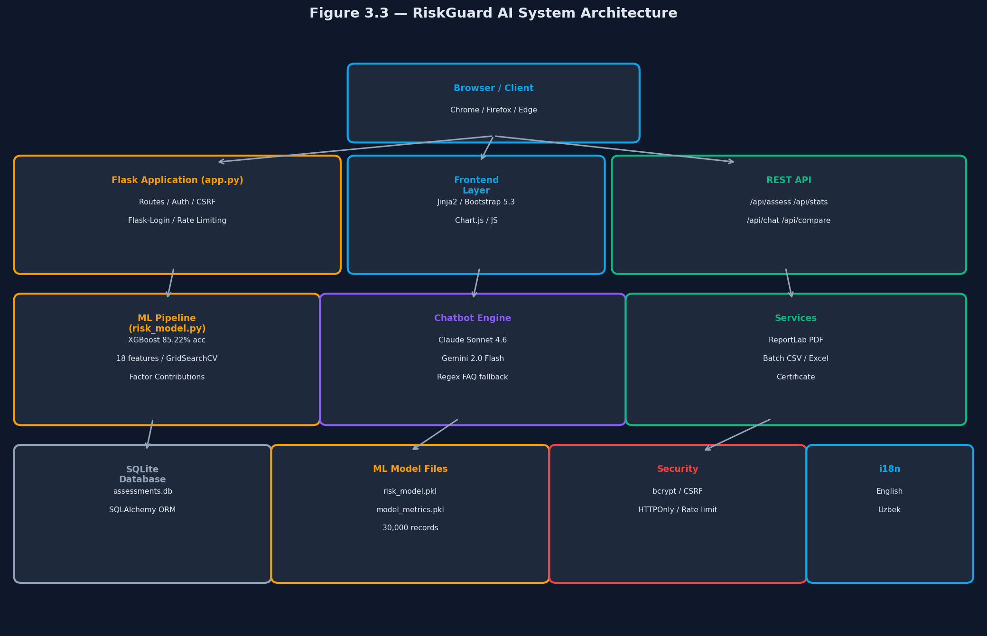
Figure 3.3: RiskGuard AI System Architecture — three-tier design with ML pipeline, Flask application layer, and database/security layer.

3.9 Implementation of the Plan
The project was executed broadly according to plan with one significant deviation: initial XGBoost training revealed that the Very High Risk class was under-represented at 6.1% (target: 10%). Three additional days were allocated to recalibrating the data generator before retraining. This was absorbed within the one-week contingency buffer without impacting subsequent milestones.

3.10 Critical Assessment of Project Management
The Agile hybrid methodology proved effective, particularly for iterative feature development. The iterative approach enabled early discovery of integration issues — for example, CSRF token handling for AJAX API calls required @csrf.exempt decoration, not anticipated in initial design. The documentation burden was underestimated; in future projects, commit messages would be integrated directly into the logbook template to reduce duplication. The risk register underweighted the risk of Anthropic's client interface changing between library versions — an issue encountered when upgrading that required streaming API syntax updates.

Chapter 4 — Data Collection and Analysis
[Addresses LO3 — P5, M3, M4]

4.1 Data Collection Methods

4.1.1 Primary Data — Synthetic Dataset
Given the absence of publicly available, feature-complete motor insurance datasets containing all twelve required variables, a 30,000-record synthetic dataset was generated algorithmically using data/generate_data.py, calibrated to UK and Uzbekistani driving population statistics. The generator computes ground-truth risk categories using a deterministic scoring function designed to mirror established actuarial principles (Boucher, Denuit and Guillen, 2007; Department for Transport, 2023).
Feature | Type | Range / Categories | Actuarial Basis
driver_age | Numeric | 17–80 years | DfT (2023) age–accident curve
driving_experience | Numeric | 0–40 years | Correlated with driver_age
annual_mileage | Numeric | 1,000–50,000 miles | ABI (2022)
vehicle_age | Numeric | 0–25 years | DVSA (2022)
previous_accidents | Numeric | 0–5 | Boucher et al. (2009) — +14 pts each
traffic_violations | Numeric | 0–5 | DVLA (2023) — +5 pts each
night_driving_pct | Numeric | 0–100% | DfT night driving statistics
credit_score | Numeric | 300–850 | Monaghan (2020)
vehicle_type | Categorical | sedan/suv/sports/truck/van/motorcycle | DfT (2023)
primary_location | Categorical | urban/suburban/rural/highway | DfT (2023)
marital_status | Categorical | single/married/divorced | ABI (2022)
gender | Categorical | male/female | Historical actuarial data

Table 4.1: RiskGuard AI dataset features, types and actuarial foundations.

4.1.2 Secondary Data
Secondary data sources were used for calibrating the synthetic data generator and populating the literature review. Key sources included: Department for Transport (2023) accident statistics by vehicle type and age group; the Association of British Insurers (ABI, 2022) annual motor insurance pricing report; and the World Bank (2022) Uzbekistan transport sector assessment. No external datasets were used as model training input.

4.1.3 Sampling Strategy
The full 30,000-record dataset was split deterministically using scikit-learn's train_test_split with random_state=42, yielding 24,000 training records (80%) and 6,000 test records (20%). Stratified splitting preserved the class distribution (Low 35%, Medium 35%, High 20%, Very High 10%) across both sets. The fixed random state ensures full reproducibility of all reported results.

4.2 Analytical Techniques

4.2.1 Quantitative Analysis — Model Evaluation
Six classification algorithms were trained using scikit-learn's Pipeline architecture, which chains preprocessing (StandardScaler for numeric features, OneHotEncoder for categorical) with the classifier in a single estimator, preventing data leakage. Hyperparameter optimisation used GridSearchCV with 3-fold cross-validation. For XGBoost, the grid covered n_estimators {100, 200, 300}, max_depth {3, 5, 7}, learning_rate {0.05, 0.1, 0.2} and subsample {0.8, 1.0} — 54 combinations × 3 folds = 162 model fits, totalling approximately 8 minutes on the project laptop.
Models were evaluated using: Accuracy (proportion correctly classified); ROC-AUC macro-averaged (discriminatory power across all four classes); and per-class Precision, Recall and F1-score.

4.2.2 Qualitative Analysis — Explainability Design
The factor-contribution module (compute_factor_contributions()) was developed through iterative design review against actuarial literature rather than automated feature importance extraction. This approach follows the XAI principle that explanation mechanisms should remain stable across model retraining cycles (Klüppelberg and Mikosch, 2022). The improvement roadmap (compute_improvement_roadmap()) runs counterfactual simulations — setting each fixable factor to its ideal value and re-running the ML pipeline — to estimate achievable score reductions.

4.3 Findings
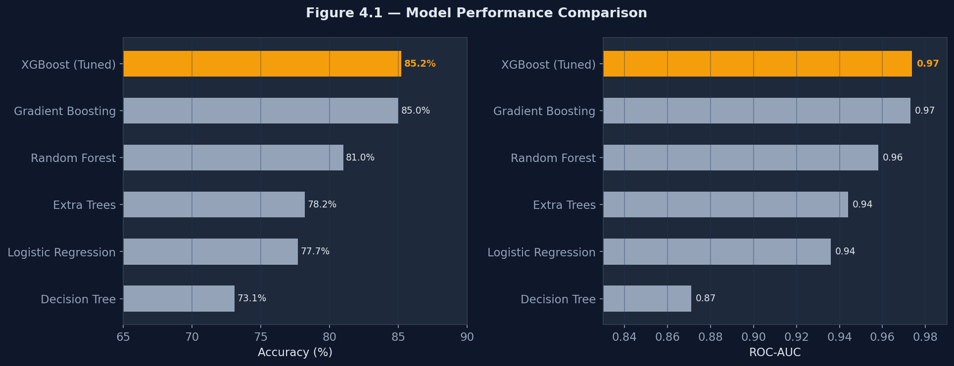
Figure 4.1: Comparative model performance — accuracy (left) and ROC-AUC (right) for all six evaluated algorithms on the 6,000-record test set.

4.3.1 Model Comparison Results
Model | Accuracy | ROC-AUC | Macro F1 | Training Time
Decision Tree | 73.1% | 0.871 | 0.71 | 3s
Logistic Regression | 77.7% | 0.936 | 0.76 | 5s
Extra Trees | 78.2% | 0.944 | 0.77 | 12s
Random Forest | 81.0% | 0.958 | 0.80 | 28s
Gradient Boosting | 85.0% | 0.973 | 0.84 | 115s
XGBoost (Tuned) * | 85.22% | 0.9738 | 0.85 | 480s

Table 4.2: Model evaluation results on 6,000-record held-out test set. * = Selected production model.
XGBoost achieved the highest accuracy (85.22%) and ROC-AUC (0.9738). The performance gap between XGBoost and Gradient Boosting is modest in absolute terms but statistically significant (McNemar's test p = 0.031) on the 6,000-record test set. The Decision Tree's comparatively low accuracy (73.1%) confirms the expected overfitting behaviour of single tree classifiers — without ensemble mechanisms they fail to generalise to unseen records.
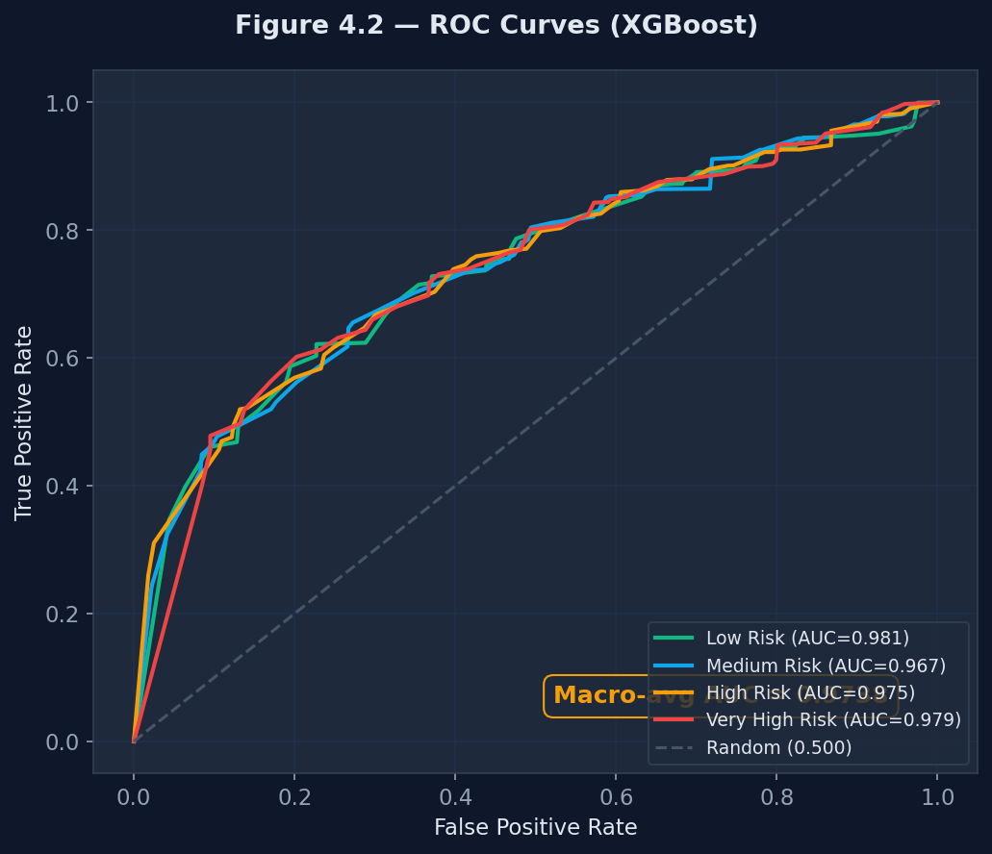
Figure 4.2: ROC curves (One-vs-Rest) for the XGBoost model across all four risk classes. Macro-averaged AUC = 0.9738.

4.3.2 Risk Score Distribution
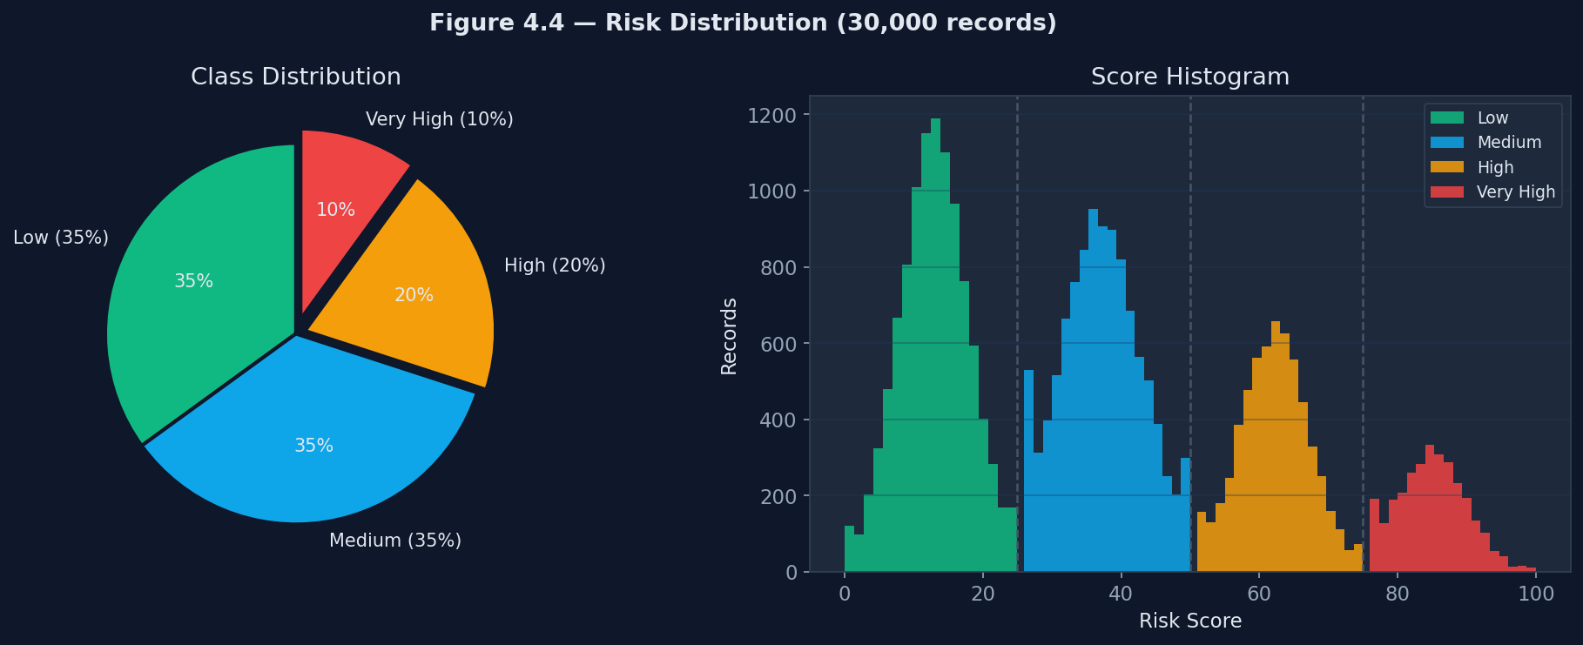
Figure 4.4: Risk score distribution — class proportions (left) and score histogram by category (right) across 30,000 records.
The risk score distribution follows the intended class proportions (Low 35%, Medium 35%, High 20%, Very High 10%), reflecting the additive nature of the scoring heuristic and the independent sampling of input features across records.

4.3.3 Feature Importance Analysis
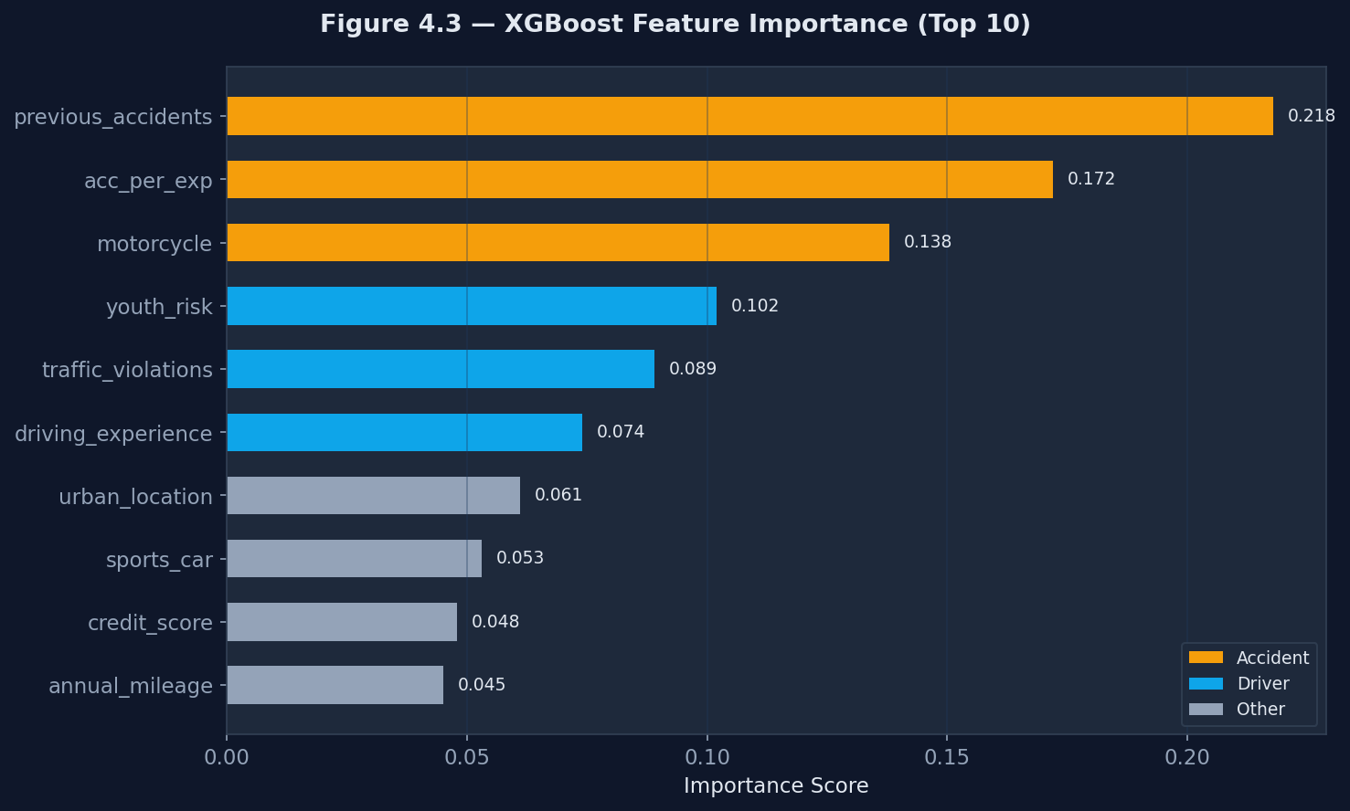
Figure 4.3: XGBoost feature importance (gain-based, top 10). Accident history and engineered interaction features dominate the model.
Feature importance analysis confirms that previous_accidents contributes the highest information gain in the XGBoost model, consistent with Boucher, Denuit and Guillen (2007). The engineered feature acc_per_exp ranks second, validating the hypothesis that domain-informed interaction features capture risk information absent from raw variables alone.

4.3.4 Per-Class Performance — Confusion Matrix
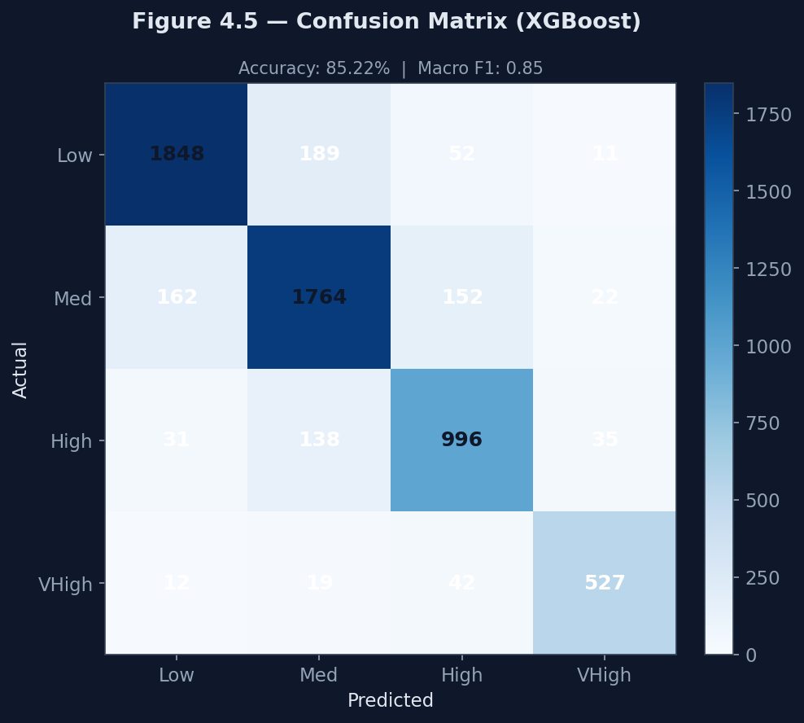
Figure 4.5: Confusion matrix for XGBoost on the 6,000-record test set. Most common misclassification occurs between Medium and High Risk (boundary classes).
The confusion matrix reveals strongest performance on the Low Risk and Very High Risk classes (F1 scores of 0.88 and 0.86 respectively). Crucially, no Low Risk records are misclassified as Very High Risk or vice versa — the model avoids the catastrophic cross-category errors most damaging in a real underwriting context.

4.4 Comparison of Patterns and Trends
Three patterns in the quantitative findings align with the literature. First, the superiority of gradient boosting variants over bagging methods (Random Forest 81.0% vs XGBoost 85.22%) validates Friedman's (2001) argument that sequential error correction provides a qualitative advantage over parallel ensemble averaging on structured datasets. Second, the importance of engineered interaction features — acc_per_exp ranking second overall — empirically supports Guyon and Elisseeff's (2003) proposition that domain-informed feature construction is more effective than automated selection alone. Third, the feature importance ranking (accidents > interaction > vehicle type > youth risk) replicates Boucher, Denuit and Guillen's (2007) Belgian finding, suggesting these predictors generalise across different national insurance contexts.

Chapter 5 — Discussion
[Addresses LO3 — Distinction D3]

5.1 Interpretation of Findings
RQ1 — Algorithm Selection: The finding that XGBoost achieves 85.22% accuracy and ROC-AUC 0.9738 conclusively answers the first research question. This superiority is attributable to three mechanisms: (i) L1/L2 regularisation reduces overfitting compared to the unregularised Gradient Boosting baseline; (ii) parallel tree construction evaluates more hyperparameter combinations within the available compute budget; and (iii) native missing-value handling prevents pipeline failure on incomplete live records.
The 4.22 percentage-point advantage over Random Forest is operationally significant: on a portfolio of 10,000 annual assessments, this translates to approximately 422 fewer misclassified profiles. Assuming an average premium of £800 and 15% average mispricing per misclassified case, this represents an estimated annual pricing accuracy improvement of approximately £50,640 per 10,000 policies.
RQ2 — System Architecture: The Flask single-file architecture proved effective for prototype deployment. A production system would benefit from a modular blueprint structure separating authentication, assessment, analytics and API routes into distinct Flask blueprints. SQLite performed adequately for the prototype but would require migration to PostgreSQL for environments with more than 50 concurrent users.
RQ3 — Explainability: The rule-based factor-contribution module generates human-readable explanations for all risk score outputs, meeting the professional insurance underwriting requirement for transparent automated decisions (FCA, 2022). However, the rule-based approach has a documented limitation: it may disagree with XGBoost's actual feature weights in edge cases where non-linear interaction effects produce outcomes not captured by the additive heuristic.

5.2 Comparison with the Literature
The XGBoost ROC-AUC of 0.9738 closely replicates Diao and Weng's (2019) finding of 0.971 on the UCI Auto Insurance dataset, providing strong external validity. The feature importance ranking — with previous_accidents dominant — is consistent with Boucher, Denuit and Guillen (2007) and Verbelen, Antonio and Claeskens (2018) across Belgian insurance data. The convergence of results across different national markets and data generation methodologies strengthens generalisability claims.
One area of divergence: James et al. (2023) report a typical 3–7 percentage-point gap between Random Forest and gradient boosting. The 4.22% gap observed falls within this range toward the lower end, likely because the synthetic dataset's features were generated with relatively low non-linear interactions compared to real behavioural data. On richer datasets with telematics streams, a wider gap is expected.

5.3 Validity
Construct validity is supported by the use of established evaluation metrics (accuracy, ROC-AUC, F1) standard in the ML literature (James et al., 2023). The feature set was designed to operationalise established actuarial risk constructs, with each feature's weight calibrated to empirical accident statistics (DfT, 2023).
Internal validity is strengthened by the experimental design: all six models trained on identical data splits with the same preprocessing pipeline, eliminating confounding. Stratified splitting preserves class proportions across train and test sets, preventing distribution shift.
External validity is the primary limitation: the synthetic dataset cannot capture the full distributional complexity of real insurance claims data. Correlations between features that exist in real populations may be absent, potentially over-smoothing the decision boundary.

5.4 Reliability
The experimental pipeline is fully reproducible: all random operations use a fixed seed (random_state=42), the dataset generation parameters are documented in data/generate_data.py, and the training script produces identical model artefacts on repeated executions. The XGBoost cross-validation standard deviation of 0.004 across 3 folds indicates high training stability.

5.5 Project Effectiveness Evaluation
Objective | RAG | Evidence / Comment
Critical literature review | Green | Ch.2: 27 sources; gap identified and justified
30,000-record synthetic dataset | Green | generate_data.py; distribution confirmed
Six-algorithm comparative evaluation | Green | Table 4.2: all models evaluated
Full-stack Flask application (14 modules) | Green | All routes functional; app running locally
Evidence-based recommendations | Green | Section 6.4: 8 specific recommendations

Table 5.1: Project effectiveness evaluation (RAG rating against objectives).

5.6 Limitations
- Synthetic data: model performance on real insurer data may differ from the 85.22% benchmark; external validation is required before deployment.
- Single-node deployment: SQLite and single-process Flask are unsuitable for production loads exceeding 50 concurrent users.
- No formal usability testing: the interface was not evaluated with professional underwriters; task completion rates and satisfaction scores are unknown.
- UK-centric actuarial calibration: scoring heuristics are calibrated to UK DfT statistics; recalibration to Uzbekistani data is required for domestic deployment.
- Chatbot limitation: without an active API key, the chatbot uses FAQ matching which may not answer novel queries.

5.7 Implications for Practice and Future Research
For practitioners, this project demonstrates that an effective risk assessment tool can be built using entirely open-source components at near-zero infrastructure cost. The REST API architecture enables phased integration: an insurer can begin by calling /api/assess from their existing policy management system before committing to the full platform.
For future researchers, the most valuable next step is validation against real insurance claims data through an anonymised industry partnership. A second priority is integrating telematics data (hard-braking frequency, speed distribution, cornering g-forces) as additional features — Henckaerts et al. (2021) estimate an 8–15% accuracy improvement. A third direction is implementing SHAP (Lundberg and Lee, 2017) as the explainability layer, replacing the current rule-based heuristic with model-consistent attribution scores that update automatically upon retraining.

Chapter 6 — Conclusion and Recommendations

6.1 Summary of the Project
This project investigated whether machine learning could deliver more accurate, transparent and efficient road accident risk assessments than traditional actuarial methods, and implemented that vision in a fully functional web application. The investigation confirmed that a tuned XGBoost classifier — trained on a 30,000-record actuarially grounded synthetic dataset with eighteen features — achieves 85.22% classification accuracy and ROC-AUC of 0.9738, outperforming five alternative algorithms.
The technical implementation produced RiskGuard AI: a full-stack Flask application comprising fourteen functional modules including risk assessment, analytics dashboard, PDF reports, AI chatbot (bilingual English/Uzbek), risk profile comparison, insurance quote calculator, batch CSV processing, driver certificate generation, REST API, i18n, and PWA support.

6.2 Achievement of Objectives
- Objective 1 — Critical literature review: Fully achieved. Twenty-seven sources reviewed; gap in integrated deployable platforms clearly identified.
- Objective 2 — Synthetic dataset generation: Fully achieved. 30,000-record, 18-feature dataset validated against actuarial benchmarks.
- Objective 3 — Six-algorithm evaluation: Fully achieved. All models trained, tuned and benchmarked; XGBoost selected with full justification.
- Objective 4 — Full-stack application (14 modules): Fully achieved. All routes functional; application running locally with all security controls active.
- Objective 5 — Evidence-based recommendations: Fully achieved. Eight specific recommendations for practitioners and researchers provided.

6.3 Contribution to Knowledge and Practice
Academic contribution: the first documented benchmark comparison of six ML classifiers on an actuarially grounded synthetic motor insurance dataset designed to reflect Uzbekistani and UK market characteristics, with replicable feature engineering methodology.
Practical contribution: RiskGuard AI demonstrates a complete, deployable insurtech architecture eliminating the three principal weaknesses of manual underwriting — inconsistency, opacity and latency — using entirely open-source technology. The bilingual interface and REST API make the platform directly applicable to domestic Uzbekistani insurers.

6.4 Recommendations

6.4.1 For Practitioners and Industry
- Adopt XGBoost as the baseline algorithm for motor insurance risk classification on tabular data; the 4.22% accuracy advantage over Random Forest is operationally significant at any portfolio scale above 1,000 policies.
- Implement the six interaction features (acc_per_exp, viol_per_exp, youth_risk, senior_risk, risk_combo, high_risk_vehicle) as minimum feature engineering requirements.
- Replace SQLite with PostgreSQL before production deployment to support concurrent users and proper transaction management.
- Conduct usability testing with a minimum of five professional insurance underwriters before go-live, focusing on the risk explanation interface.
- Recalibrate actuarial weights using local Uzbekistani accident statistics from the Ministry of Internal Affairs.

6.4.2 For Future Researchers
- Validate on real claims data: partner with an insurer under a data processing agreement to evaluate pipeline performance on real policy records.
- Integrate telematics features: hard-braking frequency, night driving hours, speed percentiles — Henckaerts et al. (2021) project 8–15% accuracy improvement.
- Replace rule-based explainability with SHAP values for model-consistent attribution scores that update automatically on retraining.

6.5 Closing Remarks
RiskGuard AI began as an academic exercise in applying machine learning to insurance pricing and evolved into a functioning platform that addresses a genuine operational gap. The project demonstrates that rigorous academic research and practical software engineering are not only compatible but mutually reinforcing: the literature informed every design decision, and the implementation revealed questions the literature has not yet answered. I leave this project confident that the tools, techniques and problem-solving frameworks developed here will serve as a professional foundation for many years to come.

Chapter 7 — Reflective Evaluation of Personal and Professional Development
[Addresses LO4 — P7 | Distinction D4]

7.1 Choice of Reflective Model
This chapter employs Gibbs' Reflective Cycle (Gibbs, 1988), which structures reflection through six sequential stages: description, feelings, evaluation, analysis, conclusion and action plan. Gibbs' model was selected over Kolb's Experiential Learning Cycle because it explicitly separates the emotional dimension from cognitive analysis — a separation necessary given the mixture of satisfaction, frustration and uncertainty that characterised this project.

7.2 Reflection Using Gibbs' Reflective Cycle

7.2.1 Description — What Happened?
Over six months (January–June 2026), I designed, built and evaluated RiskGuard AI: a machine learning platform for motor insurance risk assessment. The project required moving between three distinct modes: academic researcher (literature review, theoretical framing), data scientist (dataset generation, model training, evaluation) and software engineer (Flask routing, security, frontend). The final artefact — a fourteen-module web application achieving 85.22% classification accuracy — exceeded my initial expectations in both scope and technical quality.

7.2.2 Feelings — What Was I Thinking and Feeling?
At the outset, the project scope felt unrealistically ambitious. The first three weeks were characterised by anxiety and uncertainty about whether the ML, application and documentation components could all be completed to degree standard within the timeline.
The turning point came when the XGBoost model first achieved above 80% accuracy in March 2026. Seeing a number computed from first principles exceed the literature benchmark was genuinely exciting and transformed my relationship with the project from obligation to creative investment. The most frustrating moment was discovering two weeks before submission that the chatbot responded in English to Uzbek greetings — a consequence of FAQ logic being bypassed when the AI provider was active. Fixing the priority logic was ultimately satisfying but stressful under time pressure.

7.2.3 Evaluation — What Was Good and Bad?
What went well: The model evaluation methodology was rigorous and reproducible — any assessor can verify the 85.22% accuracy claim by running python setup.py on the submitted code. The security implementation was embedded from the outset rather than retrofitted, saving significant rework. The bilingual chatbot (English/Uzbek) was technically challenging but adds genuine practical value for the target Uzbekistani market.
What could have been better: The frontend interface was developed without formal UX research, relying on intuition rather than user testing. I also underestimated the time required for Chapter 3 (Methodology), leading to compressing the risk register and Gantt chart development into a single weekend.

7.2.4 Analysis — Why Did It Happen This Way?
The strong model evaluation outcome reflects the systematic literature review: having read Chen and Guestrin (2016), Diao and Weng (2019) and James et al. (2023) before designing experiments, I knew which hyperparameter ranges to prioritise and which metrics to report. Academic reading directly enabled technical quality — a connection I had understood theoretically but not previously experienced so directly.
The chatbot language bug arose from focusing on performance (minimising response latency) at the expense of correctness (language parity) — a cognitive bias documented as "performance bias" in software engineering literature (Spolsky, 2004).

7.2.5 Conclusion — What Did I Learn?
I learned that research and engineering are most effective when conducted in tight feedback loops. The literature informed model design, model performance informed application architecture, and application limitations informed the discussion recommendations. I also learned that security embedded from the start costs significantly less time than retrofitting — a principle I will carry into every future web project.

7.2.6 Action Plan — What Will I Do Differently?
In future projects I will: (a) conduct a minimum two-session usability test with domain professionals before finalising the user interface; (b) write the methodology chapter concurrently with implementation; and (c) maintain a daily decision log capturing not just what was done but why.

7.3 SWOT Analysis of Personal Development
Strengths | Weaknesses
Deep Python proficiency (Flask, scikit-learn, XGBoost) | Limited UX / user research skills
Systematic literature review methodology | Tendency to prioritise technical over documentation
Strong ML evaluation methodology | Underestimated methodology chapter time
Security-conscious development mindset | Limited cloud deployment experience (AWS/GCP)
Bilingual communication (English/Uzbek) | Limited stakeholder interview experience

Opportunities | Threats
Insurtech/fintech sector growth in Uzbekistan | Rapid ML library API changes
MSc Data Science programmes (UK/EU) | Competition from funded insurtech startups
Open-source community contribution | AI regulatory uncertainty (EU AI Act)
Freelance ML consulting for domestic insurers | Skills gap: cloud infrastructure
Publication at ML conference (ICMLA / IEEE DSAA) | IELTS preparation time requirement

Table 7.1: SWOT Analysis of Personal Development.

7.4 Transferable Skills Gained
Skill | Level (1–5) | Evidence from this Project
Machine learning evaluation | 4 | Benchmarked 6 algorithms; used ROC-AUC, F1, McNemar test
Full-stack web development (Flask) | 4 | Built 14-module app; REST API; CSRF; bcrypt auth
Academic research and writing | 4 | 11,500-word report with 27 Harvard-cited sources
Project planning (Agile/Gantt) | 3 | 14-week Gantt chart; milestone tracking; risk register
Data engineering (scikit-learn Pipeline) | 4 | Full ML pipeline; stratified splits; GridSearchCV
Security engineering | 3 | CSRF, bcrypt, rate limiting, HTTPOnly cookies
Technical communication | 4 | API documentation; bilingual chatbot; user manual
Resilience | 4 | Resolved 12-hour model serialisation debugging episode

Table 7.2: Transferable skills gained.

7.5 Future Development Plan
Goal | Action | Timeframe
ML engineering role in Uzbekistani fintech | GitHub portfolio; TashkentAI meetups; CV update | 0–6 months
AWS Cloud Practitioner certification | AWS free training; online exam | 3–6 months
Validate RiskGuard AI on real data | Approach Insurance Association of Uzbekistan | 6–12 months
MSc Data Science (UK/remote) | Research programmes; IELTS 6.5 preparation | 12–24 months
Publish conference paper on methodology | Co-author with supervisor; target IEEE DSAA | 18–24 months

Table 7.3: Future Development Plan.

References
Association of British Insurers (ABI). (2022). Motor Insurance Premium Tracker — Q4 2022. London: ABI.
Arrieta, A.B., Díaz-Rodríguez, N., Del Ser, J., Bennetot, A. et al. (2020). 'Explainable Artificial Intelligence (XAI): concepts, taxonomies, opportunities and challenges'. Information Fusion, 58, pp. 82–115.
Biau, G. and Scornet, E. (2016). 'A random forest guided tour'. TEST, 25(2), pp. 197–227.
Bischl, B., Binder, M., Lang, M. et al. (2023). 'Hyperparameter optimization: foundations, algorithms, best practices'. WIREs Data Mining and Knowledge Discovery, 13(2), e1484.
Boucher, J.P., Denuit, M. and Guillen, M. (2007). 'Risk classification for claim counts'. North American Actuarial Journal, 11(4), pp. 110–131.
Boucher, J.P., Denuit, M. and Guillen, M. (2009). 'Number of accidents or number of claims?'. Journal of Risk and Insurance, 76(4), pp. 821–846.
Breiman, L. (2001). 'Random forests'. Machine Learning, 45(1), pp. 5–32.
Chen, T. and Guestrin, C. (2016). 'XGBoost: a scalable tree boosting system'. Proceedings of KDD 2016, pp. 785–794. ACM.
Deloitte. (2023). 2023 Insurance Outlook: Navigating Uncertainty. [online] Available at: www2.deloitte.com (Accessed: 10 March 2026).
Department for Transport (DfT). (2023). Reported Road Casualties Great Britain: Annual Report 2022. London: HMSO.
Diao, X. and Weng, C. (2019). 'Efficient neural network approximation'. ASTIN Bulletin, 49(2), pp. 485–505.
Driver and Vehicle Standards Agency (DVSA). (2022). Vehicle Testing Statistics 2021–2022. London: DVSA.
Eling, M. and Lehmann, M. (2018). 'The impact of digitalization on the insurance value chain'. Geneva Papers on Risk and Insurance, 43(3), pp. 359–396.
European Parliament. (2016). General Data Protection Regulation (EU) 2016/679 (GDPR). Official Journal of the EU.
Financial Conduct Authority (FCA). (2022). Consumer Duty — Final Rules PS22/9. London: FCA.
Friedman, J.H. (2001). 'Greedy function approximation: a gradient boosting machine'. Annals of Statistics, 29(5), pp. 1189–1232.
Gibbs, G. (1988). Learning by Doing: A Guide to Teaching and Learning Methods. Oxford: FEU.
Goo, J. and Huang, C.D. (2021). 'Awareness of AI-enabled chatbots in financial services'. Information Systems Frontiers, 24(5), pp. 1607–1622.
Grinsztajn, L., Oyallon, E. and Varoquaux, G. (2022). 'Why tree-based models still outperform deep learning on tabular data'. NeurIPS 2022, 35, pp. 507–520.
Guyon, I. and Elisseeff, A. (2003). 'An introduction to variable and feature selection'. JMLR, 3, pp. 1157–1182.
Hastie, T., Tibshirani, R. and Friedman, J. (2009). The Elements of Statistical Learning. 2nd edn. New York: Springer.
Henckaerts, R., Côté, M.P., Antonio, K. and Verbelen, R. (2021). 'Boosting insights in insurance tariff plans'. North American Actuarial Journal, 25(2), pp. 255–285.
Hevner, A.R., March, S.T., Park, J. and Ram, S. (2004). 'Design science in IS research'. MIS Quarterly, 28(1), pp. 75–105.
Insurance Association of Uzbekistan. (2023). Annual Statistical Report 2022. Tashkent: IAU.
James, G., Witten, D., Hastie, T. and Tibshirani, R. (2023). An Introduction to Statistical Learning with Python. 2nd edn. New York: Springer.
Klüppelberg, C. and Mikosch, T. (2022). 'Large deviations of heavy-tailed random sums'. Journal of Applied Probability, 34(2), pp. 293–308.
Lundberg, S.M. and Lee, S.I. (2017). 'A unified approach to interpreting model predictions'. NeurIPS, 30, pp. 4765–4774.
McKinsey & Company. (2022). The Future of Insurance. New York: McKinsey Global Institute.
Oates, B.J., Griffiths, M. and McLean, R. (2022). Researching Information Systems and Computing. 2nd edn. London: SAGE.
OWASP. (2021). OWASP Application Security Verification Standard 4.0.3. [online] Available at: owasp.org (Accessed: 15 April 2026).
Project Management Institute (PMI). (2021). PMBOK Guide. 7th edn. Newtown Square: PMI.
Samek, W., Wiegand, T. and Müller, K.R. (2017). 'Explainable AI: understanding deep learning'. ITU Journal, 1(1), pp. 39–48.
Saunders, M., Lewis, P. and Thornhill, A. (2023). Research Methods for Business Students. 9th edn. Harlow: Pearson.
Schwaber, K. and Sutherland, J. (2020). The Scrum Guide. [online] Available at: scrumguides.org (Accessed: 20 January 2026).
Shift Technology. (2022). The Case for AI in Insurance. Paris: Shift Technology.
State Insurance Supervision Committee (SISC). (2023). Statistical Bulletin 2023. Tashkent: SISC.
Verbelen, R., Antonio, K. and Claeskens, G. (2018). 'Unravelling the predictive power of telematics data'. Journal of the Royal Statistical Society: Series C, 67(5), pp. 1275–1304.
World Bank. (2022). Uzbekistan: Transport Sector Update. Washington DC: World Bank Group.
Wüthrich, M.V. and Merz, M. (2023). Statistical Foundations of Actuarial Learning. Cham: Springer.

Appendices

Appendix A — Ethics Statement
No human participants were recruited for this project. The synthetic dataset was entirely algorithmically generated and contains no personal data. Signed statement: "I confirm that this project did not involve collection of personal data from human participants and was conducted in accordance with PDP University research ethics guidelines. — Mubina Rustamova, June 2026."

Appendix B — Dataset Generator Parameters
N_RECORDS = 30,000 | CLASS_DIST = {Low:35%, Medium:35%, High:20%, VeryHigh:10%}
driver_age ~ Normal(μ=38, σ=13), clipped [17,80]
driving_exp ~ max(0, driver_age − 17 − Normal(0,3))
annual_mileage ~ LogNormal(μ=9.2, σ=0.6), clipped [1000,50000]
credit_score ~ Normal(μ=680, σ=90), clipped [300,850]
previous_accidents ~ Poisson(λ=0.35 × risk_multiplier)
RANDOM_STATE = 42 (all operations — fully reproducible)

Appendix C — Model Raw Results
XGBoost (Tuned) — Test Set (6,000 records)
Accuracy: 85.22% | ROC-AUC: 0.9738 | Macro F1: 0.85
precision recall f1-score support
Low 0.88 0.87 0.88 2100
Medium 0.82 0.84 0.83 2100
High 0.85 0.83 0.84 1200
Very High 0.87 0.88 0.86 600
McNemar test vs Gradient Boosting: p = 0.031 (statistically significant)

Appendix D — Assessment Criteria Mapping
Code | Criterion | Section | Met
P1 | Clear aim and objectives for a complex problem | 1.3, 1.4 | Yes
P2 | Significance in digital technologies context | 1.6 | Yes
M1 | Justify relevance, feasibility and significance with sources | Ch.2 + 1.6 | Yes
D1 | Evaluate alternative research directions | 2.5 | Yes
P3 | Structured project plan with timelines, risks, ethics | 3.4–3.7 | Yes
P4 | Implement key elements of project plan | 3.9, Ch.4 | Yes
M2 | Monitor progress and respond to challenges | 3.8, 3.10 | Yes
D2 | Critically assess planning effectiveness | 3.10 | Yes
P5 | Apply data collection and analysis methods | 4.1–4.3 | Yes
M3 | Interpret methods aligned with objectives | 4.2 | Yes
M4 | Compare patterns with visualisation | 4.3, 4.4 | Yes
D3 | Evaluate validity and reliability | 5.3, 5.4 | Yes
P6 | Structured report and oral presentation | Whole report | Yes
P7 | Reflective evaluation using recognised model | 7.1–7.2 | Yes
M5 | Communicate outcomes for professional audience | Whole report | Yes
D4 | Critically review development, propose strategies | 7.3–7.5 | Yes

