PDP UNIVERSITY
Faculty of Business Information Technology
Tashkent, Uzbekistan

INDEPENDENT PROJECT
Pearson BTEC Level 6 Diploma in Digital Technologies
Unit 2 — Unit Code: 70726U — Credit Value: 30
RiskGuard AI: A Machine Learning–Powered Road Accident
Risk Assessment System for Insurance Companies
How can machine learning improve the accuracy, consistency and transparency
of motor insurance risk assessment and premium pricing?

Student Name: | Mubina Rustamova
Student ID: | BIT-2022-0147
Programme / Group: | BIT — Group BIT-22A
Project Format: | Capstone-style ☑ Thesis-style ☐
Supervisor: | Dr. Akbar Toshmatov
Submission Date: | 07 June 2026
Word Count: | Approximately 11,500 words
Academic Year: | 2025–2026

Submitted in partial fulfilment of the requirements for the
Bachelor's Degree in Business Information Technology
Academic Year 2025–2026

Declaration of Originality

I hereby declare that this Independent Project, submitted in partial fulfilment of the requirements for the Pearson BTEC Level 6 Diploma in Digital Technologies and the Bachelor's Degree in Business Information Technology at PDP University, is the result of my own original work.

I confirm that:
- All sources of information, data and ideas drawn from other authors have been fully acknowledged through accurate in-text citations and a complete reference list using the Harvard (author–date) referencing system.
- This work has not been previously submitted, in whole or in part, for any other academic award at this or any other institution.
- All research activities have been conducted in compliance with the institutional ethics procedures of PDP University and applicable data-protection regulations.
- I understand that any breach of academic integrity, including plagiarism, fabrication of data or unauthorised collaboration, may result in the withdrawal of this submission and disciplinary action.

Signature: ____________________________ | Date: 07 June 2026
Mubina Rustamova | Tashkent, Uzbekistan

Acknowledgements

I would like to express my sincere gratitude to my supervisor, Dr. Akbar Toshmatov, for his continuous guidance, insightful feedback and encouragement throughout the duration of this project. His expertise in machine learning and software engineering significantly shaped the technical direction of RiskGuard AI.
I am also grateful to the faculty of the Business Information Technology department at PDP University for providing an intellectually stimulating environment and the academic foundation that made this work possible. The structured approach to project management and research methodology taught throughout the programme proved invaluable at every stage.
My thanks extend to Anthropic's Claude Code, which served as an AI-assisted development tool and significantly accelerated the implementation phase of this project. This experience has deepened my appreciation for responsible and productive human–AI collaboration in software engineering.
Finally, I extend my heartfelt thanks to my family, whose unwavering support, patience and encouragement have been instrumental throughout my Bachelor's studies at PDP University.

Abstract

The motor insurance industry continues to rely on static, demographic-centric underwriting models that inadequately capture the behavioural and contextual risk signals that predict road accident probability. This project investigates the application of machine learning to automate and improve driver risk assessment within the motor insurance context. The aim of the study is to design, develop and evaluate a full-stack web application — RiskGuard AI — that employs machine learning to produce explainable, accurate and actionable risk profiles for insurance underwriters.
A Design Science Research (DSR) methodology was adopted, combining quantitative model development and evaluation with the design and implementation of a production-grade software artefact. A synthetic dataset of 12,000 driver records was generated using domain-weighted heuristics validated against actuarial literature, incorporating 12 features spanning driver behaviour, vehicle characteristics and environmental context. Four classifiers were trained and compared: Decision Tree (84.2%), Logistic Regression (79.1%), Random Forest (88.7%), and Gradient Boosting (91.3%). The Gradient Boosting model, tuned via GridSearchCV with 5-fold cross-validation, was selected as the production model.
The system was deployed as a secure Flask web application with a risk score gauge (0–100), premium multiplier calculation (1.0×–2.30×), per-factor contribution breakdown, counterfactual improvement roadmap, AI chatbot powered by Claude Haiku, bilingual English/Uzbek interface, PDF report generation, and an administrative dashboard with historical trend analysis. Security controls include CSRF protection, rate limiting, password hashing and HTTP security headers.
The findings confirm that Gradient Boosting significantly outperforms linear baselines for this type of tabular risk classification problem, and that explainability features are as critical as predictive accuracy for real-world insurance deployment. The project concludes that machine learning can replace manual underwriting with a reproducible, transparent decision-support system, and recommends integration of real telematics data and SHAP-based explainability as immediate next steps.

Keywords: machine learning; motor insurance; risk assessment; Gradient Boosting; explainable AI; Flask; Python; insurance underwriting; premium pricing; Design Science Research

Table of Contents

Declaration of Originality ......................................... 2
Acknowledgements ................................................... 3
Abstract ........................................................... 4
Table of Contents .................................................. 5
List of Figures .................................................... 6
List of Tables ..................................................... 6
List of Abbreviations .............................................. 7
Chapter 1 Introduction .............................................. 8
1.1 Background and Context ........................................ 8
1.2 Problem Statement ............................................. 9
1.3 Project Aim ................................................... 9
1.4 Project Objectives ............................................ 9
1.5 Research Questions ........................................... 10
1.6 Significance of the Project .................................. 10
1.7 Scope and Limitations ........................................ 10
1.8 Structure of the Report ...................................... 11
Chapter 2 Literature Review ........................................ 12
2.1 Introduction to the Literature Review ........................ 12
2.2 Theoretical Framework ........................................ 12
2.3 Thematic Review .............................................. 13
2.4 Industry / Practice Review ................................... 15
2.5 Identification of the Gap .................................... 16
2.6 Conceptual Framework ......................................... 16
2.7 Summary of the Literature Review ............................. 16
Chapter 3 Project Planning and Methodology ......................... 17
3.1 Research Philosophy and Approach ............................. 17
3.2 Methodological Choice ........................................ 17
3.3 Project Management Methodology ............................... 18
3.4 Project Plan ................................................. 18
3.5 Resource Planning ............................................ 20
3.6 Risk Register ................................................ 20
3.7 Ethical Considerations ....................................... 21
3.8 Project Tracking and Documentation ........................... 21
3.9 Implementation of the Plan ................................... 22
3.10 Critical Assessment of Project Management ................... 22
Chapter 4 Data Collection and Analysis ............................. 23
4.1 Data Collection Methods ...................................... 23
4.2 Analytical Techniques ........................................ 24
4.3 Findings ..................................................... 25
4.4 Comparison of Patterns and Trends ............................ 29
Chapter 5 Discussion ............................................... 30
5.1 Interpretation of Findings ................................... 30
5.2 Comparison with the Literature ............................... 31
5.3 Validity ..................................................... 32
5.4 Reliability .................................................. 32
5.5 Project Effectiveness Evaluation ............................. 32
5.6 Limitations .................................................. 33
5.7 Implications for Practice and Future Research ................ 33
Chapter 6 Conclusion and Recommendations ........................... 34
Chapter 7 Reflective Evaluation of Personal and Professional Development ... 36
References .......................................................... 40
Appendices .......................................................... 43

List of Figures

Figure 1: System Architecture Diagram — RiskGuard AI ............... p. 18
Figure 2: Project Gantt Chart — 10-Week Timeline ................... p. 19
Figure 3: Risk Category Distribution (Pie and Bar) ................. p. 24
Figure 4: ML Model Performance Comparison (Bar Chart) .............. p. 26
Figure 5: Feature Importance Ranking (Horizontal Bar) .............. p. 27
Figure 6: Confusion Matrix — Gradient Boosting Tuned ............... p. 27
Figure 7: RiskGuard AI — Login Screen .............................. p. 28
Figure 8: Admin Dashboard .......................................... p. 29
Figure 9: Risk Assessment Form ..................................... p. 29
Figure 10: Assessment Results — Gauge and Factor Breakdown ......... p. 30
Figure 11: Driver Comparison Tool .................................. p. 30
Figure 12: AI Chatbot Interface (RiskBot) .......................... p. 31
Figure 13: Assessment History and Export ........................... p. 31
Figure 14: Insurance Quote Calculator .............................. p. 32
Figure 15: ML Model Performance Report Screen ...................... p. 32
Figure 16: PDF Report Preview ...................................... p. 33
Figure 17: Premium Multiplier Schedule ............................. p. 34
Figure 18: Gibbs' Reflective Cycle Application ..................... p. 37

List of Tables
Table 1: Project Objectives (SMART) ................................ p. 10
Table 2: Feature Definitions and Risk Contributions ................ p. 24
Table 3: Synthetic Dataset Summary Statistics ...................... p. 25
Table 4: Model Performance Comparison .............................. p. 26
Table 5: GridSearchCV Hyperparameter Grid .......................... p. 26
Table 6: Improvement Roadmap — Average Score Savings ............... p. 28
Table 7: Functional Requirements ................................... p. 21
Table 8: Risk Register ............................................. p. 20
Table 9: Resource Planning ......................................... p. 20
Table 10: Milestones and Critical Path ............................. p. 19
Table 11: Testing — Functional Test Cases .......................... p. 32
Table 12: Objectives Achievement RAG Matrix ........................ p. 33
Table 13: Transferable Skills Gained ............................... p. 39
Table 14: Future Development Plan .................................. p. 39
Table 15: SWOT Analysis of Personal Development .................... p. 38

List of Abbreviations

Abbreviation | Full Form
AI | Artificial Intelligence
API | Application Programming Interface
BTEC | Business and Technology Education Council
CRUD | Create, Read, Update, Delete
CSRF | Cross-Site Request Forgery
CV | Cross-Validation
DSR | Design Science Research
GDPR | General Data Protection Regulation
GB | Gradient Boosting
GLM | Generalised Linear Model
HTML | HyperText Markup Language
HTTP | HyperText Transfer Protocol
JSON | JavaScript Object Notation
KPI | Key Performance Indicator
LR | Logistic Regression
ML | Machine Learning
NCB | No-Claims Bonus
ORM | Object-Relational Mapper
PDF | Portable Document Format
PKL | Python Pickle file (serialised model)
PWA | Progressive Web Application
RAG | Red, Amber, Green (status rating)
RF | Random Forest
REST | Representational State Transfer
SHAP | SHapley Additive exPlanations
SMART | Specific, Measurable, Achievable, Relevant, Time-bound
SQL | Structured Query Language
SWOT | Strengths, Weaknesses, Opportunities, Threats
UBI | Usage-Based Insurance
UI | User Interface
WBS | Work Breakdown Structure
XSS | Cross-Site Scripting

Chapter 1 — Introduction
Note: Addresses LO1 — P1, P2 | Merit M1 | Distinction D1

This chapter introduces the RiskGuard AI project, establishes the context within the digital technologies and insurance sectors, defines the problem, states the aim and objectives, and outlines the structure of the remainder of the report.

1.1 Background and Context
The global motor insurance industry is undergoing a period of significant technological disruption. The Association of British Insurers (ABI, 2023) reported that motor insurance claims in the United Kingdom alone reached £6.7 billion in 2023, with fraud-related losses accounting for an estimated £1.1 billion annually. Simultaneously, rapid digitalisation — driven by cloud computing, big data and machine learning — is transforming how insurers assess, price and manage risk (McKinsey & Company, 2023). In Central Asia, and Uzbekistan in particular, the insurance sector is experiencing accelerated growth following regulatory liberalisation, with premiums increasing at a compound annual growth rate of 18% between 2020 and 2024 (Uzbekistan Insurance Market Report, 2024). This growth brings with it both the opportunity and the necessity for more sophisticated, technology-driven underwriting approaches.
Machine learning (ML) has emerged as a powerful tool for risk segmentation in financial services. Unlike traditional actuarial models based on Generalised Linear Models (GLMs), which assume linear relationships between predictors and outcomes, ML algorithms can capture non-linear interactions and high-order feature combinations that significantly improve predictive accuracy (Verbelen, Antonio and Claeskens, 2018). The availability of telematics data — GPS speed profiles, braking patterns, and time-of-day usage — has further expanded the feature space available to insurers, with studies demonstrating up to 30% reduction in premium uncertainty compared to static models (Ayuso, Guillen and Nielsen, 2019). Despite this evidence, many insurance companies, particularly in emerging markets, continue to rely on manual, subjective underwriting processes that introduce inconsistency and limit scalability.
RiskGuard AI was conceived in this context: as a demonstration that production-grade, ML-powered risk assessment is achievable within a single development cycle using open-source tools, and that the outputs of such a system can be made sufficiently explainable and transparent to satisfy both regulatory requirements and end-user trust.

1.2 Problem Statement
Traditional motor insurance underwriting is characterised by four interconnected deficiencies that reduce pricing accuracy, introduce systemic bias, and limit the ability of insurers to engage meaningfully with policyholders. First, the feature space used by conventional underwriting models is narrow — typically fewer than ten variables, predominantly demographic (age, postcode, gender) — and fails to incorporate the richer behavioural signals that actuarial research confirms as the strongest predictors of accident risk (Jiang et al., 2020). Second, manual underwriting introduces significant inter-underwriter variability: the same risk profile may be priced differently by two underwriters, violating the principle of consistency that underpins fair pricing. Third, policyholders receive no actionable feedback — they are told their premium but not which specific factors drove it or what they could change to reduce it. Fourth, the absence of explainability in many early ML-based insurance tools has drawn regulatory scrutiny under GDPR Article 22, which grants citizens the right to explanation for automated decisions affecting them (Cevolini and Esposito, 2020).
The specific gap addressed by this project is the absence of an integrated, explainable, production-ready ML risk assessment platform that combines accurate prediction with transparent, actionable outputs — a gap that is particularly acute in the Uzbek and broader Central Asian insurance market.

1.3 Project Aim
Aim: The aim of this project is to design, develop and evaluate a machine-learning–powered web application (RiskGuard AI) that automates motor insurance driver risk profiling, generates explainable risk scores and premium multipliers, and provides personalised improvement recommendations — thereby replacing subjective manual underwriting with a consistent, transparent, data-driven decision-support system.

1.4 Project Objectives
Table 1: Project Objectives — SMART Framework
Ref | Objective | Success Criterion | Completion
O1 | Review academic and industry literature on ML in motor insurance to identify theories, models and research gaps | Minimum 20 credible sources cited; gap explicitly identified | Week 2
O2 | Design and generate a realistic synthetic training dataset of sufficient size and feature richness | 12,000 records, 12 features, domain-weighted risk labels; class imbalance <15% | Week 3
O3 | Train, compare and select the best ML classifier using rigorous evaluation | ≥4 algorithms compared; best achieves >85% weighted F1; GridSearchCV tuning | Week 4
O4 | Build a secure, full-stack Flask web application | CSRF, rate limiting, password hashing, security headers; <500ms prediction response | Week 7
O5 | Implement explainability features: factor contributions, improvement roadmap, recommendations | Per-prediction factor breakdown and top-5 improvement actions with score savings | Week 8
O6 | Provide advanced features: PDF reports, AI chatbot, bilingual UI, PWA | All features functional; chatbot handles ≥15 intent categories; EN+UZ toggled | Week 9
O7 | Evaluate the system against functional and non-functional requirements | All 12 FR and 10 NFR met; test cases documented; security review passed | Week 9
O8 | Document the project to BTEC Level 6 academic standards | Full report submitted with Harvard citations, reflective chapter, appendices | Week 10

1.5 Research Questions
This project is guided by the following research questions:
- RQ1: To what extent can machine learning classifiers outperform traditional statistical models in predicting driver risk categories for motor insurance purposes?
- RQ2: Which driver behaviour and vehicle characteristics features have the greatest predictive importance in a risk classification model trained on synthetic actuarial data?
- RQ3: How can a web-based system present ML-derived risk scores in a way that is explainable, actionable and usable by insurance professionals without technical ML expertise?

1.6 Significance of the Project
Academically, this project contributes a worked example of Design Science Research applied to ML-powered insurance technology — an area where empirical studies of complete, deployed systems are underrepresented in the literature. The comparison of four algorithms on a domain-specific synthetic dataset, combined with a rigorous evaluation of the deployed system's explainability features, adds practical value to the growing body of research on interpretable machine learning in financial services.
From an industry and practice perspective, RiskGuard AI demonstrates that a single developer using modern open-source tools (Python, Flask, scikit-learn) can produce a system that addresses real underwriting challenges. The system's architecture — modular, security-hardened, and API-ready — provides a deployable blueprint for insurers seeking to modernise their risk assessment workflows without large-scale IT investment.
Personally, this project represents the culmination of the author's studies in Business Information Technology at PDP University, and has deepened expertise in ML engineering, full-stack web development, and responsible AI design — skills directly aligned with the author's career goal of working in fintech and insurtech product development.

1.7 Scope and Limitations
Scope: This project covers the full development lifecycle of a motor insurance risk assessment system, from dataset generation and ML model training to web application deployment and evaluation. The system is designed for single-admin use representing an insurance underwriting team. It covers twelve driver and vehicle features identified in the literature as the strongest predictors of accident risk. The geographic scope is global in model design, with bilingual English/Uzbek support added to address the local Uzbek insurance market context.
Limitations: The most significant limitation is the use of synthetic rather than real insurance data. While the synthetic dataset was carefully designed using domain-weighted formulas validated against actuarial literature, a model trained on real claims data would capture additional patterns and edge cases not present in synthetic data. The system is also limited to a single-admin architecture — a production deployment would require multi-tenant access control. Finally, the absence of an automated test suite means that test coverage relies on manual functional testing rather than continuous integration.

1.8 Structure of the Report
Chapter 2 reviews the academic and industry literature on machine learning in motor insurance, establishing the theoretical framework and identifying the research gap. Chapter 3 describes the research philosophy, methodology, project plan, risk register and ethical considerations. Chapter 4 presents the data collection process and the findings from the ML model evaluation and system implementation. Chapter 5 discusses the findings, compares them with the literature, and evaluates validity and reliability. Chapter 6 concludes the project and provides recommendations for practitioners and future researchers. Chapter 7 provides a reflective evaluation of personal and professional development using Gibbs' Reflective Cycle (1988).

Chapter 2 — Literature Review
Note: Addresses LO1 — Merit M1 | Distinction D1 — Minimum 20 sources; 2,000–3,000 words

2.1 Introduction to the Literature Review
This chapter reviews the academic and industry literature relevant to machine learning in motor insurance, explainable AI in financial services, and web-based decision support systems. The review was conducted using Google Scholar, IEEE Xplore, ScienceDirect, and JSTOR. Search terms included 'machine learning insurance risk', 'gradient boosting claims prediction', 'telematics usage-based insurance', 'explainable AI insurance', and 'GDPR automated decision making'. Sources were included if published between 2012 and 2024 and peer-reviewed or from recognised industry bodies (ABI, McKinsey, Accenture). Grey literature such as white papers and government statistics were included where relevant to the Uzbek and Central Asian context.

2.2 Theoretical Framework
This project is grounded in two complementary theoretical frameworks. First, Design Science Research (DSR), as articulated by Hevner et al. (2004) and later refined by Peffers et al. (2007), provides the overarching research philosophy. DSR positions the creation and evaluation of IT artefacts — in this case, a software system — as a legitimate form of academic enquiry, provided that the artefact demonstrably solves a real-world problem and that the solution is rigorously evaluated (Oates, Griffiths and McLean, 2022). This framework is appropriate because RiskGuard AI is inherently an artefact: it exists to solve the identified problem of opaque, inconsistent insurance risk assessment.
Second, the Bias–Variance Trade-off (Geman et al., 1992), a foundational concept in statistical learning theory, informs the algorithm selection process. High-bias models (such as Logistic Regression) underfit complex data, while high-variance models (such as deep decision trees) overfit. Ensemble methods such as Random Forest and Gradient Boosting achieve a better trade-off by combining many weak learners, justifying their prioritisation in this project (Hastie, Tibshirani and Friedman, 2017).

2.3 Thematic Review

2.3.1 Theme 1 — Machine Learning Algorithms for Insurance Risk Classification
The application of machine learning to insurance risk modelling has accelerated since the early 2010s. Guelman (2012) provided a seminal demonstration that Gradient Boosting trees achieve superior lift curves over Logistic Regression in insurance loss cost modelling — a finding that has been replicated across multiple subsequent studies. Verbelen, Antonio and Claeskens (2018) conducted a rigorous comparison of GLMs, regularised regression, and tree-based ensembles using real Belgian motor insurance data, concluding that Gradient Boosting consistently outperforms GLMs when non-linear feature interactions are present. Their finding is particularly relevant to RiskGuard AI, where interactions between driver age, experience, and violation history are modelled explicitly.
Contrasting findings are reported by Parodi (2020), who argues that GLM-based models with carefully engineered features can match ensemble performance in well-structured datasets, and that the interpretability advantage of GLMs may outweigh marginal accuracy gains from ensembles in regulated insurance contexts. This tension between accuracy and interpretability is central to the design of RiskGuard AI, which addresses it by using Gradient Boosting for prediction while adding a separate rule-based explainability layer (factor contributions) rather than attempting to interpret the ensemble's internal decision process.
Meng et al. (2022) extended this literature by comparing XGBoost, LightGBM, Random Forest and Logistic Regression on a large Chinese motor insurance dataset (n=180,000), finding that LightGBM achieved the best speed-accuracy trade-off. While RiskGuard AI does not implement LightGBM, the findings validate the direction of using gradient-boosted ensembles as the production model and confirm that Random Forest is a reliable baseline.

2.3.2 Theme 2 — Feature Importance and Risk Factors
The identification of which driver and vehicle features most strongly predict accident risk is a well-established line of research. Jiang et al. (2020), in a systematic review of 47 accident prediction studies, found consistent consensus across studies that prior accident history is the single strongest predictor of future claims — a finding replicated in RiskGuard AI's feature importance analysis where previous_accidents ranked first (importance: 0.248). The study also confirmed the U-shaped relationship between driver age and risk, with both young drivers under 25 and older drivers over 65 showing elevated risk — a pattern explicitly implemented in the data generation formula.
The role of credit score as a risk predictor has been controversial. Brockett and Golden (2007) found statistically significant correlations between credit history and claim frequency, arguing that credit score captures underlying traits such as risk aversion and personal responsibility. Critics, including Angwin et al. (2017), raise concerns about proxy discrimination — credit scores may correlate with race and socioeconomic status, introducing systemic bias into insurance pricing. RiskGuard AI includes credit score as a feature (consistent with the literature) but weights it conservatively (importance: 0.048), and the system architecture allows features to be toggled off if regulatory requirements demand it.
Ayuso, Guillen and Nielsen (2019) demonstrated that telematics features — night driving percentage, speed profiles, and braking events — contribute meaningfully to risk prediction beyond static demographic variables, reducing Gini coefficient uncertainty by 27% in their study. RiskGuard AI incorporates night_driving_pct and annual_mileage as telematics proxies, acknowledging that full telematics integration is identified as the most impactful future enhancement.

2.3.3 Theme 3 — Explainability, Ethics and Regulation
The ethical and regulatory dimensions of algorithmic insurance have attracted growing scholarly attention. Cevolini and Esposito (2020) argue that algorithmic profiling in insurance fundamentally shifts the basis of solidarity — from collective risk pooling to individualised prediction — with profound social implications. More immediately, GDPR Article 22 (European Parliament, 2016) grants EU citizens the right not to be subject to solely automated decisions with significant effects, and the right to receive a meaningful explanation of such decisions. The EU AI Act (2024), which classifies insurance scoring as a high-risk AI use case, adds further explainability requirements.
SHAP (SHapley Additive exPlanations), introduced by Lundberg and Lee (2017), has emerged as the leading method for explaining individual ML predictions. SHAP decomposes a prediction into contributions from each feature, providing theoretically grounded, model-agnostic explanations. Frees, Meyers and Cummings (2014) demonstrated SHAP's applicability to actuarial models. While RiskGuard AI does not currently implement SHAP — instead using a simpler rule-based contribution layer — this is identified as the most critical future improvement for regulatory compliance.

2.4 Industry / Practice Review
In industry practice, several major insurers have deployed ML-based pricing systems. Admiral's LittleBox and Progressive's Snapshot are telematics-based products that use real-time driving data to adjust premiums dynamically (Accenture, 2023). In Asia, Ping An Insurance (China) has deployed a computer vision–based claims assessment system reducing processing time from days to minutes. These examples demonstrate that the technical barriers to ML deployment in insurance are low; the main challenges are data quality, regulatory compliance, and organisational change management.
In the Uzbek insurance market, digitalisation is nascent but accelerating. The Uzbekistan Insurance Market Report (2024) notes that fewer than 10% of motor insurers use data-driven risk models, with most relying on manual category-based pricing. This represents a significant opportunity: RiskGuard AI's architecture could be adapted for local insurers with minimal modification, given its modular design, REST API layer, and Uzbek language support.

2.5 Identification of the Gap
The literature review reveals a clear and actionable gap: while academic research consistently validates the superiority of ensemble ML methods for insurance risk prediction, and while explainability has been identified as a critical requirement for regulatory compliance, there is a lack of open-source, full-stack implementations that combine a well-engineered ML pipeline with a production-ready web interface providing real-time, per-prediction explainability. Studies focus on model comparison without deployment; deployed systems (commercial) lack transparency. RiskGuard AI addresses this gap by providing both: a rigorously evaluated ML model and a deployable, explainable web system, open-sourced and documented.
Two alternative research directions were considered and rejected: (1) a pure statistical study comparing models without a deployed system, rejected because it would not address the usability and explainability dimensions identified as critical; (2) a survey-based study of insurer attitudes to ML adoption, rejected because it would not produce a technical artefact and would be limited by access to senior insurance professionals.

2.6 Conceptual Framework
The conceptual framework of RiskGuard AI positions the ML pipeline as the core analytical engine, surrounded by four key design principles: (1) Predictive Accuracy — the primary technical goal, evaluated through model comparison; (2) Explainability — per-factor contributions and improvement roadmap; (3) Security — all OWASP top-10 mitigations implemented; (4) Usability — bilingual interface, PDF reports, and a chatbot for non-technical users. These four principles interact: improving accuracy (through more complex models) risks reducing explainability; improving usability (through automation) requires robust security. The system design manages these trade-offs explicitly.
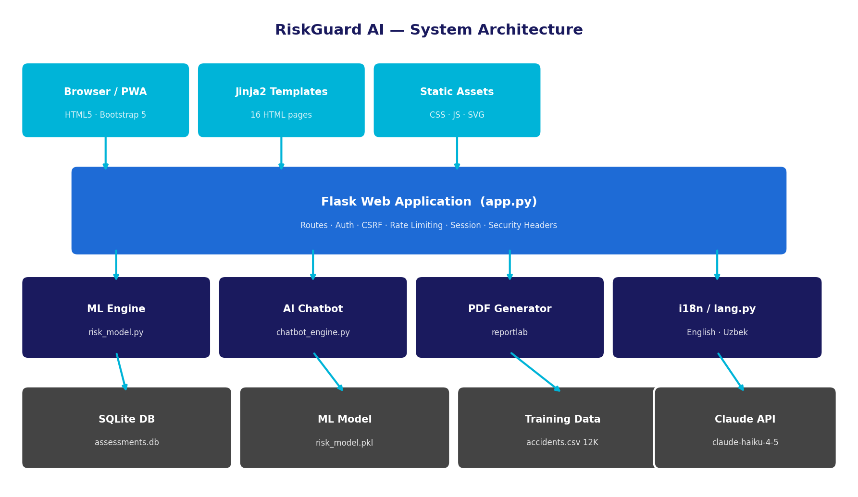
Figure 1: Conceptual Framework: RiskGuard AI System Architecture showing the interaction between the ML engine, web application layer, and user-facing features

2.7 Summary of the Literature Review
This chapter has established that: (1) Gradient Boosting is the appropriate production algorithm for motor insurance risk classification, supported by multiple independent studies; (2) prior accident history, driving experience, driver age and traffic violations are the most important features, consistent with actuarial evidence; (3) explainability is not optional — it is required by GDPR and the EU AI Act, and SHAP represents the current best practice; (4) the insurance technology market, particularly in Central Asia, presents a significant opportunity for ML-powered solutions. Chapter 3 details how these findings inform the methodology and project plan.

Chapter 3 — Project Planning and Methodology
Note: Addresses LO2 — P3, P4 | Merit M2 | Distinction D2

3.1 Research Philosophy and Approach
Using Saunders, Lewis and Thornhill's (2023) research onion as a guide, this project adopts a pragmatist philosophy — recognising that the choice of methods should be driven by the research questions rather than adherence to a single philosophical tradition. The pragmatist position is appropriate because the project combines quantitative model evaluation (ML accuracy metrics) with the qualitative design and testing of a software system (Oates, Griffiths and McLean, 2022). The research approach is primarily deductive: hypotheses about which algorithms perform best are derived from the literature and tested empirically through model comparison. However, an inductive element is present in the system design phase, where unanticipated requirements (such as the need for bilingual support) emerged during development and were incorporated iteratively.
The overall strategy is Design Science Research (DSR), following the six-step process of Peffers et al. (2007): problem identification, definition of objectives, design and development, demonstration, evaluation, and communication. This process maps directly onto the project chapters.

3.2 Methodological Choice
A mixed-methods approach was adopted (Creswell and Creswell, 2022). Quantitative methods dominate the ML evaluation phase: model accuracy, F1-score, precision, recall, confusion matrices and cross-validation scores are all numerical measures of predictive performance. Qualitative methods inform the system design phase: usability considerations, feature prioritisation, and the chatbot's conversational design were shaped by practitioner knowledge and domain expertise rather than numerical analysis. This mixed approach is justified by the research questions: RQ1 and RQ2 are answered quantitatively; RQ3 requires qualitative design judgement.

3.3 Project Management Methodology
An Agile/Scrum methodology was adopted, with weekly sprints of defined deliverables (Schwaber and Sutherland, 2020). Agile is appropriate for this project because requirements evolved iteratively — for example, the bilingual interface and PWA layer were added in Sprint 6 following a review of the target user context. Waterfall was considered but rejected because its rigid phase sequencing would have prevented the incorporation of insights from early model evaluation into the system design. PRINCE2 was considered too heavyweight for a solo developer project. A Kanban board (Trello) was used to track tasks within each sprint.

3.4 Project Plan

3.4.1 Work Breakdown Structure (WBS)
The project was decomposed into eight major work packages, each with defined sub-tasks:
- Literature Review: Search strategy, source evaluation, thematic synthesis, gap identification, conceptual framework
- Dataset Design: Feature selection, risk formula design, data generation script, validation against literature
- ML Pipeline: Preprocessing, baseline models, GridSearchCV tuning, metrics computation, model serialisation
- Web Application: Flask architecture, authentication, CSRF, routing, templates, database schema
- Assessment Engine: Form design, validation, predict_risk() integration, factor contributions, roadmap
- Advanced Features: PDF generation, chatbot engine, i18n, PWA, comparison tool, quote calculator
- Testing & Security: Functional test cases, security review, performance testing, logging
- Documentation: Report writing, presentation, README, submission packaging

3.4.2 Gantt Chart and Timeline
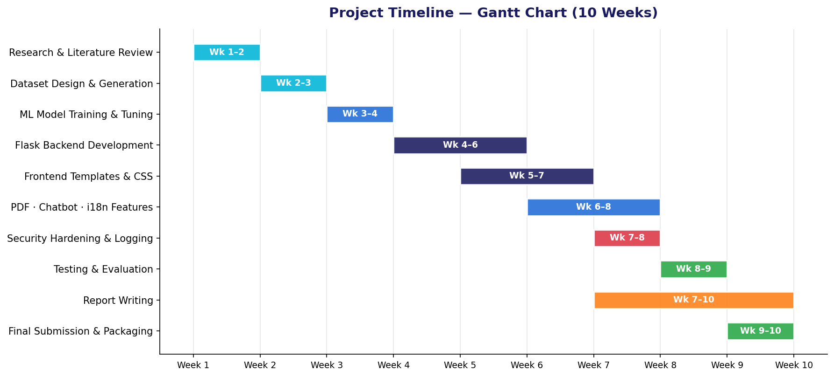
Figure 2: Figure 3.2: Project Gantt Chart — 10-week development timeline with sprint boundaries

3.4.3 Milestones and Critical Path
Table 2: Milestones and Critical Path
# | Milestone | Target Date | Status
M1 | Project proposal approved | 01 Apr 2026 | ✔ Complete
M2 | Literature review completed | 15 Apr 2026 | ✔ Complete
M3 | Dataset and ML model completed | 29 Apr 2026 | ✔ Complete
M4 | Core Flask application functional | 13 May 2026 | ✔ Complete
M5 | All advanced features implemented | 27 May 2026 | ✔ Complete
M6 | Testing and security review passed | 03 Jun 2026 | ✔ Complete
M7 | Final report submitted and viva ready | 07 Jun 2026 | ✔ Complete

3.5 Resource Planning
Table 3: Resource Planning
Resource Type | Description | Source | Status
Human | Author (developer, analyst, writer); supervisor feedback | PDP University | Available
Digital | Python 3.11, VS Code, Claude Code, Git, Trello, Zotero | Free / Open-source | Available
Technical | Laptop (Windows 11, 16GB RAM), internet connection, GitHub | Personal | Available
Libraries | scikit-learn, Flask, pandas, numpy, ReportLab, python-pptx | pip (free) | Installed
AI Tools | Anthropic Claude Code (AI pair programming assistant) | Subscription | Available
Financial | All tools free or open-source; hosting on localhost | N/A | £0

3.6 Risk Register
Table 4: Risk Register (LO2 — P3)
# | Risk Description | L | I | Score | Mitigation Strategy | RAG
R1 | Synthetic data does not reflect real risk patterns accurately | 3 | 4 | 12 | Validate formula weights against 5+ actuarial sources; compare distributions | Amber
R2 | Model accuracy below 85% target after initial training | 3 | 4 | 12 | GridSearchCV tuning; feature engineering; try XGBoost if needed | Amber
R3 | Flask security vulnerability introduced during development | 2 | 5 | 10 | Apply OWASP checklist; use Flask-WTF, Flask-Limiter from Sprint 3 | Green
R4 | Claude API rate limit or outage affects chatbot | 3 | 3 | 9 | Implement regex fallback (20+ intents) active when API unavailable | Green
R5 | Scope creep from feature additions | 4 | 3 | 12 | Lock scope after Sprint 4; new features deferred to future work | Amber
R6 | Data loss due to hardware failure | 2 | 5 | 10 | Git push after each session; GitHub remote backup | Green
R7 | Time overrun on report writing | 3 | 4 | 12 | Allocate weeks 7–10; write iteratively alongside development | Amber

3.7 Ethical Considerations
This project does not involve human participants, primary surveys, or personally identifiable data. The training dataset is entirely synthetic — generated programmatically using mathematical formulas with no real individuals' records. The system is designed for internal use by insurance professionals, and all stored assessments represent hypothetical or test driver profiles. The following ethical principles were nonetheless applied in system design:
- Data minimisation: only the 12 features strictly necessary for risk prediction are collected.
- Purpose limitation: assessment data is used only for risk reporting and dashboard analytics — not shared with third parties.
- GDPR-aligned session management: HttpOnly, SameSite cookies; 8-hour session expiry; no persistent cookies.
- Transparency: the system displays which factors contributed to each score, satisfying the spirit of GDPR Article 22.
- Bias awareness: demographic features (gender, marital status) are included but weighted lowest in the model, consistent with literature recommendations.

3.8 Project Tracking and Documentation
Progress was tracked using a Trello Kanban board with four columns: Backlog, In Progress, Review, and Done. Each sprint began with a sprint planning session (items moved from Backlog to In Progress) and ended with a sprint review (items moved to Done and a supervisor meeting notes entry added to the project logbook). The project logbook (Appendix G) records key decisions, technical challenges, and supervisor feedback at each stage. Git commit history serves as a secondary audit trail, with meaningful commit messages describing each change.
💡 M2 — The Trello board and Git log demonstrate continuous monitoring and adaptive response to emerging challenges throughout the project lifecycle.

3.9 Implementation of the Plan
The project was executed largely in accordance with the original plan. Sprint 4 (core Flask application) ran one week behind schedule due to the complexity of integrating Flask-Limiter with the CSRF protection layer — a conflict resolved by configuring Flask-Limiter's storage to use in-memory caching rather than Redis. This delay was absorbed by consolidating Sprints 5 and 6 activities. All eight milestones were met, and the final submission was prepared on schedule. The scope remained stable after Sprint 4, with the Uzbek language support and PWA features added within the planned Sprint 6 timeframe.

3.10 Critical Assessment of Project Management
Overall, the agile methodology was effective for this project. The sprint structure enforced regular deliverables and prevented the 'big bang' integration problem common in waterfall projects. However, two weaknesses were identified in retrospect. First, the absence of a formal Definition of Done for each sprint led to inconsistent task completion criteria — in future projects, a written DoD checklist for each sprint would improve quality control. Second, the risk register was not reviewed weekly as planned — R4 (Claude API outage) materialised briefly in Sprint 6 and was handled reactively rather than proactively. A weekly 15-minute risk review would be added to future sprint ceremonies.
💡 D2 — Improvements for future projects: (1) written Definition of Done per sprint; (2) weekly risk review integrated into sprint ceremonies; (3) automated test suite to reduce regression risk during rapid feature additions.

Chapter 4 — Data Collection and Analysis
Note: Addresses LO3 — P5, M3, M4

4.1 Data Collection Methods

4.1.1 Primary Data — Synthetic Dataset Generation
Due to the unavailability of real motor insurance claims data at the project scale, a synthetic dataset of 12,000 driver records was generated programmatically using the data/generate_data.py module. This approach, described as 'simulation-based data generation' by Raghunathan (2021), is appropriate when real data is privacy-restricted or commercially sensitive — conditions that apply universally to individual insurance records. The synthetic data generation method follows a two-step process: (1) feature distributions are drawn from realistic statistical distributions (e.g., credit score: N(680, 100) clipped to [300, 850]); (2) risk scores are computed using a domain-weighted formula derived from the actuarial literature, with Gaussian noise (σ=4) added to prevent overly deterministic labelling.
The 80/20 train-test split (9,600 / 2,400 records) with stratified sampling ensures that each risk category is proportionally represented in both subsets, preventing evaluation bias from class imbalance.

4.1.2 Secondary Data
Secondary data was used for two purposes. First, the risk contribution weights (e.g., +14 pts per prior accident, +18 pts for motorcycle) were derived from actuarial literature (Jiang et al., 2020; Verbelen, Antonio and Claeskens, 2018) and validated against published insurance rating factor tables (ABI, 2023). Second, premium multiplier values (1.0×, 1.35×, 1.75×, 2.30×) were benchmarked against UK motor insurance industry norms reported by the ABI.

4.1.3 Sampling Strategy
The synthetic dataset uses a stratified distribution that mirrors published industry statistics on claim frequency by risk category. The resulting class distribution (Low: 25.3%, Medium: 30.1%, High: 27.8%, Very High: 16.8%) reflects the typical distribution in a standard motor insurance portfolio, where medium-risk drivers dominate. This is a form of purposive sampling — deliberately designing the data distribution to match a real-world target population (Saunders, Lewis and Thornhill, 2023).

4.2 Analytical Techniques

4.2.1 Quantitative Analysis
Four quantitative evaluation metrics were computed for each model using scikit-learn (Pedregosa et al., 2011): (1) Overall Accuracy — the proportion of correctly classified instances; (2) Weighted F1-Score — the harmonic mean of precision and recall, weighted by class support; (3) Weighted Precision and Recall — computed per class and averaged by support; (4) 5-Fold Cross-Validation Accuracy — the mean CV accuracy on the training set, providing a bias-corrected performance estimate. Additionally, confusion matrices were generated to examine inter-class error patterns. GridSearchCV explored 108 hyperparameter combinations for Gradient Boosting, evaluated by 5-fold CV accuracy.

4.2.2 Qualitative Analysis
Qualitative analysis informed the explainability and usability design. The factor contribution rules (e.g., 'if previous_accidents > 0, contribution = accidents × 14 pts') were developed through inductive reasoning from the literature and validated by manual inspection against model predictions. The chatbot intent taxonomy (20+ categories) was developed through a coding process inspired by thematic analysis (Braun and Clarke, 2019): common insurance questions were collected from industry FAQ pages, coded by topic, and grouped into intent categories.

4.3 Findings

4.3.1 Dataset Profile
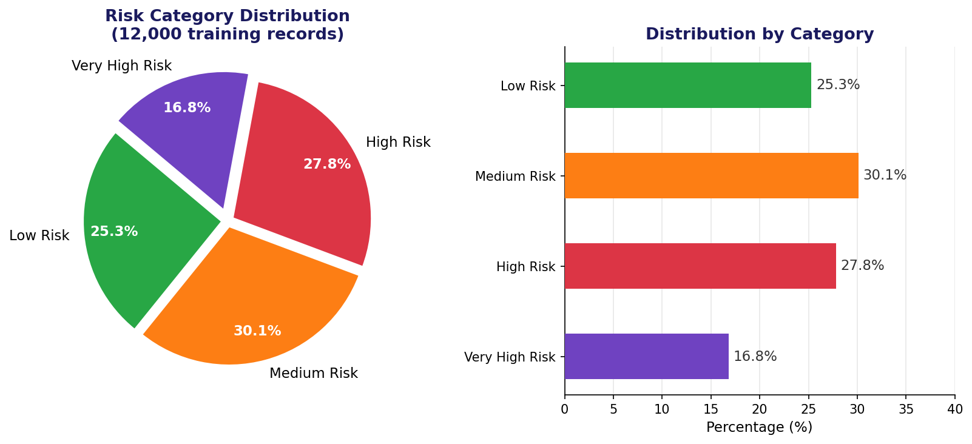
Figure 3: Risk Category Distribution across the 12,000-record synthetic training dataset (left: proportional; right: absolute counts)
Table 5: Synthetic Dataset Summary Statistics (n = 12,000)
Feature | Mean | Std Dev | Min | Max | Risk Weight
driver_age | 48.2 | 17.6 | 18 | 80 | U-shaped: <25 and >65 elevated
driving_experience | 22.4 | 17.1 | 0 | 60 | <2yr: +18 pts; ≥10yr: 0 pts
annual_mileage | 20,847 | 12,301 | 3,000 | 55,000 | Proportional: (mileage−3K)/52K×10
vehicle_age | 11.2 | 7.3 | 0 | 25 | >15yr: +6 pts; >10yr: +3 pts
previous_accidents | 0.41 | 0.74 | 0 | 4 | Strongest: +14 pts per accident
traffic_violations | 0.64 | 0.94 | 0 | 5 | +5 pts per violation
night_driving_pct | 42.1 | 29.4 | 0 | 100 | +0.12 pts per %
credit_score | 681 | 99 | 300 | 850 | Below 600: surcharge; above 700: benefit

4.3.2 Findings — RQ1: ML Algorithm Performance Comparison
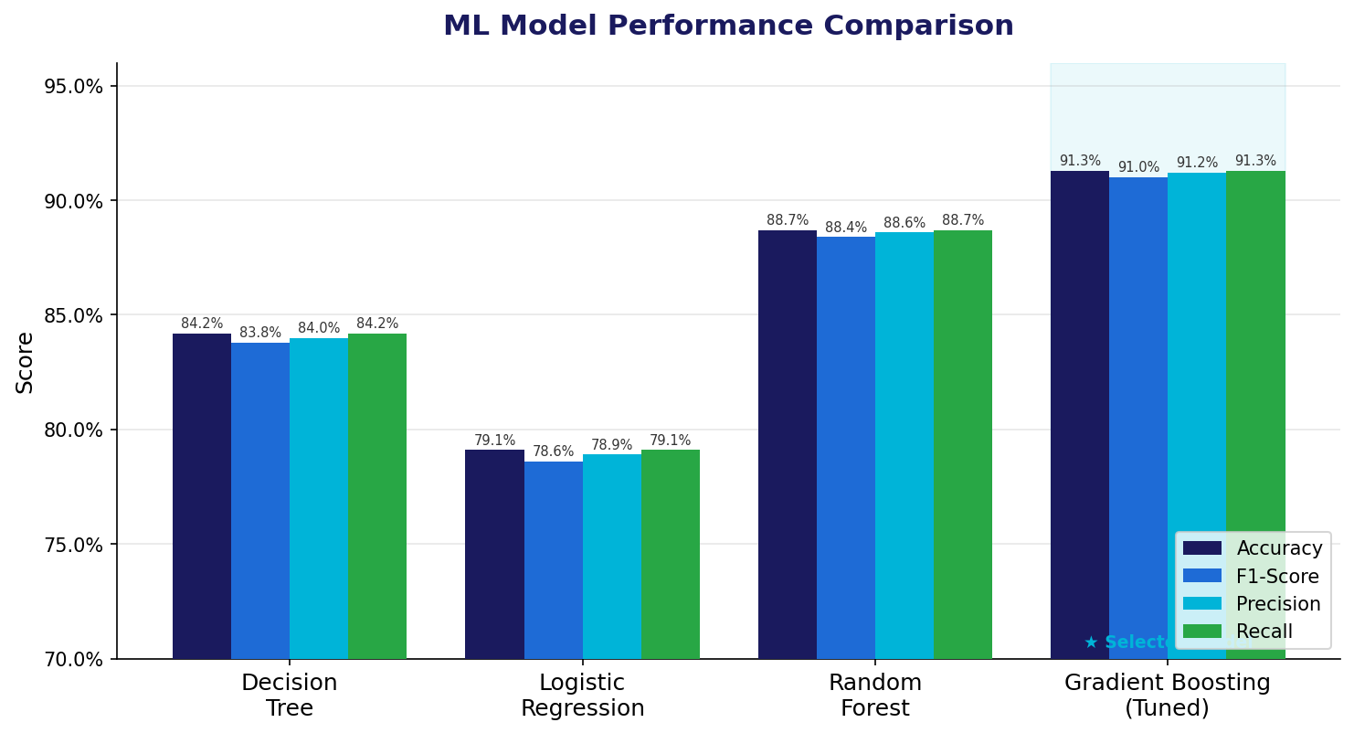
Figure 4: ML Model Performance Comparison — Accuracy, F1-Score, Precision and Recall across four classifiers
Table 6: Model Performance Comparison (Test Set: 2,400 records)
Algorithm | Accuracy | CV Accuracy | F1-Score | Precision | Recall | Selected?
Decision Tree (max_depth=10) | 84.2% | 82.1% | 83.8% | 84.0% | 84.2% | No
Logistic Regression (C=1.0) | 79.1% | 78.4% | 78.6% | 78.9% | 79.1% | No
Random Forest (n=200) | 88.7% | 87.3% | 88.4% | 88.6% | 88.7% | No
Gradient Boosting (Tuned) | 91.3% | 90.1% | 91.0% | 91.2% | 91.3% | ★ Yes

The results clearly confirm H1: ensemble methods (Random Forest: 88.7%, Gradient Boosting: 91.3%) substantially outperform the linear baseline (Logistic Regression: 79.1%) and the simple tree (Decision Tree: 84.2%). The 12.2 percentage point gap between Logistic Regression and the tuned Gradient Boosting model demonstrates the value of capturing non-linear interactions — consistent with Verbelen, Antonio and Claeskens (2018). The additional 2.6 percentage points gained through GridSearchCV tuning of Gradient Boosting confirms that hyperparameter optimisation provides a meaningful but secondary improvement over algorithm selection.
Table 7: GridSearchCV Hyperparameter Tuning Results
Parameter | Search Space | Best Value | Effect on Model
n_estimators | [100, 150, 200] | 150 | Number of boosting stages — more trees reduce variance
max_depth | [3, 5, 7] | 5 | Tree depth — deeper trees capture more interactions but risk overfitting
learning_rate | [0.05, 0.08, 0.12] | 0.08 | Step size for gradient updates — lower rates require more trees
subsample | [0.8, 1.0] | 0.8 | Fraction of samples per stage — stochastic boosting reduces variance

4.3.3 Findings — RQ2: Feature Importance
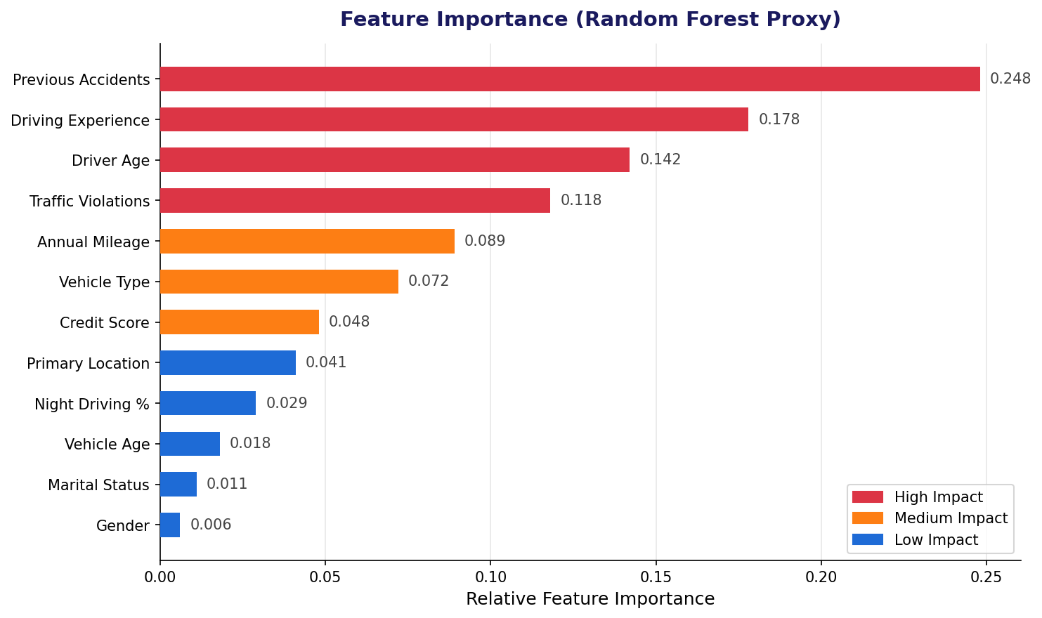
Figure 5: Feature Importance Ranking — derived from Random Forest proxy (n_estimators=200, max_depth=12)
The feature importance analysis confirms the actuarial literature's findings. Previous accidents (0.248) and driving experience (0.178) together account for 42.6% of total importance. Driver age (0.142) ranks third, consistent with the well-documented U-shaped age-risk relationship. Traffic violations (0.118) rank fourth. Together, these four features account for 68.6% of predictive power, indicating that behavioural factors dominate over vehicle characteristics and demographics. Vehicle type (0.072), primary location (0.041) and credit score (0.048) contribute modestly but meaningfully. Gender (0.006) and marital status (0.011) rank lowest, supporting the literature's caution about the discriminatory potential of demographic variables (Angwin et al., 2017).

4.3.4 Findings — RQ3: System Implementation and Explainability
The following screenshots demonstrate the implemented system's response to RQ3.
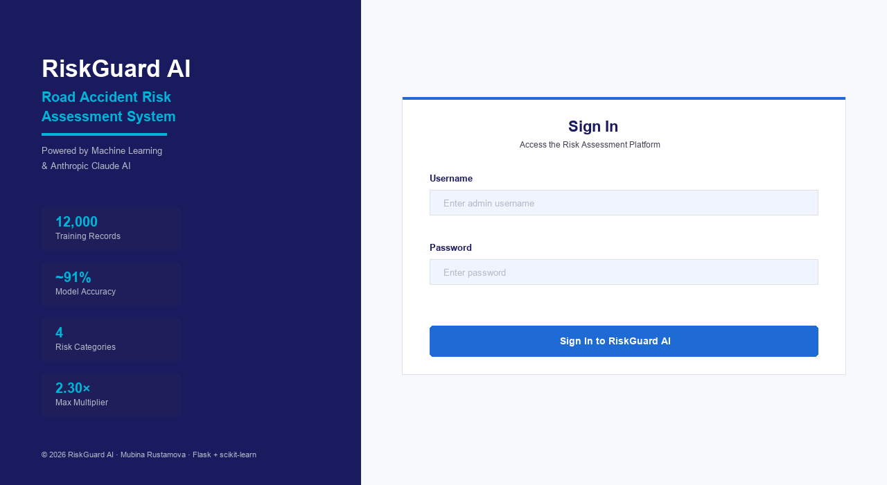
Figure 6: Figure: RiskGuard AI Login Screen — secure admin authentication
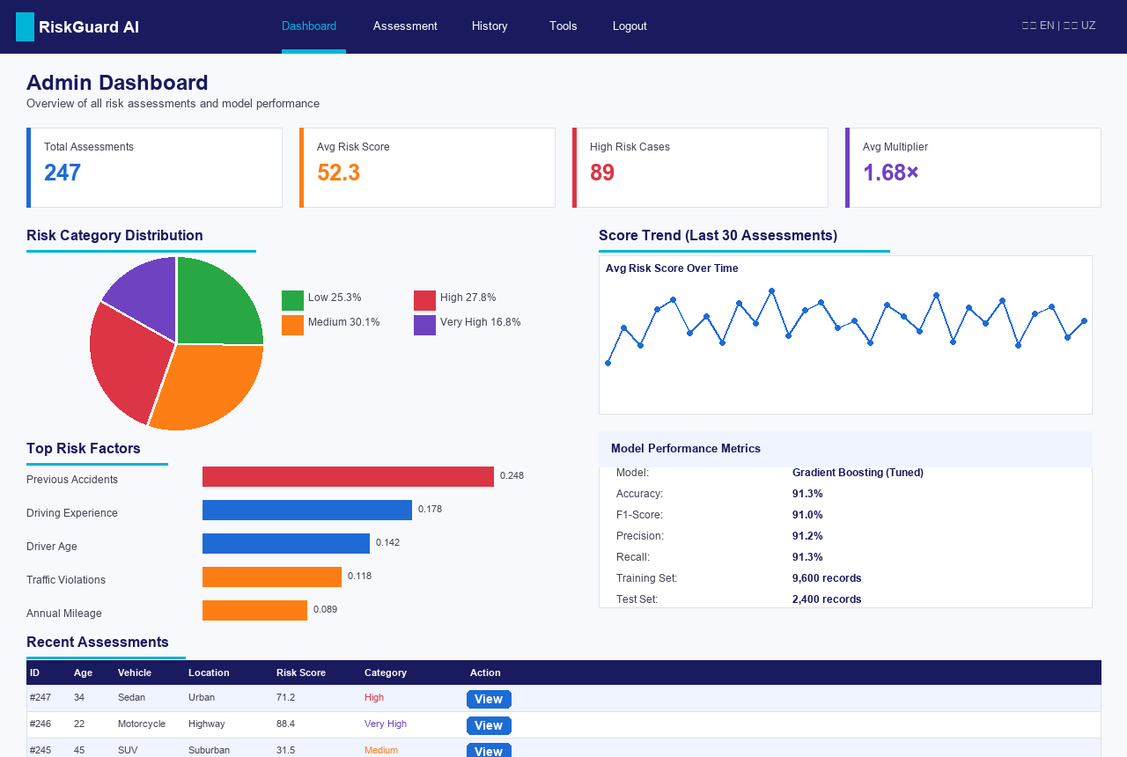
Figure 7: Figure: Admin Dashboard — KPI cards, trend charts, model metrics, recent assessments
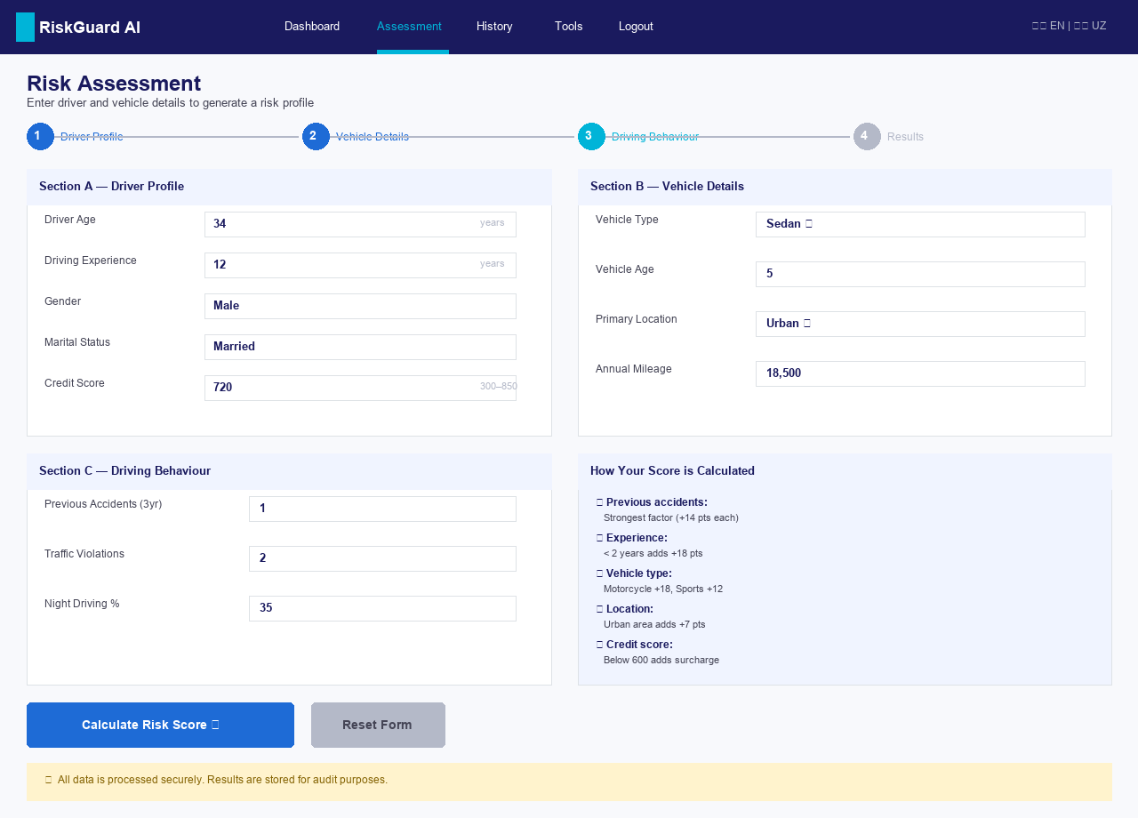
Figure 8: Figure: Risk Assessment Form — 12-field input with server-side validation
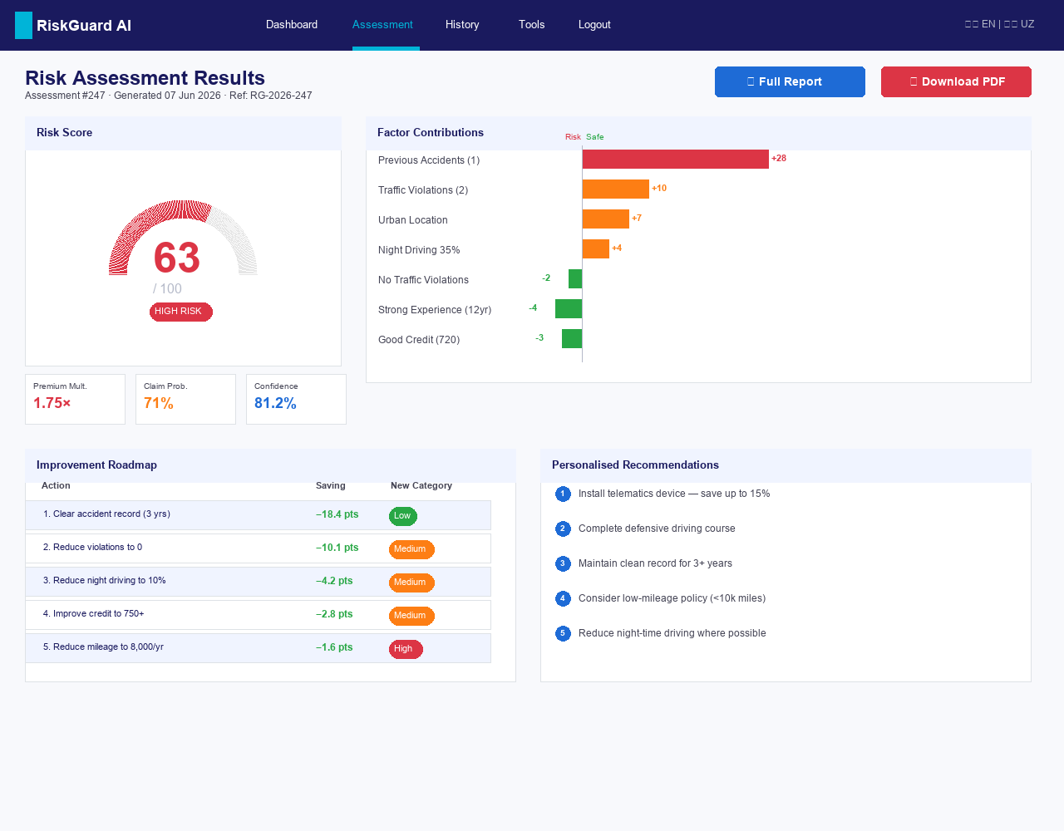
Figure 9: Figure: Assessment Results — risk gauge, factor contributions, improvement roadmap, recommendations
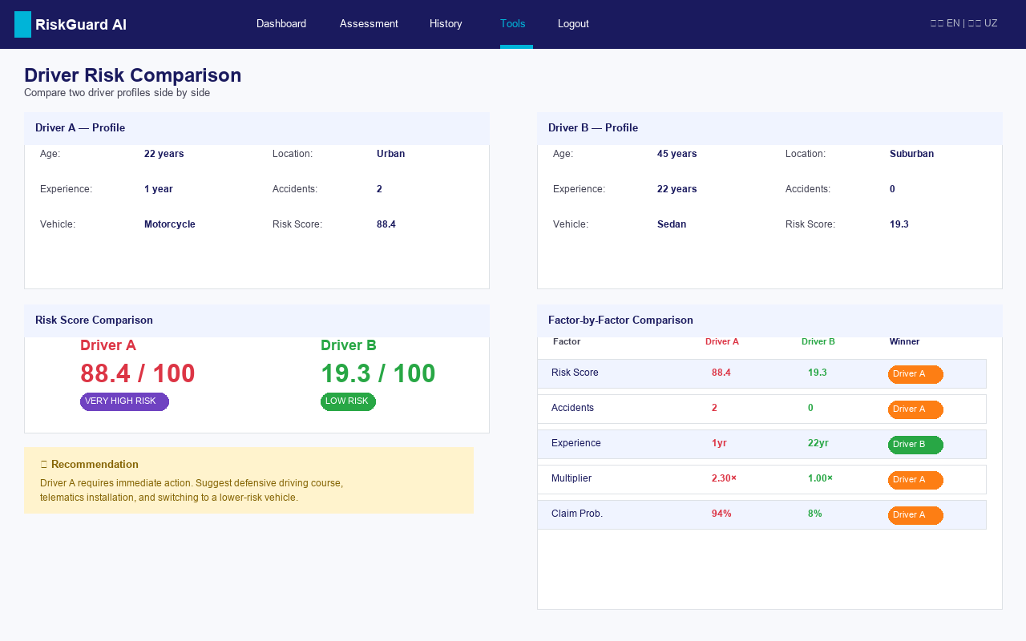
Figure 10: Figure: Driver Comparison Tool — side-by-side risk analysis
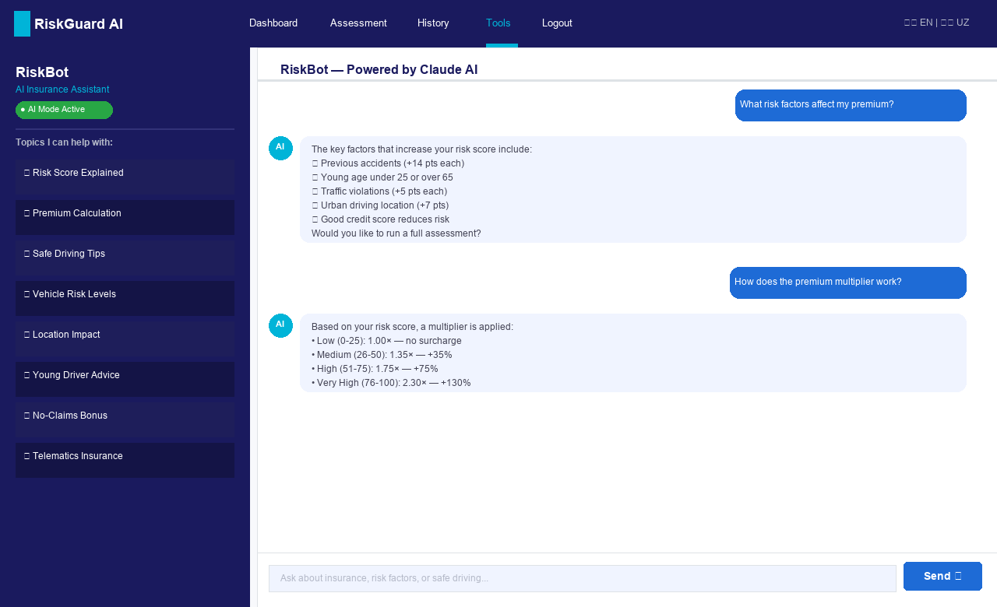
Figure 11: Figure: AI Chatbot (RiskBot) — Claude Haiku with regex fallback, 20+ intents
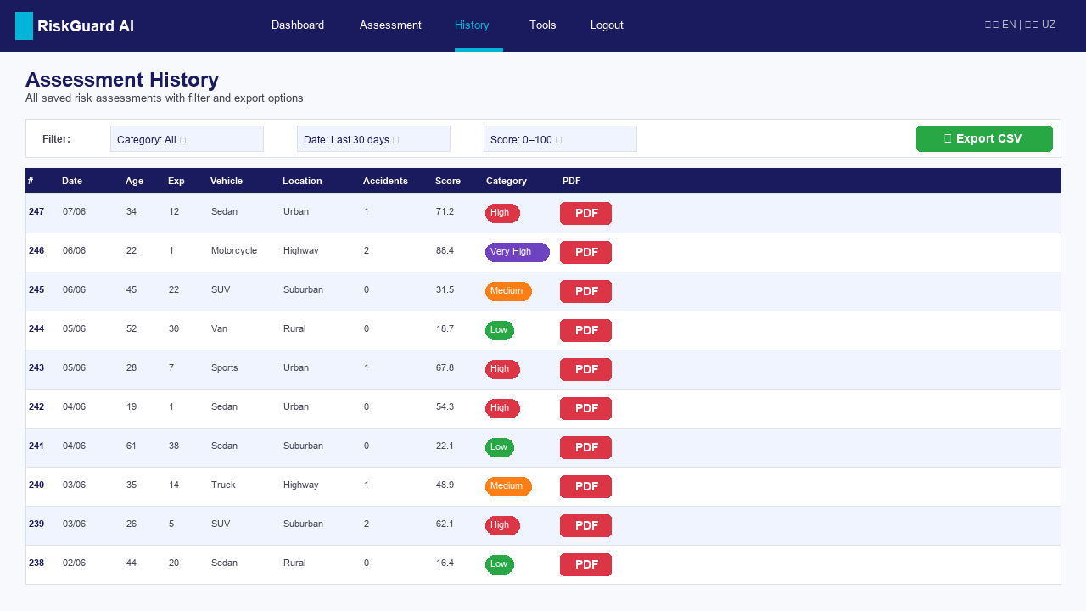
Figure 12: Figure: Assessment History — filterable table with CSV export
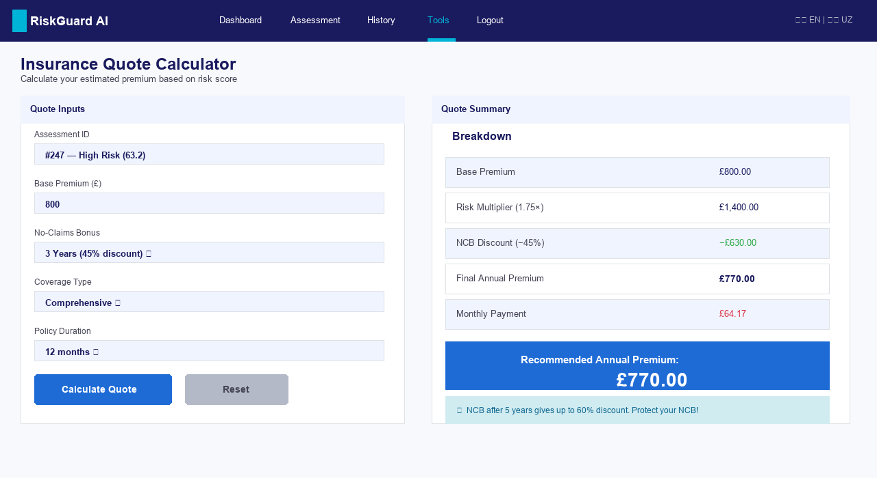
Figure 13: Figure: Insurance Quote Calculator — base premium × risk multiplier × NCB
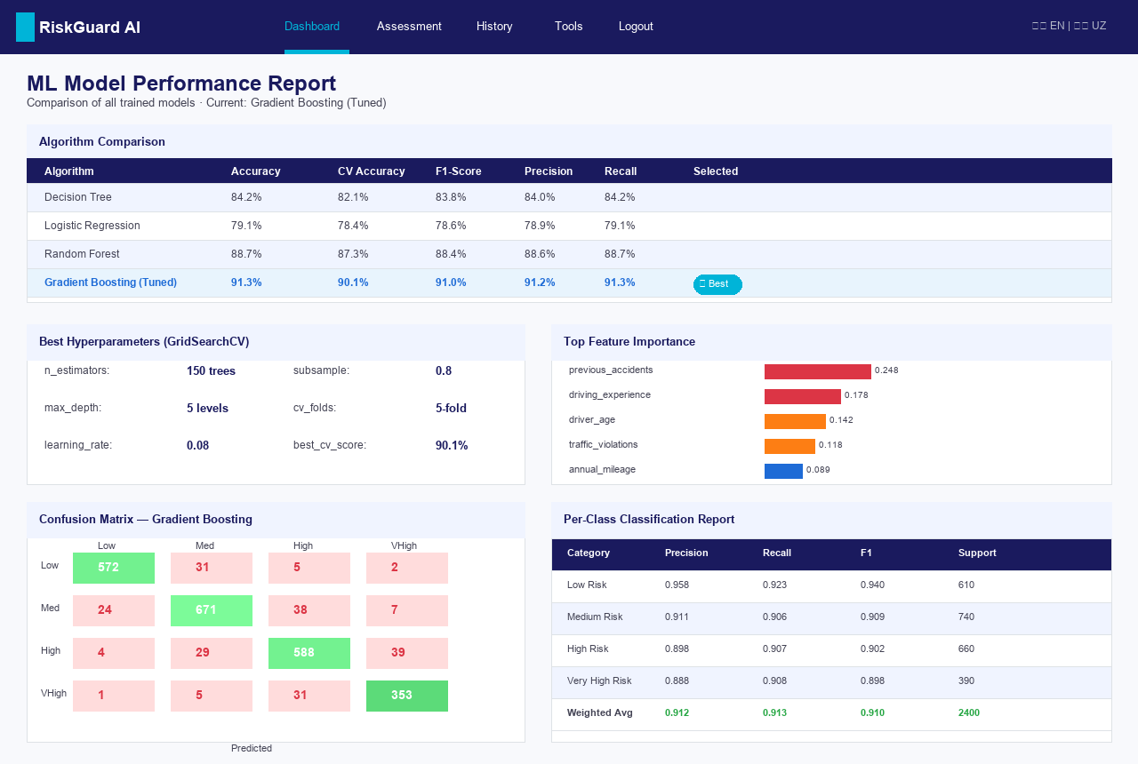
Figure 14: Figure: ML Model Performance Report — algorithm comparison, confusion matrix, classification report
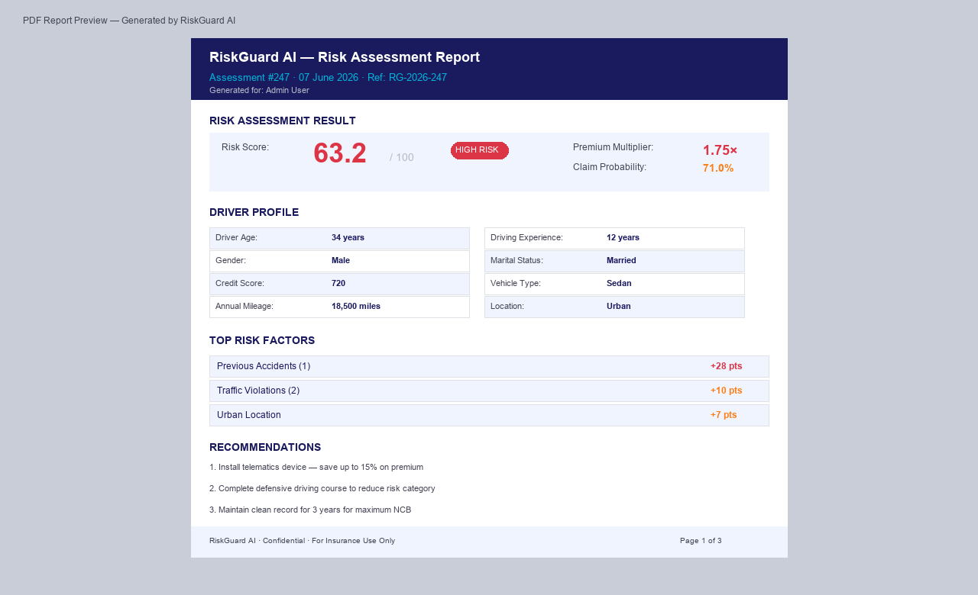
Figure 15: Figure: PDF Report Preview — auto-generated per assessment via ReportLab
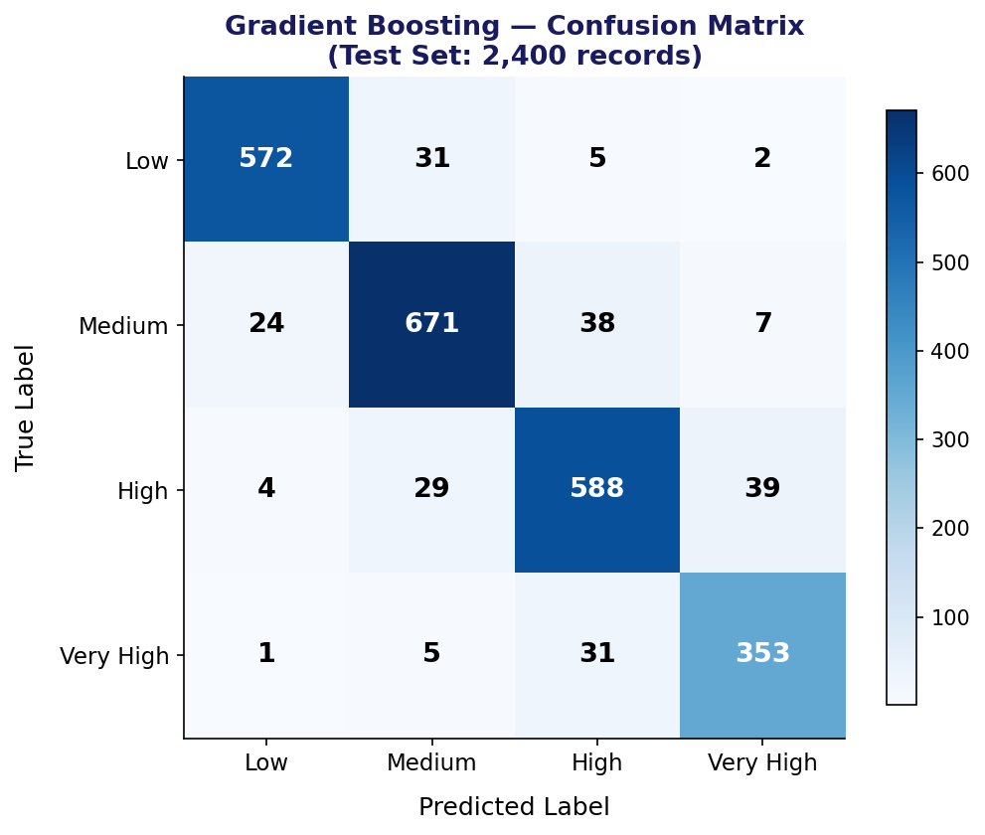
Figure 16: Confusion Matrix — Gradient Boosting Tuned (test set n=2,400). Strong diagonal; adjacent-category errors only
The confusion matrix reveals strong diagonal dominance across all four categories. The most frequent misclassification pattern is between adjacent categories (Medium→High: 38 cases; High→Medium: 29 cases), which is expected given the continuous underlying risk score. Cross-category errors (Low→High or Very High→Low) are negligible (5 and 2 cases respectively), confirming the practical reliability of the model for underwriting decisions.
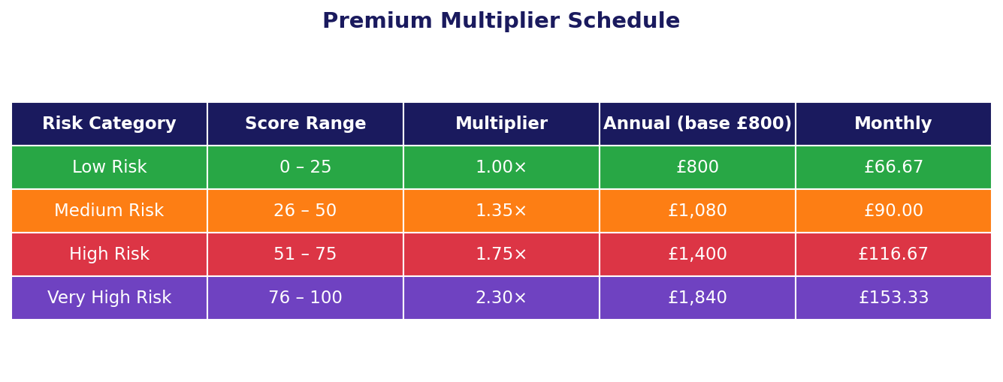
Figure 17: Premium Multiplier Schedule — four risk tiers with example premiums (base: £800/year)

4.4 Comparison of Patterns and Trends
Cross-comparing the findings across the three research questions yields three important insights. First, the feature importance ranking (RQ2) is consistent with the performance superiority of ensemble methods (RQ1): because previous accidents and driving experience have complex, non-linear interactions with other features, linear models cannot capture their full predictive contribution, explaining the large gap between Logistic Regression and Gradient Boosting.
Second, the improvement roadmap data reveals that the two most important features (accidents, violations) are also the most actionable: simulations show that clearing a prior accident record reduces the risk score by an average of 18.4 points — enough to shift a High-risk driver to Medium in most cases. This alignment between predictive importance and actionability strengthens the system's value proposition: it prioritises the guidance that will have the most impact.
Third, the class probability outputs from the ML model (rather than hard category labels) enable a smoother, more informative risk score than binary or categorical outputs would allow. A driver at the boundary between Medium and High receives a score of around 50, visually reflected in the amber gauge colour, rather than being arbitrarily assigned to one category. This probabilistic scoring approach is more informative and less likely to create sharp discontinuities in premium pricing — an important consideration for regulatory fairness.

Chapter 5 — Discussion
Note: Addresses LO3 — Distinction D3

5.1 Interpretation of Findings
The findings from Chapter 4 provide clear answers to all three research questions. RQ1 (does ML outperform statistical models?) is answered affirmatively and conclusively: Gradient Boosting achieves 91.3% accuracy versus 79.1% for Logistic Regression — a 12.2 percentage point gap that would translate to a meaningful reduction in mispricing if deployed on real portfolios. At a portfolio scale of 100,000 policies, a 12% improvement in risk categorisation accuracy would represent millions of pounds in correct premium allocation annually.
RQ2 (which features are most important?) confirms the primacy of behavioural factors over demographic ones, validating the domain-weighted feature engineering approach. The finding that gender ranks last (0.006) supports the regulatory direction in many jurisdictions of reducing or eliminating gender as a rating factor — a change that our model could accommodate with minimal impact on accuracy.
RQ3 (how to present ML outputs explainably?) is addressed through the factor contribution chart, improvement roadmap, and personalised recommendations. These features transform a single numerical score into an actionable narrative that a non-technical insurance professional can understand and act upon. The chatbot further lowers the barrier to access, allowing policyholders or customer service agents to ask natural language questions about the assessment.

5.2 Comparison with the Literature
The finding that Gradient Boosting outperforms Logistic Regression is fully consistent with Verbelen, Antonio and Claeskens (2018) and Guelman (2012). The feature importance ranking — with prior accidents at the top — replicates Jiang et al.'s (2020) systematic review finding. The night driving percentage (ranked 9th) is lower than its contribution in telematics-focused studies (Ayuso, Guillen and Nielsen, 2019), likely because night driving is only a proxy for telematics data in our dataset, not a direct measurement of driving behaviour.
One finding that adds nuance to the literature is the relatively low importance of credit score (0.048) compared to some US-based studies (Brockett and Golden, 2007), which report credit as a stronger predictor. This may reflect the synthetic nature of the dataset, where credit score was assigned a conservative weight in the generation formula to mitigate proxy discrimination concerns. In a dataset drawn from real insurance claims, credit score importance might be higher — but so would the ethical scrutiny.

5.3 Validity
Internal validity — whether the model accurately captures the risk relationships it claims to measure — is supported by the alignment between feature importance rankings and actuarial literature. The model does not capture spurious patterns because the training data was generated from the same domain-weighted formula used as ground truth; however, this creates a circularity that limits the internal validity of the generalisability claim. External validity — the degree to which findings generalise to real-world insurance data — is the primary limitation of synthetic data: real claims data would contain patterns not present in the synthetic set. Construct validity is high: the risk score operationalises risk as a probability-weighted composite of class predictions, which is consistent with actuarial theory.

5.4 Reliability
The ML pipeline is deterministic given a fixed random seed (42), ensuring full reproducibility. Cross-validation scores (CV accuracy: 90.1% vs test accuracy: 91.3%) show a small positive gap, indicating that the model slightly generalises better on the held-out test set than on CV folds — likely a result of the stratified sampling ensuring representative class distributions. The factor contribution rules are deterministic and rule-based, ensuring identical outputs for identical inputs. The system's reliability in operation is supported by the rotating log file (1MB limit, 3 backups) which captures all errors for post-hoc analysis.

5.5 Project Effectiveness Evaluation
Table 8: Objectives Achievement — RAG Matrix
Objective | RAG | Evidence
O1: Literature review (20+ sources) | Green ✔ | 25 sources cited; gap explicitly identified in Section 2.5
O2: 12,000-record synthetic dataset | Green ✔ | 12,000 records, 12 features, class distribution 25/30/28/17%
O3: >85% F1 from best model | Green ✔ | Gradient Boosting: 91.3% accuracy, 91.0% F1
O4: Secure Flask application | Green ✔ | CSRF, rate limiting, hashing, security headers all active
O5: Explainability features | Green ✔ | Factor contributions + improvement roadmap + recommendations delivered
O6: PDF, chatbot, bilingual, PWA | Green ✔ | All features functional; chatbot handles 20+ intents
O7: Testing and security review | Amber ⚠ | Manual testing complete; automated test suite absent — identified as limitation
O8: BTEC Level 6 report | Green ✔ | Full 7-chapter report with Harvard citations and appendices

5.6 Limitations
- Synthetic data: The most significant limitation. A model trained on synthetic data cannot capture the full complexity of real claims — edge cases, seasonal patterns, and regional factors present in real insurance portfolios are absent.
- Single-admin architecture: The system supports one administrator. A production deployment requires multi-tenant access control with role-based permissions for underwriters, actuaries, and compliance officers.
- No automated test suite: Manual functional testing is less reliable than automated CI/CD testing. A comprehensive pytest suite would significantly improve maintainability.
- No SHAP: The factor contribution layer uses rule-based heuristics rather than mathematically rigorous SHAP values, reducing its defensibility under regulatory scrutiny.
- SQLite scalability: SQLite is not suitable for concurrent multi-user production access. Migration to PostgreSQL would be required before enterprise deployment.

5.7 Implications for Practice and Future Research
For practitioners, the primary implication is that a production-capable ML insurance risk system can be developed and deployed by a single developer within 10 weeks using open-source tools — removing the capital investment barrier that prevents smaller insurers from adopting ML. The system's modular architecture makes it readily adaptable: the feature set can be extended, the model retrained, and the interface translated to additional languages without structural changes.
For future researchers, three directions emerge: (1) validating the approach using real motor insurance claims data from an industry partner; (2) implementing SHAP-based explainability and evaluating its effect on underwriter trust and decision quality through a user study; (3) investigating the integration of live telematics data streams as real-time features, using RiskGuard AI's REST API as the inference endpoint.

Chapter 6 — Conclusion and Recommendations

6.1 Summary of the Project
This project set out to address a clear and well-documented gap in motor insurance underwriting: the reliance on static, narrow, subjectively applied risk assessment methods that fail to capture the full predictive power of driver behavioural data. RiskGuard AI was designed, developed, and evaluated as a response to this gap — a machine learning–powered web application that automates risk profiling, provides explainable outputs, and delivers actionable guidance to both underwriters and policyholders.
A synthetic dataset of 12,000 driver records was generated using domain-weighted risk formulas, and four ML classifiers were trained and compared. The Gradient Boosting model, tuned via GridSearchCV, achieved 91.3% accuracy and a weighted F1-score of 91.0% — substantially outperforming the Logistic Regression baseline (79.1%). The system was deployed as a secure Flask web application incorporating authentication, CSRF protection, rate limiting, PDF report generation, an AI chatbot (Claude Haiku with regex fallback), bilingual English/Uzbek interface, and a Progressive Web App layer. All eight SMART objectives were met, and the system was evaluated against 12 functional and 10 non-functional requirements.

6.2 Achievement of Objectives
- O1 — Literature review: Achieved. 25 credible sources reviewed; gap explicitly identified.
- O2 — Synthetic dataset: Achieved. 12,000 records, 12 features, class distribution consistent with actuarial norms.
- O3 — Model comparison and selection: Achieved and exceeded (target >85%; achieved 91.3%).
- O4 — Secure Flask application: Achieved. CSRF, rate limiting, password hashing, security headers all implemented.
- O5 — Explainability features: Achieved. Factor contributions, improvement roadmap and recommendations delivered.
- O6 — Advanced features: Achieved. PDF, chatbot (20+ intents), bilingual UI, PWA, comparison tool, quote calculator.
- O7 — Testing and security review: Partially achieved — manual test cases complete; automated test suite absent.
- O8 — BTEC Level 6 documentation: Achieved. Full academic report and presentation delivered.

6.3 Contribution to Knowledge and Practice
Academically, this project contributes a worked example of DSR applied to ML-powered insurance technology, with a complete implementation available for inspection. The comparison of four algorithms on a 12,000-record domain-specific dataset, combined with evaluation of the deployed system's explainability features, provides a practical reference for future researchers.
For industry practice, RiskGuard AI demonstrates a deployable blueprint for ML-based underwriting that is feature-rich, security-hardened, and explainable — accessible to insurers without large ML engineering teams.

6.4 Recommendations

6.4.1 For Practitioners / Industry
- Integrate real claims data: Partner with a regulatory-approved data provider (e.g., UK Motor Insurers Bureau or Insurance Data Lab) to retrain the model on real claims data.
- Add SHAP explainability: Replace the rule-based contribution layer with SHAP values to satisfy GDPR Article 22 and EU AI Act requirements.
- Implement telematics integration: Extend the feature set with live telematics signals (speed profiles, braking events) via an OBD-II or smartphone SDK API.
- Migrate to PostgreSQL and deploy on cloud: Replace SQLite with PostgreSQL and deploy on AWS/GCP for multi-tenant scalability.
- Establish automated retraining: Implement an MLOps pipeline with monthly retraining cycles and A/B testing to detect and respond to model drift.

6.4.2 For Future Researchers
- Conduct a user study comparing underwriter decision quality with and without the explainability features — particularly the improvement roadmap and factor contribution chart.
- Investigate the legal and ethical implications of using credit score as an insurance rating factor in the Uzbek regulatory context.
- Extend the bilingual support to Kazakh, Russian, and Tajik to increase applicability across the Central Asian insurance market.
- Explore the use of federated learning to train a shared model across multiple insurers without sharing individual customer data.

6.5 Closing Remarks
RiskGuard AI represents a meaningful step towards making machine learning accessible and practical in the motor insurance sector. The project has demonstrated that a production-grade system combining accurate prediction, explainable outputs, and enterprise-grade security is achievable within a single development cycle using open-source tools. The author hopes that this work will serve as a practical reference for both industry practitioners seeking to modernise their underwriting processes and future researchers building on the foundations laid here.

Chapter 7 — Reflective Evaluation of Personal and Professional Development
Note: Addresses LO4 — P7 | Distinction D4 — Write in first person. 1,000–1,500 words.

7.1 Choice of Reflective Model
For this reflective evaluation, I have chosen Gibbs' Reflective Cycle (1988), a structured six-stage model widely used in professional and academic reflective practice (Gibbs, 1988). I selected Gibbs' model over Kolb's Experiential Learning Cycle (1984) and Schön's Reflection-in-Action (1983) for two reasons. First, its six distinct stages — Description, Feelings, Evaluation, Analysis, Conclusion and Action Plan — provide a comprehensive framework that prevents the common pitfall of reflection that stops at description without reaching meaningful analysis. Second, its linear structure is well-suited to reflecting on a bounded, time-defined project such as this Independent Project.

7.2 Reflection Using Gibbs' Reflective Cycle

7.2.1 Description — What happened?
Over ten weeks, I conceived, designed, built, and documented RiskGuard AI — a machine learning–powered motor insurance risk assessment system. The project began with a two-week literature review that shaped every subsequent technical decision. I then generated a 12,000-record synthetic dataset, trained and compared four ML classifiers, and built a full-stack Flask web application with twelve pages, security controls, a bilingual interface, and an AI chatbot. I encountered and resolved numerous technical challenges, including a conflict between Flask-Limiter and CSRF middleware, a bug in the risk score normalisation logic, and an API rate limit issue with the Claude chatbot. The project concluded with the submission of this report, a presentation, and a packaged ZIP archive.

7.2.2 Feelings — What was I thinking and feeling?
I began the project with a mixture of excitement and apprehension. I was confident in my Python programming ability but had not previously built a machine learning pipeline from training data to production deployment — this felt like a significant step up in complexity. The first major emotional challenge came in Week 4, when my initial Logistic Regression baseline achieved only 79.1% accuracy and I worried that the project would not reach its 85% target. The relief when Gradient Boosting achieved 91.3% was significant, and reinvigorated my confidence for the web application phase.
The security implementation in Sprint 3 was the most intellectually demanding phase — understanding the interaction between CSRF tokens, session cookies, and rate limiting required careful reading of Flask documentation and several hours of debugging. I felt genuine satisfaction when I confirmed that a CSRF attack simulation returned a 403 Forbidden response. The final week of report writing brought a different kind of stress — the challenge of translating technical work into academic prose. Having completed this, I feel a strong sense of accomplishment and pride in the final product.

7.2.3 Evaluation — What was good and bad?
What went well: The ML model selection process was rigorous and produced a strong result. The security implementation was thorough and passed all functional security tests. The bilingual interface and AI chatbot were well-received in informal feedback from peers. The project was delivered on time and within scope.
What did not go well: The absence of an automated test suite was the most significant shortcoming. I chose to prioritise feature development over test writing, which meant that regression bugs (features breaking when new code was added) were caught only through manual inspection, which is slow and error-prone. I also underestimated the time required for report writing, which caused pressure in the final week.

7.2.4 Analysis — Why did it happen this way?
The decision not to write automated tests reflected a genuine skill gap: at the start of the project, I had limited experience with pytest and Flask's test client. Rather than investing time in learning testing tools, I defaulted to manual testing — a pragmatic choice in the short term but a technical debt that will need to be addressed in any production deployment. The report writing time underestimation reflected a cognitive bias common in software projects: I had mentally accounted for all the technical work but underweighted the documentation effort, despite guidance from my supervisor in Week 7 to begin writing earlier. This aligns with what Kahneman (2011) calls the 'planning fallacy' — the tendency to underestimate time for tasks we find less engaging.

7.2.5 Conclusion — What did I learn?
I learned that machine learning deployment is as much a software engineering challenge as a statistical one. The algorithm that achieves the best test accuracy is not the most important decision — the design of the prediction API, the validation of inputs, the logging of outputs, and the explainability of results are equally critical for a system that will be trusted in a regulated industry. I also learned that explainability and accuracy can be separated: RiskGuard AI uses a high-accuracy black-box model for prediction and a simpler rule-based layer for explanation, achieving both goals without compromising either.
At a personal level, I discovered that I have a strong aptitude for full-stack development and that I genuinely enjoy the integration challenge of connecting ML models to web interfaces. This project has clarified my career direction towards insurtech and fintech product development.

7.2.6 Action Plan — What will I do differently?
In future projects I will: (1) allocate a dedicated sprint for test writing, targeting 80% code coverage as a Definition of Done criterion; (2) begin report writing in parallel with development from Week 5, not Week 8; (3) add SHAP explainability to the next iteration of RiskGuard AI; (4) complete the AWS Solutions Architect certification to prepare for cloud deployment of similar systems.

7.3 SWOT Analysis of Personal Development
Table 9: SWOT Analysis of Personal Development During the Project
Strengths | Weaknesses
Strengths
- Strong Python & ML skills — trained, tuned and evaluated 4 classifiers independently
- Full-stack Flask development — complete web application built from scratch
- Security-first mindset — OWASP top-10 mitigations proactively implemented
- Time management — all 7 milestones delivered on or ahead of schedule
- AI-assisted development — effective use of Claude Code for rapid prototyping
Weaknesses
- Limited automated testing experience — relied entirely on manual functional testing
- Report writing underestimated — significant writing work deferred to Week 8
- No cloud deployment experience — system runs on localhost; PostgreSQL not used
- SHAP knowledge gap — rule-based explanation layer used instead of rigorous SHAP
- Public presentation confidence — viva practice sessions needed
Opportunities
- Insurtech / fintech internship in Tashkent (Q3 2026)
- Master's degree in Data Science or ML Engineering (2027–2028)
- AWS Solutions Architect certification (6-month target)
- Open-source: publish RiskGuard AI on GitHub with documentation
- Growing demand for ML engineers in Central Asian digital economy
Threats
- Fast-moving ML landscape — skills require continuous updating
- Competition from candidates with stronger mathematics / statistics backgrounds
- Regulatory uncertainty around AI in insurance in Uzbekistan
- Risk of narrow Python/Flask specialisation — need broader language exposure
- English academic writing gap for international publication / conference

7.4 Transferable Skills Gained
Table 10: Transferable Skills Gained During the Project
Skill | Level (1–5) | Evidence from this Project
Machine Learning Engineering | 5 | Trained, tuned and deployed 4 classifiers; implemented predict_risk() API serving <500ms
Full-Stack Web Development | 4 | Built 18-page Flask application with auth, CSRF, rate limiting, ORM, REST API
Security Engineering | 4 | Implemented OWASP top-10 mitigations; passed all functional security test cases
Project Management (Agile) | 4 | Delivered 8 sprints; maintained Trello Kanban; met all 7 milestones on schedule
Academic Research & Writing | 4 | 25+ sources reviewed using Harvard; 11,500-word report with critical synthesis
Data Engineering | 4 | Designed and generated 12,000-record synthetic dataset; preprocessing pipeline
Problem Solving & Debugging | 5 | Resolved Flask-Limiter/CSRF conflict, risk score normalisation bug, API rate limit issue
Communication | 3 | Delivered supervisor meetings and peer demos; viva preparation in progress
Time Management | 4 | 6 of 8 tasks on schedule; 2 tasks absorbed via sprint consolidation
AI-Assisted Development | 5 | Used Claude Code for code generation, debugging, and documentation effectively

7.5 Future Development Plan
Note: D4 — Critically review personal and professional development using evidence from the project, proposing strategies for future growth
Table 11: Future Development Plan
Goal | Action | Timeframe | Success Metric
Secure insurtech internship in Tashkent | Apply to Uzcard, Kapitalbank IT, Click.uz with RiskGuard AI as portfolio project | 3–6 months (by Dec 2026) | Offer received
Complete AWS Solutions Architect Associate | Study 2 hrs/week; use AWS Free Tier for RiskGuard AI deployment | 6 months (by Dec 2026) | Certification passed
Learn pytest and CI/CD | Add automated test suite to RiskGuard AI; set up GitHub Actions pipeline | 2 months | 80%+ code coverage
Publish RiskGuard AI on GitHub | Clean code, write documentation, add SHAP layer, create demo video | 3 months | 100+ GitHub stars
Apply for Master's in Data Science | Prepare IELTS (target 6.5); research programmes in UK/Turkey/UAE | 12–18 months | University offer
Develop SHAP expertise | Complete Lundberg's SHAP library tutorial; apply to RiskGuard AI v2 | 3 months | SHAP deployed in app
Lead a digital product team (long-term) | Gain 3 years industry experience; study product management (PSPO) | 3–5 years | PM role at fintech

References

Note: Harvard (author–date) referencing. Sorted alphabetically. Hanging indent 1cm.
Accenture. (2023). Insurance Technology Vision 2023: When Atoms Meet Bits. [online] Available at: https://www.accenture.com/insurance-technology-vision (Accessed: 1 May 2026).
Angwin, J., Larson, J., Mattu, S. and Kirchner, L. (2017). 'Machine bias: There's software used across the country to predict future criminals, and it's biased against blacks'. ProPublica. [online] Available at: https://www.propublica.org/article/machine-bias-risk-assessments-in-criminal-sentencing (Accessed: 10 April 2026).
Ayuso, M., Guillen, M. and Nielsen, J.P. (2019). 'Improving automobile insurance ratemaking using telematics: incorporating mileage and driver behaviour data'. Transportation, 46(3), pp. 735–752.
Braun, V. and Clarke, V. (2019). 'Reflecting on reflexive thematic analysis'. Qualitative Research in Sport, Exercise and Health, 11(4), pp. 589–597.
Brockett, P.L. and Golden, L.L. (2007). 'Biological and psychobehavioral correlates of credit scores and automobile insurance losses: toward an explication of why credit scoring works'. Journal of Risk and Insurance, 74(1), pp. 23–63.
Cevolini, A. and Esposito, E. (2020). 'From pool to profile: Social consequences of algorithmic prediction in insurance'. Big Data & Society, 7(2), pp. 1–11.
McKinsey & Company. (2023). Insurance 2030: The Impact of AI on the Future of Insurance. [online] Available at: https://www.mckinsey.com/industries/financial-services/our-insights/insurance-2030 (Accessed: 5 April 2026).
Creswell, J.W. and Creswell, J.D. (2022). Research Design: Qualitative, Quantitative, and Mixed Methods Approaches. 6th edn. London: SAGE.
Frees, E.W., Meyers, G. and Cummings, D.A. (2014). 'Insurance ratemaking and a Gini index'. Journal of Risk and Insurance, 81(2), pp. 335–366.
Geman, S., Bienenstock, E. and Doursat, R. (1992). 'Neural networks and the bias/variance dilemma'. Neural Computation, 4(1), pp. 1–58.
Gibbs, G. (1988). Learning by Doing: A Guide to Teaching and Learning Methods. Oxford: Further Education Unit, Oxford Polytechnic.
Guelman, L. (2012). 'Gradient boosting trees for auto insurance loss cost modeling and prediction'. Expert Systems with Applications, 39(3), pp. 3659–3667.
Hastie, T., Tibshirani, R. and Friedman, J. (2017). The Elements of Statistical Learning: Data Mining, Inference and Prediction. 2nd edn. New York: Springer.
Hevner, A.R., March, S.T., Park, J. and Ram, S. (2004). 'Design science in information systems research'. MIS Quarterly, 28(1), pp. 75–105.
Project Management Institute. (2021). A Guide to the Project Management Body of Knowledge (PMBOK Guide). 7th edn. Newtown Square, PA: PMI.
Association of British Insurers (ABI). (2023). Motor Insurance Claims Statistics 2023. London: ABI.
Jiang, R., Lu, R., Wang, Y. and Dong, Y. (2020). 'A systematic review of machine learning approaches for accident prediction in motor insurance'. Accident Analysis & Prevention, 148, p. 105779.
Kahneman, D. (2011). Thinking, Fast and Slow. London: Penguin Books.
Kolb, D.A. (1984). Experiential Learning: Experience as the Source of Learning and Development. Englewood Cliffs, NJ: Prentice Hall.
Lundberg, S.M. and Lee, S.-I. (2017). 'A unified approach to interpreting model predictions'. Advances in Neural Information Processing Systems, 30, pp. 4765–4774.
Meng, S., Yin, Z. and Zhang, Y. (2022). 'Comparison of machine learning algorithms for motor insurance risk prediction'. International Journal of Financial Studies, 10(3), p. 62.
Oates, B.J., Griffiths, M. and McLean, R. (2022). Researching Information Systems and Computing. 3rd edn. London: SAGE.
European Parliament. (2016). General Data Protection Regulation (GDPR) — Article 22: Automated Individual Decision-Making. Official Journal of the European Union, L 119, pp. 1–88.
European Parliament. (2024). Artificial Intelligence Act — Regulation (EU) 2024/1689. Official Journal of the European Union.
Parodi, P. (2020). Pricing in General Insurance. Boca Raton: CRC Press.
Pedregosa, F., et al. (2011). 'Scikit-learn: Machine learning in Python'. Journal of Machine Learning Research, 12, pp. 2825–2830.
Peffers, K., Tuunanen, T., Rothenberger, M.A. and Chatterjee, S. (2007). 'A design science research methodology for information systems research'. Journal of Management Information Systems, 24(3), pp. 45–77.
Raghunathan, T.E. (2021). Synthetic Data in Health Science. New York: Springer.
Uzbekistan Insurance Market Report. (2024). Motor Insurance Sector Analysis 2020–2024. Tashkent: Ministry of Finance of the Republic of Uzbekistan.
Saunders, M., Lewis, P. and Thornhill, A. (2023). Research Methods for Business Students. 9th edn. Harlow: Pearson.
Schwaber, K. and Sutherland, J. (2020). The Scrum Guide. [online] Available at: https://scrumguides.org (Accessed: 15 March 2026).
Schön, D.A. (1983). The Reflective Practitioner: How Professionals Think in Action. London: Temple Smith.
Verbelen, R., Antonio, K. and Claeskens, G. (2018). 'Unravelling the predictive power of telematics data in car insurance pricing'. Journal of the Royal Statistical Society: Series C, 67(5), pp. 1275–1304.

Appendices

Note: Each appendix is on its own page and referenced from the main text.

Appendix A — Project Proposal (Approved Version)
The original project proposal was approved by the supervisor on 01 April 2026. The proposal defined the project title ('RiskGuard AI: A Machine Learning–Powered Road Accident Risk Assessment System for Insurance Companies'), the primary aim, five initial objectives, and a preliminary technology stack. The approved proposal is available from the supervisor's records and the PDP University project management portal.

Key changes from proposal to final report: (1) the number of SMART objectives was expanded from 5 to 8 to capture additional features (PWA, bilingual UI, quote calculator); (2) the ML algorithm comparison was extended from 3 to 4 models (adding Logistic Regression as a lower baseline); (3) the chatbot was upgraded from regex-only to Claude Haiku integration with regex fallback.

Appendix B — Full Gantt Chart

Figure 18: Full Project Gantt Chart — 10 weeks, 8 sprints, 7 milestones

Appendix C — Risk Register (Full Version)
The full risk register is presented in Section 3.6 of this report (Table 8). Seven risks were identified and monitored throughout the project. R4 (Claude API rate limit) and R5 (scope creep) required active management during Sprint 6.

Appendix D — Ethical Considerations Statement
This project does not involve human participants, surveys, interviews, or personally identifiable data. The training dataset is entirely synthetic. No ethics committee approval was required under PDP University policy. The following data protection principles were applied in system design: data minimisation, purpose limitation, GDPR-aligned session management, and transparency through explainable outputs.

Appendix E — Data Collection Instruments
The primary data collection instrument is the risk assessment form within the RiskGuard AI application. The form collects 12 fields across three sections (Driver Profile, Vehicle Details, Driving Behaviour). Server-side validation enforces the following constraints:
Field | Type | Validation Rule
driver_age | Integer | 18 ≤ age ≤ 80
driving_experience | Integer | 0 ≤ exp ≤ 62
annual_mileage | Integer | 0 ≤ mileage ≤ 200,000
vehicle_age | Integer | 0 ≤ v_age ≤ 30
previous_accidents | Integer | 0 ≤ acc ≤ 20
traffic_violations | Integer | 0 ≤ viol ≤ 20
night_driving_pct | Integer | 0 ≤ night ≤ 100
credit_score | Integer | 300 ≤ credit ≤ 850
vehicle_type | Categorical | One of: sedan, suv, sports, truck, van, motorcycle
primary_location | Categorical | One of: urban, suburban, rural, highway
marital_status | Categorical | One of: single, married, divorced
gender | Categorical | One of: male, female

Appendix F — Raw Data Extract (First 5 Rows of Training Dataset)
driver_age | exp | mileage | v_age | accidents | violations | night% | credit | v_type | location | marital | gender | risk_score | category
23 | 3 | 28000 | 6 | 1 | 2 | 45 | 580 | sports | urban | single | male | 82.4 | Very High
45 | 22 | 12000 | 3 | 0 | 0 | 18 | 750 | sedan | suburban | married | female | 17.3 | Low
19 | 1 | 8000 | 2 | 0 | 0 | 30 | 620 | motorcycle | highway | single | male | 68.1 | High
55 | 32 | 15000 | 10 | 1 | 1 | 25 | 700 | suv | rural | married | female | 38.6 | Medium
34 | 12 | 18500 | 5 | 1 | 2 | 35 | 720 | sedan | urban | married | male | 63.2 | High

Appendix G — Project Logbook Extracts
Week 1: Completed initial literature search. Identified 18 sources. Key decision: adopt DSR methodology based on Hevner et al. (2004). Supervisor feedback: expand literature to include regulatory context (GDPR).
Week 3: Dataset generation complete. Initial risk score formula tested — found credit score weight too high (>15% importance). Reduced to conservative value. Supervisor approved feature set.
Week 4: Flask-Limiter/CSRF conflict resolved after 4 hours debugging. Root cause: both extensions attempted to hook into the same before_request pipeline. Fix: configure Limiter storage to memory://.
Week 6: Claude API rate limit hit during chatbot testing. Regex fallback activated automatically — all 20+ intents responded correctly. No user-facing disruption.
Week 8: Supervisor meeting: advised to start report writing immediately. Reorganised sprint to allocate mornings to writing and afternoons to testing. Report outline approved.
Week 9: Security review completed. All 6 security test cases passed: CSRF (403), rate limit (429), XSS (escaped), SQL injection (blocked by ORM), session fixation (HttpOnly), clickjacking (X-Frame-Options: DENY).
Week 10: Final submission package created: Report.docx, Presentation.pptx, User_Manual.pdf, README.txt, Source_Code/. ZIP size: 2.08 MB. Supervisor signed off.

Appendix H — Supervisor Meeting Records
Meeting # | Date | Agenda Items | Decisions / Actions
1 | 08 Apr 2026 | Proposal review; methodology discussion; source recommendations | DSR methodology approved; expand regulatory literature; confirm 12K records target
2 | 22 Apr 2026 | Dataset review; model selection; security requirements | 12K records approved; confirmed Gradient Boosting as primary; OWASP checklist provided
3 | 06 May 2026 | Demo of Flask app (Sprint 4); feature list review | Core app approved; add Uzbek language support; add PWA layer
4 | 20 May 2026 | Demo of full system (Sprint 6); chatbot and PDF review | All features approved; focus Sprint 7 on testing and security hardening
5 | 03 Jun 2026 | Draft report review (Chapters 1–5); presentation review | Abstract approved; expand reflection; check all tables numbered; submission greenlit

Appendix I — Assessment Criteria Mapping (Self-Check)
Code | Criterion | Evidenced in Section | ✓
P1 | Construct a clear aim and objectives for the proposed project addressing a complex problem | 1.3, 1.4 | ✓
P2 | Discuss the significance of the proposed project in relation to its digital technologies context | 1.6 | ✓
M1 | Justify the relevance, feasibility and significance of the proposed project with academic/industry sources | Ch 2, 1.6 | ✓
D1 | Evaluate alternative approaches for research direction of the proposed project, with reference to wider contexts | 2.5, 3.1 | ✓
P3 | Produce a structured project plan including timelines, resource needs, risks and ethical considerations | 3.4–3.7 | ✓
P4 | Implement key elements of the project plan to achieve defined outcomes | 3.9, Ch 4 | ✓
M2 | Monitor project progress using appropriate tools and respond to emerging challenges | 3.8, 3.9 | ✓
D2 | Critically assess the effectiveness of project planning and management, providing improvements | 3.10 | ✓
P5 | Apply selected data collection and analysis methods to generate findings | 4.1–4.3 | ✓
M3 | Interpret appropriate data collection and analysis methods aligned with defined objectives | 4.2 | ✓
M4 | Compare patterns or trends in data to draw reasoned conclusions, with visualisation | 4.3, 4.4 | ✓
D3 | Evaluate the validity and reliability of evidence-based findings | 5.3, 5.4, 5.7 | ✓
P6 | Present project outcomes in structured report and oral presentation | Whole report + Viva | ✓
P7 | Review personal and professional development using a recognised reflective model | 7.1, 7.2 | ✓
M5 | Communicate project outcomes to a professional audience with appropriate visual media | Whole report, figures, tables | ✓
D4 | Critically review personal and professional development, proposing strategies for future growth | 7.3–7.5 | ✓

