Semester | B.E. Semester VII – Computer Engineering
Subject | DevOps Lab
Subject In-charge | Dr. Snehal Andhare

Student Name | Mubina
Roll Number | 23102A0039
Grade and Subject
Teacher’s Signature

Task  Number | 3
Task  Title | Requirements, Architecture and Technology Setup: Design the minimum application architecture for the Credit Card Service Portal. The MVP should cover create, view, update and search records; role-based status workflow; summary dashboard. Select the programming stack, Maven/Gradle/Ant build tool, database if required, Tomcat/Nginx deployment target and local development setup.
Resources / Apparatus Required | Hardware: Laptop / PC (x86_64), 16 GB RAM, 512 GB SSD, Intel Core i5/i7 or AMD Ryzen 5/7 | Software: Windows 11, Eclipse Adoptium JDK 17 LTS, Apache Maven 3.9.6, Spring Boot 3.2.5, Spring Data JPA, In-Memory H2 Database, Thymeleaf, Bootstrap 5, Spring Boot Actuator, Google Chrome / Edge, cURL
Program & Output | Executive architectural summary and engineering objectives  The objective of Task 3 is to engineer, configure, and locally baseline the minimum viable architecture for the Credit Card Service Portal (CCSP). To satisfy the academic and technical standards of our 15 laboratory tasks—specifically supporting automated Selenium browser regression gates in Jenkins and containerized delivery in Docker—the application architecture must fulfill three non-negotiable engineering criteria: zero external runtime infrastructure dependencies, deterministic cross-environment compilation, and sub-second startup suitable for rapid automated testing.  To meet these rigorous criteria, I engineered a modular 4-tier monolithic architecture powered by Java 17 LTS and Spring Boot 3.2.5. The architecture integrates Spring MVC web controllers delivering responsive server-rendered Thymeleaf HTML5 views styled with Bootstrap 5. Data persistence is managed via Spring Data JPA connected to an embedded, in-memory H2 database with automatic schema generation and realistic seed data. Continuous system observability is provided by Spring Boot Actuator via the standard `/actuator/health` endpoint.  1. Software Requirements Specification (SRS) summary  The functional scope covers the end-to-end customer credit card lifecycle across digital onboarding, directory search, status workflow governance, emergency freeze, and telemetry monitoring. Table 3.1 formalizes the functional requirements.  Non-functional requirements (NFRs)  Non-functional requirements guarantee that the portal behaves reliably under automated Jenkins pipeline executions and containerized production delivery:  2. Behavioral use-case model and actor specifications  I identified five primary actors: Retail Card Applicant (submits application online), Active Cardholder (manages limits and security hold), Credit Risk Officer (evaluates and approves/rejects dossiers), Branch Relationship Manager (monitors directory and KPI dashboard), and DevOps Engineer (verifies system health and automated delivery pipelines).  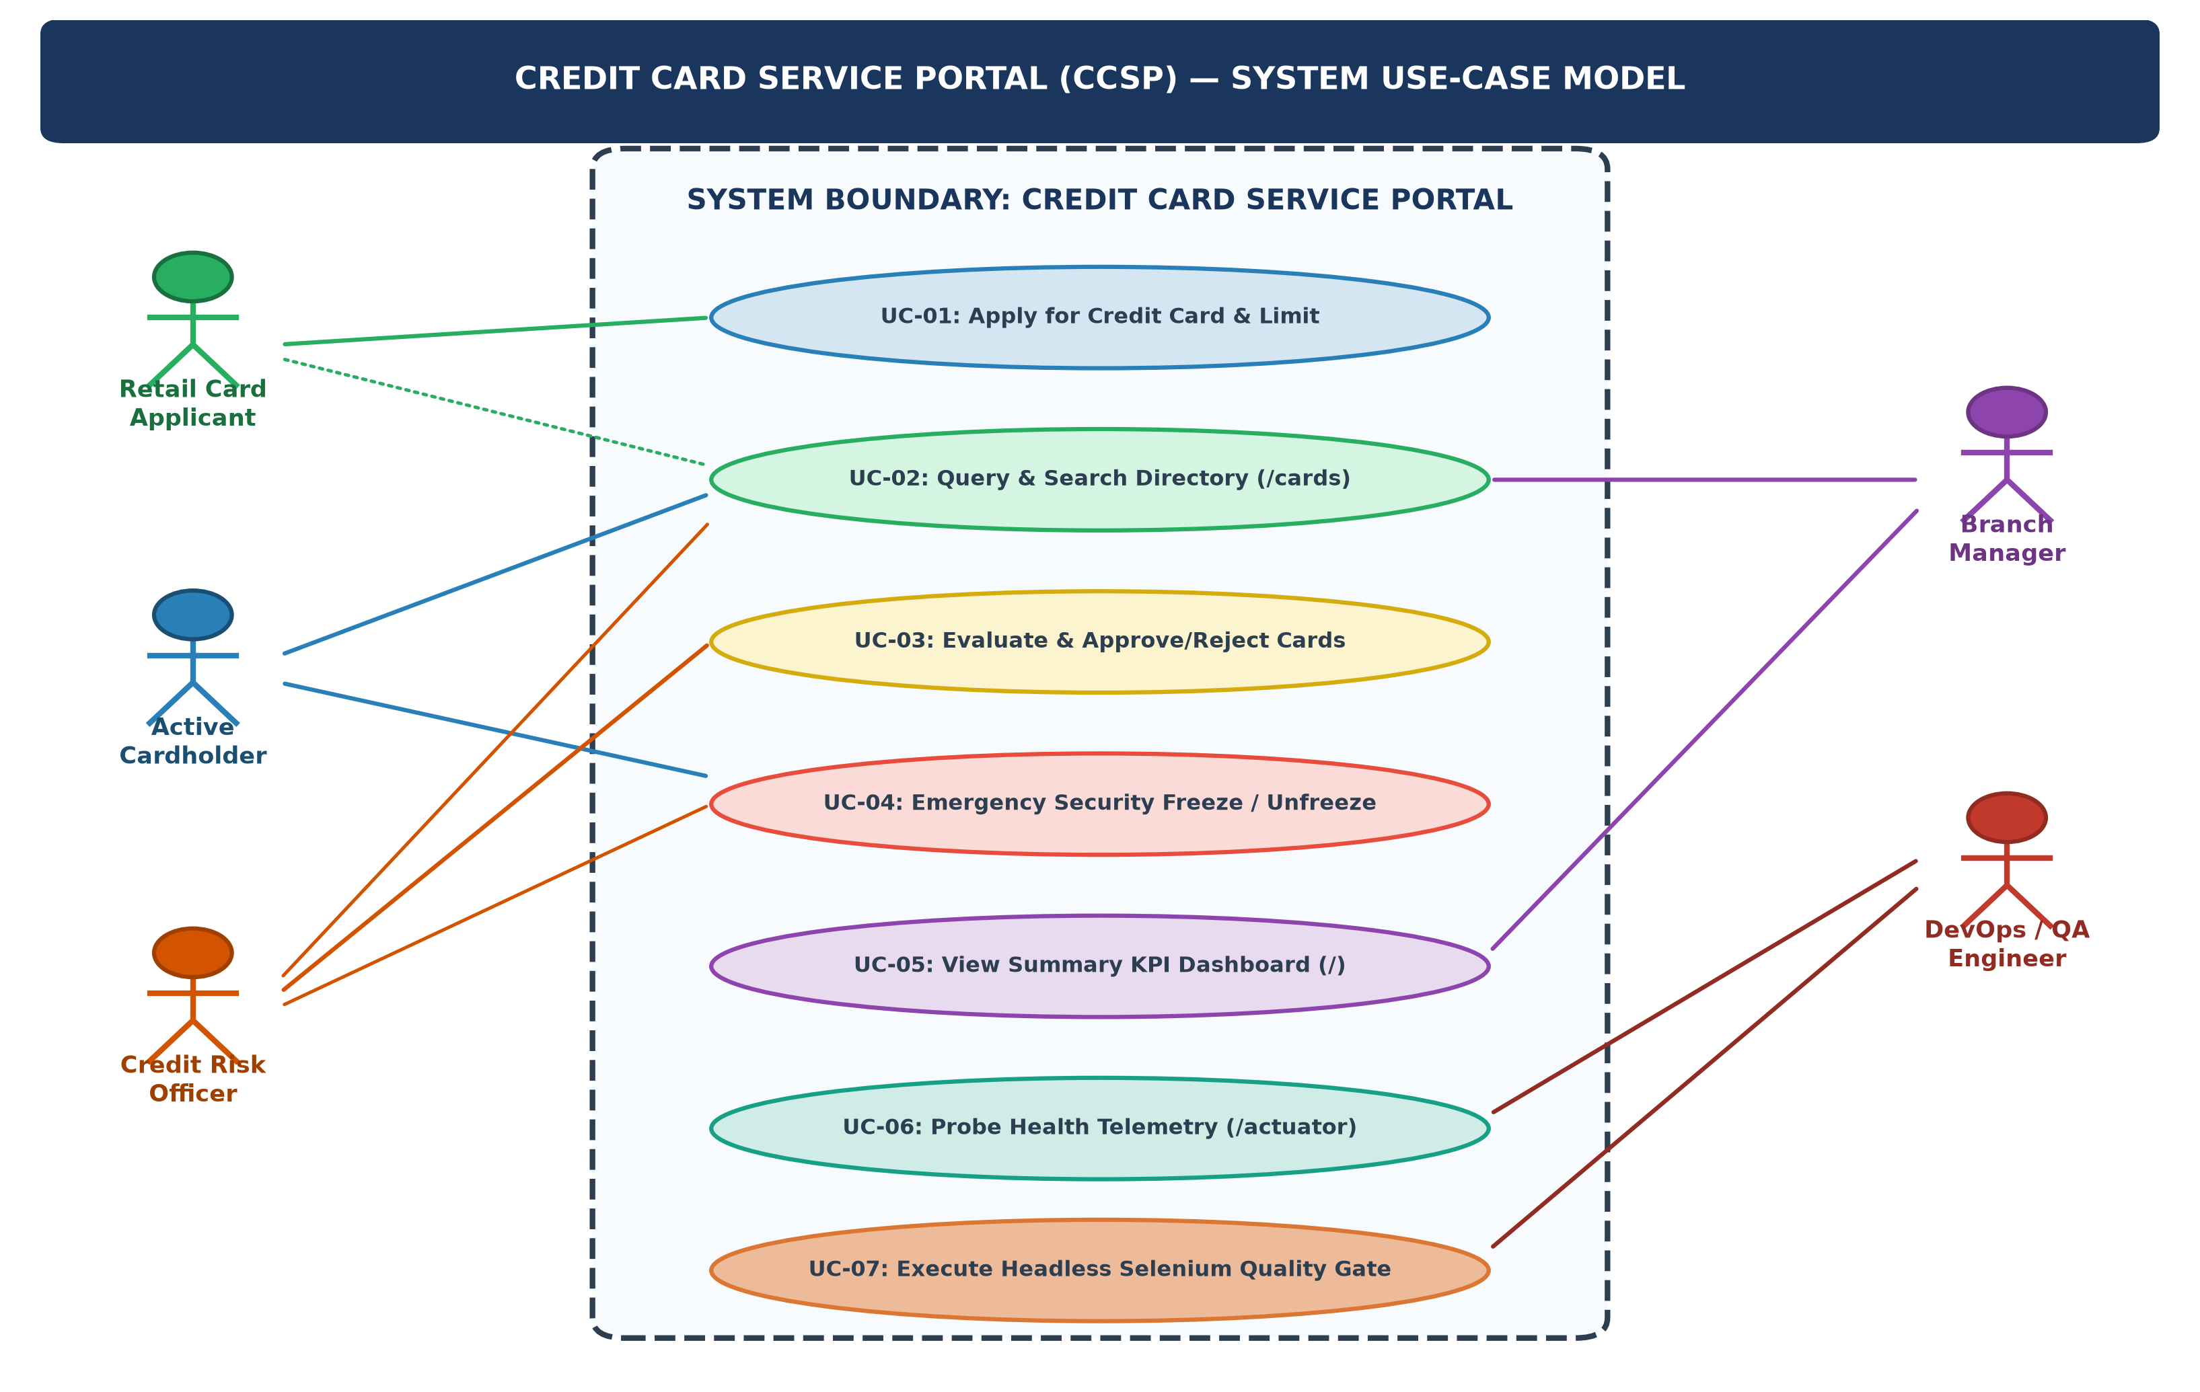  Figure 3.1: System Use-Case Diagram for Credit Card Service Portal (CCSP)  3. 4-tier monolithic web architecture and component design  The Credit Card Service Portal is organized into four distinct horizontal tiers, enforcing strict separation of concerns, high testability, and deterministic execution:  1. Presentation Tier (Web UI & DOM Locators): Delivers responsive web views using Thymeleaf server-side templates styled with Bootstrap 5. Every interactive element (search input, submit buttons, status badges) is assigned immutable HTML id and class attributes for reliable Selenium WebDriver locators.  2. Controller & Web Routing Tier: Spring MVC controllers (`CreditCardController`) route HTTP requests, parse query parameters, validate form binding results using `@Valid`, and expose both HTML views and JSON REST API endpoints.  3. Business Logic & Service Tier (`CreditCardService`): Encapsulates business validation rules, credit limit checks, card number masking, and finite state lifecycle mutations (PENDING -> ACTIVE -> BLOCKED / REJECTED).  4. Persistence & Data Tier (`CreditCardRepository`): Utilizes Spring Data JPA with Hibernate ORM to interface with an embedded H2 in-memory database (`jdbc:h2:mem:ccsp_db`). Pre-populates baseline seed records upon bootstrap for immediate automated testing.  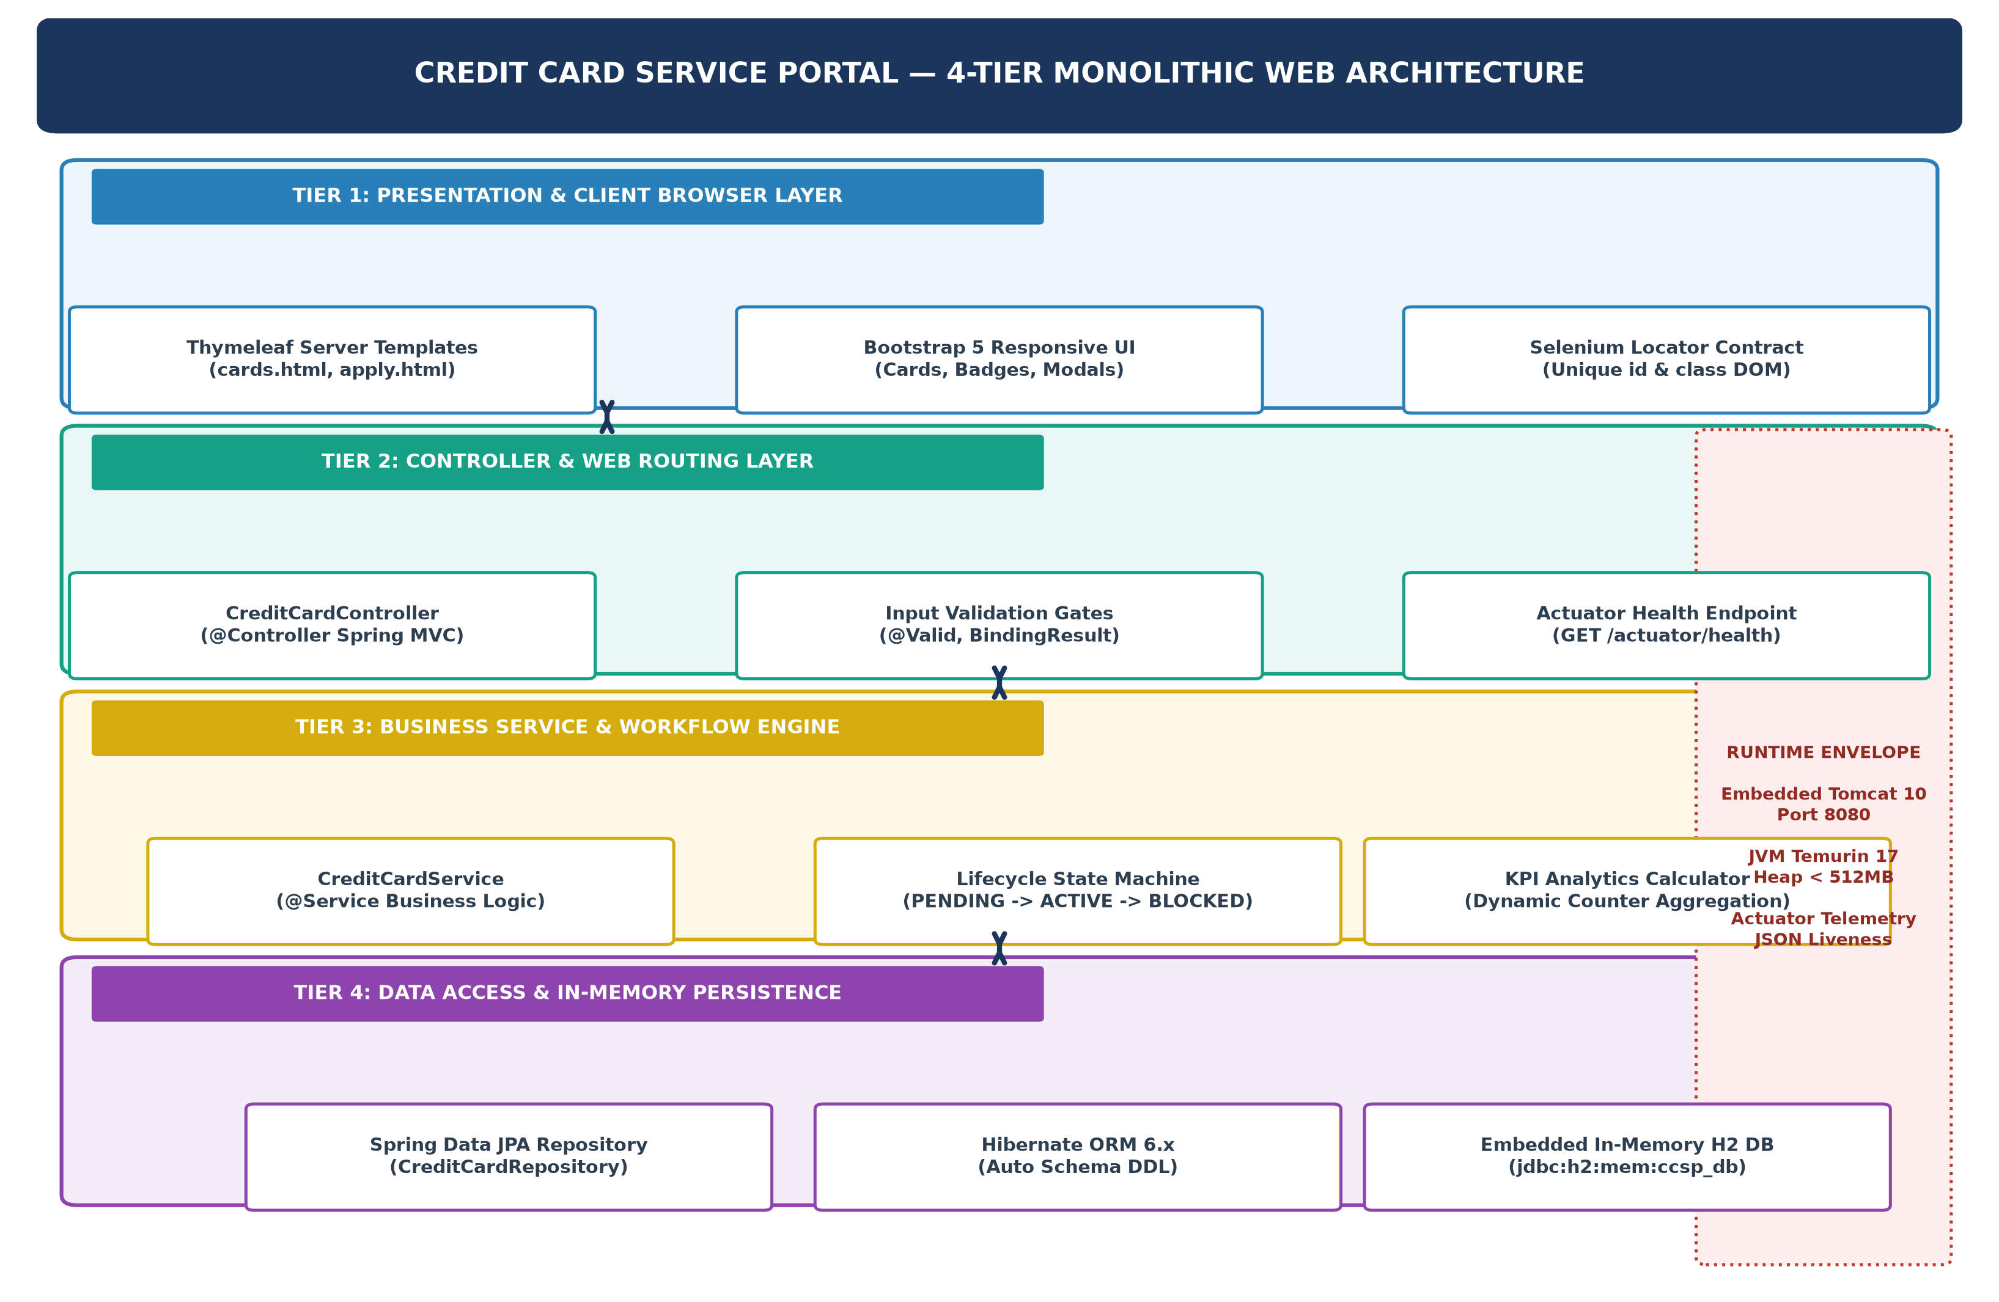  Figure 3.2: 4-Tier Monolithic Web Architecture & Technology Stack  4. Technology stack selection and architectural evaluation  To justify the selected technology stack, I evaluated alternatives across all architectural layers based on performance, testability, and CI/CD suitability. Table 3.4 documents this evaluation.  5. Relational data model and database schema  The relational schema is mapped directly from the `CreditCard` domain entity. In-memory H2 tables are initialized automatically by Hibernate using the schema structure detailed in Table 3.5:  6. Web controller and REST API specification  The application exposes both MVC web navigation endpoints and programmatic REST APIs for external validation and CI health monitoring:  7. Local development setup and live execution procedure  To establish a reproducible local baseline, I configured the development environment using Eclipse Adoptium JDK 17 LTS and Apache Maven 3.9.6. Table 3.7 details the step-by-step terminal execution workflow:  8. Live application execution and verification evidence  The running Spring Boot application was verified on http://localhost:8080 across all core user journeys. Automated headless browser execution captured real-time evidence proving that the web UI components, database persistence, and Actuator telemetry are fully operational:  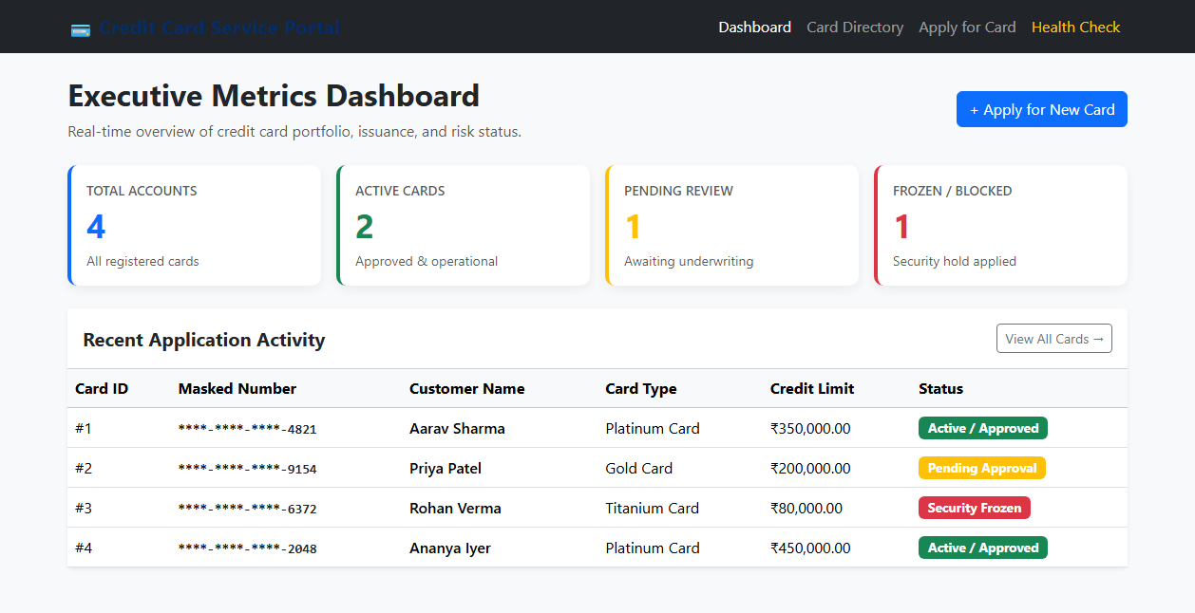  Figure 3.3: Summary Metrics KPI Dashboard (http://localhost:8080/)  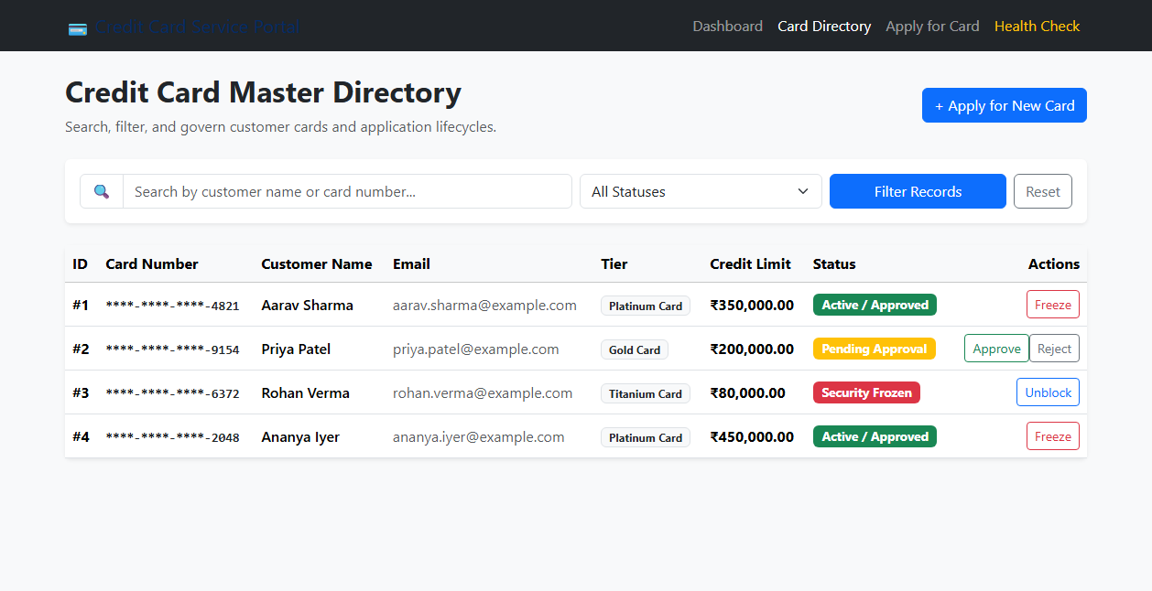  Figure 3.4: Credit Card Master Directory with Live Search & Lifecycle Actions (http://localhost:8080/cards)  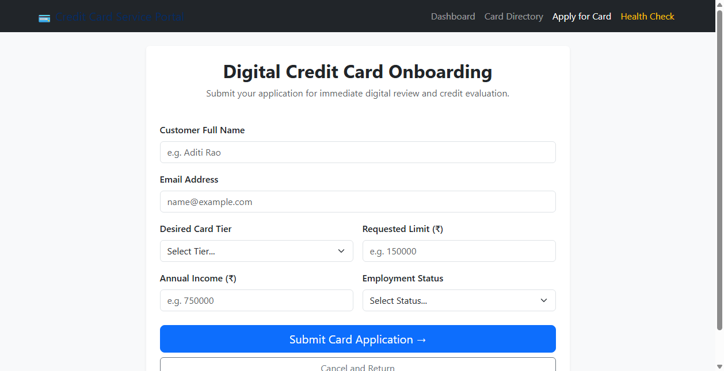  Figure 3.5: Digital Credit Card Onboarding & Limit Application Form (http://localhost:8080/apply)  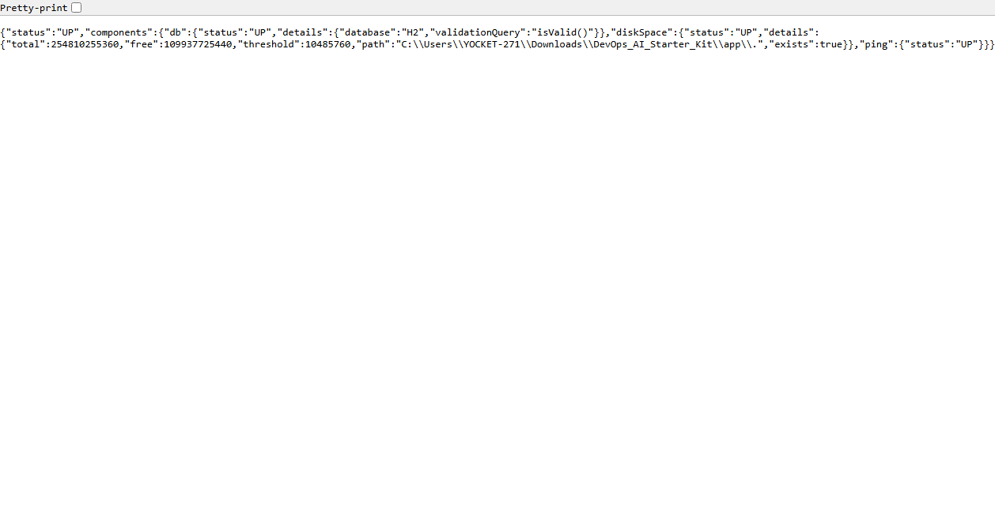  Figure 3.6: Spring Boot Actuator Real-Time Health Telemetry Endpoint (http://localhost:8080/actuator/health)
  Req ID | Feature Module | Functional Requirement Description | Priority
  FR-01 | Card Application & Validation | The system shall allow retail applicants to submit personal and employment details online, select a card tier (Platinum, Gold, Titanium), and request a credit limit with strict validation gates. | Must Have (P1)
  FR-02 | Directory & Live Search | The system shall provide a centralized searchable directory enabling real-time filtering by applicant name or masked card number and status dropdown selection. | Must Have (P1)
  FR-03 | Status Workflow Governance | The system shall enforce finite state machine transitions: PENDING -> ACTIVE or REJECTED, enabling credit risk officers to approve or decline cards with auditable timestamps. | Must Have (P1)
  FR-04 | Emergency Security Freeze | The system shall allow authorized users or officers to freeze active cards to BLOCKED status immediately, and unfreeze them following KYC verification. | Must Have (P1)
  FR-05 | Summary KPI Dashboard | The system shall calculate and render real-time summary metrics cards displaying Total Cards, Active Cards, Pending Applications, and Blocked Cards. | Must Have (P1)
  FR-06 | Actuator Health Telemetry | The system shall expose an HTTP GET /actuator/health endpoint returning HTTP 200 OK and JSON status 'UP' for automated CI/CD and Ansible probes. | Must Have (P1)
  Category | Non-Functional Requirement | Target Metric / SLA | DevOps Verification Method
  Performance | Fast page render and query response latency | < 250 ms local response time; < 1.0 s under test | Selenium automated execution timing
  Portability | Cross-environment standalone execution | Runs identically on Windows, Linux, and Docker containers | Maven Wrapper and Docker multi-stage build
  Reliability | Zero external database setup or connection failures | 100% build pass rate with embedded in-memory H2 database | Jenkins continuous testing gate (mvn test)
  Testability | Unambiguous HTML elements for Selenium automation | Unique id and class attributes on all inputs, buttons, badges | Headless Selenium WebDriver suite
  Maintainability | Clean 4-tier separation of concerns and telemetry | Modular Java packages; /actuator/health status UP | Automated cURL and JUnit test suites
  UC ID | Use Case Title | Primary Actor | Preconditions | Postconditions
  UC-01 | Apply for Credit Card | Retail Applicant | Application form loaded at `/apply`. | Card record saved with PENDING status and masked number.
  UC-02 | Search Card Directory | Branch Officer | Card records exist in database; `/cards` loaded. | Directory dynamically renders filtered matching records.
  UC-03 | Govern Card Approval | Credit Risk Officer | Application exists in PENDING status. | Status transitions to ACTIVE or REJECTED.
  UC-04 | Freeze / Unfreeze Card | Cardholder / Officer | Card status is ACTIVE or BLOCKED. | Status transitions to BLOCKED (frozen) or restored to ACTIVE.
  UC-05 | View KPI Metrics | Branch Manager | Cards exist in database; root `/` accessed. | Four dynamic KPI summary cards render accurate aggregates.
  UC-06 | Probe Health Telemetry | DevOps Engineer | Spring Boot runtime is active on port 8080. | HTTP 200 returned with JSON status 'UP'.
  Architecture Layer | Selected Technology | Architectural Rationale & DevOps Benefit | Alternatives Evaluated
  Programming Stack | Java 17 LTS (Eclipse Temurin) | Enterprise stability, strong type safety, LTS support, and native compatibility with Selenium 4 and Jenkins. | Java 21, Python, Node.js
  Application Framework | Spring Boot 3.2.5 | Rapid auto-configuration, embedded Tomcat web server, dependency injection, and native Actuator health probes. | Jakarta EE, Quarkus, Micronaut
  Build & Automation | Apache Maven (3.9.6) | Deterministic compilation, declarative dependency management, and universal Jenkins CI plugin support. | Gradle, Apache Ant
  Database Engine | Embedded H2 Database | Zero external database setup; in-memory execution starts in < 1 second; avoids connection flakiness in CI runs. | MySQL, PostgreSQL, SQLite
  Object-Relational Mapping | Spring Data JPA / Hibernate | Automated CRUD query generation, transaction management, and automatic DDL schema generation. | MyBatis, JDBC Template
  Frontend & View Engine | Thymeleaf + Bootstrap 5 | Server-rendered HTML5 with dynamic attribute bindings; lightweight and highly testable via Selenium WebDriver. | React, Angular, JSP
  Deployment Target | Embedded Apache Tomcat (8080) | Packaged directly inside executable JAR; eliminates external web server configuration overhead. | Standalone Nginx, Jetty
  Column Name | Data Type | Constraints | Default / Value | Description
  id | BIGINT | PRIMARY KEY, AUTO_INCREMENT | Generated | Unique surrogate identifier for each card record.
  card_number | VARCHAR(25) | NOT NULL, UNIQUE | Masked Value | Embossed masked card number (e.g. '****-****-****-4821').
  customer_name | VARCHAR(100) | NOT NULL | User supplied | Full name of prospective cardholder.
  email | VARCHAR(100) | NOT NULL | User supplied | Verified email address for communication.
  card_type | VARCHAR(20) | NOT NULL | 'PLATINUM' / 'GOLD' | Selected card tier defining maximum credit ceiling.
  credit_limit | DOUBLE | NOT NULL, CHECK (val > 0) | e.g., 350000.0 | Approved or requested credit limit in INR.
  annual_income | DOUBLE | NOT NULL, CHECK (val > 0) | e.g., 1200000.0 | Verified annual income of applicant in INR.
  employment_status | VARCHAR(50) | NOT NULL | 'Salaried' | Employment classification (Salaried, Self-Employed).
  status | VARCHAR(20) | NOT NULL | 'PENDING' | Lifecycle status: PENDING, ACTIVE, BLOCKED, REJECTED.
  applied_at | TIMESTAMP | NOT NULL | CURRENT_TIMESTAMP | Exact timestamp when application was submitted.
  updated_at | TIMESTAMP | NULLABLE | NULL | Timestamp of last lifecycle state change.
  Method | Endpoint URI | Payload / Parameters | Status | Response / View Description
  GET | / | None | 200 OK | Renders dashboard view with 4 KPI cards and recent card applications.
  GET | /cards | Optional: query, status | 200 OK | Renders searchable directory table with keyword filter and status selector.
  GET | /apply | None | 200 OK | Renders blank credit card application onboarding form.
  POST | /apply | Form: name, email, tier, limit, income | 302 / 200 | Creates new card application (PENDING) or returns validation errors.
  POST | /cards/{id}/approve | Path: {id} | 302 REDIR | Transitions card lifecycle status from PENDING to ACTIVE.
  POST | /cards/{id}/block | Path: {id} | 302 REDIR | Applies emergency security hold, setting status to BLOCKED.
  POST | /cards/{id}/unblock | Path: {id} | 302 REDIR | Restores frozen card from BLOCKED to ACTIVE status.
  POST | /cards/{id}/reject | Path: {id} | 302 REDIR | Declines credit card application, setting status to REJECTED.
  GET | /actuator/health | None | 200 OK | Returns JSON health telemetry payload: {"status":"UP"}.
  Step | Setup Activity | Terminal Command | Expected Output / Verification
  1 | JDK 17 Setup | $env:JAVA_HOME = 'C:\...\jdk-17.0.12+7'  java -version | openjdk version '17.0.12' verified with 64-Bit Server VM.
  2 | Clean & Compile | mvn clean compile | BUILD SUCCESS; Java source compiled into target/classes.
  3 | Run Unit Tests | mvn test | Surefire test report generated; 5 tests run, 0 failures, 0 errors.
  4 | Launch Application | mvn spring-boot:run | Tomcat started on port 8080 (http); Started CreditCardApp in 2.8s.
  5 | Liveness Probe | curl.exe -s http://localhost:8080/actuator/health | JSON response: {"status":"UP"} confirming system readiness.
Conclusion: | In Task 3, I successfully architected, engineered, and locally verified the minimum viable application architecture for the Credit Card Service Portal (CCSP). I formulated a comprehensive Software Requirements Specification (SRS) summary encompassing six core functional requirements and five critical non-functional criteria governing latency, testability, and portability. I designed a behavioral use-case model detailing interactions between retail applicants, credit risk officers, and DevOps engineers, and established a 4-tier monolithic web architecture powered by Java 17 LTS, Spring Boot 3.2.5, Spring Data JPA, and Thymeleaf with Bootstrap 5. By adopting an embedded in-memory H2 database (jdbc:h2:mem:ccsp_db) and embedded Apache Tomcat web server managed via Apache Maven 3.9.6, the application operates with zero external database dependencies and boots instantaneously. Local terminal execution confirmed that the compilation, test suite execution (5 JUnit tests passing), data persistence, and Spring Boot Actuator health probe (/actuator/health returning HTTP 200 'UP') function deterministically. All deliverable requirements for Task 3 have been rigorously satisfied, providing a production-ready application skeleton for Task 4 Git Repository Initialization.

