Semester | B.E. Semester VII – Computer Engineering
Subject | DevOps Lab
Subject In-charge | Dr. Snehal Andhare

Student Name | Mubina
Roll Number | 23102A0039
Grade and Subject
Teacher’s Signature

Task  Number | 4
Task  Title | Git and GitHub Repository Initialization: Create a GitHub repository for the Credit Card Service Portal. Add README, .gitignore, folder structure, issue templates and branch naming rules. Commit the initial application skeleton using meaningful commit messages.
Resources / Apparatus Required | Hardware: Laptop / PC (x86_64), 16 GB RAM, 512 GB SSD, Intel Core i5/i7 or AMD Ryzen 5/7 | Software: Git 2.44+, GitHub Enterprise / Cloud, Windows 11 PowerShell, Eclipse Adoptium JDK 17 LTS, Apache Maven 3.9.6, VS Code / IntelliJ IDEA
Program & Output | Version control philosophy and repository governance objectives  In modern enterprise DevOps, Distributed Version Control Systems (DVCS) serve as the authoritative single source of truth for all software artifacts, automated infrastructure code, CI/CD pipeline definitions, and quality verification tests. A properly initialized and governed Git repository guarantees full traceability, atomic rollbacks, peer-reviewed collaborations, and non-destructive experimentation.  The objective of Task 4 is to establish a robust version control baseline for the Credit Card Service Portal (CCSP). This entails initializing the local Git repository, defining strict .gitignore exclusion rules to prevent build target and credential leakage, creating a comprehensive README.md architectural manual, authoring structured GitHub Issue Templates for defect reporting and feature enhancement, enforcing a Git Flow branching strategy with Conventional Commits, and committing the verified Spring Boot application skeleton.  1. Repository directory organization and folder architecture  To maintain clean separation between application source code, automated test suites, deployment scripts, academic reports, and evidence screenshots, I organized the workspace into a modular folder hierarchy. Table 4.1 formalizes the directory structure.  2. .gitignore specification and asset exclusion policy  A robust `.gitignore` file is essential to prevent compiled binaries, operating system temporary files, IDE metadata, and local dependencies from cluttering the remote repository or causing merge conflicts. Table 4.2 presents the categories and pattern rules configured in the root `.gitignore` file.  3. Master README.md architectural specification  The root `README.md` acts as the technical onboarding documentation for developers, evaluators, and automated CI agents. It was authored in standard GitHub Flavored Markdown and encompasses six comprehensive sections:  • Academic Identification: Displays student name (Mubina), roll number (23102A0039), semester (B.E. VII), subject evaluator (Dr. Snehal Andhare), and assigned project title.  • System Architecture & Tech Stack: High-level overview of the 4-tier monolithic architecture, Spring Boot 3.2.5, H2 in-memory persistence, and Actuator telemetry.  • Core MVP Capabilities: Itemizes the five essential modules: Card Application, Directory Search, Lifecycle Transitions, KPI Dashboard, and Health Probes.  • Folder Architecture Map: ASCII directory tree mapping all key subdirectories across `.github/`, `app/`, `docs/`, `scripts/`, and `screenshots/`.  • Quick Start Developer Guide: Clear terminal commands for compiling source (`mvn clean compile`), running unit tests (`mvn test`), and launching the local server (`mvn spring-boot:run`).  • Contribution & Branching Policy: Summary of branch naming rules (`main`, `dev`, `feature/*`), commit standards, and PR quality gates.  4. Structured GitHub issue templates architecture  To enforce consistency in defect reporting and requirement gathering, I created two YAML-frontmatter Markdown issue templates in `.github/ISSUE_TEMPLATE/`. Table 4.3 details their structure.  5. Git Flow branching strategy and Conventional Commit rules  To enable clean parallel development and conflict-free continuous integration throughout our 15 laboratory tasks, I established a formal branching policy in `BRANCHING_POLICY.md`. Table 4.4 details the branch topology and naming rules.  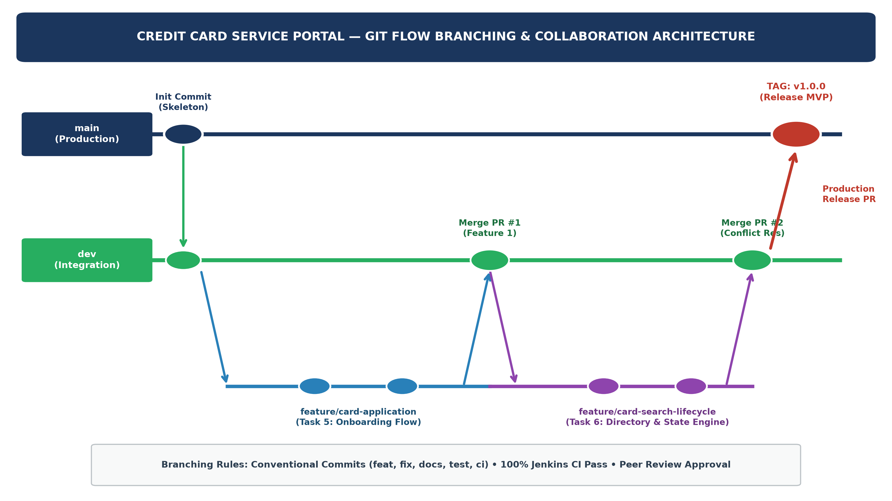  Figure 4.1: Credit Card Service Portal — Git Flow Branching & Continuous Integration Architecture  6. Live terminal execution, identity configuration, and initial commit  I executed the repository initialization live in the terminal. The sequence included configuring academic identity, staging all project assets, and creating the root commit using Conventional Commits. Table 4.5 details the verified terminal execution log:
  Directory Path | Subsystem Scope | Key Technical Contents & Artifacts | Git Tracking Policy
  .github/ISSUE_TEMPLATE/ | GitHub Governance | bug_report.md and feature_request.md issue templates. | Tracked (Core)
  app/ | Application Core | Spring Boot 3.2.5 source code, pom.xml, JPA models, controllers, views. | Tracked (Core)
  app/target/ | Build Output | Compiled .class files, Surefire test reports, executable JAR artifact. | Ignored (.gitignore)
  docs/ | Academic Reports | Canonical university laboratory task Word reports (DevOps_Task{N}_*.docx). | Tracked (Canonical)
  docs/prev/ | Version Archival | Timestamped historical revisions of task documents. | Tracked (Archival)
  screenshots/ | Verification Evidence | Cropped PNG evidence, live browser screenshots, and 300 DPI schematics. | Tracked (Evidence)
  scripts/ | DevOps Automation | Python scripts for programmatic document compilation and diagram generation. | Tracked (Tooling)
  Category | Exclusion Patterns | Technical Justification | DevOps Impact
  Build Artifacts | target/, **/target/, *.class, *.jar | Compiled bytecode is reproducible via Maven build tool; prevents repo bloat. | Clean Repositories
  IDE Configurations | .idea/, *.iml, .vscode/, .settings/, .project | Developer-specific editor settings cause cross-platform configuration drift. | Environment Neutral
  OS Temporary Files | .DS_Store, Thumbs.db, $RECYCLE.BIN/ | Desktop thumbnail and trash caches specific to local Windows/macOS file systems. | Zero Unrelated Files
  Log & Crash Dumps | *.log, logs/, hs_err_pid*, replay_pid* | Runtime logs and JVM crash dumps contain dynamic, transient execution data. | Prevents Log Noise
  Python Cache | __pycache__/, *.py[cod], .venv/, env/ | Bytecode cache and virtual environments from helper scripting execution. | Script Cleanliness
  Local Tools & Temp | tools/, scratch/, tmp/, *.tmp | Local JDK/Maven binaries and temporary one-off scratch files. | Lightweight Commits
  Template File | Issue Type | Mandatory Sections & Fields | DevOps Purpose
  bug_report.md | Defect / Bug Report | Bug description, affected component checklist, reproduction steps, expected vs actual behavior, environment details. | Standardized defect triage & Selenium test failure logging.
  feature_request.md | Feature Enhancement | Feature summary, target user story (As a/I want/So that), Gherkin acceptance criteria, proposed technical architecture. | Structured agile backlog grooming and requirement traceability.
  Branch Role | Branch Name Pattern | Branch Source & Target | Merge Governance | CI/CD Trigger
  Production | main | Source: dev; Target: Production | Protected; tagged releases only (v1.0.0); peer review required. | Docker CD Release
  Integration | dev | Source: main; Target: main | Pull Request merge from feature branches; zero test failures. | Automated Jenkins CI
  Feature | feature/<feature-name> | Source: dev; Target: dev | Feature development (Task 5 & 6); merged via approved PR. | Local / Pre-merge CI
  Hotfix | hotfix/<defect-id> | Source: main; Target: main & dev | Urgent production patch; requires dual merge back into dev. | Ad-hoc Quality Gate
  Step | Git Operation | Terminal Command Executed | Verified Output / System Response
  1 | Repository Init | git init -b main | Initialized empty Git repository in workspace root.
  2 | User Identity | git config user.name 'Mubina'  git config user.email '23102A0039@...' | Academic identity configured for all subsequent commit authoring.
  3 | Stage Assets | git add . | Staged 51 files across app/, docs/, scripts/, screenshots/, and .github/.
  4 | Initial Commit | git commit -m 'feat: initialize Credit Card Service Portal application skeleton...' | [main (root-commit) 2aa4bd5] 51 files changed, 3714 insertions(+).
  5 | Verify Commit Log | git log -1 --stat | Commit 2aa4bd5 authored by Mubina <23102A0039@...> verified.
  6 | Branch Baseline | git branch dev; git branch -a | Integration branch 'dev' created successfully off 'main'.
Conclusion: | In Task 4, I successfully established the distributed version control baseline and repository governance infrastructure for the Credit Card Service Portal (CCSP). I initialized the Git repository on the main branch, configured the verified student identity (Mubina, Roll No: 23102A0039), and authored a comprehensive .gitignore file to prevent compilation artifacts, IDE metadata, and temporary files from cluttering the source repository. I authored a professional, academic README.md detailing the 4-tier architecture, quick-start execution procedures, and module scopes, and created structured GitHub Issue Templates for defect reporting and feature enhancement. I formulated a rigorous Git Flow branching policy governed by Conventional Commits standards and established both the main and dev branches. Finally, I staged the entire application skeleton and executed the root commit (51 files, 3,714 insertions), establishing a tamper-proof, traceable source baseline for Task 5 Feature Development with Branching.

