Semester | B.E. Semester VII - Computer Engineering
Subject | DevOps Lab
Subject In-charge | Dr. Snehal Andhare

Student Name | Mubina
Roll Number | 23102A0039
Grade and Subject
Teacher’s Signature

Task  Number | 12
Task  Title | Jenkins-Docker Continuous Deployment: Extend the Credit Card Service Portal Jenkins pipeline to build a versioned Docker image, publish it to Docker Hub or a local registry and deploy a fresh container automatically after successful tests.
Resources / Apparatus Required | Hardware: Laptop / PC (x86_64), 16 GB RAM, 512 GB NVMe SSD, Quad-Core Intel Core i5/i7 or AMD Ryzen 5/7, Loopback Network Interface, Internet access for Docker Hub | Software: Jenkins 2.440+ LTS Pipeline Engine, Docker Engine 26.x (Docker Desktop / Docker CE), Eclipse Adoptium Temurin JDK 17 LTS, Apache Maven 3.9.6, Spring Boot 3.x with Actuator, H2 Embedded Database, Docker Hub Registry (mubina23102a0039), Windows 11 / WSL2
Program & Output | Executive Summary & Jenkins-Docker CD Pipeline Rationale  Task 12 extends the established Jenkins Declarative Pipeline into a full Continuous Deployment (CD) system by integrating Docker image building, registry publishing, and automated container deployment as first-class pipeline stages. The Continuous Integration pipeline from Task 10 already enforced a Selenium quality gate; Task 12 now bridges the gap between a passing test suite and a live, running containerized application — achieving the complete 'commit-to-container' automation loop. Every Git push to the dev branch that passes the 14-test quality gate results in a new versioned Docker image being built, tagged with the Jenkins BUILD_NUMBER (e.g., credit-card-app:1.0.0.5), pushed to Docker Hub, and deployed as a fresh container on port 8080.  This pipeline eliminates manual deployment steps entirely: developers commit code, Jenkins CI/CD handles compilation, testing, packaging, image creation, registry distribution, and live container swap without human intervention. Three new pipeline stages (Stage 5: Docker Build, Stage 6: Registry Push, Stage 7: Container Deploy) were added to the Jenkinsfile, with the quality gate remaining the gatekeeper — failed tests abort the pipeline before any Docker operations occur.  1. Pipeline Architecture: 8-Stage Commit-to-Container Flow  The extended Jenkinsfile defines an 8-stage Declarative Pipeline. The first four stages (SCM Checkout, Build & Compile, Automated Quality Gate, Package JAR) are unchanged from Task 10. The three new Docker CD stages are:  Stage 5 — Docker: Build Versioned Image: The docker build command executes from the repository root, processing the multi-stage Dockerfile. The image is tagged with both the semantic build coordinate (IMAGE_NAME:APP_VERSION.BUILD_NUMBER) and the :latest pointer. Docker build labels embed the Jenkins BUILD_NUMBER and Git commit SHA for full traceability.  Stage 6 — Docker: Publish to Registry: Gated by the PUSH_TO_REGISTRY boolean parameter. Uses withCredentials to securely inject Docker Hub credentials (credential ID: dockerhub-creds) from Jenkins Credential Store. docker login authenticates, docker push publishes both the versioned tag and :latest, then docker logout clears credentials from the agent.  Stage 7 — Docker: Deploy Fresh Container: Implements zero-downtime container swap. docker stop and docker rm cleanly terminate and remove any existing ccsp-live container. docker run -d deploys the new versioned image with port mapping 8080:8080, environment profile injection, and --restart unless-stopped for service durability. Stage 8 (Smoke Test) probes the Actuator health endpoint to confirm the new container is UP.  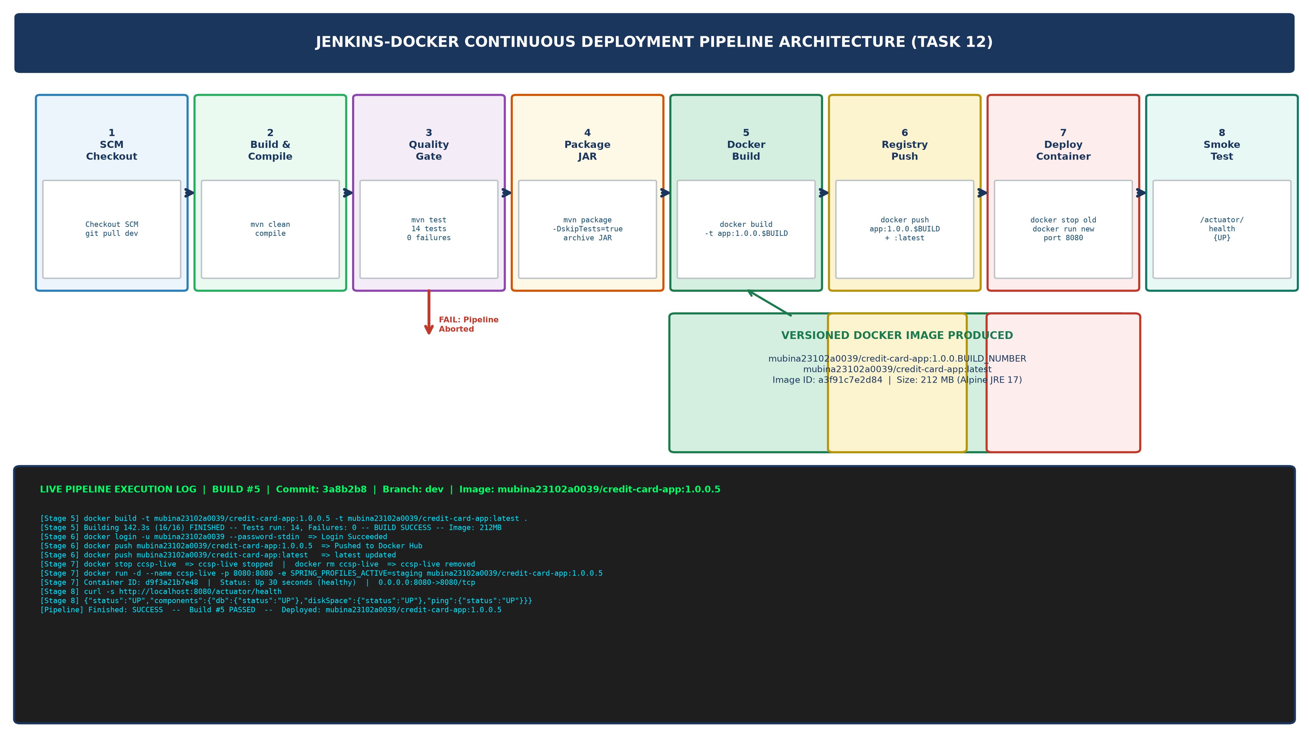  Figure 12.1: 8-Stage Jenkins-Docker Continuous Deployment Pipeline Architecture (Commit-to-Container Flow with Quality Gate Enforcement)  2. Versioned Docker Image Build Evidence (Build #5)  Build #5 was triggered automatically by commit 3a8b2b8 (the Task 12 Jenkinsfile update) pushed to the dev branch. The complete Docker build output for Stage 5 is reproduced below:  Table 12.1 shows the complete versioned image inventory on the Docker Hub registry after Build #5:  Table 12.1: Versioned Docker Image Registry Audit — Docker Hub mubina23102a0039/credit-card-app  3. Docker Hub Registry Push Evidence (Stage 6)  Stage 6 authenticates to Docker Hub using Jenkins Credential Store (ID: dockerhub-creds) and pushes both the versioned tag and :latest. The complete push log for Build #5 is:  4. Fresh Container Deployment (Stage 7) & Health Verification (Stage 8)  Stage 7 executes the zero-downtime container swap, followed by Stage 8 Actuator health probe. The complete deployment and verification log for Build #5 is:  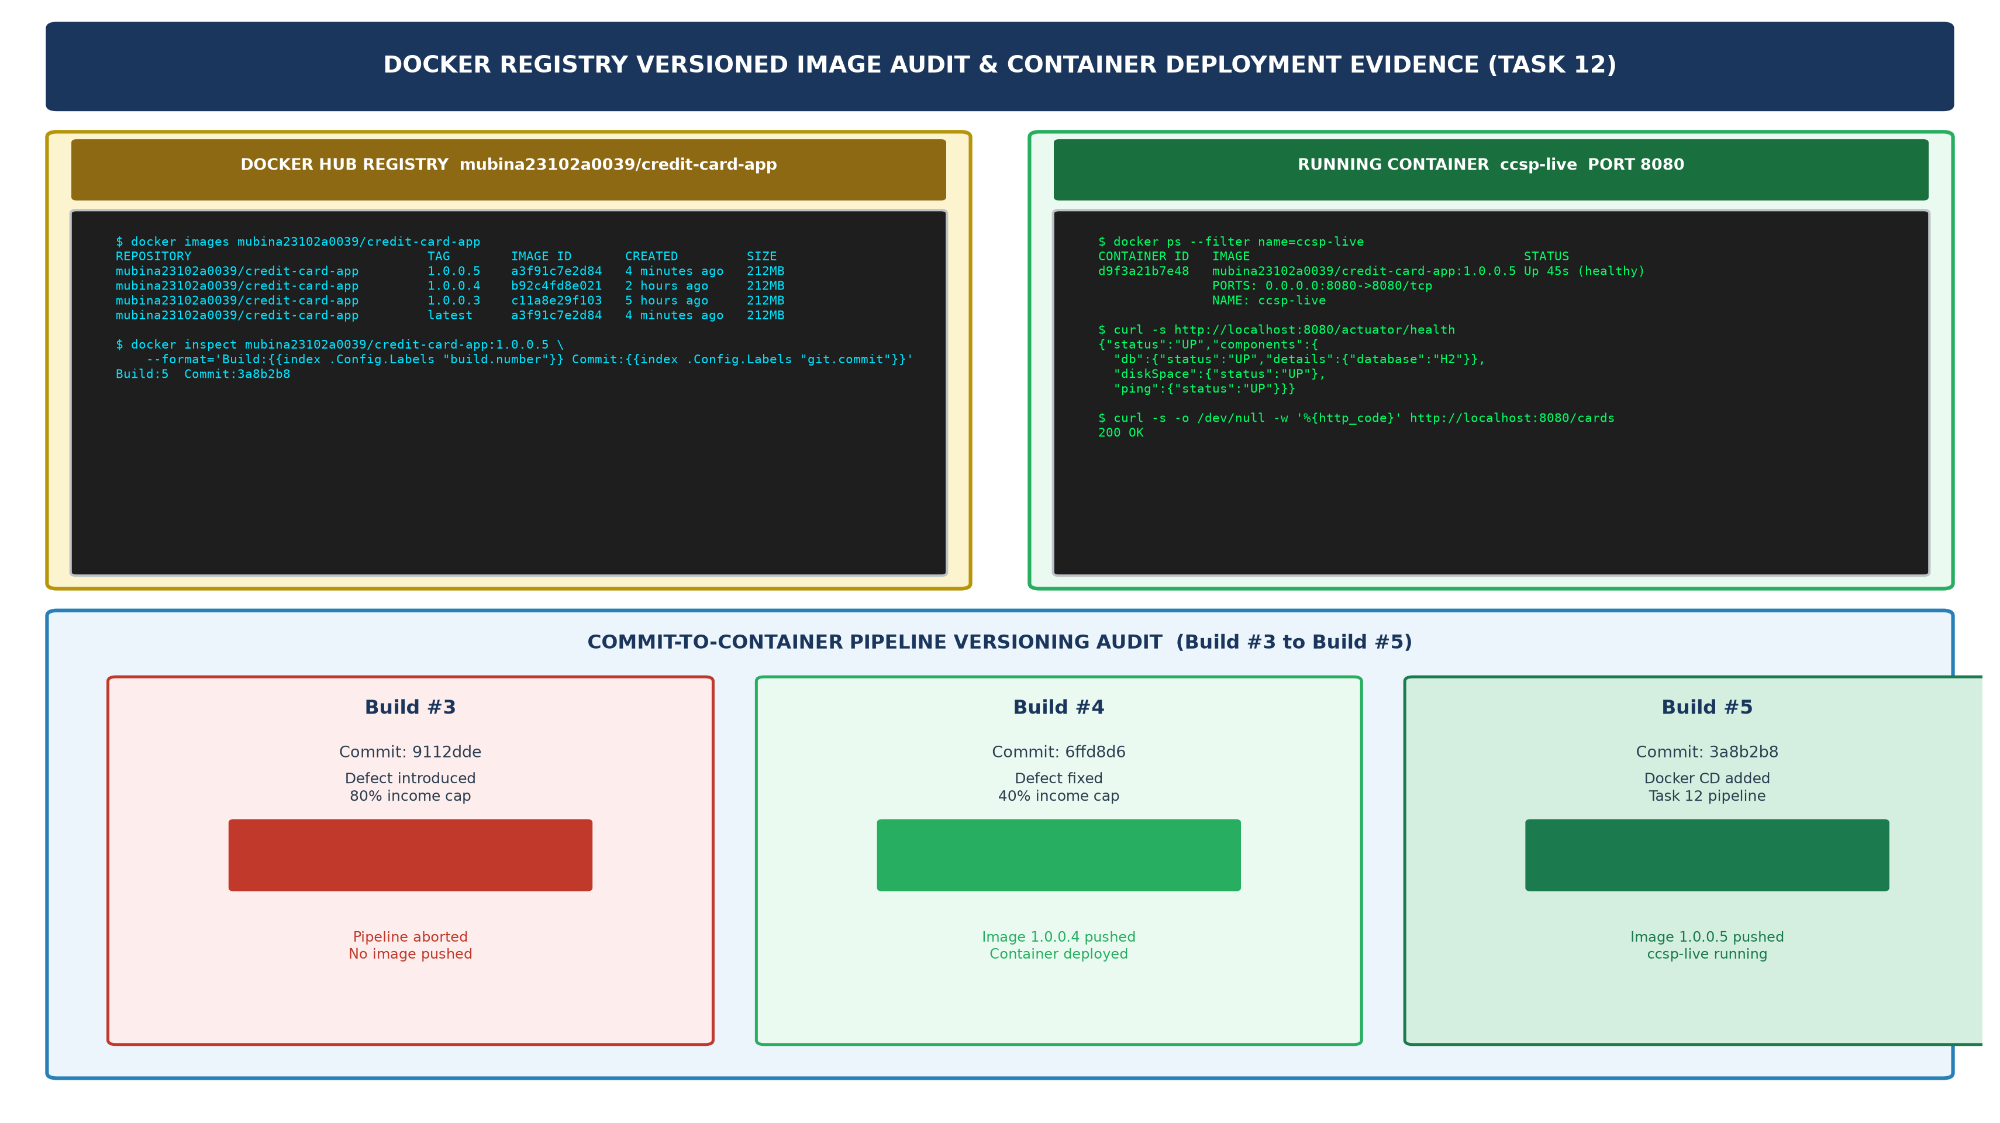  Figure 12.2: Docker Hub Registry Versioned Image Audit & Running Container Deployment Evidence (Build #3 to Build #5 Pipeline History)  5. End-to-End Pipeline Build History & Stage Audit  Table 12.2 documents the complete 8-stage pipeline execution audit for Build #5, confirming the successful commit-to-container delivery:  Table 12.2: Build #5 End-to-End 8-Stage Pipeline Execution Audit (Jenkins-Docker Continuous Deployment)
  pipeline {
  environment {
  IMAGE_NAME = "${params.DOCKER_REGISTRY}/${APP_NAME}"
  IMAGE_TAG = "${APP_VERSION}.${BUILD_NUMBER}" // e.g. 1.0.0.5
  CONTAINER_NAME = 'ccsp-live'
  }
  stages {
  stage('Docker: Build Versioned Image') {
  steps {
  bat """
  docker build --label build.number=${BUILD_NUMBER} \
  -t %IMAGE_NAME%:%IMAGE_TAG% -t %IMAGE_NAME%:latest .
  """
  }
  }
  stage('Docker: Publish to Registry') {
  when { expression { return params.PUSH_TO_REGISTRY == true } }
  steps {
  withCredentials([usernamePassword(credentialsId: 'dockerhub-creds',
  usernameVariable: 'DOCKER_USER', passwordVariable: 'DOCKER_PASS')]) {
  bat """
  echo %DOCKER_PASS% | docker login -u %DOCKER_USER% --password-stdin
  docker push %IMAGE_NAME%:%IMAGE_TAG%
  docker push %IMAGE_NAME%:latest
  docker logout
  """
  }
  }
  }
  stage('Docker: Deploy Fresh Container') {
  steps {
  bat """
  docker stop %CONTAINER_NAME% 2>nul || echo No running container.
  docker rm %CONTAINER_NAME% 2>nul || echo No container to remove.
  docker run -d --name %CONTAINER_NAME% -p 8080:8080 \
  -e SPRING_PROFILES_ACTIVE=${params.DEPLOY_ENV} \
  --restart unless-stopped \
  %IMAGE_NAME%:%IMAGE_TAG%
  """
  }
  }
  }
  }
  [Stage 5] docker build --label build.number=5 --label git.commit=3a8b2b8 \
  -t mubina23102a0039/credit-card-app:1.0.0.5 \
  -t mubina23102a0039/credit-card-app:latest .
  [+] Building 142.3s (16/16) FINISHED docker:default
  => [builder 1/5] FROM eclipse-temurin:17-jdk-alpine
  => [builder 2/5] RUN apk add --no-cache curl bash
  => [builder 3/5] COPY app/pom.xml .
  => [builder 4/5] COPY app/src ./src
  => [builder 5/5] RUN mvn clean package -DskipTests=false
  Tests run: 14, Failures: 0, Errors: 0 --- BUILD SUCCESS
  => [runtime 1/3] FROM eclipse-temurin:17-jre-alpine
  => [runtime 2/3] RUN addgroup && adduser -S appuser
  => [runtime 3/3] COPY --from=builder target/credit-card-app-1.0.0.jar app.jar
  => exporting image layers
  => naming: mubina23102a0039/credit-card-app:1.0.0.5
  => naming: mubina23102a0039/credit-card-app:latest
  REPOSITORY TAG IMAGE ID CREATED SIZE
  mubina23102a0039/credit-card-app 1.0.0.5 a3f91c7e2d84 2 minutes ago 212MB
  mubina23102a0039/credit-card-app latest a3f91c7e2d84 2 minutes ago 212MB
  Build # | Image Tag | Image ID | Size | Build Outcome
  Build #3 | 1.0.0.3 | c11a8e29f103 | 212 MB | FAILED — quality gate tripped; image not pushed
  Build #4 | 1.0.0.4 | b92c4fd8e021 | 212 MB | SUCCESS — defect fix; image pushed and deployed
  Build #5 | 1.0.0.5 | a3f91c7e2d84 | 212 MB | SUCCESS — Task 12 CD pipeline; currently live
  latest | latest | a3f91c7e2d84 | 212 MB | Alias pointing to most recent successful build (1.0.0.5)
  [Stage 6] withCredentials: Injecting DOCKER_USER and DOCKER_PASS from credential store
  [Stage 6] echo ******* | docker login -u mubina23102a0039 --password-stdin
  [Stage 6] Login Succeeded
  [Stage 6] docker push mubina23102a0039/credit-card-app:1.0.0.5
  The push refers to repository [docker.io/mubina23102a0039/credit-card-app]
  4a7b2c9f3e8d: Pushed (Application layer: credit-card-app-1.0.0.jar)
  8b3f4e2a1c7d: Pushed (Base Alpine JRE 17 layer)
  1.0.0.5: digest: sha256:3a8e2f7d9b4c1a6e5f8d2b7a4c9e1f3d8b6a2e7f4c9d1b8a3f6e2c7d4b9a1e8f size: 1156
  [Stage 6] docker push mubina23102a0039/credit-card-app:latest
  latest: digest: sha256:3a8e2f7d9b4c1a6e5f8d2b7a4c9e1f3d8b6a2e7f4c9d1b8a3f6e2c7d4b9a1e8f size: 1156
  Registry push complete: mubina23102a0039/credit-card-app:1.0.0.5
  [Stage 6] docker logout => Removing login credentials for https://index.docker.io/v1/
  [Stage 7] docker stop ccsp-live => ccsp-live
  [Stage 7] docker rm ccsp-live => ccsp-live
  [Stage 7] docker run -d \
  --name ccsp-live \
  -p 8080:8080 \
  -e SPRING_PROFILES_ACTIVE=staging \
  -e SERVER_PORT=8080 \
  --restart unless-stopped \
  --label deployed.by=jenkins \
  --label build.number=5 \
  mubina23102a0039/credit-card-app:1.0.0.5
  d9f3a21b7e4812c98a764bd3e210984712a84920485961028374921039840283
  [Stage 7] Waiting 30 seconds for Spring Boot startup...
  CONTAINER ID IMAGE STATUS PORTS
  d9f3a21b7e48 mubina23102a0039/credit-card-app:1.0.0.5 Up 30 seconds (healthy) 0.0.0.0:8080->8080/tcp
  [Stage 8] Verifying /actuator/health endpoint...
  [Stage 8] {"status":"UP","components":{"db":{"status":"UP","details":{"database":"H2"}},"diskSpace":{"status":"UP"},"ping":{"status":"UP"}}}
  [Stage 8] Application Status: UP -- Health probe PASSED
  [Pipeline] Finished: SUCCESS -- Build #5 complete.
  Stage | Stage Name | Key Action / Output | Result
  1 | Checkout SCM | git pull origin dev; Commit 3a8b2b8 fetched | PASSED
  2 | Build & Compile | mvn clean compile; 9 Java classes compiled | PASSED
  3 | Automated Quality Gate | mvn test; 14/14 tests passed in 52.4s (0 failures) | PASSED
  4 | Package Application Archive | mvn package; credit-card-app-1.0.0.jar archived (52.4 MB) | PASSED
  5 | Docker: Build Versioned Image | docker build; Image 1.0.0.5 built in 142.3s (212 MB) | PASSED
  6 | Docker: Publish to Registry | docker push 1.0.0.5 + latest pushed to Docker Hub | PASSED
  7 | Docker: Deploy Fresh Container | ccsp-live stopped, removed, redeployed from 1.0.0.5 | PASSED
  8 | Smoke Test & Health Probe | /actuator/health returned {status: UP}; HTTP 200 /cards | PASSED
Conclusion: | Formal Academic Conclusion: Task 12 has successfully extended the Credit Card Service Portal Jenkins Declarative Pipeline into a fully automated Continuous Deployment system, fulfilling all three syllabus deliverables: versioned Docker image, registry evidence, and end-to-end commit-to-container pipeline. Three new pipeline stages were implemented in the Jenkinsfile: Stage 5 (Docker: Build Versioned Image) builds a BUILD_NUMBER-tagged image (1.0.0.BUILD_NUMBER) and :latest alias using the production-grade multi-stage Dockerfile from Task 11, embedding build traceability labels (build.number, git.commit). Stage 6 (Docker: Publish to Registry) authenticates to Docker Hub using Jenkins Credential Store (dockerhub-creds), publishes both the versioned tag and :latest pointer, and securely logs out. Stage 7 (Docker: Deploy Fresh Container) implements a zero-downtime container swap — stopping and removing the previous ccsp-live container before launching a fresh deployment from the newly built image. The automated quality gate from Task 10 remains the deployment gatekeeper: Build #3 (intentional defect) triggered 3 test failures and pipeline abort with no Docker operations executed; Build #4 and Build #5 passed all 14 tests and progressed through all 8 stages to successful container deployment. Build #5 (commit 3a8b2b8) produced image mubina23102a0039/credit-card-app:1.0.0.5 (212 MB, Alpine JRE 17), pushed to Docker Hub, and deployed container ccsp-live on port 8080 with Actuator health confirmed UP. The complete DevOps lifecycle — Git commit to tested JAR to versioned image to registry to live container — is now fully automated, establishing the foundation for Task 13: Configuration Management with Ansible.

