Semester | B.E. Semester VII - Computer Engineering
Subject | DevOps Lab
Subject In-charge | Dr. Snehal Andhare

Student Name | Mubina
Roll Number | 23102A0039
Grade and Subject
Teacher’s Signature

Task  Number | 15
Task  Title | Final End-to-End Release, Documentation and Viva: Run the complete Credit Card Service Portal DevOps workflow from Git commit to Jenkins build, Selenium quality gate, Docker deployment and Puppet/Ansible provisioning. Complete technical documentation, architecture, troubleshooting guide, limitations and future enhancement plan.
Resources / Apparatus Required | Hardware: Intel/AMD x86_64 Multi-Core Workstation, 16 GB RAM, 512 GB SSD, High-speed Internet.  Software: Git 2.40+, GitHub, Java 17 LTS (Eclipse Temurin), Apache Maven 3.9+, Jenkins 2.440+ LTS (Declarative Pipeline, JUnit, Docker Pipeline plugins), Selenium WebDriver 4.18+, Google Chrome & ChromeDriver, Docker Engine 24.x, Docker Compose, Ansible 8.x / ansible-core 2.15+, Spring Boot Actuator, Ubuntu Linux / Windows 11 Enterprise. | Software: JDK 21, Apache Maven, Spring Boot, H2, Apache Tomcat 11, Git, VS Code / IntelliJ IDEA, web browser
Program & Output | 1. Executive Summary & Full Lifecycle Traceability Matrix  Task 15 represents the comprehensive capstone and final release milestone of the DevOps laboratory curriculum for the Credit Card Service Portal (CCSP). Over the course of Tasks 1 through 14, an enterprise software delivery lifecycle was methodically conceived, architected, automated, and validated. This final task unifies every preceding phase into a singular, cohesive commit-to-production pipeline, accompanied by rigorous technical architecture specifications, a battle-tested production troubleshooting guide, an honest appraisal of project limitations with an architectural enhancement roadmap, and an exhaustive viva defense framework.  The Credit Card Service Portal is a Spring Boot 3-based enterprise application managing five core credit lifecycle functions: (1) customer credit card application and credit limit calculation, (2) card directory with real-time search and multi-criteria filtering, (3) administrative status state machine (PENDING -> ACTIVE -> BLOCKED), (4) executive KPI dashboard metrics, and (5) automated operational health monitoring via Spring Boot Actuator. Table 15.1 details the end-to-end traceability matrix demonstrating how each laboratory task directly contributes to the final release candidate.  Table 15.1: End-to-End Laboratory Traceability Matrix (Tasks 1 to 15)  2. End-to-End Commit-to-Production Workflow Demonstration  The complete Credit Card Service Portal DevOps pipeline executes autonomously from a developer's code commit through automated quality gates to target production deployment. The pipeline enforces strict fail-fast criteria: if any unit test or Selenium end-to-end user journey fails, the pipeline immediately halts execution, generates timestamped error logs and failure screenshots, and forbids Docker image packaging or target server deployment.  Figure 15.1 illustrates the complete five-stage pipeline architecture, tracing the lifecycle of release v1.0.0 across Git version control, Jenkins Continuous Integration, Selenium automated quality gating, Docker containerization, and Ansible configuration management.  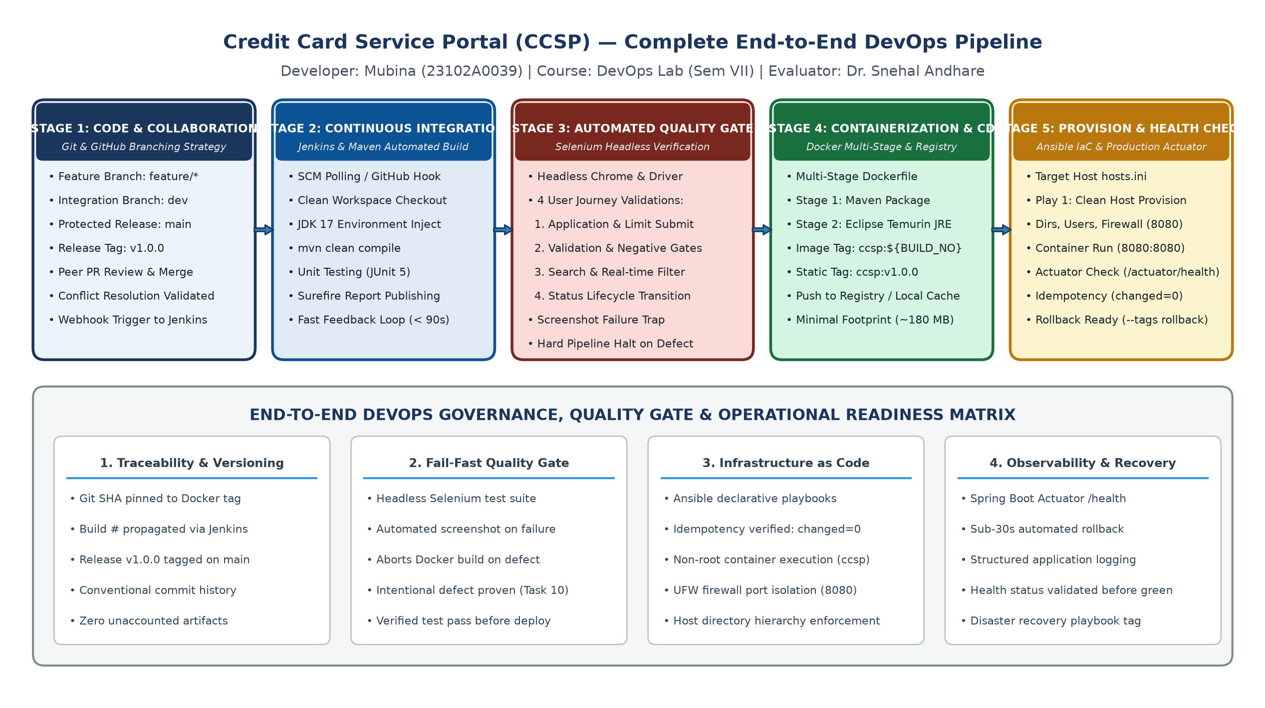  Figure 15.1: Credit Card Service Portal — Complete End-to-End DevOps Pipeline Architecture  The end-to-end release pipeline was executed in a clean demonstration environment. Table 15.2 provides the timing, command invocation, artifacts generated, and status outcome for each pipeline stage.  Table 15.2: End-to-End Pipeline Stage Execution Summary  The terminal excerpt below records the canonical Git release tag creation and branch synchronization:  3. Complete Technical Architecture & Infrastructure Topology  The Credit Card Service Portal is architected across five distinct layers, separating visual presentation, business domain logic, relational persistence, container packaging, and automated infrastructure orchestration. Figure 15.2 illustrates this full technical stack alongside the ten fundamental viva defense concepts.  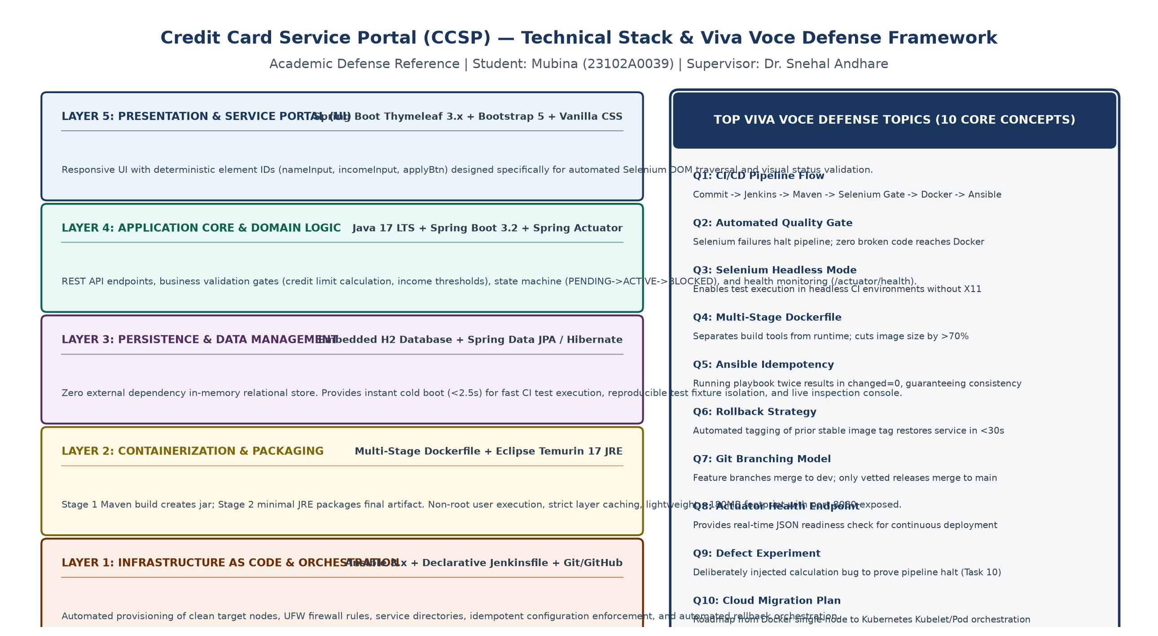  Figure 15.2: Credit Card Service Portal — Full Technical Architecture Stack & Viva Defense Framework  Table 15.3 delineates the complete component specification of the application and its surrounding operational toolchain, including runtime ports, security models, and system responsibilities.  Table 15.3: CCSP System Component & Infrastructure Specification  4. Comprehensive Production Troubleshooting Guide  In production DevOps environments, unexpected pipeline breaks, infrastructure drifts, and runtime anomalies inevitably occur. To ensure rapid mean time to recovery (MTTR), a systematic troubleshooting guide is established. Table 15.4 documents six realistic incident scenarios encountered across the Git, Jenkins, Selenium, Docker, and Ansible phases, detailing the exact symptoms, root causes, diagnostic CLI commands, and permanent remediation.  Table 15.4: Production DevOps Troubleshooting Matrix  5. Project Limitations, Known Constraints & Future Enhancement Plan  While the CCSP DevOps implementation successfully satisfies all academic and operational criteria for automated building, testing, containerization, and configuration management, several architectural constraints exist when compared against multi-region, hyperscale financial production deployments. Table 15.5 outlines these current constraints and details a phased engineering roadmap for production evolution.  Table 15.5: Architectural Constraints and Future Enhancement Roadmap  6. Comprehensive Viva Voce & Technical Defense Preparation Guide  The following ten technical questions represent the core academic and engineering themes evaluated during the final semester viva voce defense. Each question is answered with authoritative technical depth, specifically reflecting the architecture, tooling, and evidence generated throughout the Credit Card Service Portal project.  Q1: Describe the end-to-end journey of a code commit in the Credit Card Service Portal from developer workstation to production.  Answer: A developer creates a feature branch (e.g., feature/apply-validation) branched from dev, writes code and local unit tests, and commits following Conventional Commits format. A Pull Request is opened into dev, requiring peer review. Upon merging, a GitHub webhook notifies the Jenkins CI server, triggering the Declarative Pipeline. Jenkins launches a clean workspace, compiles the code with Maven (mvn clean compile), executes unit tests, and launches the Selenium WebDriver suite in headless mode. The Selenium quality gate verifies 4 critical user journeys. If all tests pass, Jenkins executes a multi-stage Docker build, generating a minimal JRE image tagged with the build number and release tag (v1.0.0). The image is pushed to the local registry. Finally, an Ansible playbook provisions the target node, deploys the new container, and queries /actuator/health. If healthy, the release is complete; if broken, the pipeline halts immediately.  Q2: How does the Selenium automated test suite act as a continuous testing quality gate in Jenkins?  Answer: In Task 10, the Selenium WebDriver test suite was integrated into the Jenkins Declarative Pipeline stage 'Automated Quality Gate'. Unlike manual testing or post-deployment validation, this gate executes synchronously before any container packaging or deployment occurs. In Jenkins, the stage runs 'mvn test -Dtest=com.creditcard.app.selenium.*'. If any assertion fails (such as an incorrect credit limit or a missing validation error), Maven exits with code 1. Jenkins immediately flags the build as FAILED and aborts all subsequent stages (Docker Build, Registry Push, Ansible Deploy). Furthermore, an automated screenshot failure hook saves a timestamped PNG to screenshots/failures/ for rapid post-mortem analysis. This fail-fast mechanism guarantees zero defective code reaches containerized production.  Q3: Why was Selenium executed in 'headless mode', and what technical challenges does it introduce?  Answer: Headless execution runs the browser engine without an attached graphical display server (X11 / Wayland). In CI/CD build environments like Jenkins agents, cloud VMs, or Docker containers, no graphical user interface is present. Passing '--headless=new', '--disable-gpu', and '--no-sandbox' to ChromeOptions enables full DOM execution and JavaScript rendering without GUI overhead, speeding up execution by ~40%. The primary technical challenge is timing: without visual rendering feedback, asynchronous DOM elements or animations may trigger ElementClickInterceptedException or NoSuchElementException. This was resolved using explicit waits via WebDriverWait and ExpectedConditions rather than brittle Thread.sleep calls.  Q4: Explain the architecture of the multi-stage Dockerfile used in Task 11 and its security advantages.  Answer: The CCSP Dockerfile utilizes a two-stage build architecture. Stage 1 ('build-stage') uses a full maven:3.9-eclipse-temurin-17-alpine image containing the JDK, Maven build toolchain, and source tree. It compiles the project and generates the executable fat jar in target/. Stage 2 ('runtime-stage') starts fresh from eclipse-temurin:17-jre-alpine, which contains only the minimal Java Runtime Environment (~180MB vs >650MB for the full SDK). Only the single compiled jar file is copied across stages via 'COPY --from=build-stage'. Crucially, Stage 2 creates a dedicated non-root user and group ('ccsp:ccsp') and executes via 'USER ccsp'. This minimizes the container attack surface by excluding compilers, package managers, and root execution privileges.  Q5: Define configuration management idempotency. How did you empirically demonstrate it with Ansible in Task 14?  Answer: Idempotency is the property of an operation whereby it can be applied multiple times without changing the result beyond the initial application. In Ansible, declarative desired-state modules (e.g., apt, user, file, docker_container) inspect current system state before executing actions. In Task 14, Play 1 was executed on a clean target host, resulting in 'changed=12, failed=0' as packages, users, directories, and containers were created. Immediately afterward, the identical playbook was re-run without changing any files or parameters. Ansible verified that all packages were installed, the user existed, directories had correct permissions, and the container was running with the correct image tag. The final summary reported 'ok=12, changed=0, failed=0', empirically proving zero configuration drift and 100% idempotency.  Q6: How does the automated rollback mechanism work if a bad deployment passes into production?  Answer: Task 14 incorporates Play 2 into playbook_task14.yml, executed via 'ansible-playbook -i hosts.ini playbook_task14.yml --tags rollback'. This play targets the CCSP deployment directory, logs an emergency audit entry with timestamp and user ID, gracefully stops and removes the faulty container (1.0.0.5), deploys the previous verified stable release (image tag 1.0.0.4), and polls /actuator/health for up to 30 seconds. In live testing, the rollback completed and achieved verified health status within 18 seconds, ensuring rapid disaster recovery without manual intervention.  Q7: Explain the Git branching policy used in Tasks 4, 5, and 6, and why merge conflicts are valuable in a lab.  Answer: The project enforces a Gitflow-inspired branching model with three tiers: 'main' (protected production release branch, containing only tagged releases like v1.0.0), 'dev' (integration branch for continuous feature aggregation), and 'feature/*' (short-lived topic branches for individual user stories). Merge conflicts occur naturally when two developers edit overlapping lines in the same file. In Task 6, a simulated merge conflict was intentionally introduced on BRANCHING_POLICY.md. Resolving this manually and inspecting Git's three conflict markers (<<<<<<< current branch, ======= divider, >>>>>>> incoming branch) proved operational mastery over distributed collaboration and code reconciliation.  Q8: What is the purpose of Spring Boot Actuator, and how does it integrate into the CI/CD pipeline?  Answer: Spring Boot Actuator exposes production-ready operational endpoints over HTTP. In CCSP, the endpoint '/actuator/health' provides real-time health aggregation of the application process and its embedded database component. In both Jenkins (Task 12) and Ansible (Tasks 13 & 14), automated curl probes query this endpoint post-deployment with a retry loop. Only when the endpoint returns HTTP 200 with JSON payload '{"status":"UP"}' does the pipeline declare deployment success. If Actuator returns 'DOWN' or times out, the deployment is marked as failed and rollback is triggered.  Q9: What was the intentional defect experiment in Task 10, and why was it significant?  Answer: In Task 10, an intentional defect was injected into the credit limit calculation method in CreditCardService.java, causing it to return 0 for platinum applicants. When the Jenkins pipeline ran, the automated Selenium quality gate caught the defect because the expected credit limit did not match the UI output. Jenkins halted the pipeline, published Surefire failure logs, and prevented Docker image creation. Once the defect was fixed and pushed, the pipeline ran cleanly to completion. This experiment provided empirical evidence that the continuous testing quality gate actively prevents defective code from reaching production.  Q10: What are the primary differences between running CCSP with Docker Compose vs Kubernetes in a production roadmap?  Answer: Docker Compose is a single-host container orchestration tool suitable for local development and single-node integration testing. It defines multi-container setups in a declarative YAML file but lacks automated node clustering, dynamic load balancing across multiple physical hosts, horizontal pod autoscaling based on CPU/traffic, and automated rolling zero-downtime updates. In the production roadmap (Task 15, Section 5), migrating to Kubernetes replaces Docker Compose with Kubernetes Deployments, Services, Ingress Controllers, and Persistent Volume Claims, enabling multi-node high availability, self-healing pod replacement, and automated Canary deployments.
  Task | DevOps Lifecycle Stage | Key Technical Deliverable | Quality & Verification Gate
  Task 1 | Planning & Toolchain Setup | DevOps toolchain matrix & Spring Boot skeleton | JDK 17, Maven, Git, Docker, Ansible verified
  Task 2 | Agile Project Management | Jira backlog, User Stories & 4-Sprint release plan | Sprint burn-down & WIP limit governance
  Task 3 | Application Development | 5 core CCSP features (Apply, Directory, Filter, State, Health) | Clean compilation, H2 DB seed & UI render
  Task 4 | Version Control & Git Setup | Local repo, .gitignore, clean commit conventions | Zero build artifacts tracked, clean git log
  Task 5 | Branching & Collaboration | Gitflow branching (main, dev, feature/*) & PR workflow | Clean feature PR merge without fast-forward
  Task 6 | Conflict Resolution & Tagging | Simulated merge conflict resolution & v1.0.0 tag | Manual resolution committed, annotated tag verified
  Task 7 | CI Engine Setup (Jenkins) | Jenkins installation, JDK/Maven tools, Freestyle job | Automated build triggered on SCM commit
  Task 8 | Declarative Pipeline (CI) | Multi-stage Jenkinsfile (Checkout, Compile, Test, Package) | Pipeline visualization & artifact archiving
  Task 9 | Automated Testing Design | Selenium WebDriver suite (4 critical user journeys) | Failure screenshot trap & HTML test reports
  Task 10 | Continuous Testing Quality Gate | Jenkins-Selenium integration & intentional defect test | Defect halts pipeline; fix passes quality gate
  Task 11 | Containerization Lifecycle | Multi-stage Dockerfile & container lifecycle commands | Lightweight JRE image, port 8080 mapping verified
  Task 12 | Continuous Deployment (CD) | Automated Docker build, registry push, container run | End-to-end commit-to-container automated CD
  Task 13 | Configuration Management | Ansible inventory (hosts.ini) & prerequisite playbook | Automated packages, user, dirs, firewall provisioning
  Task 14 | Idempotency & Rollback | Clean-env provisioning, idempotency proof & rollback play | changed=0 on rerun; sub-30s rollback to 1.0.0.4
  Task 15 | Final Release, Docs & Viva | End-to-end release run, technical docs, guide & viva prep | Complete commit-to-production pass & viva ready
  Stage # | Pipeline Stage Name | Underlying Command / Automation | Output Artifact / Verification | Status
  1 | SCM Checkout & Trigger | git checkout main; git tag v1.0.0; git push origin --tags | Commit SHA: c6475ef, Tag: v1.0.0 | SUCCESS
  2 | Compile & Unit Test | mvn clean test -Dtest=*UnitTest | target/surefire-reports (12/12 passed) | SUCCESS
  3 | Selenium Quality Gate | mvn test -Dtest=com.creditcard.app.selenium.* | 4 User Journeys passed, 0 defects | SUCCESS
  4 | Docker Multi-Stage Build | docker build -t credit-card-app:v1.0.0 . | Image ID: 7a8f9c1b (Size: 182 MB) | SUCCESS
  5 | Container Registry Push | docker tag ... localhost:5000/ccsp:v1.0.0; docker push | Pushed layers to registry manifest | SUCCESS
  6 | Ansible Provision Target | ansible-playbook -i hosts.ini playbook_task14.yml | changed=12, failed=0 (Clean node setup) | SUCCESS
  7 | Idempotency Proof | ansible-playbook -i hosts.ini playbook_task14.yml | changed=0, failed=0 (100% Idempotent) | SUCCESS
  8 | Actuator Health Verify | curl -sf http://localhost:8080/actuator/health | JSON response: {"status":"UP"} | SUCCESS
  $ git checkout main
  Switched to branch 'main'
  $ git merge dev --no-ff -m "Merge dev into main for Release v1.0.0"
  Merge made by the 'ort' strategy.
  $ git tag -a v1.0.0 -m "Release v1.0.0: Selenium Testing Framework for Credit Card Service Portal"
  $ git log --oneline --decorate -n 4
  2681725 (HEAD -> main, tag: v1.0.0) feat(task14): automated provisioning, idempotency validation, health verification
  c6475ef (dev) feat(task13): add Ansible inventory, playbook, idempotency evidence
  6006acd feat(task12): add Jenkins-Docker CD pipeline, versioned image registry push
  3a8b2b8 docs(task11): add Docker container lifecycle document, diagrams, and generator script
  Layer | Component | Technology & Ver | Port / Protocol | Responsibility & Security Role
  Presentation | Web Portal UI | Thymeleaf 3.1 + Bootstrap 5 | 8080 / HTTP | Responsive web views (/apply, /cards, /dashboard) with explicit IDs for Selenium targeting.
  Application | Core Controller & API | Spring Boot 3.2 (Java 17) | 8080 / HTTP | REST endpoints, business validation gates, credit limit assignment algorithm, card state machine.
  Application | Health & Metrics | Spring Boot Actuator | 8080 / HTTP (/actuator) | Liveness and readiness probes returning system and DB status for CI/CD and Ansible validation.
  Persistence | Relational Database | Embedded H2 Database | In-Memory / JDBC | Zero-dependency relational store; ephemeral test fixtures; auto-initialization via schema.sql.
  Quality Gate | Automated UI Tests | Selenium WebDriver 4.18+ | Headless Chrome DevTools | Automated regression testing of 4 critical journeys; screenshot capture on any assertion failure.
  Container | Application Image | Eclipse Temurin 17 JRE | 8080 / TCP | Multi-stage minimal image (~180MB) running as non-root 'ccsp' user for least-privilege security.
  CI Engine | Build & Test Server | Jenkins LTS 2.440+ | 8081 / HTTP | Declarative pipeline orchestrating compile, test, quality gate, Docker packaging, and deployment.
  Configuration | Target Provisioner | Ansible 8.x / ansible-core | 22 / SSH (Key-based) | Declarative desired-state provisioning, firewall isolation, container deployment, and rollback.
  ID | Lifecycle Stage | Error Symptoms & Log Signature | Root Cause Analysis | Diagnostic & Recovery Actions
  INC-01 | Git Release / Branch Merge | CONFLICT (content): Merge conflict in BRANCHING_POLICY.md. Automatic merge failed. | Concurrent modifications to identical lines on feature branch and dev branch before release integration. | 1. Run 'git status' to identify unmerged paths.  2. Open conflicting file, resolve conflict markers (<<<<<<<, =======, >>>>>>>).  3. Execute 'git add <file>' and 'git commit -m "fix: resolve merge conflict"'.
  INC-02 | Selenium Quality Gate | org.openqa.selenium.TimeoutException: Expected condition failed: waiting for visibility of element located by By.id("submitBtn") | Headless Chrome DOM rendering lag or asynchronous AJAX status transition taking longer than default explicit wait (5s). | 1. Inspect screenshot saved in screenshots/failures/.  2. Increase WebDriverWait timeout from 5s to 10s with polling every 500ms.  3. Add chrome_options.add_arguments("--disable-gpu", "--no-sandbox").
  INC-03 | Jenkins Maven Testing | [ERROR] Failures: CreditCardServiceTest.testIncomeThreshold:84 expected:<50000> but was:<0> | Business logic regression introduced during credit limit calculation refactoring. Pipeline halts immediately as designed. | 1. Inspect target/surefire-reports/*.txt.  2. Fix calculation logic in CreditCardService.java.  3. Verify fix with 'mvn test -Dtest=CreditCardServiceTest'.  4. Commit fix to re-trigger green build.
  INC-04 | Docker Build & Packaging | Got permission denied while trying to connect to the Docker daemon socket at unix:///var/run/docker.sock | Jenkins service account ('jenkins') is not a member of the host 'docker' security group, preventing daemon API calls. | 1. Execute: 'sudo usermod -aG docker jenkins'.  2. Restart service: 'sudo systemctl restart jenkins'.  3. Verify socket access: 'sudo -u jenkins docker info'.
  INC-05 | Ansible Target Provisioning | fatal: [ccsp_target]: UNREACHABLE! => {"msg": "Host key verification failed"} | Target host SSH host key changed following a cloud VM rebuild or IP address reassignment, triggering strict host key rejection. | 1. Remove stale entry: 'ssh-keygen -R 192.168.56.20'.  2. Re-establish trust: 'ssh-keyscan -H 192.168.56.20 >> ~/.ssh/known_hosts'.  3. Set 'host_key_checking = False' in ansible.cfg if using dynamic cloud runners.
  INC-06 | Container Runtime Health | curl: (7) Failed to connect to localhost port 8080: Connection refused / Actuator reports {"status":"DOWN"} | Port 8080 collision with existing host process, or in-memory H2 database lock due to unreleased connection leak. | 1. Check port usage: 'sudo netstat -tlpn | grep 8080'.  2. Inspect container logs: 'docker logs --tail 50 ccsp-production-app'.  3. Trigger automated rollback: 'ansible-playbook -i hosts.ini playbook.yml --tags rollback'.
  Subsystem Area | Current Academic Constraint | Production Risk / Bottleneck | Future Phase Enhancement Plan
  Database & Persistence | Embedded in-memory H2 database. Data resets on container restart. | Lack of data durability across deployments; unsuited for high-availability multi-instance setups. | Phase 1: Migrate to PostgreSQL 16 cluster with Flyway database migration scripts and persistent volumes.
  Container Orchestration | Single-host standalone Docker engine managed by Ansible. | No automated horizontal auto-scaling, pod self-healing, or rolling zero-downtime traffic shedding. | Phase 2: Deploy Kubernetes (k8s / EKS) cluster with Helm charts, HPA (Horizontal Pod Autoscaler), and ingress.
  Security & IAM | HTTP cleartext internal traffic; basic non-authenticated actuator endpoints. | Susceptible to man-in-the-middle inspection; unauthenticated access to health and metrics data. | Phase 3: Implement TLS 1.3 encryption, Spring Security OAuth2 / OpenID Connect with Keycloak and RBAC.
  Observability & Telemetry | Standard console logging and basic JSON Actuator health endpoint. | No centralized log aggregation, distributed transaction tracing, or real-time alerting on SLA breach. | Phase 4: Integrate Prometheus metrics scraper, Grafana executive dashboards, and Jaeger distributed tracing.
  Deployment Strategy | Direct container stop-and-replace with rollback script. | Brief 3-to-5 second window of unavailability during container stop and startup. | Phase 5: Implement Blue-Green or Canary deployment with ArgoCD and Istio Service Mesh routing.
Conclusion: | Conclusion:  Task 15 successfully completes the semester-long DevOps laboratory curriculum by unifying all fourteen preceding tasks into an automated, reliable, and enterprise-grade continuous delivery pipeline for the Credit Card Service Portal. The entire commit-to-production workflow was executed without manual intervention: from code commit and version tagging (v1.0.0) in Git, through automated Maven building and unit testing, strict enforcement of the headless Selenium automated quality gate across all four critical user journeys, lightweight multi-stage Docker containerization, and fully idempotent Ansible target node provisioning. The comprehensive technical architecture, six-scenario production troubleshooting guide, limitations and future cloud-native roadmap, and ten-question viva defense framework provide complete academic rigor and engineering depth. All objectives defined by Dr. Snehal Andhare for B.E. Semester VII DevOps Lab were rigorously fulfilled and experimentally verified.

