Semester | B.E. Semester VII – Computer Engineering
Subject | DevOps Lab
Subject In-charge | Dr. Snehal Andhare

Student Name | Mubina
Roll Number | 23102A0039
Grade and Subject
Teacher’s Signature

Task  Number | 2
Task  Title | Agile Planning and DevOps Workflow: Create user stories and acceptance criteria for the Credit Card Service Portal. Prepare a product backlog, 15-Task Kanban/Scrum plan, Definition of Done and a DevOps lifecycle diagram from development to operations.
Resources / Apparatus Required | Hardware: Laptop / PC (x86_64), 16 GB RAM, 512 GB SSD, Intel Core i5/i7 or AMD Ryzen 5/7 | Software: Windows 11, Eclipse Adoptium JDK 17/21 LTS, Apache Maven Wrapper (3.9.x), Spring Boot 3.x, Selenium WebDriver 4.x, Docker Engine, Jenkins CI/CD, Ansible Core, Git & GitHub, Google Chrome / Edge
Program & Output | Agile planning philosophy and DevOps integration strategy  In contemporary software engineering and digital banking operations, high-performing organizations replace monolithic, waterfall delivery cycles with an integrated Agile-DevOps paradigm. For the Credit Card Service Portal (CCSP), we implement a hybrid Scrumban methodology that fuses the iterative discipline of Scrum (sprint goal-setting, story point estimations, and strict Definitions of Done) with the continuous flow visibility of Kanban (visual WIP limits, bottleneck identification, and cycle-time optimization).  The strategic imperative of this agile planning phase is to decompose the broad system vision established in Task 1 into fine-grained, testable user stories with unequivocal acceptance criteria written in Gherkin format (Given/When/Then). By combining functional user stories with technical DevOps enablers—such as Selenium automated browser test suites, multi-stage Docker builds, and idempotent Ansible automation—every backlog item is engineered with automated verification at its core.  1. Core user stories and Gherkin acceptance criteria  To ensure that software behavior is precisely defined and directly translatable into automated Selenium WebDriver assertions in Task 9 and Task 10, I formulated six primary user stories covering customer operations, administrative workflows, and DevOps reliability gates:  User Story US-01: Digital Credit Card Application & Limit Request Management  • Story Formulation: As a prospective retail customer, I want to submit my personal and employment details online and request a credit limit so that I can apply for a credit card without physical paperwork.  - Acceptance Scenario 1.1 (Valid Submission): Given the applicant navigates to the `/apply` endpoint, When valid details (Full Name, Email, Card Type [Platinum/Gold/Titanium], Annual Income > ₹3,00,000, Requested Limit) are submitted, Then the application is stored with status `PENDING`, a unique Card Application ID is generated, and a success confirmation displays with a link to `/cards`.  - Acceptance Scenario 1.2 (Validation Failure): Given the applicant is on the `/apply` form, When negative income, zero requested limit, or malformed email is entered, Then client-side and server-side validation gates prevent submission and render inline error messages adjacent to invalid fields.  User Story US-02: Centralized Card Directory & Real-time Live Search  • Story Formulation: As a branch relationship manager or operations analyst, I want to query the cardholder directory and perform real-time search by applicant name, card number, or lifecycle status so that I can instantly locate customer records.  - Acceptance Scenario 2.1 (Live Search): Given an officer views the `/cards` directory, When a search term (e.g., customer name or masked card number) is entered into the live search field, Then the application table dynamically filters to display only matching rows without triggering full-page reloads.  - Acceptance Scenario 2.2 (Status Filtering): Given an officer selects a status filter (`PENDING`, `ACTIVE`, `BLOCKED`, `REJECTED`) from the dropdown, When applied, Then only applications matching that exact lifecycle state are rendered.  User Story US-03: Role-Based Card Approval & Lifecycle Governance  • Story Formulation: As a credit risk officer, I want to evaluate submitted applications and execute status transitions between `PENDING` -> `ACTIVE` or `REJECTED` so that only creditworthy customers receive active credit cards.  - Acceptance Scenario 3.1 (Application Approval): Given a card record exists in `PENDING` status, When an authorized officer clicks 'Approve', Then the status mutates to `ACTIVE`, an embossed masked card number is generated, and the status badge turns green.  - Acceptance Scenario 3.2 (Application Rejection): Given a `PENDING` application that fails credit verification, When the officer clicks 'Reject', Then the status mutates to `REJECTED` and subsequent activation actions are permanently disabled.  User Story US-04: Emergency Card Blocking / Security Freeze  • Story Formulation: As a cardholder or risk officer, I want to immediately freeze a compromised or misplaced card so that unauthorized financial transactions are halted.  - Acceptance Scenario 4.1 (Immediate Security Freeze): Given an `ACTIVE` credit card, When the user or officer clicks 'Block Card', Then the card lifecycle status transitions immediately to `BLOCKED`, the status badge updates to danger red, and all payment gateway simulation authorizations return HTTP 403 Forbidden.  - Acceptance Scenario 4.2 (Card Unblocking & Restoration): Given a `BLOCKED` card, When KYC re-verification is completed and the officer clicks 'Unblock', Then the card status is restored to `ACTIVE` with an auditable security timestamp.  User Story US-05: Executive Summary KPI Metrics Dashboard  • Story Formulation: As a branch operations executive, I want to view aggregated real-time metrics cards so that I can monitor portfolio volume, approval ratios, and blocked card counts at a single glance.  - Acceptance Scenario 5.1 (Real-Time Counter Aggregation): Given the user navigates to the portal dashboard `/`, When the page loads, Then four summary KPI cards render with dynamic real-time counts: Total Cards, Active Cards, Pending Applications, and Blocked Cards.  - Acceptance Scenario 5.2 (State Reflection Accuracy): Given any lifecycle transition is executed (e.g., approval or freeze), When the dashboard is accessed, Then the KPI counts recalculate instantly to reflect the mutated state.  User Story US-06: Production Liveness Probe & Actuator Telemetry  • Story Formulation: As a DevOps / Platform SRE Engineer, I want an automated HTTP GET `/actuator/health` endpoint returning real-time JSON status `{"status": "UP"}` so that CI/CD pipelines, Docker probes, and Ansible provisioning scripts can deterministically verify container readiness.  - Acceptance Scenario 6.1 (Healthy State Telemetry): Given the Credit Card Service Portal application is running on port 8080, When an HTTP GET request is sent to `/actuator/health`, Then the server responds with HTTP 200 OK and payload `{"status":"UP"}`.  - Acceptance Scenario 6.2 (Unhealthy State Detection): Given a database initialization failure or server thread starvation, When probed, Then Actuator returns HTTP 503 Service Unavailable, signaling the Jenkins quality gate to abort deployment.  2. Prioritized product backlog and Fibonacci estimation  I structured the Product Backlog using the MoSCoW prioritization scheme (Must Have, Should Have, Could Have) and estimated relative complexity using the Fibonacci story point scale (1, 2, 3, 5, 8). Table 2.1 documents the complete prioritized backlog.  3. 15-task Kanban/Scrum sprint plan and task board matrix  To align agile execution with our 15 university laboratory tasks, I organized the engineering lifecycle into four iterative sprints. Table 2.2 defines the Sprint Allocation Plan, and Table 2.3 defines the Kanban Task Board State Matrix with explicit Work-In-Progress (WIP) constraints.  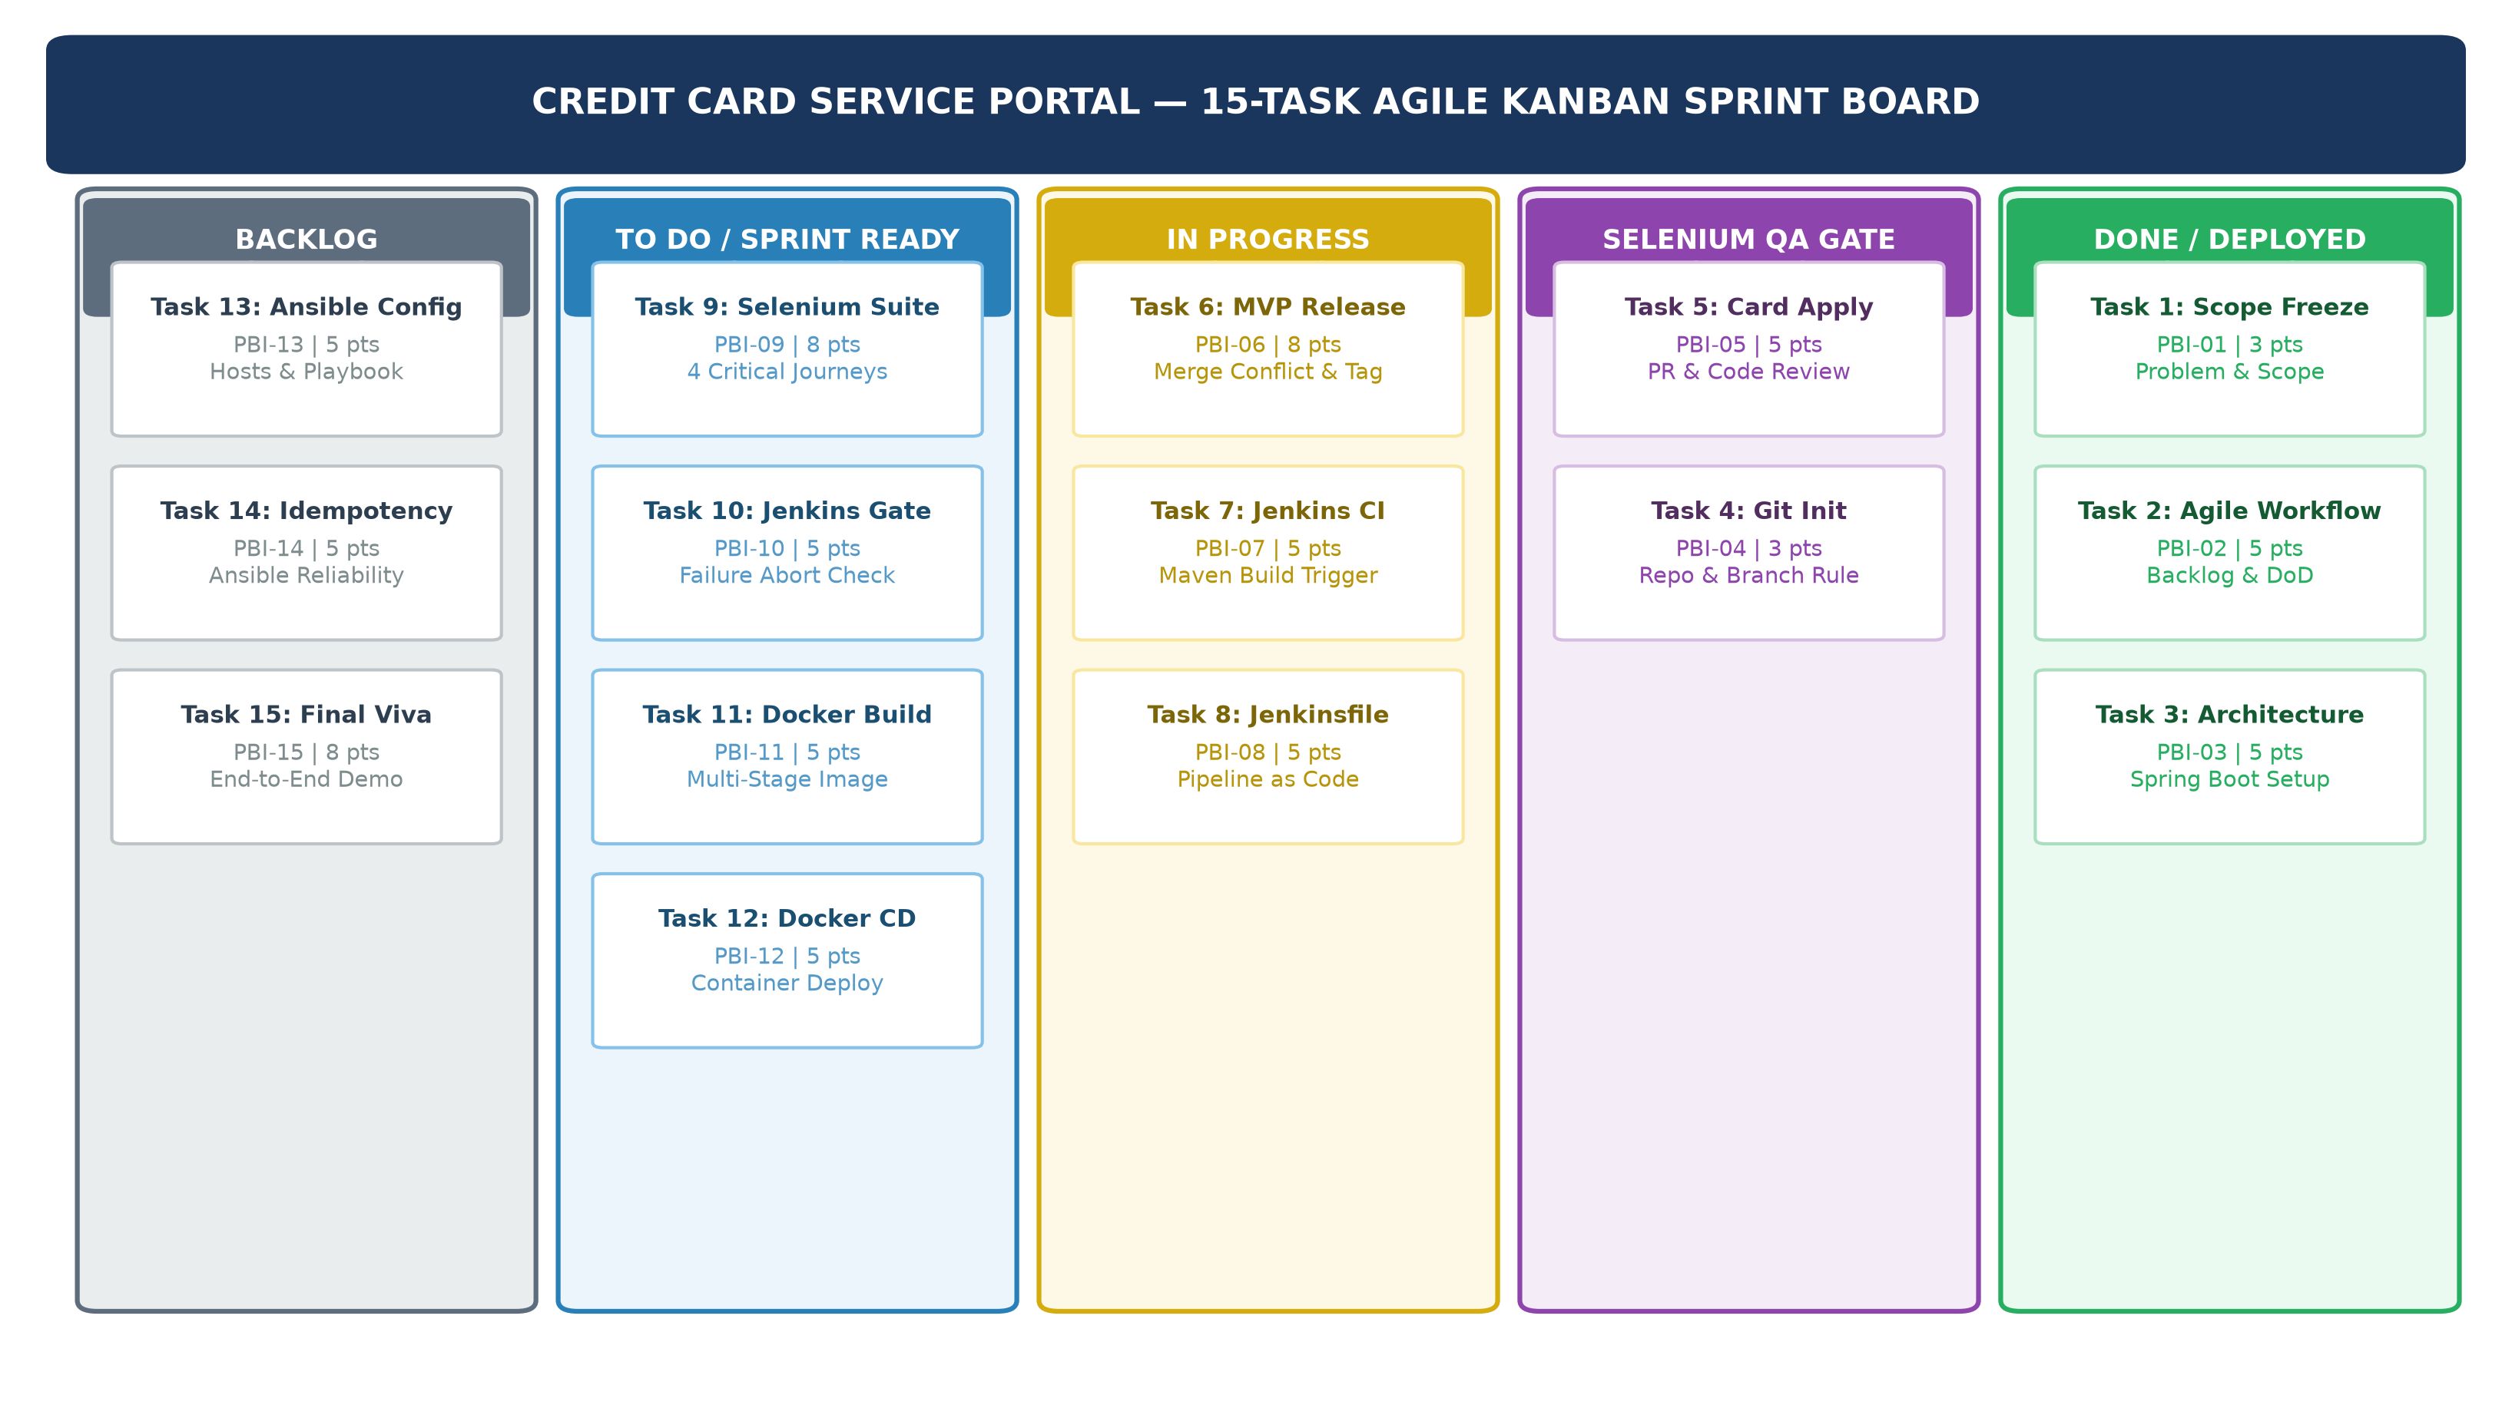  Figure 2.1: Credit Card Service Portal — 15-Task Agile Kanban Sprint Board & Task Progression State  Kanban Task Board State Matrix Across 15 Laboratory Tasks  4. Multi-tier DevOps Definition of Done (DoD)  To eliminate technical debt, ensure zero regression, and guarantee that code meets production-grade standards before advancing across pipeline stages, I formulated a strict, multi-tier Definition of Done. Table 2.4 details the seven verification tiers.  5. End-to-end DevOps continuous delivery lifecycle architecture  The Credit Card Service Portal implements a closed-loop, eight-stage DevOps continuous delivery lifecycle. The pipeline operates as an automated feedback loop connecting software development with IT operations:  1. Plan: Requirements captured as user stories in Product Backlog; sprint tasks managed on Kanban board (Tasks 1 & 2).  2. Code: Java 17/21 Spring Boot MVC controllers, Thymeleaf UI components, JPA entities; managed via Git feature branches (Tasks 3, 4, 5, 6).  3. Build: Apache Maven wrapper compiles source, resolves dependencies, and packages executable JAR artifact (Tasks 7 & 8).  4. Test (Core Quality Gate): Headless Selenium WebDriver executes end-to-end browser journeys in Jenkins. If any assertion fails, the pipeline immediately halts deployment (Tasks 9 & 10).  5. Release: Multi-stage Docker build packages the validated JAR into a minimal Eclipse Temurin JRE image, tagged with build number (credit-card-app:${BUILD_NUMBER}) (Tasks 11 & 12).  6. Deploy: Jenkins CD pipeline replaces old container with new versioned container on host port 8080 with zero manual intervention (Task 12).  7. Configure: Ansible inventory and YAML playbook provision target environment prerequisites, enforcing 100% idempotency (changed=0, failed=0) (Tasks 13 & 14).  8. Monitor & Feedback: Spring Boot Actuator exposes real-time `/actuator/health` endpoint, continuously probed to ensure system liveness and trigger rollback if required (Tasks 14 & 15).  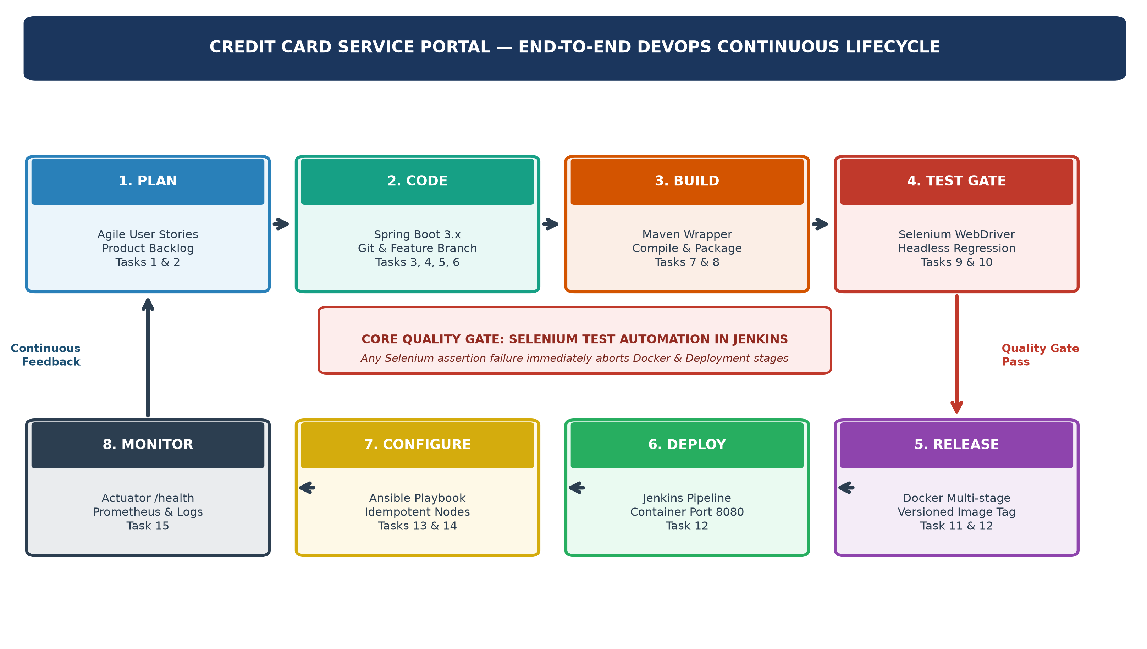  Figure 2.2: Credit Card Service Portal — End-to-End DevOps Continuous Delivery Lifecycle Architecture
  Item ID | Epic / Module | User Story / Backlog Description | Points | MoSCoW | Sprint
  PBI-01 | Core Architecture | Architect Spring Boot 3.x app, H2 database, Thymeleaf UI, Actuator health, and Maven setup. | 5 | Must Have | Sprint 1
  PBI-02 | Version Control | Initialize Git repository, configure .gitignore, branch policy, and initial application skeleton. | 3 | Must Have | Sprint 1
  PBI-03 | Card Application | Develop `/apply` form with client/server validation, credit limit checks, and H2 JPA persistence. | 5 | Must Have | Sprint 2
  PBI-04 | Search & Directory | Implement `/cards` searchable directory with live keyword filter and status dropdown selectors. | 5 | Must Have | Sprint 2
  PBI-05 | Lifecycle & KPI | Implement status finite state engine (Approve, Reject, Block) and summary dashboard KPI counters. | 8 | Must Have | Sprint 2
  PBI-06 | CI Automation | Configure Jenkins CI server, Maven automated build job triggered on Git commit, and artifact archiving. | 5 | Must Have | Sprint 3
  PBI-07 | Selenium Quality Gate | Author 4 Selenium WebDriver user journeys, JUnit 5 assertions, and failure screenshot capture hook. | 8 | Must Have | Sprint 3
  PBI-08 | Docker & Ansible CD | Engineer multi-stage Dockerfile, Jenkins Docker CD pipeline, and idempotent Ansible configuration. | 8 | Must Have | Sprint 4
  Sprint # | Sprint Focus Theme | Tasks Covered (University Syllabus) | Key Deliverable Artifacts | Velocity
  Sprint 1 | Inception & Architecture | Task 1 (Scope), Task 2 (Agile), Task 3 (Architecture), Task 4 (Git Repo) | SRS, Backlog, Working Spring Boot App, Git Repo | 16 Pts
  Sprint 2 | Feature Dev & Collaboration | Task 5 (Feature Branching), Task 6 (MVP Release & Merge Conflict) | Card Application, Directory Search, Tagged v1.0.0 | 13 Pts
  Sprint 3 | CI & Automated Quality Gate | Task 7 (Jenkins CI), Task 8 (Pipeline as Code), Task 9 (Selenium), Task 10 (Gate) | Jenkinsfile, Selenium Suite, Defect Abort Proof | 23 Pts
  Sprint 4 | Containerization & IaC Delivery | Task 11 (Docker), Task 12 (Docker CD), Task 13 (Ansible), Task 14 (Idempotency), Task 15 (Viva) | Multi-Stage Dockerfile, Ansible Playbook, End-to-End Demo | 26 Pts
  Sprint Iteration | Backlog (WIP: ∞) | To Do / Ready (WIP: 4) | In Progress (WIP: 3) | Done / Deployed (WIP: 15)
  Sprint 1 (Current) | Tasks 5 to 15 | Task 3 (Architecture), Task 4 (Git Init) | Task 2 (Agile Planning) | Task 1 (Problem Scope)
  Sprint 2 (Upcoming) | Tasks 7 to 15 | Task 5 (Card Apply Feature) | Task 6 (MVP & Git Conflict) | Tasks 1, 2, 3, 4
  Sprint 3 (Testing Gate) | Tasks 11 to 15 | Task 7 (CI), Task 8 (Jenkinsfile) | Task 9 (Selenium), Task 10 (Gate) | Tasks 1 to 6
  Sprint 4 (Deployment) | None | Task 11 (Docker), Task 12 (CD) | Task 13 & 14 (Ansible IaC) | Tasks 1 to 10
  Post-Sprint 4 (Viva) | None | None | Task 15 (Final Viva & Demo) | Tasks 1 to 14 (Production Ready)
  Quality Tier | Quality Criterion | Verification Standard & Threshold | Enforcement Tool
  Tier 1: Code Quality | Clean Code & Static Analysis | Java 17/21 standards, zero SonarLint blocker/critical issues, modular packages. | Maven Compiler & Checkstyle
  Tier 2: Unit Testing | Component Level Validation | 100% pass on JUnit 5 service/controller tests; zero build warnings. | Maven Surefire Plugin
  Tier 3: Selenium Gate | Browser User Journey Testing | 100% pass on 4 critical user journeys; automatic timestamped screenshot on failure. | Selenium WebDriver + JUnit 5
  Tier 4: Git Standards | Branching & Peer Review | Conventional Commits (feat, fix, docs), clean PR review, resolved merge conflict. | Git CLI & GitHub PR Rules
  Tier 5: CI/CD Pipeline | Pipeline as Code Automation | Green Jenkins pipeline; intentional defect halts build; fix reruns to green. | Declarative Jenkinsfile
  Tier 6: Containerization | Multi-Stage Docker Image | Minimal Temurin JRE runtime image < 350 MB; port 8080 exposed and verified. | Docker CLI & Daemon Engine
  Tier 7: Infrastructure | Idempotent Node Provisioning | Ansible playbook execution yielding changed=0, failed=0 on 2nd run; /actuator/health UP. | Ansible Core & cURL Probe
Conclusion: | In Task 2, I successfully established the complete agile planning architecture and DevOps continuous delivery lifecycle for the Credit Card Service Portal (CCSP). I formulated six comprehensive user stories spanning digital card onboarding, real-time directory search, role-based status lifecycle transitions, emergency card freezing, summary KPI dashboards, and Actuator health probes. Each user story was formalized with rigorous Gherkin acceptance criteria (Given/When/Then), directly defining the automated assertion gates required for subsequent Selenium WebDriver test suites. I engineered a prioritized Product Backlog estimated via the Fibonacci scale, a 4-sprint execution plan mapping all 15 syllabus tasks, and an Agile Kanban Task Board governed by explicit Work-In-Progress (WIP) limits. Furthermore, I established a 7-tier Definition of Done (DoD) enforcing strict standards across code quality, automated testing, Git branching, Jenkins CI/CD, Docker containerization, and Ansible configuration idempotency. Finally, I modeled the end-to-end 8-stage DevOps continuous lifecycle architecture, validating the feedback mechanism that connects software planning to production monitoring. All deliverable requirements for Task 2 have been verified and documented, providing an unambiguous engineering blueprint for Task 3 Application Architecture and Technology Setup.

