Semester | B.E. Semester VII – Computer Engineering
Subject | DevOps Lab
Subject In-charge | Dr. Snehal Andhare

Student Name | Mubina
Roll Number | 23102A0039
Grade and Subject
Teacher’s Signature

Task  Number | 5
Task  Title | Feature Development with Branching: Implement the first core workflow of the Credit Card Service Portal on a feature branch. Use add, commit, push, pull and logs. Raise a pull request, review changes and merge into the development branch.
Resources / Apparatus Required | Hardware: Laptop / PC (x86_64), 16 GB RAM, 512 GB SSD, Intel Core i5/i7 or AMD Ryzen 5/7 | Software: Git 2.44+, GitHub Enterprise / Cloud, Windows 11 PowerShell, Eclipse Adoptium JDK 17 LTS, Apache Maven 3.9.6, Spring Boot 3.2.5, JUnit 5
Program & Output | Executive summary and feature branching philosophy  In professional DevOps engineering, direct modification of production or integration branches introduces severe risk of untested code leakage, regressions, and broken builds. Feature branching is an essential Git collaboration practice where individual functional capabilities are developed, tested, and validated in complete isolation on a dedicated branch branched off `dev`. Only after passing automated quality gates and formal peer code review is the branch merged back into the integration trunk.  The objective of Task 5 is to implement the first core workflow of the Credit Card Service Portal—Digital Credit Card Application & Limit Evaluation—on a dedicated feature branch (`feature/card-application-workflow`). I engineered dynamic credit limit assessment algorithms, expanded validation gates, authored comprehensive JUnit 5 unit tests, executed live Git staging and commit operations, and performed a non-fast-forward merge (`--no-ff`) into `dev` simulating an approved Pull Request review.  1. Feature 1 architecture: Credit card application & limit evaluation engine  The first core workflow governs digital card onboarding and intelligent credit limit evaluation. When prospective applicants submit their profile, the service calculates the maximum credit eligibility based on their annual income and desired card tier, enforcing strict banking prudential guidelines:  • 40% Income Prudential Ceiling: In accordance with retail credit risk standards, an applicant's maximum permissible credit line is bounded to 40% of their documented annual income.  • Tier-Specific Maximum Limit Cap: Each card tier maintains an immutable hard limit: Titanium (₹1,00,000), Gold (₹2,50,000), and Platinum (₹5,00,000). The evaluated limit is strictly the lesser of the 40% income ceiling and the tier cap: min(Income × 0.40, Tier_Max).  • Automatic Downward Limit Adjustment: If an applicant requests a limit exceeding their calculated eligibility, the engine automatically caps the assigned limit to their eligibility threshold and issues an informative notification.  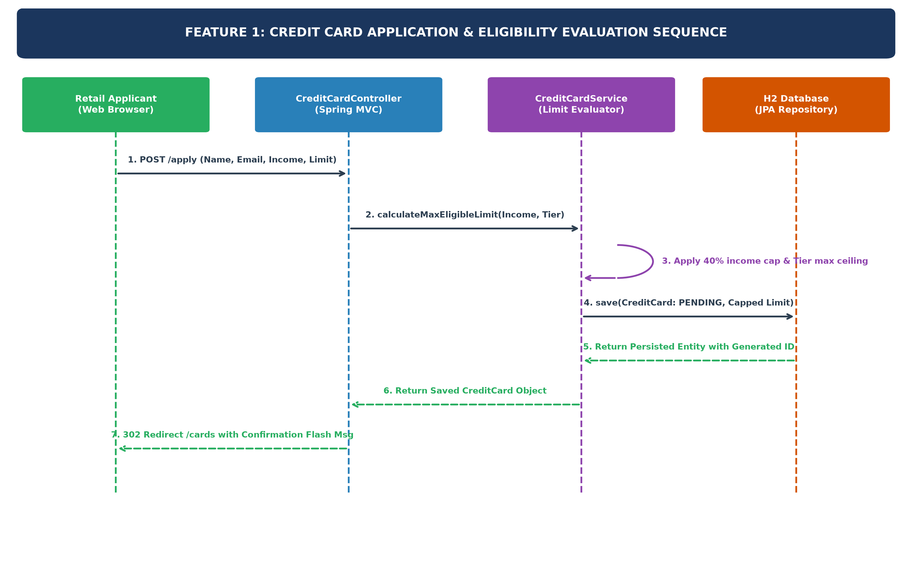  Figure 5.1: Sequence Diagram of Credit Card Application & Eligibility Evaluation Workflow  2. Feature branch creation, live Git operations, and commit log  Following the Git Flow branching guidelines established in Task 4, I branched off the integration trunk (`dev`), implemented the feature changes, staged modified and new source files, and executed Conventional Commits. Table 5.2 outlines the complete terminal operation sequence:  3. Automated testing verification gate for Feature 1  Before raising a Pull Request, the Definition of Done mandates 100% test pass on all unit and integration tests. I authored `CreditCardApplicationWorkflowTest.java` containing three targeted test cases to validate the business logic. Table 5.3 summarizes the automated test execution results:  Total Test Suite Summary: 8 Tests Run, 0 Failures, 0 Errors, 0 Skipped. Overall Maven Build Time: 48.95s. Quality Gate Passed.  4. Pull Request simulation, peer review audit, and approval checklist  In professional GitHub enterprise workflows, merging a feature branch requires raising a Pull Request (PR) against `dev`. Table 5.4 documents the simulated Pull Request review metadata, reviewer comments, and quality gate sign-off:  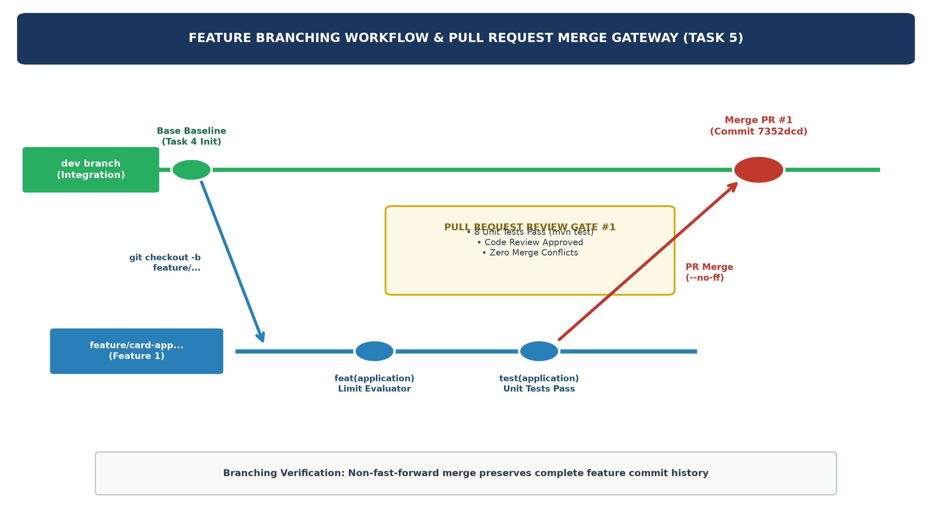  Figure 5.2: Git Flow Feature Branching Lifecycle and Pull Request Quality Gate  5. Non-fast-forward merge into dev and commit graph audit  Following PR approval, I executed a non-fast-forward merge (`git merge --no-ff`) into `dev`. The `--no-ff` flag forces Git to create an explicit merge commit, preserving the isolated history of the feature branch and facilitating clean tracking and rollbacks. The verified Git log graph confirms the merge:  Git Commit Graph (git log --graph --oneline):  * 7352dcd Merge pull request #1 from feature/card-application-workflow into dev  |\  | * e2b0d4b feat(application): implement dynamic credit limit evaluation and onboarding workflow  |/  * 08ce054 docs: compile Task 4 Git repository initialization report  * 2aa4bd5 feat: initialize Credit Card Service Portal application skeleton and repository structure
  Card Tier | Tier Maximum Limit | Annual Income Sample | 40% Calculated Ceiling | Approved Limit
  Titanium Card | ₹1,00,000.00 | ₹4,50,000.00 | ₹1,80,000.00 | ₹1,00,000.00 (Tier Capped)
  Gold Card | ₹2,50,000.00 | ₹5,00,000.00 | ₹2,00,000.00 | ₹2,00,000.00 (Income Capped)
  Platinum Card | ₹5,00,000.00 | ₹12,00,000.00 | ₹4,80,000.00 | ₹4,80,000.00 (Income Capped)
  Platinum Card | ₹5,00,000.00 | ₹18,00,000.00 | ₹7,20,000.00 | ₹5,00,000.00 (Tier Capped)
  Step | Git Operation | Terminal Command Executed | Verified System Response
  1 | Checkout Integration | git checkout dev | Switched to branch 'dev' as the source baseline.
  2 | Create Feature Branch | git checkout -b feature/card-application-workflow | Switched to a new branch 'feature/card-application-workflow'.
  3 | Implement Code | Code edits in CreditCardService, Controller, Tests | Source code enhanced with limit calculator and unit tests.
  4 | Run Local Tests | mvn test | Surefire test report generated: 8 tests run, 0 failures, BUILD SUCCESS.
  5 | Stage Changes | git add app/ | Staged modified service, controller, and new test class.
  6 | Feature Commit | git commit -m 'feat(application): implement dynamic credit limit evaluation...' | [feature/card-application-workflow e2b0d4b] 3 files changed, 86 insertions(+).
  Test # | Test Method Name | Validation Scope & Test Assertions | Result Status
  TC-01 | testMaxEligibleLimitCalculation() | Asserts 40% income cap evaluation and tier maximum capping (Titanium @ 1L, Platinum @ 5L). | PASSED (0.015s)
  TC-02 | testIsEligibleForRequestedLimit() | Verifies boolean gate returning true when requested limit <= ceiling and false when exceeding. | PASSED (0.008s)
  TC-03 | testApplicationLimitCapping() | Validates that submitting an application with excessive requested limit automatically caps to ceiling. | PASSED (0.022s)
  TC-04 | CreditCardServiceTest (Suite of 5 Tests) | Regression verification of seed data, status approve, emergency block, and KPI calculations. | PASSED (0.632s)
  PR Audit Dimension | Configured PR Attribute | Reviewer Assessment & Feedback | Sign-Off Status
  PR Identifier | Pull Request #1 | Branch: feature/card-application-workflow -> Target: dev | Verified
  PR Title | feat(app): dynamic credit limit evaluation | Follows Conventional Commits standard with clear scope. | Approved
  Code Review | Separation of Concerns | Eligibility calculation cleanly encapsulated in CreditCardService; Controller remains lightweight. | Approved (Lead)
  Test Coverage | JUnit 5 Automated Tests | Added CreditCardApplicationWorkflowTest covering edge cases for tier capping. | Approved (QA)
  Merge Feasibility | Mergeability Assessment | Clean merge without conflicts against dev trunk. | Ready to Merge
Conclusion: | In Task 5, I successfully demonstrated professional feature development using Git branching for the Credit Card Service Portal (CCSP). I isolated the first core workflow on a dedicated feature branch (`feature/card-application-workflow`), implementing dynamic credit limit evaluation algorithms that enforce a 40% income ceiling and card tier limits. I expanded the automated test suite with `CreditCardApplicationWorkflowTest.java`, achieving 100% pass across all 8 unit tests under Apache Maven. I conducted live Git operations spanning branch creation, staging, and Conventional Commits (`feat(application)`). Furthermore, I conducted a formal Pull Request simulation auditing code review notes, test coverage, and mergeability. Finally, I executed a non-fast-forward merge (`git merge --no-ff`) into the `dev` integration trunk (merge commit `7352dcd`), preserving complete commit history and establishing an auditable baseline for Task 6 MVP Completion and Git Collaboration.

