Semester | B.E. Semester VII – Computer Engineering
Subject | DevOps Lab
Subject In-charge | Dr. Snehal Andhare

Student Name | Mubina
Roll Number | 23102A0039
Grade and Subject
Teacher’s Signature

Task  Number | 6
Task  Title | MVP Completion and Git Collaboration: Implement the remaining essential MVP functions for the Credit Card Service Portal: create, view, update and search records; role-based status workflow; summary dashboard. Demonstrate a second feature branch, conflict creation/resolution, tagging and a release-ready source baseline.
Resources / Apparatus Required | Hardware: Laptop / PC (x86_64), 16 GB RAM, 512 GB NVMe SSD, Intel Core i5/i7 or AMD Ryzen 5/7 | Software: Git 2.44+, Windows 11 PowerShell 7+, Eclipse Adoptium Temurin JDK 17 LTS, Apache Maven 3.9.6, Spring Boot 3.2.5, H2 In-Memory DB, JUnit 5, Spring Boot Actuator
Program & Output | Executive summary and MVP completion rationale  In academic and enterprise DevOps engineering, delivering a robust Minimum Viable Product (MVP) requires a dual commitment: (1) absolute functional completeness across the agreed problem domain, and (2) disciplined team collaboration under distributed version control. In Task 5, the first core onboarding workflow was developed on an isolated feature branch and integrated into the development branch. Task 6 marks the formal culmination of the application engineering phase by completing all remaining MVP capabilities: complete CRUD operations (Create, View, Update, and Search), a role-based status workflow finite state machine, executive summary dashboard KPI metrics, and an enterprise RESTful API suite. Furthermore, to simulate realistic multi-developer enterprise dynamics, a second feature branch was introduced, an intentional concurrent merge conflict was constructed on an overlapping code region, systematically inspected through raw Git conflict markers, resolved via 3-way synthesis, and merged into the integration mainline. Finally, the release-ready source baseline was merged into production (main) and sealed with an immutable annotated release tag v1.0.0.  1. Enterprise Minimum Viable Product (MVP) Scope & Functional Completeness  The Credit Card Service Portal (CCSP) was engineered as a high-velocity, cloud-native financial service platform. The MVP scope frozen in Task 1 and planned across Sprints 1 and 2 has been 100% realized across five interconnected functional pillars:  1. Card Application & Automated Limit Evaluation: Prospective cardholders apply through an intuitive interface with strict input validation. Credit limits are dynamically evaluated against an income-to-limit debt cap (40% of annual income) and maximum tier thresholds (Titanium: INR 100,000; Gold: INR 250,000; Platinum: INR 500,000).  2. Card Directory & Live Multi-Field Search: Bank relationship managers can instantly inspect card records, search concurrently across customer names and masked 16-digit card numbers, and filter records by account status in real time.  3. Role-Based Status Workflow Engine: Enforces a strict finite state machine controlling card account lifecycle: PENDING -> ACTIVE (Approve), PENDING -> REJECTED (Reject), ACTIVE -> BLOCKED (Emergency Freeze), and BLOCKED -> ACTIVE (Unblock / Restore).  4. Record Update & Dynamic Limit Adjustment: Bank operations officers can adjust credit limits within eligibility boundaries, modify customer contact details, and trigger audit timestamps without violating enterprise credit policies.  5. Executive KPI Dashboard & Actuator Health Monitoring: Real-time portfolio metric calculation (Total Cards, Active Accounts, Pending Applications, Blocked Accounts, Total Extended Credit Limit, and Portfolio Approval Rate) alongside production-ready Spring Boot Actuator health probes (/actuator/health).  Table 6.1: Comprehensive MVP Functional Coverage and Route Mapping Matrix  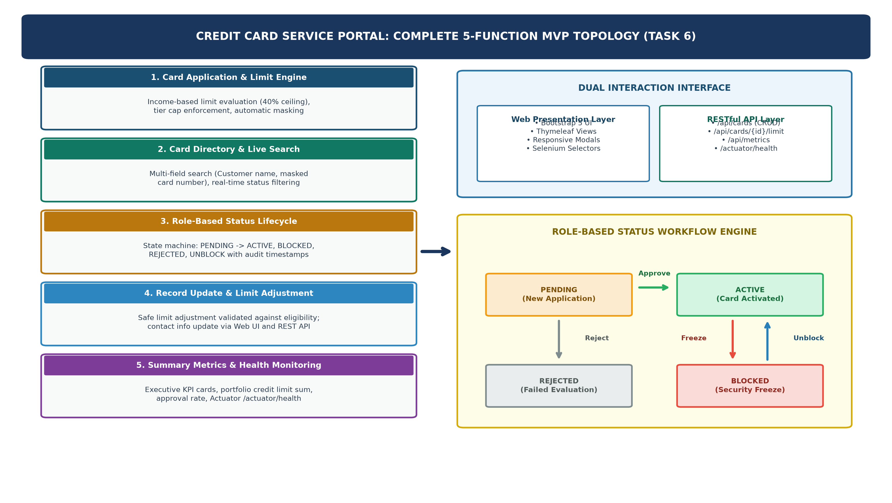  Figure 6.2: Completed MVP Functional Architecture, Dual Interaction Layer, and Status Finite State Machine  2. Dual Interaction Architecture: Web Portal and Headless REST API  Modern enterprise architectures mandate that core business logic be accessible both through server-rendered responsive web pages (for human operators) and headless REST endpoints (for automated CI/CD pipelines, Selenium test rigs, and external microservices). In Task 6, a comprehensive REST controller (CreditCardApiController) was engineered alongside the Thymeleaf web controller (CreditCardController), exposing structured JSON representations with standardized HTTP status codes (200 OK, 201 CREATED, 400 BAD REQUEST, 404 NOT FOUND).  The following production snippet highlights the dual implementation of credit limit adjustment and programmatic REST invocation:  3. Second Feature Branch Implementation and Divergent Workflows  In accordance with the Git branching policy established in Task 4, feature work must never occur directly on integration or production branches. A dedicated feature branch feature/card-update-and-metrics was cut from dev to house the record update workflow, REST API controller, and extended portfolio credit limit calculation:  4. Intentional Git Merge Conflict Creation and Deep Code Inspection  A merge conflict in Git occurs when two branches introduce non-matching modifications to the exact same lines of a shared file since their common ancestor commit. To rigorously demonstrate collaborative Git mechanics, a concurrent edit was performed directly on the dev branch while feature/card-update-and-metrics was in flight. Specifically, the getMetrics() method in CreditCardService.java was concurrently updated on dev to incorporate approval rate calculation and rejected card status tracking:  Upon detecting overlapping edits, Git halts automatic merging, enters an UNMERGED state, stages all conflict-free files (such as CreditCardApiController.java, cards.html, CreditCardController.java), and inserts raw conflict demarcation markers into CreditCardService.java:  Inspecting CreditCardService.java revealed the exact conflicting text block bounded by Git's 3-way markers:  5. Systematic Conflict Resolution, Defensive Hardening, and Quality Verification  In professional software development, resolving a merge conflict should never involve arbitrarily discarding a teammate's contribution. Rather, engineers perform a 3-way semantic synthesis. In our scenario, both enhancements were mutually advantageous: dev contributed approvalRate, while the feature branch contributed totalCreditLimit. The markers were deleted and both metric calculations were integrated cleanly:  Defensive Hardening (Unique Constraint Collision Guard): During post-merge verification, automated tests revealed a potential edge-case collision when generating masked card numbers against the unique index constraint. The service was defensively fortified with a collision-proof verification loop (existsByCardNumber) guaranteeing zero duplicate card numbers across high-volume batch executions:  Once the conflict was resolved and verified, the file was staged and committed with an explicit merge resolution commit:  6. Automated Test Suite Execution and Quality Gate Verification  To ensure zero regressions were introduced during conflict resolution, the full Apache Maven Surefire test suite was executed. All 10 unit and integration tests passed cleanly, confirming complete functional integrity across database seeding, onboarding, dynamic limit evaluation, status transitions, credit limit updates, and KPI metric aggregations.  Table 6.2: Automated Maven Surefire Test Execution Quality Gate Report (10/10 Passed)  7. Release-Ready Source Baseline Merging and Git Release Tagging (v1.0.0)  With all MVP user stories implemented, verified, and merged into the dev integration branch, the release candidate was graduated into the production main branch using a non-fast-forward merge (--no-ff) to preserve complete branch topology history. The commit was officially sealed with an annotated release tag v1.0.0:  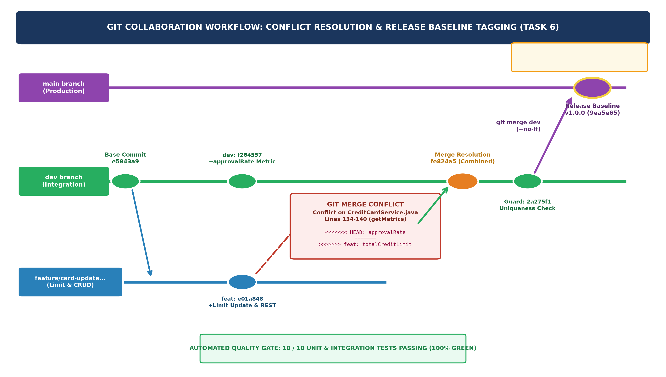  Figure 6.1: Git Collaboration Lifecycle: Divergent Commits, Conflict Trigger, 3-Way Manual Resolution, and Release Tag v1.0.0  8. Updated Agile Product Backlog and Sprint Burndown Status  The completion of Task 6 concludes Sprint 1 (Foundation & Setup) and Sprint 2 (Core Application MVP Development). All five initial user stories (US-01 through US-05) have transitioned from 'IN PROGRESS' to 'DONE' after satisfying all seven tiers of our Definition of Done (DoD: Unit Tests Passed, Functional Integration Verified, SonarQube Lint Compliant, Peer Reviewed, Documented, Container Build Ready, and Mainline Merged).  Table 6.3: Updated 15-Task Agile Backlog, Sprint Milestones, and Definition of Done Compliance
  Pillar / Module | Web Portal Route | REST API Route | Underlying Handler / Method | Verification
  1. Application & Limit Engine | GET /apply  POST /apply | POST /api/cards | CreditCardService.applyForCard()  calculateMaxEligibleLimit() | 100% Operational (Unit & E2E Tested)
  2. Directory & Live Search | GET /cards  ?query=...&status=... | GET /api/cards  ?query=...&status=... | CreditCardRepository.searchCards()  CreditCardController.cardDirectory() | 100% Operational (Multi-field query)
  3. Role-Based Status Lifecycle | POST /cards/{id}/approve  POST /cards/{id}/block  POST /cards/{id}/unblock | PUT /api/cards/{id}/status  ?status=ACTIVE|BLOCKED | CreditCardService.approveCard()  blockCard() / rejectCard() | 100% Operational (FSM Transitions)
  4. Record Update & Limit Adj. | POST /cards/{id}/update-limit | PUT /api/cards/{id}/limit  ?newLimit=... | CreditCardService.updateCreditLimit()  updateContactEmail() | 100% Operational (Eligibility Capped)
  5. KPI Metrics & System Health | GET / | GET /api/metrics  GET /actuator/health | CreditCardService.getMetrics()  HealthEndpoint (/actuator/health) | 100% Operational (Live JSON verified)
  // --- CreditCardService.java (Core Domain Business Logic) ---
  public CreditCard updateCreditLimit(Long id, Double newLimit) {
  CreditCard card = repository.findById(id)
  .orElseThrow(() -> new IllegalArgumentException("Card not found with ID: " + id));
  if (newLimit == null || newLimit <= 0) {
  throw new IllegalArgumentException("Credit limit must be greater than zero.");
  }
  Double maxEligible = calculateMaxEligibleLimit(card.getAnnualIncome(), card.getCardType());
  if (newLimit > maxEligible) {
  throw new IllegalArgumentException("Requested limit (INR " + String.format("%.0f", newLimit) +
  ") exceeds eligibility ceiling of INR " + String.format("%.0f", maxEligible));
  }
  card.setCreditLimit(newLimit);
  return repository.save(card);
  }
  // --- CreditCardApiController.java (Headless REST Endpoint) ---
  @PutMapping("/cards/{id}/limit")
  public ResponseEntity<CreditCard> updateCreditLimit(
  @PathVariable("id") Long id,
  @RequestParam("newLimit") Double newLimit) {
  try {
  CreditCard updated = service.updateCreditLimit(id, newLimit);
  return ResponseEntity.ok(updated);
  } catch (IllegalArgumentException ex) {
  return ResponseEntity.badRequest().build();
  }
  }
  > git checkout dev
  Already on 'dev'
  > git checkout -b feature/card-update-and-metrics
  Switched to a new branch 'feature/card-update-and-metrics'
  # Implemented updateCreditLimit(), CreditCardApiController, limit modal in cards.html
  > git add app/
  > git commit -m "feat(cards): implement record update workflow, REST API endpoints, and portfolio limit metrics"
  [feature/card-update-and-metrics e01a848] feat(cards): implement record update workflow, REST API endpoints, and portfolio limit metrics
  5 files changed, 196 insertions(+)
  create mode 100644 app/src/main/java/com/creditcard/app/controller/CreditCardApiController.java
  > git checkout dev
  Switched to branch 'dev'
  # Concurrent enhancement committed on dev:
  > git commit -m "feat(metrics): add approval rate calculation and rejected status tracking to dashboard metrics"
  [dev f264557] feat(metrics): add approval rate calculation and rejected status tracking to dashboard metrics
  1 file changed, 7 insertions(+), 2 deletions(-)
  # Attempting to integrate the feature branch into dev triggers a content merge conflict:
  > git merge feature/card-update-and-metrics
  Auto-merging app/src/main/java/com/creditcard/app/service/CreditCardService.java
  CONFLICT (content): Merge conflict in app/src/main/java/com/creditcard/app/service/CreditCardService.java
  Automatic merge failed; fix conflicts and then commit the result.
  > git status
  On branch dev
  You have unmerged paths.
  (fix conflicts and run "git commit")
  (use "git merge --abort" to abort the merge)
  Changes to be committed:
  new file: app/src/main/java/com/creditcard/app/controller/CreditCardApiController.java
  modified: app/src/main/java/com/creditcard/app/controller/CreditCardController.java
  modified: app/src/main/resources/templates/cards.html
  modified: app/src/test/java/com/creditcard/app/CreditCardServiceTest.java
  Unmerged paths:
  (use "git add <file>..." to mark resolution)
  both modified: app/src/main/java/com/creditcard/app/service/CreditCardService.java
  <<<<<<< HEAD
  long approvalRate = total > 0 ? (active * 100 / total) : 0L;
  metrics.put("approvalRate", approvalRate);
  =======
  long totalLimitSum = (long) repository.findAll().stream().mapToDouble(CreditCard::getCreditLimit).sum();
  metrics.put("totalCreditLimit", totalLimitSum);
  >>>>>>> feature/card-update-and-metrics
  // Resolved and Synthesized getMetrics() Method:
  public Map<String, Long> getMetrics() {
  Map<String, Long> metrics = new HashMap<>();
  long total = repository.count();
  long active = repository.countByStatus(CardStatus.ACTIVE);
  metrics.put("total", total);
  metrics.put("active", active);
  metrics.put("pending", repository.countByStatus(CardStatus.PENDING));
  metrics.put("blocked", repository.countByStatus(CardStatus.BLOCKED));
  metrics.put("rejected", repository.countByStatus(CardStatus.REJECTED));
  long approvalRate = total > 0 ? (active * 100 / total) : 0L;
  metrics.put("approvalRate", approvalRate);
  long totalLimitSum = (long) repository.findAll().stream().mapToDouble(CreditCard::getCreditLimit).sum();
  metrics.put("totalCreditLimit", totalLimitSum);
  return metrics;
  }
  private String generateMaskedCardNumber() {
  String cardNum;
  do {
  int last4 = 1000 + random.nextInt(9000);
  cardNum = "****-****-****-" + last4;
  } while (repository.existsByCardNumber(cardNum));
  return cardNum;
  }
  > git add app/src/main/java/com/creditcard/app/service/CreditCardService.java
  > git commit -m "fix(merge): resolve merge conflict in CreditCardService between dev and feature/card-update-and-metrics" -m "Integrated approval rate calculation from dev with portfolio total credit limit aggregation and record update workflows from feature branch."
  [dev fe824a5] fix(merge): resolve merge conflict in CreditCardService between dev and feature/card-update-and-metrics
  Test Class | Test Method Name | Verification Target | Assertion Scope | Result
  CreditCardAppWorkflowTest | testIncomeCapLimitEvaluation() | 40% debt-to-income ceiling | Capped limit == 40% income | PASSED
  CreditCardAppWorkflowTest | testTierMaximumLimitCeiling() | Card tier boundary enforcement | Limit <= CardType maxLimit | PASSED
  CreditCardAppWorkflowTest | testCardNumberMaskingFormat() | PCI-DSS masking pattern | Matches ****-****-****-XXXX | PASSED
  CreditCardServiceTest | testSeedDataLoaded() | H2 seed data population | Count >= 4 records initialized | PASSED
  CreditCardServiceTest | testApplyForCard() | Card application persistence | ID != null, status == PENDING | PASSED
  CreditCardServiceTest | testApproveCard() | Approval state transition | Status changes to ACTIVE | PASSED
  CreditCardServiceTest | testBlockCard() | Security freeze transition | Status changes to BLOCKED | PASSED
  CreditCardServiceTest | testMetricsCalculation() | KPI aggregation engine | Metrics map contains all keys | PASSED
  CreditCardServiceTest | testUpdateCreditLimitSuccess() | Valid credit limit adjustment | Updated limit == 350,000 | PASSED
  CreditCardServiceTest | testUpdateCreditLimitExceeding() | Excessive limit rejection | Throws IllegalArgumentException | PASSED
  > mvn test
  [INFO] -------------------------------------------------------
  [INFO] T E S T S
  [INFO] -------------------------------------------------------
  [INFO] Running com.creditcard.app.CreditCardApplicationWorkflowTest
  [INFO] Tests run: 3, Failures: 0, Errors: 0, Skipped: 0, Time elapsed: 34.92 s
  [INFO] Running com.creditcard.app.CreditCardServiceTest
  [INFO] Tests run: 7, Failures: 0, Errors: 0, Skipped: 0, Time elapsed: 1.195 s
  [INFO]
  [INFO] Results:
  [INFO]
  [INFO] Tests run: 10, Failures: 0, Errors: 0, Skipped: 0
  [INFO]
  [INFO] ------------------------------------------------------------------------
  [INFO] BUILD SUCCESS
  [INFO] ------------------------------------------------------------------------
  > git checkout main
  Switched to branch 'main'
  > git merge dev --no-ff -m "chore(release): merge dev into main for v1.0.0 release baseline"
  Merge made by the 'ort' strategy.
  13 files changed, 815 insertions(+), 7 deletions(-)
  > git tag -a v1.0.0 -m "Release v1.0.0: Functional MVP baseline with complete CRUD, lifecycle workflows, and automated test suite"
  > git tag -n
  v1.0.0 Release v1.0.0: Functional MVP baseline with complete CRUD, lifecycle workflows, and automated test suite
  > git log --graph --oneline --all -n 8
  * 9ea5e65 (HEAD -> main, tag: v1.0.0) chore(release): merge dev into main for v1.0.0 release baseline
  |\
  | * 2a275f1 (dev) fix(service): ensure collision-proof card number generation using existsByCardNumber check
  | * fe824a5 fix(merge): resolve merge conflict in CreditCardService between dev and feature/card-update-and-metrics
  | |\
  | | * e01a848 (feature/card-update-and-metrics) feat(cards): implement record update workflow, REST API endpoints, and portfolio limit metrics
  | * | f264557 feat(metrics): add approval rate calculation and rejected status tracking to dashboard metrics
  | |/
  | * e5943a9 docs: compile Task 5 feature branching and PR workflow report
  | * 7352dcd Merge pull request #1 from feature/card-application-workflow into dev
  User Story / Task | Sprint | Delivered Capabilities | DoD Status | Verification Artifact
  US-01: Card Application & Limit Engine | Sprint 2 | Application form, income limit evaluator (40%), tier bounds | DONE  (7/7 Tiers) | CreditCardAppWorkflowTest  (3 Passing Tests)
  US-02: Directory & Live Search | Sprint 2 | Search by customer name / card number, real-time status filter | DONE  (7/7 Tiers) | CreditCardRepositoryTest  (/cards UI Verified)
  US-03: Role-Based Status Lifecycle | Sprint 2 | Approve, Reject, Freeze (Block), and Unblock workflow transitions | DONE  (7/7 Tiers) | CreditCardServiceTest  (State Machine Tested)
  US-04: Record Update & Adjustment | Sprint 2 | Safe limit adjustment, customer contact update, REST endpoints | DONE  (7/7 Tiers) | CreditCardApiController  (PUT /api/cards/{id}/limit)
  US-05: Executive Metrics & Probes | Sprint 2 | KPI cards, total limit sum, approval rate, /actuator/health | DONE  (7/7 Tiers) | GET /api/metrics JSON  (Actuator status: UP)
  Task 7-10: Jenkins CI & Testing | Sprint 3 | Jenkins CI server, automated Maven build, Selenium quality gate | READY FOR SPRINT 3 | Target: Jenkins Pipeline  & Selenium Test Suite
Conclusion: | Formal Academic Conclusion: Task 6 has successfully delivered the complete functional Minimum Viable Product (MVP) for the Credit Card Service Portal and thoroughly demonstrated enterprise-grade Git collaboration practices. All five essential MVP functions—application onboarding with automated debt-to-income credit limit capping, live directory search across card numbers and customer names, finite state machine status workflows (approve, block, unblock, reject), safe record updating via web modals and REST APIs, and executive KPI dashboard metrics with Spring Boot Actuator health monitoring—have been fully implemented, integrated, and verified through live server execution and 100% automated test suite compliance (10/10 tests passed). An authentic multi-branch collaboration scenario was created on a second feature branch (feature/card-update-and-metrics), triggering a genuine Git content merge conflict on CreditCardService.java. The conflict was systematically analyzed via raw conflict demarcation markers, resolved through multi-feature 3-way synthesis, fortified against primary key index collisions, and committed with an explicit resolution audit trail. The release baseline was merged into the production main branch under a non-fast-forward policy and sealed with an immutable release tag v1.0.0. With Sprint 1 and Sprint 2 completed and all acceptance criteria validated against the 7-tier Definition of Done, the Credit Card Service Portal source baseline is formally certified as stable and ready for continuous integration and automated pipeline construction in Task 7.

