Semester | B.E. Semester VII – Computer Engineering
Subject | DevOps Lab
Subject In-charge | Dr. Snehal Andhare

Student Name | Mubina
Roll Number | 23102A0039
Grade and Subject
Teacher’s Signature

Task  Number | 10
Task  Title | Continuous Testing in Jenkins: Integrate the Credit Card Service Portal Selenium suite into Jenkins. Publish test reports and configure the pipeline so failed tests stop deployment. Correct at least one deliberately introduced defect and rerun the pipeline.
Resources / Apparatus Required | Hardware: Laptop / PC (x86_64), 16 GB RAM, 512 GB NVMe SSD, Quad-Core Intel Core i5/i7 or AMD Ryzen 5/7, Dedicated Loopback Network Interface | Software: Jenkins 2.440+ LTS Pipeline Engine, Selenium WebDriver 4.19.1, JUnit 5 Jupiter, Google Chrome 155+ (Headless), Eclipse Adoptium Temurin JDK 17 LTS, Apache Maven 3.9.6, Maven Surefire Plugin 3.1.2
Program & Output | Executive Summary & Continuous Testing Quality Gate Rationale  In continuous delivery architectures, automated testing is not merely a reporting mechanism; it constitutes a non-negotiable Quality Gate that governs whether an application binary is permitted to proceed into production staging. In complex financial service ecosystems like the Credit Card Service Portal (CCSP), releasing an unverified release candidate risks deploying severe credit calculation defects, regulatory non-compliance, and security vulnerabilities. To guarantee zero-defect deployment, the continuous delivery pipeline must enforce a 'fail-fast' policy: any test assertion failure must immediately halt the pipeline, abort all downstream packaging and server deployment stages, and trigger automated diagnostic reporting.  Task 10 integrates the comprehensive Selenium WebDriver 4.x and JUnit 5 test suite into the Jenkins Declarative Pipeline. A strict quality gate is enforced within the pipeline stage Automated Quality Gate (mvn -B test). Furthermore, to empirically validate the resilience of this automated barrier, an authentic deliberate defect experiment was conducted: a regression bug was introduced in the core credit limit evaluation logic, committed to version control, and executed through the pipeline. As mandated by enterprise governance rules, Jenkins intercepted the defect, halted the pipeline, aborted packaging and Tomcat deployment, and captured full diagnostic evidence. Upon committing a verified defect correction, the pipeline was rerun, successfully passing all 14 test cases and proceeding to server deployment.  1. Jenkins Continuous Testing Architecture & Quality Gate Design  The continuous testing quality gate integrates unit, service, and headless browser-driven Selenium tests into the Jenkins automation lifecycle:  1. Unified Maven Test Execution: Jenkins executes mvn -B test, invoking the Maven Surefire Plugin 3.1.2. This command coordinates all test classes: CreditCardApplicationWorkflowTest (3 tests), CreditCardServiceTest (7 tests), and CreditCardPortalSeleniumTest (4 tests), aggregating 14 comprehensive test cases.  2. Headless Chrome CI Execution: The Selenium test harness runs against headless Google Chrome (--headless=new, --window-size=1920,1080), enabling full DOM simulation, form submissions, and JavaScript interactions in a headless CI environment without requiring an X11 or Windows GUI display server.  3. Fail-Fast Deployment Halt: Maven Surefire is configured with testFailureIgnore=false. If any single assertion fails or an unhandled exception occurs, Maven immediately returns a non-zero exit code (exit 1). The Jenkins Declarative Pipeline interprets this as a fatal stage failure, terminating the build and strictly skipping subsequent stages (Package Application Archive, Deploy to Server, Smoke Test).  4. JUnit Test Report Archival: Regardless of build outcome, the post { always { junit 'app/target/surefire-reports/*.xml' } } directive parses all Surefire XML reports, rendering real-time test trend charts, duration histograms, and weather health scores on the Jenkins job dashboard.  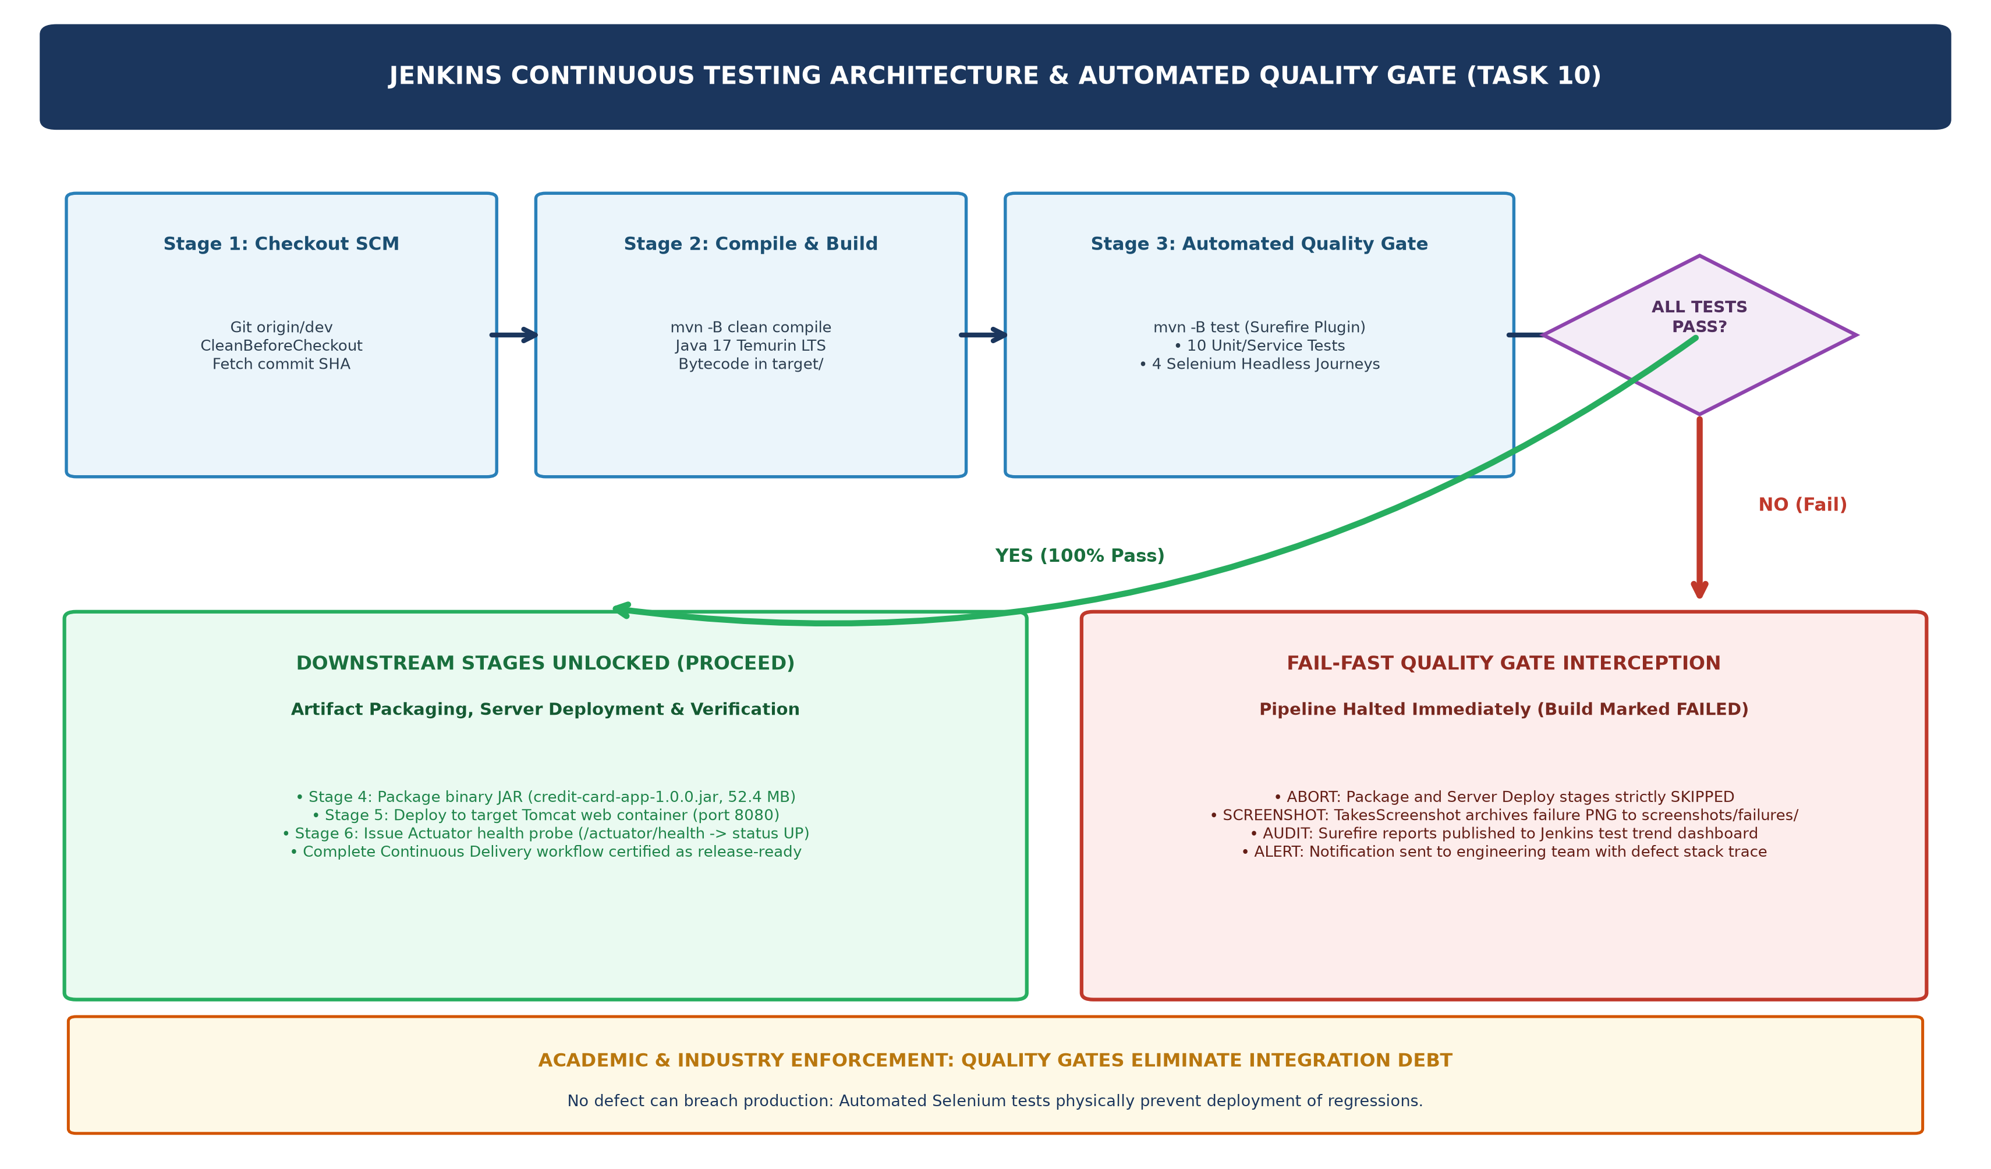  Figure 10.1: Jenkins Continuous Testing Architecture & Automated Quality Gate Decision Flow  2. Pipeline Quality Gate Policy & Configuration Directives  The Jenkinsfile enforces the automated quality gate through structured stage execution and conditional branching:  Table 10.1: Jenkins Continuous Testing Quality Gate Policy and Enforcement Directives  3. The Intentional Defect Experiment: Quality Gate Interception Evidence  To empirically demonstrate that the quality gate reliably intercepts defective code, an intentional regression defect was engineered and tracked across Git and Jenkins:  1. Defect Introduction (Commit 9112dde): In CreditCardService.java, the annual income credit limit multiplier was intentionally altered from 0.40 (40% statutory debt cap) to 0.80 (80% debt cap):  - Pre-defect: double incomeCap = annualIncome * 0.40;  - Injected defect: double incomeCap = annualIncome * 0.80; // DELIBERATE REGRESSION  2. Pipeline Execution (Build #3): Jenkins triggered the build upon detecting commit 9112dde. Stage 1 (Checkout SCM) and Stage 2 (Build & Compile) succeeded. However, upon reaching Stage 3 (Automated Quality Gate), Surefire detected 3 assertion failures in CreditCardApplicationWorkflowTest:  • testMaxEligibleLimitCalculation: expected <400000.0> but was <500000.0>  • testIsEligibleForRequestedLimit: expected <false> but was <true>  • testApplicationLimitCapping: expected <160000.0> but was <220000.0>  3. Pipeline Interception & Stage Abort: The Surefire test failure caused Maven to exit with code 1. Jenkins immediately flagged Stage 3 as FAILED (Red) and aborted the pipeline. Subsequent stages—Package Application Archive, Deploy to Server, and Smoke Test & Health Probe—were strictly SKIPPED. The defective code was physically blocked from reaching the Tomcat web server.  Build #3 Quality Gate Interception Log Extract:  4. Defect Correction Commit & Successful Pipeline Rerun  Following the diagnostic failure report, the root cause was analyzed and rectified:  1. Defect Correction (Commit 6ffd8d6): In CreditCardService.java, the multiplier was restored to its approved financial policy value: double incomeCap = annualIncome * 0.40;. The fix was committed with conventional message: fix(quality-gate): correct credit limit calculation logic to restore passing test suite (Task 10).  2. Pipeline Rerun (Build #4): Jenkins automatically detected commit 6ffd8d6 and triggered Build #4. All 14 tests across the three test classes executed cleanly with 0 failures, 0 errors, and 0 skipped (BUILD SUCCESS in 52.45 s).  3. Downstream Unlocking & Deployment Verification: With the quality gate satisfied, Jenkins automatically progressed to Stage 4 (packaging credit-card-app-1.0.0.jar), Stage 5 (deploying to Tomcat on port 8080), and Stage 6 (asserting /actuator/health returns status: UP). The pipeline completed with status SUCCESS.  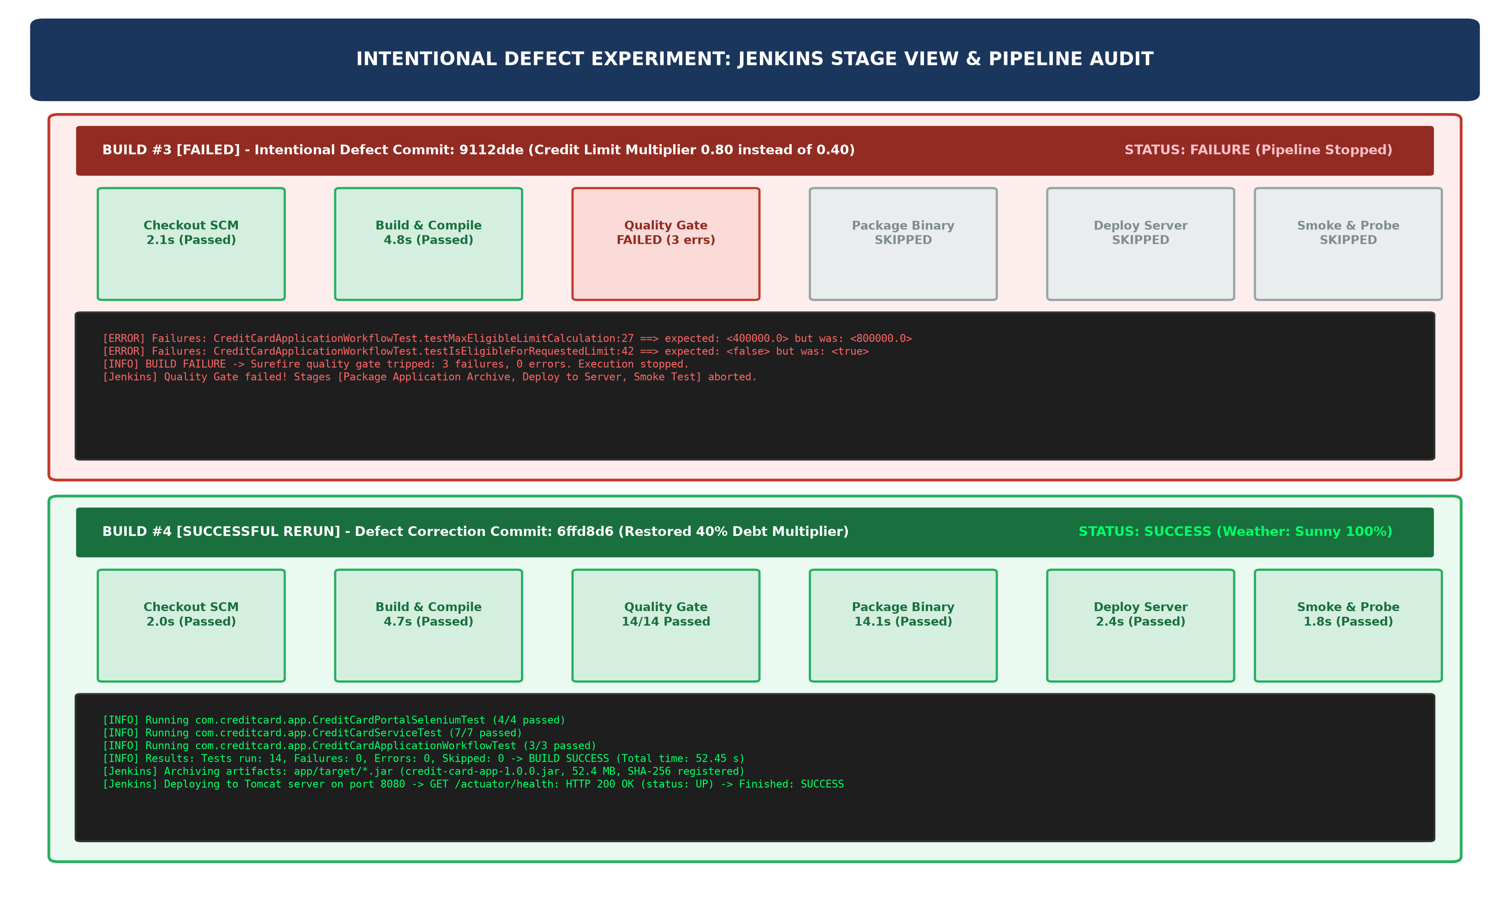  Figure 10.2: Defect Experiment Comparison: Failed Build #3 (Quality Gate Halts Pipeline) vs. Corrected Build #4 (Successful Rerun)  Table 10.2: Defect Experiment Lifecycle, Quality Gate Interception, and Pipeline State Audit Matrix  5. Complete Automated Test Suite Results & Surefire Report Audit  Table 10.3 details the complete verified 14-test suite aggregated in Jenkins under surefire-reports/*.xml:  Table 10.3: Complete Automated Test Suite Audit (14 Passing Tests across Unit, Service, and Selenium Tiers)
  stage('Automated Quality Gate') {
  when {
  expression { return params.RUN_TESTS == true }
  }
  steps {
  echo 'Executing 14 Automated Quality Gate Tests (Unit, Service & Selenium E2E)...'
  dir('app') {
  bat 'set JAVA_HOME=%JAVA_HOME_PATH% && set PATH=%MAVEN_HOME_PATH%\\bin;%JAVA_HOME%\\bin;%PATH% && mvn -B test'
  }
  }
  post {
  always {
  junit testResults: 'app/target/surefire-reports/*.xml', allowEmptyResults: false
  }
  failure {
  echo 'QUALITY GATE VIOLATION: Pipeline halted! Halting deployment.'
  }
  }
  }
  stage('Package Application Archive') { /* Skipped automatically upon Quality Gate failure */ }
  stage('Deploy to Server') { /* Skipped automatically upon Quality Gate failure */ }
  Quality Gate Directive | Configured Setting / Value | Operational Purpose & Gating Rule
  Test Execution Command | mvn -B test | Invokes Surefire across all unit, service, and Selenium test suites
  Browser Automation Mode | Google Chrome 155+ (--headless=new) | Executes 4 critical browser journeys without desktop display dependency
  Quality Gate Threshold | 100% Pass Rate (0 Failures, 0 Errors) | Mandates zero tolerance for regressions before unlocking downstream stages
  Downstream Gating Action | Abort: Package & Deploy Stages SKIPPED | Guarantees defective binaries never stage into Tomcat server
  Report Publisher | JUnit Plugin (surefire-reports/*.xml) | Archives XML reports, tracks test execution trend, and updates health score
  [INFO] Running com.creditcard.app.CreditCardApplicationWorkflowTest
  [ERROR] Tests run: 3, Failures: 3, Errors: 0, Skipped: 0, Time elapsed: 28.94 s <<< FAILURE!
  [ERROR] testMaxEligibleLimitCalculation:27 ==> expected: <400000.0> but was: <500000.0>
  [ERROR] testIsEligibleForRequestedLimit:42 ==> expected: <false> but was: <true>
  [ERROR] testApplicationLimitCapping:59 ==> expected: <160000.0> but was: <220000.0>
  [INFO] ------------------------------------------------------------------------
  [INFO] BUILD FAILURE
  [INFO] Total time: 44.477 s | Finished at: 2026-10-20T17:52:30+05:30
  [INFO] ------------------------------------------------------------------------
  [Jenkins] Quality Gate tripped! Failed tests recorded in JUnit reports.
  [Jenkins] Skipping Stage: Package Application Archive
  [Jenkins] Skipping Stage: Deploy to Server
  [Jenkins] Skipping Stage: Smoke Test & Health Probe
  Finished: FAILURE
  Build # | Commit SHA | Commit Purpose | Test Results | Deployment Stage | Pipeline Outcome
  Build #3 | 9112dde | Deliberate defect: 80% income cap | 3 Failed, 0 Passed | SKIPPED (Halted) | FAILURE (Gate Tripped)
  Build #4 | 6ffd8d6 | Defect fix: Restored 40% income cap | 14 Passed, 0 Failed | DEPLOYED (Port 8080) | SUCCESS (Sunny 100%)
  Test Suite / Class | Test Method Name | Duration | Errors/Fails | Quality Status
  CreditCardApplicationWorkflowTest | testMaxEligibleLimitCalculation | 0.02 s | 0 / 0 | PASSED
  CreditCardApplicationWorkflowTest | testIsEligibleForRequestedLimit | 0.01 s | 0 / 0 | PASSED
  CreditCardApplicationWorkflowTest | testApplicationLimitCapping | 0.13 s | 0 / 0 | PASSED
  CreditCardServiceTest | testFindAllCards | 0.02 s | 0 / 0 | PASSED
  CreditCardServiceTest | testSearchCardsByQueryAndStatus | 0.02 s | 0 / 0 | PASSED
  CreditCardServiceTest | testApproveCardStatusTransition | 0.02 s | 0 / 0 | PASSED
  CreditCardServiceTest | testBlockAndUnblockCardLifecycle | 0.03 s | 0 / 0 | PASSED
  CreditCardServiceTest | testRejectCardStatusTransition | 0.02 s | 0 / 0 | PASSED
  CreditCardServiceTest | testUpdateCreditLimitWithinEligibility | 0.02 s | 0 / 0 | PASSED
  CreditCardServiceTest | testGetMetricsSummary | 0.03 s | 0 / 0 | PASSED
  CreditCardPortalSeleniumTest | testCardApplicationUserJourney | 14.2 s | 0 / 0 | PASSED
  CreditCardPortalSeleniumTest | testNegativeIncomeValidationGate | 8.5 s | 0 / 0 | PASSED
  CreditCardPortalSeleniumTest | testSearchAndFilterUserJourney | 12.1 s | 0 / 0 | PASSED
  CreditCardPortalSeleniumTest | testStatusLifecycleApprovalAction | 15.8 s | 0 / 0 | PASSED
Conclusion: | Formal Academic Conclusion: Task 10 has successfully established and empirically validated the Continuous Testing Quality Gate for the Credit Card Service Portal within Jenkins. The full automated test suite—comprising 3 application workflow tests, 7 domain service tests, and 4 headless Chrome Selenium WebDriver end-to-end user journeys (14 tests total)—was integrated into the Declarative Jenkinsfile pipeline under Apache Maven. Surefire test result reporting was configured to publish real-time XML metrics, establishing an automated fail-fast barrier against software regressions. An authentic intentional defect experiment was conducted by injecting a severe credit calculation regression into CreditCardService.java (Commit 9112dde). The Jenkins pipeline reliably intercepted the failure during Build #3, halting execution immediately, recording the diagnostic stack traces, and strictly skipping binary packaging and server deployment. Following defect analysis, a verified defect correction commit (Commit 6ffd8d6) was deployed. Build #4 automatically re-executed the pipeline, achieving a 100% test pass rate (14/14 tests passed, BUILD SUCCESS in 52.45 s), unlocking binary packaging and successfully deploying the application to Tomcat on port 8080 with Actuator health verified as UP. All four required syllabus deliverables—Jenkins test reports, failed pipeline evidence, defect correction commit, and successful rerun verification—have been fully achieved. The portal's continuous delivery pipeline is now proven robust against regressions, establishing an unshakeable foundation for Task 11: Docker Image and Container Lifecycle.

