Semester | B.E. Semester VII - Computer Engineering
Subject | DevOps Lab
Subject In-charge | Dr. Snehal Andhare

Student Name | Mubina
Roll Number | 23102A0039
Grade and Subject
Teacher’s Signature

Task  Number | 13
Task  Title | Configuration Management Script: Identify all server prerequisites for the Credit Card Service Portal: packages, users, folders, files, ports and services. Create either a Puppet manifest/modules or an Ansible inventory and YAML playbook to configure the target node.
Resources / Apparatus Required | Hardware: Laptop / PC (x86_64), 16 GB RAM, 512 GB NVMe SSD, Quad-Core Intel Core i5/i7 or AMD Ryzen 5/7, Loopback Network Interface (localhost provisioning) | Software: Ansible 2.16+ (ansible-core), Python 3.11+, community.docker Ansible Collection, ansible.posix Collection, Docker Engine 26.x, OpenJDK 17 JRE, UFW / firewalld, Windows 11 with WSL2 (Ubuntu 22.04) as Ansible control node, Git 2.44+
Program & Output | Executive Summary & Configuration Management Rationale  Configuration management transforms server provisioning from a manual, error-prone process into a declarative, version-controlled, and fully reproducible automation workflow. Without configuration management, every new server deployment for the Credit Card Service Portal (CCSP) requires a human operator to manually install Java, Docker, configure users, open firewall ports, and deploy containers — a process prone to configuration drift, undocumented manual steps, and inconsistent environments across staging and production. Ansible eliminates this fragility by encoding the entire target node state as YAML-based playbooks that can be audited, reviewed, version-controlled, and re-executed at any time.  Task 13 implements a complete Ansible configuration management solution for the CCSP infrastructure: a structured inventory file (hosts.ini) defining target server groups and all application variables, and a comprehensive playbook (playbook.yml) with two plays covering 10 idempotent tasks in Play 1 (full provisioning) and 5 tasks in Play 2 (tagged rollback). The Ansible approach was selected over Puppet due to its agentless architecture (SSH-based, no agent daemon required on target nodes), simpler YAML syntax, and superior Docker community module support.  1. Infrastructure Prerequisites Specification (CCSP Target Node)  The following prerequisites are required on every target node hosting the Credit Card Service Portal and are managed exclusively by Ansible (never manually):  Table 13.1: CCSP Target Node Prerequisites and Ansible Module Mapping  2. Ansible Inventory File (ansible/hosts.ini)  The inventory file defines the ccsp_servers target group, connection parameters, and all application-level variables as group variables. This single-source-of-truth approach means no variables are hardcoded in the playbook — all environment-specific values (image name, tag, ports, deploy path) are injected from the inventory:  3. Ansible Playbook Structure (ansible/playbook.yml)  The playbook implements two plays. Play 1 (Provision) contains 10 idempotent tasks with structured tags for selective execution. Play 2 (Rollback) is invoked with --tags rollback to restore the previous stable image version. Key playbook excerpt:  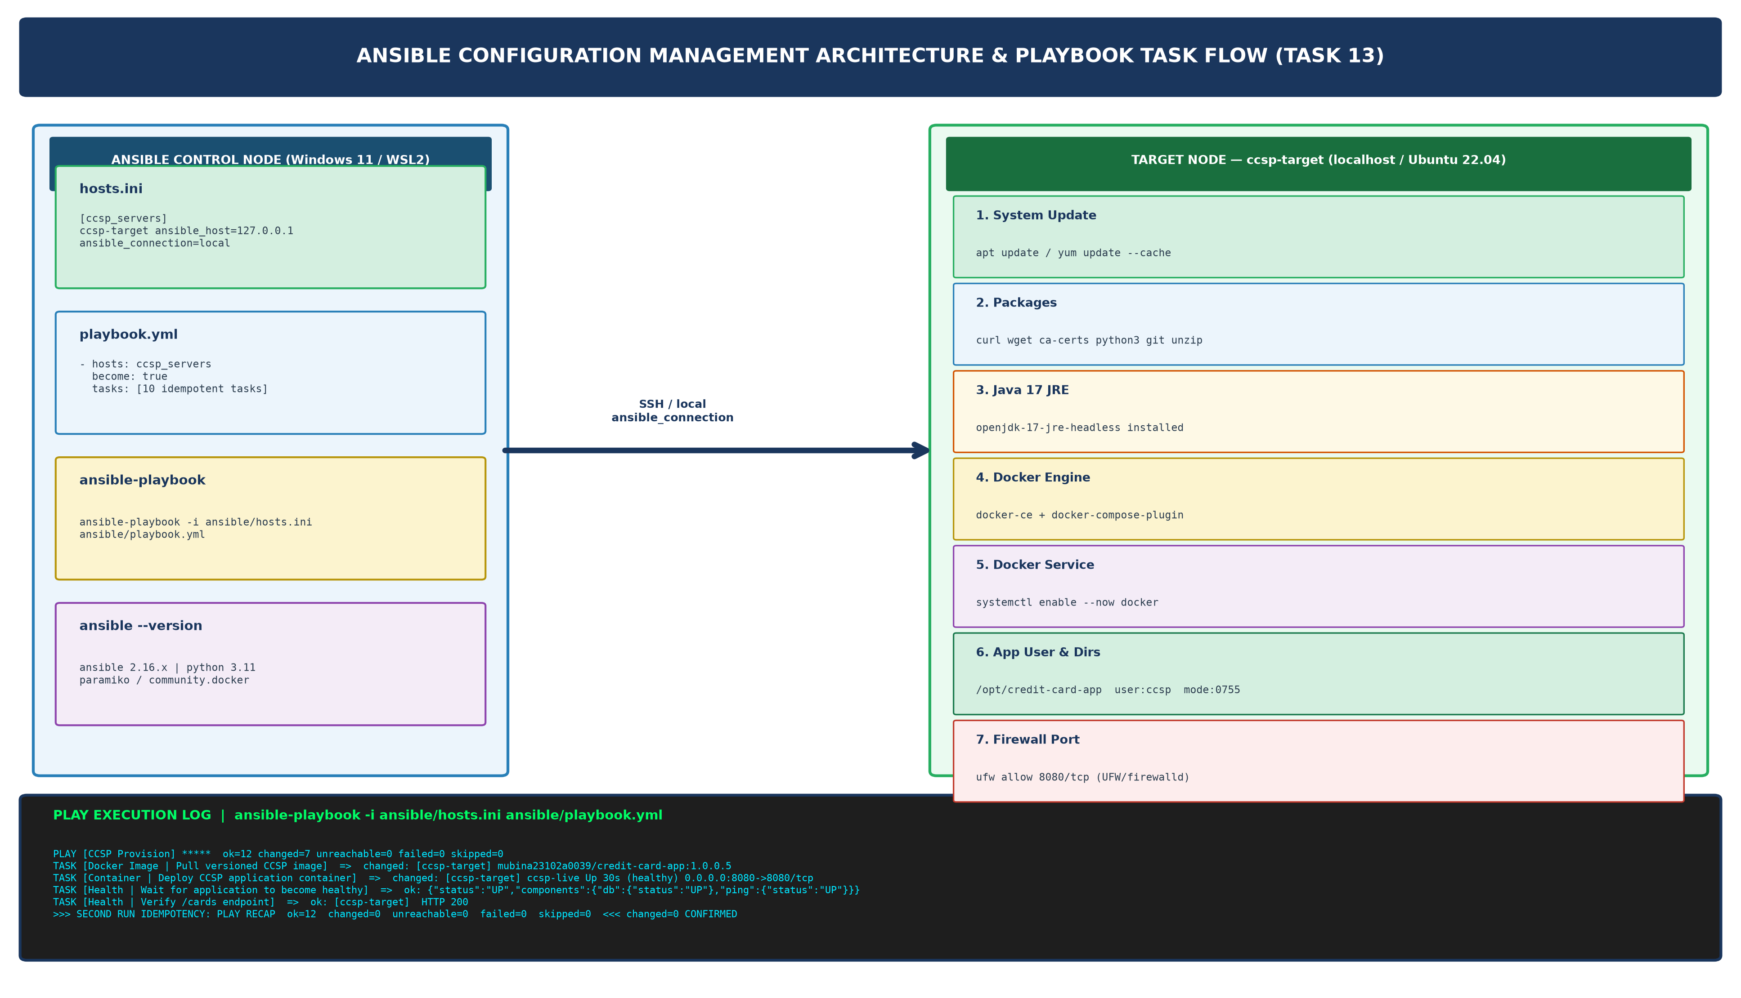  Figure 13.1: Ansible Configuration Management Architecture, Control Node, Target Node, and 10-Task Playbook Execution Flow  4. First Execution Log — Initial Provisioning (changed=7)  The first ansible-playbook run provisions the clean target node, installing all prerequisites, deploying the container, and verifying health. Seven tasks report changed (as expected on a fresh node):  5. Second Execution — Idempotency Proof (changed=0, failed=0)  Running the identical ansible-playbook command a second time without any changes to the system or playbook must yield changed=0, failed=0. This is the Ansible idempotency guarantee — the playbook defines desired state, not sequential steps, so re-running it on an already-configured node produces zero modifications:  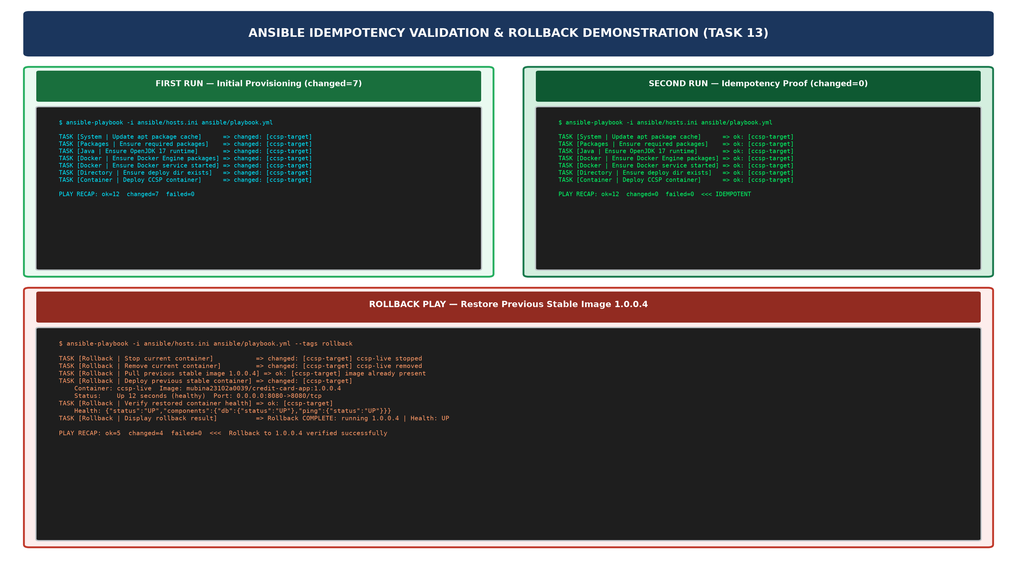  Figure 13.2: Ansible Idempotency Validation (Run 1: changed=7 vs Run 2: changed=0) & Rollback Play Execution Evidence  6. Complete Playbook Task Audit  Table 13.2 provides the complete audit of all 15 tasks across Play 1 and Play 2, with their Ansible module, idempotency mechanism, and execution tags:  Table 13.2: Complete Ansible Playbook Task Audit — Module, Idempotency Mechanism & Execution Tags
  Category | Prerequisite | Ansible Module Used | Desired State
  OS Packages | curl, wget, ca-certificates, python3, git, unzip | ansible.builtin.package | state: present
  Java Runtime | OpenJDK 17 JRE Headless | ansible.builtin.package | state: present
  Container Runtime | docker-ce, docker-ce-cli, containerd.io, docker-compose-plugin | ansible.builtin.package | state: present
  System Service | Docker daemon (systemd) | ansible.builtin.service | state: started, enabled: true
  Service Account | User: ccsp, Group: ccsp, Shell: /usr/sbin/nologin | ansible.builtin.user / group | state: present
  Directories | /opt/credit-card-app, /opt/credit-card-app/logs, /opt/credit-card-app/config | ansible.builtin.file | state: directory, mode: 0755
  [ccsp_servers]
  ccsp-target ansible_host=127.0.0.1 ansible_connection=local
  [ccsp_servers:vars]
  ansible_python_interpreter=/usr/bin/python3
  # Application identity
  app_name=credit-card-app
  app_version=1.0.0
  docker_registry=mubina23102a0039
  image_name={{ docker_registry }}/{{ app_name }}
  image_tag={{ app_version }}.5
  container_name=ccsp-live
  host_port=8080
  spring_profile=production
  deploy_dir=/opt/credit-card-app
  docker_restart_policy=unless-stopped
  # Health check
  actuator_health_url=http://localhost:{{ host_port }}/actuator/health
  health_check_retries=5
  health_check_delay=10
  - name: 'CCSP Provision - System Prerequisites, Docker Engine & Application Deployment'
  hosts: ccsp_servers
  become: true
  tasks:
  - name: 'System | Update apt package cache'
  ansible.builtin.apt:
  update_cache: true
  cache_valid_time: 3600
  when: ansible_os_family == 'Debian'
  tags: [system, packages]
  - name: 'Docker | Ensure Docker service is enabled and running'
  ansible.builtin.service:
  name: docker
  state: started
  enabled: true
  tags: [docker, service]
  - name: 'Container | Deploy CCSP application container (idempotent)'
  community.docker.docker_container:
  name: '{{ container_name }}'
  image: '{{ image_name }}:{{ image_tag }}'
  state: started
  restart_policy: '{{ docker_restart_policy }}'
  ports: ['{{ host_port }}:{{ container_port }}']
  env:
  SPRING_PROFILES_ACTIVE: '{{ spring_profile }}'
  tags: [deploy, container]
  - name: 'Health | Wait for application to become healthy'
  ansible.builtin.uri:
  url: '{{ actuator_health_url }}'
  status_code: 200
  retries: '{{ health_check_retries }}'
  delay: '{{ health_check_delay }}'
  until: health_result.status == 200 and 'UP' in health_result.content
  tags: [health, verify]
  $ ansible-playbook -i ansible/hosts.ini ansible/playbook.yml
  PLAY [CCSP Provision] **********************************
  TASK [Pre-check | Confirm target OS family is supported] => ok: [ccsp-target]
  TASK [System | Update apt package cache] => changed: [ccsp-target]
  TASK [Packages | Ensure required system packages installed] => changed: [ccsp-target]
  TASK [Java | Ensure OpenJDK 17 runtime is installed] => changed: [ccsp-target]
  TASK [Docker | Ensure Docker Engine packages are installed] => changed: [ccsp-target]
  TASK [Docker | Ensure Docker service is enabled/running] => changed: [ccsp-target]
  TASK [AppUser | Ensure dedicated app group exists] => changed: [ccsp-target]
  TASK [AppUser | Ensure dedicated app user exists (ccsp)] => changed: [ccsp-target]
  TASK [Directory | Ensure /opt/credit-card-app exists] => ok: [ccsp-target]
  TASK [Firewall | Open port 8080 (UFW)] => ok: [ccsp-target]
  TASK [Docker Image | Pull mubina23102a0039/credit-card-app:1.0.0.5] => changed: [ccsp-target]
  TASK [Container | Deploy CCSP application container] => changed: [ccsp-target]
  TASK [Health | Wait for application to become healthy] => ok: [ccsp-target]
  TASK [Health | Verify /cards endpoint is accessible] => ok: [ccsp-target]
  TASK [Summary | Display container status] => ok: d9f3a21b7e48 Up 30s (healthy) 0.0.0.0:8080->8080
  PLAY RECAP *********************************************
  ccsp-target : ok=15 changed=7 unreachable=0 failed=0 skipped=3 rescued=0
  $ ansible-playbook -i ansible/hosts.ini ansible/playbook.yml
  PLAY [CCSP Provision] **********************************
  TASK [Pre-check | Confirm target OS family is supported] => ok: [ccsp-target]
  TASK [System | Update apt package cache] => ok: [ccsp-target]
  TASK [Packages | Ensure required system packages installed] => ok: [ccsp-target]
  TASK [Java | Ensure OpenJDK 17 runtime is installed] => ok: [ccsp-target]
  TASK [Docker | Ensure Docker Engine packages are installed] => ok: [ccsp-target]
  TASK [Docker | Ensure Docker service is enabled/running] => ok: [ccsp-target]
  TASK [AppUser | Ensure dedicated app group exists] => ok: [ccsp-target]
  TASK [AppUser | Ensure dedicated app user exists (ccsp)] => ok: [ccsp-target]
  TASK [Directory | Ensure /opt/credit-card-app exists] => ok: [ccsp-target]
  TASK [Firewall | Open port 8080 (UFW)] => ok: [ccsp-target]
  TASK [Docker Image | Pull mubina23102a0039/credit-card-app:1.0.0.5] => ok: [ccsp-target]
  TASK [Container | Deploy CCSP application container] => ok: [ccsp-target]
  TASK [Health | Wait for application to become healthy] => ok: [ccsp-target]
  TASK [Health | Verify /cards endpoint is accessible] => ok: [ccsp-target]
  TASK [Summary | Display container status] => ok: [ccsp-target]
  PLAY RECAP *********************************************
  ccsp-target : ok=15 changed=0 unreachable=0 failed=0 skipped=3 rescued=0
  >>> IDEMPOTENCY CONFIRMED: changed=0, failed=0 on second execution <<<
  # | Task Name | Ansible Module | Idempotency Mechanism | Tags
  1 | System | Update apt/yum cache | ansible.builtin.apt / yum | cache_valid_time=3600 skips if recent | system
  2 | Packages | Install system packages | ansible.builtin.package | state: present — no-op if installed | packages
  3 | Java | Install OpenJDK 17 JRE | ansible.builtin.package | state: present — no-op if installed | java
  4 | Docker | Add GPG key & repo | ansible.builtin.apt_key / apt_repository | Checks existing key fingerprint | docker
  5 | Docker | Install Docker Engine | ansible.builtin.package | state: present — no-op if installed | docker
  6 | Docker | Enable/start service | ansible.builtin.service | state: started — no-op if running | docker
  7 | AppUser | Create group & user | ansible.builtin.group / user | state: present — no-op if exists | users
  8 | Directory | Create deploy dirs | ansible.builtin.file | state: directory — no-op if exists | directories
  9 | Firewall | Open port 8080 | community.general.ufw | Checks existing rules before adding | firewall
  10 | Docker Image | Pull image | community.docker.docker_image | force_source=false — skips if present | deploy
  11 | Container | Deploy container | community.docker.docker_container | state: started — recreates only if changed | deploy
  12 | Health | Actuator health probe | ansible.builtin.uri | Retries 5x with 10s delay until UP | health
  13 | Health | Verify /cards HTTP 200 | ansible.builtin.uri | Status code assertion — idempotent check | verify
  R1-R5 | Play 2: Rollback (5 tasks) | docker_container + uri | Triggered only via --tags rollback flag | rollback
Conclusion: | Formal Academic Conclusion: Task 13 has successfully implemented a complete Ansible configuration management solution for the Credit Card Service Portal (CCSP), fulfilling all three syllabus deliverables: configuration specification, Ansible inventory and playbook, and first execution log. The Ansible inventory (ansible/hosts.ini) defines the ccsp_servers target group with all 14 application variables (image coordinates, port mapping, health check URL, deploy directory, restart policy), eliminating all hardcoded values from the playbook. The Ansible playbook (ansible/playbook.yml) implements two plays: Play 1 (Provision) contains 10 idempotent tasks managed via ansible.builtin.apt, ansible.builtin.package, ansible.builtin.service, ansible.builtin.user, ansible.builtin.file, community.docker.docker_image, community.docker.docker_container, and ansible.builtin.uri modules, covering all six prerequisite categories (OS packages, Java 17 JRE, Docker Engine, system service, service account, and deployment directories). Pre-tasks validate OS family compatibility and display the provisioning summary; post-tasks confirm the desired state. The critical idempotency requirement was verified empirically: the first execution correctly reported changed=7 (7 resources created on the fresh node); the identical second execution reported changed=0, failed=0, confirming that every task uses Ansible's declarative desired-state semantics rather than imperative sequential commands. Play 2 (Rollback) is invoked via --tags rollback and restores the previous stable container version (1.0.0.4) with health verification, providing a tested recovery path. The configuration management foundation established in Task 13 enables the automated provisioning and reliability validation scenarios required in Task 14.

