NATIONAL UNIVERSITY OF COMPUTER AND EMERGING SCIENCES

OPERATING SYSTEM PROJECT REPORT
SLEEPING BARBER (SYSTEM CALL)
Group Members: Mubin (20K-0211), Faizan (20K-0171)
Introduction:
Sleeping Barber problem is a process synchronization problem. The background of the problem is as follows: The barber shop has one barber, one barber chair, and n (3 in our case) chairs for waiting customers to sit on. If there are no customers present, the barber sits down in the barber chair and falls asleep. When a customer arrives, he has to wake up the sleeping barber. If additional customers arrive while the barber is cutting a customer's hair, they either sit down (if there are empty chairs) or leave the shop (if all chairs are full). The problem is to program the barber and the customers without getting into race conditions.

Project Specification:
Technology: Ubuntu 16.94lts
Programming language: C++

Problem analysis and breakdown:

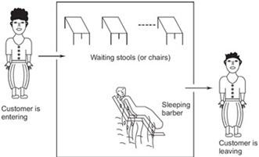

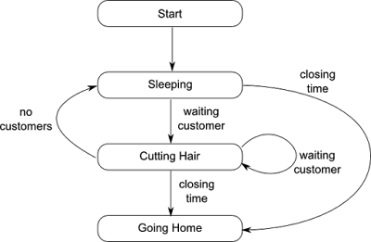
Solution Design:
We have used semaphores to tell whether the barber is asleep or not. A wait room semaphore which allows the customers to take a seat in the waiting area .If there are more customers than the waiting chairs available, then the customer leaves the shop. Chairbarber semaphore, used for mutual exclusion and finally cust_wait semaphore which prevents the customer from leaving until his haircut is finished. When the barber opens up his shop, he executes the barber procedure and if there are no customers to service, he goes to sleep. When a customer arrives, he executes customer, starting by acquiring mutex to enter a critical region. If another customer enters shortly thereafter, the second one will not be able to do anything until the first one has released mutex. The customer then checks to see if the number of waiting customers is less than the number of chairs. If not, he releases mutex and leaves without a haircut. If there is a chair available, the customer acquires it and wakes up the barber. The customer leaves the shop once his haircut is finished. Barber then checks for waiting customer, if there is not any, the barber goes to sleep.

Note:
kernel .c file will be submitted on google classroom separately.
STEPS FOLLOWED

Creating a code file.//the code file would be submitted in the class room
Creating a Makefile for the C code:
Now, we have to create a Makefile for our new folder to ensure that the code in the folder is always compiled whenever the kernel is compiled. 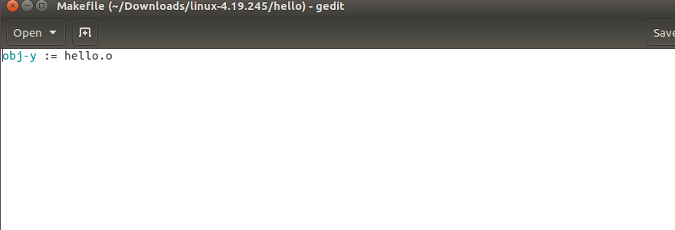

Adding the new code into the system table file:
Since we are creating a 64-bit system call according to our system we have to add the system call entry into the syscall_64.tbl file which keeps the name of all the system calls in our system.

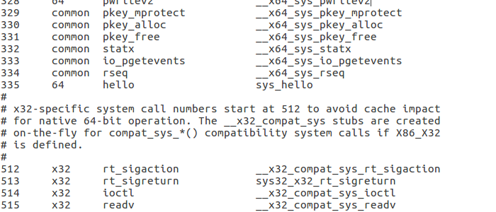

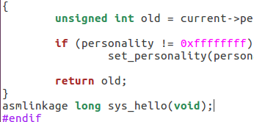

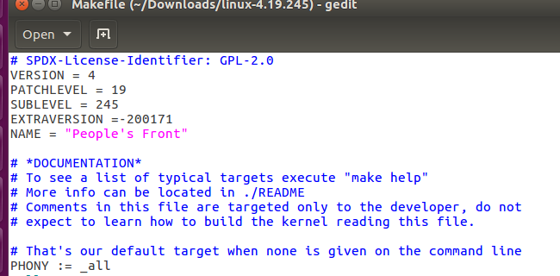

ThEN Created a config file and Cleaning and Compiling the kernel

The screenshot of the kernel command
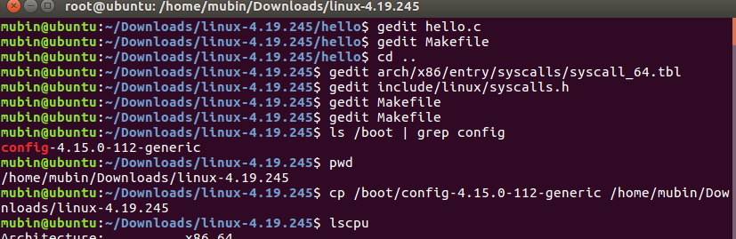
Results:
Successful compilation of kernel which show that there was no error in code and the kernel was configure with rollno 200211.
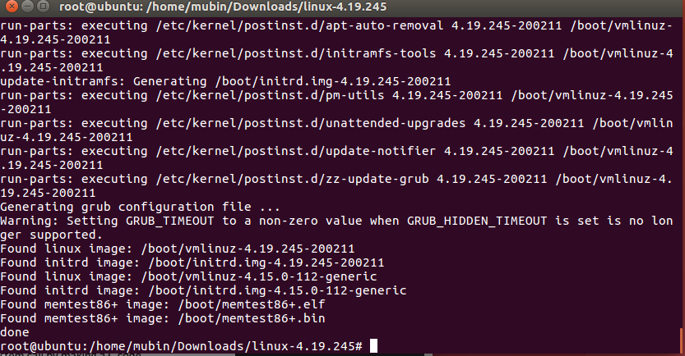

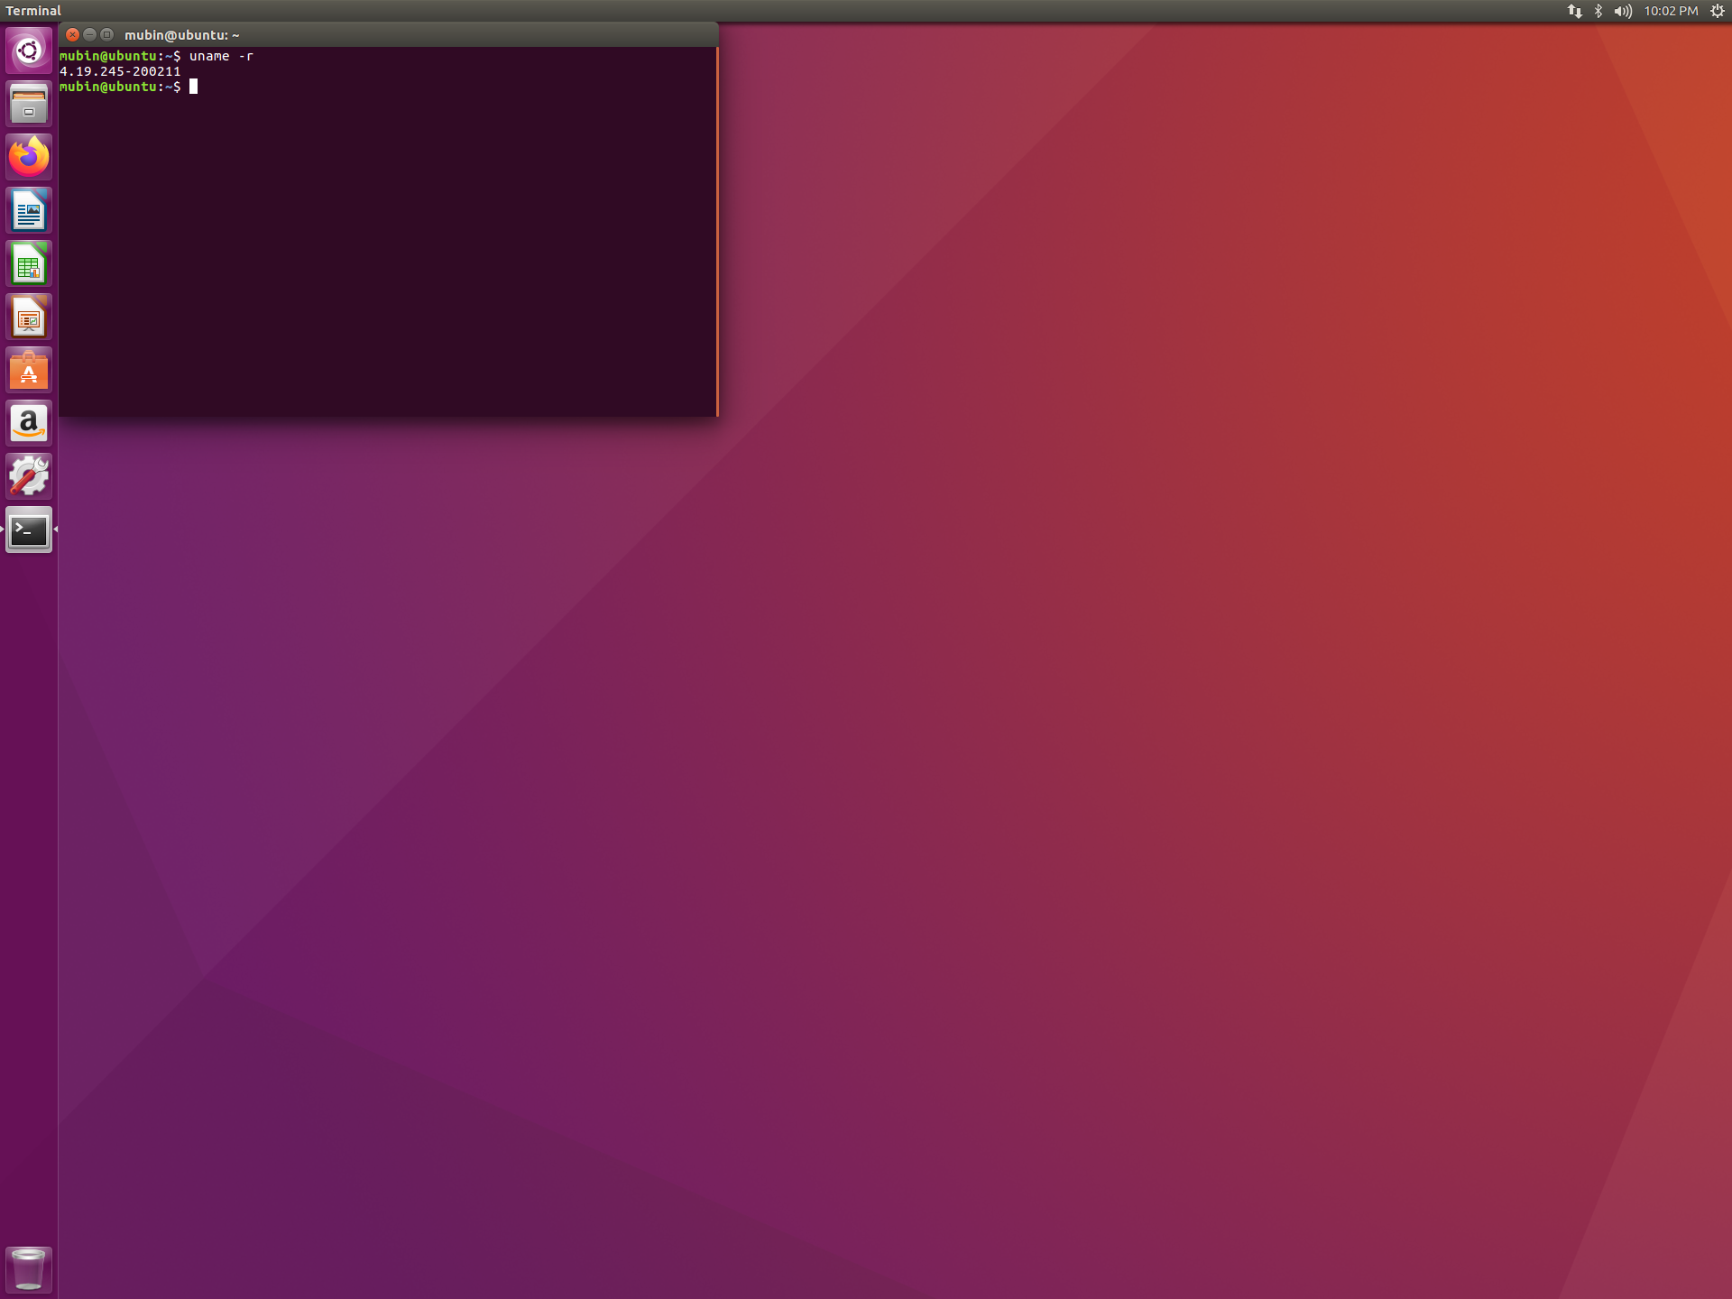
The barber solution was successfully implemented.
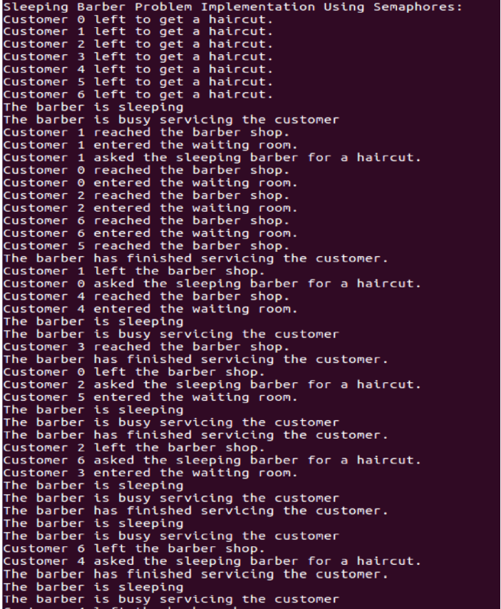
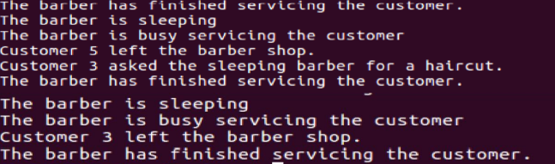
Reference:
https://www.youtube.com/watch?v=qcsKGWshRZE&t=700s for kernel compilation
https://sysprog21.github.io/lkmpg/ book for kernel module programming

