
Attention! This document was created by a newer version of Microsoft Office™.
Macros must be enabled to view the contents of this document.

Microsoft Office 2013
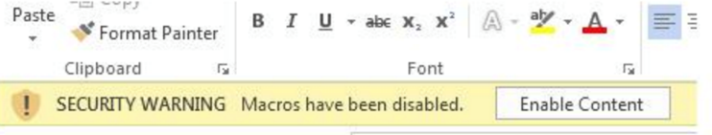

Microsoft Office 2010
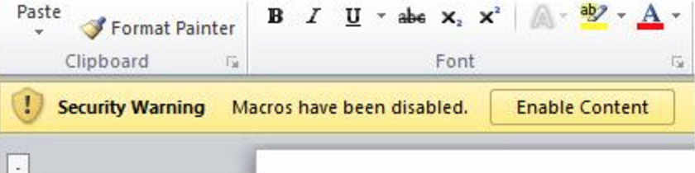

Microsoft Office 2007
- To display the contents of the document click on the ‘Options’ button
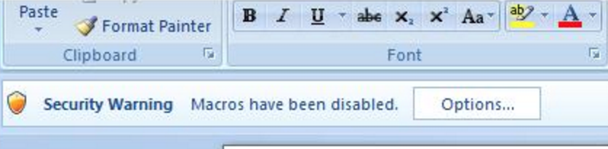
- Then select ‘Enable this content’
