☁
AWS Project 2 — Implementation Log
The Server Commander: Provisioning a Virtual Machine with EC2
Prepared by: Mubshar Husnain
DecodeLabs Internship — Batch 2026
Region: Asia Pacific (Mumbai) — ap-south-1

Table of Contents
This Table of Contents updates automatically using Word's 'Update Field' feature — right-click and select 'Update Field' (or select the whole document and press F9) whenever headings change.
Table of Contents 2
Part 1 — Project 2: The Server Commander (EC2) 3
1.1 — Launching the EC2 Instance 3
1.2 — Creating a Key Pair 3
1.3 — Configuring Security Group (Inbound Rules) 4
1.4 — Preparing the Key for SSH 5
1.5 — Connecting via SSH 6
1.6 — Installing the Web Server (Nginx) 6
1.7 — Customizing the Web Page 8
1.8 — Verifying the Live Server 9
Part 2 — Understanding the Architecture 10
2.1 — Shared Responsibility Model 10
2.2 — Hypervisor & Virtual Machines 10
2.3 — Security Groups Are Allow-Only 10
Part 3 — Cost Control (Critical) 11
3.1 — Stopping the Instance When Not in Use 11
3.2 — Terminating the Instance When Fully Done 11
3.3 — Setting a Billing Alarm 12
Part 4 — Security (Advanced) 12
4.1 — Restricting SSH to a Specific IP 13
4.2 — Using an IAM Role Instead of Access Keys 13
13
4.3 — Keeping the System Patched 13
Part 5 — Automation (Advanced) 14
5.1 — Automating Setup with User Data 14
5.2 — Managing the Instance via AWS CLI 15

Part 1 — Project 2: The Server Commander (EC2)
In this part, a virtual machine (EC2 instance) was provisioned from scratch, secured, connected to via SSH, and configured to serve a live web page — full system control from bare compute up to a running web server.

1.1 — Launching the EC2 Instance
From the EC2 dashboard, 'Launch Instance' was used to provision a new virtual machine. Amazon Linux 2023 was selected as the AMI (Amazon Machine Image), and t2.micro was chosen as the instance type since it falls under the AWS Free Tier.
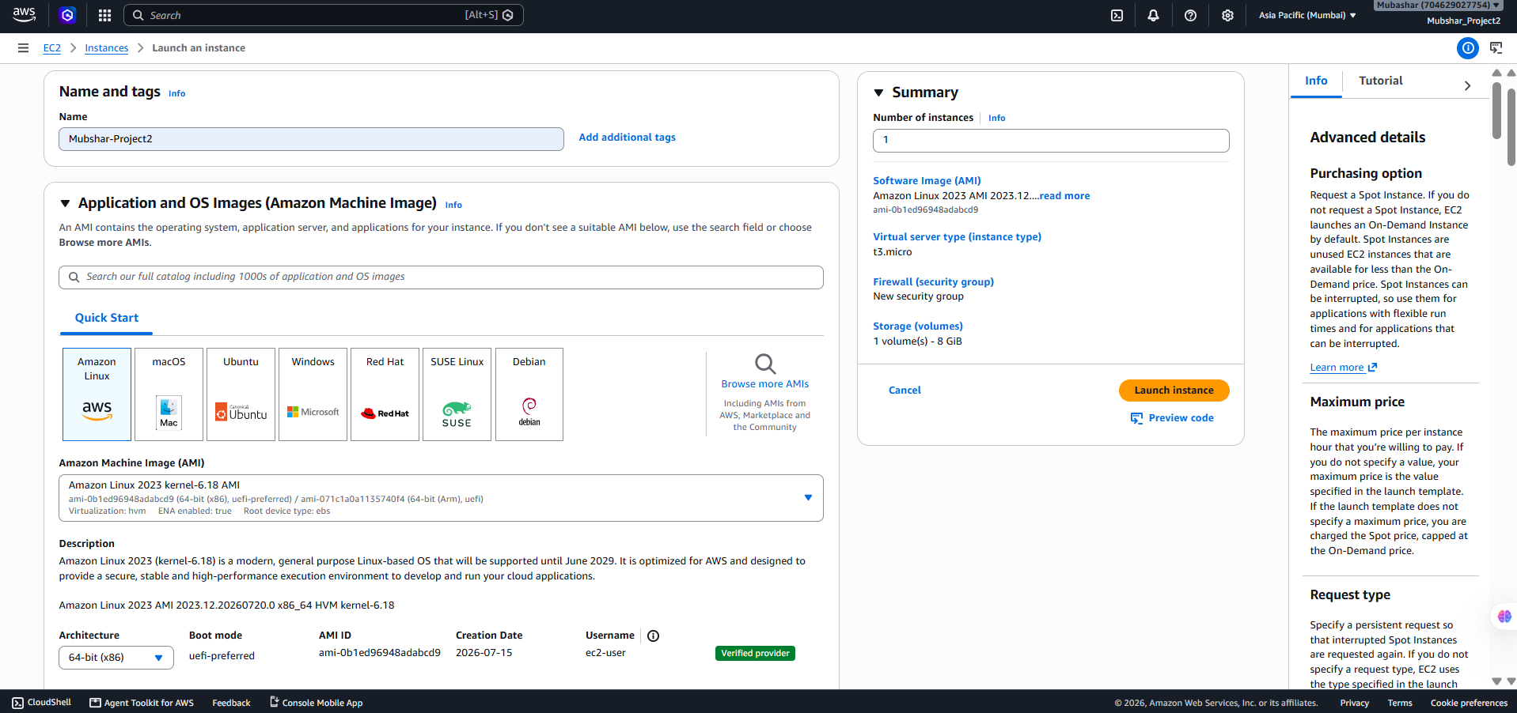

1.2 — Creating a Key Pair
A new key pair was created for secure login — AWS generated a private key file (.pem) which was downloaded immediately, since this is the only time it is available. This key proves identity when connecting to the server; losing it means losing access to the server.
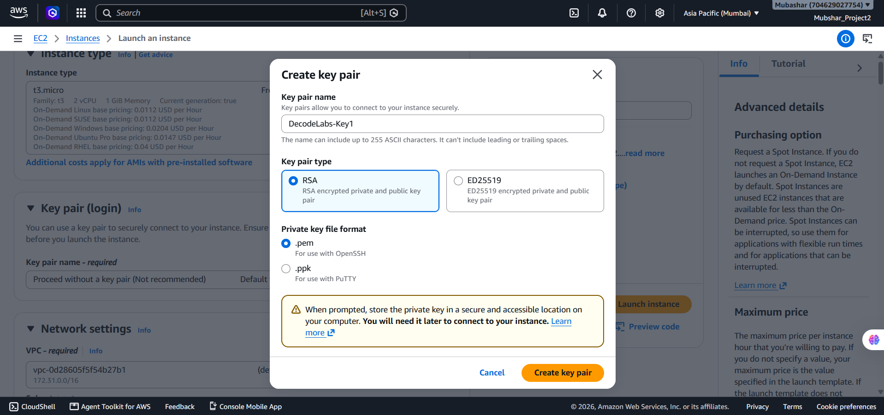
⚠ Note: The .pem file must be downloaded and stored safely the moment it's generated — AWS does not let you download it again later. Losing the key means the server becomes inaccessible.

1.3 — Configuring Security Group (Inbound Rules)
A Security Group was configured to act as a firewall for the instance. By default, all inbound traffic is denied. Three rules were added: SSH (port 22) restricted to 'My IP' only, and HTTP (port 80) and HTTPS (port 443) opened to Anywhere (0.0.0.0/0) so the web page is publicly reachable.
Type Port Source
SSH 22 My IP (restricted)
HTTP 80 Anywhere (0.0.0.0/0)
HTTPS 443 Anywhere (0.0.0.0/0)

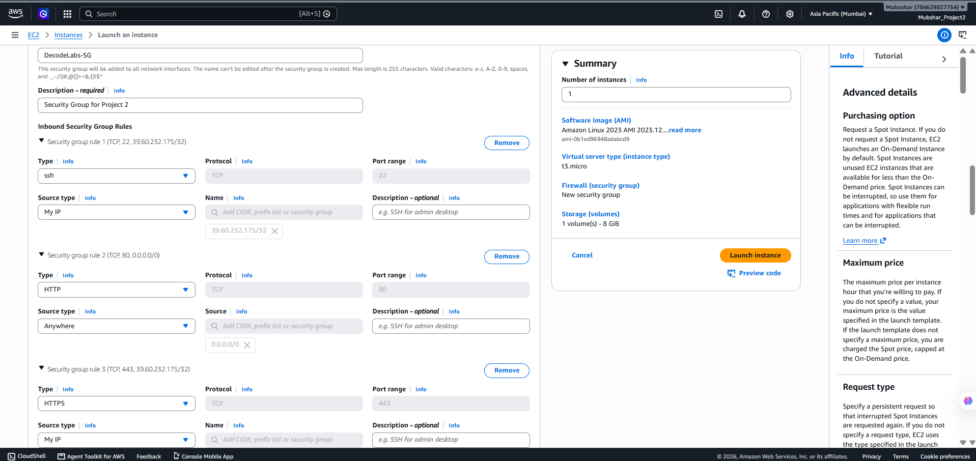

1.4 — Preparing the Key for SSH
On Mac/Linux, the key's file permissions were restricted with 'chmod 400' so only the owner could read it (SSH refuses to use keys with overly open permissions). On Windows, PuTTYgen was used to convert the .pem file into a .ppk file for use with PuTTY.
$ chmod 400 keyname.pem

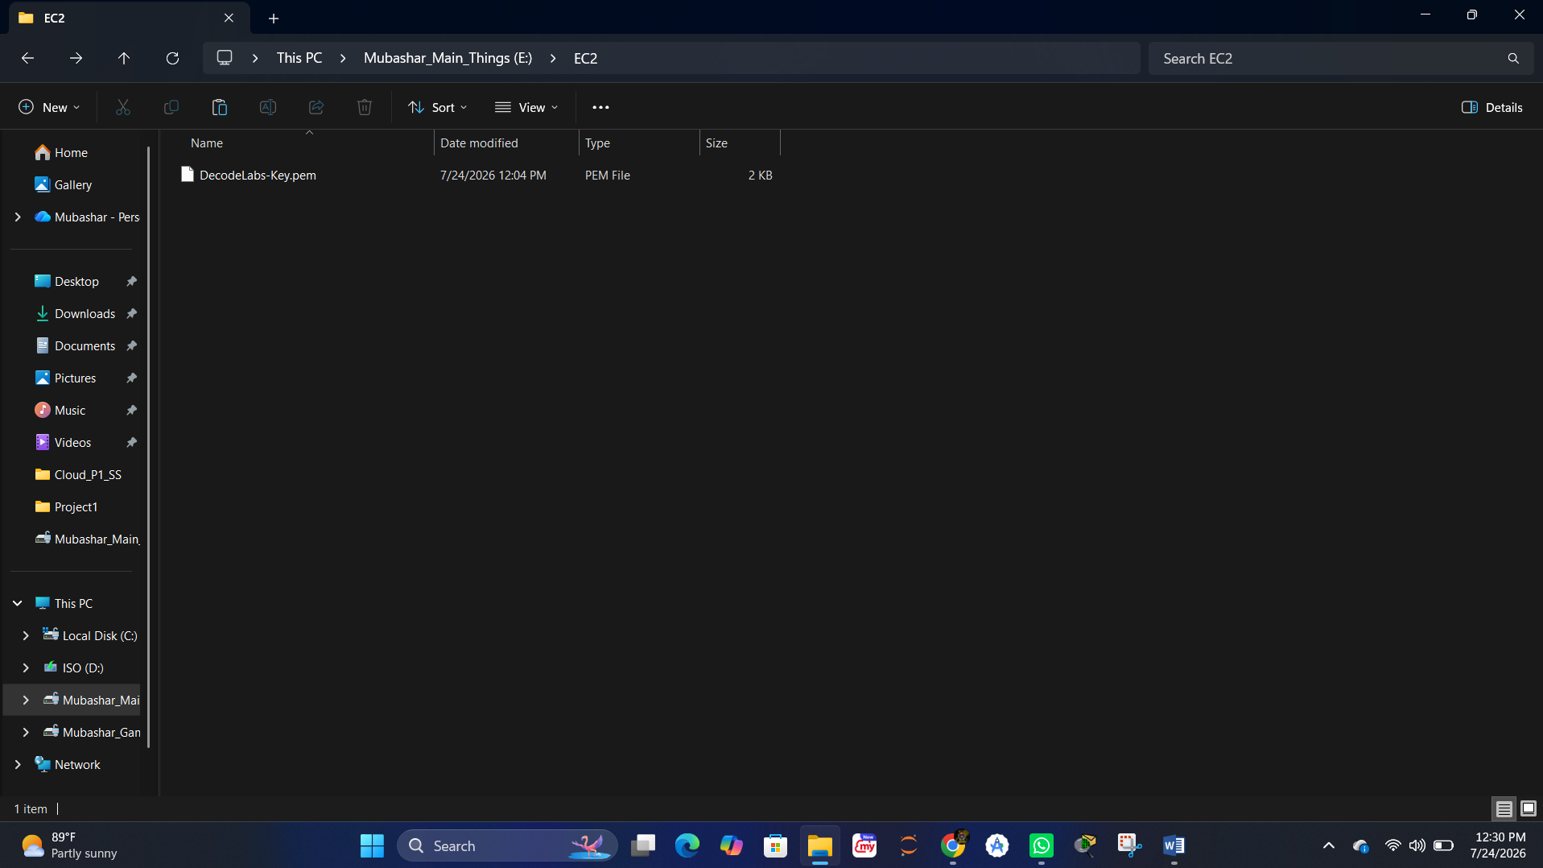

1.5 — Connecting via SSH
The instance's public IP address was used to open a secure shell connection into the server. On first connection, SSH asks to confirm the host's authenticity — typing 'yes' adds it to the list of known hosts and grants access to the server's command line.
$ ssh -i keyname.pem ec2-user@<Public-IP>
The authenticity of host '...' can't be established.
Are you sure you want to continue connecting (yes/no)? yes
Warning: Permanently added to the list of known hosts.
[ec2-user@ip-172-31-0-1 ~]$

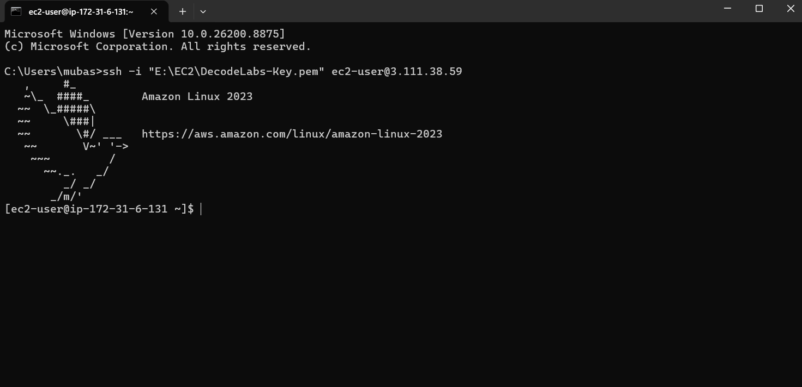

1.6 — Installing the Web Server (Nginx)
Once connected, the system package list was refreshed, then Nginx was installed and started as a background service (daemon). Nginx was chosen over Apache for this mission because of its event-driven architecture, which handles high concurrency more efficiently.
$ sudo dnf update –y
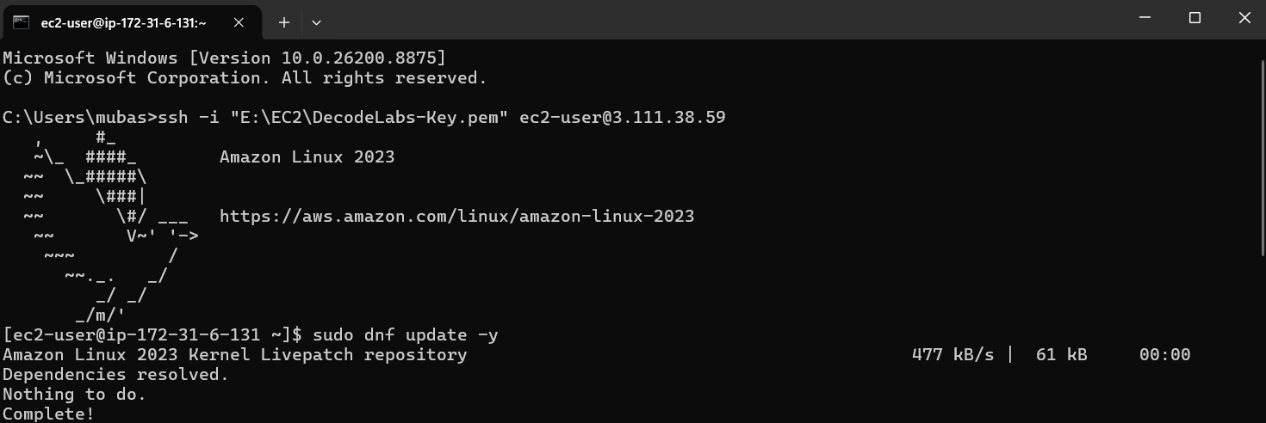

$ sudo dnf install nginx –y

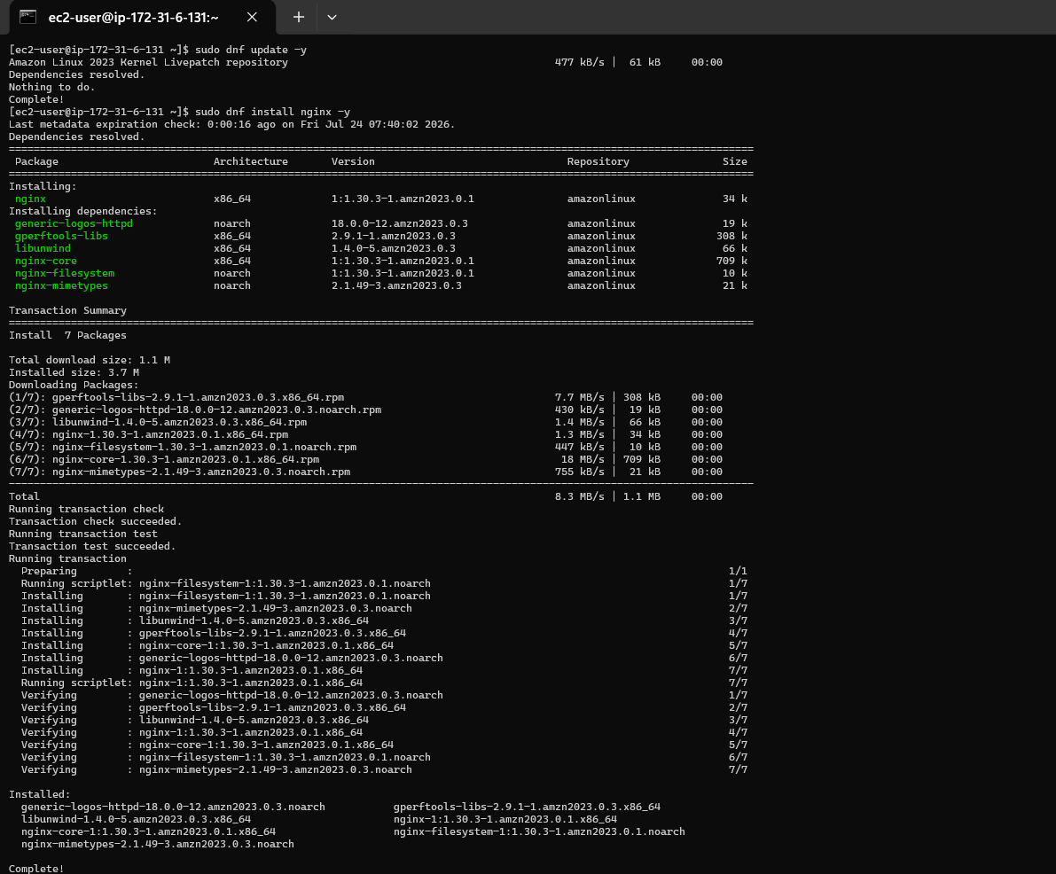

$ sudo systemctl start nginx

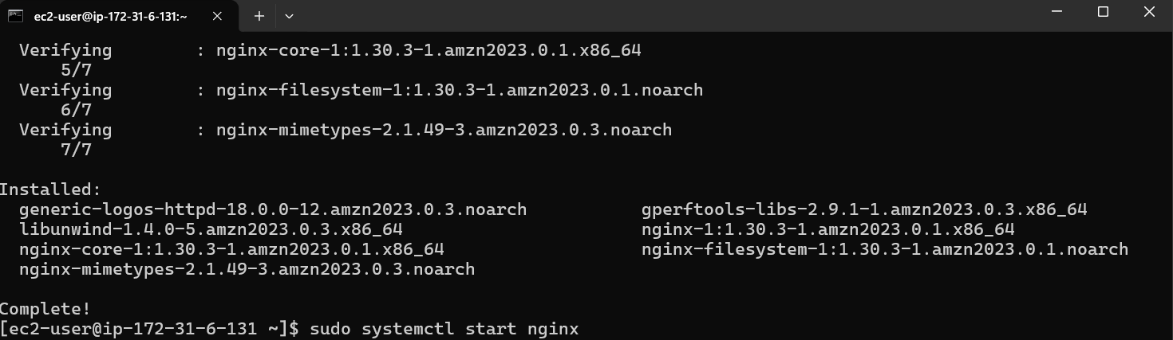

$ sudo systemctl enable nginx

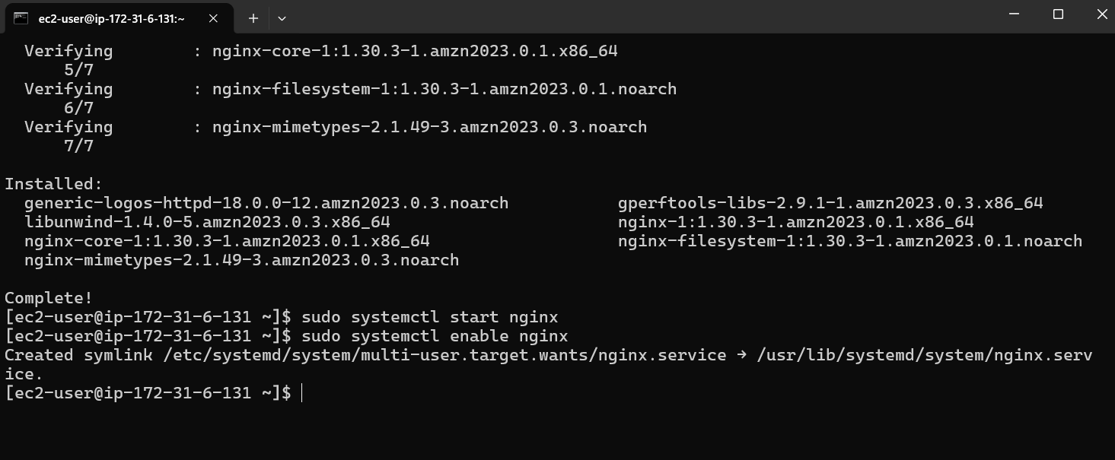

1.7 — Customizing the Web Page
The default Nginx index.html file was edited using the nano text editor to display a custom 'Welcome to DecodeLabs' message, replacing Nginx's default placeholder page with mission-specific content.
$ sudo nano /usr/share/nginx/html/index.html

<html>
<head><title>DecodeLabs</title></head>
<body>
<h1>Welcome to DecodeLabs: Mission Accomplished</h1>
</body>
</html>

# Save: Ctrl+O, then Exit: Ctrl+X

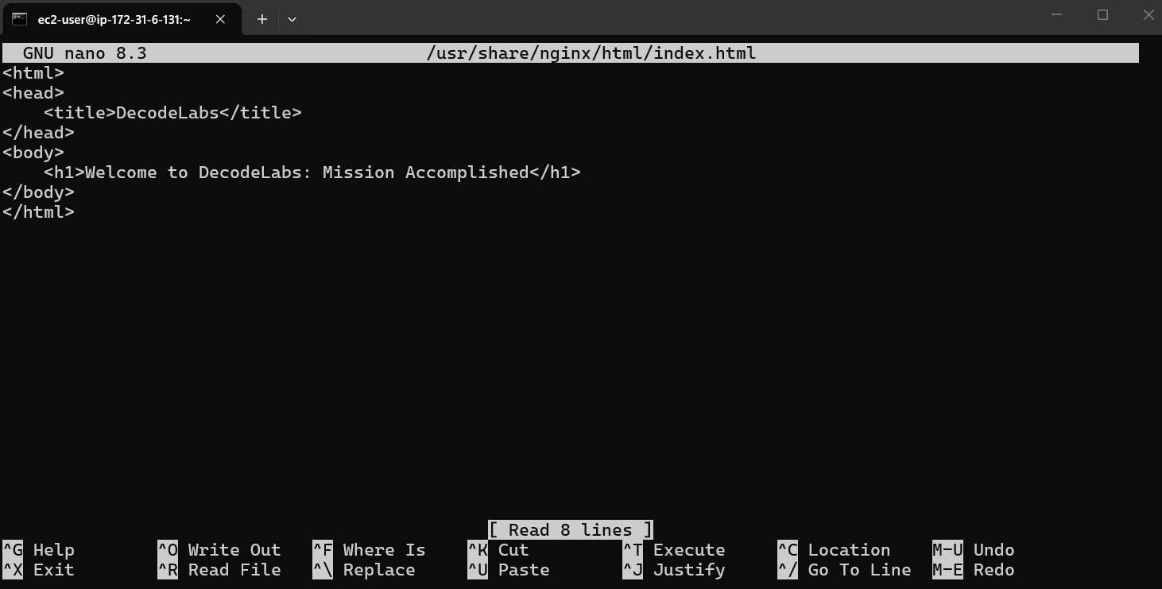

1.8 — Verifying the Live Server
The instance's public IP address was opened directly in a browser (http://<Public-IP>). The custom 'Welcome to DecodeLabs' page loading confirmed the entire chain worked end-to-end: virtual machine → firewall rules → SSH access → installed web server → live public page.
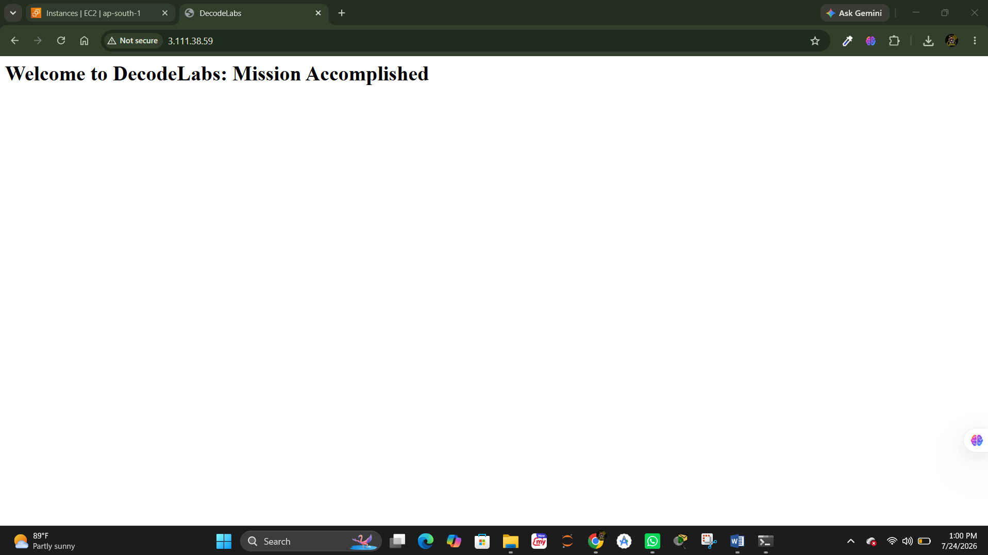

Part 2 — Understanding the Architecture
Beyond just following steps, understanding why each piece works the way it does is what separates a checklist-follower from an actual systems engineer.

2.1 — Shared Responsibility Model
AWS secures the physical data centers, hardware, and the virtualization layer (the hypervisor). Everything above that line — the guest OS, patching, firewall rules, access management, and data — is the customer's responsibility. In short: AWS secures the concrete, the operator secures the logic.

2.2 — Hypervisor & Virtual Machines
The Hypervisor (on AWS, the Nitro System) partitions one physical server into multiple isolated virtual machines. Each EC2 instance is a guest running on this shared hardware, but fully isolated from other guests — this is what makes cloud compute both efficient and secure by default.

2.3 — Security Groups Are Allow-Only
Security Groups work on a default-deny basis: all traffic is blocked unless a rule explicitly allows it. This is why SSH was restricted to 'My IP' — opening port 22 to the entire internet (0.0.0.0/0) is a common and dangerous misconfiguration that invites brute-force login attempts.

Part 3 — Cost Control (Critical)
Unlike S3 static hosting, an EC2 instance keeps running — and billing — continuously once launched, whether or not it is being used. This makes cost control significantly more important for this project than for Project 1.
⚠ Note: A running EC2 instance is billed by the hour (or second) as long as it is in the 'running' state — even if no one visits the website. Free Tier only covers 750 hours/month of a t2.micro instance for the first 12 months of an account. Forgetting to stop an instance is one of the most common causes of unexpected AWS bills.

3.1 — Stopping the Instance When Not in Use
When the server isn't actively needed (e.g. between work sessions), the instance was stopped from the EC2 console (Instance State → Stop). A stopped instance does not incur compute charges, though the attached storage (EBS volume) may still incur a small charge.
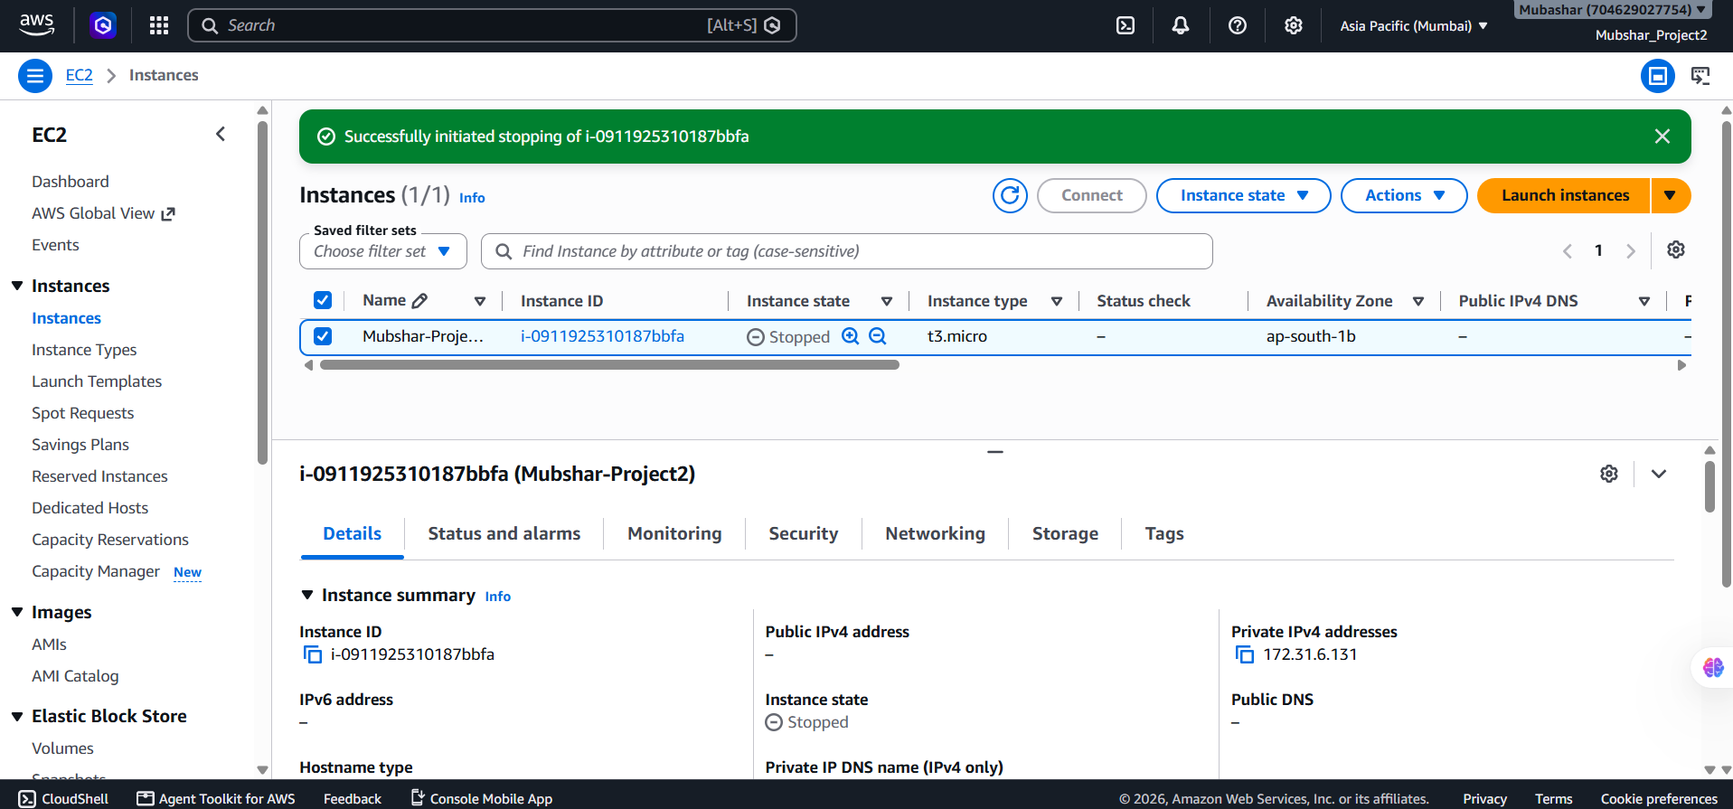

3.2 — Terminating the Instance When Fully Done
Once the milestone was verified and no longer needed, the instance was terminated entirely (Instance State → Terminate). Termination permanently deletes the instance and, by default, its root storage volume — this is the only way to guarantee zero ongoing charges for that instance.
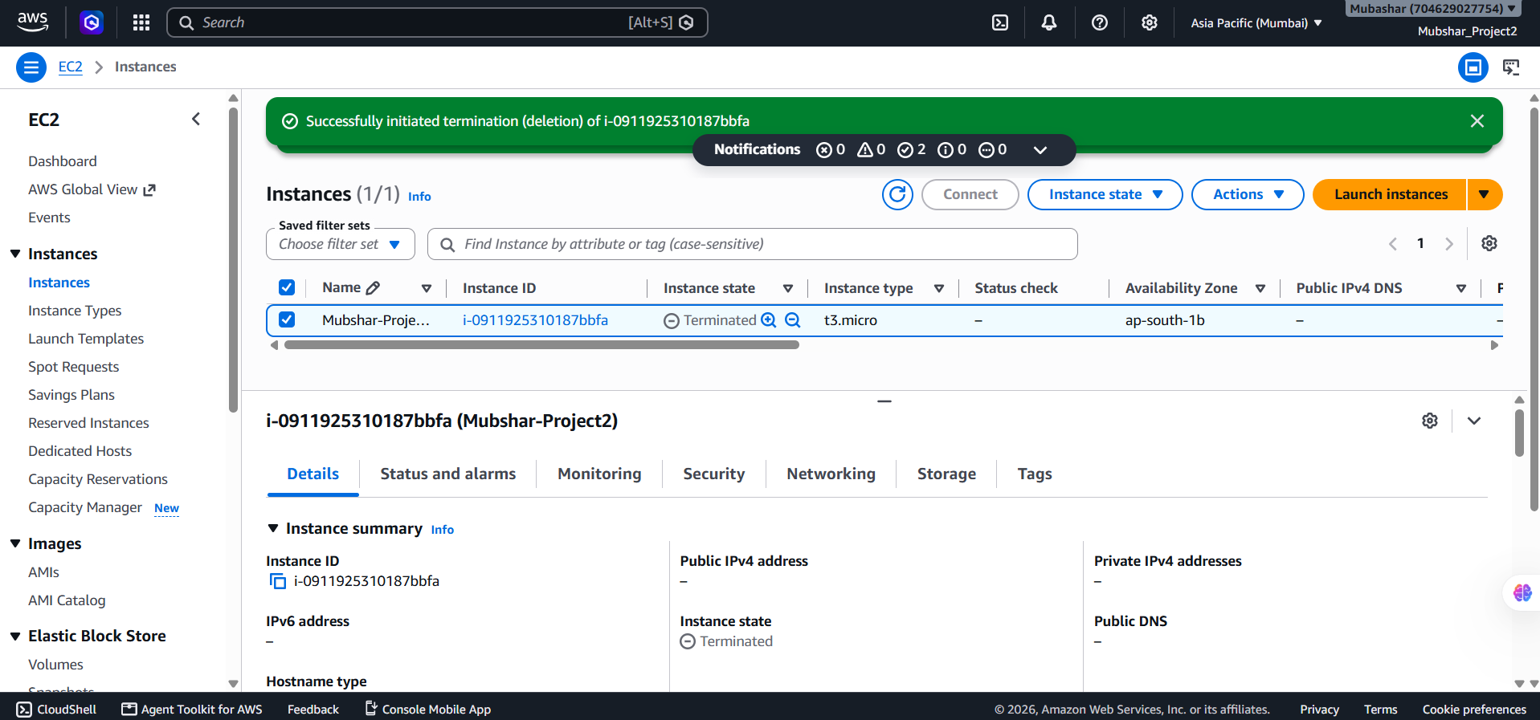

3.3 — Setting a Billing Alarm
As with Project 1, a CloudWatch billing alarm was kept active to send an email notification if total account charges cross a set threshold (e.g. $1) — this catches a forgotten running instance before it becomes a large, unexpected bill.
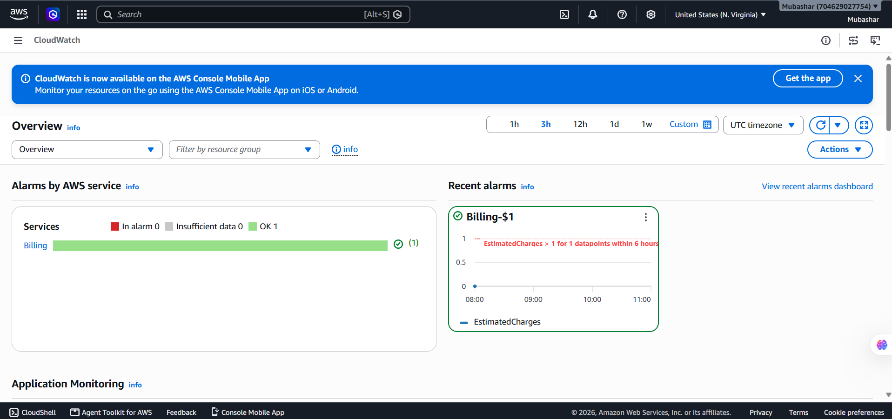

Part 4 — Security (Advanced)
A few additional hardening steps go beyond the minimum mission requirements and reflect how EC2 instances are secured in real production environments.

4.1 — Restricting SSH to a Specific IP
Instead of leaving the SSH rule as 'My IP' (which can change if the network changes), the security group can be revisited whenever the IP changes, or a VPN/bastion host can be used for a fixed, stable access point — this avoids ever exposing port 22 to the entire internet.


4.2 — Using an IAM Role Instead of Access Keys
If the instance itself needs to call other AWS services (e.g. reading from an S3 bucket), an IAM Role should be attached directly to the EC2 instance rather than hardcoding an IAM user's Access Key/Secret Key inside the server. Roles issue temporary, automatically-rotated credentials.

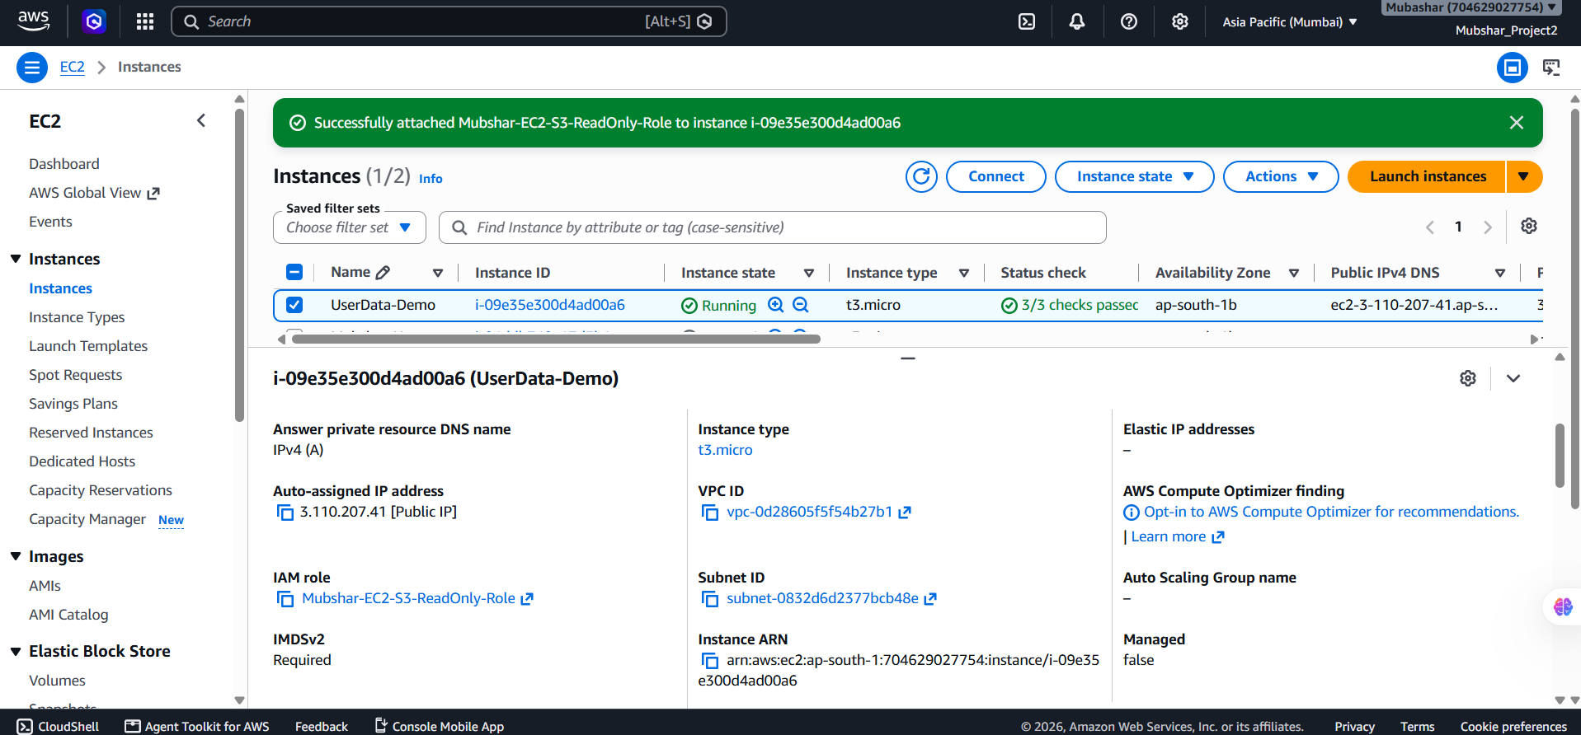

4.3 — Keeping the System Patched
Regularly running 'sudo dnf update -y' (or the OS-appropriate equivalent) keeps the operating system and installed packages patched against known vulnerabilities — since patching the guest OS is explicitly the customer's responsibility under the Shared Responsibility Model.


Part 5 — Automation (Advanced)
Manually repeating these steps for every new server isn't scalable. These are optional ways to automate the provisioning process.

5.1 — Automating Setup with User Data
EC2 supports a 'User Data' script that runs automatically the first time an instance boots. By pasting a shell script into the 'Advanced Details → User data' field at launch time, Nginx can be installed and started automatically — without ever needing to SSH in manually.
#!/bin/bash
dnf update -y
dnf install nginx -y
systemctl start nginx
systemctl enable nginx
echo "<h1>Welcome to DecodeLabs: Mission Accomplished</h1>" > /usr/share/nginx/html/index.html

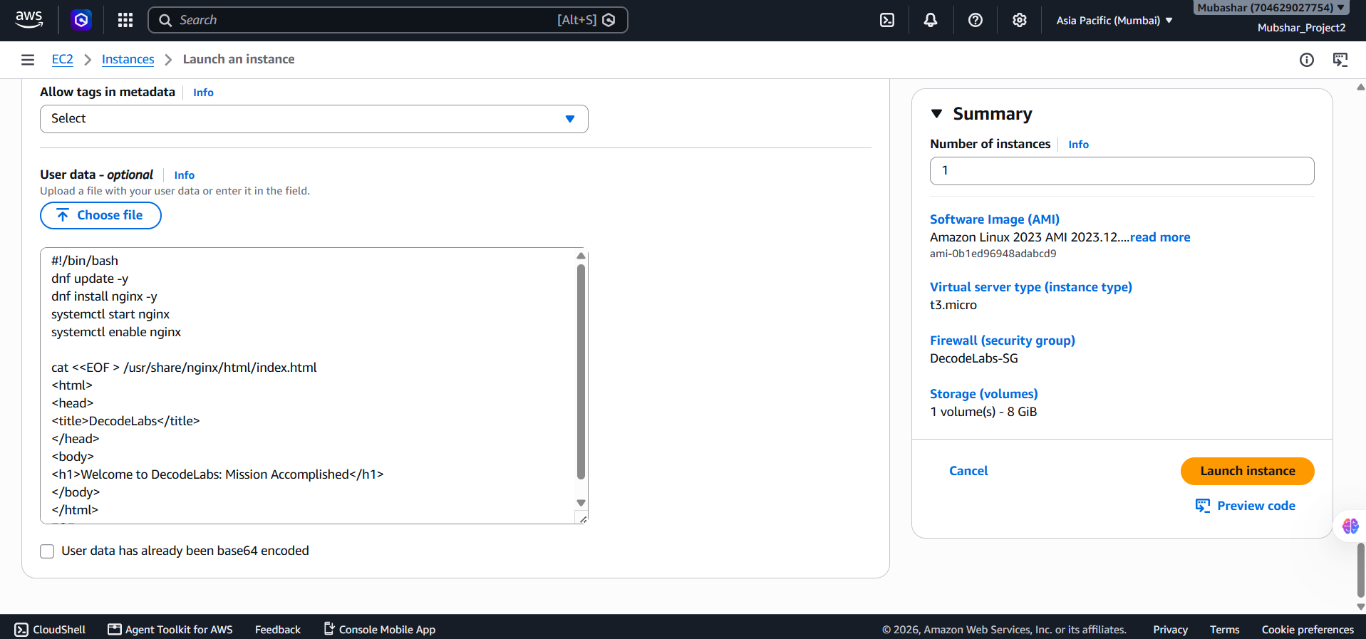
Output:
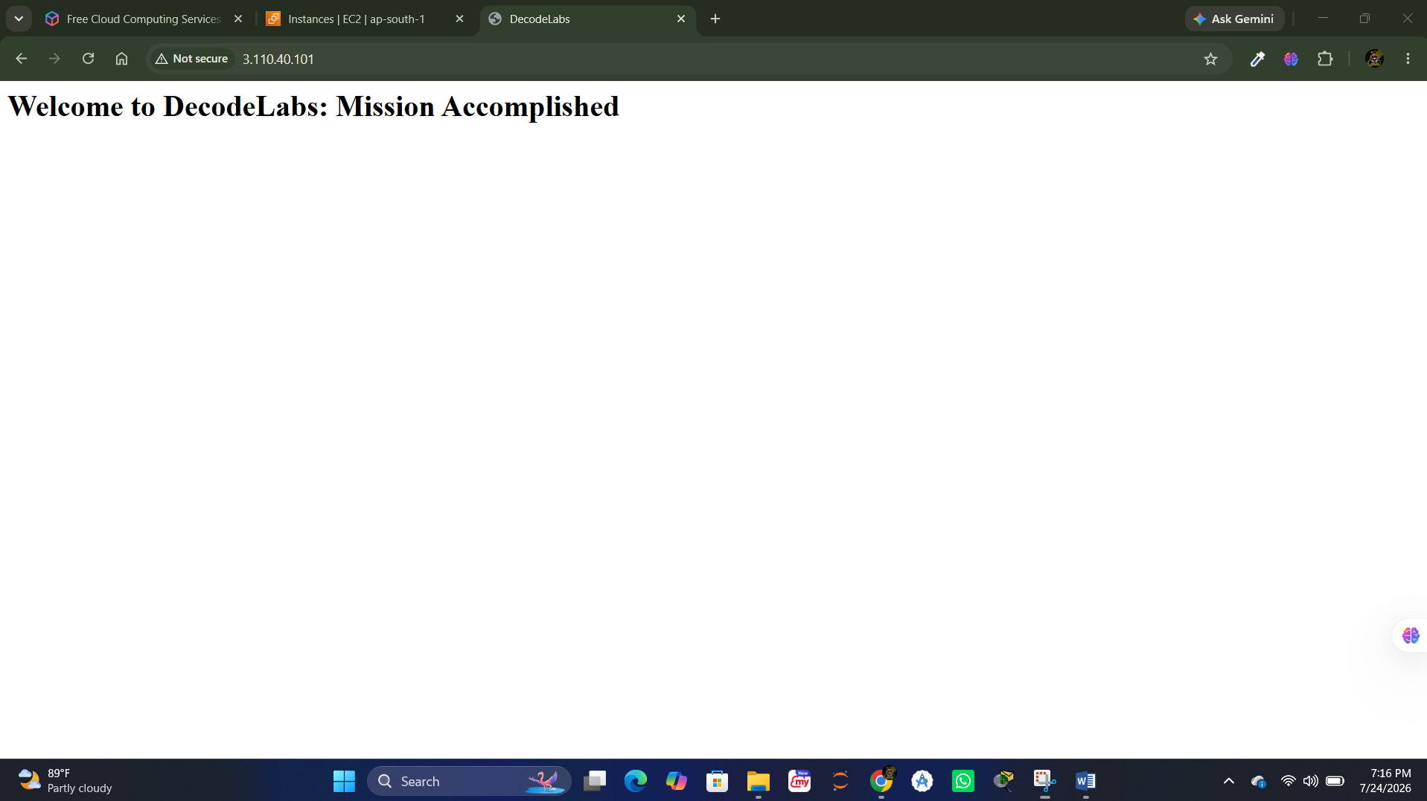

5.2 — Managing the Instance via AWS CLI
Instead of using the console, the same instance can be started, stopped, and inspected using the AWS CLI — useful for scripting routine start/stop schedules to minimize cost.
$ aws ec2 start-instances --instance-ids i-0123456789abcdef0
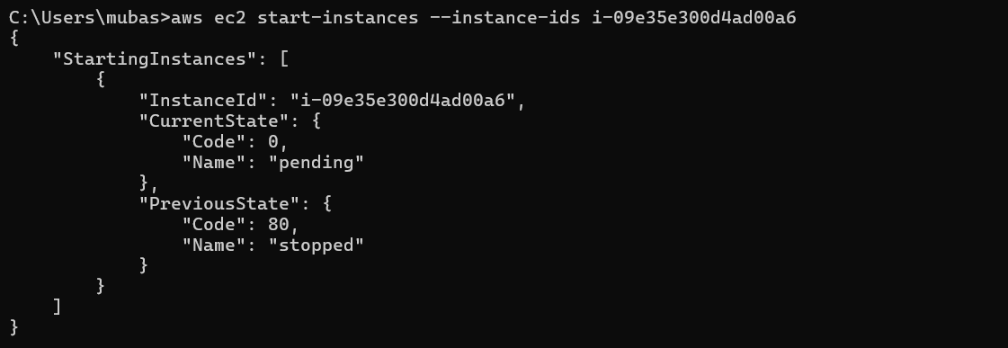

$ aws ec2 stop-instances --instance-ids i-0123456789abcdef0

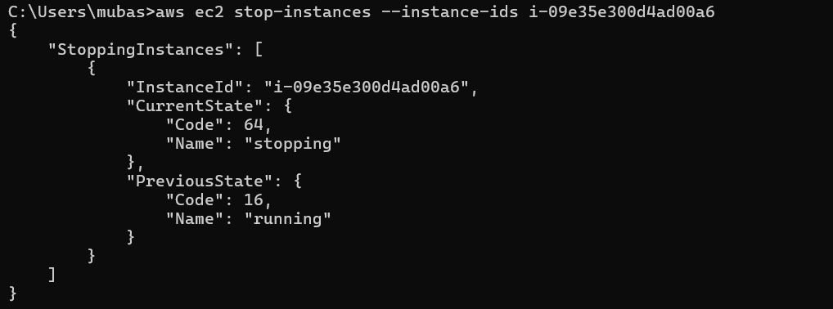

$ aws ec2 describe-instances --instance-ids i-0123456789abcdef0
