☁
AWS Project 3 — Implementation Log
The Data Warehouse: Provisioning a Managed Database with RDS
Prepared by: Mubshar Husnain
DecodeLabs Internship — Batch 2026
Region: Asia Pacific (Mumbai) — ap-south-1

Table of Contents
This Table of Contents updates automatically using Word's 'Update Field' feature — right-click and select 'Update Field' (or select the whole document and press F9) whenever headings change.
Table of Contents 2
Part 1 — Project 3: The Data Warehouse (RDS) 3
1.1 — Choosing the Database Engine and Instance Class 3
1.2 — Disabling Public Accessibility 3
1.3 — Configuring the Security Group (Port 3306) 3
1.4 — Designing the Schema 4
1.5 — Inserting Dummy Records 4
1.6 — Connecting via SSH Tunnel (Bastion Host) 5
1.7 — Verifying Data Persistence 5
Part 2 — Understanding the Architecture 7
2.1 — RDS vs DynamoDB 7
2.2 — Why Private Subnets Matter 7
2.3 — Schema Constraints as Data Integrity 7
Part 3 — Cost Control (Critical) 8
3.1 — Stopping the RDS Instance When Not in Use 8
3.2 — Deleting the Instance When Fully Done 8
3.3 — Billing Alarm 8
Part 4 — Security (Advanced) 9
4.1 — Restricting the Security Group to the Bastion Only 9
4.2 — Using AWS Secrets Manager for Credentials 9
4.3 — Enabling Automated Backups 9
Part 5 — Automation (Advanced) 11
5.1 — Managing Infrastructure with Boto3 11
5.2 — Querying Data with PyMySQL 11
Final Checklist 13

Part 1 — Project 3: The Data Warehouse (RDS)
In this part, a managed relational database was provisioned on AWS RDS, isolated inside a private subnet, structured with a proper schema, populated with records, and verified through a secure SSH tunnel — moving data management off local spreadsheets and onto scalable cloud infrastructure.

1.1 — Choosing the Database Engine and Instance Class
Amazon RDS was selected with MySQL (or MariaDB) as the engine, since the data (Interns table) is highly structured and benefits from relational integrity. The db.t3.micro instance class was chosen as it is Free Tier eligible, with 20 GB of General Purpose SSD (gp2) storage allocated.
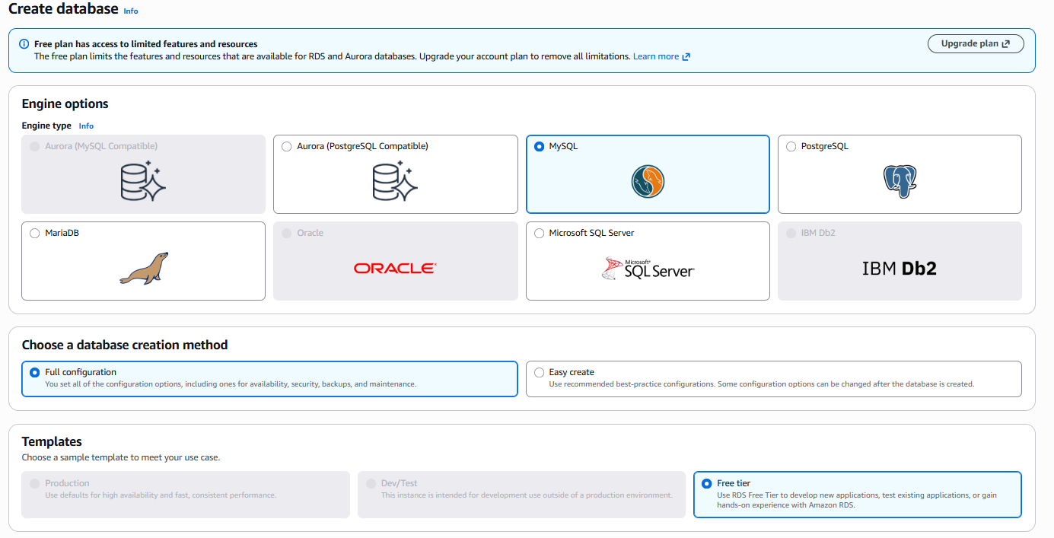
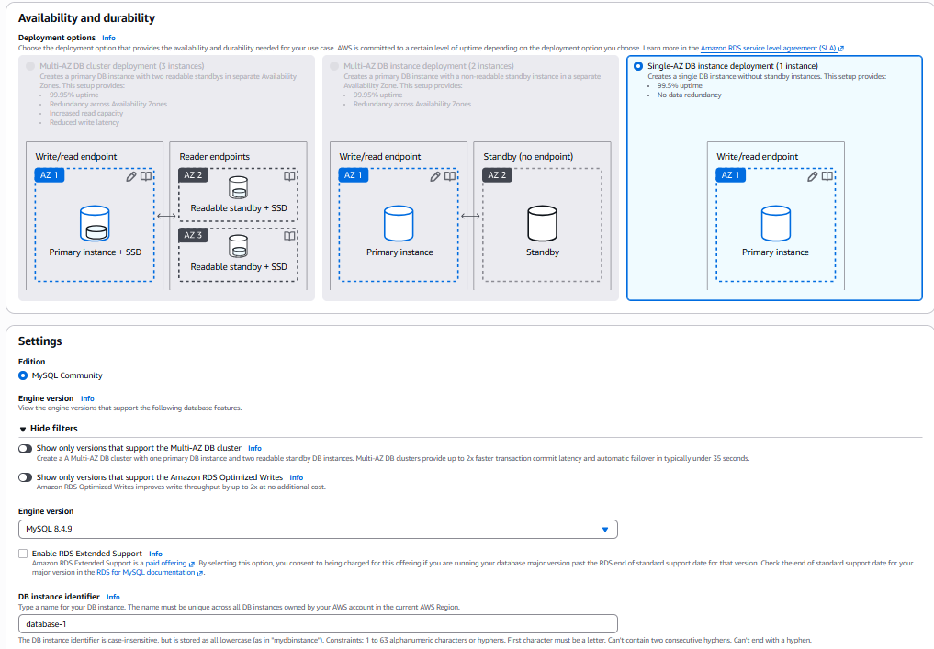

1.2 — Disabling Public Accessibility
During setup, Public Accessibility was explicitly set to 'No'. This places the database inside a private subnet with no direct route to the internet — a publicly reachable database is a compromised database, since it becomes exposed to automated scanning and brute-force attempts.
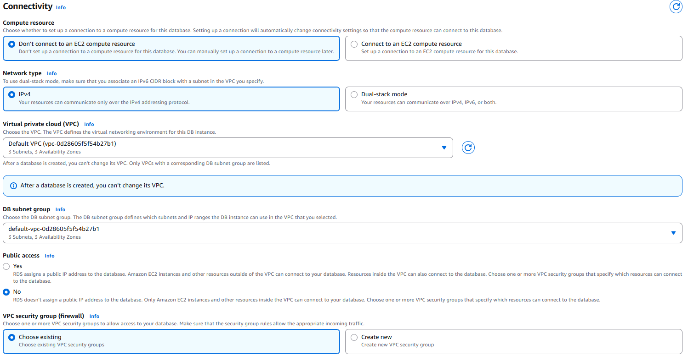
⚠ Note: A database should never be directly reachable from the internet. Keeping RDS in a private subnet with public access disabled is a non-negotiable baseline for any production or graded deployment.

1.3 — Configuring the Security Group (Port 3306)
A security group was attached to the RDS instance allowing inbound traffic only on TCP port 3306 (MySQL's default port). The source was restricted to the security group of the EC2 bastion host (or a specific IP), not to 'Anywhere' — matching the same allow-only firewall logic used in Project 2.
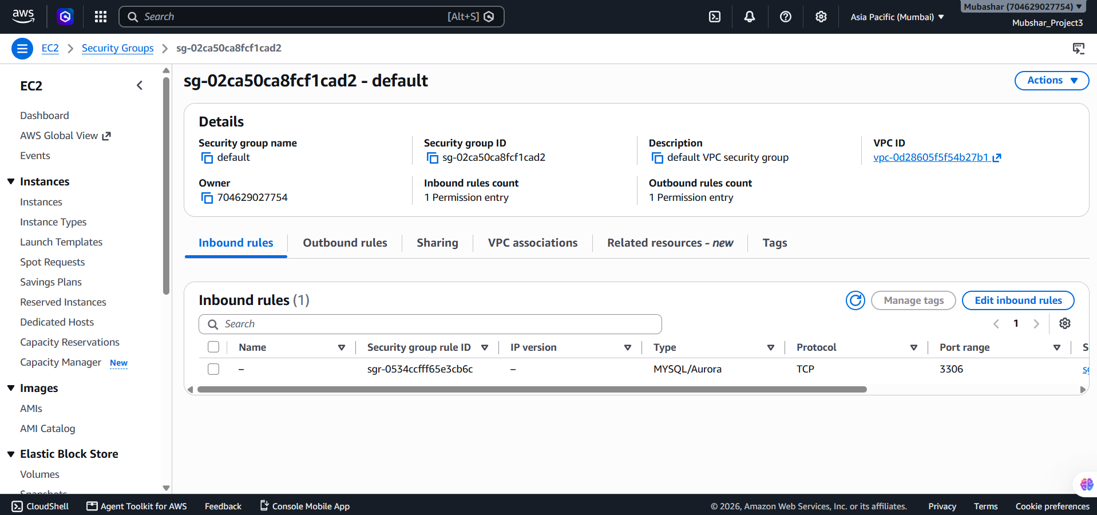

1.4 — Designing the Schema
A table named Interns was defined using SQL's Data Definition Language (DDL). InternID was set as an INT PRIMARY KEY to uniquely identify each row, FirstName/LastName as VARCHAR with NOT NULL, and Email as VARCHAR with a UNIQUE NOT NULL constraint to prevent duplicate registrations.
CREATE TABLE Interns (
InternID INT PRIMARY KEY,
FirstName VARCHAR(50) NOT NULL,
LastName VARCHAR(50) NOT NULL,
Email VARCHAR(100) UNIQUE NOT NULL
);

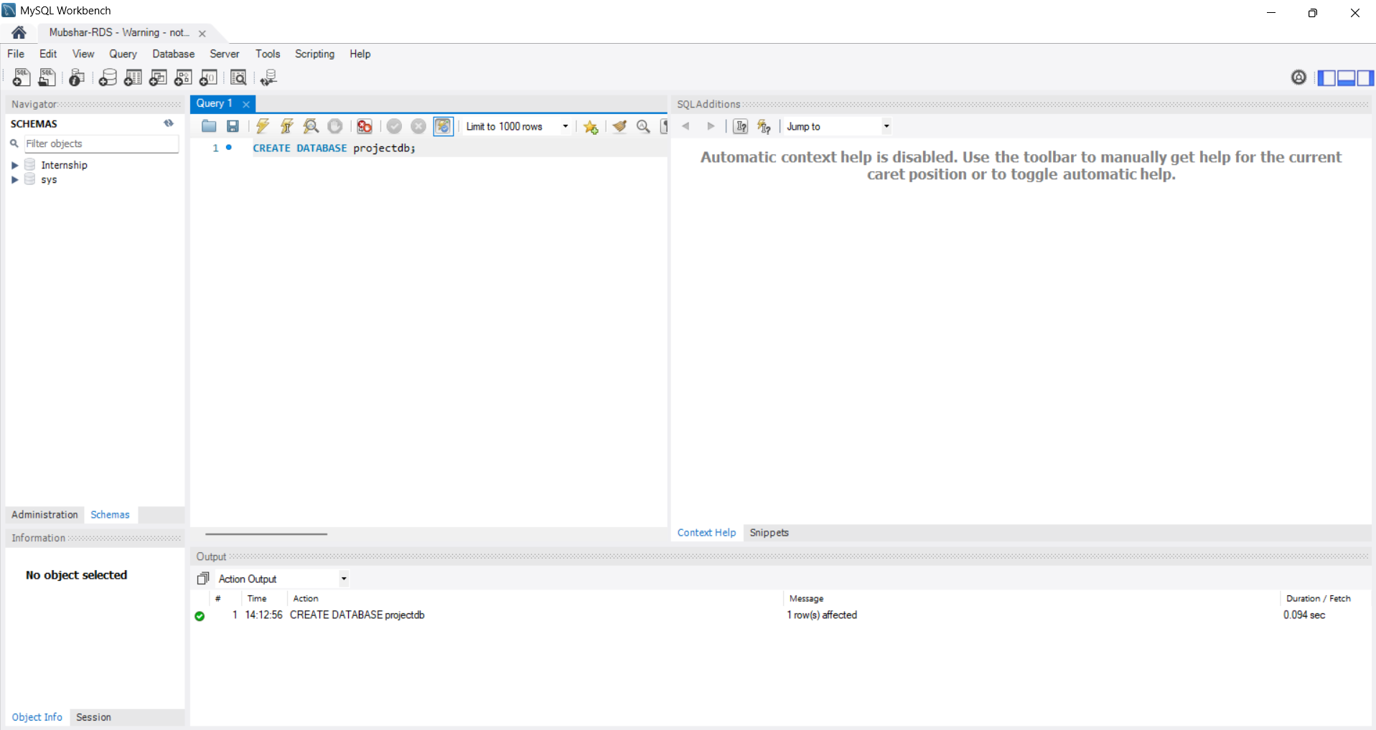

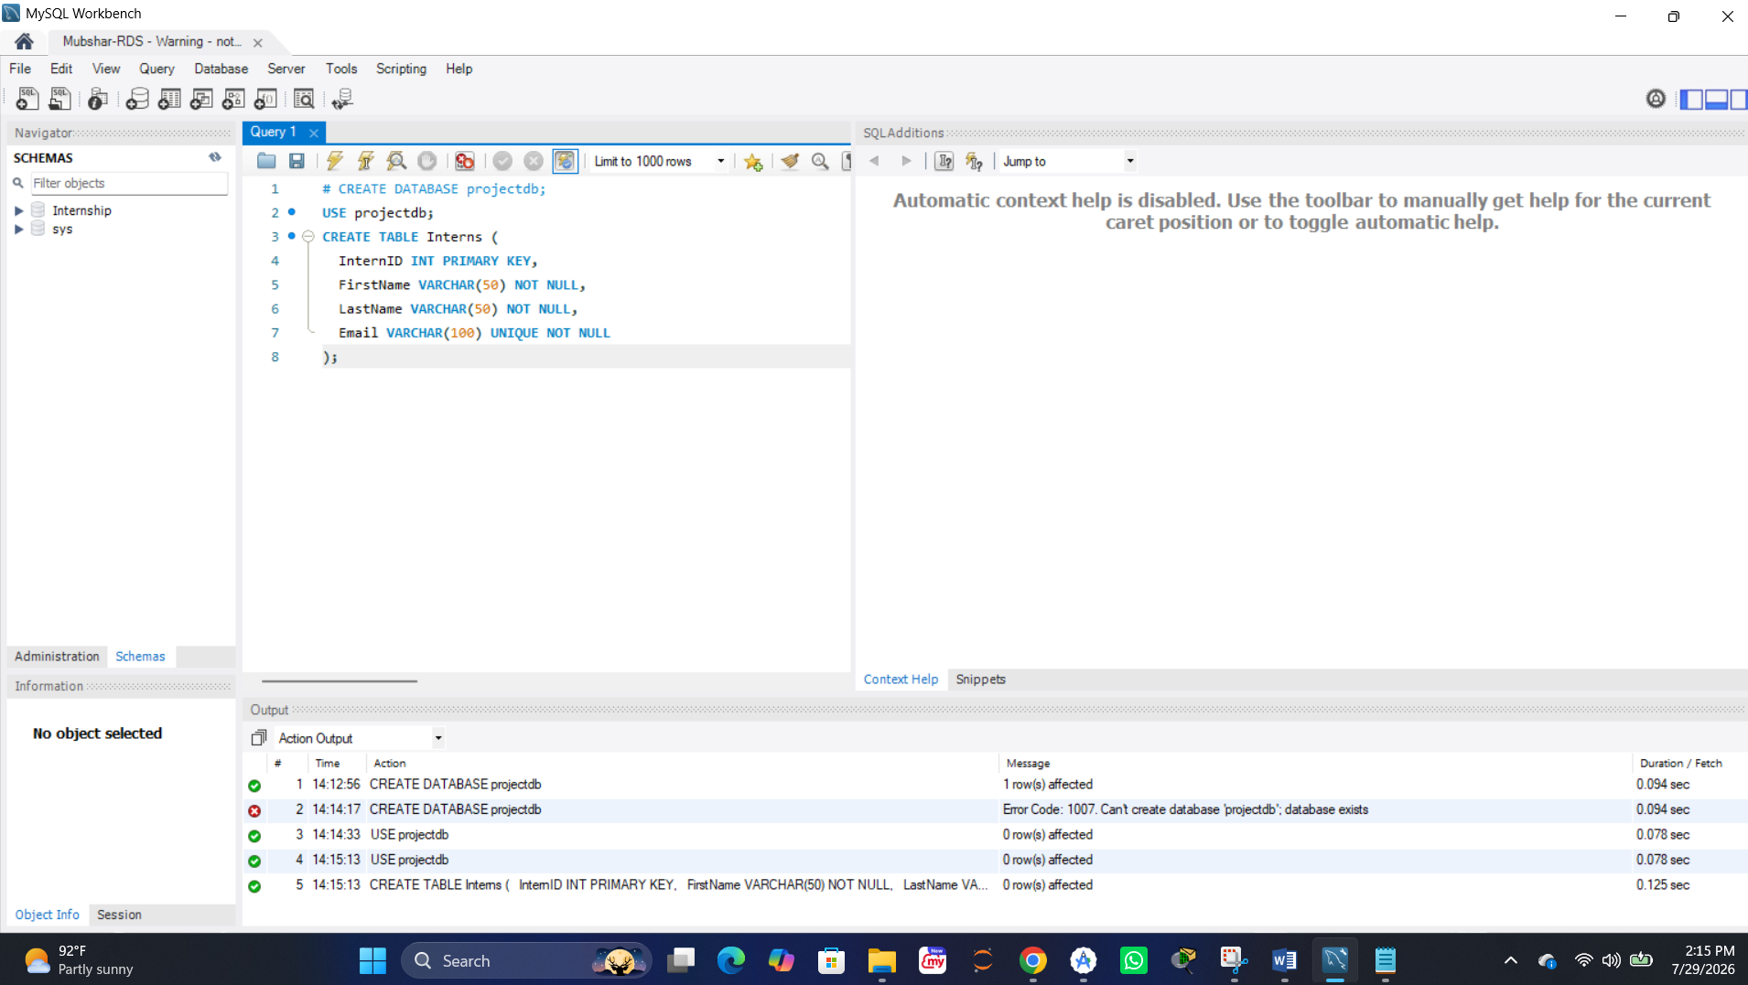

1.5 — Inserting Dummy Records
Sample records were inserted using SQL's Data Manipulation Language (DML) via the INSERT INTO statement. Multiple rows were added in a single batch statement, and a name containing an apostrophe (O'Leary) was correctly escaped using a doubled single quote.
INSERT INTO Interns (InternID, FirstName, LastName, Email)
VALUES
(1, 'John', 'Doe', 'jdoe@decodelabs.com'),
(2, 'Jane', 'Smith', 'jsmith@decodelabs.com'),
(3, 'Conan', 'O''Leary', 'coleary@decodelabs.com');

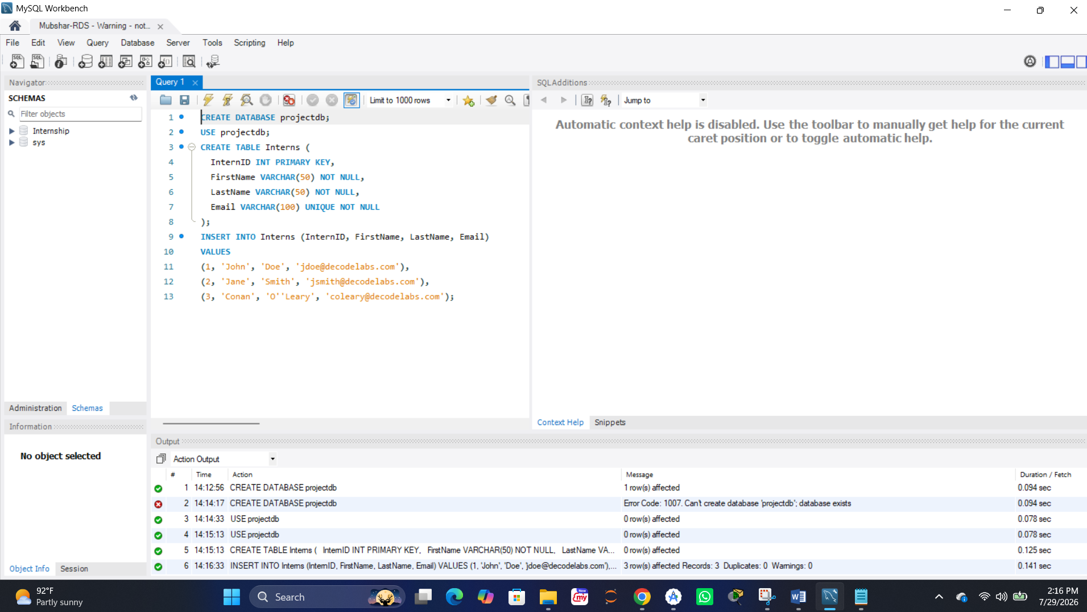

1.6 — Connecting via SSH Tunnel (Bastion Host)
Since the RDS instance sits in a private subnet, a direct local connection is refused. An EC2 instance acting as a bastion host was used to tunnel the connection: the local SQL client connects over SSH to the bastion's public IP, which then forwards the traffic internally to the private RDS endpoint on port 3306.
Connection Method : Standard TCP/IP over SSH
SSH Hostname : <Bastion EC2 Public IP>
SSH Username : ec2-user
SSH Key File : ~/keys/bastion-key.pem
MySQL Hostname : <RDS Endpoint>.rds.amazonaws.com
Port : 3306
Username : admin

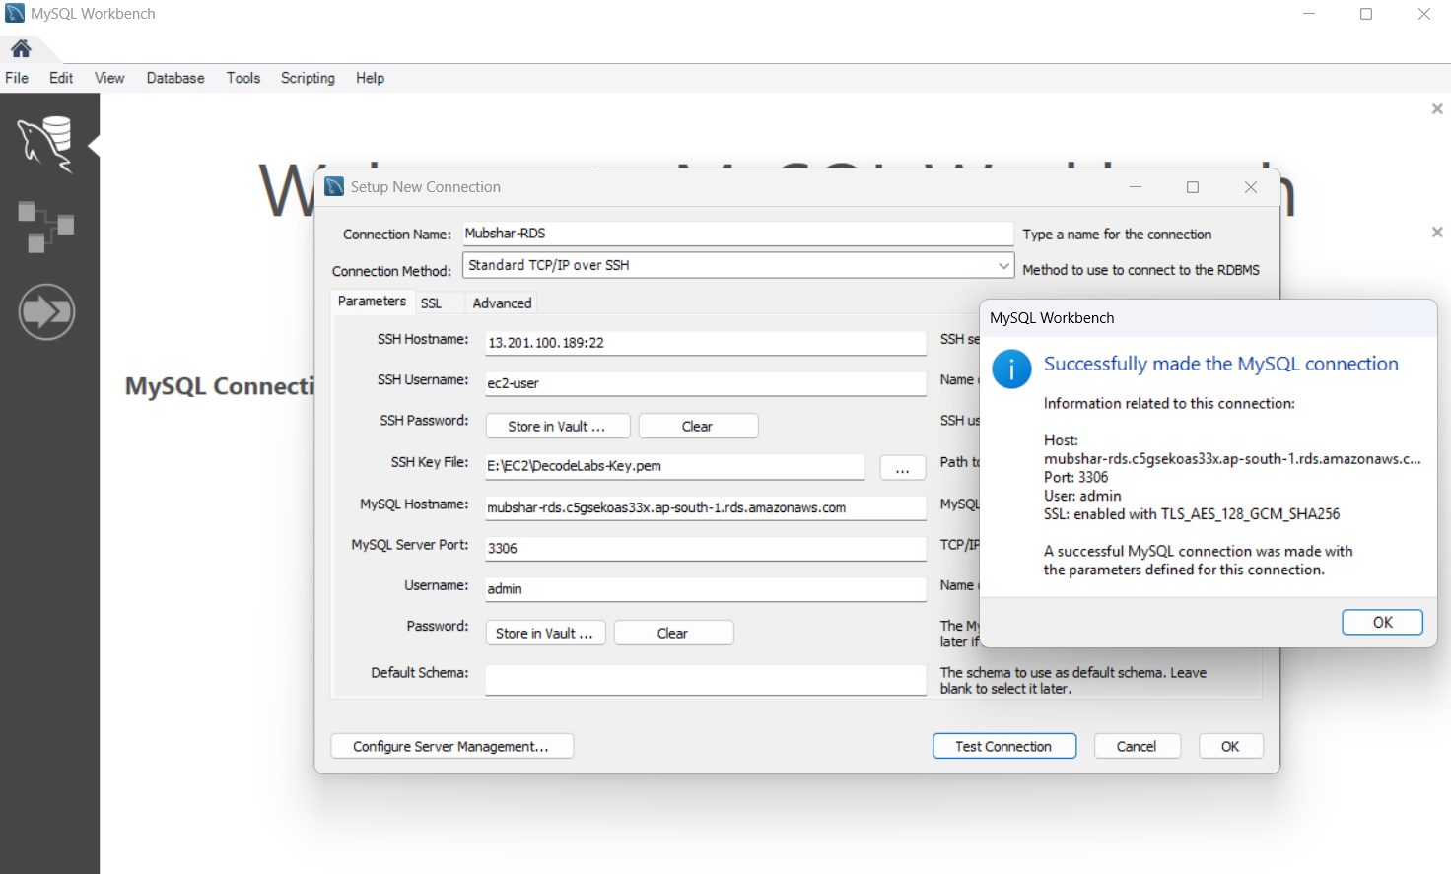

1.7 — Verifying Data Persistence
A SELECT query was run against the Interns table through the tunneled connection. The inserted records being returned successfully confirmed that the RDS instance is live, the network tunnel works, the schema constraints are valid, and the data is permanently stored on disk.
SELECT * FROM Interns;

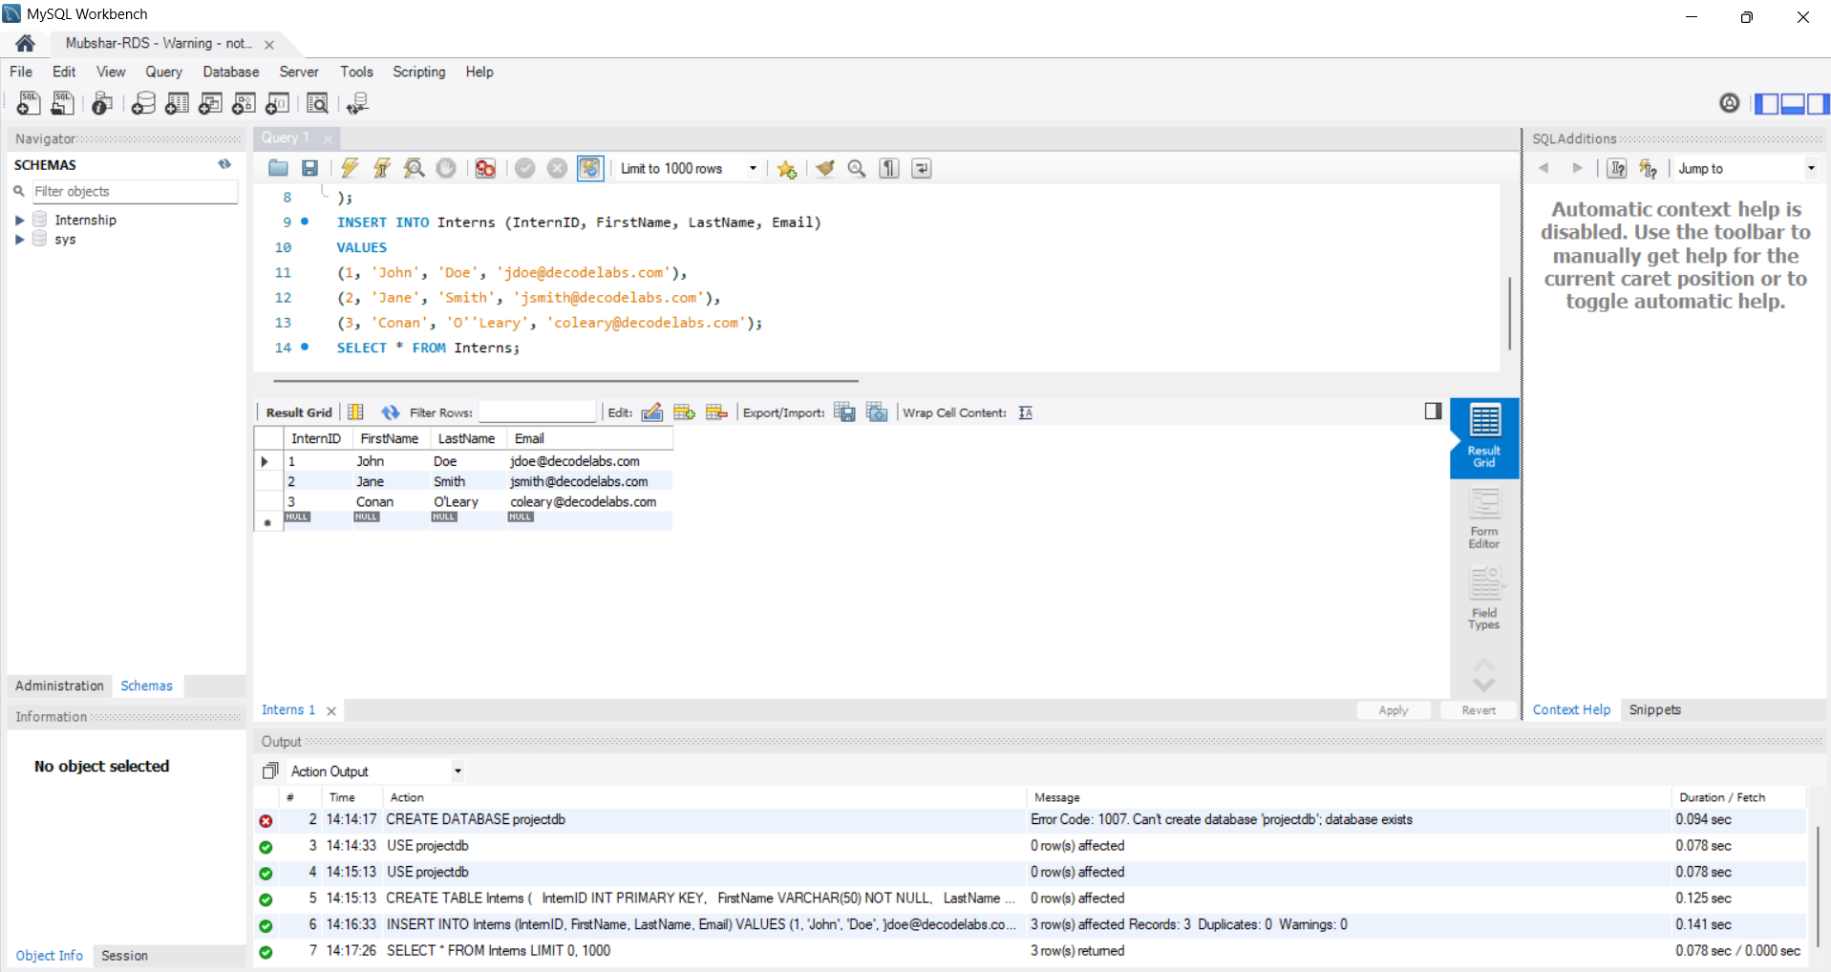

Part 2 — Understanding the Architecture
Knowing why RDS was chosen over alternatives, and why each isolation layer exists, is what separates following steps from actually understanding cloud database design.

2.1 — RDS vs DynamoDB
Amazon RDS is relational: rigid tables with rows and columns, ACID transactions, and support for complex joins — ideal for structured data like the Interns table where relationships and uniqueness matter. Amazon DynamoDB is a serverless NoSQL option built for flexible JSON documents and horizontal auto-scaling, better suited to high-velocity, unpredictable traffic. For this mission's structured, relationship-driven data, RDS was the correct choice.

2.2 — Why Private Subnets Matter
Placing RDS inside a private subnet with no direct route to an Internet Gateway means the database endpoint only resolves to a private IP address. Combined with disabling public accessibility, this ensures the database can only ever be reached from within the AWS network — never directly from the public internet.

2.3 — Schema Constraints as Data Integrity
PRIMARY KEY guarantees each row is uniquely identifiable and enables automatic indexing. UNIQUE ensures no two interns can register with the same email. NOT NULL prevents empty, meaningless entries in required fields. These constraints enforce data quality at the structural level, before an application even has a chance to introduce bad data.

Part 3 — Cost Control (Critical)
Like EC2, an RDS instance bills continuously while it exists — even an idle db.t3.micro accrues charges once the Free Tier allowance is exhausted. Managed databases can be easy to forget about since there's no visible 'website' reminding you it's running.
⚠ Note: RDS Free Tier covers 750 hours/month of a db.t3.micro (or db.t4g.micro) instance for the first 12 months, plus 20 GB of storage. Beyond that, or after 12 months, charges apply per hour the instance exists — whether or not it's actively queried. An idle forgotten RDS instance is a common, quiet source of surprise AWS bills.

3.1 — Stopping the RDS Instance When Not in Use
When the database isn't actively needed, it was stopped from the RDS console (Actions → Stop temporarily). Note that AWS automatically restarts a stopped RDS instance after 7 days if left stopped, so this is only a short-term pause, not a permanent cost-saving measure.
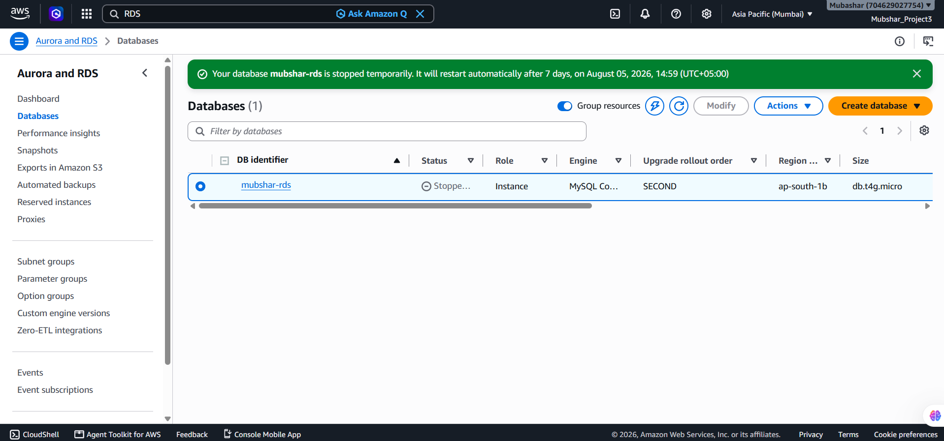

3.2 — Deleting the Instance When Fully Done
Once the milestone was verified and no longer needed, the instance was deleted entirely (Actions → Delete), with a final snapshot skipped since this was a training exercise with only dummy data. Deletion is the only way to guarantee zero ongoing charges for that database.
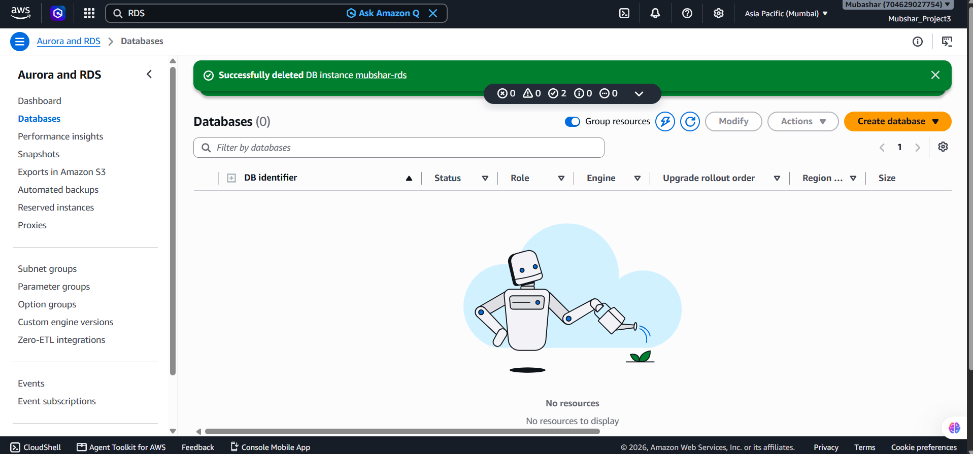

3.3 — Billing Alarm
As with Projects 1 and 2, an active CloudWatch billing alarm remains the safety net that catches a forgotten running RDS instance before it becomes a large, unexpected charge.
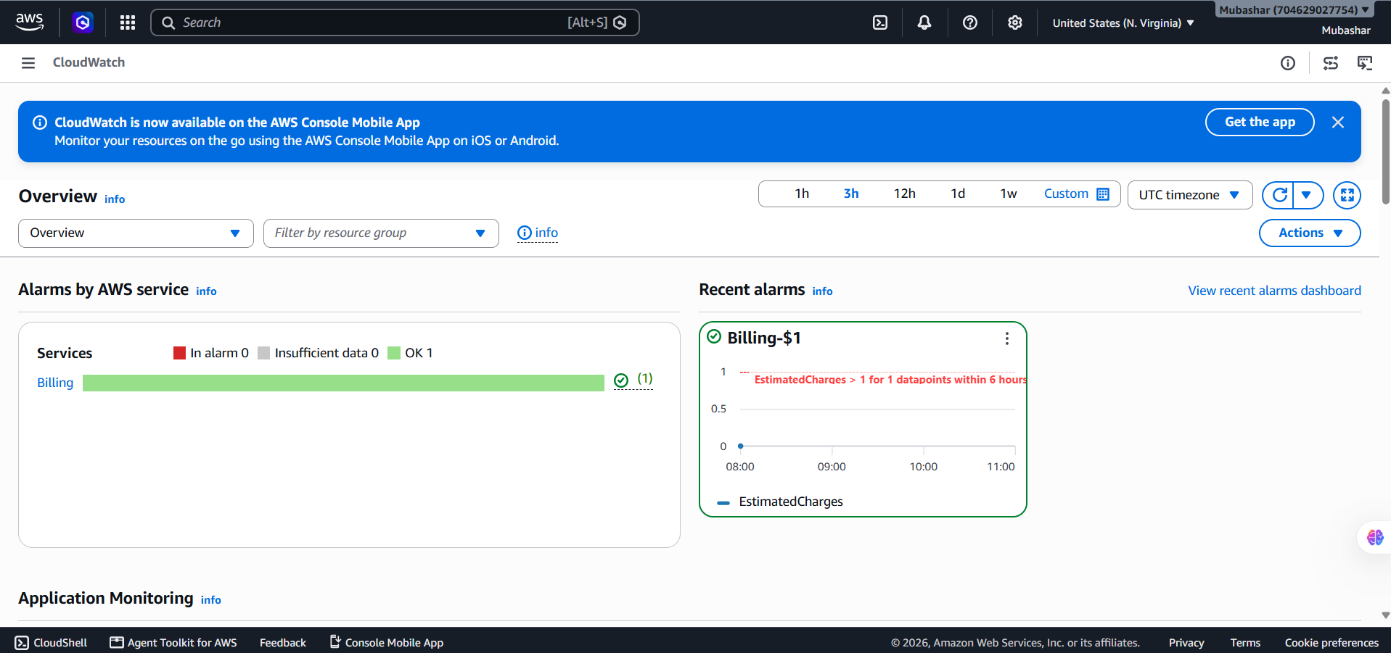

Part 4 — Security (Advanced)
A few additional hardening steps reflect how managed databases are secured in real production environments, beyond the minimum mission requirements.

4.1 — Restricting the Security Group to the Bastion Only
Rather than allowing port 3306 from a broad IP range, the security group's source was locked to the specific security group ID of the bastion EC2 host. This means only traffic actually originating from that one trusted instance can ever reach the database, regardless of where the bastion itself is accessed from.


4.2 — Using AWS Secrets Manager for Credentials
Instead of hardcoding the database username and password inside scripts or connection strings, AWS Secrets Manager can store and automatically rotate these credentials. Applications retrieve credentials at runtime via an API call rather than reading them from a plaintext file.
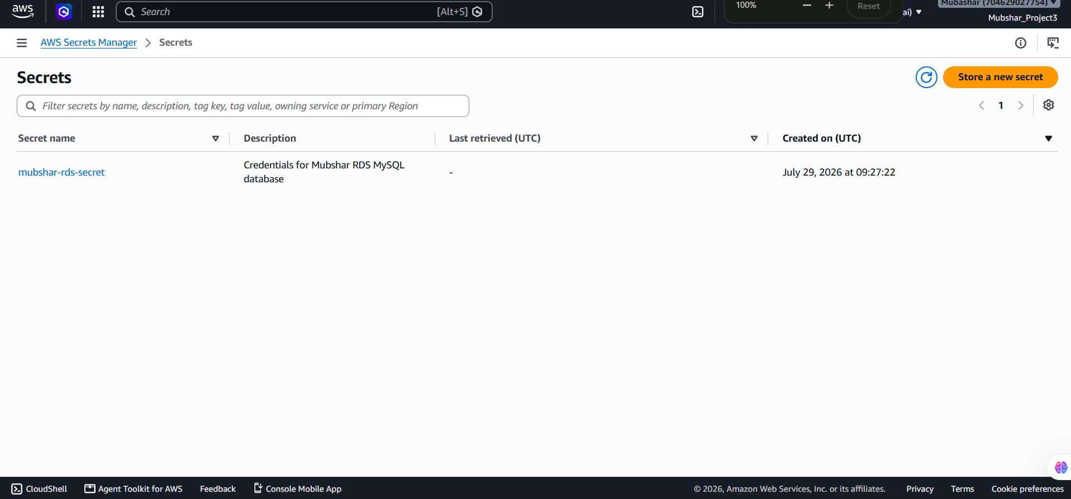

4.3 — Enabling Automated Backups
Automated backups were enabled on the RDS instance, allowing point-in-time recovery within the configured retention window. This protects against accidental data loss (e.g. a bad DELETE statement) without requiring manual snapshot management.
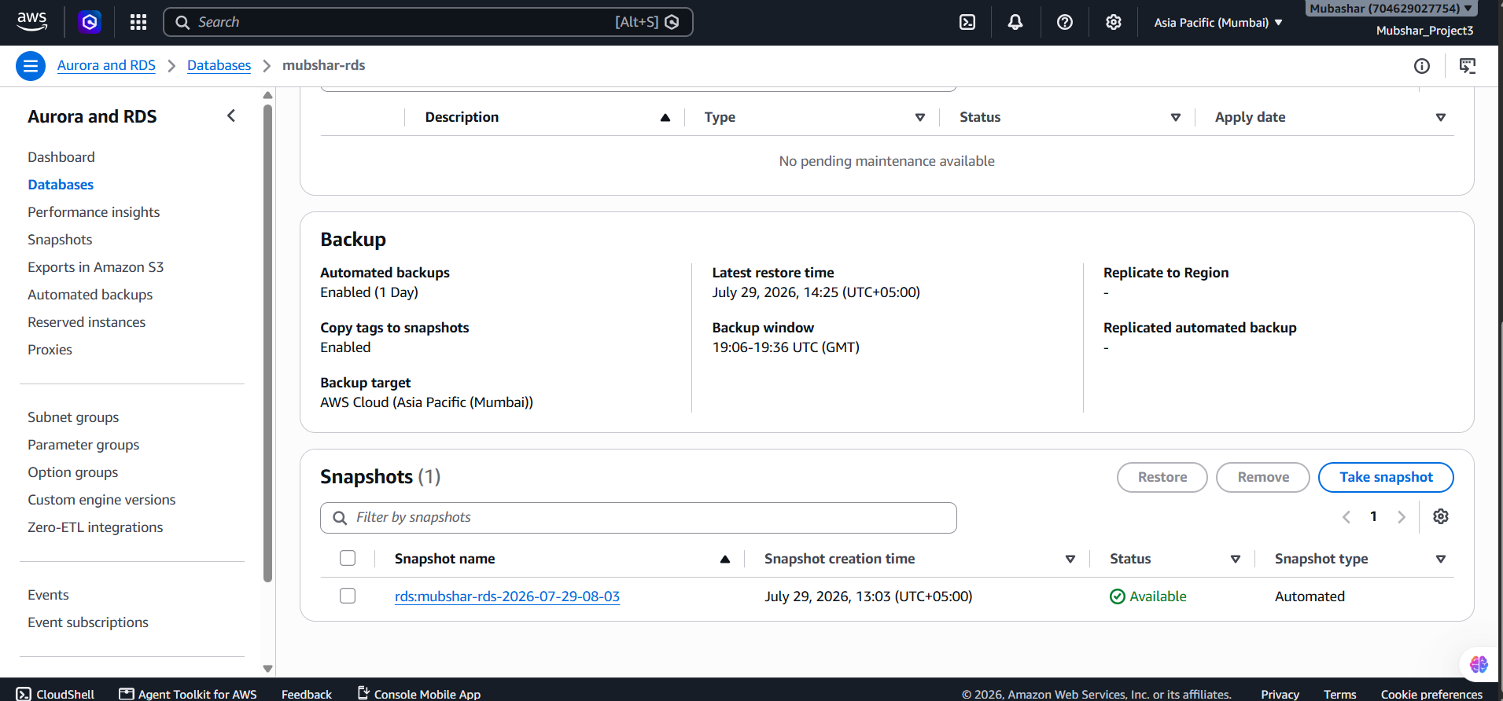

Part 5 — Automation (Advanced)
Manually opening a SQL client for every operation doesn't scale for real applications. These are optional ways to interact with the database programmatically.

5.1 — Managing Infrastructure with Boto3
The Boto3 Python SDK was used to interact with RDS at the infrastructure level — for example, listing instances or checking their status — without needing to open the AWS Console.
import boto3
rds = boto3.client('rds')
response = rds.describe_db_instances()

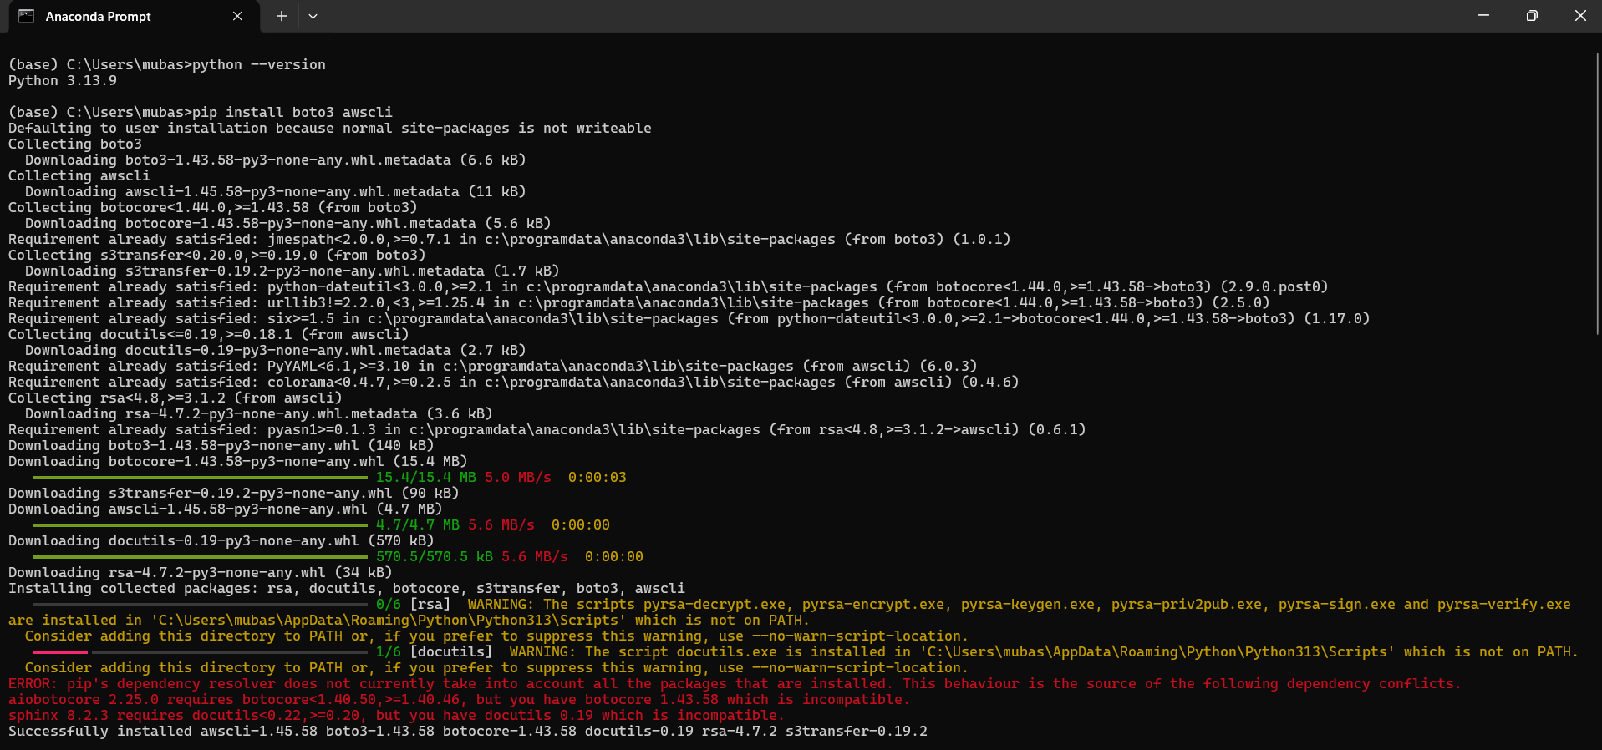
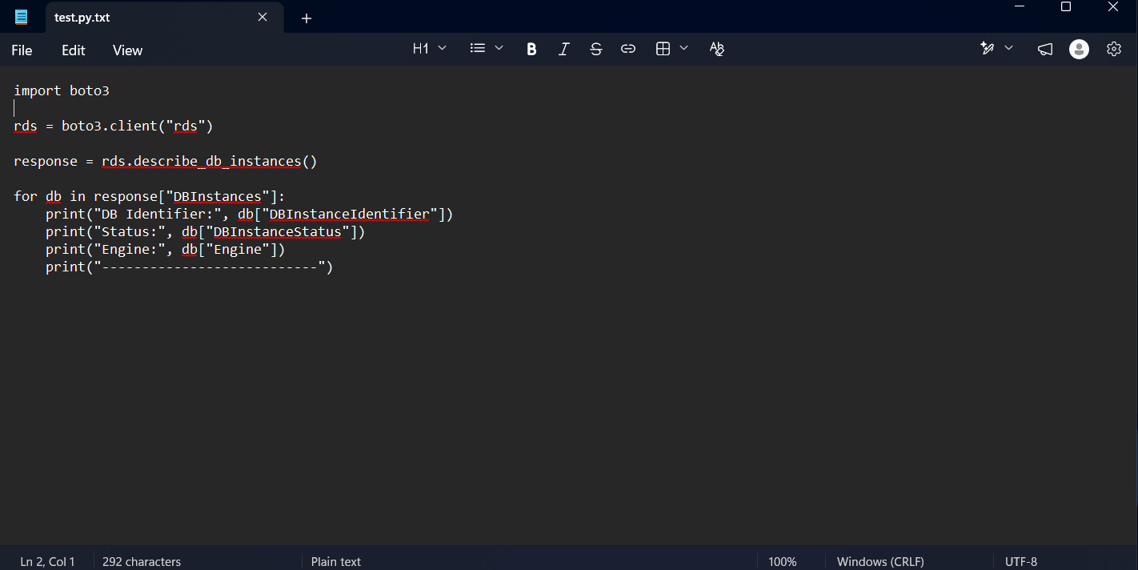

5.2 — Querying Data with PyMySQL
The PyMySQL library was used from a Python script to connect directly to the MySQL engine and execute INSERT/SELECT statements programmatically — the foundation for any application that needs to read or write data automatically rather than through manual SQL client sessions.
import pymysql
conn = pymysql.connect(
host='endpoint.rds.amazonaws.com',
user='admin',
password='password'
)

