CURRICULUM VITAE

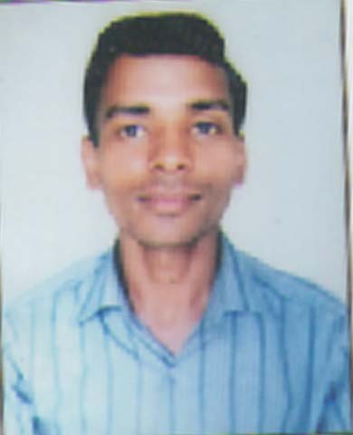
Dharmendra kumar

Mobile: +9759374370,9761615382
E-mail:- dkumar.1500@rediffmail.com,Shakya.939@gmail.com
OBJECTIVE
- Looking for a career in your organization where there are high chances of growth that can provide satisfaction to my professional zeal and opportunity to learn through a Long-term relationship
EXPERIENCE
PWD Data Entry operator/typist Hindi/English .Hardworking/Software Networking
PROFESSIONAL QUALIFICATION
- B.A (M.J.P.RU BAREILLY)
- 12th from UTTAR PRADESH BOARD, in 2009.
- 10th from CENTRAL BOARD OF SECONDARY EDUCATION, in 2007.
TEACHING SKILLS
●1-year Diploma in Computer Application for L.B.I.of College puranpur pilibhit.
Work
P.W.D Budaun Computer Oppretar
Project
● Organization Visit: PARLE-G RUDRAPUR (UTTRANCHAL)
IGL- RUDRAPUR (UTTRANCHAL)
● Attend 3days National Seminar on Critical Issue on Corporate GoverenceA SYNTHESIS, APRIL9-11-2009.
●1 month traning in IWP(Indian wood product),BAREILLY.
● Participate in uninor marketing programme.
● Participate in Kcmt quiz competition.
PERSONAL DETAILS
- Father’s Name : Mr.Ram Bharose Lal

- Permanent Address : vill/po paliya Gujar Dataganj Budaun
- Sex : male

- Marital Status : Single

- Date of Birth : 07 jan 1990

- Hobbies : Making Friends & Internet surfing.

DECLARATION
I hereby declare that above furnished information is true to best of my knowledge.

Date Signature
Place: Dataganj Budaun (Dharmendra kumar )
UP-243635

