**LAB3 ANSWERS**

1. **SELECT studentName, age FROM lab3.student;**

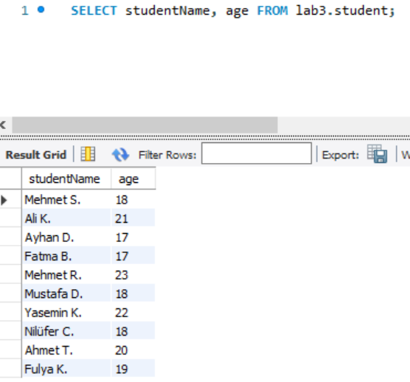

1. **SELECT studentName, studentID age FROM lab3.student WHERE gpa>3.0;**

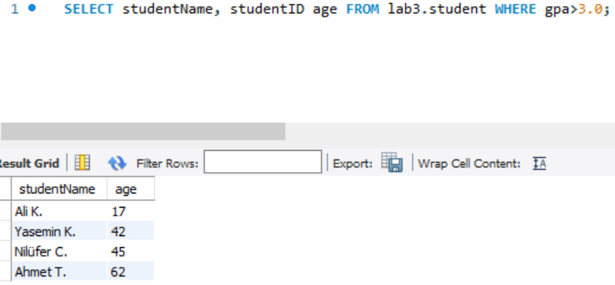

1. **SELECT avg(gpa) FROM lab3.student WHERE gpa>2.5;**

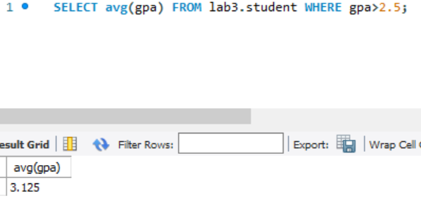

1. **SELECT max(age) FROM lab3.student;**

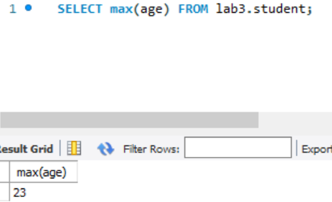

1. **SELECT avg(age), avg(gpa) FROM lab3.student;**

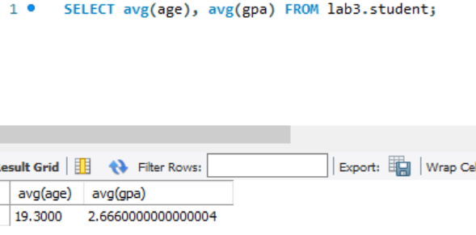

1. **SELECT avg(age) FROM lab3.student WHERE studentName LIKE 'M%';**

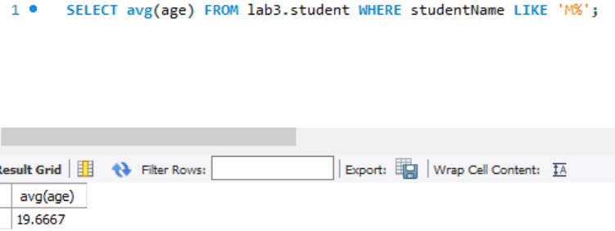

1. **SELECT * FROM lab3.student ORDER BY age desc;**

