**2058 LAB4 ANSWERS**

1. **SELECT team, avg(salary) FROM new_table group by team;**

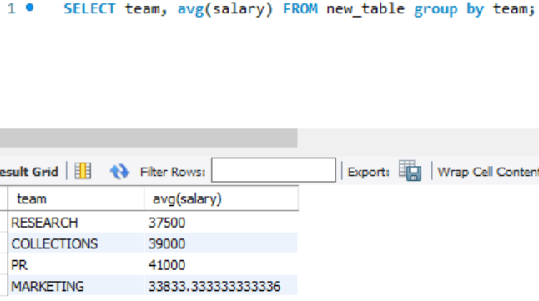

1. **SELECT team FROM new_table GROUP BY team HAVING avg(salary) < 39000;**

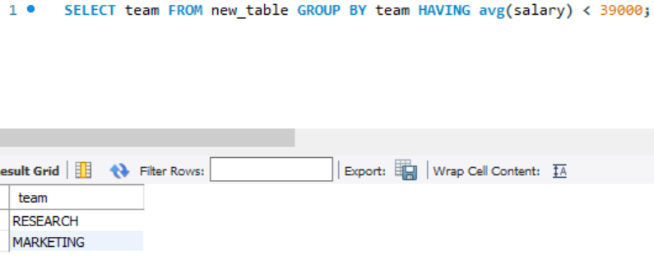

1. **SELECT name, salary FROM new_table WHERE SICKLEAVE < 25 ORDER BY name;**

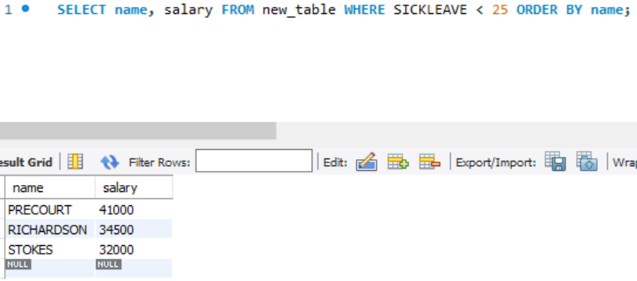

1. **SELECT team, count(*) FROM new_table WHERE SICKLEAVE < 30 GROUP BY team;**

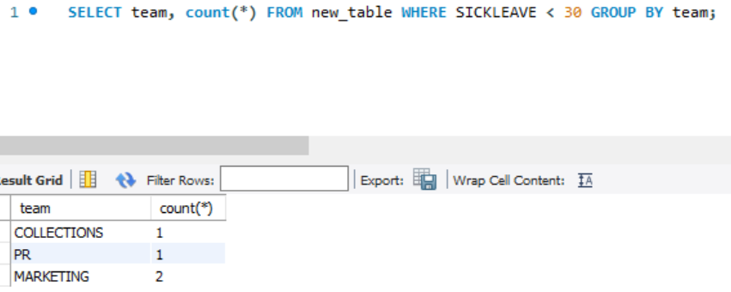

1. **SELECT name FROM new_table WHERE SICKLEAVE > ANNUALLEAVE;**

