**2058 LAB6 ANSWERS**

1. select sum(quantity*price) from part,orders

where part.partnum=orders.partnum;

|  |  |
| --- | --- |
| **sum(quantity*price)** | |
| **33868.3** |  |

2. select name, sum(quantity*price) from part,orders

where part.partnum=orders.partnum group by name;

|  |  |
| --- | --- |
| **name,sum(quantity*price)** | |
| **AAA BIKE,3533.5** |  |
| **BIKE SPEC,11576.1** |  |
| **JACKS BIKE,7420** |  |
| **LE SHOPPE,6250** |  |
| **TRUE WHEEL,5088.7** |  |

3. select description, sum(quantity) from part,orders

where part.partnum=orders.partnum group by description;

|  |  |  |
| --- | --- | --- |
| **description,sum(quantity)** | | |
| **MOUNTAIN BIKE,14** | |  |
| **PEDALS,10** | |  |
| **ROAD BIKE,37** | |  |
| **SEATS,8** |  |  |
| **TANDEM,7** | |  |
| **TIRES,14** |  |  |

4. select sum(quantity*price) from part,orders

where part.partnum=orders.partnum and description='mountain bike';

**sum(quantity*price)**

**4906.3**

5. select orders.name, address, quantity*price as total, description

from customer, orders, part

where orders.partnum=part.partnum and orders.name=customer.name;

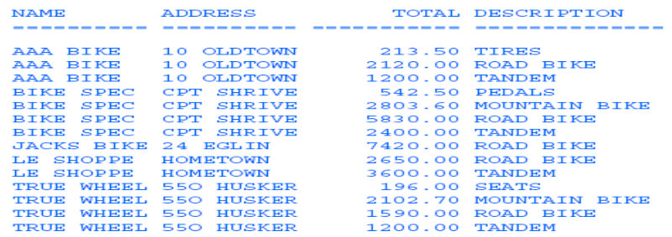

6.

