Linear Regression Application

CE 475

Samet ŞİMŞEK

Mücahit ZOR

2023-10-25

## Packages

Load necessary packages

suppressPackageStartupMessages({  
 library(tidyverse) # data wrangling  
 library(tidymodels)# modeling  
 library(hrbrthemes)# plot themes  
})  
theme_set(theme_ipsum_es(axis_title_size = 11 , axis_title_just = "c") + theme(axis.line = element_line(color ="black")))

# The data

penguins_rawdata <- palmerpenguins::penguins   
penguins_rawdata

# A tibble: 344 × 8  
 species island bill_length_mm bill_depth_mm flipper_length_mm body_mass_g  
 <fct> <fct> <dbl> <dbl> <int> <int>  
 1 Adelie Torgersen 39.1 18.7 181 3750  
 2 Adelie Torgersen 39.5 17.4 186 3800  
 3 Adelie Torgersen 40.3 18 195 3250  
 4 Adelie Torgersen NA NA NA NA  
 5 Adelie Torgersen 36.7 19.3 193 3450  
 6 Adelie Torgersen 39.3 20.6 190 3650  
 7 Adelie Torgersen 38.9 17.8 181 3625  
 8 Adelie Torgersen 39.2 19.6 195 4675  
 9 Adelie Torgersen 34.1 18.1 193 3475  
10 Adelie Torgersen 42 20.2 190 4250  
# ℹ 334 more rows  
# ℹ 2 more variables: sex <fct>, year <int>

The data contains size measurements for three penguin species that lives on three islands.

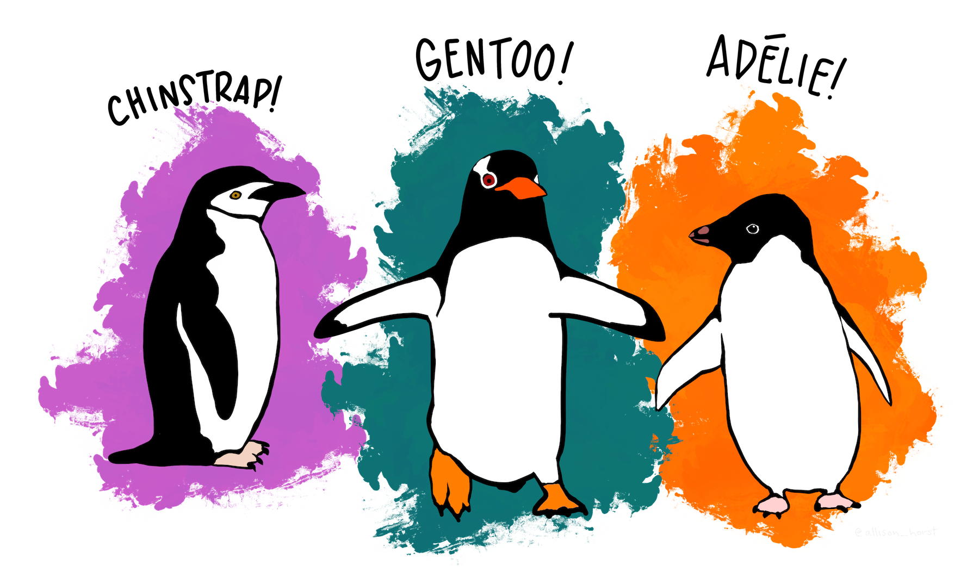

The distribution of the penguins is as follows:

penguins_rawdata %>%   
 na.omit() %>%   
 count(species, island)

# A tibble: 5 × 3  
 species island n  
 <fct> <fct> <int>  
1 Adelie Biscoe 44  
2 Adelie Dream 55  
3 Adelie Torgersen 47  
4 Chinstrap Dream 68  
5 Gentoo Biscoe 119

Since Adelie is the only one that lives on 3 of the islands we hesitate to use island variable in our model, but we can’t be sure. We’ll do a further analysis about this.

### Data Cleaning

* removing NA values
* transforming body_mass_g to body_mass_kg
* assigning results to a new data frame

penguins_rawdata %>%   
 na.omit() %>%   
 mutate(body_mass_kg = body_mass_g / 1000) %>%  
 select(-body_mass_g) -> penguins  
penguins

# A tibble: 333 × 8  
 species island bill_length_mm bill_depth_mm flipper_length_mm sex year  
 <fct> <fct> <dbl> <dbl> <int> <fct> <int>  
 1 Adelie Torgersen 39.1 18.7 181 male 2007  
 2 Adelie Torgersen 39.5 17.4 186 female 2007  
 3 Adelie Torgersen 40.3 18 195 female 2007  
 4 Adelie Torgersen 36.7 19.3 193 female 2007  
 5 Adelie Torgersen 39.3 20.6 190 male 2007  
 6 Adelie Torgersen 38.9 17.8 181 female 2007  
 7 Adelie Torgersen 39.2 19.6 195 male 2007  
 8 Adelie Torgersen 41.1 17.6 182 female 2007  
 9 Adelie Torgersen 38.6 21.2 191 male 2007  
10 Adelie Torgersen 34.6 21.1 198 male 2007  
# ℹ 323 more rows  
# ℹ 1 more variable: body_mass_kg <dbl>

### Split the Data

set.seed(25112023)  
penguins_split <- penguins %>% initial_split()   
penguins_split

<Training/Testing/Total>  
<249/84/333>

Extract the training and test data;

penguins_training <- training(penguins_split)  
penguins_training

# A tibble: 249 × 8  
 species island bill_length_mm bill_depth_mm flipper_length_mm sex year  
 <fct> <fct> <dbl> <dbl> <int> <fct> <int>  
 1 Adelie Biscoe 41.1 18.2 192 male 2008  
 2 Adelie Torgers… 34.6 21.1 198 male 2007  
 3 Gentoo Biscoe 53.4 15.8 219 male 2009  
 4 Adelie Biscoe 42.7 18.3 196 male 2009  
 5 Chinstrap Dream 49.8 17.3 198 fema… 2009  
 6 Gentoo Biscoe 45.5 14.5 212 fema… 2009  
 7 Adelie Dream 39 18.7 185 male 2009  
 8 Gentoo Biscoe 43.6 13.9 217 fema… 2008  
 9 Adelie Dream 36 17.8 195 fema… 2009  
10 Adelie Torgers… 35.5 17.5 190 fema… 2008  
# ℹ 239 more rows  
# ℹ 1 more variable: body_mass_kg <dbl>

penguins_testing <- testing(penguins_split)  
penguins_testing

# A tibble: 84 × 8  
 species island bill_length_mm bill_depth_mm flipper_length_mm sex year  
 <fct> <fct> <dbl> <dbl> <int> <fct> <int>  
 1 Adelie Torgersen 40.3 18 195 female 2007  
 2 Adelie Torgersen 39.3 20.6 190 male 2007  
 3 Adelie Torgersen 42.5 20.7 197 male 2007  
 4 Adelie Torgersen 34.4 18.4 184 female 2007  
 5 Adelie Biscoe 40.5 17.9 187 female 2007  
 6 Adelie Dream 40.9 18.9 184 male 2007  
 7 Adelie Dream 38.8 20 190 male 2007  
 8 Adelie Dream 36.5 18 182 female 2007  
 9 Adelie Dream 36 18.5 186 female 2007  
10 Adelie Dream 39.6 18.8 190 male 2007  
# ℹ 74 more rows  
# ℹ 1 more variable: body_mass_kg <dbl>

# Our model

Our aim is to predict the body mass values of penguins. First we check out the correlation between numeric variables.

penguins_training %>% select(where(is.numeric)) %>% cor()

bill_length_mm bill_depth_mm flipper_length_mm year  
bill_length_mm 1.0000000 -0.16867443 0.6355054 0.02054490  
bill_depth_mm -0.1686744 1.00000000 -0.5556389 -0.05960619  
flipper_length_mm 0.6355054 -0.55563894 1.0000000 0.17326138  
year 0.0205449 -0.05960619 0.1732614 1.00000000  
body_mass_kg 0.5750427 -0.43001181 0.8605754 0.02176427  
 body_mass_kg  
bill_length_mm 0.57504266  
bill_depth_mm -0.43001181  
flipper_length_mm 0.86057543  
year 0.02176427  
body_mass_kg 1.00000000

There seems like a correlation between body_mass_g and all the numeric variables expect year which we cannot consider a numeric variable.

We now need to decide which variables to use.

leaps::regsubsets(  
 body_mass_kg ~ ., data = penguins_training, nvmax = NULL, method = "exhaustive", force.in = NULL, force.out = "year"  
) -> best_subset  
best_subset

Subset selection object  
Call: regsubsets.formula(body_mass_kg ~ ., data = penguins_training,   
 nvmax = NULL, method = "exhaustive", force.in = NULL, force.out = "year")  
9 Variables (and intercept)  
 Forced in Forced out  
speciesAdelie FALSE FALSE  
speciesChinstrap FALSE FALSE  
islandDream FALSE FALSE  
islandTorgersen FALSE FALSE  
bill_length_mm FALSE FALSE  
bill_depth_mm FALSE FALSE  
flipper_length_mm FALSE FALSE  
sexmale FALSE FALSE  
year FALSE TRUE  
1 subsets of each size up to 9  
Selection Algorithm: exhaustive

best_subset %>%   
 summary() -> best_subset_summary  
best_subset_summary$adjr2

[1] 0.7395398 0.7927699 0.8346512 0.8561028 0.8647157 0.8679239 0.8675853  
[8] 0.8670709

best_subset_summary$adjr2 %>% which.max() -> best_mod_n  
best_mod_n

[1] 6

best_subset_summary$which[best_mod_n,]

(Intercept) speciesAdelie speciesChinstrap islandDream   
 TRUE TRUE TRUE FALSE   
 islandTorgersen bill_length_mm bill_depth_mm flipper_length_mm   
 FALSE TRUE TRUE TRUE   
 sexmale year   
 TRUE FALSE

Variable island is not on the best model so we are not going to include it to our model formula. Now we can define our *recipe* :

penguins_training %>%  
 recipe(body_mass_kg ~ flipper_length_mm + bill_length_mm + bill_depth_mm+ species + sex) %>%   
 step_dummy(species) %>%   
 step_dummy(sex) -> penguins_recipe  
penguins_recipe

── Recipe ──────────────────────────────────────────────────────────────────────

── Inputs

Number of variables by role

outcome: 1  
predictor: 5

── Operations

• Dummy variables from: species

• Dummy variables from: sex

Now we tell R that we are going to use linear model and do a regression. Define the Linear Model Specs

linear_reg() %>%   
 set_engine("lm") %>%   
 set_mode("regression") -> lm_spec  
lm_spec

Linear Regression Model Specification (regression)  
  
Computational engine: lm

Then we define our Workflow

workflow() %>%   
 add_model(lm_spec) %>%   
 add_recipe(penguins_recipe) -> penguins_workflow  
penguins_workflow

══ Workflow ════════════════════════════════════════════════════════════════════  
Preprocessor: Recipe  
Model: linear_reg()  
  
── Preprocessor ────────────────────────────────────────────────────────────────  
2 Recipe Steps  
  
• step_dummy()  
• step_dummy()  
  
── Model ───────────────────────────────────────────────────────────────────────  
Linear Regression Model Specification (regression)  
  
Computational engine: lm

# Fit the Model

Now we fit our model to the training data.

penguins_workflow %>%   
 fit(data = penguins_training)

══ Workflow [trained] ══════════════════════════════════════════════════════════  
Preprocessor: Recipe  
Model: linear_reg()  
  
── Preprocessor ────────────────────────────────────────────────────────────────  
2 Recipe Steps  
  
• step_dummy()  
• step_dummy()  
  
── Model ───────────────────────────────────────────────────────────────────────  
  
Call:  
stats::lm(formula = ..y ~ ., data = data)  
  
Coefficients:  
 (Intercept) flipper_length_mm bill_length_mm bill_depth_mm   
 -0.48514 0.01476 0.02097 0.07828   
 species_Adelie species_Chinstrap sex_male   
 -1.02378 -1.30278 0.36468

We now have the coefficients of each variable. To get more information we can summarise the model:

penguins_workflow %>%   
 fit(data = penguins_training) %>%   
 extract_fit_engine() %>%   
 summary()

Call:  
stats::lm(formula = ..y ~ ., data = data)  
  
Residuals:  
 Min 1Q Median 3Q Max   
-0.66547 -0.17076 -0.01046 0.17987 0.93694   
  
Coefficients:  
 Estimate Std. Error t value Pr(>|t|)   
(Intercept) -0.485144 0.696529 -0.697 0.486773   
flipper_length_mm 0.014759 0.003261 4.525 9.45e-06 ***  
bill_length_mm 0.020973 0.007983 2.627 0.009157 **   
bill_depth_mm 0.078276 0.021951 3.566 0.000437 ***  
species_Adelie -1.023783 0.148582 -6.890 4.79e-11 ***  
species_Chinstrap -1.302781 0.123746 -10.528 < 2e-16 ***  
sex_male 0.364682 0.054548 6.686 1.58e-10 ***  
---  
Signif. codes: 0 '***' 0.001 '**' 0.01 '*' 0.05 '.' 0.1 ' ' 1  
  
Residual standard error: 0.2849 on 242 degrees of freedom  
Multiple R-squared: 0.8711, Adjusted R-squared: 0.8679   
F-statistic: 272.6 on 6 and 242 DF, p-value: < 2.2e-16

To see the root mean squared error we use rmse function

penguins_workflow %>%   
 fit(data = penguins_training) %>%   
 augment(new_data = penguins_training) %>%   
 rmse(truth = body_mass_kg, estimate = .pred)

# A tibble: 1 × 3  
 .metric .estimator .estimate  
 <chr> <chr> <dbl>  
1 rmse standard 0.281

To see the actual values of dependent varaible and our estimation together we use augment function and select the two

penguins_workflow %>%   
 fit(data = penguins_training) %>%   
 extract_fit_engine() %>%   
 augment(data = penguins_training) %>%   
 select(body_mass_kg, .fitted)

# A tibble: 249 × 2  
 body_mass_kg .fitted  
 <dbl> <dbl>  
 1 4.05 3.98  
 2 4.4 4.16  
 3 5.5 5.47  
 4 4.08 4.08  
 5 3.68 3.53  
 6 4.75 4.73  
 7 3.65 3.87  
 8 4.9 4.72  
 9 3.45 3.52  
10 3.7 3.41  
# ℹ 239 more rows

penguins_workflow %>%   
 fit(data = penguins_training) %>%   
 extract_fit_engine() %>%   
 augment( data = penguins_training) %>%   
 ggplot() + aes(x = .fitted, y = body_mass_kg) +geom_point() +   
 geom_smooth(method = "lm", color = "red") + facet_wrap(sex~species, scales = "fixed") + geom_abline(slope =1, intercept = 0)

`geom_smooth()` using formula = 'y ~ x'

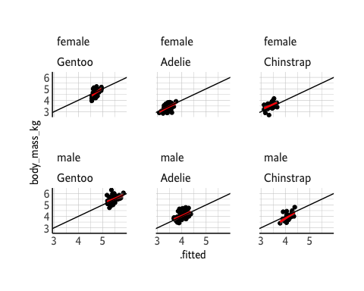

penguins_workflow %>%   
 fit(data = penguins_training) %>%   
 extract_fit_engine() %>%   
 augment( data = penguins_training) %>%   
 ggplot() + aes(x = .fitted, y = body_mass_kg) +#geom_point() +   
 geom_smooth(method = "lm", color = "red") + facet_wrap(sex~species, scales = "fixed") + geom_abline(slope =1, intercept = 0)

`geom_smooth()` using formula = 'y ~ x'

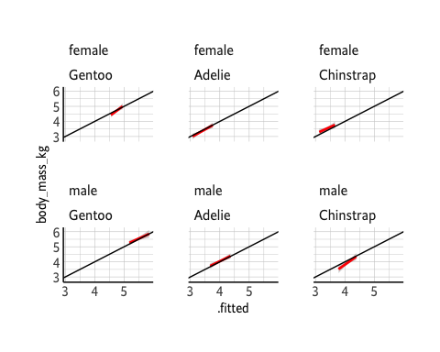

# accuracy in testing data

Now we get the rmse and rsq of testing data fit

penguins_workflow %>%   
 last_fit(penguins_split) %>%   
 collect_metrics()

# A tibble: 2 × 4  
 .metric .estimator .estimate .config   
 <chr> <chr> <dbl> <chr>   
1 rmse standard 0.298 Preprocessor1_Model1  
2 rsq standard 0.886 Preprocessor1_Model1

We see that they are very close to training data, which is what we were looking for.

We can get the predictions on test data set:

penguins_workflow %>%   
 last_fit(penguins_split) %>%   
 collect_predictions()

# A tibble: 84 × 5  
 id .pred .row body_mass_kg .config   
 <chr> <dbl> <int> <dbl> <chr>   
 1 train/test split 3.62 3 3.25 Preprocessor1_Model1  
 2 train/test split 4.10 5 3.65 Preprocessor1_Model1  
 3 train/test split 4.28 13 4.5 Preprocessor1_Model1  
 4 train/test split 3.37 14 3.32 Preprocessor1_Model1  
 5 train/test split 3.50 23 3.2 Preprocessor1_Model1  
 6 train/test split 3.91 29 3.9 Preprocessor1_Model1  
 7 train/test split 4.04 32 3.95 Preprocessor1_Model1  
 8 train/test split 3.35 36 3.15 Preprocessor1_Model1  
 9 train/test split 3.44 38 3.1 Preprocessor1_Model1  
10 train/test split 3.96 41 4.6 Preprocessor1_Model1  
# ℹ 74 more rows

Here is a plot to see how accurate our predictions look like

penguins_workflow %>%   
 last_fit(penguins_split) %>%   
 collect_predictions() %>%   
 ggplot() + aes(x = .pred, y = body_mass_kg) +geom_point() +   
 geom_smooth(method = "lm", color = "red") + geom_abline(slope =1, intercept = 0)

`geom_smooth()` using formula = 'y ~ x'

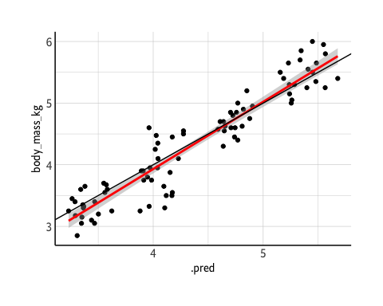

Here is the breakdown of predictions on sex and gender. Seems like we did a good job overall!

penguins_workflow %>%   
 last_fit(penguins_split) %>%   
 collect_predictions() %>%   
 bind_cols(sex = penguins_testing$sex, species = penguins_testing$species) %>%   
 ggplot() + aes(x = .pred, y = body_mass_kg) +#geom_point() +   
 geom_smooth(method = "lm", color = "red") + facet_wrap(sex~species, scales = "fixed") + geom_abline(slope =1, intercept = 0)

`geom_smooth()` using formula = 'y ~ x'

