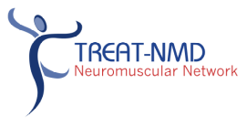


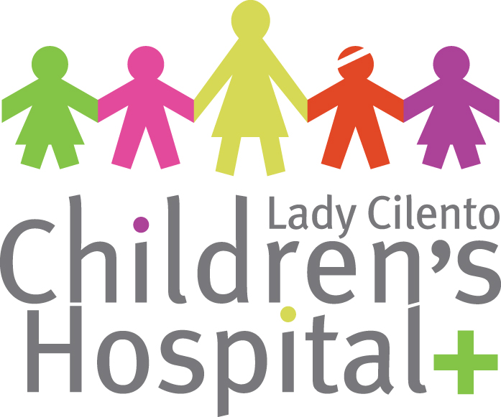
Children, Youth and Women’s Health Service
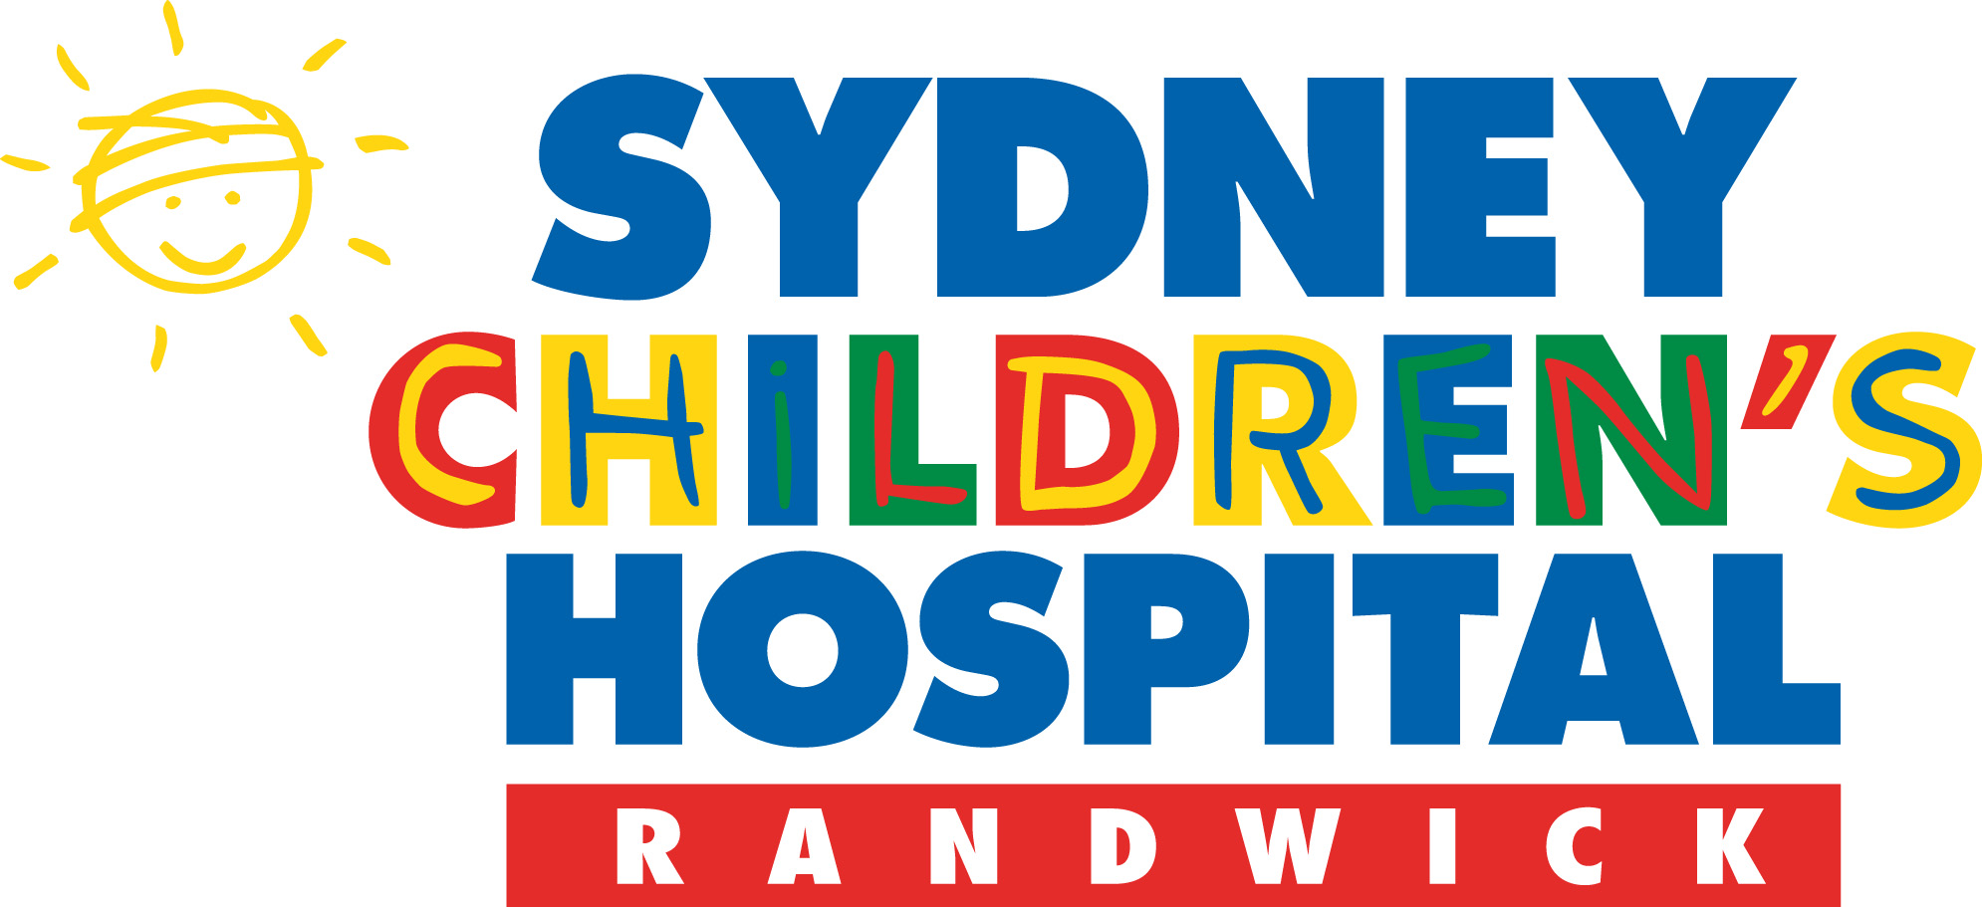
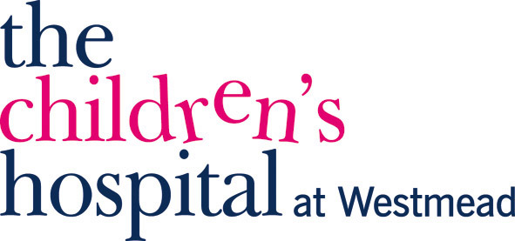

Australian National Neuromuscular Disorders (NMD) Registry

Clinician and HREC Contact Details

If you would like any additional information or need to tell us about any change in your data, or if you wish to withdraw your data from the registry, please contact the person listed from the hospital you attend for the specific registry in which you are participating.

Duchenne muscular dystrophy
State | Hospital
NSW | The Children’s Hospital at Westmead | Dr Kristi Jones  Institute for Neuroscience & Muscle Research  Ph: (02) 9845 3273  Email: kristi.jones@health.nsw.gov.au  Clinical Trials Coordinator  Institute for Neuroscience & Muscle Research  Ph: (02) 9845 1328  Email: schn-inmrcrt@health.nsw.gov.au
 | The Sydney Children’s Hospital | Dr Michelle Farrar  Neurology Department  Ph: (02) 9382 1549  Email: michelle.farrar@sesiahs.health.nsw.gov.au  Sandra Holland  Neuromuscular CNC  Level 1, Sydney Children’s Hospital  High Street, Randwick, 2031, NSW
If you registered through The Children’s Hospital at Westmead or The Sydney Children’s Hospital, have any concerns regarding this project and would like to speak to someone independent please contact the Secretary, SWAHS Human Research Ethics Committee (Westmead Campus) on telephone: (02) 9845 8183 or email: researchoffice@swahs.health.nsw.gov.au.

Qld | Lady Cilento Children’s Hospital | Dr Anita Cairns  Neurosciences Department  Ph: (07) 3068 2880  Email: anita.cairns@health.qld.gov.au
If you registered through Lady Cilento Children’s Hospital, have any concerns regarding this project and would like to speak to someone independent please contact the Research Ethics Coordinator on telephone: (07) 3636 9167 or email: CHQEthics@health.qld.gov.au.

SA | Women’s and Children’s Hospital | Dr Sui Yu  Department of Genetic Medicine  Ph: (08) 8161 7139  Email: sui.yu@health.sa.gov.au
If you registered through the Children’s, Youth and Women’s Health Service, have any concerns regarding this project and would like to speak to someone independent please contact the Secretary of the CYWHS Human Research Ethics Committee, Ms Brenda Penny on telephone: (08) 8161 6521.

Vic | The Royal Children’s Hospital Melbourne | Dr Monique Ryan  Children’s Neurosciences Centre  Ph: (03) 9345 5661  Email: Monique.ryan@rch.org.au
If you registered through The Royal Children’s Hospital in Melbourne, have any concerns regarding this project and would like to speak to someone independent please contact the Director, Ethics & Research, The Royal Children’s Hospital on telephone: (03) 9345 5044.

WA | Princess Margaret Hospital for Children | Dr Peter Rowe  Department of Neurology  Ph: (08) 9340 8364  Email: Peter.Rowe@health.wa.gov.au
Dr Phillipa Lamont
Department of Neurology
Ph: (08) 9340 8364
Email: Phillipa.Lamont@health.wa.gov.au
If you registered through Princess Margaret Hospital, have any concerns regarding this project and would like to speak to someone independent please contact the Director of Medical Services at PMH on telephone (08) 9340 8222.

Spinal muscular atrophy
State | Hospital
NSW | The Children’s Hospital at Westmead | Dr Kristi Jones  Institute for Neuroscience & Muscle Research  Ph: (02) 9845 3273  Email: kristi.jones@health.nsw.gov.au  Clinical Trials Coordinator  Institute for Neuroscience & Muscle Research  Ph: (02) 9845 1328  Email: schn-inmrcrt@health.nsw.gov.au
 | The Sydney Children’s Hospital | Dr Michelle Farrar  Neurology Department  Ph: (02) 9382 1549  Email: michelle.farrar@sesiahs.health.nsw.gov.au  Sandra Holland  Neuromuscular CNC  Level 1, Sydney Children’s Hospital  High Street, Randwick, 2031, NSW
If you registered through The Children’s Hospital at Westmead or The Sydney Children’s Hospital, have any concerns regarding this project and would like to speak to someone independent please contact the Secretary, SWAHS Human Research Ethics Committee (Westmead Campus) on telephone: (02) 9845 8183 or email: researchoffice@swahs.health.nsw.gov.au.

Qld | Lady Cilento Children’s Hospital | Dr Anita Cairns  Neurosciences Department  Ph: (07) 3068 2880  Email: anita.cairns@health.qld.gov.au
If you registered through Lady Cilento Children’s Hospital, have any concerns regarding this project and would like to speak to someone independent please contact the Research Ethics Coordinator on telephone: (07) 3636 9167 or email: CHQEthics@health.qld.gov.au.

SA | Women’s and Children’s Hospital | Dr Sui Yu  Department of Genetic Medicine  Ph: (08) 8161 7139  Email: sui.yu@health.sa.gov.au
If you registered through the Children’s, Youth and Women’s Health Service, have any concerns regarding this project and would like to speak to someone independent please contact the Secretary of the CYWHS Human Research Ethics Committee, Ms Brenda Penny on telephone: (08) 8161 6521.

Vic | The Royal Children’s Hospital Melbourne | Dr Monique Ryan  Children’s Neurosciences Centre  Ph: (03) 9345 5661  Email: Monique.ryan@rch.org.au
If you registered through The Royal Children’s Hospital in Melbourne, have any concerns regarding this project and would like to speak to someone independent please contact the Director, Ethics & Research, The Royal Children’s Hospital on telephone: (03) 9345 5044.

WA | Princess Margaret Hospital for Children | Dr Peter Rowe  Department of Neurology  Ph: (08) 9340 8364  Email: Peter.Rowe@health.wa.gov.au
Dr Phillipa Lamont
Department of Neurology
Ph: (08) 9340 8364
Email: Phillipa.Lamont@health.wa.gov.au
If you registered through Princess Margaret Hospital, have any concerns regarding this project and would like to speak to someone independent please contact the Director of Medical Services at PMH on telephone (08) 9340 8222.

