







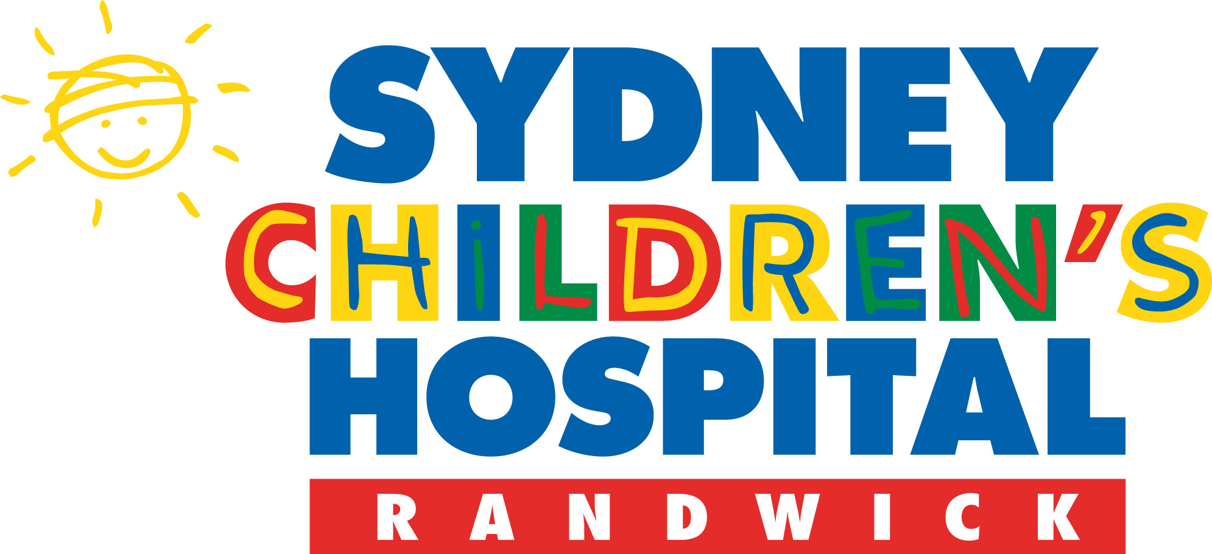

Children, Youth and Women’s Health Service

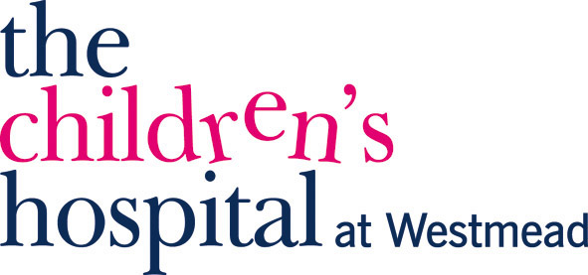

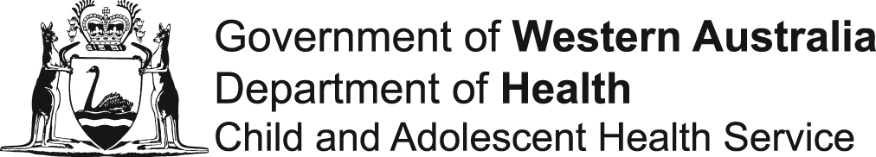

**Australian National Neuromuscular Disorders (NMD) Registry**

**Patient Information and Informed Consent**

**The Australian National NMD Registry is a member of the**

**TREAT-NMD global network of national patient registries.**

# INFORMATION FOR PATIENTS

# We invite you to register in the Australian National Neuromuscular Disorders (NMD) Registry. You can fill in and sign the consent form yourself provided you are 18 years of age or older. Before you do, it is important that you understand what is involved and what will be done with the information you provide. This form contains answers to some of the questions you might have. At the end of the form there is a section for you to sign to confirm that you agree to participate. If you have any questions after reading this form, please contact the relevant person in your state before signing the form. You will find a list of contact details at the end of this document. This project has been approved by the local Human Research Ethics Committee (For each site the HREC reference is provided at the end of the document)

# “What is a patient registry and why would you want to participate in one?”

Scientific advances over recent years have lead to substantial changes in the treatment of many conditions. For some potential new treatments plans for large studies involving patients from more than one country are already in place.

When a clinical trial is being planned, it is very important that patients suitable for that trial can be found and contacted quickly. The best way of ensuring this can happen is to collect patients’ details in a single patient registry, which contains all the information needed, including each patient’s particular genetic defect and other key information about their condition.

The TREAT-NMD network is creating this kind of registry in countries across Europe. As well as each national registry, TREAT-NMD is also creating a single global registry which will combine the information from each of the national registries around the world, including those in Australia. This will ensure that patients who register in their national registry anywhere in the world can be contacted for voluntary participation if their profile fits a clinical trial. In addition, these registries will help researchers to answer questions such as how common conditions like NMD are in Europe, America, Australia, Japan and other member countries. This information will also support other activities to improve patient care, such as the assessment of standards of care.

# “Whose data is being collected in this registry?”

This registry is for individuals living with a Neuromuscular Disorder and known carriers. Examples of disorders included in the registry are:

* Duchenne muscular dystrophy
* Becker muscular dystrophy
* Spinal muscular atrophy
* Myotonic dystrophy
* Congenital muscular dystrophy
* Fascioscapulohumeral dystrophy

The primary purpose of the registry is to identify persons who might be suitable for new treatments, and to help clinicians identify the highest standards of caring for patients with NMD.

The registry will not retain records of those who have died from a neuromuscular disorder, or anyone who decides to withdraw their participation from the registry.

## “What information is being collected and why?”

The Registry will contain demographic information about the patient including: name, address, date of birth, email and contact number as well as your doctor’s name, address and telephone number. This information will be stored in a secure and confidential manner in order to prevent you from being identified by anyone other than those directly involved with your clinical care. Your regular doctor shall provide any relevant clinical data and the genetic testing laboratory services will provide the specific genetic typing. This information shall all be collected through the clinical site where you enrol.

This information will enable you to be contacted quickly about any clinical trials for which you may be eligible. The information in the registry will also allow us to provide you with new information relevant to standards of care for your condition, and to collect a small amount of statistical information that may be used to improve Australian and international knowledge of NMD.

## “Who should fill in this form?”

If you are the patient, you can fill in and sign the form yourself, provided you are 18 years of age or older. If you are under 18 years of age but can understand this information, you may sign the consent form, but we also require your parent or guardian to sign it with you. Whatever your age, please discuss registration with your family and/or your doctor, and don’t hesitate to contact us if you have any questions. If you are the parent or guardian of a child who is not old enough to understand this form, please sign the form yourself if you want your child’s data to be included in the registry.

## “What do I have to do and where will my data go?”

If you agree to take part in this project, you should read this patient information and sign the consent form at the end. Your doctor or a Clinical Coordinator will then add some personal data and some information about your condition into the registry with you. It is very important that the Registry is able to collect your clinical information and also details of genetic testing to identify the DNA sequence of the gene that has caused your neuromuscular disorder. This clinical information will be provided to the registry by your clinician from your medical records. If you have not already had a genetic test this will need to be performed by a designated laboratory before your registration can be completed. The information you provide and the genetic information about your gene sequence will then be entered into the Australian National NMD Registry by the specific clinical site where you have enrolled.

Nationally the registry will be supervised by the Office of Population Health Genomics, Department of Health, Western Australia. Additionally an Advisory Committee of experts from all around Australia and New Zealand provide guidance and advice on the management of the registry. For more on the Advisory Committee Terms of Reference and the Registry Charter refer to the Australian NMD Registry website.

Your data will be stored securely and no unauthorized people will be able to gain access to any information about you. Selected data about all patients in each country’s national registry will then be fed into the TREAT-NMD global registry, which is accessible to researchers worldwide. When planning clinical trials, researchers can search this global registry for participants eligible for their trial, based on the patients’ clinical and genetic data. **Only researchers who have been approved by their own local ethics committee and by the Australian National NMD governing board and ethics council can access the registry.**

**In global disease registries , for example in the TREAT-NMD global registry, your clinical data and gene sequence data will be identified only by an anonymous code, not by your name.** This means that when researchers search the registry, they will not be able to access your personal information (name, address etc.), but only the information they need about your condition that will help them decide whether you might be suitable for the trial. If they think you meet the criteria and might benefit from the trial, they will contact the person in charge of the Australian National NMD Registry.

Staff with adequate authority within the specific clinical site you have enrolled in for the Australian National NMD Registry will “de-code” the data to find out your personal details and will ask your nominated doctor to contact you to give you information about the trial or about any other issues relevant to your condition. Aside from the national curator of the registry, staff within other states will not have access to your personal information. Neither the Australian National NMD Registry nor any third party global registry will give your name or any other personal information to researchers or other third parties. If you are interested in the information you receive about a particular clinical trial, you will be given additional information about the trial by your doctor.

You are completely free to make your own decision about your participation in any trial we inform you about[1]. If you decide not to take part in a particular trial, your data will still be kept in the registry and we will continue to inform you, through your doctor, about other trials unless you tell us not to. If, after careful consideration and discussion with your doctor, you decide to take part in the trial you will need to review and sign a separate consent form. Your doctor will then contact us at the Australian National NMD Registry, and we will in turn, send the required information to the researchers running the trial.

**“How will my privacy be protected?”**

A registry is a stored electronic record of a patient’s personal, clinical and genetic test data. These data are stored together in a coded file. This file will be subject to the regulations on data protection,[2],[3] at both state and national levels, and we will only transfer non-identifiable data to any global registry under national laws1,2. Any information we collect in this registry that can identify you will be treated as confidential. We can disclose identified information only with your permission, except as required by law. All confidential information shall be encrypted and stored securely, in accordance with each state’s and national privacy laws.

If we publish any research or other documents based on data from the registries, this research will never identify you by name.

Third parties wishing to have access to data in the Australian National NMD Registry or the TREAT-NMD global registry (such as researchers or companies planning clinical trials or conducting research on new treatments) will **only have access to anonymous information identifiable only by a code.** Before they are granted access even to this anonymous information, they must have the approval of a Human Research Ethics Committee. Your data will not be made available to employers, government departments, insurance companies or educational institutions. Your information will remain confidential except in the case of a legal requirement to pass on personal information to authorised third parties. This requirement is standard and applies to information collected both in research and non-research situations. Such requests to access information are rare; however we have an obligation to inform you of this possibility.

**“How can I update my data if it changes?”**

We will need to review data in the registry regularly, to ensure that it is up to date. To do this, we will request your doctor to update your clinical records at least once per year. In order to help us and your doctor we ask that you inform your doctor of: any changes in your contact details (such as change of address); and any major changes in your medical condition (for example the loss of the ability to walk unassisted). Reporting to your doctor about any changes is important as your doctor can then report back to us to modify our records in order to ensure they are accurate. Your DNA does not change and the information from your NMD genetic test, once entered, will not need to be updated.

**“Who will have access to my medical records?”**

Staff in charge of the Australian NMD Registry might need to gain access to your medical records to obtain information necessary to the registry (for example, we might need to ask your neurologist or geneticist to give us access to a copy of your genetic report). Only people specifically authorised by the Registry will be able to do this. This means researchers will only be able to gain access to your medical records if they have been approved by an ethics committee and consent is given by the patient.

# “How will I be identified in the Registry?”

Your personal details (name, address etc.) and those of your doctor have to be stored in the Australian National NMD Registry so that we can contact your doctor to inform you about possible clinical trials or anything else that might be relevant to your condition. This data will be stored in a secure manner and your records will be assigned **a unique code**. When we transfer your data to any third party, including the global Treat-NMD registry or other disease registry,, we will not transfer any of your personal details, and your records will only be identifiable by the code they have been assigned. Researchers searching in the global registry therefore cannot identify you personally from the information they can access. Only the person in charge of the Australian National NMD Registry (currently the national Curator is Dr Hugh Dawkins, Office of Population Health Genomics, Department of Health in Western Australia) or a person explicitly appointed by him will be able to “de-code” the data to get access to your personal details in relation to Treat-NMD or other enquiries.

“How long will my data be kept?”

Unless you notify the registry coordinator that you wish to withdraw your consent to participate, or if you die, your data will be kept indefinitely on the registry under the responsibility of the Director of the Office of Population Health Genomics, Department of Health in Western Australia. Data shall be kept in a re-identifiable form. Only specific people within the Registry are given authority to access identifiable data. If the registry closes down or ceases to function, then all records held within the registry will be stored in a secure setting by the national curator for a period of 10 years and then destroyed.

“Will my relationship to any affected family members or relatives be linked to my record?”

It is very useful for the Registry to have a record of your family history. The Registry proposes to link your record, using only your unique registry code. The link will show your unique registry code, your relationship to all consented and registered affected family members. Only those people with access specifically to your records will be able to see your details. They will not see any details about your relative other than their unique identifier and their relationship to you. The same restrictions will apply to their records and the registry link to you.

# “How will I benefit from registering?”

This registry is intended as a public service for the benefit of patients living with NMD. You will not receive any payment or any other financial benefit as a result of submitting your data to the registry. The results of research facilitated by the registry may be patentable or may have commercial potential. However, you will not receive patent rights and will not receive financial benefits from future commercial development. Nevertheless, there may be other benefits to participating, including the following:

* We will inform your doctor who will inform you if (on the basis of the information you provide) you might be a suitable candidate for a certain clinical trial.
* We will also inform your doctor who will inform you if we receive any new information on your condition which might be of interest to you – for example if we find better ways of caring for patients with NMD.
* The data collected might also provide benefits to other patients with your condition, for example by revealing statistics on how many people in Australia and in each of the other contributing countries have the same condition, or providing information for researchers interested in the best standards of care for your condition.
* We will publish some general statistical information from the Australian registry and from the other European and national registries on our website.

**“I want to be involved in a clinical trial. If I register, is this guaranteed?”**

Although one of the main aims of this registry is to make it easier for patients to be recruited for clinical trials, there is no guarantee that registering your details will ensure you will be involved in a clinical trial. If you are interested in receiving details of trials you might be eligible for, please tick the appropriate box at the end of this form. However, it is important that you understand that mounting clinical trials is very complex and criteria for inclusion are sometimes subject to change to meet regulatory and trial design. Consequently, even if you are contacted or believe that you might be eligible for a specific trial based on your registry data, it is still possible that during the assessment process you might not meet all the essential trial inclusion criteria after all.

**“I don’t want to be involved in a clinical trial. Should I still register?”**

We hope you will be interested in registering even if you don’t want to take part in a trial. Your information will still be useful to researchers who are trying to find out more about patients living with NMD, and we will still provide you with other information that might be relevant to your condition. If you do not want to receive any information about clinical trials that you might be eligible for, please tick “no” in question 3 of the informed consent section at the end of this form.

“Do I have to participate in the registry and can I withdraw if I change my mind?”

Your participation in this project is completely voluntary. The Federal Privacy Act and associated principles and guidelines1,2 grants you the right to rectify your data or withdraw from further participation in the registry at any time. Should you wish to withdraw from the registry you will be free to do so without having to provide any explanation. Once you withdraw your file will be electronically deleted from the registry in a secure manor. If you wish to withdraw, you should get in touch with the staff in charge of the Australian National NMD Registry. Contact details are provided below.

“Who should I contact if I have any questions?”

If you would like any additional information or need to tell us about any change in your data, or if you wish to withdraw your data from the registry, please contact the person from the hospital you attend listed in the contact table at the end of this form.

|  |  |
| --- | --- |
| **Human Research Ethics Committee Reference Details** | |
| Western Australia | 2010/23. 1 Jul 2010 |
| New South Wales | HREC2010/12/4.16(3246) AU RED HREC/10/WMEAD/235. 31 Jan 2010 |
| South Australia | REC2321/11/13. 26 Oct 2011 |
| Queensland | HREC/10/QRCH/106. 1 Feb 2012 |
| Victoria | 32180 A. 22 Oct 2012 |

# INFORMED CONSENT

**You can fill in and sign the consent form yourself provided you are 18 years of age or older.** **If you are under18 years of age then you may also sign the consent form, and additionally your parent or guardian will need to provide their signed consent for your participation.**

|  |  |  |  |
| --- | --- | --- | --- |
|  | Do we have your permission to store your personal & clinical data in the Australian National NMD Registry and to transfer it (in a form identifiable only by a code) to global registries for research and for the planning of clinical trials? | * + NO | * + YES |
|  | Do we have your permission to obtain your NMD genetic test result from the relevant testing laboratory to store this information with your clinical and personal information in the Australian National NMD Registry and to transfer it (in a form identifiable only by a code) to global registries where it may be used for research and for the planning of clinical trials? | * + NO | * + YES |
|  | If we receive information on projects or other information related to your condition which might be relevant to you, would you like to be informed about this? | * + NO | * + YES |
|  | If your doctor receives information about a clinical trial which you might be eligible for, would you like to be informed about this? [4] | * + NO | * + YES |
|  | So that we can keep the registry up to date, we will need to update your records once a year. Do you agree to receive follow-up forms once a year which you will be asked to complete in order to register any changes in your medical condition or contact details? | * + NO | * + YES |
|  | To improve the quality of the family history data on the Registry, we propose to link your record to any other affected family member or relative on the Registry. The link will only show your Unique identification number and your relationship to the affected relative. Do you agree to have your record linked to any other affected relatives on the Registry? | * + NO | * + YES |
|  | If there are any major changes in your data (for example change of address or changes in your medical condition, such as loss of ability to walk unassisted) that occur in the period between updates, are you willing to inform us? | * + NO | * + YES |

The nature of the registry has been fully explained to me. I have understood the patient information and informed consent form and have received a copy to take away with me. I have had the opportunity to ask questions, and all my questions have been answered to my satisfaction. Upon reflection, I agree to participate in this registry.

___________________________ ___________________________

Signature of participant Date

___________________________ ___________________________

Signature of parent/guardian Date

(Required if the participant is a child under 18 years of age)

Parent/Guardian Details:

Full Name: ____________________________________________

Address: ____________________________________________

Telephone: ____________________________________________

**PATIENT REGISTRATION DETAILS**

First name: ___________________________

Family name: ___________________________

Neuromuscular Disorder:________________________

Date of Birth: ___________________________(dd/mm/yyyy)

Address: ___________________________

___________________________

___________________________

Postcode: ___________________________

Telephone: ___________________________

Mobile phone: ___________________________

Email: ___________________________

If you would like to register directly with the NMD Registry please provide the name of your doctor below giving us permission to contact your doctor directly if we require further information to complete your registration

You have my/our permission to contact my doctor for my personal/our child’s/ details:

Doctors Name: ___________________________

Clinic / Medical Practice Address: ___________________________

___________________________

___________________________

Clinic / Medical Practice Telephone: ___________________________

Neurologist/Specialist Name: ___________________________

**Clinician and HREC Contact Details**

|  |  |  |
| --- | --- | --- |
| **Duchenne muscular dystrophy** | | |
| State | Hospital |  |
| NSW | The Children’s Hospital at Westmead | Dr Nigel Clarke  Institute for Neuroscience & Muscle Research  Ph: (02) 9845 1905  Email: [nigel.clarke@health.nsw.gov.au](mailto:nigel.clarke@health.nsw.gov.au)  Clinical Trials Coordinator  Institute for Neuroscience & Muscle Research  Ph: (02) 9845 1328 |
|  | The Sydney Children’s Hospital | Dr Michelle Farrar  Neurology Department  Ph: (02) 9382 1549  Email: [michelle.farrar@sesiahs.health.nsw.gov.au](mailto:michelle.farrar@sesiahs.health.nsw.gov.au)  Sandra Holland  Neuromuscular CNC  Level 1, Sydney Children’s Hospital  High Street, Randwick, 2031, NSW |
| If you registered through The Children’s Hospital at Westmead or The Sydney Children’s Hospital, have any concerns regarding this project and would like to speak to someone independent please contact the Secretary, SWAHS Human Research Ethics Committee (Westmead Campus) on telephone: (02) 9845 8183 or email: [researchoffice@swahs.health.nsw.gov.au](mailto:researchoffice@swahs.health.nsw.gov.au). | | |
| Qld | The Royal Children’s Hospital Brisbane | Dr Anita Cairns  Neurosciences Department  Ph: (07) 3636 7487  Email: anita_cairns@health.qld.gov.au |
|  | Mater Children’s Hospital Brisbane | Dr Anita Cairns  Neurosciences Department  Ph: (07) 3163 1697  Email: anita.cairns@mater.org.au |
| If you registered through Mater Children’s Hospital, have any concerns regarding this project and would like to speak to someone independent please contact the Research Ethics Coordinator on telephone: (07) 3163 1585. | | |
| SA | Women’s and Children’s Hospital | Dr Sui Yu  Department of Genetic Medicine  Ph: (08) 8161 7139  Email: [sui.yu@health.sa.gov.au](mailto:sui.yu@health.sa.gov.au) |
| If you registered through the Children’s, Youth and Women’s Health Service, have any concerns regarding this project and would like to speak to someone independent please contact the Secretary of the CYWHS Human Research Ethics Committee, Ms Brenda Penny on telephone: (08) 8161 6521. | | |
| Vic | The Royal Children’s Hospital Melbourne | Dr Monique Ryan  Children’s Neurosciences Centre  Ph: (03) 9345 5661  Email: Monique.ryan@rch.org.au |
| If you registered through The Royal Children’s Hospital in Melbourne, have any concerns regarding this project and would like to speak to someone independent please contact the Director, Ethics & Research, The Royal Children’s Hospital on telephone: (03) 9345 5044. | | |
| WA | Princess Margaret Hospital for Children | Dr Peter Rowe  Department of Neurology  Ph: (08) 9340 8364  Email: Peter.Rowe@health.wa.gov.au |
|  |  | Dr Phillipa Lamont  Department of Neurology  Ph: (08) 9340 8364  Email: Phillipa.Lamont@health.wa.gov.au |
| If you registered through Princess Margaret Hospital, have any concerns regarding this project and would like to speak to someone independent please contact the Director of Medical Services at PMH on telephone (08) 9340 8222. | | |

|  |  |  |
| --- | --- | --- |
| **Spinal muscular atrophy** | | |
| State | Hospital |  |
| NSW | The Children’s Hospital at Westmead | Dr Nigel Clarke  Institute for Neuroscience & Muscle Research  Ph: (02) 9845 1905  Email: [nigel.clarke@health.nsw.gov.au](mailto:nigel.clarke@health.nsw.gov.au)  Clinical Trials Coordinator  Institute for Neuroscience & Muscle Research  Ph: (02) 9845 1328 |
|  | The Sydney Children’s Hospital | Dr Michelle Farrar  Neurology Department  Ph: (02) 9382 1549  Email: [michelle.farrar@sesiahs.health.nsw.gov.au](mailto:michelle.farrar@sesiahs.health.nsw.gov.au)  Sandra Holland  Neuromuscular CNC  Level 1, Sydney Children’s Hospital  High Street, Randwick, 2031, NSW |
| If you registered through The Children’s Hospital at Westmead or The Sydney Children’s Hospital, have any concerns regarding this project and would like to speak to someone independent please contact the Secretary, SWAHS Human Research Ethics Committee (Westmead Campus) on telephone: (02) 9845 8183 or email: [researchoffice@swahs.health.nsw.gov.au](mailto:researchoffice@swahs.health.nsw.gov.au). | | |
| Qld | The Royal Children’s Hospital Brisbane | Dr Anita Cairns  Neurosciences Department  Ph: (07) 3636 7487  Email: anita_cairns@health.qld.gov.au |
|  | Mater Children’s Hospital Brisbane | Dr Anita Cairns  Neurosciences Department  Ph: (07) 3163 1697  Email: anita.cairns@mater.org.au |
| If you registered through Mater Children’s Hospital, have any concerns regarding this project and would like to speak to someone independent please contact the Research Ethics Coordinator on telephone: (07) 3163 1585. | | |
| SA | Women’s and Children’s Hospital | Dr Sui Yu  Department of Genetic Medicine  Ph: (08) 8161 7139  Email: [sui.yu@health.sa.gov.au](mailto:sui.yu@health.sa.gov.au) |
| If you registered through the Children’s, Youth and Women’s Health Service, have any concerns regarding this project and would like to speak to someone independent please contact the Secretary of the CYWHS Human Research Ethics Committee, Ms Brenda Penny on telephone: (08) 8161 6521. | | |
| Vic | The Royal Children’s Hospital Melbourne | Dr Monique Ryan  Children’s Neurosciences Centre  Ph: (03) 9345 5661  Email: Monique.ryan@rch.org.au |
| If you registered through The Royal Children’s Hospital in Melbourne, have any concerns regarding this project and would like to speak to someone independent please contact the Director, Ethics & Research, The Royal Children’s Hospital on telephone: (03) 9345 5044. | | |
| WA | Princess Margaret Hospital for Children | Dr Peter Rowe  Department of Neurology  Ph: (08) 9340 8364  Email: Peter.Rowe@health.wa.gov.au |
|  |  | Dr Phillipa Lamont  Department of Neurology  Ph: (08) 9340 8364  Email: Phillipa.Lamont@health.wa.gov.au |
| If you registered through Princess Margaret Hospital, have any concerns regarding this project and would like to speak to someone independent please contact the Director of Medical Services at PMH on telephone (08) 9340 8222. | | |

1. As clinical trial information becomes available the Registry will forward this information to support groups and doctors. In performing this service we are not making any recommendation about the trial or suggesting that it might be of any benefit to you. The Registry will simply act as a contact organisation through which international companies and overseas researchers can have information about their work and any clinical trials distributed to people affected by DMD.
2. The Federal Privacy Act 1988 is Australia's national law for the protection of personal information when handled by Federal and ACT Government Agencies and many private sector organisations. Within the Act, eleven Information Privacy Principles have been developed to govern things such as the collection, storage, use and disclosure of personal information. The Principles also provide individuals with certain rights to access their personal information and correct any errors.
3. National Health & Medical Research Council (NHMRC) National Statement on Ethical Conduct in Human Research (2007); The primary purpose “… is the protection of the welfare and the rights of participants in research…” and the secondary purpose “… is to facilitate research that is or will be of benefit to the researcher’s community or to humankind..”.
4. **Please note** that if we inform your doctor about the existence of a trial, this does not imply that we endorse it. In order to participate in any trial, you will need to discuss it with your family and your doctor and will be required to fill out a separate informed consent form that relates to that specific trial.