Metabolomics Australia Metabolite Mass Spectral Database
(MAMBO-MS)

SPECIFICATIONS DOCUMENT

Authors
Saravanan Dayalan
Vladimir Likic

5th May 2009 - 19th August 2010

This work is licensed under the Creative Commons Attribution-Noncommercial-Share Alike 2.5 Australia License. To view a copy of this license, visit
http://creativecommons.org/licenses/by-nc-sa/2.5/au/ or send a letter to
Creative Commons, 171 Second Street, Suite 300, San Francisco, California, 94105, USA.

Contents

1 Introduction 5
1.1 User Groups 5
1.2 Modules 5
1.3 Overview, User Groups and Privileges 6
2 User Management System 7
2.1 Use Case - Login, Logoff 7
2.2 Use Case - Edit Personal Details 7
2.3 Use Case - Edit User Details 7
2.4 Use Case - Forgot Password 7
3 NIST Records 8
3.1 Background 8
3.1.1 Introduction 8
3.1.2 Record 8
3.1.3 Nature of Data 9
3.1.4 Building the NIST Database 9
3.2 Use Case - Searching NIST Records 9
4 MA Records (GC) 10
4.1 Background 10
4.2 Node 11
4.2.1 Use Case – Add, Edit, Delete Nodes 11
4.2.2 Table Overview 11
4.2.3 Key Information 11
4.2.4 Table Details 11
4.3 Chromatography Type 12
4.3.1 Use Case – Add, Edit, Delete Chromatography Type 12
4.3.2 Table Overview 12
4.3.3 Key Information 12
4.3.4 Table Details 12
4.4 MS Geometry 13
4.4.1 Use Case – Add, Edit, Delete MS Geometry 13
4.4.2 Table Overview 13
4.4.3 Key Information 13
4.4.4 Table Details 13
4.5 Ionization Mode 14
4.5.1 Use Case – Add, Edit, Delete Ionization Mode 14
4.5.2 Table Overview 14
4.5.3 Key Information 14
4.5.4 Table Details 14
4.6 Instrument 15
4.6.1 Use Case – Add, Edit, Delete Instruments 15
4.6.2 Table Overview 15
4.6.3 Key Information 15
4.6.4 Table Details 15
4.7 Method 16
4.7.1 Use Case – Add, Edit, Delete Methods 16
4.7.2 Table Overview 16
4.7.3 Key Information 16
4.7.4 Table Details 17
4.8 Column 19
4.8.1 Use Case – Add, Edit, Delete Columns 19
4.8.2 Table Overview 19
4.8.3 Update 1 19
4.8.4 Key Information 19
4.8.5 Table Details 20
4.9 Biological Systems 22
4.9.1 Use Case – Add, Edit, Delete Biological Systems 22
4.9.2 Table Overview 22
4.9.3 Key Information 22
4.9.4 Table Details 22
4.10 GCMS MA Metabolite Record 23
4.10.1 Use Case - Add, Edit, Delete GCMS MA Metabolite Records 23
4.10.2 Table Overview 24
4.10.3 Key Information 25
4.10.4 Table Details 26
4.10.5 Update 1 32
4.11 Use Case - Searching MA Records 34
5 MA Records (LC) 35
5.1 Background 35
5.2 Node 36
5.3 Chromatography Type 36
5.4 MS Geometry 36
5.5 Ionization Mode 36
5.6 Instrument 36
5.7 Column 36
5.8 Biological Systems/Sample Origins 36
5.9 Mass Spectra Type (LC) 37
5.9.1 Use Case – Add, Edit, Delete Mass Spectra Type 37
5.9.2 Table Overview 37
5.9.3 Key Information 37
5.10 Metabolite Class 38
5.10.1 Use Case – Add, Edit, Delete Metabolite Class 38
5.10.2 Table Overview 38
5.10.3 Key Information 38
5.11 LC Method 39
5.11.1 Use Case – Add, Edit, Delete LC Methods 39
5.11.2 Table Overview 39
5.11.3 Key Information 39
5.11.4 Table Details 40
5.12 LC Modifications Table 42
5.12.1 Use Case – Add, Edit, Delete LC Modifications Table 42
5.12.2 Table Overview 42
5.12.3 Key Information 42
5.12.4 Table Details 42
5.13 LC Metabolite Record 43
5.13.1 Use Case - Add, Edit, Delete LC MA Metabolite Records 43
5.13.2 Table Overview 44
5.13.3 Update 1 45
5.13.4 Update 2 45
5.13.5 Update 3 45
5.13.6 Update 4 46
5.13.7 Key Information 46
5.14 Spectrum 47
5.14.1 Use Case - Add, Edit, Delete Spectrum 47
5.14.2 Table Overview 47
5.14.3 Update 1 47
5.14.4 Update 2 48
5.14.5 Update 3 48
6 Search by Keyword 49
6.1 Version 1 49
6.1.1 Screen Suggestions 49
6.1.2 Search Query – Details 50
6.1.3 Search Results 51
6.2 Version 2 52
6.2.1 Basic Search 52
6.2.2 Advance Search 52
6.2.3 Searchable Fields 53
6.2.4 Update 1 56
6.2.5 Search Results 57
7 Search By Spectra 59
7.1 Search Query - Screen Suggestions 59
7.1.1 Version 1 59
7.1.2 Version 2 60
7.2 Search Query - Screen Details 61
7.2.1 Update 1 61
7.3 Spectral Search Algorithm 62
7.3.1 Algorithm 1 62
7.3.2 Algorithm 2 63
7.4 Spectral Search Algorithm - Example 64
7.5 Spectral Search Algorithm - Notes 66
7.6 Search Results 67
7.6.1 Update 1 67
8 Appendix I – Extract of the NIST Database 68
9 Appendix II – A GC Metabolite Spectrum Entry / Spectral Search Query 70

Introduction
The aim of this project is to create a mass spectral database for Metabolomics Australia (MA). Following are the high-level requirements for this database.
- Is accessible across all Nodes.
- Has a user management system with different user privileges and functionalities.
- Allows upload, edit, delete and search functionalities of mass spectral data of compounds.

User Groups
The system consists of the following user groups,
- Admin
- Node Rep
- MA Staff
- Client

Each of these user groups consists of the following fields,
- Email address : This field is the username.
- First name
- Last name
- Password
- Node : This field is used to differentiate between the user groups “MA Staff” and “Client. As in MADAS, if this field contains as its value one of the Nodes, then it depicts that the user is of the “MA Staff” category. On the other hand, if this field contains “None”, then the user belongs to the “Client” category.
- Node Rep (Y/N) : As in MADAS, a checkbox would present and determine this field.
- Admin (Y/N) : As in MADAS, a checkbox would present and determine this field.

Of the above shown fields, Email address, First name, Last name, Password and Node needs to be retrieved from MADAS. The value of the fields Node Rep and Admin shall NOT be retrieved from MADAS but determined in MAMBO-MS.

Modules
This project is made up of three modules,
- The User Management System: This module consists of functionalities involving managing users.
- NIST Records: This module consists on functionalities involving building the NIST database and searching NIST by the different user groups.
- MA Records: This module consists of functionalities involving uploading, editing and deleting and searching MA records by the different user groups.

Overview, User Groups and Privileges

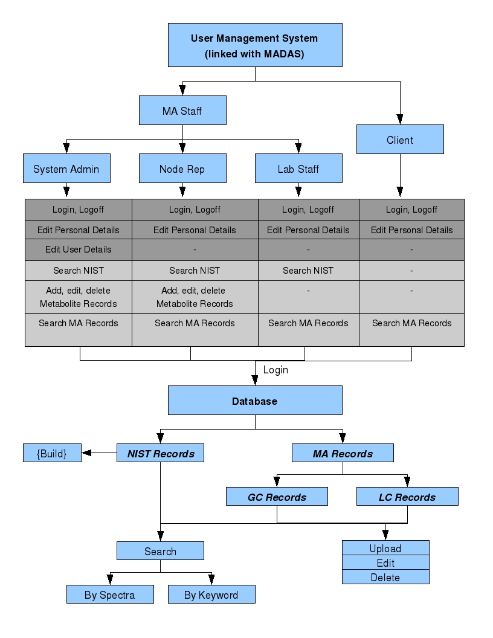

User Management System

Use Case - Login, Logoff
User Groups: Admin, Node Rep, MA Staff, Client

Detail: Users are able to login and logoff the MAMBO-MS system.

Use Case - Edit Personal Details
User Groups: Admin, Node Rep, MA Staff, Client

Detail: This functionality lets the users to edit the following fields: First name, Last name, Password. Note that a change in these fields should reflect in the MADAS system as well.

Use Case - Edit User Details
User Groups: Admin

Detail: The Admin should be able to edit all fields (First name, Last name, Password, Node, Node Rep (Y/N) and Admin (Y/N)) of a user.

Use Case - Forgot Password
User Groups: Admin, Node Rep, MA Staff, Client

Detail: A “Forgot password” option needs to be provided for all user groups.

NIST Records
This section presents background information of the NIST database, its records structures and the different functionalities to be performed on the NIST records.

Background

Introduction
This is a database of mass-spectral data of compounds. Currently this database resides as a single text file (~500MB) of the format shown in Appendix I. This database has a total of 220,460 records. A sample recird is shown below,

##TITLE=Library Entry 3 in d:\nist08.l
##JCAMPDX=Revision 4.10
##DATA TYPE=MASS SPECTRUM
##SAMPLE DESCRIPTION=NIST MS# 61313, Seq# M30
##NAMES=NIST 2008
##CAS NAME=Methane
##MOLFORM=CH4
##CAS REGISTRY NO=000074-82-8
##MP= -300
##BP= -300
##MW= 16.031
##$RETENTION INDEX=0
##$CONDENSED SPECTRUM=NO
##NPOINTS= 6
##XYDATA=(XY..XY)
12 380
13 1060
14 2040
15 8870
16 9999
17 160

This record shows the mass spectral data (the list of numbers under ##XYDATA) for the compound Methane. All records of compounds of this database contain the same set of headers (line starting with ##).

Record
In a record, we can ignore the following headers and hence do NOT store its related information,
##TITLE=
##JCAMPDX=
##DATA TYPE=
##SAMPLE DESCRIPTION=
##NAMES=
##MP=
##BP=
##$RETENTION INDEX=
##$CONDENSED SPECTRUM=

Therefore, in each record we are interested only in the following headers and its related values,
##CAS NAME=
##MOLFORM=
##CAS REGISTRY NO=
##MW=
##NPOINTS=
##XYDATA=(XY..XY)
X1 Y1
X2 Y2
X3 Y3
X4 Y4

##CAS NAME: This field presents the name of the compound.
##MOLFORM: This field presents the compound's molecular formula.
##CAS REGISTRY NO: This field shows the unique CAS registry number for this compound.
##MW: This field shows the molecular weight of the compound.
##NPOINTS: This field shows the number of points of XYDATA (spectral data) this record has.
##XYDATA=(XY..XY): The lines following this header (the next ##NPOINTS lines) in the record represent the actual XY pair of values that is the spectral data.

Nature of Data
- The unique property that identifies a compound is its CAS REGISTRY NO.
- Each compound can have different CAS NAMES and therefore have different records, but these records would bear the same CAS REGISTRY NO.
- NIST also contains different records for the same compound containing the same CAS NAME and the same CAS REGISTRY NO. The differing factor in these entries are the XYDATA (the spectra).
- Some CAS NAMES are long and are entered in multiple lines.

Building the NIST Database
As one of the functionalities of MAMBO-MS is the option of searching the NIST database, the NIST records has to be stored in a database. Note that only the fields of interest needs to be stored and the nature of the NIST data needs to be taken into account while designing the database.

Use Case - Searching NIST Records
User Groups: Admin, Node Rep, MA Staff

Detail: The users are provided with a search functionality to search the NIST records. This option is discussed in detail under the Search Section.

MA Records (GC)

Background
Uploading, editing, deleting and searching of MA records is the most crucial aspect of MAMBO-MS. These records are generated at the different MA labs and would be uploaded into MAMBO-MS.
Detailed below are the different tables that together would be used to upload and store a GCMS Metabolite record.

Node

Use Case – Add, Edit, Delete Nodes

User Groups: Admin

Detail: Admin should be able to add, edit and delete Nodes.

Table Overview

Node Name | User Entered Text

Key Information

Primary Key: Node Name

Table Details

Field: Node Name
Values:-University of Melbourne
-University of Queensland
-University of Western Australian
-Murdoch University
-AWRI

Chromatography Type

Use Case – Add, Edit, Delete Chromatography Type

User Groups: Admin

Detail: Admin should be able to add, edit and delete Chromatography Type values.

Table Overview

Chromatography Type | User Entered Text

Key Information

Primary Key: Chromatography Type

Table Details

Field: Chromatography Type
Values: User entered text

MS Geometry

Use Case – Add, Edit, Delete MS Geometry

User Groups: Admin

Detail: Admin should be able to add, edit and delete MS Geometry values.

Table Overview

MS Geometry | User Entered Text

Key Information

Primary Key: MS Geometry

Table Details

Field: MS Geometry
Values: User entered text

Ionization Mode

Use Case – Add, Edit, Delete Ionization Mode

User Groups: Admin

Detail: Admin should be able to add, edit and delete Ionization Mode values.

Table Overview

Ionization Mode | User Entered Text

Key Information

Primary Key: Ionization Mode

Table Details

Field: Ionization Mode
Values: User entered text

Instrument

Use Case – Add, Edit, Delete Instruments

User Groups: Admin, Node Rep

Detail: Admin and Node Reps should be able to add, edit and delete the instruments in their Nodes.

Table Overview

Node Name | Pull-down menu  (Node: Node Name)
Instrument Name | User Entered Text

Key Information

Primary Key: Node Name, Instrument Name

Table Details

Field: Node Name
Values: Values for this field is obtained from the table Node (Node: Node Name)
Implementation for Use Case: This field needs to be auto-filled, which is obtained from the user's login information.

Field: Instrument Name
Values: User Entered Text
Implementation for Use Case: The user is provided with a text field to enter a value for this field.

Method

Use Case – Add, Edit, Delete Methods

User Groups: Admin, Node Rep

Detail: Admin and Node Reps should be able to add, edit and delete Methods information.

Table Overview
Node Name | Auto generated
Method Name | User Entered Text
Chromatography Type | Pull-down menu  (Chromatography Type: Chromatography Type)
MS Geometry | Pull-down menu  (MS Geometry: MS Geometry)
Ionization Mode | Pull-down menu  (Ionization Mode: Ionization Mode)
Polarity | Pull-down menu  (Values: Positive, Negative)
Derivitization Agent | User Entered Text
Mass of Expected Derivitization Adducts | User Entered Text
Mass Range Acquired | User Entered Text

Key Information

Primary Key: Node Name, Method Name

Table Details

Field: Node Name
Values: Auto generated
Implementation for Use Case: The value for this field should be auto generated. The “Node Name” should be obtained through the logged in user details. That is, this field should contain the name of the Node to which the user belongs to.

Field: Method Name
Values: User Entered Text
Implementation for Use Case: The user is provided with a text field to enter this field.

Field: Chromatography Type
Values: The values for this field is obtained from the table Chromatography Type (Chromatography Type: Chromatography Type)
Implementation for Use Case: The user is provided with a pull-down menu with values for this field.

Field: Ionization Mode
Values: The values for this field is obtained from the table Ionization Mode (Ionization Mode: Ionization Mode)
Implementation for Use Case: The user is provided with a pull-down menu with values for this field.

Field: Polarity
Values:- Positive
- Negative
Implementation for Use Case:The user is provided with a pull-down menu with values for this field.

Field: Derivitization Agent
Values: User Entered Text.
Implementation for Use Case: The user is provided with a text field to enter this field.

Field: Mass of Expected Derivitization Adducts
Values: User Entered Text.
Implementation for Use Case: The user is provided with a text field to enter this field.

Field: Mass Range Acquired
Values: User Entered Text.
Implementation for Use Case: The user is provided with a text field to enter this field.

Column

Use Case – Add, Edit, Delete Columns

User Groups: Admin, Node Rep

Detail: Admin and Node Reps should be able to add, edit and delete Columns information.

Table Overview

Node Name | Auto generated
Chromatography Type | Pull-down menu  (Chromatography Type: Chromatography Type)
Column Name | User Entered Text
Manufacturer | User Entered Text
Length | User Entered Text
Type | User Entered Text
Dimension | User Entered Text
Guard Column Used | User Entered Text
Product Number | User Entered Text

Update 1

The following fields needs to be added to the table,

Internal Diameter | User Entered Text
Particle size | User Entered Text

Note: In the screen design, the field “Internal Diameter” is to be placed after “Length” and before “Type” and the field “Particle size” can be added at the end of the other fields.

Key Information

Primary Key: Node Name, Column Name, Length, Dimension

Table Details

Field: Node Name
Values: Auto generated
Implementation for Use Case: The value for this field should be auto generated. The “Node Name” should be obtained through the logged in user details. That is, this field should contain the name of the Node to which the user belongs to.

Field: Chromatography Type
Values: The values for this field is obtained from the table Chromatography Type (Chromatography Type: Chromatography Type)
Implementation for Use Case: The user is provided with a pull-down menu with values for this field.

Field: Column Name
Values: User Entered Text.
Implementation for Use Case: The user is provided with a text field to enter this field.

Field: Manufacturer
Values: User Entered Text.
Implementation for Use Case: The user is provided with a text field to enter this field.

Field: Length
Values: User Entered Text.
Implementation for Use Case: The user is provided with a text field to enter this field.

Field: Type
Values: User Entered Text.
Implementation for Use Case: The user is provided with a text field to enter this field.

Field: Dimension
Values: User Entered Text.
Implementation for Use Case: The user is provided with a text field to enter this field.

Field: Guard Column Used
Values: User Entered Text.
Implementation for Use Case: The user is provided with a text field to enter this field.

Field: Product Number
Values: User Entered Text.
Implementation for Use Case: The user is provided with a text field to enter this field.

Biological Systems

Use Case – Add, Edit, Delete Biological Systems

User Groups: Admin, Node Rep

Detail: Admin and Node Reps should be able to add, edit and delete Biological Systems information.

Table Overview
Kingdom | User Entered Text
Species | User Entered Text

Key Information

Primary Key: Kingdom, Species

Table Details

Field: Kingdom
Values: User Entered Text.
Implementation for Use Case: The user is provided with a text field to enter this field.

Field: Species
Values: User Entered Text.
Implementation for Use Case: The user is provided with a text field to enter this field.

GCMS MA Metabolite Record

Use Case - Add, Edit, Delete GCMS MA Metabolite Records

User Groups: Admin, Node Rep

Detail: Admin and Node Reps should be able to add, edit and delete GCMS MA Metabolite records.

Table Overview
Unique Metabolite ID | Auto generated
Type | GC
Known/Unknown | Pull-down menu  (Values:Known, Unknown)
Node Name | Auto generated
Instrument Name | Pull-down menu  (Instrument: Instrument Name)
Method Name | Pull-down menu  (Method: Method Name)
Platform Name | Auto filled  (Method:Chromatography Type - Method:MS Geometry - Method:Ionization Mode - Method:Polarity)
Derivitization Agent | Auto filled  (Method: Derivitization Agent)
Mass of Expected Derivitization Adducts | Auto filled  (Method: Mass of Expected Derivitization Adducts)
Mass Range Acquired | Auto filled  (Method: Mass Range)
Column | Pull-down menu  (Column:Column Name – Column:Length - Column:Dimension)
Sample Run By | Pull-down menu  (User Management System)
Record Uploaded By | Auto filled  (User Management System)
Record Uploaded Date | Auto filled
Record Vetted By | Pull-down menu  (User Management System)
Record Vetted Date | Auto filled
Compound Name | User Entered Text
Synonyms | User Entered Text  (Multiple entries)
Biological Systems | Pull-down menu  (Biological System:Kingdom – Biological System:Species)
CAS Name | User Entered Text  (N/A for Unknown)
CAS Registration Number | User Entered Text  (N/A for Unknown)
Molecular Formula | User Entered Text  (N/A for Unknown)
Molecular Weight | User Entered Text  (N/A for Unknown)
Retention Time | User Entered Text
Retention Index | User Entered Text
KEGG ID | User Entered Text  (N/A for Unknown)
KEGG Link | User Entered Text  (N/A for Unknown)
Mass Spectra | User Entered Text
Quant Ion | User Entered Number
Qualifying Ion 1 | User Entered Number
Qualifying Ion 2 | User Entered Number
Qualifying Ion 3 | User Entered Number
Qualifying Ion Ratio  (Ion 1 : Ion2) | Auto generated
Qualifying Ion Ratio  (Ion 2 : Ion 3) | Auto generated
Extract Description | User Entered Text
Structure | User Uploaded File

Key Information

Primary Key: Unique Metabolite ID

Table Details

Field: Unique Metabolite ID
Values: Auto generated
Explanation: This is the ID that would uniquely identify a GC metabolite record.
Implementation for Use Case: The value for this field should be auto generated. A sequential numbering system should suffice.

Field: Type
Value: GC
Explanation: This field is primarily used to differentiate between the GCMS MA metabolite records and the LCMS MA metabolite records that is to be defined at a later stage.
Implementation for Use Case: To be implemented as a fixed value for GCMS records.

Field: Known/Unknown
Values: Known, Unknown
Explanation: This field is used to differentiate between the two types of GCMS MA metabolite records, known and unknown.
Implementation for Use Case: The user is provided with a pull-down menu with values for this field.

Field: Node Name
Values: Auto generated
Explanation: This field identifies the Node at which the metabolite record originated.
Implementation for Use Case: The value for this field should be auto generated. The “Node Name” should be obtained through the logged in user details. That is, this field should contain the name of the Node to which the user belongs to.

Field: Instrument name
Values: The values for this field is obtained from the table Instrument (Instrument: Instrument Name).
Implementation for Use Case: The user is provided with a pull-down menu with values for this field. Note that only the Instruments under the specific Node should be displayed in the pull-down menu. For example, a user from AWRI attempting to create a GC metabolite record should see only Instruments from the AWRI Node in the menu.

Field: Method Name
Values: The values for this field is obtained from the table Method (Method: Method Name).
Implementation for Use Case: The user is provided with a pull-down menu with values for this field. Note that only the Methods under the specific Node should be displayed in the pull-down menu. For example, a user from AWRI attempting to create a GC metabolite record should see only Methods from the AWRI Node in the menu.

Field: Platform Name
Values: Auto generated
Implementation for Use Case: The value for this field should be auto generated in the following format.
Method:Chromatography Type - Method:MS Geometry - Method:Ionization Mode – Method:Polarity

For example, for the selected Method for the current record,

Method: Chromatography Type = GC
Method: MS Geometry = QQQ
Method: Ionization Mode = ESI and
Method: Polarity = Positive

then, 'Platform Name' = GC-QQQ-ESI-Positive

Field: Derivitization Agent
Values: Auto generated
Implementation for Use Case: The value for this field should be auto generated using the Method: Derivitization Agent for the selected Method Name.

Field: Mass of Expected Derivitization Adducts
Values: Auto generated
Implementation for Use Case: The value for this field should be auto generated using the Method: Mass of Expected Derivitization Adducts for the selected Method Name.

Field: Mass Range Acquired
Values: Auto generated
Implementation for Use Case: The value for this field should be auto generated using the Method: Mass Range Acquired for the selected Method Name.

Field: Column
Values: The values for this field is obtained from the table Column.
Implementation for Use Case: The user is provided with a pull-down menu with the values in the following format,
Column:Column Name – Column:Length – Column:Dimension

Field: Sample Run By
Values: The values for this field is obtained from the User Management System
Implementation for Use Case: The user is provided with a pull-down menu with the list of users under the specific Node (User Management System: First name Last name).

Field: Record Uploaded By
Values: Auto generated from User Management System.
Implementation for Use Case: The value for this field is auto generated where it contains the First name Last name of the logged in user.

Field: Record Uploaded Date
Values: Auto generated
Implementation for Use Case: The value for this field is auto generated with the date on which the user uploads the current record.

Field: Record Vetted By
Values: The values for this field is obtained from the User Management System
Implementation for Use Case: This field is a pull-down menu made up of
- a blank entry (this is the default selection)
- the First Name Last Name of the user (MA Staff) who is logged in.

This field exists in order for users to vet a record entered by someone else and is optional.

Hence, if the logged in MA Staff would like to vet a record uploaded by someone else, then the user needs to select their name using the pull-down menu and select a push-button confirming their vetting process.

Note that the same user cannot upload a record as well as vet it. Hence, the fields
Record Uploaded By and Record Vetted By should not be allowed to have the same value.

Field: Record Vetted Date
Values: Auto generated
Implementation for Use Case: The value for this field is auto generated with the date on which a user vet's the current record.

Field: Compound Name
Values: User Entered Text.
Implementation for Use Case: The user is provided with a text field to enter this field.

Field: Synonyms
Values: User Entered Text.
Implementation for Use Case: The compound under consideration may be known by several other names and hence this field can have multiple entries. That is, the user can at different times edit a record and add additional values to these fields. Also note that each of these synonyms can be used as a keyword to search metabolite records.

Field: Biological Systems
Values: The values for this field is obtained from the table Biological Systems.
Implementation for Use Case: The user is provided with a pull-down menu with the values in the following format,
Biological System:Kingdom – Biological System:Species

Field: CAS Name
Values: User Entered Text.
Implementation for Use Case: The user is provided with a text field to enter this field.

Field: CAS Registration Number
Values: User Entered Text.
Implementation for Use Case: The user is provided with a text field to enter this field.

Field: Molecular Formula
Values: User Entered Text.
Implementation for Use Case: The user is provided with a text field to enter this field.

Field: Molecular Weight
Values: User Entered Text.
Implementation for Use Case: The user is provided with a text field to enter this field.

Field: Retention Time
Values: User Entered Text.
Implementation for Use Case: The user is provided with a text field to enter this field.

Field: Retention Index
Values: User Entered Text.
Implementation for Use Case: The user is provided with a text field to enter this field.

Field: KEGG ID
Values: User Entered Text.
Implementation for Use Case: The user is provided with a text field to enter this field.

Field: KEDD Link
Values: User Entered Text.
Implementation for Use Case: The user is provided with a text field to enter this field.

Field: Mass Spectra
Values: User Entered Text.
Implementation for Use Case: The user is provided with a text field to enter this field. Note that this is the field that would store the compound's (mass, intensity) pair values and would be entered in the following format,
51.10 5641.0
52.10 2028.0
53.00 9711.0
54.10 9035.0
55.10 163392.0
56.10 60168.0
57.00 181312.0
58.00 9376.0
58.90 9166.0
59.90 2686.0
61.10 3506.0
...

A complete entry is shown in Appendix II (Note the large number of entries of this mass spectra). The users would make this entry by simply copying these values from their instrument's software and paste it in the text field MAMBO-MS interface provides.
Also note that these values needs to be stored similar to the way the NIST (mass, intensity) values were stored.

Field: Quant Ion
Values: User Entered Number.
Implementation for Use Case: The user is provided with a text field to enter this field.

Field: Qualifying Ion 1
Values: User Entered Number.
Implementation for Use Case: The user is provided with a text field to enter this field.

Field: Qualifying Ion 2
Values: User Entered Number.
Implementation for Use Case: The user is provided with a text field to enter this field.

Field: Qualifying Ion 3
Values: User Entered Number.
Implementation for Use Case: The user is provided with a text field to enter this field.

Field: Qualifying Ion Ratio (Ion 1 : Ion 2)
Values: Auto generated
Implementation for Use Case: The value for this field is auto generated as follows,
Qualifying Ions 1 and 2 entered by the users in the above fields are specific masses in the mass spectra.

Qualifying Ion Ratio (Ion 1 : Ion 2) =
Intensity of Qualifying Ion 1 / Intensity of Qualifying Ion 2

Consider the following example,

If the mass, intensity values of a spectrum is,
51.10 5641.0
52.10 2028.0
53.00 9711.0
54.10 9035.0
55.10 163392.0
56.10 60168.0
57.00 181312.0
58.00 9376.0
58.90 9166.0
59.90 2686.0

and
Qualifying Ion 1 = 51.10
Qualifying Ion 2 = 52.10
then
Qualifying Ion Ratio (Ion 1 : Ion 2) = 5641.0/2028.0 = 2.781

Field: Qualifying Ion Ratio (Ion 2 : Ion 3)
Values: Auto generated
Implementation for Use Case:
Qualifying Ion Ratio (Ion 2 : Ion 3) =
Intensity of Qualifying Ion 2 / Intensity of Qualifying Ion 3

Field: Extract Description
Values: User Entered Text.
Implementation for Use Case: The user is provided with a text field to enter this field.

Field: Structure
Values: User Uploaded File
Implementation for Use Case: The user is provided with an option to upload a small file that would contain the structure of the metabolite (format is yet to be decided).

Update 1

Add to the above table, the following field,

Metabolite Class | Pull down menu  (Metabolite Class: Metabolite Class Name)

Note 1: “Metabolite Class” is detailed in the LC Section of this document.

Note 2: In the screen design, this field is to be placed after “Biological System” and before “Compound Name”.

Use Case - Searching MA Records
User Groups: Admin, Node Rep, MA Staff, Client

Detail: The users are provided with a search functionality to search the MA records. This option is discussed in detail under the Search Section.

MA Records (LC)

Background
Most of the components of LC records are similar to GC records. As a result, many of the Tables designed and populated for the GC records can be used for LC records and is noted below.

Node

Can re-use the Node table designed for GC records.

Chromatography Type

Can re-use the Node table designed for GC records.

MS Geometry

Can re-use the Node table designed for GC records.

Ionization Mode

Can re-use the Node table designed for GC records.

Instrument

Can re-use the Node table designed for GC records.

Column

Can re-use the Node table designed for GC records.

Biological Systems/Sample Origins

Can re-use the Node table designed for GC records.

Mass Spectra Type (LC)

Use Case – Add, Edit, Delete Mass Spectra Type

User Groups: Admin, Node Rep

Detail: Admin and Node Reps should be able to add, edit and delete Mass Spectra Type information.

Table Overview

Mass Spectra Type | User Entered Text

Key Information

Primary Key: Name

Metabolite Class

Use Case – Add, Edit, Delete Metabolite Class

User Groups: Admin, Node Rep

Detail: Admin and Node Reps should be able to add, edit and delete Metabolite Class information.

Table Overview

Metabolite Class Name | User Entered Text

Key Information

Primary Key: Metabolite Class Name

LC Method

Use Case – Add, Edit, Delete LC Methods

User Groups: Admin, Node Rep

Detail: Admin and Node Reps should be able to add, edit and delete Methods information.

Table Overview
Unique ID | Auto generated
Node Name | Auto generated
Method Name | User Entered Text
Chromatography Type | Pull-down menu  (Chromatography Type: Chromatography Type)
MS Geometry | Pull-down menu  (MS Geometry: MS Geometry)
Ionization Mode | Pull-down menu  (Ionization Mode: Ionization Mode)
Polarity | Pull-down menu  (Values: Positive, Negative)
Derivitization Agent | User Entered Text
m/z of Expected Derivitization Adducts | User Entered Text
Mass Range Acquired | User Entered Text
Flow Rate | User Entered Text
Solvent Composition A | User Entered Text
Solvent Composition B | User Entered Text
Solvent Composition C | User Entered Text
Solvent Composition D | User Entered Text

Key Information

Primary Key: Node Name, Method Name

Table Details

Field: Node Name
Values: Auto generated
Implementation for Use Case: The value for this field should be auto generated. The “Node Name” should be obtained through the logged in user details. That is, this field should contain the name of the Node to which the user belongs to.

Field: Method Name
Values: User Entered Text
Implementation for Use Case: The user is provided with a text field to enter this field.

Field: Chromatography Type
Values: The values for this field is obtained from the table Chromatography Type (Chromatography Type: Chromatography Type)
Implementation for Use Case: The user is provided with a pull-down menu with values for this field.

Field: Ionization Mode
Values: The values for this field is obtained from the table Ionization Mode (Ionization Mode: Ionization Mode)
Implementation for Use Case: The user is provided with a pull-down menu with values for this field.

Field: Polarity
Values:- Positive
- Negative
Implementation for Use Case:The user is provided with a pull-down menu with values for this field.

Field: Derivitization Agent
Values: User Entered Text.
Implementation for Use Case: The user is provided with a text field to enter this field.

Field: Mass of Expected Derivitization Adducts
Values: User Entered Text.
Implementation for Use Case: The user is provided with a text field to enter this field.

Field: Mass Range Acquired
Values: User Entered Text.
Implementation for Use Case: The user is provided with a text field to enter this field.

Field: Flow Rate
Values: User Entered Text.
Implementation for Use Case: The user is provided with a text field to enter this field.

Field: Solvent Composition A
Values: User Entered Text.
Implementation for Use Case: The user is provided with a text field to enter this field.

Field: Solvent Composition B
Values: User Entered Text.
Implementation for Use Case: The user is provided with a text field to enter this field.

Field: Solvent Composition C
Values: User Entered Text.
Implementation for Use Case: The user is provided with a text field to enter this field.

Field: Solvent Composition D
Values: User Entered Text.
Implementation for Use Case: The user is provided with a text field to enter this field.

LC Modifications Table

Use Case – Add, Edit, Delete LC Modifications Table

User Groups: Admin, Node Rep

Detail: Admin and Node Reps should be able to add, edit and delete Modifications Table information.

Table Overview
Unique ID | Auto generated
Name of Compound | User Entered Text
Mass | User Entered Text
Molecular Formula | User Entered Text

Key Information

Primary Key: Name of Compound, Mass, Molecular Formula

Table Details

Field: Name of Compound
Values: User Entered Text
Implementation for Use Case: The user is provided with a text field to enter this field.

Field: Mass
Values: User Entered Text
Implementation for Use Case: The user is provided with a text field to enter this field.

Field: Molecular Formula
Values: User Entered Text
Implementation for Use Case: The user is provided with a text field to enter this field.

LC Metabolite Record

Use Case - Add, Edit, Delete LC MA Metabolite Records

User Groups: Admin, Node Rep

Detail: Admin and Node Reps should be able to add, edit and delete LC MA Metabolite records.

Table Overview
Unique Metabolite ID | Auto generated
Type | LC
Known/Unknown | Pull-down menu  (Values:Known, Unknown)
Node Name | Auto generated
Instrument Name | Pull-down menu  (Instrument: Instrument Name)
Method Name | Pull-down menu  (Method: Method Name)
Platform Name | Auto filled  (Method:Chromatography Type - Method:MS Geometry - Method:Ionization Mode - Method:Polarity)
Derivitization Agent | Auto filled  (Method: Derivitization Agent)
m/z of Expected Derivitization Adducts | Auto filled  (Method: m/z of Expected Derivitization Adducts)
Mass Range Acquired | Auto filled  (Method: Mass Range Acquired)
Column | Pull-down menu  (Column:Column Name – Column:Length - Column:Dimension)
Sample Run By | Pull-down menu  (User Management System)
Record Uploaded By | Auto filled  (User Management System)
Record Uploaded Date | Auto filled
Record Vetted By | Pull-down menu  (User Management System)
Record Vetted Date | Auto filled
Compound Name | User Entered Text
Synonyms | User Entered Text  (Multiple entries)
Biological Systems | Pull-down menu  (Biological System:Kingdom – Biological System:Species)
CAS Name | User Entered Text  (N/A for Unknown)
CAS Registration Number | User Entered Text  (N/A for Unknown)
Molecular Formula | User Entered Text  (N/A for Unknown)
Mono Isotopic Mass | User Entered Text  (N/A for Unknown)
Retention Time | User Entered Text
Retention Index | User Entered Text
KEGG ID | User Entered Text  (N/A for Unknown)
KEGG Link | User Entered Text  (N/A for Unknown)
Sample/Extract Description | User Entered Text
Structure | User Uploaded File

Update 1

Add to the above table, the following field,

Metabolite Class | Pull down menu  (Metabolite Class: Metabolite Class Name)

Note: In the screen design, this field is to be placed after “Biological System” and before “CAS Name”.

Update 2

The following field needs to be added to the table,

Molecular weight | User Entered Text

Note: In the screen design, this field is to be placed after “Mono Isotopic mass” and before “Retention time”.

Update 3

The following field needs to be added to the table,

Ionized Species | Pull down menu  (LC Modifications: Name of Compound)

Note: In the screen design, this field is to be placed after “Mono Isotopic mass” and before “Molecular Weight”.

Update 4

The “Ionized Species” presently is part of “LC Metabolite Record” and needs to be moved to “Spectrum” of the metabolite record. Further details under the “Spectrum” Section.

Key Information

Primary Key: Unique Metabolite ID

Spectrum

Use Case - Add, Edit, Delete Spectrum

User Groups: Admin, Node Rep

Table Overview

Unique Spectral ID | Auto generated
Metabolite ID | LC Records: Unique Metabolite ID
Spectrum Description | User Entered Text
Ionization Mode | Auto filled  LC Method: Ionization Mode
Polarity | Auto filled  LC Method: Polarity
Precursor Type | Pull down menu  (Values if Polarity is “Positive” : [M+H]+, [M+Na]+, [M+K]+, [M-H2O+H]+)  (Values is Polarity is “Negative:” [M-H]-, [M+FA-H]-, [M+HAc-H]-)
Precursor Selection | Pull down menu  (Values: Quadrupole, Paul Trap, ISCID)
Collison Energy | User Entered Text
Mass Spectra | User Entered Text

Update 1

Add to the above table, the following field,

Mass Spectra Type | Pull down menu  (Mass Spectra Type (LC): Mass Spectra Type)

Note: In the screen design, this field is to be placed after “Spectral ID” and before “Description”.

Update 2

The following field that originally was present under the “LC Metabolite Record” needs to be added to the table,

Ionized Species | Pull down menu  (LC Modifications: Name of Compound)

Notes:
- In the screen design, this field is to be placed after “Description” and before “Ionization Mode”.
- User needs to be present with the option of selecting multiple entries from the pull-down menu (similar to how the user is currently able to select multiple Biological System entries)

Update 3

Values of the pull down menu have been updated below.

Precursor Type | Pull down menu  (Values if Polarity is “Positive” : [M+H]+, [M+Na]+, [M+K]+, [M-H2O+H]+, [M+2H]2+, [2M+H]+, [M+NH4]+)  (Values is Polarity is “Negative:” [M-H]-, [M+FA-H]-, [M+HAc-H]-, [2M-H]-)

Search by Keyword

Version 1

Screen Suggestions
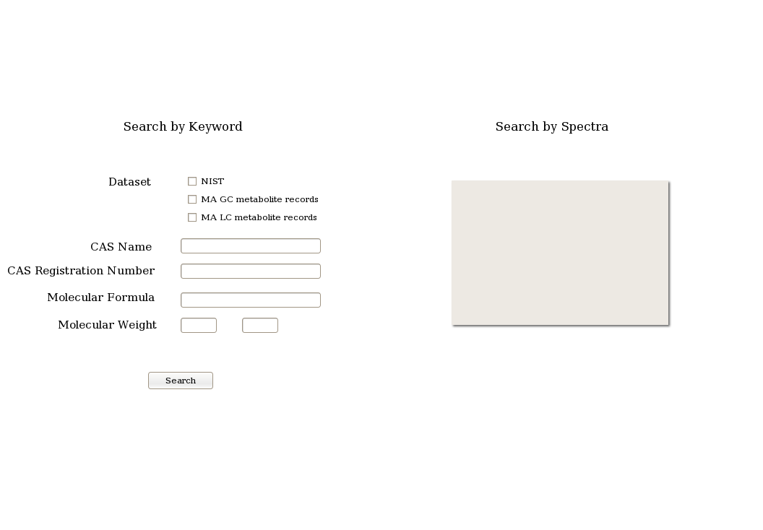

Search Query – Details

Note that the following fields are only a partial list with which we start our implementation. The following fields would suffice to search the NIST records but keyword based search would contain many more fields once the GC Metabolite records are built. This section would be updated as the GC and later components are designed and built.

Dataset
An option to select different datasets needs to be provided.
- Clients should not be able to search the NIST records and hence the NIST check-box should be unchecked and disabled or absent when an user logs in as Client.
- For all other user groups, all three check-boxes should be selected by default.

CAS Name
This is a string based search option that compares against the records' CAS NAME field. Since many records in the database could have the search string as part of the CAS NAME entry, a simple grep returns thousands of results. Therefore, a search option can be included that would reduce the number of matches. One of the methods would be to include with the search criteria, the following three options to choose from, the search string is “exact”, “starts with” or “contains”.

CAS Register Number
This is a perfect match search option against the CAS REGISTRY NO. field.

Molecular Formula
This is a perfect match search option against the MOLFORM field.

Molecular Weight
In this option, the user should be able to enter a range of values (from, to) and the search should produce a list of all compounds whose MW field falls within the search range.

Search Results
A search using any of the above discussed fields should produce a list of hits displaying the following information,
- Name (CAS NAME)
- CAS REGISTRY NO.
- Molecular Formula (MOLFORM)
- Molecular Weight (MW)

Since multiple matches are expected for an average search, the above information of each match needs to be displayed as a single line with a clickable link to the spectra. Once the user selects the line (clicks the link to view the spectra), the following information is to be displayed in a separate window,
- Name (CAS NAME)
- CAS REGISTRY NO.
- Molecular Formula (MOLFORM)
- Molecular Weight (MW)
- the spectra (set of XY values). This should be displayed in a graphical format.

Displaying Spectra

Display a zoomable graph.

Version 2

The previous section (Version 1) was a simple design implemented as a basic search feature to browse through the NIST records. This section is aimed at re-designing the search by keyword feature to include the GC and LC records. Under the Search by Keyword feature, two types of search features are to be implemented, a) a basic search consisting of only a few searchable fields and b) an advance search option for that includes more fields.

Basic Search
In the basic search option, the user should be able to,

- Choose the following datasets they want to search,
  - NIST Records
  - GC Metabolite Records
  - LC Metabolite Records
Note: The user should be able to select one or more of the above databases.

- Have the following searchable fields,
  - Compound Name
  - CAS Registration Number
  - Molecular Formula
  - Molecular Weight

These search fields are explained in detail below.

Advance Search
In the advance search option, the user should be able to,

- Choose the following datasets they want to search,
  - NIST Records
  - GC Metabolite Records
  - LC Metabolite Records
Note: The user should be able to select one or more of the above databases.

- Have the following searchable fields,
  - Compound name
  - CAS Registration Number
  - Molecular Formula
  - Molecular Weight
  - Mono Isotopic Mass
  - Derivitization Agent
  - Instrument Type
  - Biological Systems
  - Metabolite Class
  - Retention Time

Searchable Fields

- Compound Name
  - To be displayed as “Compound Name”
  - In NIST, this is to be searched against the field CAS NAME (If NIST is selected as one of the datasets that needs to be searched)
  - In GC Metabolite Records, this is to be searched against the fields
    - Compound Name and
    - Synonyms
(If GC Metabolite Records is selected as one of the datasets that needs to be searched)
  - In LC Metabolite Records, this is to be searched against the fields
    - Compound Name and
    - Synonyms
(If LC Metabolite Records is selected as one of the datasets that needs to be searched)
  - Type of search: Exact and partial match search with the “contains”, “starts with” and “exact” options.

- CAS Registration Number
  - To be displayed as “CAS Registration Number”
  - In NIST, this is to be searched against the field CAS REGISTRY NO (If NIST is selected as one of the datasets that needs to be searched)
  - In GC Metabolite Records, this is to be searched against the field “CAS Registration Number” (If GC Metabolite Records is selected as one of the datasets that needs to be searched)
  - In LC Metabolite Records, this is to be searched against the field “CAS Registration Number” (If LC Metabolite Records is selected as one of the datasets that needs to be searched)
  - Type of search: Exact match

- Molecular Formula
  - To be displayed as “Molecular Formula”
  - In NIST, this is to be searched against the field MOLFORM (If NIST is selected as one of the datasets that needs to be searched)
  - In GC Metabolite Records, this is to be searched against the field “Molecular Formula” (If GC Metabolite Records is selected as one of the datasets that needs to be searched)
  - In LC Metabolite Records, this is to be searched against the field “Molecular Formula” (If LC Metabolite Records is selected as one of the datasets that needs to be searched)
  - Type of search: Exact match

- Derivitization Agent
  - To be displayed as “Derivitization Agent”
  - NIST does not store this field and hence is not searched.
  - In GC Metabolite Records, this is to be searched against the field “Derivitization Agent” (If GC Metabolite Records is selected as one of the datasets that needs to be searched).
  - In LC Metabolite Records, this is to be searched against the field “Derivitization Agent” (If LC Metabolite Records is selected as one of the datasets that needs to be searched).
  - Type of search: A list of derivitization agents from both GC Methods:Derivitization Agent and LC Methods:Derivitization Agent needs to be displayed from which, the user is able to select one or more values (through selecting/deselecting checkboxes).
Note: The user also has to be presented with a “Select All” option.

- Biological Systems
  - To be displayed as “Biological Systems”
  - NIST does not store this field and hence is not searched.
  - In GC Metabolite Records, this is to be searched against the field “GCMS MA Metabolite Record:Biological Systems” (If GC Metabolite Records is selected as one of the datasets that needs to be searched).
  - In LC Metabolite Records, this is to be searched against the field “LCMS MA Metabolite Record:Biological Systems” (If LC Metabolite Records is selected as one of the datasets that needs to be searched).
  - Type of search: A list of values (Kingdom-Species) from Biological Systems needs to be displayed from which, the user is able to select one or more values (through selecting/deselecting checkboxes).
Note: The user also has to be presented with a “Select All” option.

- Metabolite Class
  - To be displayed as “Metabolite Class”
  - NIST does not store this field and hence is not searched.
  - In GC Metabolite Records, this is to be searched against the field “GCMS MA Metabolite Record:Metabolite Class” (If GC Metabolite Records is selected as one of the datasets that needs to be searched).
  - In LC Metabolite Records, this is to be searched against the field “LCMS MA Metabolite Record:Metabolite Class” (If LC Metabolite Records is selected as one of the datasets that needs to be searched).
  - Type of search: A list of values from Metabolite Class (detailed under the LC MA Records Section) needs to be displayed from which, the user is able to select one or more values (through selecting/deselecting checkboxes).
Note: The user also has to be presented with a “Select All” option.

- Retention Time
  - To be displayed as “Retention Time”
  - NIST does not store this field and hence is not searched.
  - In GC Metabolite Records, this is to be searched against the field “GCMS MA Metabolite Record:Retention Time” (If GC Metabolite Records is selected as one of the datasets that needs to be searched).
  - In LC Metabolite Records, this is to be searched against the field “LCMS MA Metabolite Record:Retention Time” (If LC Metabolite Records is selected as one of the datasets that needs to be searched).
  - Type of search: Exact match

- Molecular Weight
  - To be displayed as “Molecular Weight”
  - In NIST, this is to be searched against the field MW (If NIST is selected as one of the datasets that needs to be searched)
  - In GC Metabolite Records, this is to be searched against the field “GCMS MA Metabolite Record:Molecular Weight” (If GC Metabolite Records is selected as one of the datasets that needs to be searched).
  - In LC Metabolite Records, this is to be searched against the field “LCMS MA Metabolite Record:Molecular Weight” (If LC Metabolite Records is selected as one of the datasets that needs to be searched).
  - Type of search: The user should be able to enter a range of values (from, to) and the search should produce a list of all compounds whose molecular weight falls within the search range.

- Mono Isotopic Mass
  - To be displayed as “Mono Isotopic Mass (LC Only)”
  - NIST does not store this field and hence is not searched.
  - GC Metabolite Records does not store this field and hence is not searched.
  - In LC Metabolite Records, this is to be searched against the field “LCMS MA Metabolite Record:Mono Isotopic Mass” (If LC Metabolite Records is selected as one of the datasets that needs to be searched).
  - Type of search: The user should be able to enter a range of values (from, to) and the search should produce a list of all compounds whose mono isotopic mass falls within the search range.

- Instrument Type
  - To be displayed as “Instrument Type”
  - NIST does not store this field and hence is not searched.
  - In GC Metabolite Records, this is to be searched against the field “GCMS MA Metabolite Record:Platform Name” (If GC Metabolite Records is selected as one of the datasets that needs to be searched).
  - In LC Metabolite Records, this is to be searched against the field “LCMS MA Metabolite Record:Platform Name” (If LC Metabolite Records is selected as one of the datasets that needs to be searched).
  - Type of search: List of values for the following needs to be presented to the user from which, the user is able to select one or more values (through selecting/deselecting checkboxes),
    - Chromatography Type
    - MS Geometry
    - Ionization Mode

Note: The user also has to be presented with a “Select All” option.

Update 1

In the “Advanced Search” option, the following field needs to be included.

- Mass Spectra Type
  - To be displayed as “Mass Spectra Type (LC Only)”
  - NIST does not store this field and hence is not searched.
  - GC Metabolite Records does not store this field and hence is not searched.
  - In LC Metabolite Records, this is to be searched against the field “Mass Spectra Type (LC): Mass Spectra Type” (If LC Metabolite Records is selected as one of the datasets that needs to be searched).
  - Type of search: List of values for the field needs to be presented to the user from which, the user is able to select one or more values (through selecting/deselecting checkboxes),
Note: The user also has to be presented with a “Select All” option.

Search Results

A search using the above discussed fields should produced a list of hits displaying the following fields in the specified order below,
- Compound Name
- CAS Name
- Molecular Formula
- Molecular Weight
- CAS Registry Number
- Record Type

Since multiple matches are expected for an average search, the above information of each match needs to be displayed as a single line with a clickable link to the spectra. Once the user selects an entry, the following information is to be displayed:

For GCMS MA Metabolite Records

- First the spectra needs to be displayed at the top of the page along with the structure.
- Next, all fields that make up the GCMS MA Metabolite Record as displayed in the “Upload → GCMS MA Metabolite Record” feature needs to be displayed, except the values of the mass spectra as the spectra is visually displayed already.

For LCMS MA Metabolite Records

- First the various spectrum of LC needs to be displayed at the top of the page along with the structure. With each spectrum, its following related information needs to displayed as well
  - Spectral ID
  - Mass Spectra Type
  - Description
  - Ionization Mode
  - Polarity
  - Precursor Selection
  - Precursor Type and
  - Collison Energy

Note that the values of the field “Mass Spectra” need not be displayed as the spectra is visually displayed already.

- Next, all fields that make up the LCMS MA Metabolite Record as displayed in the “Upload → LCMS MA Metabolite Record” feature needs to be displayed.

Note: Since the above discussed design involves a view only feature, a separate option to edit these records needs to be provided.

A sample design of the search results screen for LC is presented below.

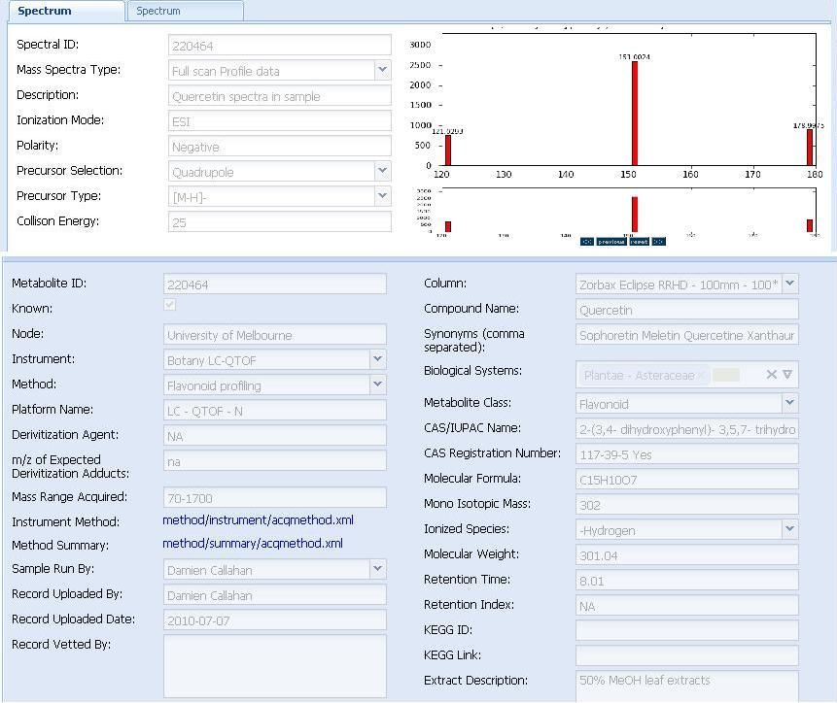

Search By Spectra
In this option, the user uploads a range of (mass, intensity) pair values and searches the metabolite records for similar spectra.

Search Query - Screen Suggestions

Version 1
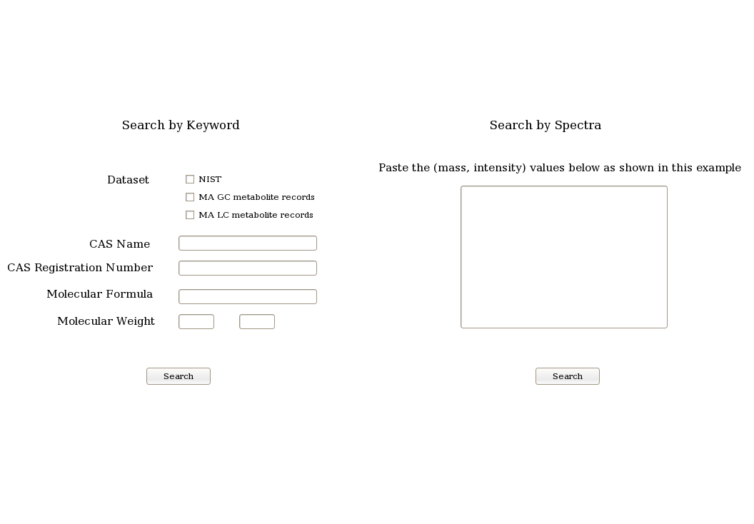

Version 2

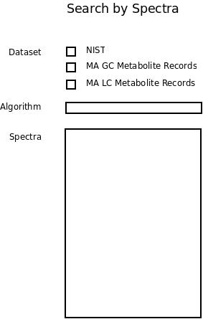

Search Query - Screen Details
The user copies and pastes the spectra (as mass, intensity pair values) that needs to be searched in the text box. The user is also provided with a sample file showing the format in which the query spectra information needs to be uploaded. The format is similar to the one shown in Appendix II – A GC Metabolite Spectrum Entry / Spectral search query.
Once the user uploads the query spectra, it is searched against the metabolite records using the spectral search algorithm detailed in the next Section.

Update 1

The user is to be presented with
- The option of selecting one or more datasets (similar to the “Search by Keyword” feature).
- The option to select the algorithm that is to be used for the spectral search. The list of algorithms could be presented in a pull-down menu.
- The option to enter/paste the query spectra. The query spectra would be entered in the form of x, y values (Details in the main section “Search Query – Screen Details”).

Spectral Search Algorithm

Algorithm 1

This algorithm is to be displayed in the search algorithm pull-down menu as “MA in-house Dot product”

Similarity between two spectra is calculated using the following formula

where,

is the total number of common masses between the query spectra and the library spectra.

is the total number of masses in the query spectra.

is the total number of masses in the library spectra.

This factor is calculated ONLY for common masses, where Iq is the intensity in the query spectra of the common mass and Il is the intensity of the library spectra of the common mass.

is the sum of the squares of the intensities of the query spectra for ONLY the common masses.

is the sum of the squares of the intensities of the library spectra for ONLY the common masses.

Algorithm 2

This algorithm is to be displayed in the search algorithm pull-down menu as “Dot product”

Calculations for this formula is performed very similar to the one described in Algorithm 1.

Spectral Search Algorithm - Example

Assume the query spectra to be ((mass, intensity) pairs),
5 10
10 15
15 5
20 5

Similarly, assume a library record to be,
2 10
10 5
15 5

Then,

would be calculated as follows,

(the total number of common masses between the query spectra and the library spectra)

(the total number of masses in the query spectra)

(the total number of masses in the library spectra)

(This factor is calculated ONLY for common masses, where Iq is the intensity in the query spectra of the common mass and Il is the intensity of the library spectra of the common mass)

(the sum of the squares of the intensities of the query spectra for ONLY the common masses)

(the sum of the squares of the intensities of the library spectra for ONLY the common masses)

Spectral Search Algorithm - Notes

Rounding Mass Values for NIST records

The following is an extract from Appendix II – A GC Metabolite Spectrum Entry / Spectral Search Query.
51.10 5641.0
52.10 2028.0
53.00 9711.0
54.10 9035.0
55.10 163392.0
56.10 60168.0
57.00 181312.0
58.00 9376.0
58.90 9166.0
59.90 2686.0
61.10 3506.0

Note that the mass values are not integers but are floating point numbers, whereas the NIST entries (Appendix I – Extract of the NIST Database) have mass values as integers (round numbers).

Therefore, in the query spectra the mass values needs to be rounded using the following range: (-0.3 to +0.6). For example,

51.0 = 51.0
51.2 = 51.0
51.3 = 51.0
51.4 = 51.0
51.5 = 51.0
51.6 = 51.0
51.7 = 52.0
51.8 = 52.0
51.9 = 52.0
52.0 = 52.0
52.1 = 52.0
52.2 = 52.0
52.3 = 52.0
52.4 = 52.0
52.5 = 52.0
52.6 = 52.0
52.7 = 53.0

Search Results

The top 10 matches needs to be presented to the user. Temporarily, it would suffice to present a link to these compounds, clicking on which would take the user to the compound's mass spectra.

Update 1

A search should produce a list of hits displaying the following fields in the specified order below,
- Compound Name
- CAS Name
- Rank (1 to 10, instead of displaying the score)
- Molecular Formula
- Molecular Weight
- CAS Registry Number
- Record Type

Appendix I – Extract of the NIST Database
##TITLE=Library Entry 1 in d:\nist08.l
##JCAMPDX=Revision 4.10
##DATA TYPE=MASS SPECTRUM
##SAMPLE DESCRIPTION=NIST MS# 245692, Seq# M1
##NAMES=NIST 2008
##CAS NAME=Hydrogen
##MOLFORM=H2
##CAS REGISTRY NO=001333-74-0
##MP= -300
##BP= -300
##MW= 2.016
##$RETENTION INDEX=0
##$CONDENSED SPECTRUM=NO
##NPOINTS= 2
##XYDATA=(XY..XY)
1 210
2 9999
##TITLE=Library Entry 2 in d:\nist08.l
##JCAMPDX=Revision 4.10
##DATA TYPE=MASS SPECTRUM
##SAMPLE DESCRIPTION=NIST MS# 61316, Seq# M2
##NAMES=NIST 2008
##CAS NAME=Deuterium
##MOLFORM=D2
##CAS REGISTRY NO=007782-39-0
##MP= -300
##BP= -300
##MW= 4.028
##$RETENTION INDEX=0
##$CONDENSED SPECTRUM=NO
##NPOINTS= 2
##XYDATA=(XY..XY)
2 150
4 9999
##TITLE=Library Entry 3 in d:\nist08.l
##JCAMPDX=Revision 4.10
##DATA TYPE=MASS SPECTRUM
##SAMPLE DESCRIPTION=NIST MS# 61313, Seq# M30
##NAMES=NIST 2008
##CAS NAME=Methane
##MOLFORM=CH4
##CAS REGISTRY NO=000074-82-8
##MP= -300
##BP= -300
##MW= 16.031
##$RETENTION INDEX=0
##$CONDENSED SPECTRUM=NO
##NPOINTS= 6
##XYDATA=(XY..XY)
12 380
13 1060
14 2040
15 8870
16 9999
17 160

Appendix II – A GC Metabolite Spectrum Entry / Spectral Search Query

51.10 5641.0
52.10 2028.0
53.00 9711.0
54.10 9035.0
55.10 163392.0
56.10 60168.0
57.00 181312.0
58.00 9376.0
58.90 9166.0
59.90 2686.0
61.10 3506.0
62.10 1291.0
62.90 787.0
63.90 599.0
65.10 3022.0
65.80 1072.0
66.20 1095.0
67.10 14519.0
68.00 12303.0
69.00 49224.0
70.10 170624.0
71.10 126648.0
72.10 11490.0
73.10 15242.0
74.00 2901.0
74.90 2209.0
76.10 848.0
77.00 5188.0
77.90 5097.0
79.00 5107.0
80.10 1821.0
81.10 8618.0
82.10 16736.0
83.10 89512.0
84.10 55728.0
85.10 11822.0
86.00 3320.0
87.10 24576.0
87.90 1436.0
88.20 1267.0
89.20 912.0
90.80 2672.0
91.30 3443.0
92.00 1014.0
93.00 1978.0
94.10 1871.0
95.00 6839.0
96.10 6662.0
97.10 13517.0
98.00 4511.0
99.10 4039.0
100.00 26208.0
101.00 37272.0
102.10 13969.0
102.90 3984.0
104.10 2837.0
105.00 5396.0
106.30 873.0
107.00 2412.0
108.00 2772.0
108.90 4091.0
110.00 4929.0
111.00 75320.0
112.10 157440.0
113.10 63936.0
114.10 5533.0
115.10 2949.0
116.10 378.0
117.20 709.0
118.00 1013.0
119.10 2730.0
120.00 1298.0
120.90 2347.0
122.00 2382.0
122.90 1365.0
124.00 997.0
124.90 1452.0
126.00 1680.0
127.10 5516.0
128.10 25520.0
129.00 510656.0
130.10 24712.0
131.00 4532.0
132.00 1213.0
133.00 2333.0
134.00 565.0
135.20 2175.0
136.20 935.0
136.90 1624.0
138.00 553.0
139.10 1249.0
140.00 1316.0
141.10 1302.0
142.00 11791.0
143.00 4343.0
144.00 915.0
145.10 2853.0
146.00 14981.0
147.00 103816.0
148.10 6232.0
149.00 10940.0
150.00 3016.0
150.90 2211.0
152.10 835.0
152.80 416.0
153.30 1351.0
154.10 2231.0
155.00 2785.0
155.90 1196.0
156.90 4788.0
158.10 2140.0
159.00 884.0
160.00 3901.0
160.90 2054.0
161.70 688.0
162.20 648.0
162.90 2077.0
164.00 908.0
164.90 1828.0
166.20 781.0
167.10 1326.0
168.10 1303.0
169.10 693.0
170.10 643.0
171.20 175.0
171.90 1112.0
172.70 500.0
173.10 664.0
174.00 627.0
175.00 1003.0
176.00 512.0
177.20 1712.0
177.70 617.0
178.00 581.0
178.90 1754.0
180.20 500.0
180.70 502.0
181.10 453.0
182.10 322.0
183.10 1428.0
184.00 318.0
185.10 529.0
185.90 590.0
186.80 220.0
188.90 759.0
189.90 232.0
191.10 2195.0
192.00 1795.0
192.90 2472.0
193.70 484.0
194.30 676.0
195.10 1412.0
195.80 1039.0
196.30 295.0
196.90 926.0
198.30 1448.0
199.10 5311.0
199.90 750.0
201.80 385.0
202.90 150.0
204.10 505.0
204.80 968.0
206.00 181.0
207.00 20992.0
208.00 5032.0
209.10 3900.0
210.00 1833.0
211.10 1963.0
212.10 8724.0
213.10 1439.0
214.30 589.0
215.20 946.0
215.90 234.0
217.00 686.0
217.90 677.0
218.90 494.0
220.80 1024.0
221.10 1075.0
222.00 170.0
222.90 1866.0
224.10 719.0
225.20 1593.0
228.30 365.0
228.90 561.0
229.90 586.0
231.20 206.0
232.00 173.0
233.00 554.0
235.10 166.0
236.10 443.0
237.00 578.0
238.60 390.0
239.10 569.0
240.10 2039.0
241.10 39064.0
242.20 6118.0
243.10 1910.0
245.10 674.0
247.00 421.0
248.90 919.0
251.00 1352.0
252.20 688.0
253.20 1738.0
253.80 935.0
254.90 1326.0
256.10 257.0
256.90 769.0
258.30 893.0
259.20 24584.0
260.20 3744.0
261.20 1068.0
262.20 279.0
264.10 358.0
264.80 835.0
265.70 433.0
266.20 935.0
266.90 1647.0
267.90 624.0
269.10 1645.0
270.00 735.0
272.30 825.0
274.30 179.0
276.70 269.0
281.10 6371.0
282.00 2479.0
283.20 1458.0
283.90 1559.0
284.80 368.0
285.40 228.0
288.10 189.0
296.10 1282.0
296.90 669.0
298.90 312.0
300.40 496.0
301.30 358.0
302.30 463.0
307.00 234.0
308.90 162.0
311.10 353.0
313.20 2383.0
314.80 468.0
315.30 638.0
317.30 597.0
324.80 866.0
325.40 266.0
326.30 994.0
327.10 2192.0
328.20 889.0
329.00 393.0
330.90 547.0
331.40 344.0
331.80 502.0
332.30 456.0
332.90 188.0
338.40 664.0
339.50 555.0
341.10 3463.0
342.00 1211.0
343.00 1559.0
344.10 311.0
344.90 461.0
346.30 408.0
346.90 723.0
354.20 308.0
354.90 599.0
356.10 669.0
357.00 824.0
358.00 415.0
370.00 246.0
370.60 373.0
372.00 373.0
373.70 332.0
383.70 338.0
384.80 371.0
386.40 491.0
390.20 321.0
391.20 298.0
399.00 439.0
400.20 220.0
403.20 597.0
405.20 735.0
405.90 425.0
406.30 400.0
417.30 606.0
429.20 1260.0
431.10 151.0
431.70 237.0
444.90 890.0
446.20 751.0
479.10 176.0
492.80 575.0
533.00 1292.0
534.10 244.0

