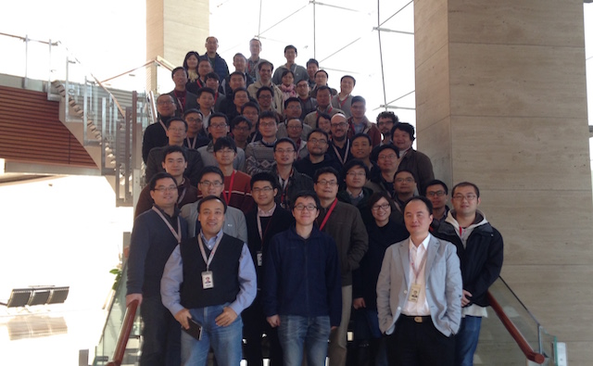

**The Noah’s Ark Lab** is a research lab of **Huawei Technologies**, located in Hong Kong and Shenzhen. The mission of the lab is to make significant contributions to both the company and society by innovating in data mining, artificial intelligence, and related fields. Founded in 2012, the lab has now grown to be a research organization with many significant achievements. We welcome talented researchers and engineers to join us to realize their dreams.