CASE STUDY: IMPLEMENTING AGILE METHODOLOGY IN A SOFTWARE DEVELOPMENT PROJECT

NAME:-K.Lokesh
ROLL NO:-25B21CS080
SECTION:-CSE-8
1. Introduction:-
Flipkart is one of India's largest e-commerce platforms, offering millions of products across various categories. Developing and maintaining such a large-scale application requires
flexibility, rapid delivery, and continuous customer feedback. To achieve this, Agile methodology, particularly Scrum, is implemented.


2. Objectives
- Develop a scalable, user-friendly, and secure online shopping application.
- Ensure continuous integration and delivery. - Incorporate customer feedback quickly.
- Deliver working features in short iterations.

3. Agile Framework Chosen
Scrum is chosen as the Agile framework for Flipkart app development because it focuses on delivering product increments in short sprints, ensures close collaboration with stakeholders, and adapts well to changing requirements.
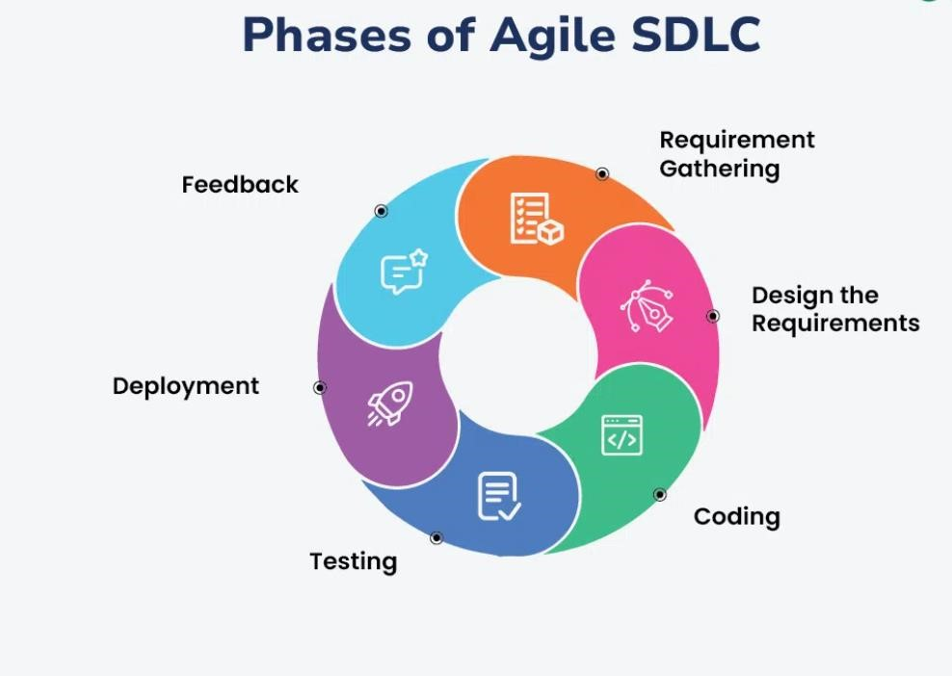

4. Roles & Responsibilities
- Product Owner: Defines vision, manages backlog, and prioritizes features.
- Scrum Master: Facilitates Agile practices, removes blockers.
- Development Team: Designers, developers, testers responsible for delivering increments.
- Stakeholders: Provide feedback and suggestions.

5. Agile Implementation
The project is broken down into multiple sprints, each delivering working product features.

- Product Backlog Creation: Features like user login, product search, cart, checkout, payment gateway, delivery tracking, and reviews.
- Sprint Planning: Features divided into 2-3 week sprints.
- Daily Stand-ups: 15-minute sync-up meetings to discuss progress and blockers.
- Sprint Review & Retrospective: Feedback gathering and continuous improvement.
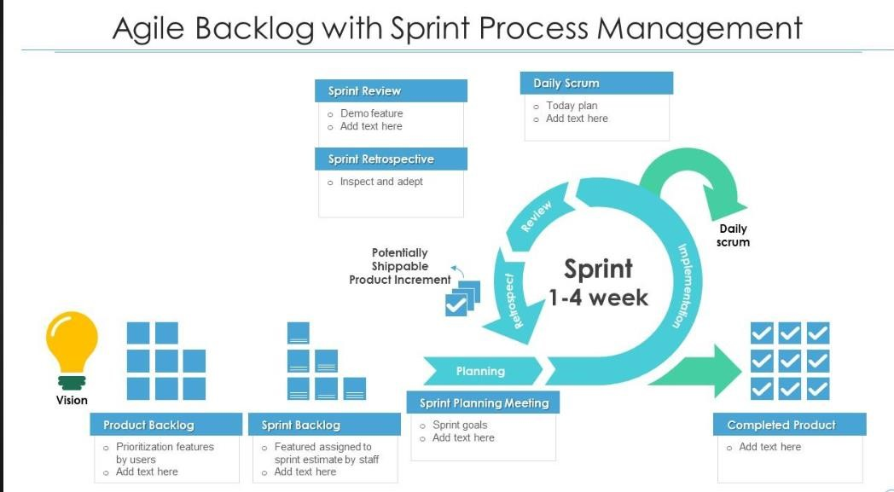

6. Tools Used
- Jira / Trello: Sprint planning and backlog management.
- GitHub: Version control.
- Jenkins: Continuous Integration/Continuous Deployment (CI/CD).
7. Agile Ceremonies with Flipkart Example
- Sprint 1 → User authentication system.
- Sprint 2 → Product catalog & search functionality.
- Sprint 3 → Shopping cart & checkout.
- Sprint 4 → Payment gateway integration.
- Sprint 5 → Delivery tracking & push notifications.
- Sprint 6 → Reviews, offers, and ad integration.
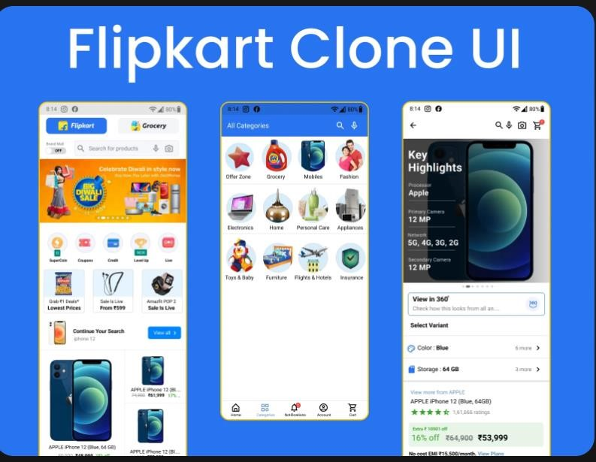

8. Challenges & Solutions
- Scalability: Handled with cloud-based infrastructure.
- Payment Security: Integrated with secure payment gateways.
- Frequent Updates: Achieved with CI/CD pipelines and automated testing.

9. Conclusion
By implementing Agile methodology, Flipkart ensures faster delivery of features, continuous customer satisfaction, and adaptability to dynamic market needs. Scrum practices such as sprints, reviews, and retrospectives played a vital role in the project’s success.

