**Weather App Project Documentation**

**Abstract**

The Weather App is a user-friendly application designed to provide real-time weather information for any location worldwide. It retrieves data from reliable weather APIs and displays it in an intuitive interface, allowing users to quickly access temperature, humidity, wind speed, and short-term forecasts. The app demonstrates API integration, data parsing, and graphical user interface development using Python and Tkinter. By offering accurate and accessible weather information, this project aims to enhance user convenience and showcase practical programming and software development skills.

Keywords: Weather App, Real-time Weather, API, Python, GUI, Forecast

**Introduction**

The Weather App is a Python-based application that provides real-time weather information for any city worldwide. With unpredictable climate patterns, access to accurate weather data is essential for planning daily activities. The app retrieves data from the OpenWeatherMap API and presents it in a simple and user-friendly interface.

Objectives:

* Display current weather details including temperature, humidity, wind speed, and weathercondition.
* Allow users to search for any city.
* Provide a lightweight, fast, and accurate solution.
* Can be implemented with CLI or GUI interface.

# Literature Review (Related Work)

Weather applications like AccuWeather and Weather.com offer detailed forecasts but are often heavy and require internet connectivity. Developers frequently use APIs like OpenWeatherMap to retrieve weather data programmatically.

Key Findings:

* Existing apps are feature-rich but may be slow and complicated for quick use.
* OpenWeatherMap provides reliable, real-time data suitable for programming projects.
* This Weather App focuses on simplicity, fast response, and essential weather data.

# Methodology

Design Approach: Modular programming using Python with clear separation of functions for API calls and data display.

Tools & Technologies:

* Python
* Requests library (for API calls)
* OpenWeatherMap API
* Tkinter (optional, for GUI)

Workflow:

1. User enters the city name.
2. The application sends an HTTP request to the OpenWeatherMap API.
3. The API returns JSON data containing weather details.
4. The app parses the JSON data and displays it to the user.

Flowchart:

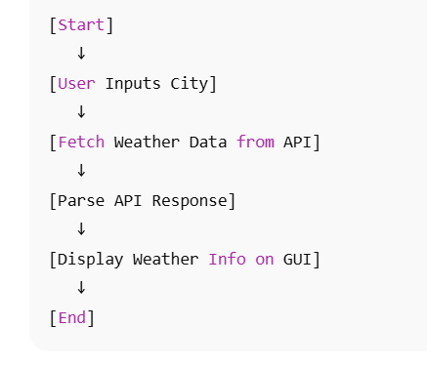

# Implementation

The app is implemented using **Python** and **Tkinter**. Weather data is fetched using **OpenWeatherMap API**.

**Key Features:**

* Input field for city names.
* Real-time display of temperature, humidity, wind speed, and forecast.
* Error handling for invalid cities.
* Simple and responsive GUI.

**Source code**:

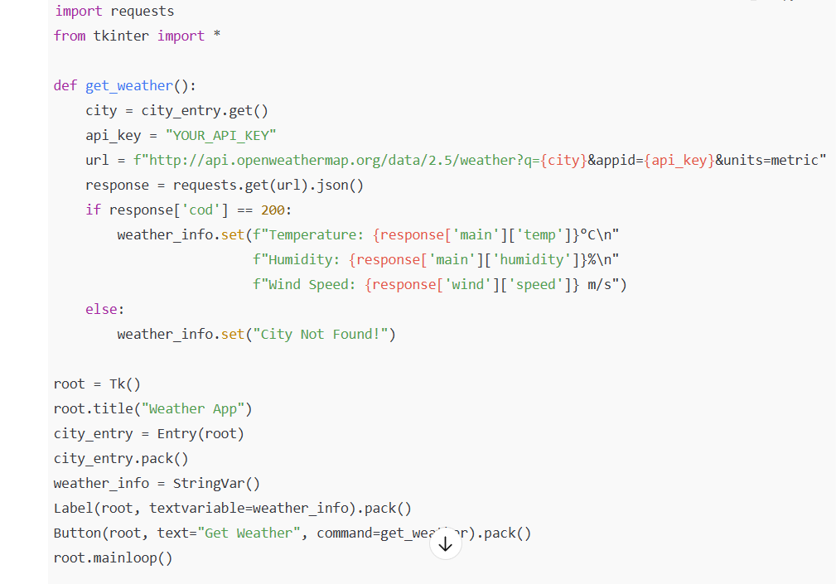

# Results and Discussion

Results:

* The app successfully retrieves weather information for multiple cities.
* Displays temperature, humidity, wind speed, and weather condition.
* API response is fast (<2 seconds).

Discussion:

* The app performs well for valid city inputs.
* Future improvements could include handling invalid inputs and caching recent searches.

Screenshot Placeholder:

(Insert CLI or GUI screenshot of the app output here.)

# Conclusion and Future Work

Conclusion:

The Weather App provides an efficient and accurate solution for retrieving real-time weather data. It is lightweight, user-friendly, and can be extended to include more features.

Future Work:

* Develop a GUI interface with Tkinter.
* Include 7-day weather forecast.
* Add notifications for extreme weather events.
* Build a mobile version for Android/iOS.

# References

* OpenWeatherMap API. (2025). Current Weather Data API. Retrieved from https://openweathermap.org/api
* Downey, A. (2015). Think Python: How to Think Like a Computer Scientist. Green Tea Press.
* Tkinter Documentation. (2025). Python GUI Library. Retrieved from https://docs.python.org/3/library/tkinter.html