|  |  |  |
| --- | --- | --- |
| **NAME** | **:** | **MUCHAMMAD NABIL HAYKAL WIDARTO** |
| **CLASS** | **:** | **SIB-1G** |
| **NIM** | **:** | **2341760152** |

Questions 2.1 !

1. Do array elements have to be filled in sequentially starting from the 0th index? Please explain!

2. Why is there a null in the list of audience names?

3. Complete the audience list in step 4 so that it looks like the following program code

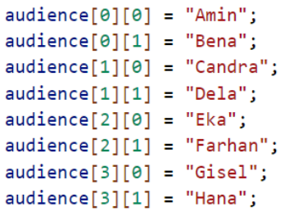

4. Add the following program code :

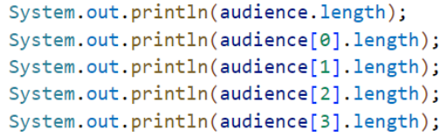

5. Modify the program code in step 4 to display the length of each row in the array using

a for loop. Compile, run, then commit.

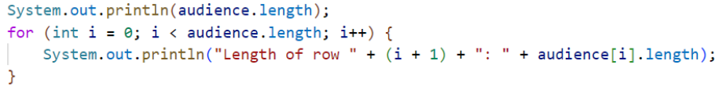

6. Modify the program code in step 5 to display the length of each row in the array using

a foreach loop. Compile, run, then commit.

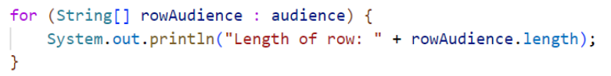

7. In your opinion, what are the advantages and disadvantages of foreach loop compared to for loop?

8. What is the max row index for the audience array?

9. What is the max column index for the audience array?

10. Add program code to display the audience’s name on the 3rd line using a for loop. Compile, run, then commit.

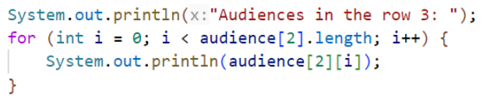

11. Modify the code in question number 10 to repeat using a foreach loop. Compile, run, then commit.

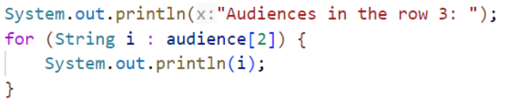

12. Modify the program code in question number 11 again to display the audience’s name for each line. Compile and run the program then observe the results, then commit.



13. What is the function of String.join()?

14. Commit and push to GitHub

Answer

1. Array elements in Java do not have to be filled sequentially, but if an element is not filled, its value will default to the array's data type.

2. Because there is an array that has not been declared

3. 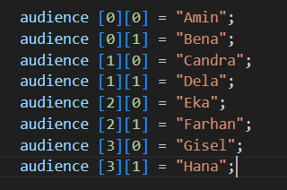 Hasil : 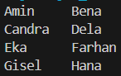

4. A. Use of audience.length as a variable for the number of elements in an array The use of audience[0].length as a variable for the number of array elements in an array, in a two-dimensional array, [] to determine the outer array index.

B. audience[0].length, audience[1].length, audience[2].length, and audience[3].length have the same value because in the program above, the array has been declared with 4 elements which each element has 2 elements.

5. 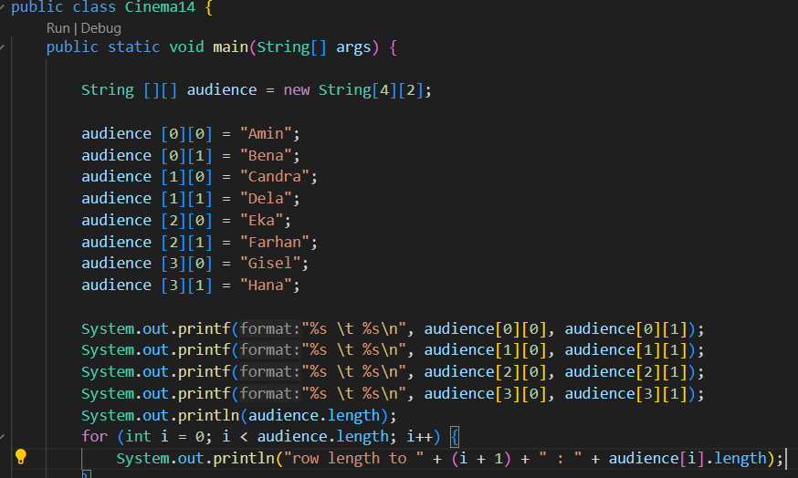

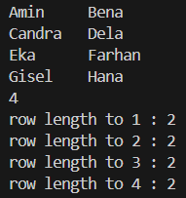

6. 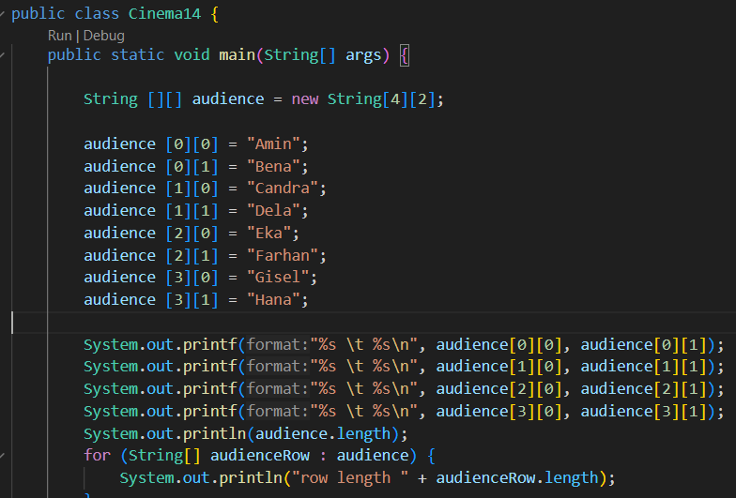

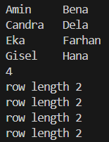

7. 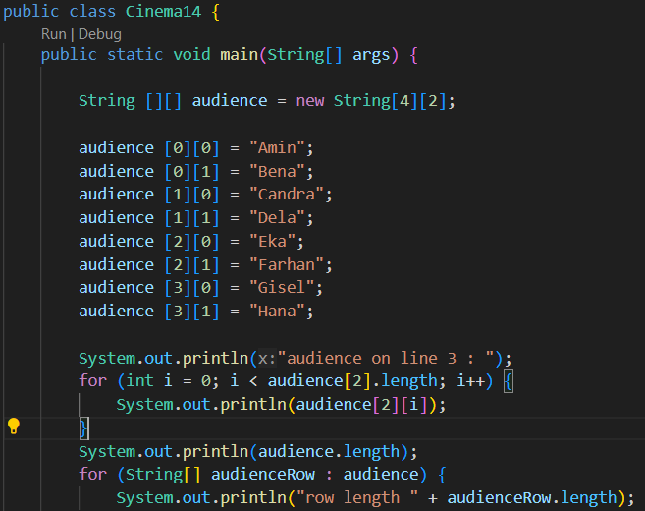

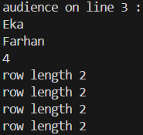

8. 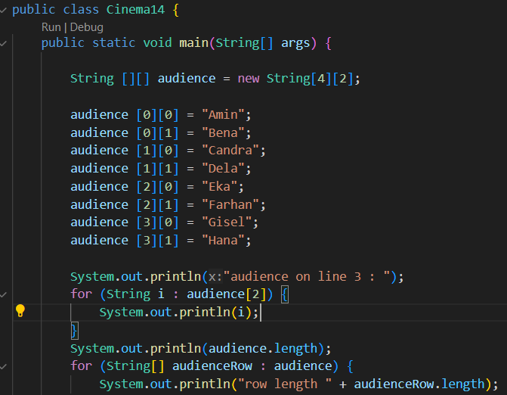

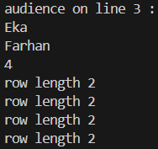

9. 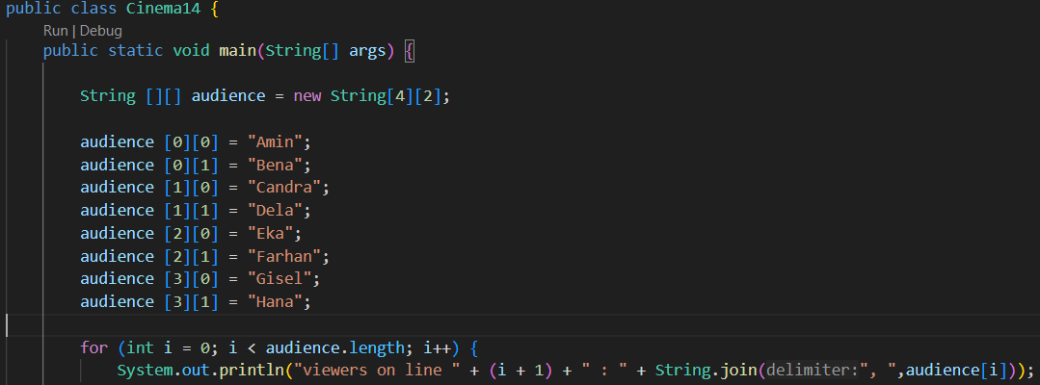

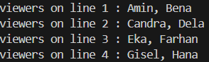

10. Disadvantages are more difficult to understand because there are no 3 structures like fori the advantage is that the program is more efficient

11. 3

12. 1

13. To replace + and display any number of elements.

Question 2.2 !

1. Should the array elements from the scanner be filled in sequentially starting from the

0th index? Please explain!

2. Modify the program code to provide the following menu options:

- Menu 1: Input audience data

- Menu 2: Show audience list

- Menu 3: Exit

3. Modify the program code to handle if the seat row/column number is not available

4. In menu 1, modify the program code to give a warning if the selected seat is already

occupied by other audiences, then display a command to enter rows and columns

again

5. In menu 2, if the seat is empty, replace null with ***

Answer

1. filling the array elements of the scanner does not have to be done sequentially starting from the from index 0 and must not exceed a predetermined distance.

2. 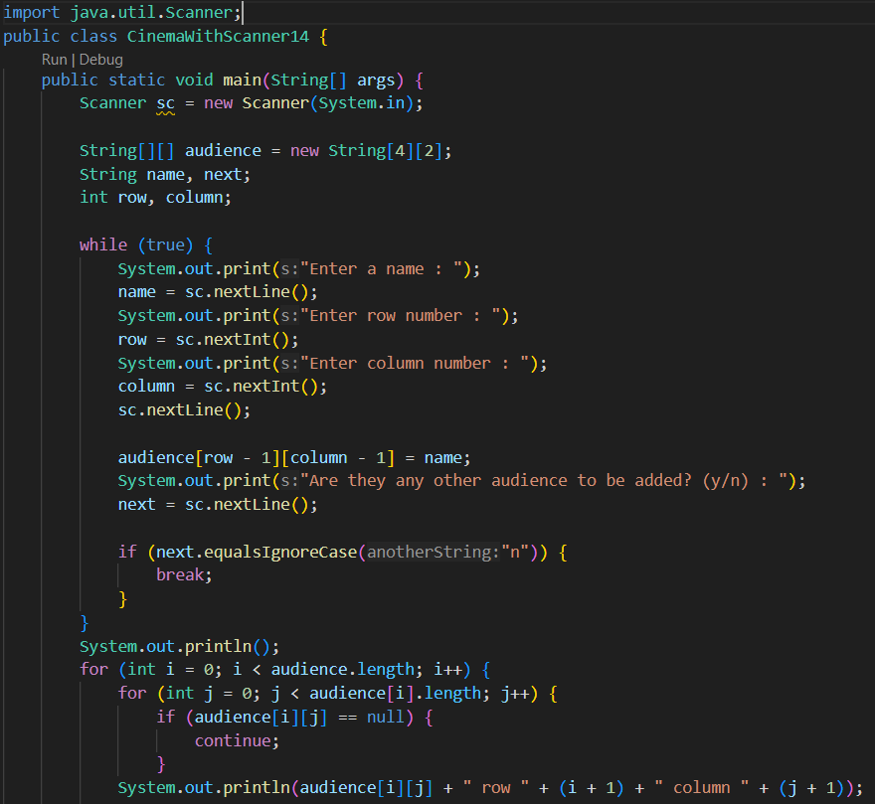

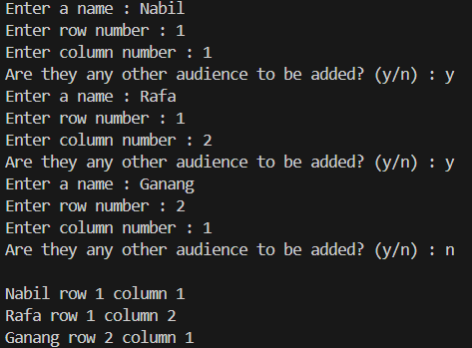

3. 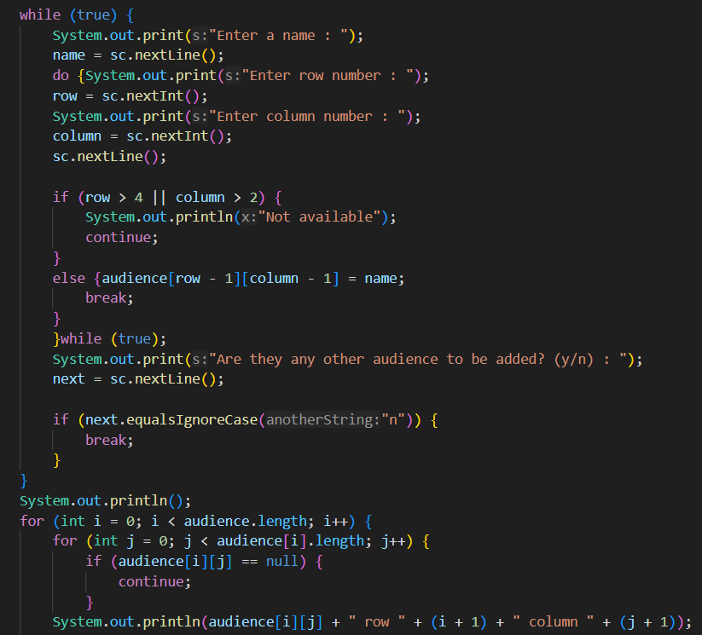

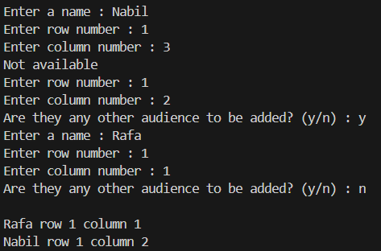

4.