
Bartłomiej Balcerek,
Bartosz Szurgot,
Wojciech Waga

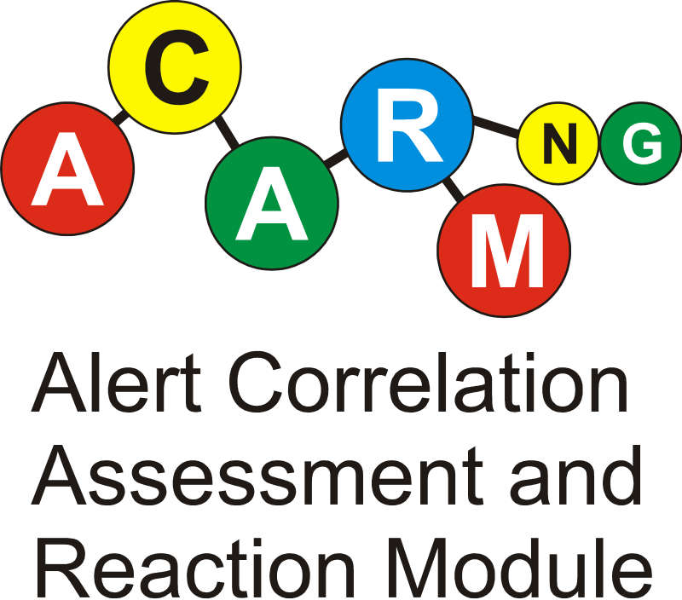

Polska Infrastruktura Informatycznego Wspomagania Nauki w Europejskiej Przestrzeni Badawczej – PL-Grid
 | Biuro Projektu PL-Grid biuro@plgrid.pl |  | Politechnika  Wrocławska | Wrocławskie Centrum Sieciowo-Superkomputerowe | 
 | tel.: (48 12) 632 33 55 w.327  fax: (48 12) 634 10 84 |  | Wybrzeże Wyspiańskiego 27  50-370 Wrocław | Pl. Grunwaldzki 9  50-377 Wrocław
 | http://plgrid.pl/ |  | http://www.pwr.wroc.pl | http://www.wcss.pl
1. Short summary

ACARM-ng (Alert Correlation, Assessment and Reaction Module - new generation) is a security tool designed to facilitate administration of possible intrusion attempts, which are reported by network IDSs (Intrusion Detection System) or host IDSs, hereinafter called 'intrusion alerts' or 'alerts'. Its functionality consists of gathering, processing and reporting noteworthy events to the system administrators. All alerts that are send to ACARM-ng are subject to correlation rules, which can also be written by the user, and system administrators are notified of the results of this process.

2. Motivation and functionality

As PL-GRID aspires to be the country-wide and broadly available platform, system security is not to be underestimated. Number of PL-GRID cooperating computers and network devices is unprecedented in Poland and potential risks go hand in hand with the size of the infrastructure. It is more than sure that installation of this size can also be used with malicious intent by hackers to target attacks on cryptography or on remote systems. Detection of this type of activity is essential for proper administration of the system.
ACARM-ng is a swiss army knife for providing security in a distributed environment. It can collect alerts from sensors deployed across whole network structure, identify patterns of misuse, assess them and report to system administrators. Actions taken upon successful correlation can be defined by the users. They can range from sending emails or instant messages to fully automatic reaction i.e. changing policies of firewall.

3. Architecture: internal modules and external subsystems

Since functionality and ease of development are the primary features of ACARM-ng, it is build of fully configurable modules and defines API for further development of correlation rules or reaction schemes.

Whole infrastructure consists of:

* HIDS and NIDS sensors
* one or more Prelude Managers
* ACARM-ng

HIDS and NIDS are responsible for collecting information of possible break-in attempts by eavesdropping network traffic and analyzing system logs. There is an public API so that new sensors could be easily developed. Prelude Manager is as a concentrator for alerts and can queue them in case of network failure for further analysis. ACARM-ng is a final stage of this architecture and is responsible for receiving data from Prelude Managers and performing correlations and severity assessments.

ACARM-ng itself is split into 4 functional parts:

* input
* filters
* triggers
* output

Input provides all the functionality related to alert gathering from multiple sources. Filters do the actual correlations and are partially responsible for severity assessments. Triggers are meant to be the user notification mechanism, they can perform such actions as sending emails or invoking scripts. Output is due to record all the events in the database for future use or archivisation.

This diagram presents ACARM-ng engine with sample triggers and filters (as described in [1]).

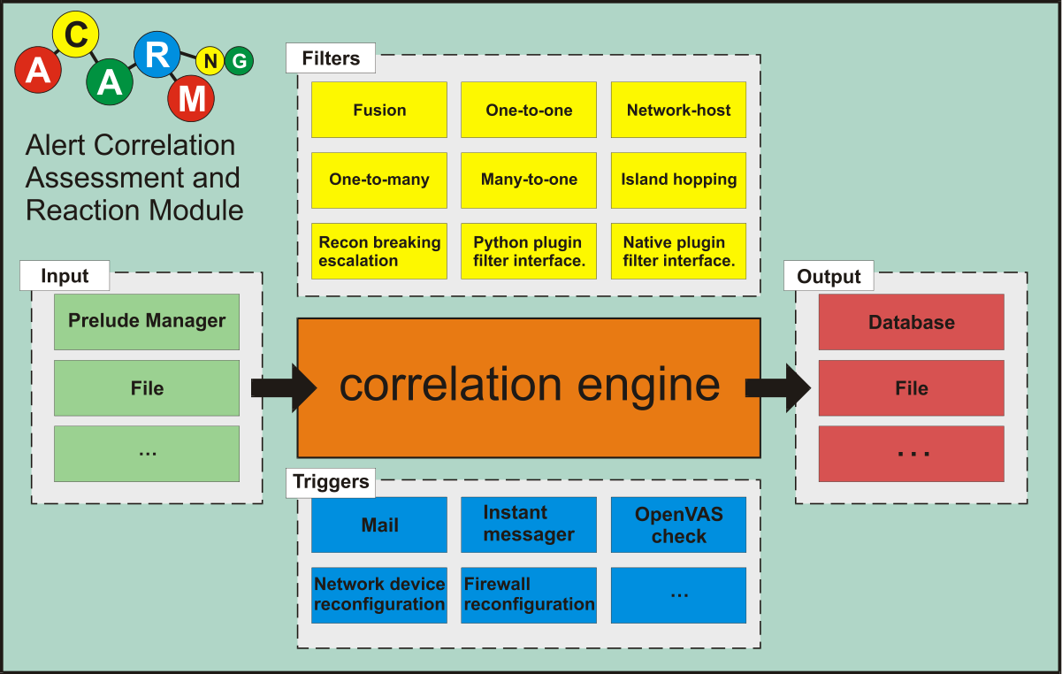

4. Control flow (sequence diagram, collaboration diagram, activity diagram)

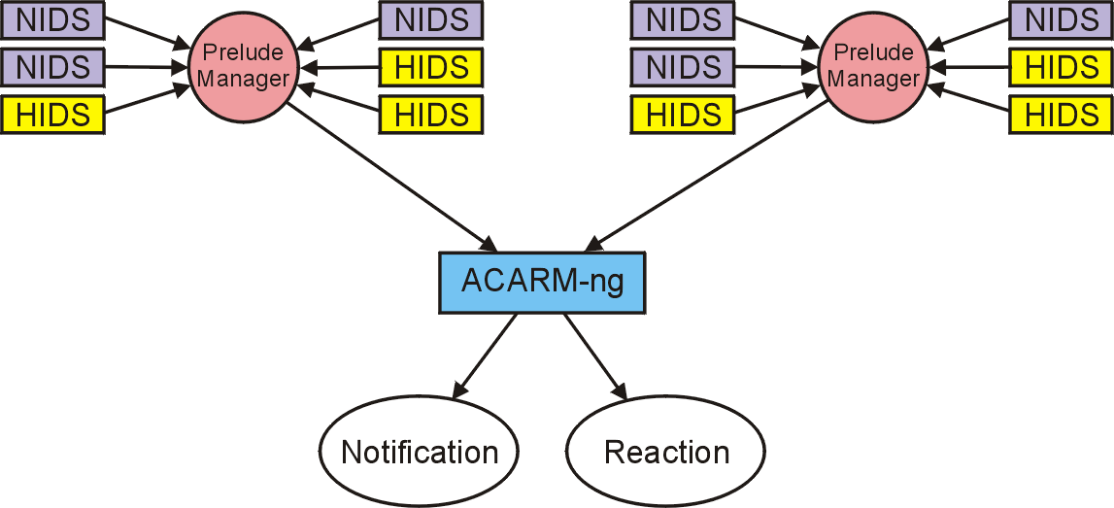

5. External interfaces and dependencies (including interfaces to other components of the system)

- Prelude Manager
- system specific sensors i.e. Snort, Prelude-LML.

6. References
1. Fredrik Valeur, Giovanni Vigna, Christopher Kruegel, Richard A. Kemmerer, "A Comprehensive Approach to Intrusion Detection Alert Correlation," IEEE Transactions on Dependable and Secure Computing, vol. 1, no. 3, pp. 146-169, July-Sept. 2004, doi:10.1109/TDSC.2004.21

7. List of acronyms

IDS - Intrusion Detection System
NIDS – Network Intrusion Detection System
HIDS – Host Intrusion Detection System
ACARM-ng - Alert Correlation, Assessment and Reaction Module new generation

