Nama : Gigih Hernandha

Kelas : 2B

1. Constrain layout

Order

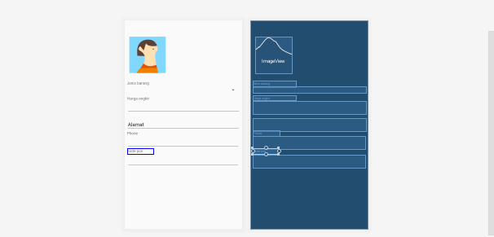

*<?***xml version="1.0" encoding="utf-8"***?>*< **android.support.constraint.ConstraintLayout xmlns:android="http://schemas.android.com/apk/res/android"  
 xmlns:app="http://schemas.android.com/apk/res-auto"  
 xmlns:tools="http://schemas.android.com/tools"  
 android:layout_width="match_parent"  
 android:layout_height="match_parent"  
 tools:context=".order"**>  
  
 <**ImageView  
 android:id="@+id/imageView2"  
 android:layout_width="wrap_content"  
 android:layout_height="wrap_content"  
 tools:layout_editor_absoluteX="16dp"  
 tools:layout_editor_absoluteY="57dp"  
 tools:srcCompat="@tools:sample/avatars[9]"** />  
  
 <**TextView  
 android:id="@+id/textView2"  
 android:layout_width="150dp"  
 android:layout_height="22dp"  
 android:text="Jenis barang"  
 tools:layout_editor_absoluteX="8dp"  
 tools:layout_editor_absoluteY="210dp"** />  
  
 <**Spinner  
 android:id="@+id/spinner2"  
 android:layout_width="396dp"  
 android:layout_height="wrap_content"  
 tools:layout_editor_absoluteX="8dp"  
 tools:layout_editor_absoluteY="232dp"** />  
  
 <**TextView  
 android:id="@+id/textView3"  
 android:layout_width="150dp"  
 android:layout_height="18dp"  
 android:text="Harga ongkir"  
 tools:layout_editor_absoluteX="8dp"  
 tools:layout_editor_absoluteY="264dp"** />  
  
 <**EditText  
 android:id="@+id/editText"  
 android:layout_width="397dp"  
 android:layout_height="wrap_content"  
 android:ems="10"  
 android:inputType="number"  
 tools:layout_editor_absoluteX="8dp"  
 tools:layout_editor_absoluteY="282dp"** />  
  
 <**EditText  
 android:id="@+id/editText2"  
 android:layout_width="397dp"  
 android:layout_height="wrap_content"  
 android:ems="10"  
 android:inputType="textPersonName"  
 android:text="Alamat"  
 tools:layout_editor_absoluteX="7dp"  
 tools:layout_editor_absoluteY="343dp"** />  
  
 <**EditText  
 android:id="@+id/editText3"  
 android:layout_width="395dp"  
 android:layout_height="wrap_content"  
 android:ems="10"  
 android:inputType="phone"  
 tools:layout_editor_absoluteX="8dp"  
 tools:layout_editor_absoluteY="405dp"** />  
  
 <**TextView  
 android:id="@+id/textView4"  
 android:layout_width="94dp"  
 android:layout_height="21dp"  
 android:text="Phone"  
 tools:layout_editor_absoluteX="8dp"  
 tools:layout_editor_absoluteY="386dp"** />  
  
 <**EditText  
 android:id="@+id/editText4"  
 android:layout_width="393dp"  
 android:layout_height="wrap_content"  
 android:ems="10"  
 android:inputType="number"  
 tools:layout_editor_absoluteX="8dp"  
 tools:layout_editor_absoluteY="470dp"** />  
  
 <**TextView  
 android:id="@+id/textView5"  
 android:layout_width="91dp"  
 android:layout_height="21dp"  
 android:text="Kode pos"  
 tools:layout_editor_absoluteX="8dp"  
 tools:layout_editor_absoluteY="448dp"** />  
</**android.support.constraint.ConstraintLayout**>

1. Relativ layout

Laporan

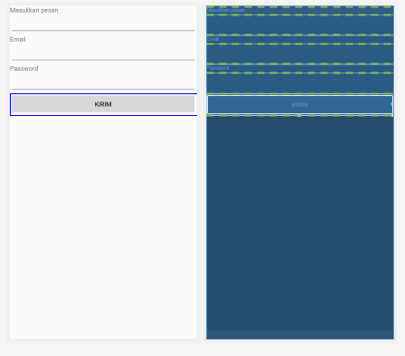

*<?***xml version="1.0" encoding="utf-8"***?>*<**android.support.constraint.ConstraintLayout xmlns:android="http://schemas.android.com/apk/res/android"  
 xmlns:app="http://schemas.android.com/apk/res-auto"  
 xmlns:tools="http://schemas.android.com/tools"  
 android:layout_width="match_parent"  
 android:layout_height="match_parent"  
 tools:context=".setting"**>  
  
 <**LinearLayout  
 android:layout_width="match_parent"  
 android:layout_height="match_parent"  
 android:orientation="vertical"  
 tools:layout_editor_absoluteX="0dp"  
 tools:layout_editor_absoluteY="47dp"**>  
  
 <**TextView  
 android:id="@+id/textView"  
 android:layout_width="match_parent"  
 android:layout_height="wrap_content"  
 android:text="Masukkan pesan "** />  
  
 <**EditText  
 android:id="@+id/editText5"  
 android:layout_width="match_parent"  
 android:layout_height="wrap_content"  
 android:ems="10"  
 android:inputType="textPersonName"** />  
  
 <**TextView  
 android:id="@+id/textView6"  
 android:layout_width="match_parent"  
 android:layout_height="wrap_content"  
 android:text="Email"** />  
  
 <**EditText  
 android:id="@+id/editText6"  
 android:layout_width="match_parent"  
 android:layout_height="wrap_content"  
 android:ems="10"  
 android:inputType="textEmailAddress"** />  
  
 <**TextView  
 android:id="@+id/textView7"  
 android:layout_width="match_parent"  
 android:layout_height="wrap_content"  
 android:text="Password"** />  
  
 <**EditText  
 android:id="@+id/editText7"  
 android:layout_width="match_parent"  
 android:layout_height="wrap_content"  
 android:ems="10"  
 android:inputType="textPersonName"** />  
  
 <**Button  
 android:id="@+id/button2"  
 android:layout_width="match_parent"  
 android:layout_height="wrap_content"  
 android:text="Kirim"** />  
 </**LinearLayout**>  
  
</**android.support.constraint.ConstraintLayout**>