Lab 1 – Setting Up Flutter and Running Your First App
1. Objective
This lab helps students set up the Flutter environment and run their first Flutter application. Students will learn how to install tools, create a project, execute it on a device/emulator, and perform basic UI customization.
2. Requirements
Students must:
- Install Flutter SDK
- Configure IDE (Android Studio or VS Code)
- Create and run a Flutter app
- Customize the layout
- Submit screenshots as evidence
3. Guided Steps
Exercise 1 – Flutter Environment Setup
Goal: Install and verify Flutter tools.
Steps
- Install Flutter SDK.
- Add Flutter to PATH.
- Run:
flutter doctor
- Ensure all items are properly configured.
- Verify Flutter & Dart plugins in Android Studio.
Deliverables

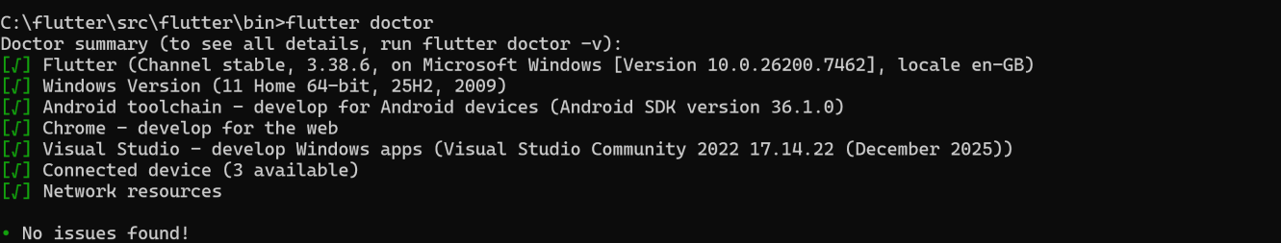
- Screenshot of flutter doctor

- Screenshot of Flutter/Dart plugin screen
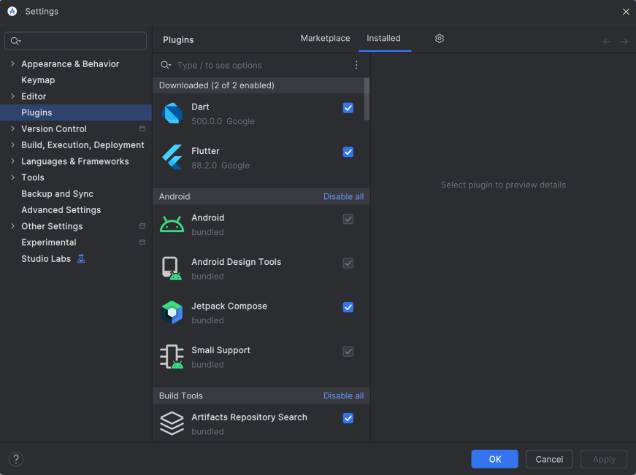
Exercise 2 – Create and Run Your First Flutter App
Goal: Learn how to create a Flutter project and run the default app.
Steps
- Open Android Studio → New Flutter Project
- Use project name: hello_flutter_lab1
- Explore key folders: lib/, android/, ios/, pubspec.yaml
- Start emulator or connect device
- Run the default counter app
- Modify the AppBar title in main.dart:
title: 'My First Flutter App',
- Use Hot Reload and observe changes
Deliverables
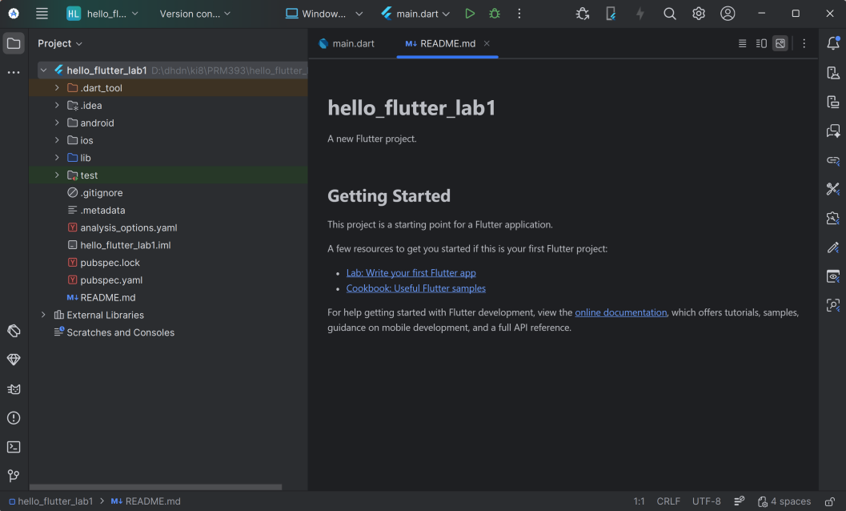
- Screenshot of project structure

- Screenshot of running counter app
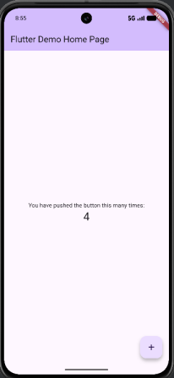
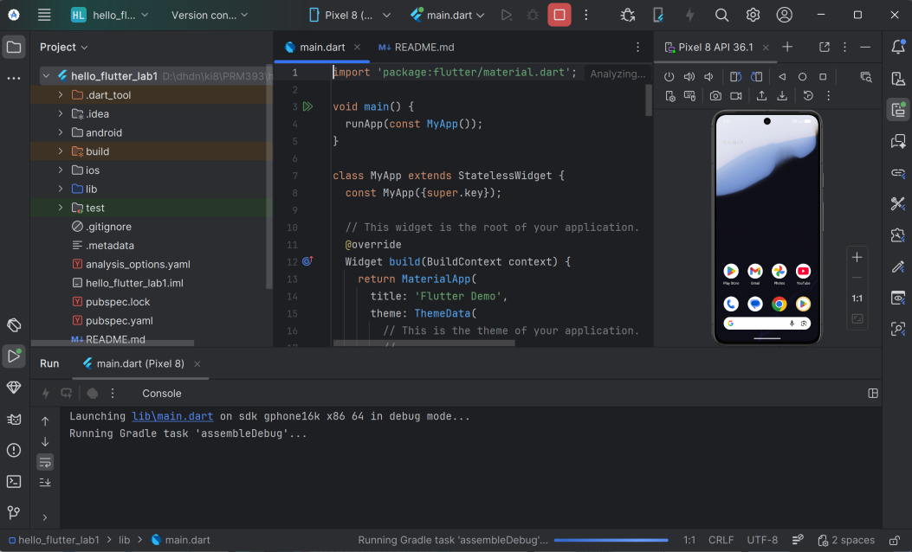

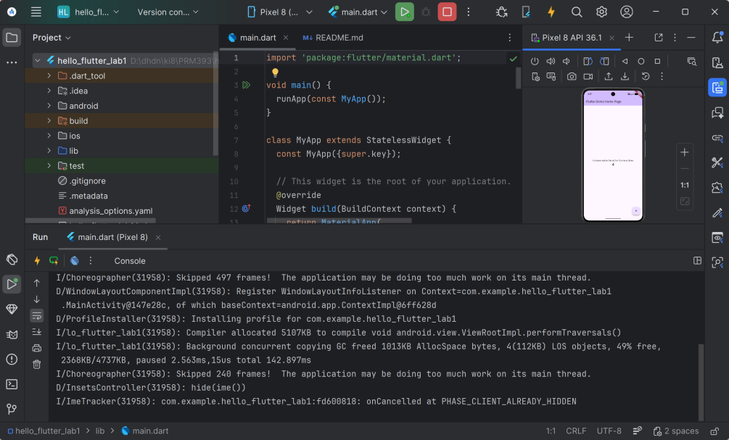
- Screenshot showing updated title via Hot Reload

Exercise 3 – Customize Your First Flutter UI
Goal: Build a simple custom UI with widgets learned in class.
Steps
- Replace default code in main.dart with:
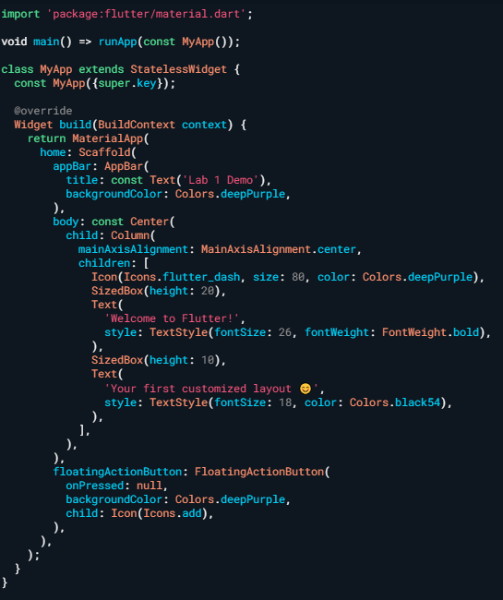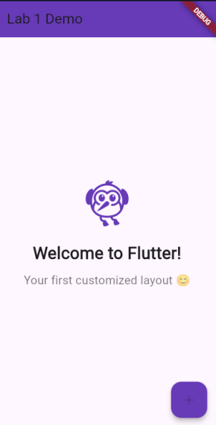
- Perform Hot Reload and verify UI updates.
- Modify colors/text and reload again.
Exercise 4 – Reflection Questions
- What is the purpose of the flutter doctor command?
This command checks your development environment to ensure all required tools are correctly installed and configured. It identifies missing components or version issues and provides a diagnosis and suggested fixes for your toolchain.
- What file acts as the entry point of a Flutter application?
The lib/main.dart file acts as the entry point. It contains the mandatory main() function where the application execution begins.
- Explain the difference between Hot Reload and Hot Restart.
• Hot Reload: Loads code changes instantly without losing the app's current state or data.
• Hot Restart: Resets the app's state and restarts the application from the beginning.
- How does runApp() build the widget tree?
The runApp() function takes a root widget and processes its build() method. This method returns a nested structure of widgets inside widgets, forming a tree that represents the entire user interface.
- Describe how Flutter’s architecture enables cross-platform development.
Flutter uses a single codebase written in Dart that compiles directly to native code for iOS, Android, and the Web. It simplifies development by using the same language for both logic and UI (known as "UI as code") and provides platform-specific folders for necessary configurations.

4. Expected Results
- Successful setup of Flutter environment
- Ability to create and run Flutter projects
- Understanding of widgets, layout, and hot reload
- Complete screenshots for all required steps

5. Submission
- Zipped Flutter project folder or GitHub link
- All screenshots
- Written answers for reflection questions

