Lab 2 – Dart Essentials Practice Lab
1. Objective
This lab helps students build a strong foundation in Dart by practicing core language features including program structure, data types, variables, collections, control flow, functions, OOP basics, null safety, async/await, and streams.
All exercises can run directly on DartPad, Android Studio, or VS Code.
2. Requirements
Complete five exercises covering the fundamental concepts of Dart:
- Basic Syntax & Data Types – practice printing output and using core types.
- Collections & Operators – manipulate lists, sets, and maps using Dart operators.
- Control Flow & Functions – implement logic using if/else, switch, loops, and functions.
- Intro OOP – create classes, constructors, inheritance, and method overriding.
- Async & Null Safety – work with async/await, Futures, and null-safety operators.
Each task must:
- Compile and run successfully.
- Print results to the console.
- Contain comments explaining the code.

3. Guided Steps
Exercise 1 – Basic Syntax & Data Types
Goal: Practice program structure and variable declarations.
Steps
- Create a main() function.
- Declare variables using: int, double, String, bool.
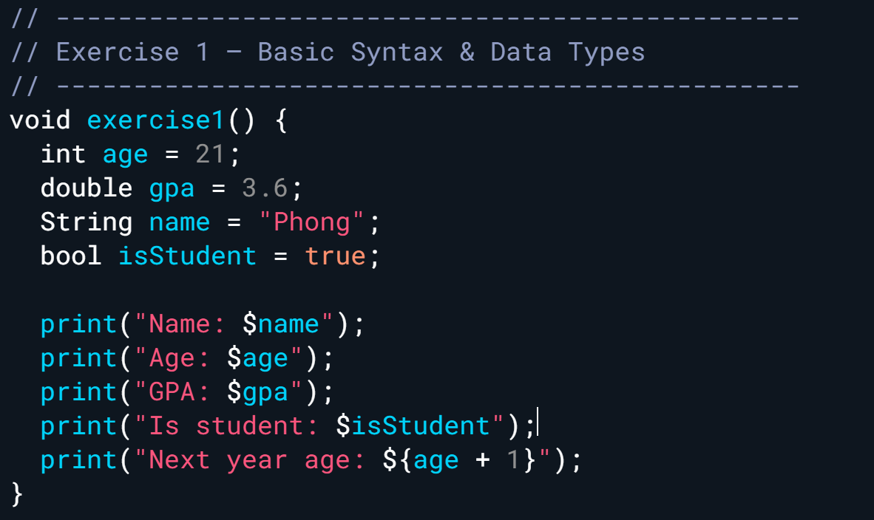
- Use print() and string interpolation ($var, ${expr}) to show values.
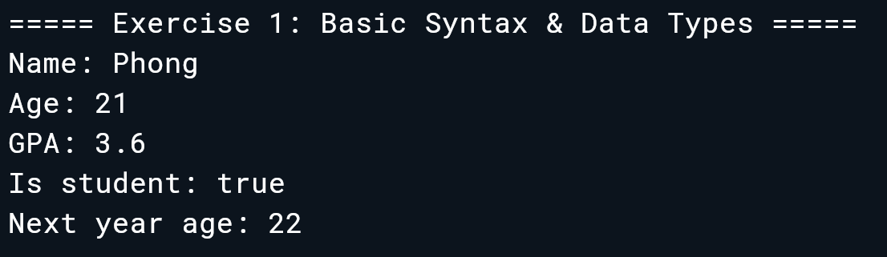
Exercise 2 – Collections & Operators
Goal: Work with List, Set, Map and operators (+, -, ==, &&, ? :).
Steps
- Create a List of integers.
- Use arithmetic & comparison operators.
- Create a Set (unique values) and a Map (key-value).
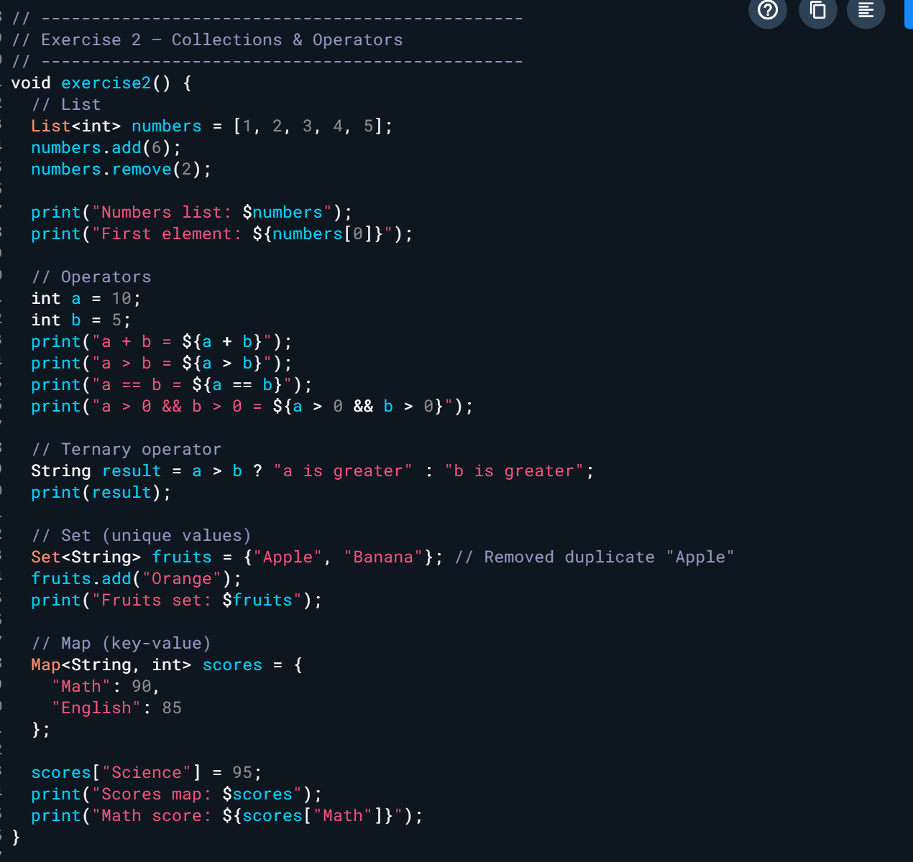
- Use indexing, add(), remove(), and map access.
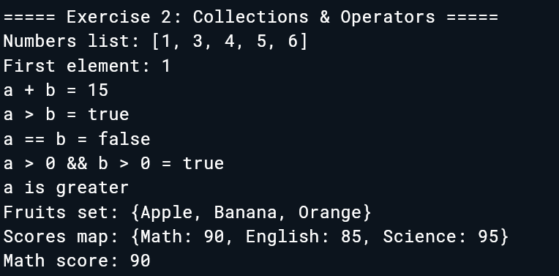
Exercise 3 – Control Flow & Functions
Goal: Apply if/else, switch, loops, and functions.
Steps
- Write an if/else block to check score.
- Write a switch case for day of week.
- Loop through a collection using for, for-in, and forEach().
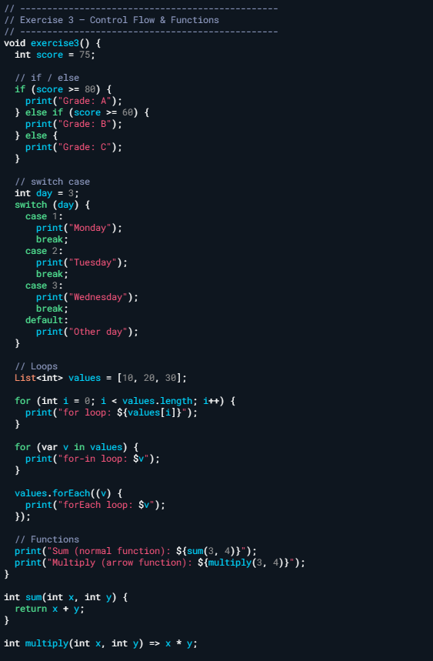
- Create a function using normal and arrow syntax.
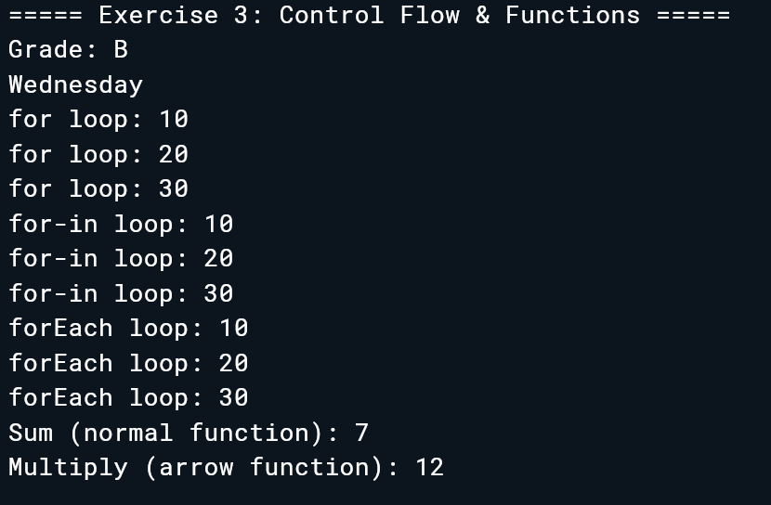
Exercise 4 – Intro to OOP
Goal: Practice classes, objects, constructors, inheritance, and overriding.
Steps
- Create a class Car with one property and a method.
- Create a named constructor.
- Create a subclass ElectricCar that overrides a method.
- Instantiate objects and print results.
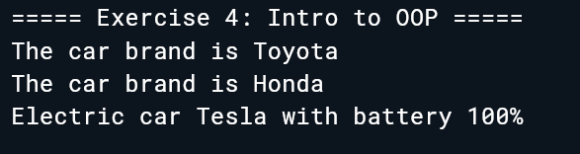
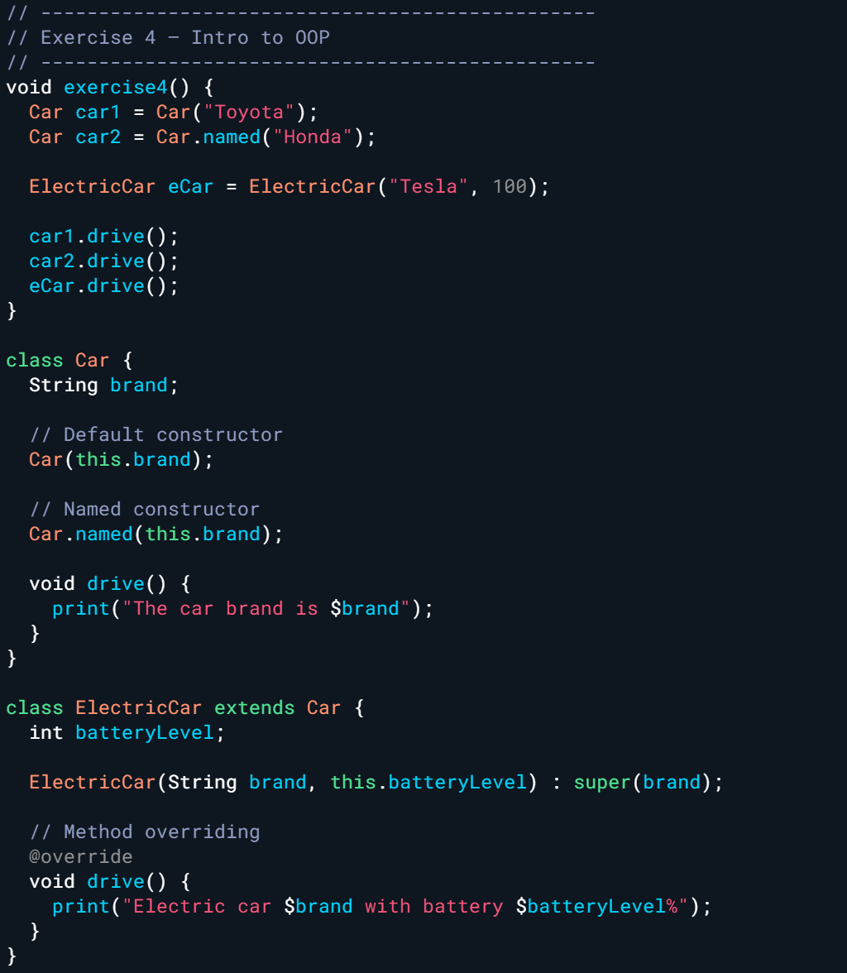
Exercise 5 – Async, Future, Null Safety & Streams
Goal: Work with Dart’s asynchronous features.
Steps
- Create an async function using Future + await.
- Use Future.delayed() to simulate loading.
- Practice null-safety operators (?, ??, !).
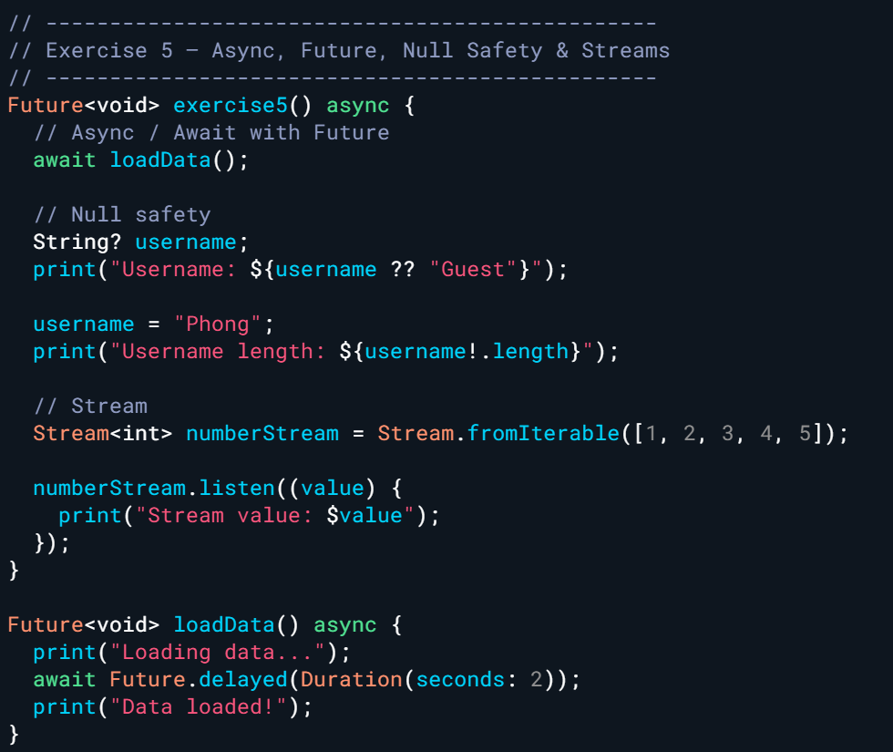
- Create a simple Stream of integers and listen to values.
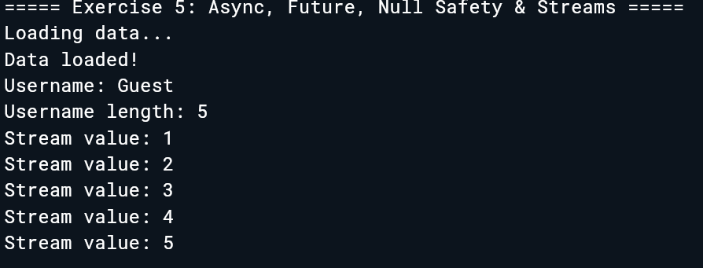
4. Expected Results
- Students execute all exercises without errors.
- Output shows correct values, loop counts, OOP behavior, and async sequencing.
- Students understand Dart essentials needed for Module 3 onward.
5. Submission
- Deliverable: A single Dart file containing all exercises, or a zipped project.
- Evaluation Criteria:
  - Correctness (40%)
  - Use of Dart features (25%)
  - Output accuracy (20%)
  - Code readability & comments (15%)
