Ihave staterd by creating pluggable database as you see in the photo below 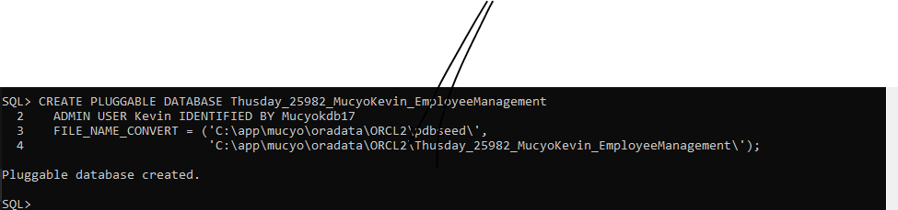

And again also I created user and assigned him previlleges as you see

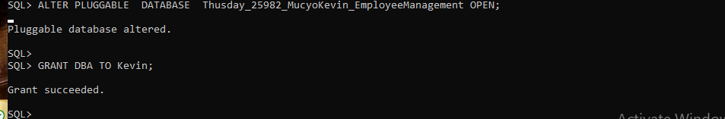

Testing perfomance of my database

