## ✅ ****Phase 6: Database Interaction and Transactions****

### Objective:

To interact with your EMS database using PL/SQL through:

DML/DDL operations

Stored **procedures**, **functions**, and **packages**

Use of **cursors**

**Exception handling**

**Testing**

### What We’ll Implement

#### 1. ****DML & DDL Operations****

We’ve already done INSERT. Now, let’s define a simple UPDATE, DELETE, and DDL example for your report.

#### 2. ****Procedure****

Fetch employee details by ID.

#### 3. ****Function****

Calculate net salary based on salary, overtime, and deductions.

#### 4. ****Cursor****

Loop through payroll and print employee payments.

#### 5. ****Exception Handling****

Catch common errors (e.g., invalid IDs).

#### 6. ****Package****

Group the procedure and function into one reusable package.

## 🧪 STEP 1: Simple DML and DDL Examples (for report)

**✅ STEP 1: Test UPDATE** 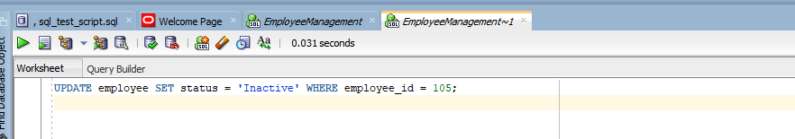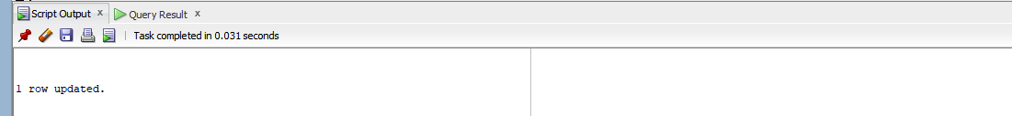

**Testing Update :**

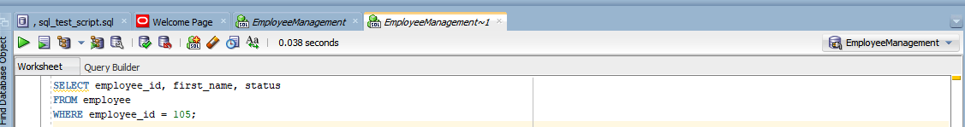

**✅ STEP 2: Test DELETE**

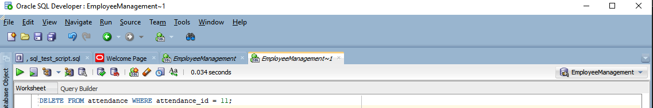

**Testing Delete:**





## ✅ STEP 3: Test ALTER TABLE:

**Testing Alter:** 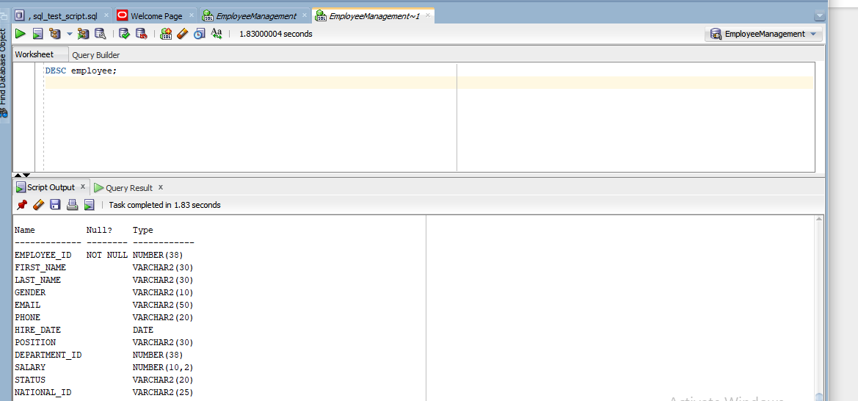

**OR:** 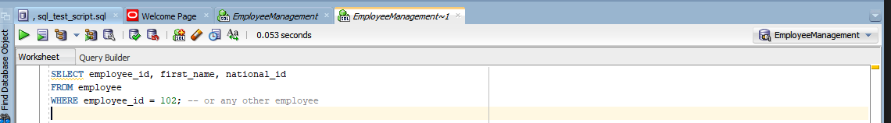

**Optionally, test inserting a value into the new column:** 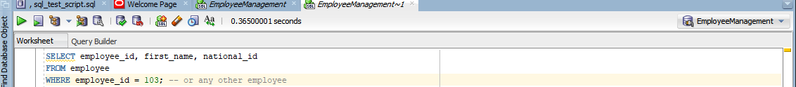

**OUTPUT:**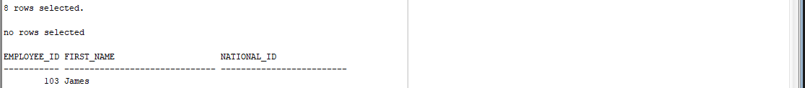

### 🔹🧪 STEP 2: Procedure – Get Employee Info by ID

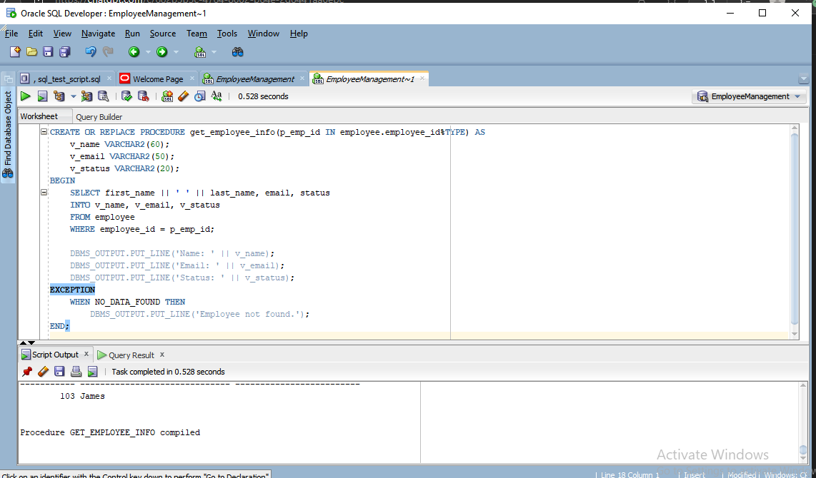

🔁 **Test it**: 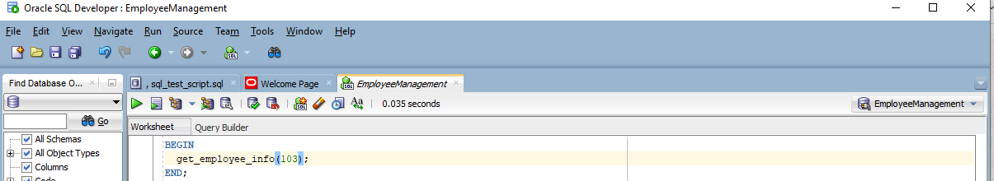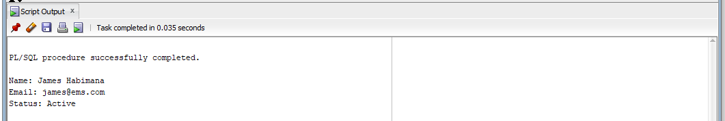

🧪 **STEP 3: Function – Calculate Net Salary**

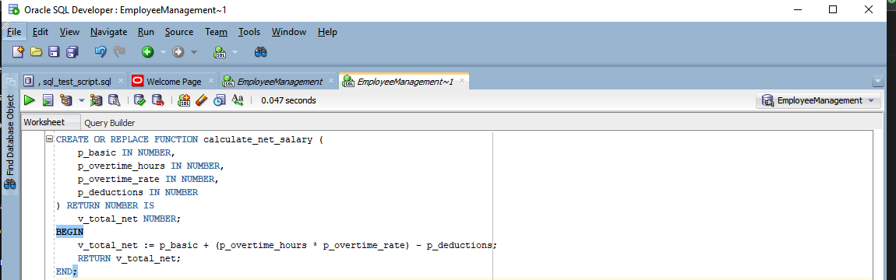

🔁 **Test it**:

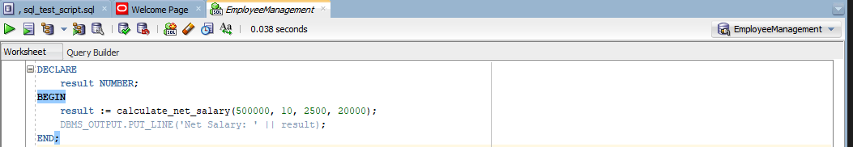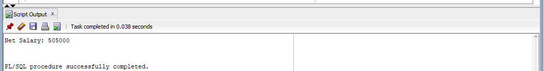

**🧪 STEP 4: Cursor – List Net Salary for All Payrolls:**

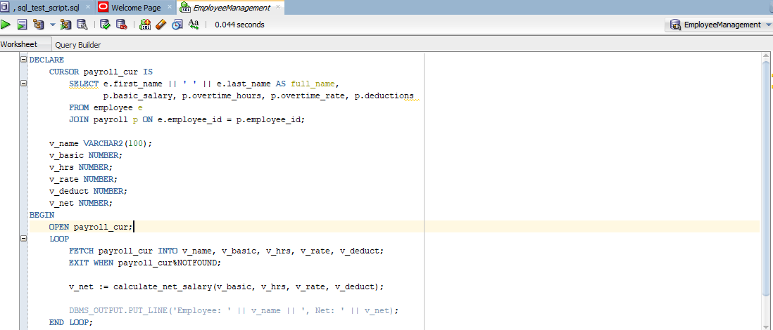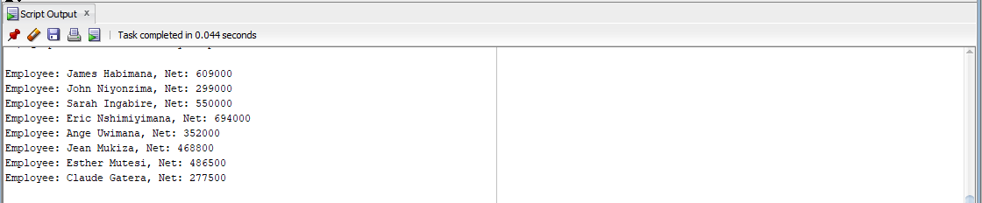

## 🧪 STEP 5: Package – Group Function & Procedure

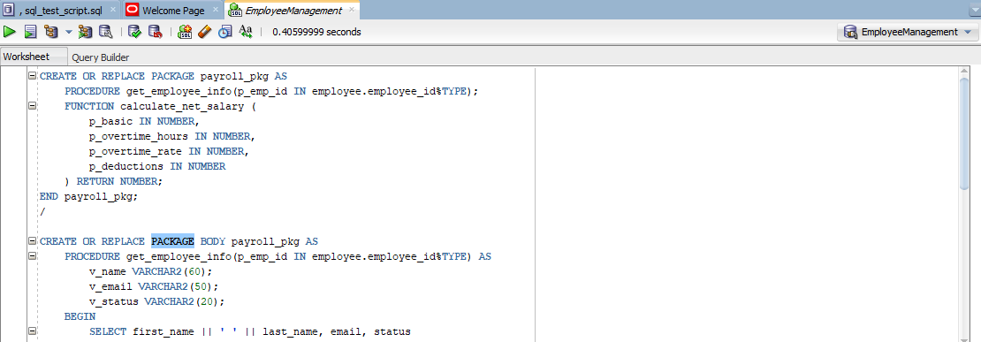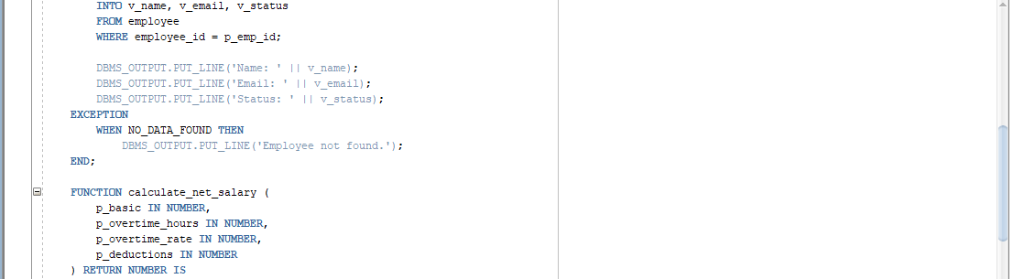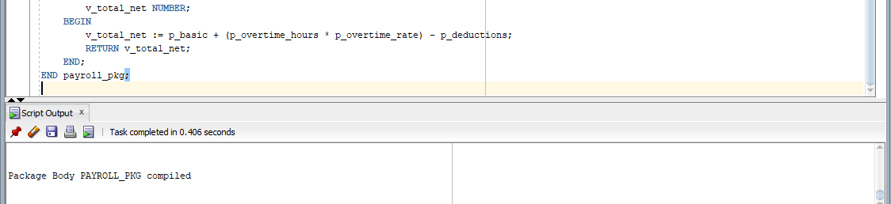

**Test the package**:

