## ✅ ****Phase 7: Advanced Database Programming and Auditing****

### Objective:

In this phase, you’ll

Write **advanced PL/SQL triggers**

Implement **auditing** and restriction logic

Enforce **security rules**, such as:

Blocking DML operations on weekdays (Mon–Fri)

Blocking operations on **public holidays** (stored in a holiday table)

Log all attempts into an **audit table** with:

User ID

Date/time

Operation

Status (allowed/denied)

## ✅ Step-by-Step Implementation Plan:

1. **Create an Audit Table:** 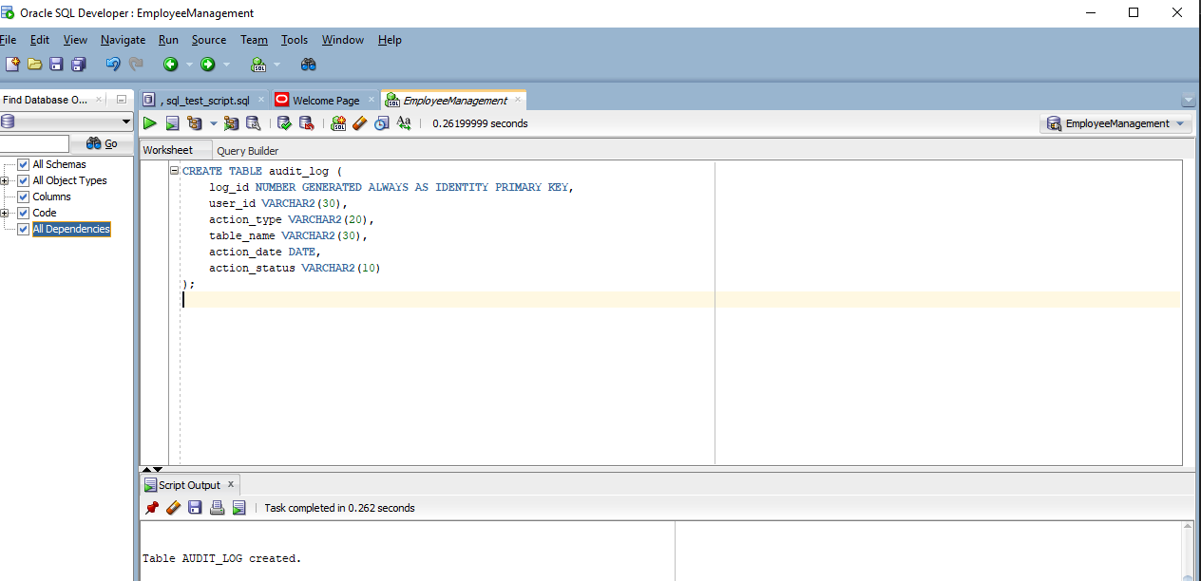

Test If Table Was Created: 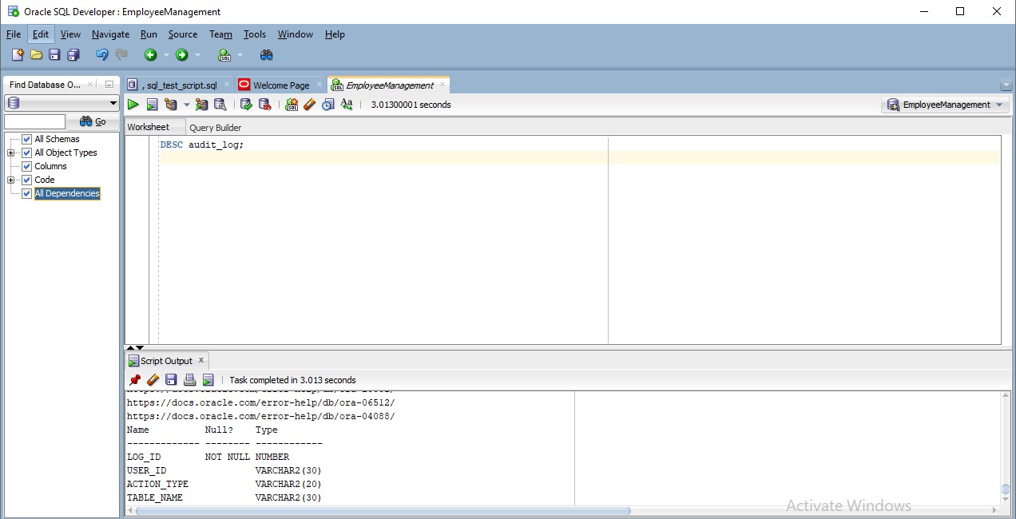

### 🧱 2. ****Create a Trigger to Block DML on Weekdays and Holidays****

## We’ll create a BEFORE INSERT OR UPDATE OR DELETE ****trigger**** on the employee table (you can apply similar logic to other tables).✅ Step 3: Test DML on Weekday or Holiday Run This UPDATE Statement

