DECLARATION
I, MUCYO TUYISENGE Rene hereby declare that the dissertation submitted for the diploma of A2 level in computer science entitled “ONLINE SCHOOL REPORTING AND INFORMATION SYSTEM” at ECOLE TECHNIQUE SAINT KIZITO SAVE, is my own original work and has not previously been submitted to any other institution of higher education.
I further declare that all sources cited or quoted are indicated and acknowledged by means of a comprehensive list of references.

Signature:
…………………………

MUCYO TUYISENGE Rene
Done on …….. /………. /2016

DEDICATION
I dedicate this final project:
- To the almighty God for his protection
- To my parents
- To my brothers and sisters
- To my colleagues and classmates
- To all my friends

BONAFIDE CERTIFICATE
I, NDIZEYE Patrick hereby certify that this project report entitled “DESIGN AND IMPLEMENTATION OF ONLINE SCHOOL REPORTING AND INFORMATION SYSTEM” is the original work MUCYO TUYISENGE Rene who carried out the research under my supervision.
I certify further that, to the best of my knowledge, the work reported here in does not form part of any other project report or dissertation.

Signature of the supervisor
……………………………
Patrick NDIZEYE

Done on ………../……………/2016

ABSTRACT
Nowadays, information and communication technology is playing a major role in the development of the world and is changing the very nature of the society itself and the way people do their jobs.
Success in any of human occupation lies more in application of information technology especially using computers and their surrounding tools as far as the ability to control the information processing and follow is concerned.

I developed this project because I realised that in Rwanda the school reporting at most high schools was still being done with the legacy paper based system which presents many disadvantages and inconvenient.
The administrator of this system will have to sign in into the system so that he may register a new student, teacher. He will have to fill the provided form in order to register him/her. He will also be able to create a new course with its teacher in charge’s information respectively. As the full control is for him he will be able to view all information about registered students, school teachers and created lessons and read comments sent by students.

This system was run successfully on different operating systems (such windows XP, windows 7 as well as 8 and window 10) and on different browsers (like Mozilla Firefox, Internet Explorer, Opera, Google Chrome).

ACKNOWLEDGEMENT
I would like to present my thanks to the staff of my school E.T. Saint KIZITO. Special thanks are addressed to my supervisor M^{r}. Patrick NDIZEYE for his tireless effort, guidance and support within my project implementation.
My sincere gratitude goes to computer science’s staff, especially its chief of technical department Patrick NDIZEYE.

I am also very grateful to my parents, relatives and friends for their valuable support throughout the years of my education.
I would not forget to appreciate the company and friendship from my colleagues especially those who contribute to the completion of this work.
Thanks to those who have so faithfully supported my life and this part in it.

TABLE OF CONTENT
DECLARATION i
DEDICATION ii
BONAFIDE CERTIFICATE iii
ABSTRACT iv
ACKNOWLEDGEMENT v
TABLE OF CONTENT vi
LIST OF TABLES viii
LIST OF FIGURES x
LIST OF ABBREVIATIONS xi
CHAP.I. GENERAL INTRODUCTION 1
1.1. Background 1
1.2. Problem statements 1
1.3. Project interest 2
1.4. Objectives of the project 2
1.4.1. General Objective 2
1.4.2. Specific Objective 2
1.5. Scope of the project 2
1.6. Methodology 2
1.6.1. Research methodology 2
1.6.2. Software development 2
1.7. Hypothesis of the project 3
1.8. Organization of the project 3
CHAP II. LITERATURE REVIEW 4
2.0. Introduction 4
2.1. Introduction to languages 4
2.1.1. HTML 4
2.1.2. PHP 4
2.1.3. Introduction to CSS 6
2.1.4. Introduction to JavaScript 7
2.2. Introduction to database 7
2.3. Introduction to MySQL server 9
2.3.1. Definitions 9
2.3.2. How MySQL use? 9
2.4. Concept of Database 10
2.4.1. Database development process used (SDLC) 10
2.4.2. Referential constraint definition 11
CHAP. III.RESEARCH METHODOLOGY AND SYSTEM ANALYSIS 11
3.1. Introduction 11
3.2. Analysis of existing system 12
3.3. Techniques 12
3.3.1. Document project technique 12
3.3.2. Techniques of interview 12
3.4. Software used 12
3.5. System Development Methods 13
3.5.1. Software Development Process Methodologies 13
2.1 Waterfall model 13
2.2 Iterative/ Incremental models 14
2.2.1 Spiral model 14
2.2.2. Prototyping model 14
2.2.3. RUP (Rational Unified Process) 14
Agile processes 15
2.3.1 XP (eXtreme Programming) 15
2.3.2 FDD (Feature Driven Development) 15
CHAP IV. SYSTEM DESIGN AND IMPLEMENTATION 17
4.1. Introduction 17
4.2. Entity Relationship Diagram 17
4.3. Data dictionary 21
Site organization 24
4.5. Some screenshots of the system 26
5.1. Conclusion 30
5.2. Recommendation 30
BIBLIOGRAPHY 31

LIST OF TABLES
Table 1: MySQL_connect() parameters 5
Table 2: MySQL syntaxes 9
Table 3: admin table 21
Table 4: courses table 22
Table 5: student’s table 22
Table 6: year table 22
Table7: Department’s table 23
Table 8: Marks table 23

LIST OF FIGURES
Figure 1: PhpMyAdmin 10
Figure 2: Prototyping model 16
Figure 3: Entity Relationship Diagram 21
Figure 4: Dean of studies privileges 26
Figure 5: administrator privileges form 26
Figure 6: Department registration page 27
Figure 7: Student’s registration. 28
Figure 8: Course registration 28
Figure 9: Student’s report. 29

LIST OF ABBREVIATIONS
Admin: Administrator
DB: Database
ETS: Ecole Technique Saint KIZITO SAVE
SQL: Structured Query Language
PHP: Hypertext Preprocessor
DML: Data Manipulation Language
DCL: Data Control Language
DDL: Data Definition Language
ID: Identification
PWD: Password
ERD: Entity Relationship Diagram
XAMPP: Extended Apache MySQL PHP PERL

CHAP.I. GENERAL INTRODUCTION

1.1. Background
Information system technology is widely used and is rapidly becoming a common asset of modern socio-economic life in this new world.

Our country Rwanda has a long way to attain success in this area. Software development and the use of automated systems, network system development the need to share resources within the country and with the outside world, is what among other things that hold largely the degree of measure of development in the Rwandan society.

Given the typical nature of information technology evolving day after day, there are wide ranges of activities that must be executed to implement ICT strategic activities presented as interactive and ONLINE information. Among these activities, software development projects are made put into action to reinforce the quest for automated systems in companies, institutions, academic institutions and organisations.

Ecole Technique Saint Kizito Save within computer science options, it is starting building up.
I decided to orient my research in developing a ONLINE School Reporting And Information System that would help and replace the existing paper based systems and it would reduce tasks and time taken by the teachers and dean of study to recopy the recorded information into computers. All this will be carried under a research topic entitled: “ONLINE SCHOOL REPORTING AND INFORMATION SYSTEM”

1.2. Problem statements
All over the world, Africa and Rwanda in particular, ONLINE school reporting and information system was done in different ways which is somehow difficult or legacy, for example: record marks of students, on papers , Rewriting the information recorded on papers into computers which is sometimes not accurate (errors can occur while writing).
The paper based system presents some disadvantages including: time consumption and many problems can also arise from there like loss of stored documents which can cause so many difficulties to use papers.
After realizing that students who finished their courses are still get their reports after return to their schools and waste their money, l made this project so as to get their collected report easy.
.

1.3. Project interest
The development of this project presented the following opportunities:
- To increase the knowledge in ICT application by using computer based systems.
- To promote information technology applications in various organizations
- To reduce the time and transport fees students paid to go back to school where their report is when finished their courses.
- To reduce time consumption while the recording student’s marks is going on

1.4. Objectives of the project

1.4.1. General Objective
The general objective of this project is to develop a reliable system that will be more useful and more accurate compared to the existing paper based system.

1.4.2. Specific Objective
The specific objective of this project is to develop a system that will be able to store information about students and their marks, permit the dean of study to record students and teachers and provide a school report to the students themselves.

1.5. Scope of the project
Since ONLINE school reporting and information system has much functionality and different service.my project handles few of them due to time and cost constrain including:

1.6. Methodology

1.6.1. Research methodology
Interview was the main methodology used in the development of this project.
The ETS library is the main source of books that helped our research to understand basic concepts and terminologies, which has been used during the whole process.
Consultation of our courses syllabus
The internet helped us as a wide resource to gather and gain knowledge related to this work.

1.6.2. Software development
The scientific methodology used in this research is iterative model which is a sequential software development process, in which progress is seen as flowing steadily downwards (like water fall) through phases.

1.7. Hypothesis of the project
ONLINE School Reporting and Information system service in such recording marks, and recording students can be moved from legacy paper system to computerized way.so that service can be good. With this they can reduce time consumption.

1.8. Organization of the project
This project is subdivided into 5 chapters.
CHAPTER.I. General Introduction
CHAPTER.II. Literature review
CHAPTER.III. Research methodology
CHAPTER.IV. System design and implementation
CHAPTER.V: Conclusion and recommendation

CHAP II. LITERATURE REVIEW

2.0. Introduction
This chapter explains related theoretical work or references used to develop the
ONLINE School Reporting And Information System and a background of the system. It also expounds on technologies to be used with a view of providing an overview for the concept of the system’s design.
The World Wide Web uses many languages to develop and perform tasks on websites. The most common languages are HTML, PHP, JAVA script, ASP/NET, Cold Fusion, XHTML, XMHL, DHTML, etc….
To facilitate the work to programmers, many other tools have been developed to help programmers. These tools are for example XAMMP, WAMP servers etc…..

2.1. Introduction to languages

2.1.1. HTML
HTML (Hyper Text mark-up Languages) is a language used to create and to describe the web pages. It is simply a collection of certain keywords called “tags” that are helpful in designing a document to be displayed using a browser on internet.

Description of tags
The <Html> tag encloses all other HTML tags and associated text within your document. The <Head> tag comes after the Html start tag. It contains title tag to give the document bar at top bar.
The <Body> tag contains all the text and graphics of the document with all the HTML tags that are used for control and formatting of the page.
To read html documents and displays them as web pages; we need a browser such as Mozilla, Internet explorer, Opera, etc….
Browser is the set of instruction programmed to interprets the html tags (code) and display it on the browser as a web page.

2.1.2. PHP
PHP is a powerful server-side scripting language for creating dynamic and interactive websites.
Connecting PHP on Database Using Functions
To connect PHP on database we deal with some basic function used when working with database and each function is prefixed with the string “MySQL”. There are some of the functions used to connect and work with database:
MySQL_connect ( );
Before accessing data in a database, you must create a connection to the database. This function has three parameters (server name, username, password)
Parameters | Description
Server name | Specify the server name to connect to. By default value is ”localhost”
Username | Specify the username to log in with. Default value is the name of the user that owns the server process
Password | Specify the password to login with. Default is””
Table 1: MySQL_connect() parameters

MySQL_select_db ();
Once you connect, you can select db. to use through the connection with this function.
MySQL_select_db (“name of database”)
MySQL_query (); is used to run the query and returns a result set handle resource, by declaring a variable used to run the query.
Example: $row=MySQL_fecth_row(“Query to be executed”)
MySQL_close (); this function is used to disconnect your database on MySQL server by using function before closing PHP statement.

Using Variables in PHP
With PHP the variables name must answer some criteria:
- A variable name must start with the letter (capital or small) or an underscore (“_”) not the numbers
- A variable name can include some letters, of the number and the _temper (the spaces are not allowed)

Variable $_POST And Variable $_GET
One of the best features of PHP is the possibility to respond to user queries or data submitted from html forms. You can process information gathered by an html form and use PHP code to make decision based on this information to create dynamic webpage. There are two methods used: Post and Get
- $_POST: is the method used to send information. The information sent from the html from with the POST method is invisible to others and has no limits on the amount of information to be sent.
- $_GET: is also the method used to send information as $_POST method. The information sent from the html form with the $_GET method are displayed in the URL bar.
Note: the $_GET method should not be used when sending password or other sensitive information and this is not suitable for the large variables cause the value cannot extended to 100 characters.

2.1.3. Introduction to CSS
CSS: stands for Cascading Style Sheets (CSS) is a single mechanism for adding style. It gives up more control over the appearance and presentation of your pages. Using cascading style sheets you can extend the ability to process by specifying the location and appearance of element on a page and create special effects.
Types of CSS
CSS have three types: External, Internal and Inline style. You can use each style to build a webpage.

How to Insert a Style Sheet
When a browser reads a style sheet, it will format the document according to it. There are three ways of inserting a style sheet:
External Style Sheet
An external style sheet is ideal when the style is applied to many pages. With an external style sheet, you can change the look of an entire Web site by changing one file. Each page must link to the style sheet using the <link> tag.
The browser will read the style definitions from the file mystyle.css, and format the document according to it. (mystyle should be the name of the css file that contains all styles).
An external style sheet can be written in any text editor. The file should not contain any html tags. Your style sheet should be saved with a .css extension.
Internal Style Sheet
An internal style sheet should be used when a single document has a unique style. You define internal styles in the head section by using the <style> tag.
Inline Styles
An inline style loses many of the advantages of style sheets by mixing content with presentation. Use this method sparingly, such as when a style is to be applied to a single occurrence of an element.

2.1.4. Introduction to JavaScript
What is JavaScript?
JavaScript is a language designed to add interactivity to HTML pages. JavaScript is a scripting language. A scripting language is a lightweight programming language. JavaScript is usually embedded directly into HTML pages. JavaScript is an interpreted language (means that scripts execute without preliminary compilation).

Difference between Java and JavaScript
Java and JavaScript are two completely different languages in both concept and design! Java (developed by Sun Microsystems) is a powerful and much more complex programming language - in the same category as C and C++.
What can a JavaScript Do?
- JavaScript gives HTML designers a programming tool - HTML authors are normally not programmers, but JavaScript is a scripting language with a very simple syntax. Almost anyone can put small "snippets" of code into their HTML pages.
- JavaScript can read and write HTML elements - A JavaScript can read and change the content of an HTML element
- JavaScript can be used to validate data - A JavaScript can be used to validate form data before it is submitted to a server. This saves the server from extra processing
- JavaScript can be used to detect the visitor's browser - A JavaScript can be used to detect the visitor's browser, and depending on the browser load another page specifically designed for that browser

2.2. Introduction to database
Definition of database
A database is an organized collection of logically related data which are stored in form of tables.
Data
Historically the term data is referred to as a row fact that could be recorded and stored in computer. For example (in workshop database, the data would include facts such as materials of workshop, administrator name, address and telephone number). This definition needs to be extended, to reflect a new reality of database. Database is used to store objects such as document, image sounds even video segments.

Database environment
Database (DB) is used to store, manipulate and retrieve data easily in nearly every type of organization including business, health care, education, government and libraries. Database technology is used by individual on pc work group accessing database on network services and by all employees using pricewise distributed application.

Case tools: used to design database and application
Repository: a centralized area to collect data.
DBMS: Database Management System is a suite of software applications that enable users or businesses to store, modify, and extract information from a database.
User interface: language, menus, and other facilities by which user interact with various system components such as case tools application programs, DBMS and repository.
Data administrators: persons who are responsible for the overall information resources of an organization.
System developer: persons such as system analysts and programmers who design new application programs.
End-user: persons throughout the organization who add delete and modify data in the databases and who request or receive information from it.

Information: The term information is related in fact one often useful to distinguish between data and information, we define information as data that have been processed.
Importance of database
From definition we have seen that database is organized collection of logically related data, here database is used to store, manipulate and retrieve data any time they are needed.

Introduction to SQL Database
Definitions
SQL standard for (Structured Query Language) uses Data Definition Language (DDL), Data Manipulation Language (DML), and Data Control Language (DCL) in relational databases.
The Data Definition Language (DDL) is a language which permits a user to create and define tables in a database.
The Data Manipulation Language (DML) allows to SELECT, UPDATE, DELETE and INSERT data in database, simply is a language which permits data to be manipulated in a database.
The Data Control Language (DCL) allows the user to define the permission level of users of database.

Importance of SQL
- SQL can create stored procedures in database.
- SQL can set permission on tables and views.
- SQL can insert records in database.
- SQL can create view data in a database
Some Clauses Used In SQL or MySQL and Syntaxes
SQL | SYNTAX
SELECT | SELECT <col1>from<table>
INSERT | INSERT into <table>value (val1,val2,) or (col1,col2)value (val1,val2)
UPDATE | UPDATE<table>SET<col>= new value WHERE <col>=current value
ORDER BY | Select<column>from<table> order by <column>
DELETE | DELETE FROM<table>WHERE<column>=value
ALTER TABLE DROP | ALTER TABLE<table> DROP<column>
ALTER TABLE ADD | ALTER TABLE<TABLE> ADD<column>
WHERE | Select <column>from<table>WHERE<operation><val1>
BETWEEN ….AND | Select<column>from<table>where<column>BETWEEN val1 AND val2
NOT BETWEEN...AND | Select<column>from<table>where<column>NOT BETWEEN val1 AND val2
Table 2: MySQL syntaxes

2.3. Introduction to MySQL server

2.3.1. Definitions
MYSQL standard for My Structured Query Language is opened the DBMS relation that uses SQL. Is used to create the application websites used to execute in UNIX.

2.3.2. How MySQL use?
- MYSQL is ideal for both small and large application.
- MYSQL supports standard sql
- MYSQL compiles on number of platform

Use of PhpMyAdmin in Creating DB
Introduction
PhpMyAdmin can manage a whole MySQL server as well as a single database. To accomplish the latter you'll need a properly set up MYSQL user who can read/write only the desired database.
Currently PhpMyAdmin can browse and drop databases, tables, views, fields and indexes; create, copy, drop, rename and alter databases, tables, fields and indexes, maintenance server, databases and tables, with proposals on server configuration, execute, edit and bookmark any SQL-statement, load text files into tables, create and read dumps of tables export data to various formats: XML, PDF, Open Document Text and Spreadsheet, Word and Excel formats , administer multiple servers, manage MySQL users and privileges, using Query-by-example (QBE), create complex queries automatically connecting required tables, create PDF graphics of your Database layout, search globally in a database or a subset of it, transform stored data into any format using a set of predefined functions, like displaying data as image or download-link, support tables and foreign keys , support MySQL and the improved MySQL extension.

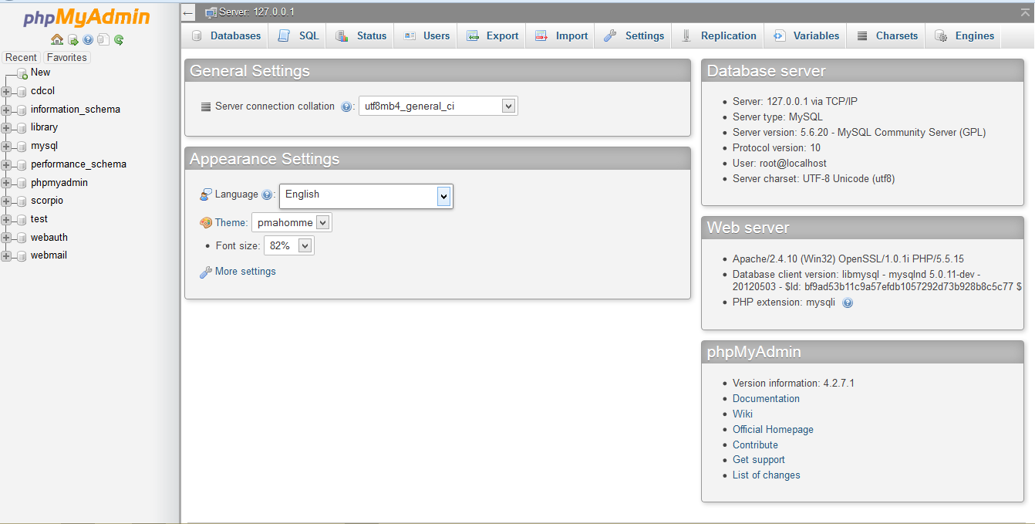
Figure 1: PhpMyAdmin

2.4. Concept of Database

2.4.1. Database development process used (SDLC)
This database development process is concerned to the process of conducting information, the System Development Life Cycle (SDLC) is a complete set of steps that a team of information system and programmers follow in an organization to specify , to develop, to maintain and replace information system.
This process is viewed as cascade of steps the output of each step is an input of the next step. It is also possible to back track to previous steps when prior discuss need to be reconsidered.

2.4.2. Referential constraint definition
The referential constraint defines a foreign key which consists of one or more column in the table that together must match the primary key (or else be null) of the specified table.
A foreign key value is null when only one of the columns is the row comprising the foreign key. Once the foreign key constraint is defined, the DBMS will check every insert and update to ensure that the constraint is observed.
The references table-name specifies the name of the existing table that contains the primary key which cannot be the name of the table being created. The delete clause defines the action taken when a row is deleted from the table containing the primary key. There are three options:
1. RESTRICT present deletion of the primary key row until all corresponding rows in related table, the one containing the foreign key, have been deleted. This is the default value for the clause and also caution approach for preserving data integrity.
2. CASCADE causes all corresponding rows in the related table also to be deleted.
3. SET NULL sets the foreign key to null for all corresponding rows in the related table.

INSERTION OF DATA IN DATABASE
We use insert command for entering data or inserting new row in the table or name of the table.
SYNTAX: insert into name of table value (val1, val2…)
Insert into NAME OF TABLE values (column1, column2) values (value1, value2)

DELETING DATA INTO DATABASE
For deleting data in database use the keywords DELETE and clause WHERE from table name.
SYNTAX: delete from table where qualification (values)

UPDATING DATA IN DATABASE
To update data in database use the command.
SYNTAX: update<table>set<column=new value>where <column>=current value.

CHAP. III.RESEARCH METHODOLOGY AND SYSTEM ANALYSIS

3.1. Introduction
Methodology refers to a set of methods and principles that are used when projecting a particular kind of work. Research methods refer to a number of ways of arriving at the knowledge regarding that research. This research is carrying out to develop and implement a ONLINE School Reporting and information System. This chapter is a review of analyses of the existing system of a web based application, techniques and the software development process model that will be used as the methodology, for building this Online school reporting and information system
The software development process model chosen for this project is the “Waterfall “model. It is commonly used for web application.

3.2. Analysis of existing system
The initial step while developing an application program consists exactly to find out what to be solved and what should be done. All those features help the developer to find out what the requirements specifications that the system will use are, what the users are and what is the benefit of the application. There’s application that the schools use during the school reporting process, so they use the traditional system characterized by papers, others have more functionalities other than school reporting which is the major bases of bottle neck of services delivery and bad results during the data collection. I compared the existing system process used at different schools, with the new proposed system, in order to better analyze the operational system. It is noted that the existing system is paper-based and large project of school reporting and information systems. Data recording and retrieving are done manually; or getting the forms to large software, which can result in some inconvenience such as easy loss of data and the lack of accessibility of information about the system.

3.3. Techniques

3.3.1. Document project technique
This technique permits the researcher to consult books, reviews, project report, class notes, and webpages related to the subject of this work.

3.3.2. Techniques of interview
To understand deeply the requirements and the problem domain, some techniques will help to achieve the aim of this work. The main technique used is” Interview schedule”.

3.4. Software used
Xampp
XAMPP is developed by Apache Friends to promote the Apache web server. Apache Friends was founded in the spring of 2002 by Kai ‘Oswald’ Seidler and Kay Vogelgesang. Its Alexa rank is 7,939 as on today. Because, I use any software or website based on its alexa rank, I am mentioning its rank here to help my blog readers. XAMPP Acronym is X or extended (Apache, MySQL, PHP, PERL); Apache Friends developed this software to help the people to install and configure Apache web server along with MySQL, PHP and Perl.
So, when I was releasing my project I used this software in order to be connected together with Mysql database, PHP and Apache as a web server within local host. And also to be able to acces Mysql database through graphical interface of web browser by using one feature of Xampp called PHPMyAdmin.
Web browser
A web browser (commonly referred to as a browser) is a software application for retrieving, presenting and traversing information resources on the World. An information resource is identified by a Uniform Resource Identifier (URI) and may be a web page, image, video or other piece of content. Hyperlinks present in resources enable users easily to navigate their browsers to related resources.
Although browsers are primarily intended to use the World Wide Web, they can also be used to access information provided by web servers in private networks or files in file systems.
The major web browsers are Google Chrome, Mozilla Firefox, Internet Explorer, Opera, and Safari.
The primary purpose of a web browser is to bring information resources to the user ("retrieval" or "fetching"), allowing them to view the information ("display", "rendering"), and then access other information ("navigation", "following links").
This process begins when the user inputs a Uniform Resource Locator (URL), for example http://w3schools.com/, into the browser. The prefix of the URL, the Uniform Resource Identifier or URI, determines how the URL will be interpreted.
Sublime text 3
Sublime text 3 is a text editor and source code editor for Windows. It aims to be a lightweight and robust editor for a variety of programming and scripting languages. One advantage of Sublime text 3over the built-in Windows Notepad text editor is that Sublime text 3 supports tabbed editing, which allows working with multiple open files. Sublime text 3 opens large files significantly faster and can be used as a replacement for Windows Notepad and notepad++.

3.5. System Development Methods

3.5.1. Software Development Process Methodologies
The software development process focus on the phase of activities directly related to production of the software, for example design, coding, and testing.

Any software development process is divided into several logical stages that allow a software development company to organize its work efficiently in order to build a software .Model show is how to arrange these processes or steps of SDLC.
The most common software development models applied for the development process are:

2.1 Waterfall model
Waterfall model is the oldest concept of software development model to start from RA&D process and proceed to next process one by one.
There the outputs of the first activity flow into the second and these outputs flow into the third and so on. In a waterfall model each activity must be completed before the next activity starts.

2.2 Iterative/ Incremental models

One of the most popular alternative for waterfall model is iterative models, which repeats (iterates) the sequence of software development processes. Is a cyclic software development process developed in response to the weaknesses of the waterfall model. It starts with an initial planning and ends with deployment with the cyclic interaction in between. Incremental model is also a kind of iterative model to start with small portion of target system and gradually adding the functions and portions to it. Depending on how these iteration and increment occurs, there are following popular models.

2.2.1 Spiral model

Spiral model is one of the first proposed alternative to waterfall model. It combines the process of waterfall model and prototyping. It adds iterative planning and risk analysis processes to reduce the risk of requirements change.

2.2.2. Prototyping model

Prototyping is developed based on the currently known requirements and is designed for online systems which are OOA. By using this prototype, the client can get an “actual feel” of the system, since the interactions with prototype can enable the client to better understand the requirements of the desired system. Prototyping is an attractive idea for complicated and large systems for which there is no manual process or existing system to help determining the requirements.
Prototyping process is said to be an iterative process as it helps to fulfill the needs of the users and customers depend on the moment.

2.2.3. RUP (Rational Unified Process)

The Rational Unified Process (RUP) is an iterative model for object-oriented software development with large scale of area and complex data. It is originally created by the Rational Software Corporation, now a division of IBM. RUP is not actually a single process, but rather an adaptable process framework with large number of activities that can be customized and tailed to individual software development project.

Agile processes
Agile processes are also based on the iterative model. But agile processes are radically different from other iterative processes in the way of performing tasks for individual engineer. Agile processes have more human-centric viewpoint than traditional approaches. They use feedback, rather than planning, as their primary control mechanism.
Below is the key difference of agile processes from conventional processes.

XP (eXtreme Programming)

XP is the best-known agile process. In XP, the iterations are performed in extremely small (or "continuous") steps compared to conventional processes. The (intentionally incomplete) first pass through the steps might take a day or a week, rather than the months or years of each complete step in other models. Actually XP is not exactly a software development model, but rather a collection of best practices for programmer. There are 13 core practices in XP as shown below.

FDD (Feature Driven Development)
FDD is another kind of agile process that focuses on the decomposition of target software into “features”, which can be described as a use case (such as in UML).

In my case I used prototyping model which is developed based on the currently known requirements and is designed for online systems that are OOA. It start from initial investigation in order to verify the weakness of existing system and how to replace it with a new system.
Advantages of Prototype model
- Users are actively involved in the development
- The users get a better understanding of the system being developed.
- Errors can be detected much earlier.
- Quicker user feedback is available leading to better solutions.
- Missing functionality can be identified easily
- Confusing or difficult functions can be identified in Requirements validation step

Disadvantages of Prototype model

- Requirements may frequently change significantly.
- .Identification of non-functional elements is difficult todocument.
- Practically, this methodology may increase the complexity of the system as scope of the system may expand beyond original plans (difficult to precise the scope).

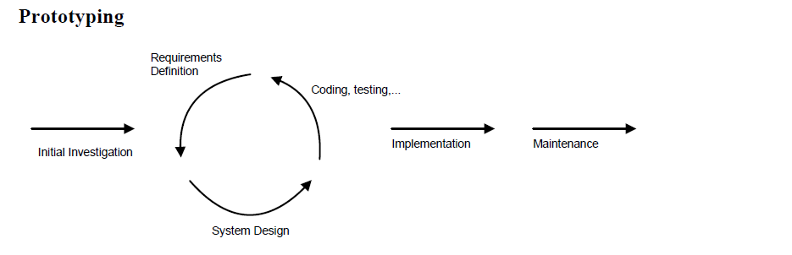
Figure 2: Prototyping model
Situation where most appropriate
- Where Projects are an online system requiring extensive user dialog.
- Where Project is large with many users, interrelationships.
- Where functional requirements may change frequently and significantly
- Where there are Innovative, flexible designs that will accommodate future changes are not critical (seriously) means future scalability is unlimited depend on technology
- Where no strict requirement

Situation where least appropriate

- Office automation system
- Project team composition is unstable.
- Future scalability of design is critical(serious)

CHAP IV. SYSTEM DESIGN AND IMPLEMENTATION

4.1. Introduction
This chapter explains a bit more about the development of ONLINE SCHOOL REPORTING AND INFORMATION SYSTEM. It therefore illustrates the entity relationship diagram, data dictionary and some screenshots of the system.

4.2. Entity Relationship Diagram
Symbols:
Entity: is an existing, object, concept or real thing that is uniquely identifiable where is used for storing the organizational data.
Its symbol is a box:

Attribute: is a part of the description of the entity. The entity itself is described by one or more attributes together; they describe all things of importance about the entity.
Its symbol is an oval:

Relation: is an association between several entities; it is on ordered pair consisting of particular related entities.
Its symbol is a diamond:

Line: is used to join entities to their attributes, and joining entities with their relations
Its symbol is a line:

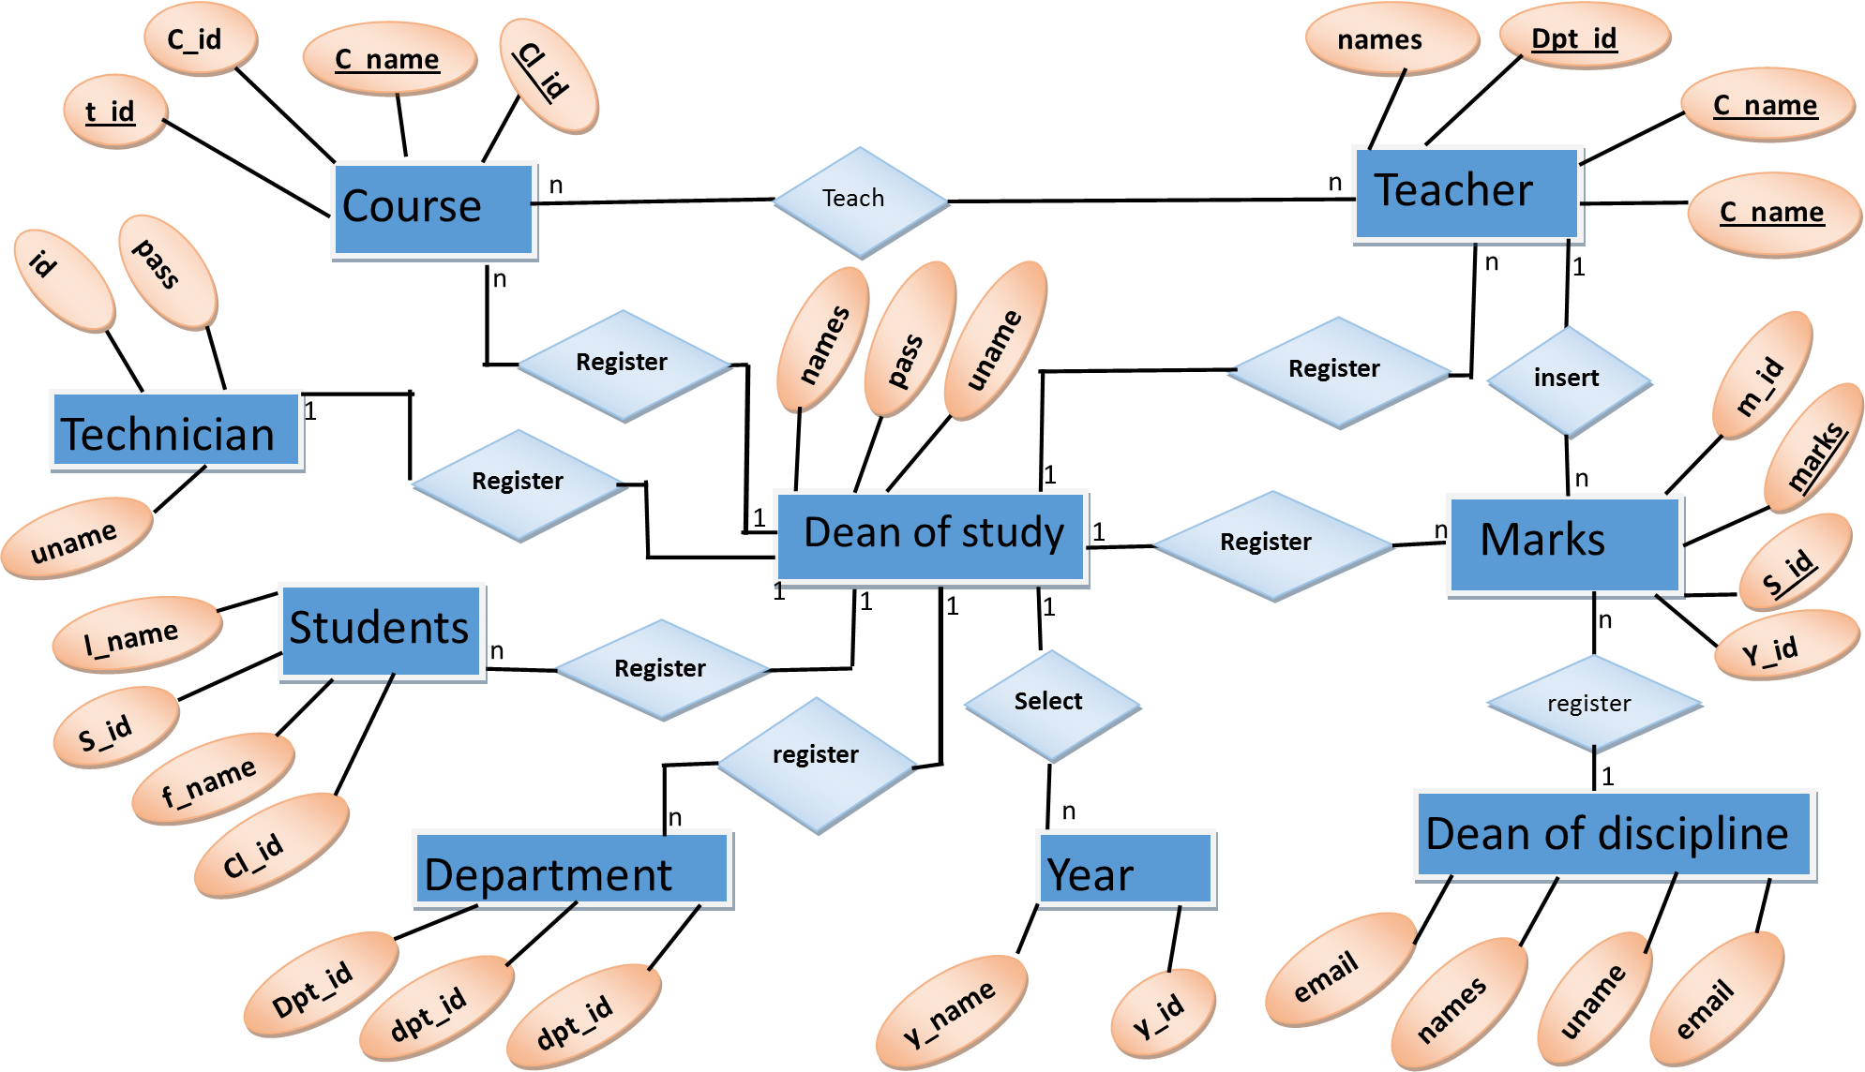
Figure 3: Entity Relationship Diagram

4.3. Data dictionary
Here is a list of tables that have been used in the database
Admin: this is the table used for storing the dean of studies informations.
Table name | Attributes | Type | Length | Occurrence
Admin | ID | Int() | 11 | Primary key
Admin | Names | Varchar() | 255
Admin | Emails | Varchar() | 255
Admin | Username | Varchar() | 255
Admin | Password | Varchar() | 255

Table 3: admin table
Courses: this table is used to store the courses which belongs to school
Table name | Attributes | Type | Length | Occurrence
Courses | ID | Int() | 11 | Primary key
Courses | CourseNames | Varchar() | 255
Courses | acronym | Varchar() | 255
Courses | Maximum | Varchar() | 255
Courses | T_id | Int() | 11 | Foreign key
Courses | D_id | Int() | 11 | Foreign key
Courses | Cl_id | Int() | 11 | Foreign key

Table 4: courses table
Students : this table is used to store the student’s information.
Table name | Attributes | Type | Length | Occurrence
Students | ID | Int() | 11 | Primary key
Students | First name | Varchar() | 255
Students | Surname | Varchar() | 255
Students | DOB | Varchar() | 255
Students | Username | Varchar() | 255
Students | password | Varchar() | 255

Table 5: student’s table
Years: this table is used to store academic year’s records.
Table name | Attributes | Type | Length | Occurrence
Admin | Y_id | Int() | 11 | Primary key
Admin | year | Varchar() | 255

Table 6: year table
Department: This table is used to store department information
Table name | Attributes | Type | Length | Occurrence
Admin | ID | Int() | 11 | Primary key
Admin | Names | Varchar() | 255
Admin | Emails | Varchar() | 255
Admin | Username | Varchar() | 255
Admin | password | Varchar() | 255
Table7: Department’s table
Marks: this is the table used for store the student’s marks.
Table name | Attributes | Type | Length | Occurrence
Admin | M_id | Int() | 11 | Primary key
Admin | StudentId | int() | 255 | Foreign key
Admin | Student’s marks | Int() | 255
Table 8: Marks table

Site organization

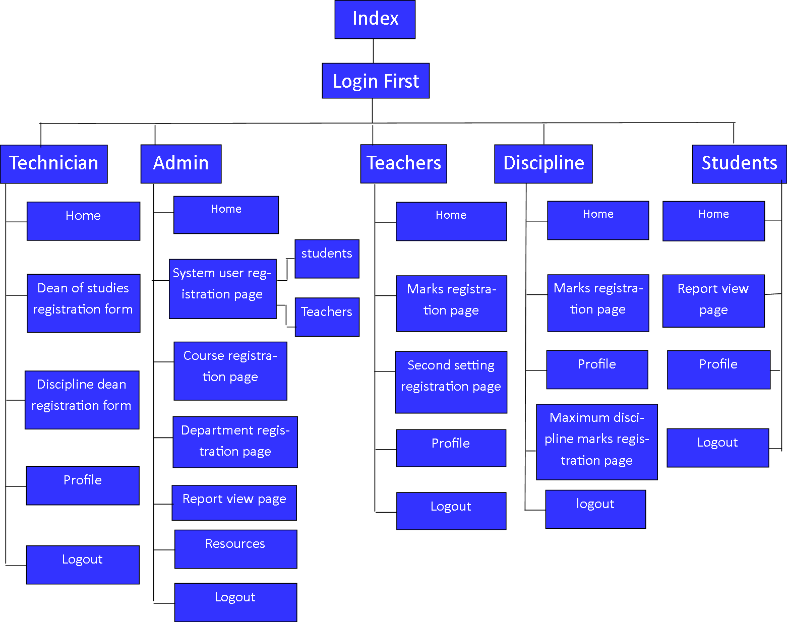

4.5. Some screenshots of the system
Index page
This is the first page that appears to everyone who is going to start using the system
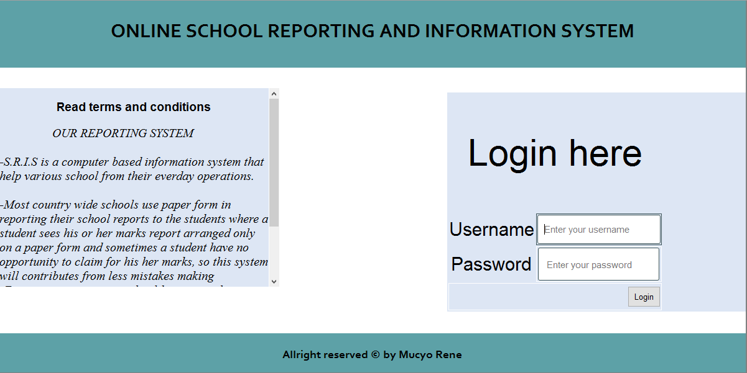
Figure 4: Dean of studies privileges
When the administrator logs in the systems, this page presents to him a list of privileged actions that he can perform.
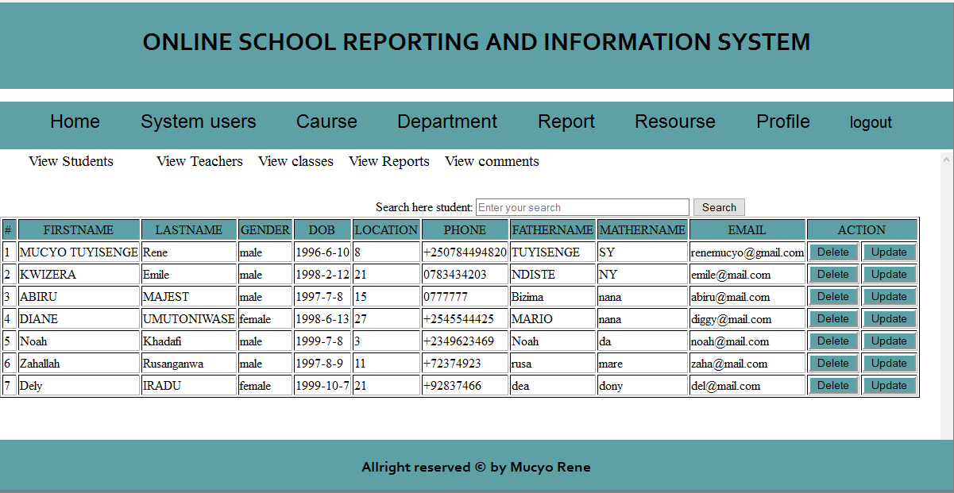
Figure 5: administrator privileges form

Department registration page
When the administrator logs in the system, this page presents department registration.
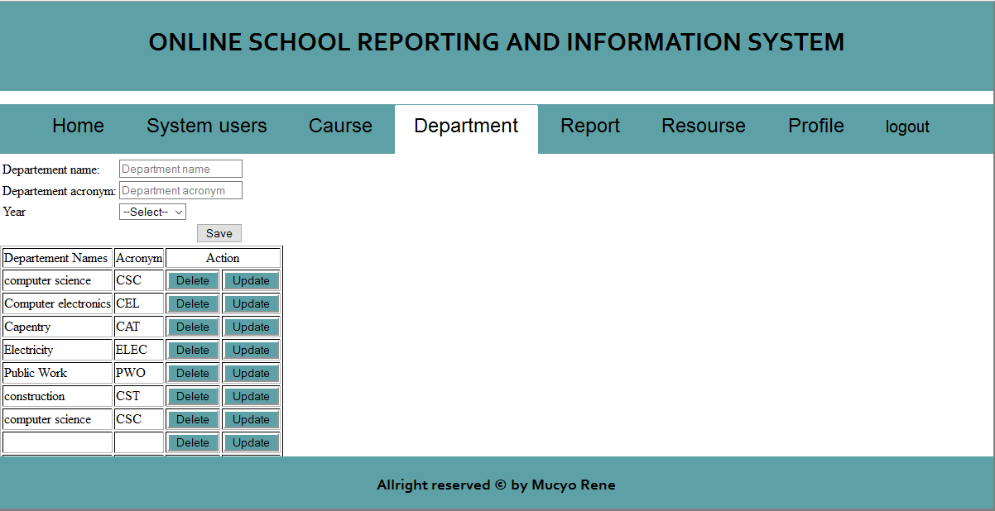
Figure 6: Department registration page

Student’s registration form
Here this page student registration
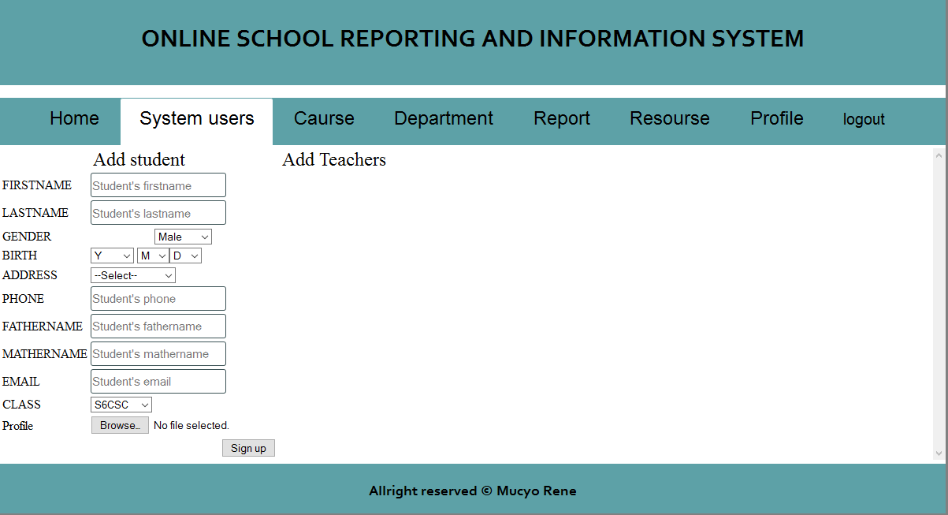
Figure 7: Student’s registration.

Courses:
Here this page present course registration.
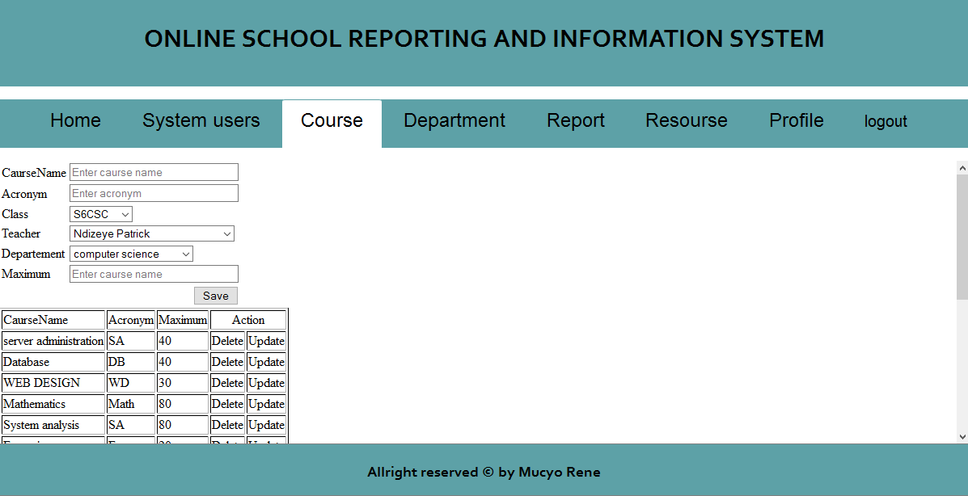
Figure 8: Course registration

Student’s report page
This page represent the student’s report page.
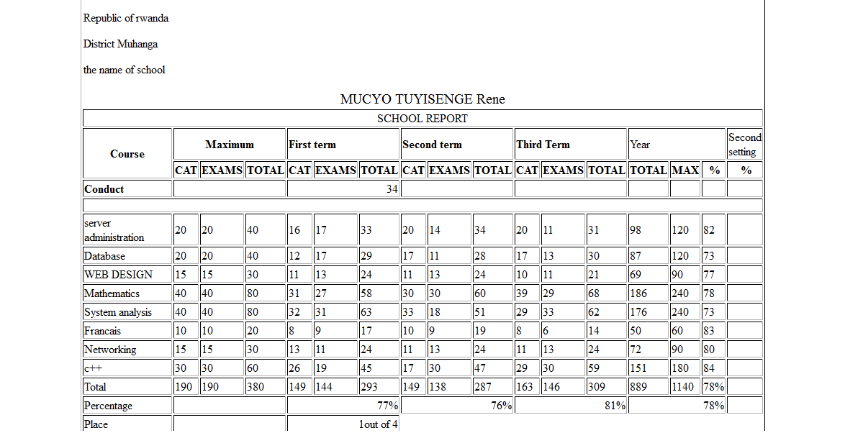
Figure 9: Student’s report.

CHAP V. CONCLUSION AND RECOMMENDATION

5.1. Conclusion
The development of ONLINE School Reporting And Information system involves many phases. The approach used is a top-down one concentrating on what first, then how and moving to successive levels of details. The first phase started with a detailed study of the problems. In the course of this study, many problems were discovered to have hindered the effectiveness of the existing manual system. These problems, information needs and activities were documented and later used as the basis for the application design, which immediately followed the first phase. The design phase was concerned primarily with the specification of the application essential elements in manner that best met a support center needs. During this phase, strict adherence was made on proven application engineering principles and practices. To implement this design, ONLINE SCHOOL REPORTING AND INFORMATION system was created with use of XAMPP software package, browser and text editor and the use HTML, PHP, CSS and MySQL database. It is hoped that effective implementation of this application product would eliminate many problems discovered during legacy systems investigation and large system that have school reporting.

5.2. Recommendation
As we know at the end of this dissertation, we met many obstacles like:
Insufficient time that was given us to do the dissertation in laboratory(practice),so we wish that the school may give long time to students to work on their dissertation and access the laboratory of computer science without the normal difficulties to them.
In fact also as this is a system application it should help most school in their operations of coordinating their student’s marks and their information and for our country in easy development of technology and decrease of time consumption in different activities such as most dean of study’s activities and transports to the students.

BIBLIOGRAPHY
Book and publications
- Learning web design 3rd edition by o’reilly
- Php and MySQL – wrox beginning
- Extended html and php programming with css.
- Web standard programmers reference html, css,javascript and php
- Website the right way
ELECTRONIC REFERENCES
http://en.wikipedia.org/wiki/Object-relational_database access 15/03/2016
http://www.w3schools.com/tags/att_input_required.asp access 16/04/2016
http://www.w3schools.com/js/js_functions.asp access 12/03/2016
http://www.google.com/about/report/java_script access 25/07/2016
http://www.w3schools.com/tags/att_input_required.asp access 10/07/2016
http://www.w3schools.com/js/js_functions.asp access 25/07/2016
http://www.php.net/ functions, access 03/07/2016
http://www.stackoverflow.com/index.php access 6/17/2016
http://www.w3.org/MarkUp access 09/08/2016
http://www.MYSQL.com access 11/02/2015

