Jenkins:::

1. Java application, platform independent
2. Used for Continuous Integration and continuous delivery.

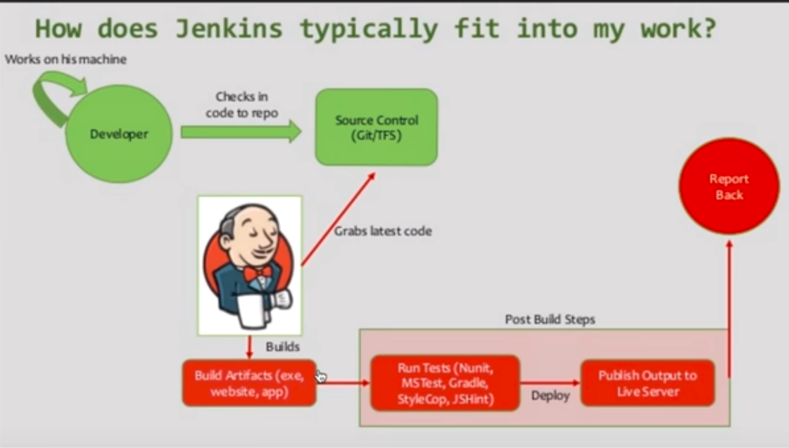

1. Download Jenkins
2. Jenkins run on by default: <http://localhost:8080>
3. We can use Command Line Interface for running Jenkins—easier, faster, better memory management, CI:

Go to : <http://localhost:8080/cli>

Download Jenkins CLI jar and place it in any location.

(Passphrase- SSH key🡪Configure user)

1. Create new users—Login as admin🡪 Mange Jenkins🡪Manage Usres🡪Create User
2. Configure the users-🡪Go to the configure section of that user and you can change your username, password, passphrase.
3. Create and manage user roles (Roles strategy plugin)—either download the plugin and place it in plugin folder in home directory or go to manage plugins and download the plugin.

Manage Jenkins🡪Configure Global security🡪Enable security check and under Authorization🡪select Role based Strategy

Manage Jenkins🡪Manage roles

Global roles—At a global level

Project Roles—At project level (Dev/Tester can access all the projects with names starting with dev and test respectively.)

1. Manage Jenkins🡪 Configure System.

Number of executors—Number of jobs that can run in parallel.

Labels: Go to Manage Nodes🡪Meaning the jobs can run in parallel on multiple machines.

Quiet period: Number of seconds that Jenkins should wait before starting a build.

SCM(Source Code management) checkout retry count: Maximum times Jenkins should retry for getting updated information from GIT.

1. Creating a Job:

Build periodically—Cron language used.

Job Dashboard-status, build, duration

Build trigger remotely.

Chaining jobs

1. GIT integration—Manage Jenkins🡪 Global tools configuration and enter till git.exe path